**Exercise 2**

*Using SOAPUI to interact with a sample SOAP Service*

**Prior Knowledge**

XML

**Objectives**

Deploy a ready built service into Tomcat

Call the service using SOAP message

See sample SOAP messages

**Software Requirements**

(see separate document for installation of these)

* Java Development Kit 7
* Tomcat 7.0.30 or later
* SOAPUI 4.5.1 or later

**Step 1. Deploy the service into Tomcat**

The sample service is already coded and available as a WAR file. It was written with Apache CXF and is available here:

[*https://github.com/pzfreo/ox-soa/blob/master/lab-exercises/code/sample-service-1.0.war?raw=true*](https://github.com/pzfreo/ox-soa/blob/master/lab-exercises/code/sample-service-1.0.war?raw=true)

Simply copy the WAR file into <tomcat>/webapps/ directory

Now start Tomcat:

Rather than use the “daemon” server startup we will use the model that keeps the server running in the open window.

cd <tomcat>

bin/catalina.sh run [Linux/Mac]

bin\catalina.bat run [Windows]

For reference here is the Server Startup approach.

cd <tomcat>

bin/startup.sh [Linux/Mac]

bin\startup.bat [Windows]

Check to see if its running:

Browse <http://localhost:8080/sample-service-1.0/>

You should see a SOAP Web Service listed with a link to the WSDL. Copy the WSDL Link into the Clipboard.

Now start up SOAPUI

File->New SOAPUI Project

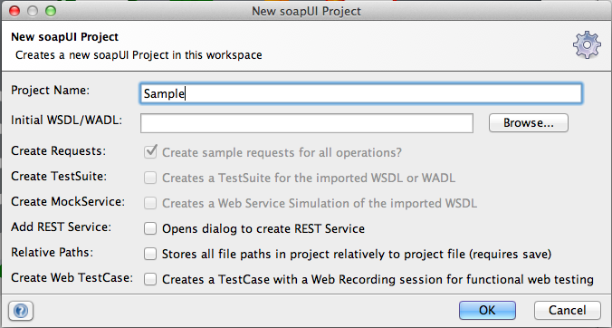

Type in a name for the project (e.g. Sample)

Paste the WSDL URI into the Initial WSDL field

Hit OK

Now open up the Request editor for one of the operations:

In the XML Payload, change any ‘?’ fields into something useful. Now hit the little green arrow (Run) button.

You should see a response from the service.

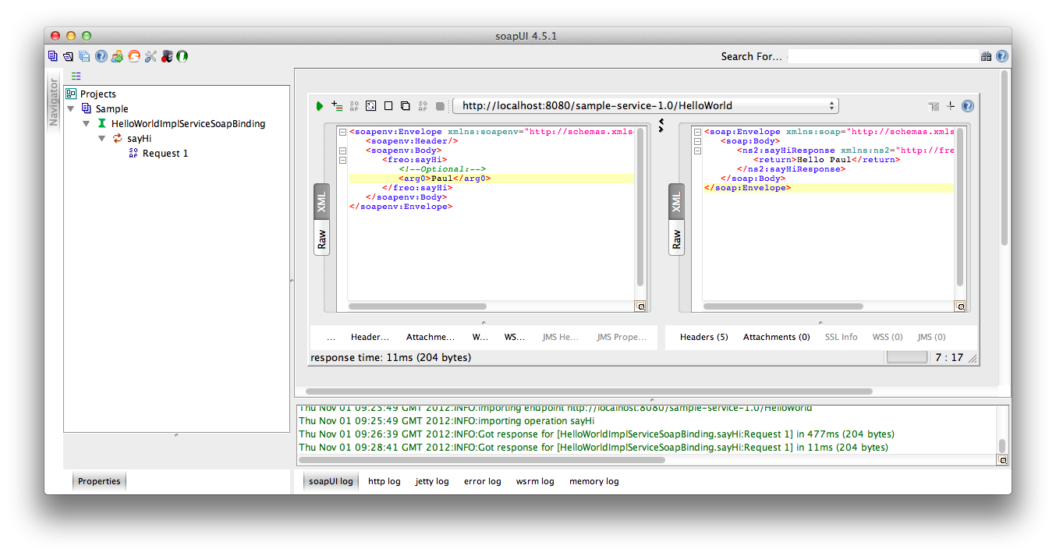

Use some of the SOAP UI capabilities to inspect the HTTP Headers, etc.

Try some other options and see what happens.