**Exercise 3a**

*Creating a WSDL-first service*

**Prior Knowledge**

*Understand WSDL and Schema*

**Objectives**

*Learn how to model services contract first and then implement.*

**Software Requirements**

* Java Development Kit 7
* Eclipse JEE

1. In Eclipse create a new Dynamic Web Project
2. Create a WSDL file using File->New->Other->Web Services->WSDL  
   Call it PurchaseOrder.wsdl  
   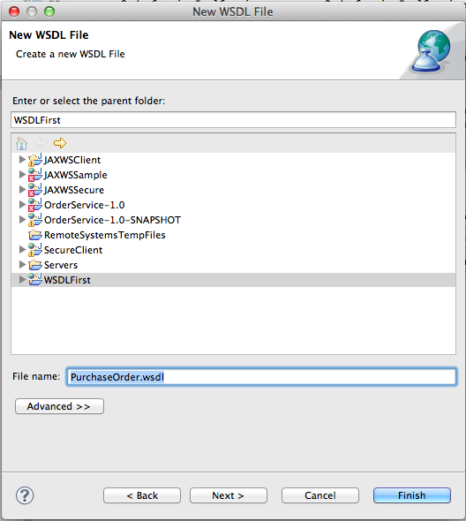
3. Click Next>  
   Make sure it is Doc/Lit, and create the skeleton.  
   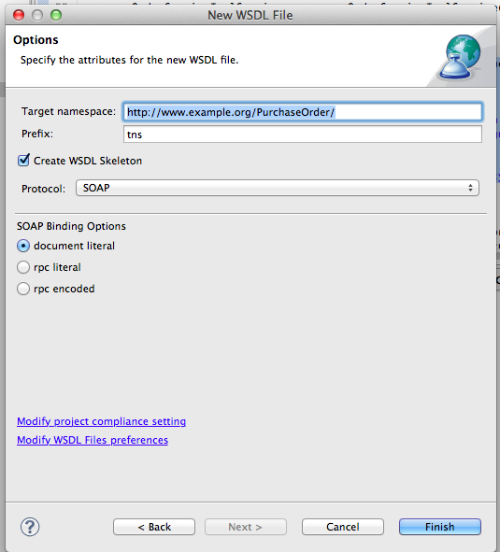
4. Switch to Design View  
     
   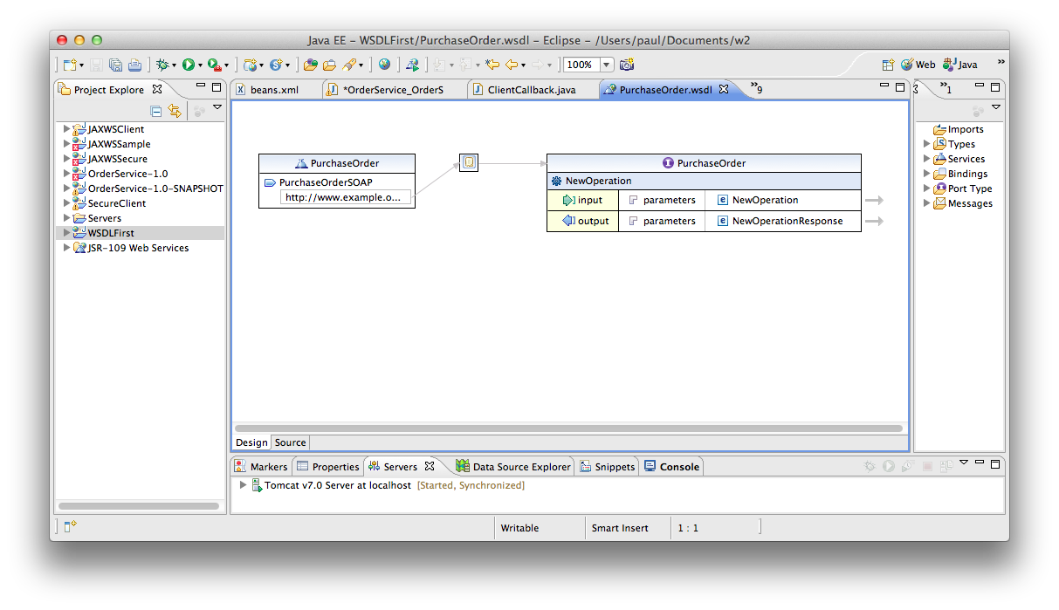
5. Now edit the Operation name to be purchase  
   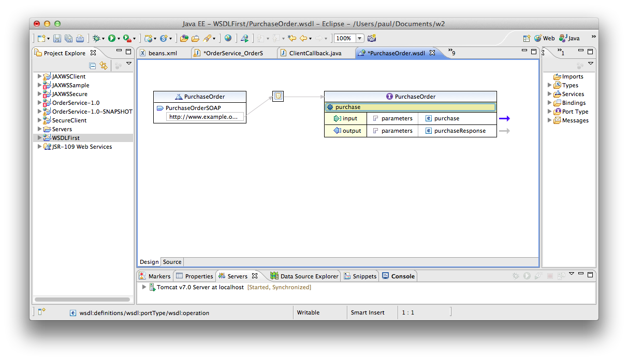
6. Now click on the 🡪 next to purchase
7. You will see some XML Schema  
   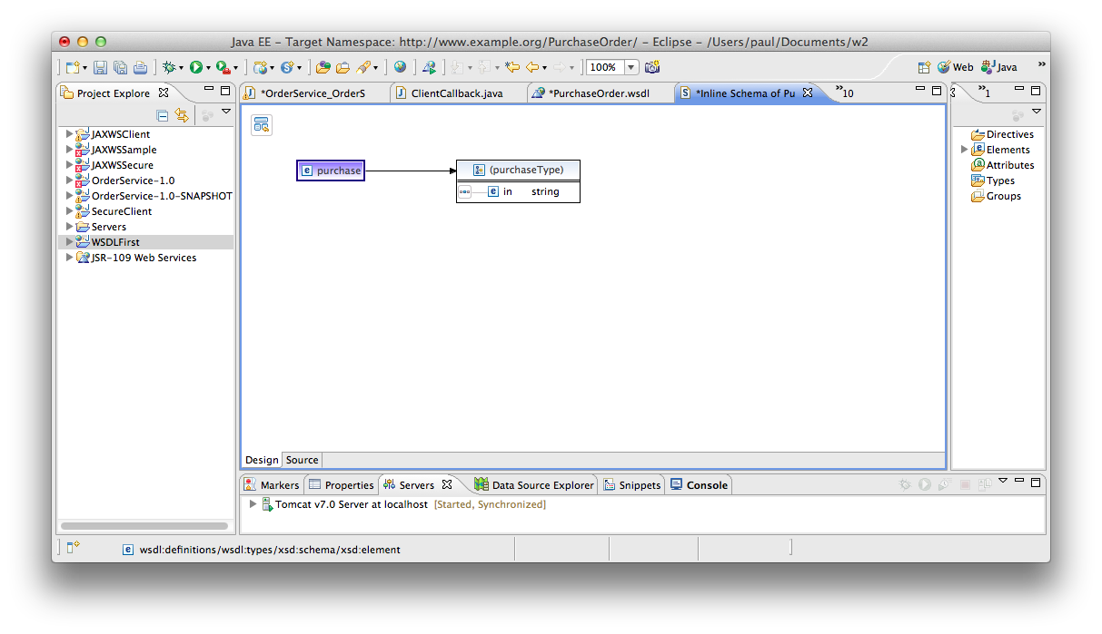
8. Replace the default single element that makes up the Purchase type with some useful elements. You should end up with something like:

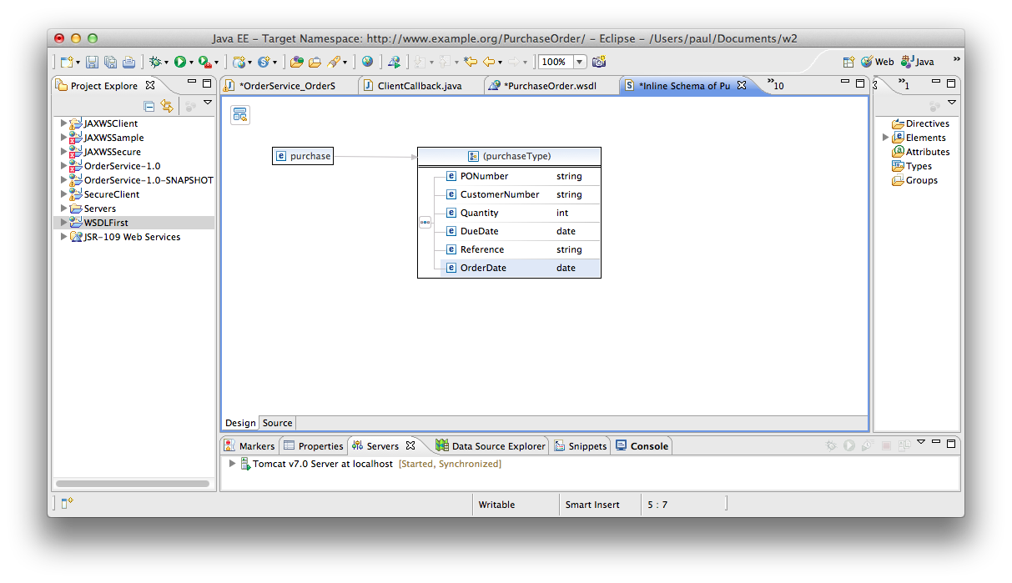

1. Save the schema (Ctrl-S)
2. Navigate back and do the same to make an intelligent response.
3. Right click on your WSDL file and select Validate. Check it all looks nice.
4. If you really want to, add some further operations, and schemas.
5. Now let’s create some code. Right-click on your WSDL and select Web-Services->Generate Java Bean Skeleton.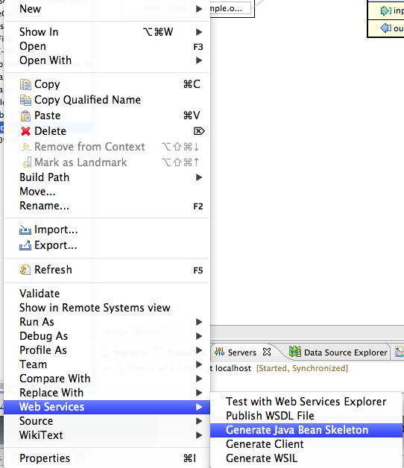
6. Change the runtime to be CXF: 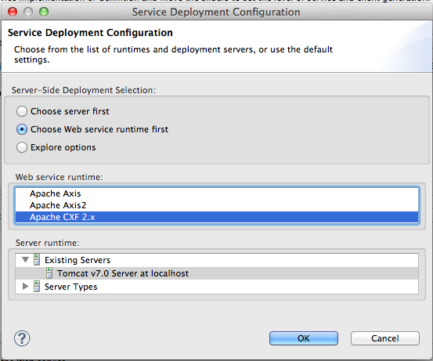
7. Click Next> and then make sure the Service Name is selected properly 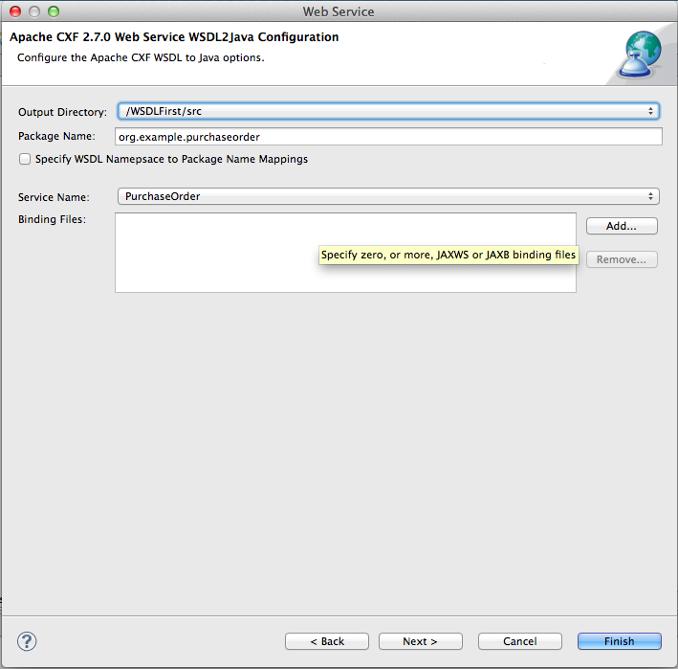
8. Click Next> and review the options. I suggest you check the same ones as shown below:  
   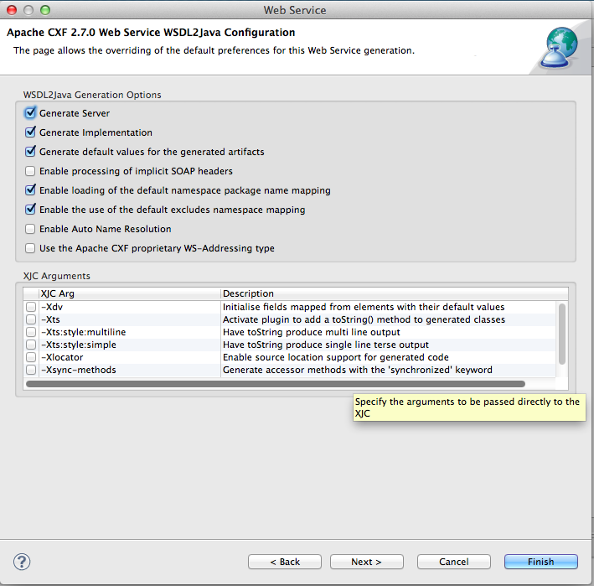
9. Click Next>
10. Don’t do any UDDI stuff! Click Finish.
11. The server has generated a nice implementation for you.
12. To find the WSDL, you need to either use the WSDD stuff (which we will cover later!). Alternatively you need to put together the project name into a URL like this:  
     http://localhost:8080/YourProjectNameGoesHere/services
13. Replace/Improve the logic in PurchaseOrderImpl with your logic. Run the service and test it with SOAPUI.
14. Extension: Find a WSDL on the internet and see if you can implement a clone.