**Exercise 4**

*Creating a JAX-WS Client using WSDL2Java*

**Prior Knowledge**

*Basic understanding of SOAP and WSDL*

**Objectives**

*Understand how to create Web Service Clients in Java*

**Software Requirements**

* Java Development Kit 7
* Tomcat 7.0.57 or later
* Eclipse JEE workbench Kepler
* Apache CXF 2.7.13 or later
* Service running from Exercise 3

1. To make a change we are going to use a command-line tool to create a Web Service Client. Later you can also try the wizard in Eclipse.
2. Start up a command-line shell / Terminal
3. I have already setup your environment so you DON'T need to do:  
   export CXF_HOME=~/servers/apache-cxf-2.7.13

export PATH=$PATH:~/servers/apache-cxf-2.7.13/bin

1. Create a directory to store your generated code, e.g.   
   mkdir ~/oxsoa/jaxwsclient

cd ~/oxsoa/jaxwsclient

1. Start up your service implementation in Tomcat (if it isn’t already running)  
     
   From the directory you want the code in, execute the following command:  
     
   wsdl2java -ant -verbose -client -d . -fe jaxws21 http://localhost:8080/JAXWSSample/services/OrderServiceImplPort?wsdl   
     
   **Put all on one line!**
2. Check it builds. In the directory where the code is generated, there should be an Ant build.xml. Type **ant** in the command line. You should see something like:  
   >ant  
   Buildfile: /Users/paul/oxsoa/client/build.xml  
     
   compile:  
    [mkdir] Created dir: /Users/paul/oxsoa/client/build/classes  
    [javac] /Users/paul/oxsoa/client/build.xml:110: warning: 'includeantruntime' was not set, defaulting to build.sysclasspath=last; set to false for repeatable builds  
    [javac] Compiling 14 source files to /Users/paul/oxsoa/client/build/classe  
     
   build:  
     
   BUILD SUCCESSFUL  
   Total time: 3 seconds
3. Now let’s import into Eclipse.
4. Start up Eclipse.
5. I have already done this:  
   Go to Preferences, Ant, Runtime, Properties Tab, Add Property with the values:  
   Name: cxf.home  
   Value: /home/ox-soa/servers/apache-cxf-2.7.13

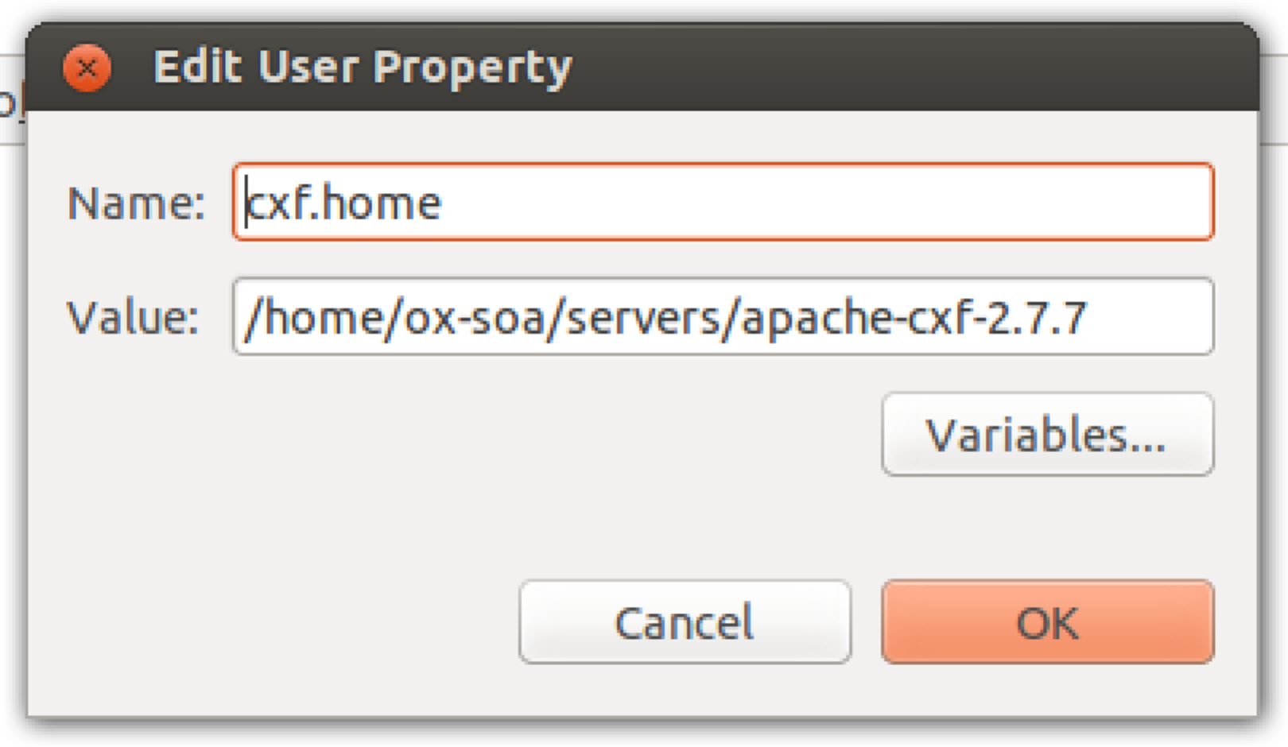

1. Now create a new project using New->Other->Java Project from Existing Ant Build File.   
     
   Browse to the build file in your generated code directory.  
     
   Give the project a decent name (e.g. JAXWSClient)
2. Take a look at the generated code.
3. Find the class named **OrderService_OrderServiceImplPort_Client** and run it. (**Run As->Java Application**).

***Hint:*** *If you double click on the word Console (or any window title in Eclipse) it maximizes that sub-window. Double click again to return to normal.* **  
Is the behaviour you are getting expected?

1. Edit the client to create at least one Order and correctly list all the orders.
2. Congratulations, you have succeeded (if you got this far!)
3. Extension: Do the same using the Eclipse wizards (hint: start with a Dynamic Web Project)