**Exercise 5**

*Debugging SOAP flows by setting TCPMON as an HTTP Proxy*

**Prior Knowledge**

*Exercises 3 and 4 – creating a JAXWS Service and CXF Client.*

**Objectives**

*Learn to run TCPMON and configure your client to call via the client.*

**Software Requirements**

* Java Development Kit 7
* Tomcat 7.0.33 or later
* Eclipse JEE workbench
* Apache CXF 2.7.0 or later
* Service running from Exercise 3, Client from Exercise 4

1. You should have tcpmon in the VM.
2. cd ~/servers/tcpmon/build
3. ./tcpmon.sh
4. You should see a screen like this appear:  
   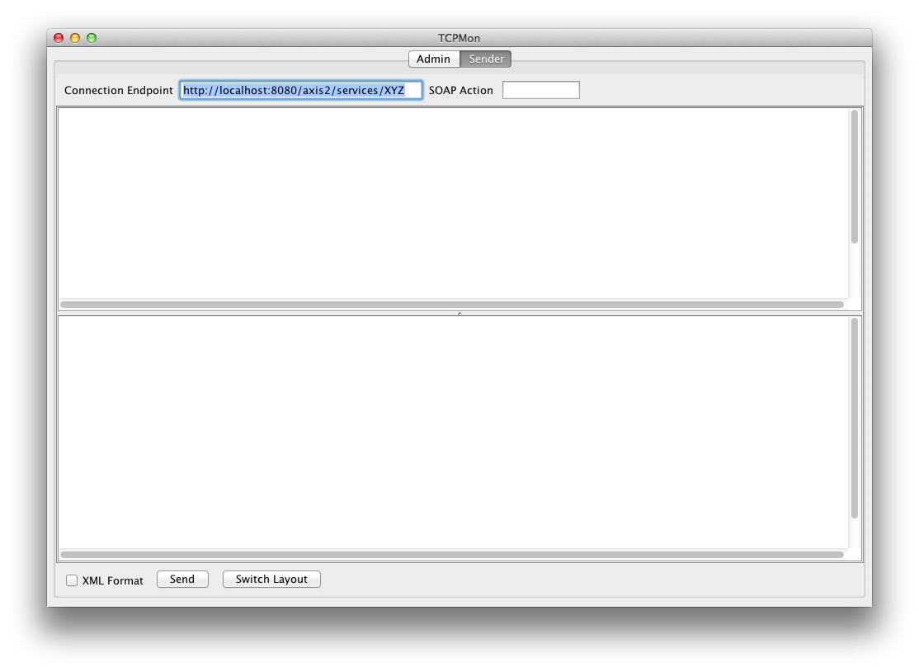
5. Now click on **Admin**
6. Enter 8000 as the listen port, Click on the Proxy button.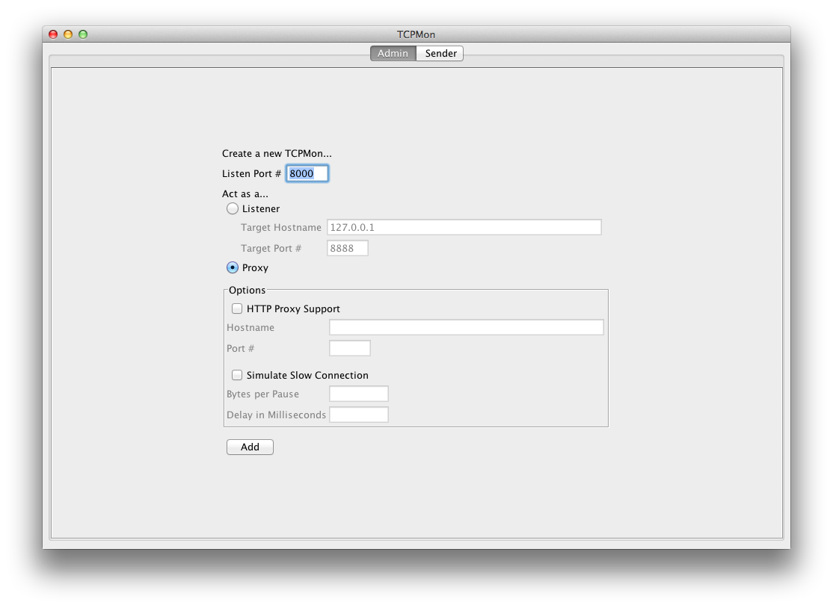
7. Click Add
8. Now select the new tab **Port 8000** that appears.
9. Change one of your clients to include the following lines which will make it use the Proxy:

First add the following imports to your client.

**import** org.apache.cxf.endpoint.Client;

**import** org.apache.cxf.frontend.ClientProxy;

**import** org.apache.cxf.transport.http.HTTPConduit;

**import** org.apache.cxf.transports.http.configuration.HTTPClientPolicy;

Now find the **port**  object and just after it is initialized add:

Client client = ClientProxy.*getClient*(port);

HTTPConduit http = (HTTPConduit) client.getConduit();

HTTPClientPolicy httpClientPolicy = **new** HTTPClientPolicy();

httpClientPolicy.setProxyServer("localhost");

httpClientPolicy.setProxyServerPort(8000);

http.setClient(httpClientPolicy);  
  
This could also be set in an XML config file, but it is simpler for now to use Java. Now re-run your client and look at the trace in TCPMON. You might want to put it into XML mode.

The screenshot below is a rough approximation but based on a different client and server than you are currently using.

