**Exercise 9**

*Using a Registry to publish endpoint metadata and retrieving that endpoint data*

*Looking at wider Registry Governance issues*

**Prior Knowledge**

Using the ESB, creating services, deploying services

WSDL

**Objectives**

*Deploy a governance registry, connect the services server to the governance registry, publish services into it. Find those services from the ESB.*

**Software Requirements**

* Previous installations of ESB and AS from Exercise 7
* Java Development Kit 7
* WSO2 Governance Registry 4.5.2

1. Switch to your home directory:  
   cd
2. Now unzip the Governance Registry product:  
   unzip ~/Downloads/wso2greg-4.5.2.zip
3. Jump into the G-Reg directory:  
   cd wso2greg-4.5.2
4. Change the port offset to 2: edit the   
   **~/oxsoa/wso2greg-4.5.2/repository/conf/carbon.xml**config file  
     
   You can use nano on the command line or gedit in the windowing environment.
5. Search for offset and change the entry to read:  
     
   <Offset>2</Offset>
6. This will move all the ports up by 1.
7. chmod +x bin/*.sh
8. Start the server:  
   bin/wso2server.sh
9. Go to the administrators console: https://localhost:9445/
10. Login with admin/admin
11. You should see a screen like this: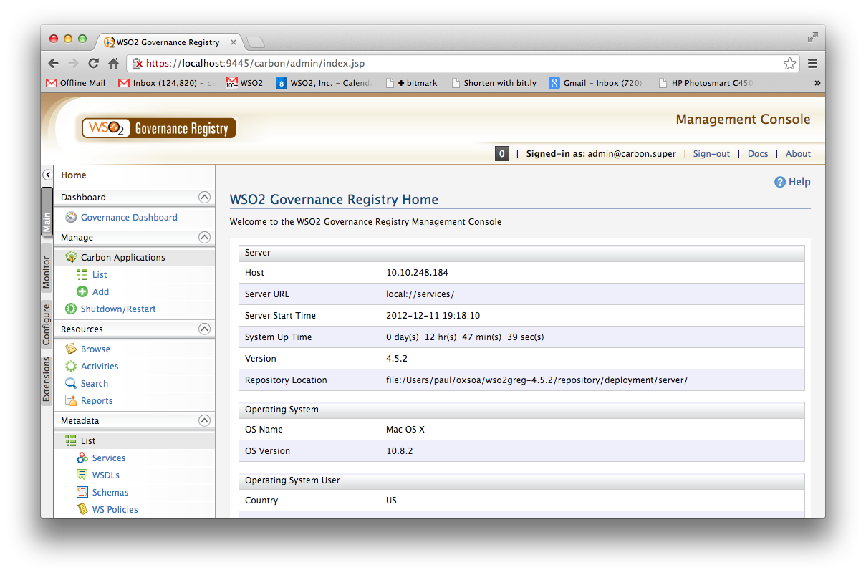
12. If you click on Services you should see an empty list (since we haven’t registered any services with the Registry)
13. In a moment we are going to automatically add some services, but let’s first do one the “hard way” – by hand. To make it easy we are going to be quite lazy.
14. Go to the **Add /Service** button on the left hand side.
15. This is a “top-down” way of defining a service. Fill in some information.  
    Use the following information / leave other fields empty:  
    Name: OrderService  
    Namespace: me.freo.po  
    Version: 0.0.1  
    Description: Ordering Service.  
    Save it.
16. Find the Lifecycle section on the right hand side and expand it. Click Add Lifecycle   
    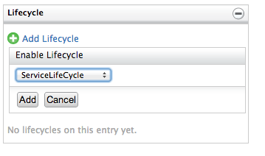  
    Click Add
17. Now in order to move this Service out of Development we need to complete some tasks:  
    * Code Completed  
    * WSDL, Schema Created  
    * QoS Created
18. Pretend you’ve done all that. Select the checkboxes. Now click Promote. You will be prompted to enter a new Version Number. Type in 1.0.0
19. Now look at you Services list again. You will have another version of this service available, now in the Testing Lifecycle. Take a look at it.
20. If you want to understand the gory details of how to configure your own lifecycles and lifecycle actions, go to the left hand **Extensions** tab, click Configure/Lifecycles, then **View** the ServiceLifecycle configuration. You will see an XML based on the SCXML standard.  
    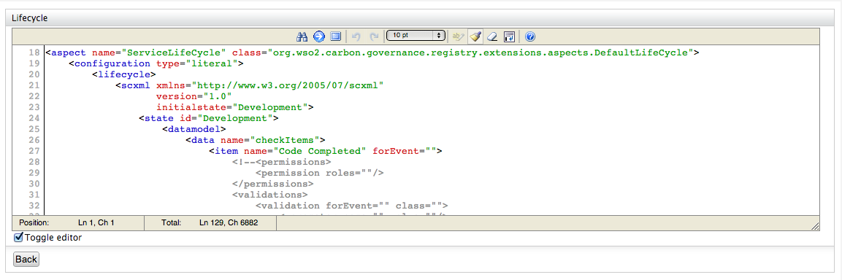
21. Now lets get our AppServer Services published in the Registry. Our services are hosted in WSO2 Application Server, and this can automatically publish into the Registry using WS-Dynamic Discovery. To do this, we need to tell the AppServer where the Registry is.   
    [Please note this only currently works for Axis2 services deployed in AS as there is an incompatibility between CXF’s WSDD and G-Reg’s WSDD which we are looking into.
22. To do this, edit the ~/wso2as-5.0.1/repository/conf/axis2/axis2.xml
23. Add the following (bold) line in the correct place:

<!-- ================================================= -->

<!-- Parameters -->

<!-- ================================================= -->

**<parameter name="DiscoveryProxy">https://localhost:9445/services/DiscoveryProxy</parameter>**

<parameter name="hotdeployment">true</parameter>

1. Restart (or Start) the Application Server. You can do this from the Web Admin Console or from the command line.
2. Wait a bit and then check the Registry Services list: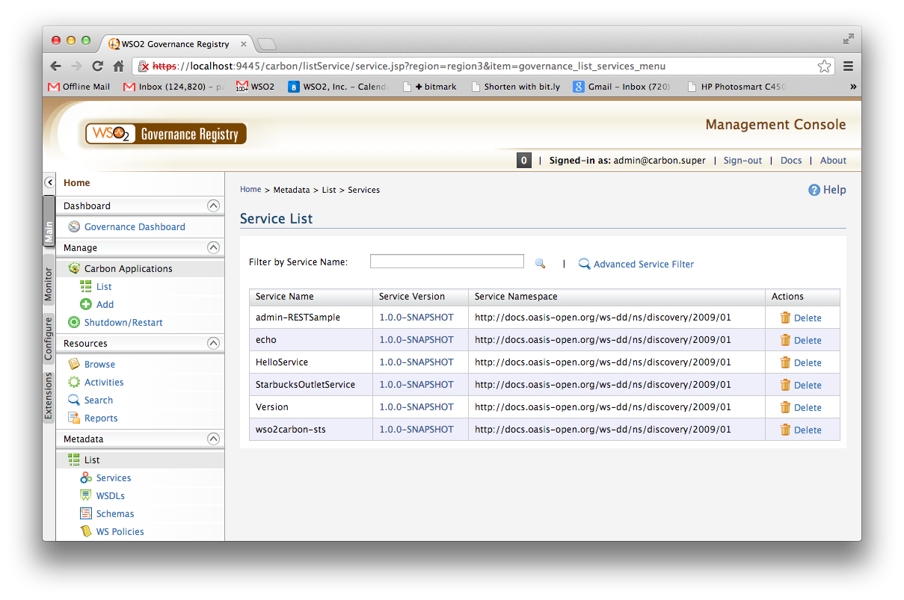
3. You can also find the WSDLs from these services in the WSDL list.
4. We can now “Link” the ESB to the Registry:
5. Start the ESB if it isn’t running.
6. Go to the ESB Admin Console (https://localhost:9444)
7. Change the left hand menu tab to Configure
8. Select WS-Discovery
9. Click Add Discovery Proxy
10. Fill in the details as follows:   
    Proxy Name: WSO2Registry  
    URL: <https://localhost:9445/services/DiscoveryProxy>  
    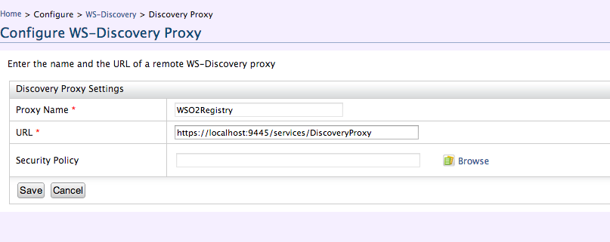
11. Click Save
12. It should now say that the server is Online 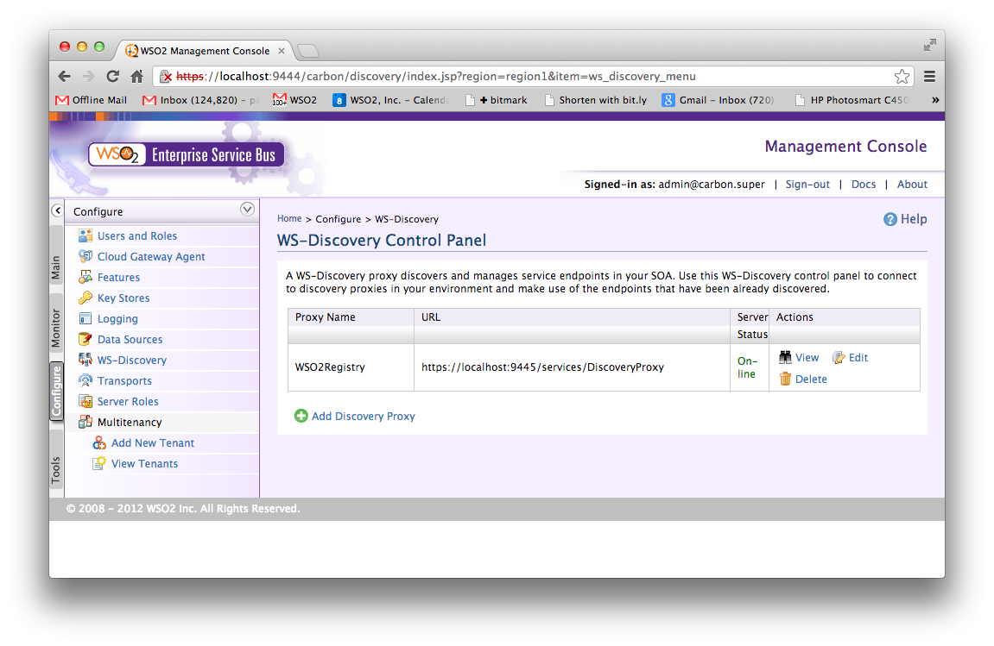
13. Click View

You will see the various endpoints from the services that are published in the Registry. Find the service with the “Starbucks endpoints” e.g. <http://10.10.248.184:9763/services/StarbucksOutletService>

1. Click on the UUID link
2. Go down to the section “Create ESB Endpoints” and expand it.  
   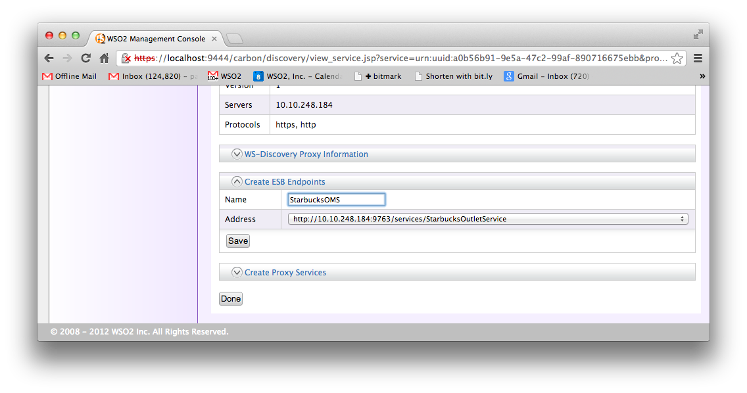
3. Give the name StarbucksOMS and hit Save. You should see:  
   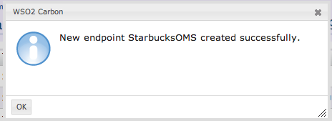
4. If you switch back to the Manage tab and look at the endpoints, you should now find it is there.
5. That’s all folks!