**Exercise 9**

*Creating a BPEL flow*

**Prior Knowledge**

*Understand WSDL and Services*

**Objectives**

Understand the basics of the BPEL specification

**Software Requirements**

* Java Development Kit 7
* Eclipse
* WSO2 Developer Studio
* WSO2 BPS 3.0.0
* WSO2 AS 5.0.1 running the Starbucks OMS service from the previous lab

1. From the Developer Studio Dashboard select BPEL Workflow.  
   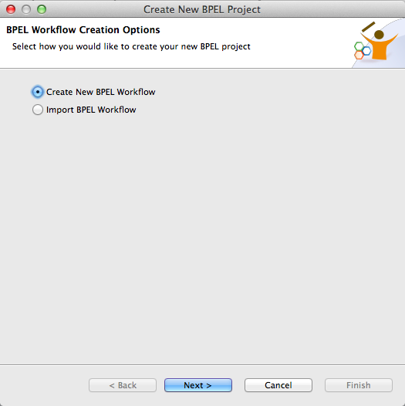
2. Select Create new BPEL Workflow
3. Use:  
   Project Name: QuickOrder  
   Process Name: QuickOrder  
   Template: Synchronous BPEL Process  
   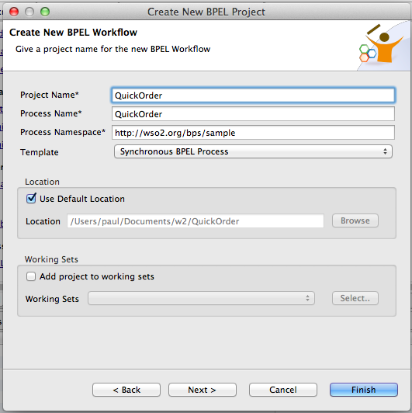
4. Click Finish
5. Your screen should look similar to this: 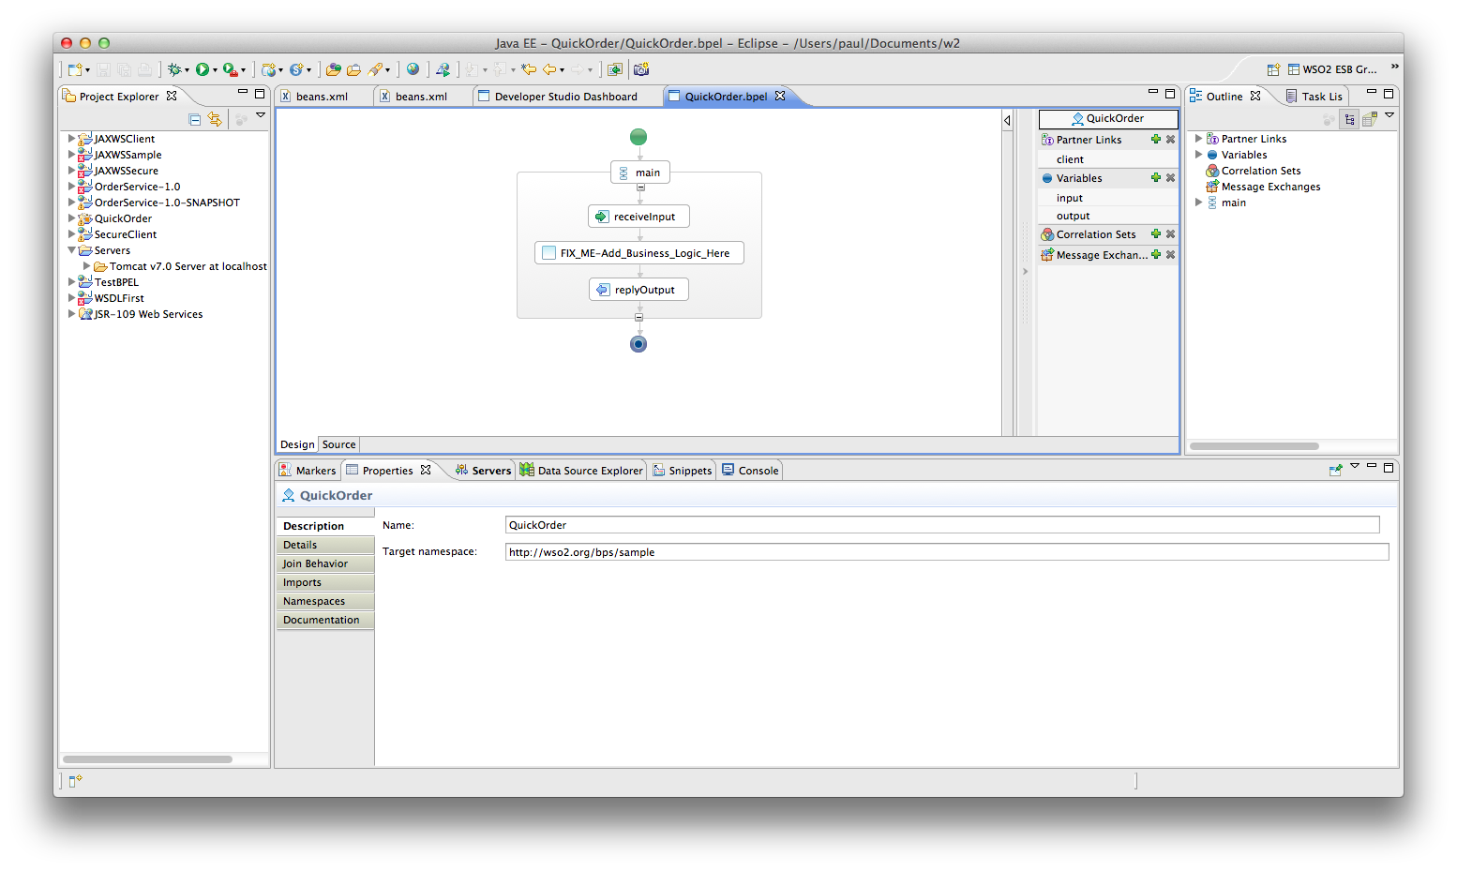
6. For the moment ignore the beautiful flow diagram. Instead, edit the QuickOrderArtefacts.wsdl   
   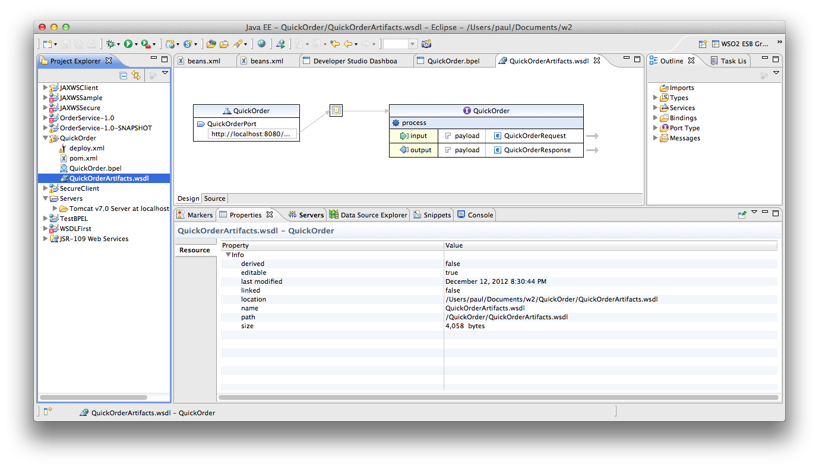
7. Click on the arrow next to QuickOrderRequest. This will edit the schema for this operation. 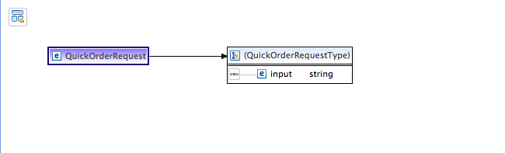
8. Click on the word “input” and rename it to “name”
9. Now Right Click and Insert Element->After
10. Change the name of the NewElement to drink
11. Add another new element after. Make it an int and call it number
12. Now it should look like this: 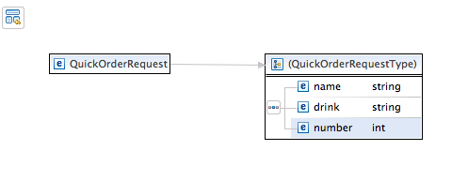
13. Hit Command-S/Ctrl-S to save.
14. Close the Inline Schema tab and the WSDL tab
15. Go back to the Flow Diagram / BPEL page.
16. We are now going to import the Starbucks WSDL.
17. Make sure the AppServer is running and the Starbucks WSDL is available using the AppServer console on <https://localhost:9443>
18. Browse the WSDL, and download it to your local file system. Make sure its called .wsdl (not .xml)
19. Now import it into the QuickOrder project.
20. Click on the + next to Partner Links also on the right hand side.
21. Change the name of the Partner Link to CoffeeProvider
22. In the properties tab below select Browse: 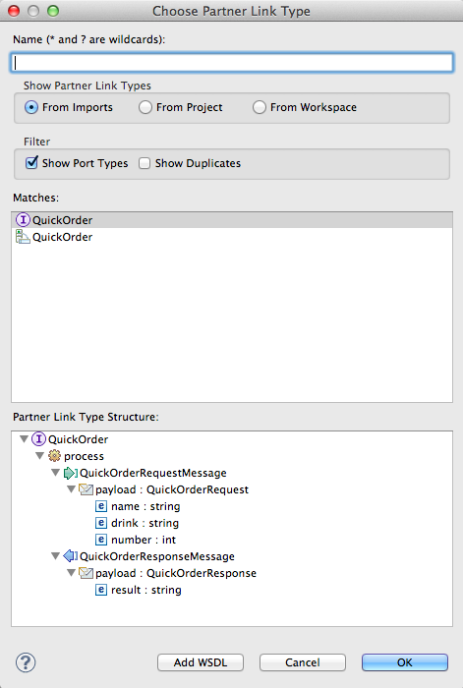  
    Click Add WSDL
23. Browse to your imported WSDL: 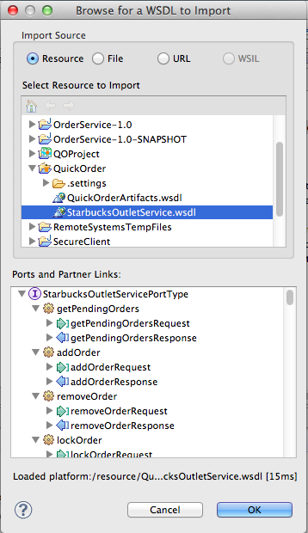  
    Click **OK**
24. Now Select the **StarbuckOutletServicePortType**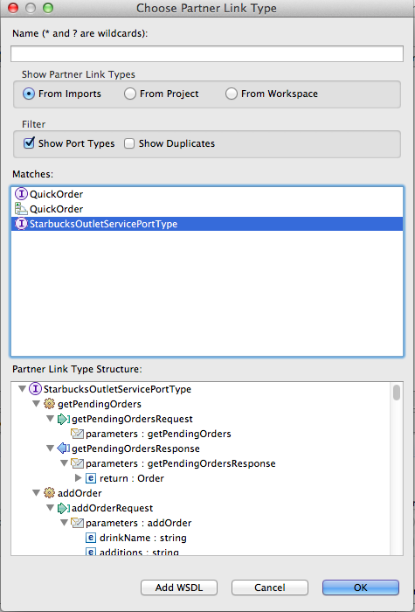
25. Click OK
26. Name it CoffeeProviderType 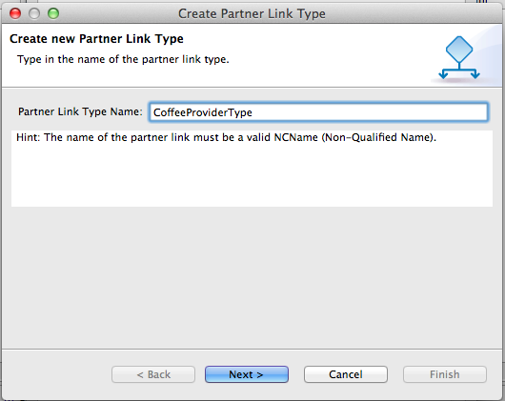
27. Give the role a name (CoffeeProviderRole) and make sure the Starbucks Port type is selected again 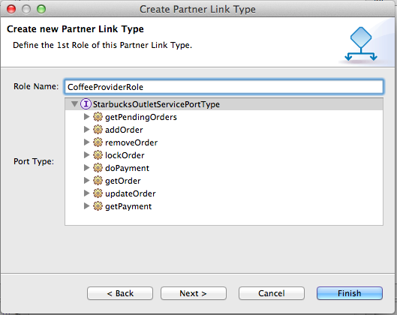
28. Click Finish
29. Back in the Properties pane for the PartnerLink make sure My Role is None and the Partner Role is CoffeeProviderRole:  
    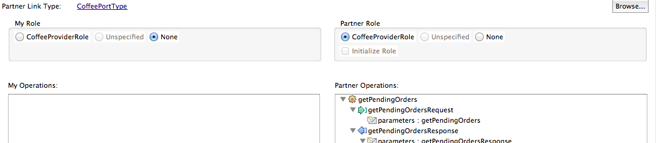
30. **Insert** an **Invoke** before FIX_ME:  
    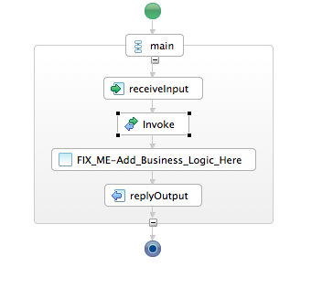
31. Select the invoke. In the properties pane choose the CoffeeProvider partner link and the addOrder operation.  
    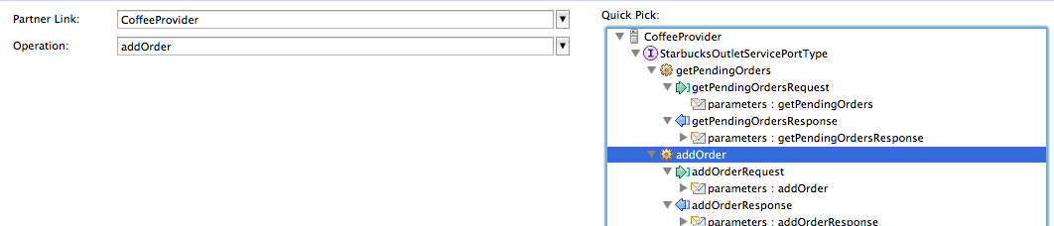
32. Now insert an Assign before Invoke: 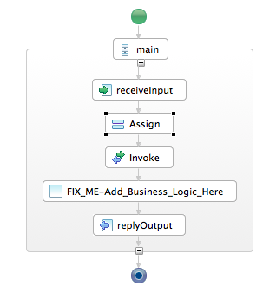
33. In the Properties pane below, click New
34. Choose Variable to Variable
35. Choose the drink from the input/payload and map it to the drinkName in the CoffeeProviderRequest
36. Click back on the input pane and it will prompt Eclipse to ask you 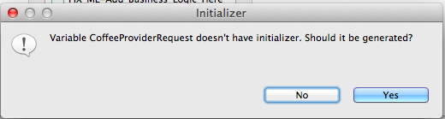Click Yes
37. This will auto generate a second “copy” operation which is required by the BPEL spec to initialize the XML message for the call out to Starbucks. Your properties should now look like:   
    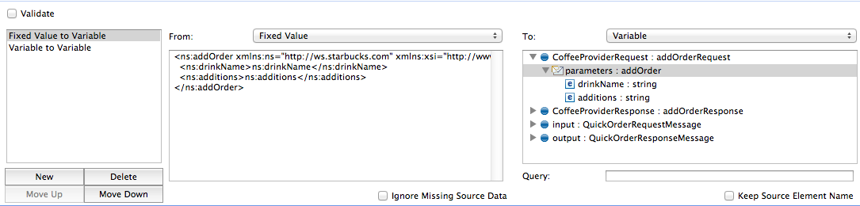  
    Remove the contents of the additions element, so it reads <ns:additions/>
38. Create before replyOutput 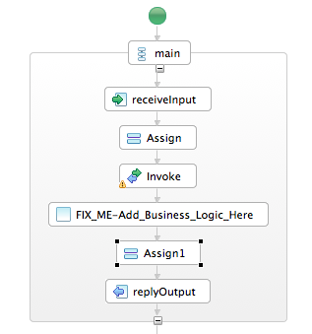
39. Get it to copy from **CoffeeProviderResponse/payload/orderId** into **output/payload/response**
40. Go to the deploy.xml
41. Choose the right inbound port type for the client partnerlink: QuickOrderPort.
42. Choose the StarbucksOutletServiceHttpSoap11Endpoint for the CoffeeProvider partnerlink.  
      
    Our process isn’t finished, but we should be able to run it.   
    -------------
43. Hit Command-N/Ctrl-N to pull up the New dialog.
44. Choose Carbon Application Project  
    Give it a Name QOProject and ensure that your QuickOrder process is selected:  
    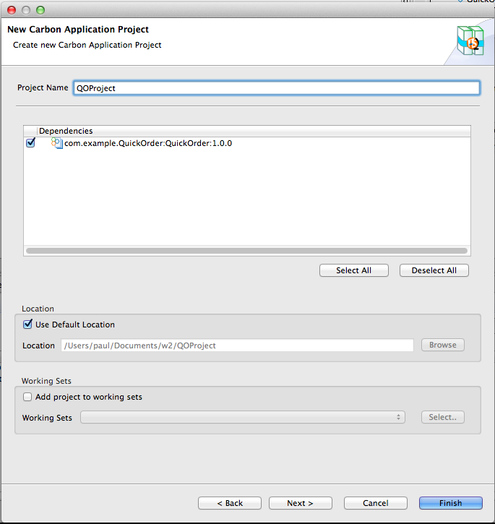
45. Click Finish
46. Hit Command-N/Ctrl-N to pull up the New dialog.
47. Create a new Server
48. Choose WSO2 -> WSO2 Carbon Remote Server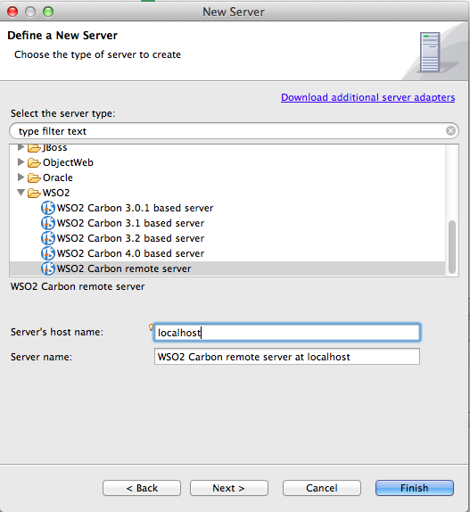
49. Click Next
50. Choose the URL of your BPS server (e.g. https://localhost:9446/)  
    Test it connects successfully. Then Validate the Credentials: 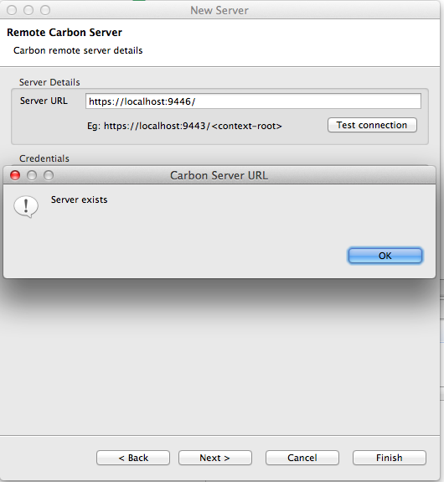
51. Click Next
52. Add your QOProject to the Server: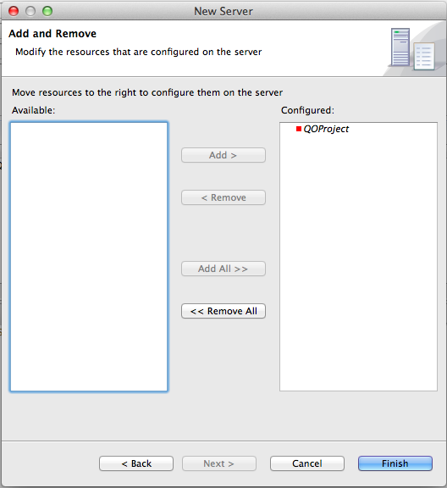
53. Click Finish
54. Go to the QOProject. Right-Click and Run As -> Run on Server
55. Go to your BPS console and wait a bit. Your process should be deployed. 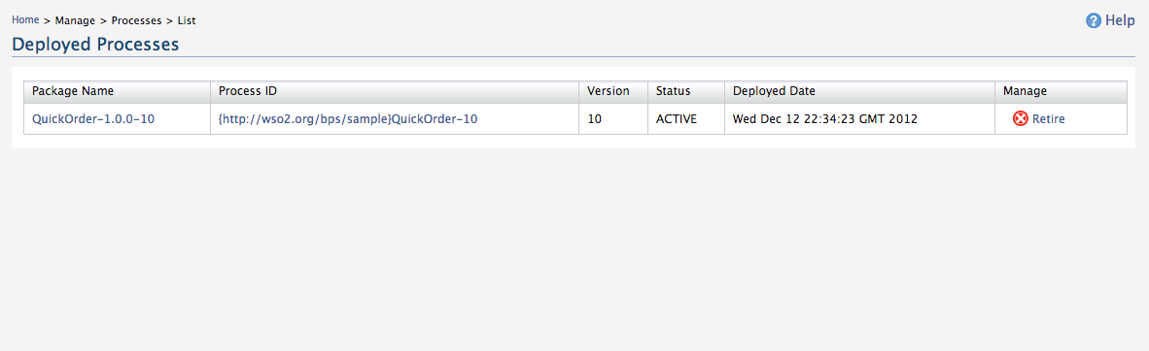
56. Click on the QuickOrder-1.0.0-x Process Id. Click Try It.
57. Fill in some plausible data *(make sure your int is an int!)* 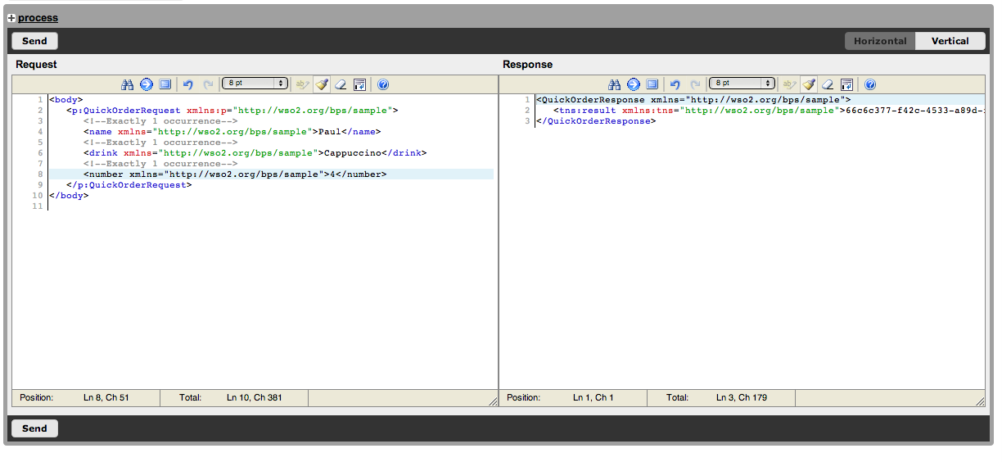
58. Hopefully you have created an Order!
59. Ideally you will now do more. The idea is to automate the Ordering and Payment, using a fixed credit card. See if you can get the Process to Order and Pay for a Drink.
60. If you really want to stretch, now get it to Order and pay for n drinks!