**Exercise 11**

*Creating a BPEL flow*

**Prior Knowledge**

*Understand WSDL and Services*

**Objectives**

Understand the basics of the BPEL specification, and be able to create and execute a business process using the BPEL tooling in Eclipse. Deploy the BPEL into the WSO2 BPS and be able to track instances etc.

**Software Requirements**

* Java Development Kit 7
* WSO2 Developer Studio 3.7
* WSO2 BPS 3.2.0
* WSO2 AS 5.2.1 running the Starbucks OMS service from the previous lab

1. In Eclipse, Hit Command-N/Ctrl-N to pull up the New dialog.
2. Choose **Composite Application Project**  
   Give it a Name **QOProject**. 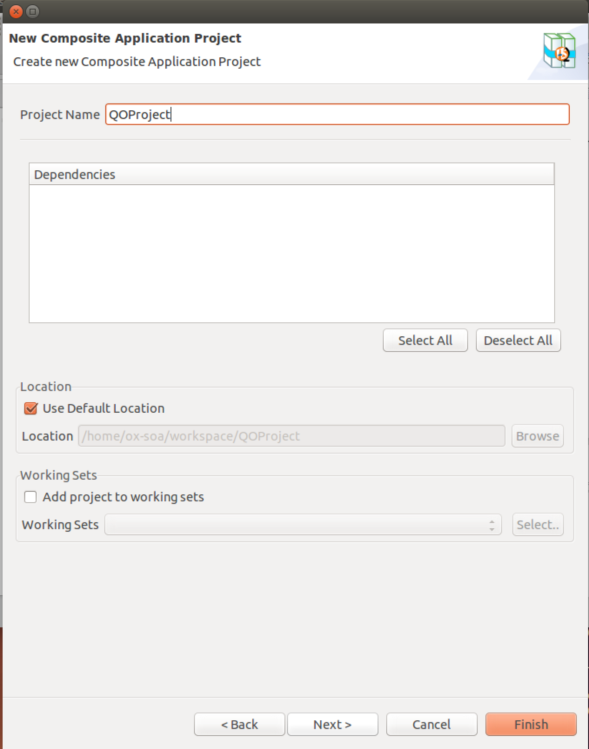
3. Click **Finish**
4. Select **QOProject** and right-click. Select New->BPEL Workflow
5. Select Create New BPEL Workflow: 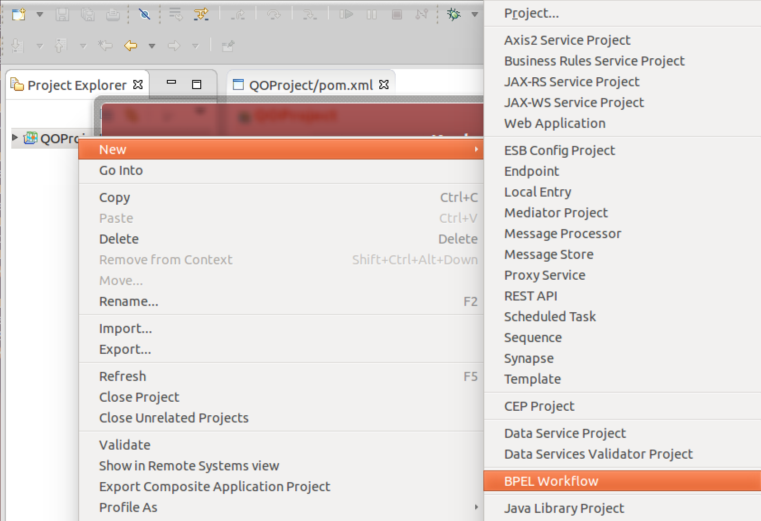  
     
   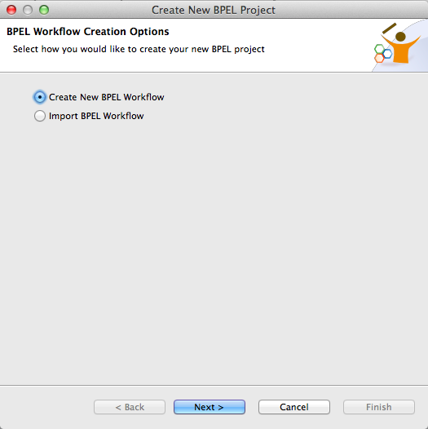

1. Use:  
   Project Name: **QuickOrder**  
   Process Name: **QuickOrder**  
   Template: **Synchronous BPEL Process** [note this is NOT the default!]  
     
   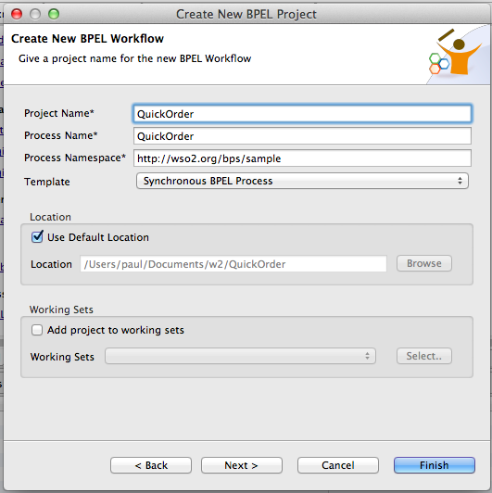
2. Click Finish
3. You may be asked if you want to use the BPEL perspective. You do.
4. Now go back to the “owner” project of QOProject and double-click on the pom.xml file. Select the check box next to the BPEL process: 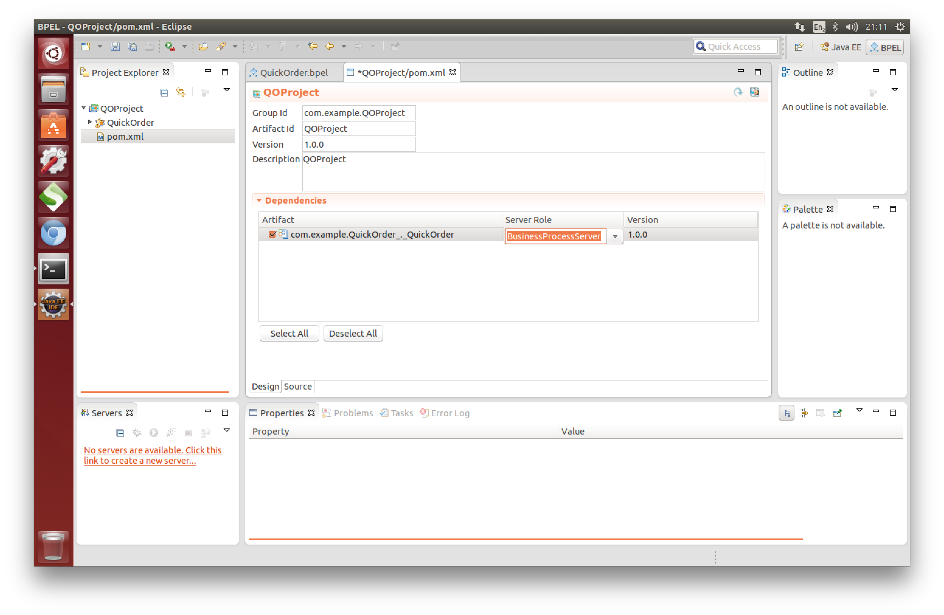
5. Now go back to the QuickOrder.bpel
6. Your screen should look similar to this: 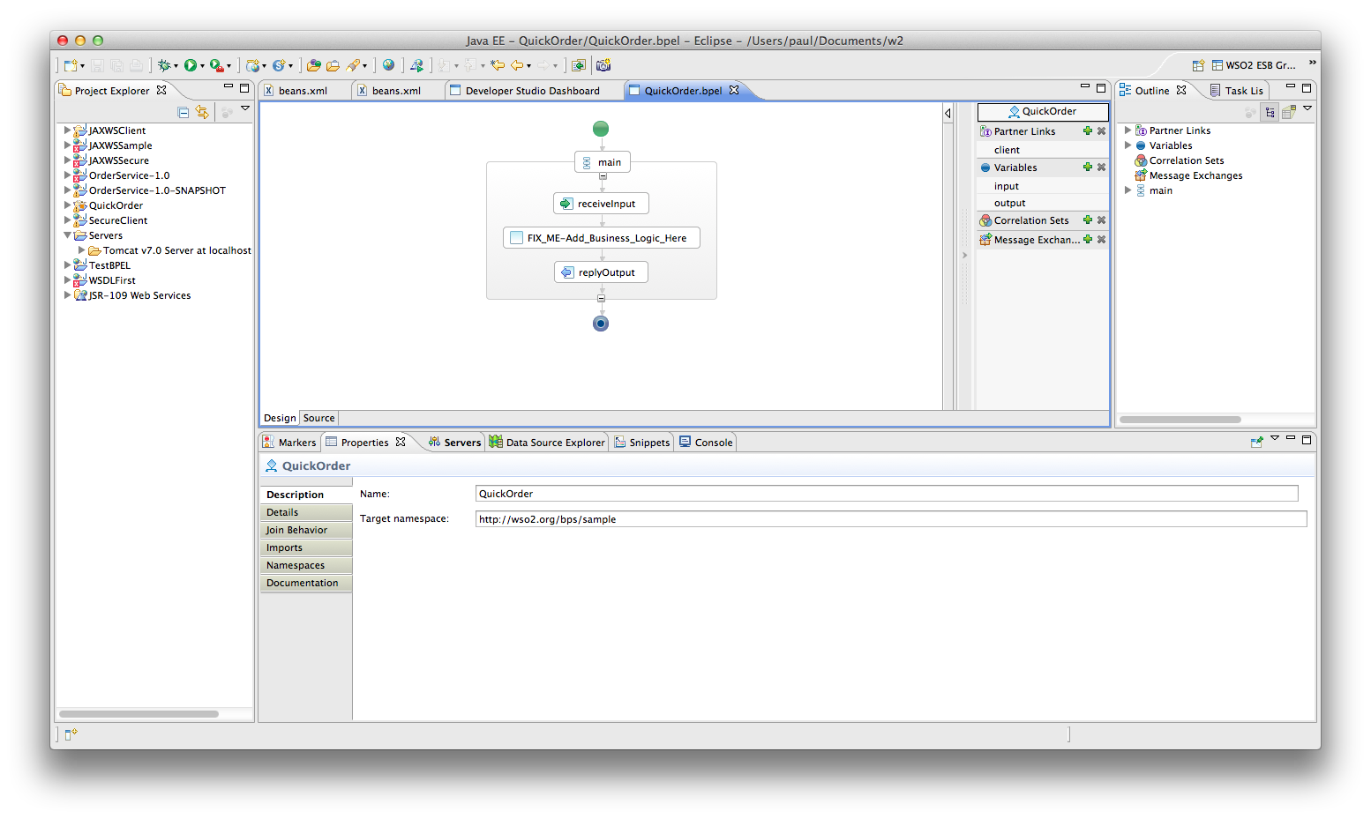
7. For the moment ignore the beautiful flow diagram. Instead, edit the QuickOrderArtefacts.wsdl   
   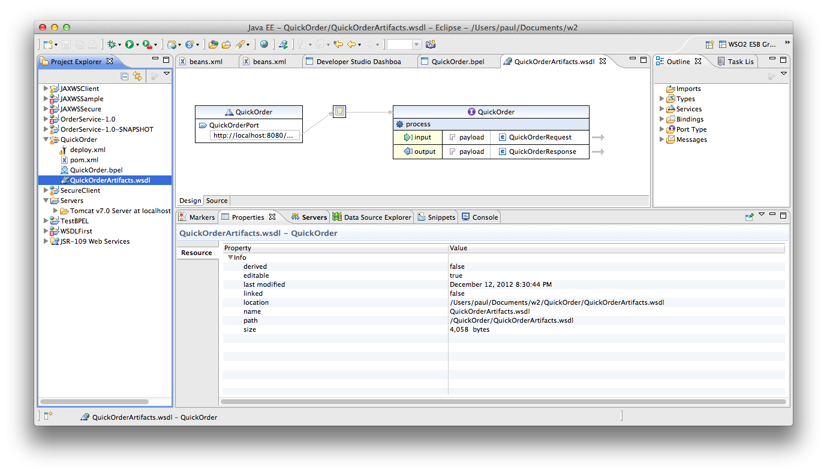
8. Click on the arrow next to QuickOrderRequest. This will edit the schema for this operation. 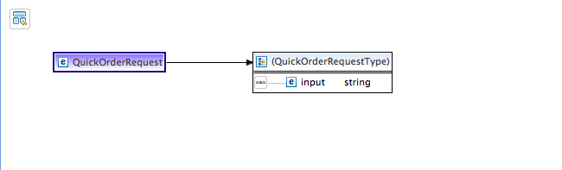
9. Click on the word “input” and rename it to “name”
10. Now Right Click and Insert Element->After
11. Change the name of the NewElement to drink
12. Add another new element after. Make it an int and call it number
13. Now it should look like this: 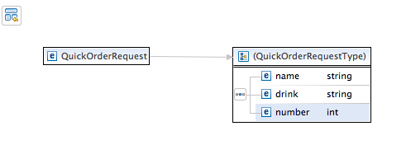
14. Hit Command-S/Ctrl-S to save.
15. Close the Inline Schema tab and the WSDL tab
16. Go back to the Flow Diagram / BPEL page.
17. We are now going to import the Starbucks WSDL.
18. Make sure the AppServer is running and the **Starbucks WSDL** is available using the AppServer console on <https://localhost:9443>
19. Browse the WSDL, and download it to your local file system. Make sure its called .wsdl (not .xml)
20. Now import it into the QuickOrder project **bpelContent** section. Select **bpelContent** using a right-click then select **Import**. Then **File System**  
      
    The Eclipse file imported window is a bit weird and pretty hard to describe, but here at least is a picture of what you are aiming for!  
    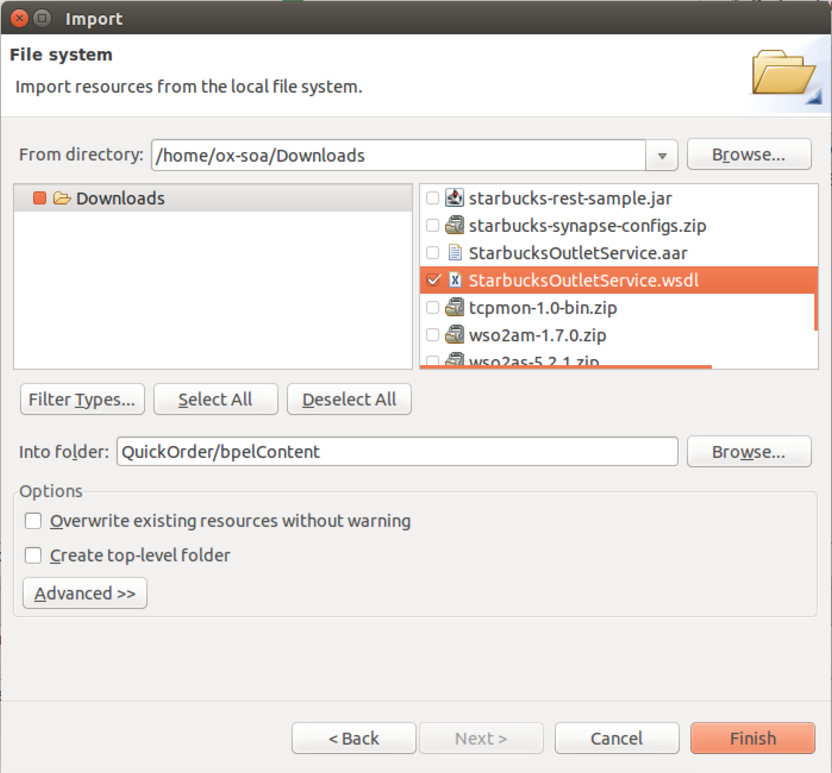
21. Click **Finish**
22. Click on the + next to Partner Links also on the right hand side.
23. Change the name of the Partner Link to CoffeeProvider. Note the edit box is a bit weird ☺
24. *BIG HINT. Whenever editing the Properties in the sections below, it is* ***very*** *helpful to double click maximize the properties window.*
25. In the properties tab below select **Browse**: 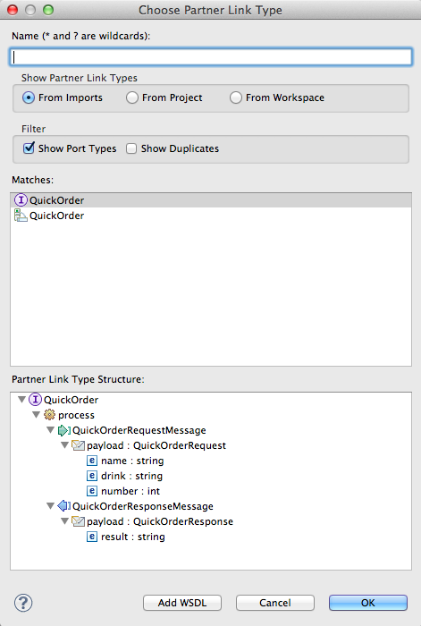  
    Click Add WSDL
26. Browse to your imported WSDL: 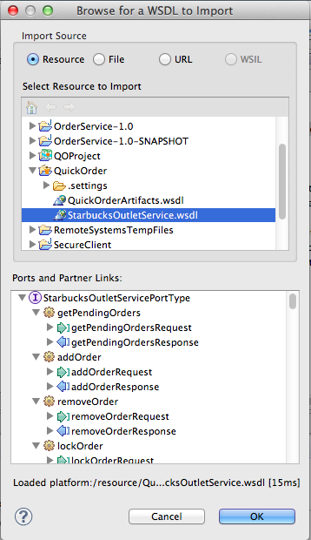  
    Click **OK**
27. Now Select the **StarbuckOutletServicePortType**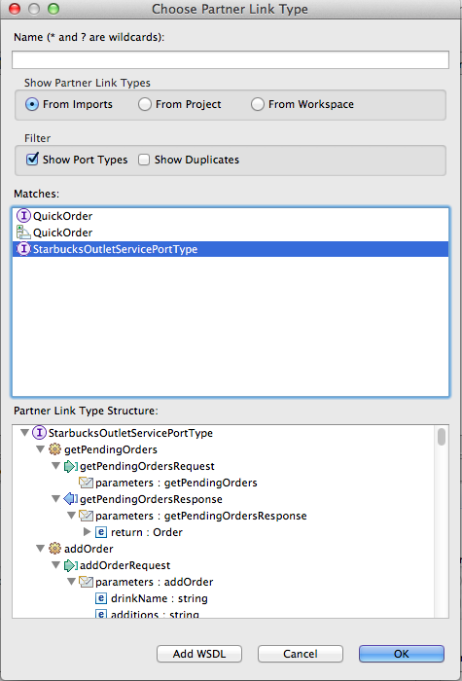
28. Click OK
29. Name it CoffeeProviderType 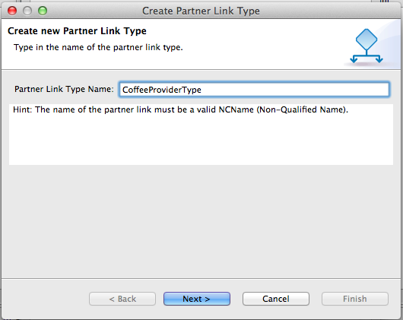
30. Give the role a name (CoffeeProviderRole) and make sure the Starbucks Port type is selected again 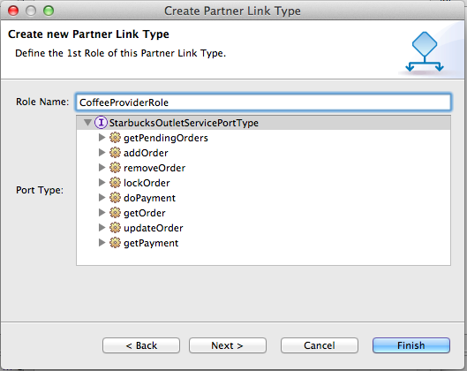
31. Click Finish
32. Back in the Properties pane for the PartnerLink make sure My Role is None and the Partner Role is CoffeeProviderRole:  
    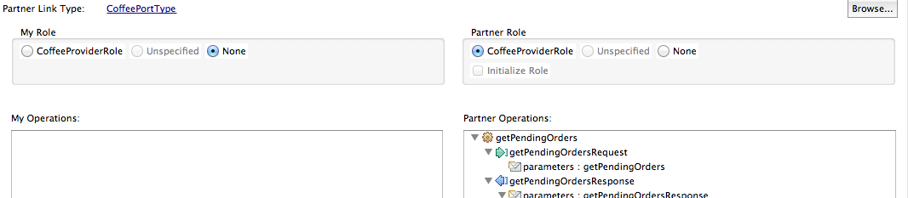
33. **Insert** an **Invoke** before FIX_ME:  
    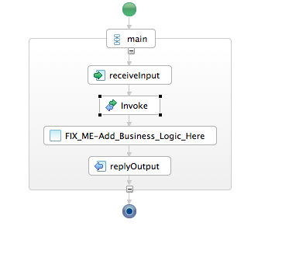
34. Select the invoke. In the properties pane choose the CoffeeProvider partner link and the addOrder operation.  
    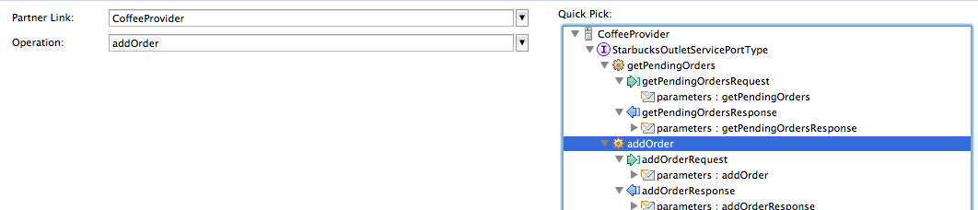
35. Now insert an Assign before Invoke: 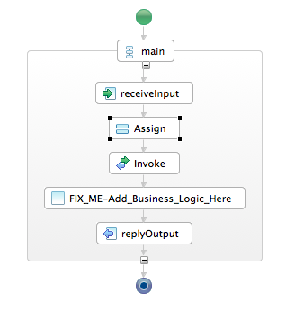
36. In the Properties pane below, click New
37. Choose Variable to Variable
38. Choose the drink from the input/payload and map it to the drinkName in the CoffeeProviderRequest
39. Click back on the input pane and it will prompt Eclipse to ask you 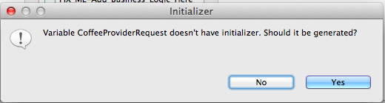Click Yes
40. This will auto generate a second “copy” operation which is required by the BPEL spec to initialize the XML message for the call out to Starbucks. Your properties should now look like:   
    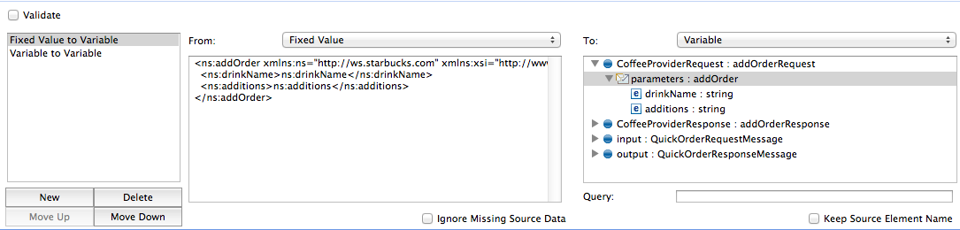  
    Remove the contents of the additions element, so it reads <ns:additions/>
41. Create another Assign before replyOutput 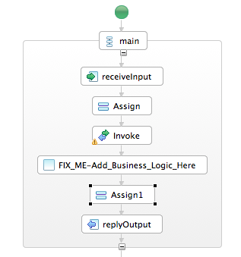
42. Get it to copy from **CoffeeProviderResponse/payload/orderId** into **output/payload/response** [This is several steps equivalent to steps 38-42]
43. Delete the FIXME thingy.
44. Save the BPELProcess.
45. Go to the deploy.xml
46. Choose the right inbound port type for the client partnerlink: QuickOrderPort.
47. Choose the StarbucksOutletServiceHttpSoap11Endpoint for the CoffeeProvider partnerlink.  
      
    Our process isn’t finished, but we should be able to run it.
48. Make sure your Business Process Server is running  
    cd ~/servers/wso2bps-3.2.0  
    bin/wso2server.sh
49. Hit Command-N/Ctrl-N to pull up the New dialog.
50. Create a new Server
51. Choose WSO2 -> WSO2 Carbon Remote Server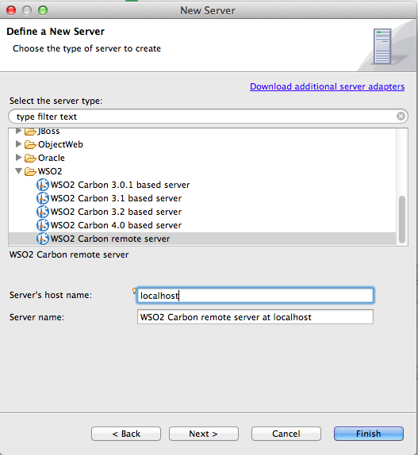
52. Click Next
53. Choose the URL of your BPS server (e.g. https://localhost:9446/)  
    Test it connects successfully. Then Validate the Credentials: 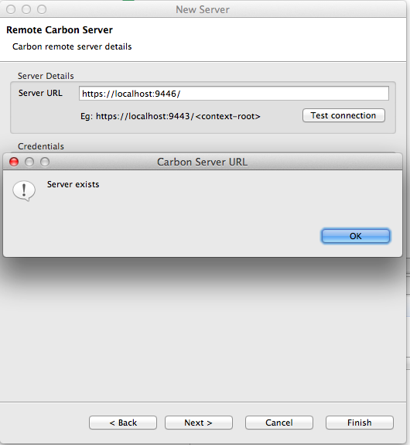
54. Click Next
55. Add your QOProject to the Server: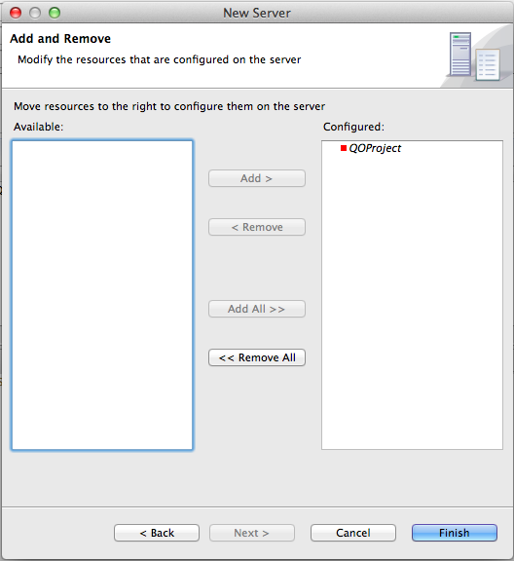
56. Click Finish
57. Go to the QOProject. Right-Click and Run As -> Run on Server
58. Go to your BPS console and wait a bit. Your process should be deployed. 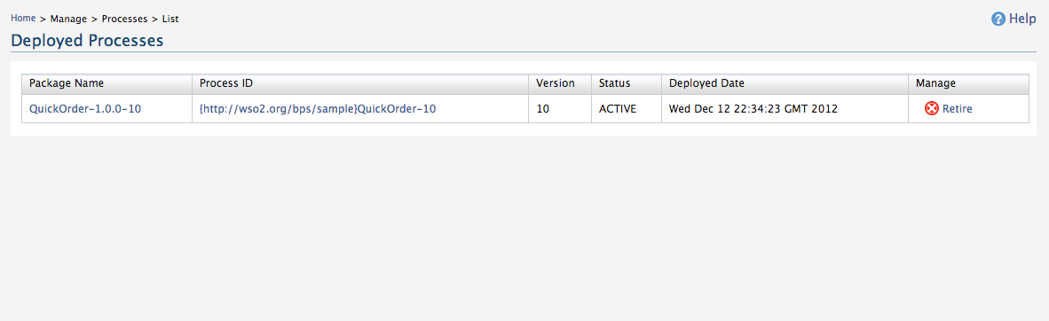
59. Click on the QuickOrder-1.0.0-x Process Id. Click Try It.
60. Fill in some plausible data *(make sure your int is an int!)* 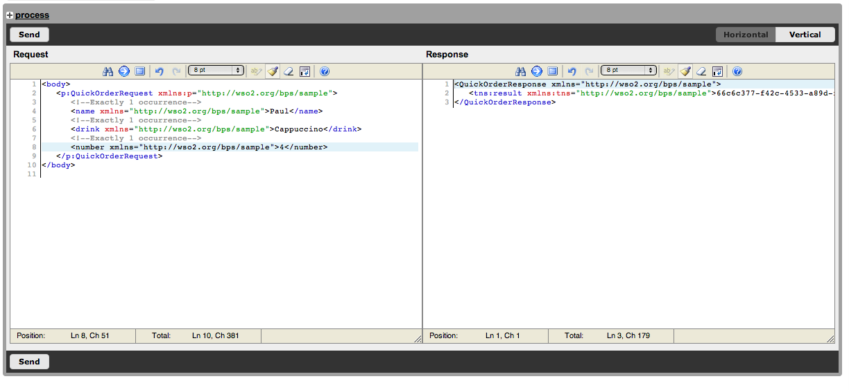
61. Hopefully you have created an Order!
62. Ideally you will now do more. The idea is to automate the Ordering and Payment, using a fixed credit card. See if you can get the Process to Order and Pay for a Drink.
63. If you really want to stretch, now get it to Order and pay for n drinks!