**Install**

**WSO2 Developer Studio 3.0.0**

*Installing the ESB and BPEL tools into the Eclipse Helios system*

**Software Requirements**

(see separate document for installation of these)

* Java Development Kit 7
* Eclipse

1. Start Eclipse
2. Goto Help/Install New Software  
   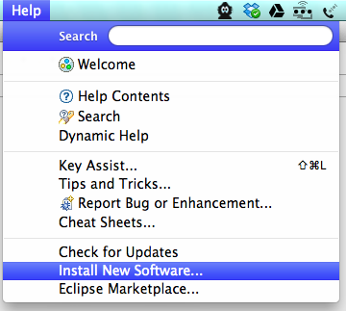  
   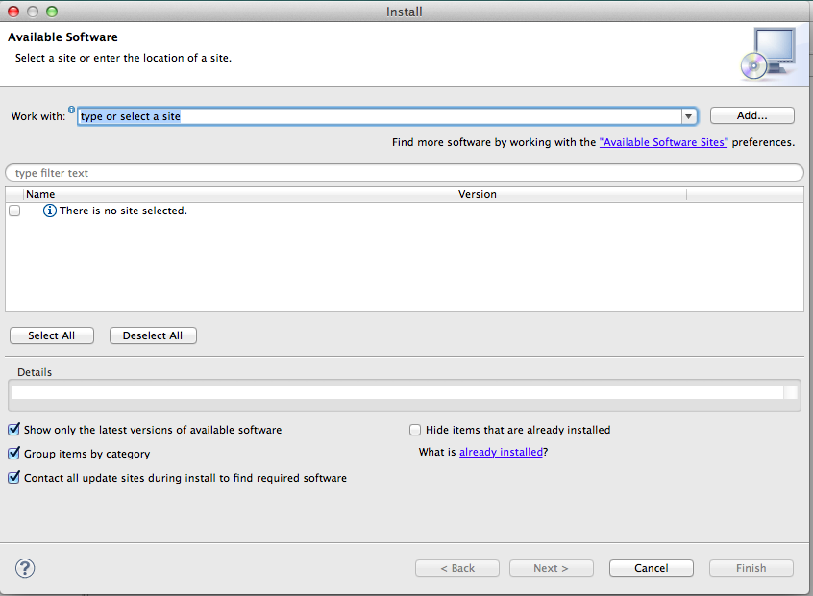
3. Click Add  
   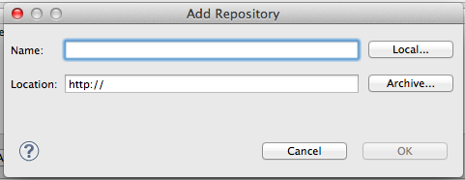
4. Type **WSO2 Dev Studio 3.0.0** as the name  
   Click Archive and browse to the file **wso2-developer-studio_3.0.0.zip**
5. Click OK
6. Select the checkbox next to WSO2 Developer Studio 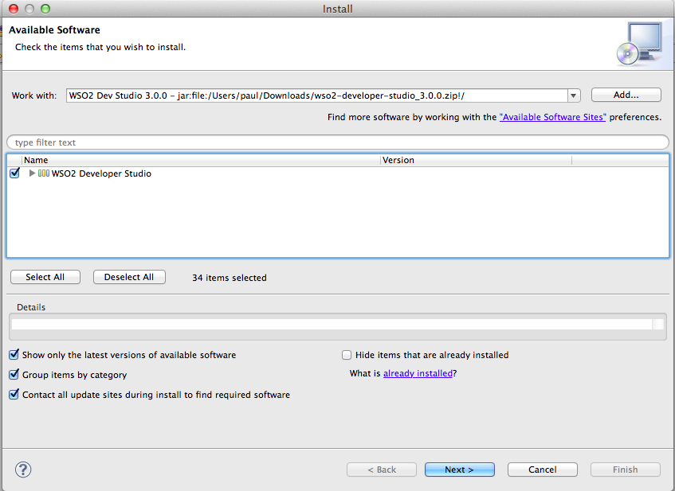
7. Click Next, then Next again.
8. Click “I Accept…” 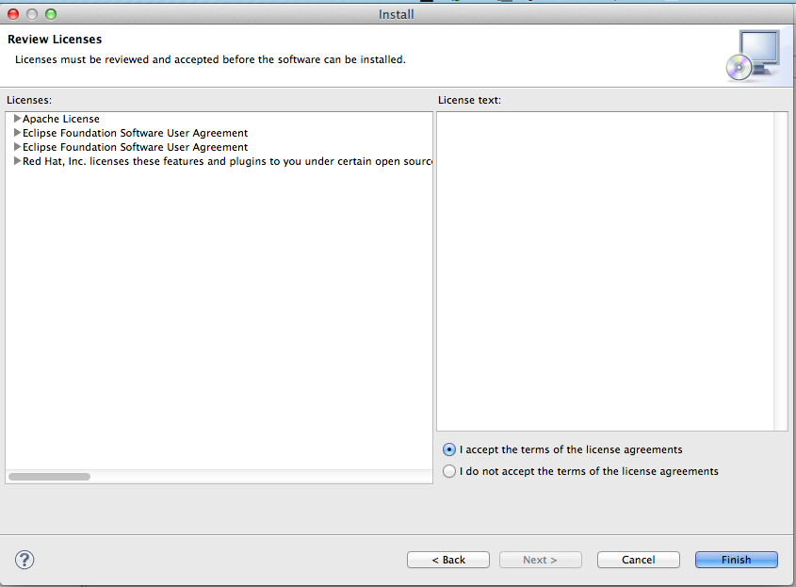
9. Click Finish
10. Go make some real coffee.
11. You will get a warning 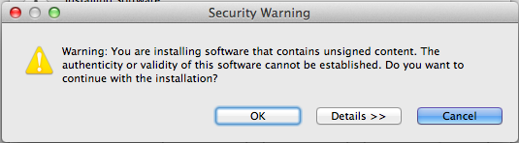
12. Click OK
13. Trust me – I’m a developer  
     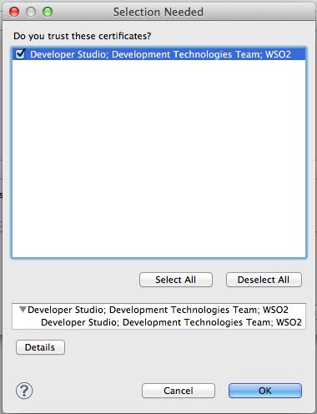
14. Select the checkbox and click OK.   
    Restart Now when prompted: 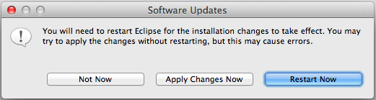
15. You should now be able to open up the Developer Studio Dashboard. You can always get back to the Dashboard from the top menu:   
    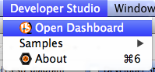
16. It should look like: 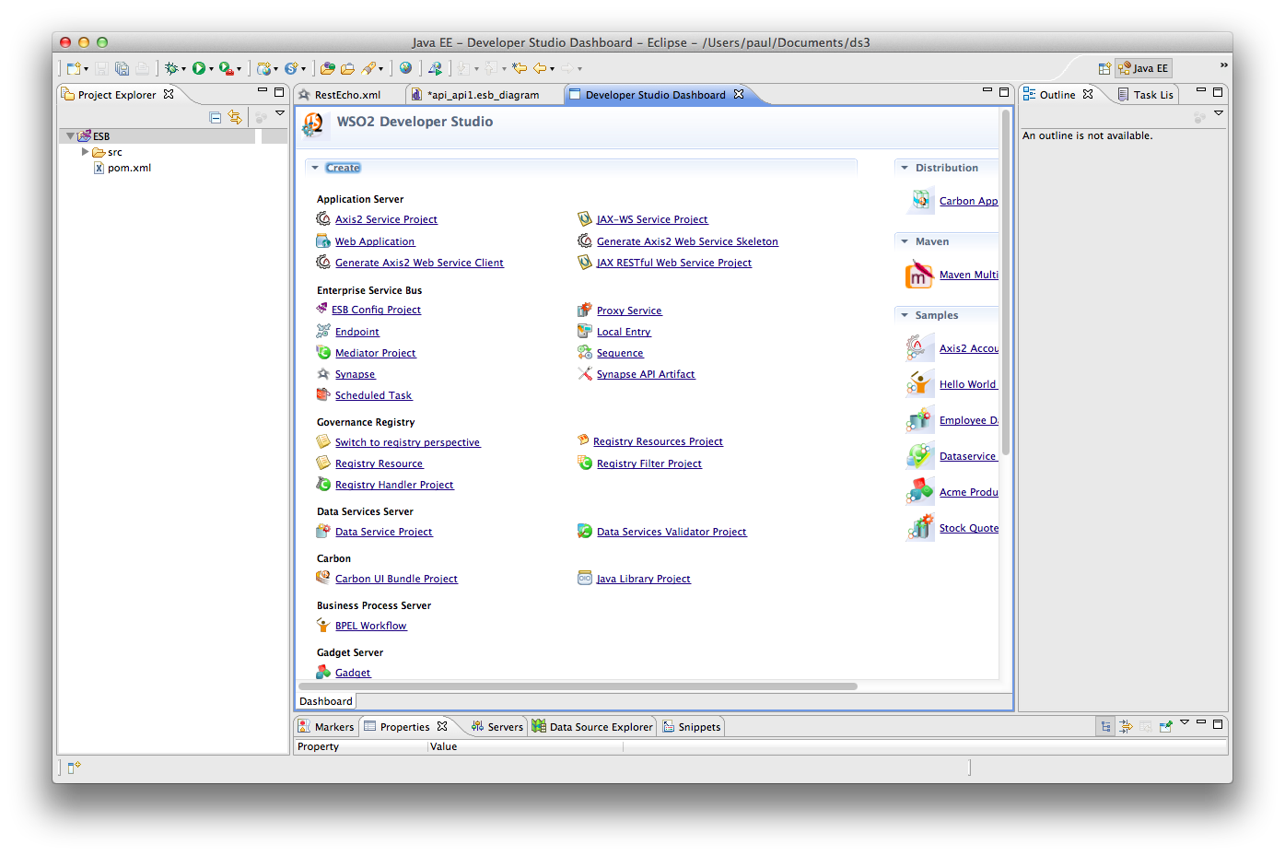
17. Congratulations