**Install**

**WSO2 Developer Studio 3.0.0**

1. Now let’s install the WSO2 Developer Studio into Eclipse.
2. Start Eclipse
3. Goto Help/Install New Software  
   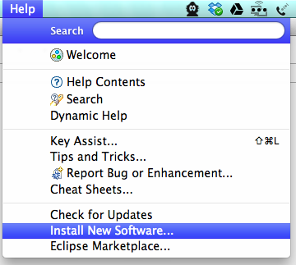  
   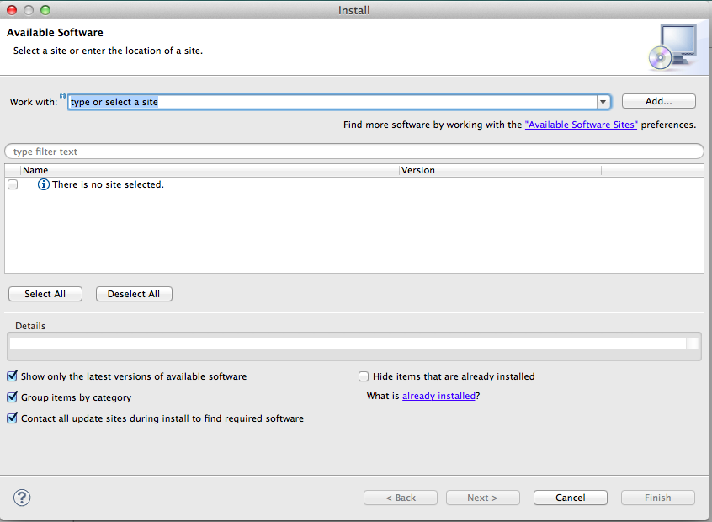
4. Click Add  
   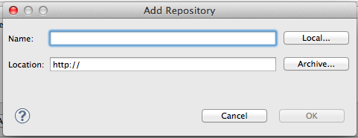
5. Type **WSO2 Dev Studio 3.0.0** as the name  
   Click Archive and browse to the file **wso2-developer-studio_3.0.0.zip**
6. Click OK
7. Select the checkbox next to WSO2 Developer Studio 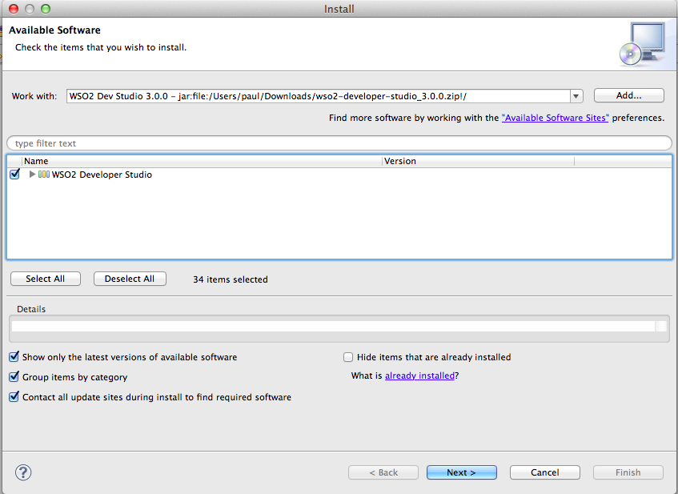
8. Click Next, then Next again.
9. Click “I Accept…” 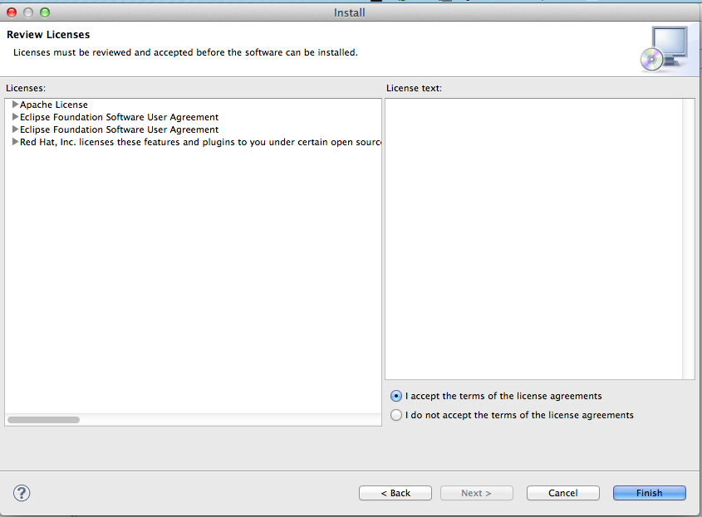
10. Click Finish
11. Go make some real coffee.
12. You will get a warning 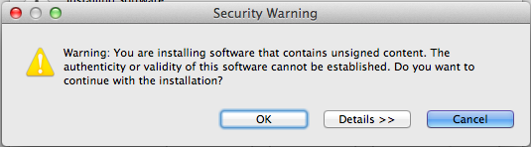
13. Click OK
14. Trust me – I’m a developer  
     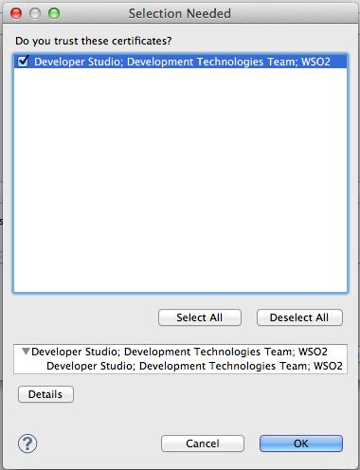
15. Select the checkbox and click OK.   
    Restart Now when prompted: 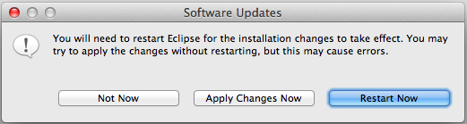
16. You should now be able to open up the Developer Studio Dashboard. You can always get back to the Dashboard from the top menu:   
    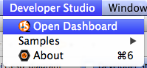
17. It should look like: 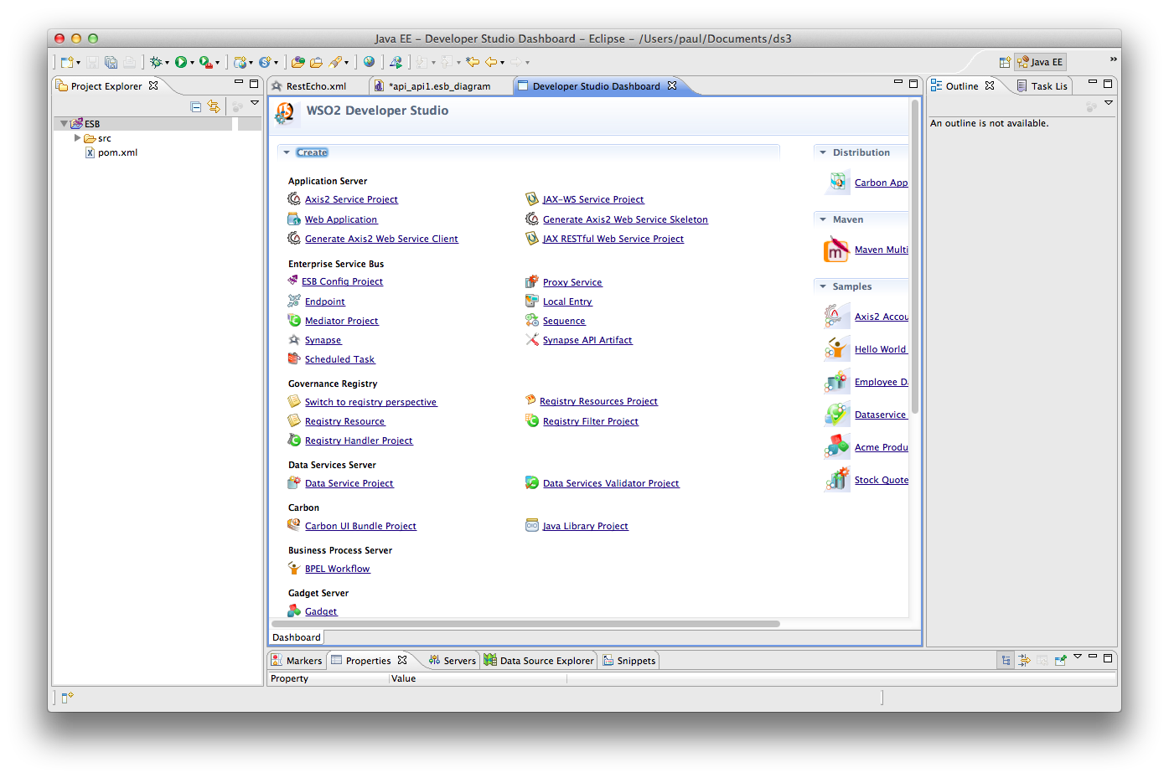
18. Congratulations