**Exercise 12**

*API Management and Governance including Business Activity Monitoring*

**Prior Knowledge**

RESTful services

Previous ESB exercises

**Objectives**

Understand API management and key issuing. Understand Business Activity Monitoring. Be able to configure the API Manager and Business Activity Monitor, and use OAuth2 Bearer Tokens

**Software Requirements**

(see separate document for installation of these)

* Java Development Kit 7
* WSO2 App Server and WSO2 ESB working from Exercises 8, 9
* WSO2 API Manager and WSO2 BAM installed and configured to talk to each other
* Google Chrome plus Chrome Advanced REST extension

1. We have already configured the API Manager to publish statistics to the Business Activity Monitor.
2. In addition we have done some of the setup tasks outlined in the API Manager Getting Started Guide. This is good reading:  
   (Find it on this page: <http://wso2.com/products/api-manager/>)  
   1. We have created roles “creator” and “publisher”
   2. We have created users *chris* (a creator) and *peter* (a publisher) both with password “password”.
3. Firstly make sure the ESB and AppServer are running.
4. Now in two separate terminal windows start up the BAM, and then AM:

cd ~/servers/wso2bam-2.4.0/

bin/wso2server.sh  
  
cd ~/servers/wso2am-1.5.0/  
bin/wso2server.sh

1. You are now ready to create and publish an API, and then subscribe to it.
2. Pull up the “Publisher” webapp by going to URL:  
   <https://localhost:9447/publisher/>
3. Login as chris/password
4. You should see similar to:  
   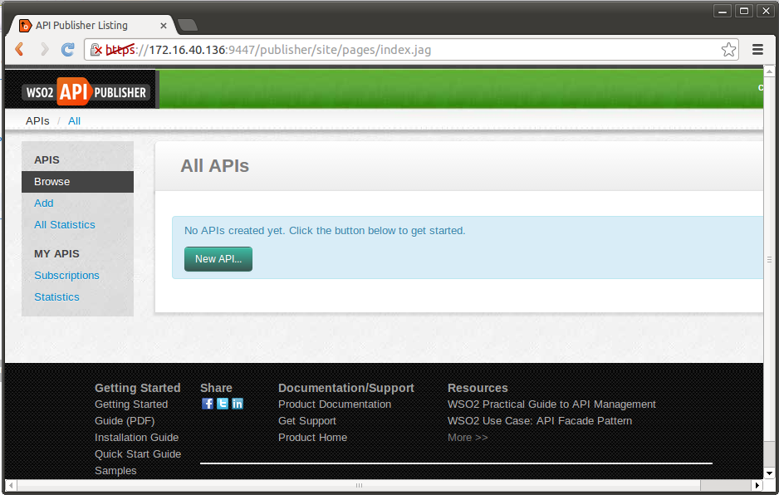
5. Click **New API**
6. Use the following values:  
     
   Name: CoffeeOrder  
   Context: /order  
   Version: 1.0.0  
   Tier Availability: Multi-Select All options   
   Endpoints/Production Endpoint: <http://localhost:8281/order>  
   Sandbox URL: Leave blank  
   Transports: Uncheck HTTP leaving HTTPS

*Why can you select more than one throttling level?*

If you want a nice coffee icon for this API, expand more options. You will find an icon in the Downloads directory.  
Fill in the business information if you wish  
  
Update the Resource definitions as follows:   
- Uncheck the DELETE  
- Change all the Auth types to be Application (= two legged OAuth)  
- Make sure OPTIONS has None authtype  
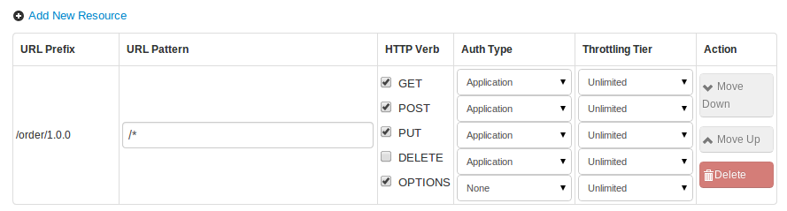

1. Click Create.
2. You should see similar to:  
   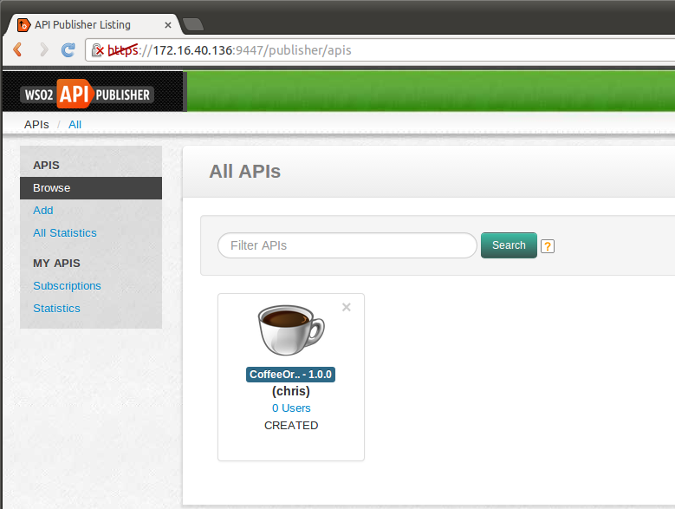
3. Click on the CoffeeOrder Icon.
4. You can now add some documentation in the Documentation tab. A good idea would be to link to the existing docs that are available for the Starbucks APIs.
5. Once you are happy with the API and the documentation, you can log out.
6. Now lets pretend to be a subscriber (i.e. a third-party developer).   
   The subscribers can sign up themselves.
7. Go to the Store: <https://localhost:9447/store/>
8. You should NOT see any APIs in the store, because the API has not yet been authorized by the publisher to be used.  
   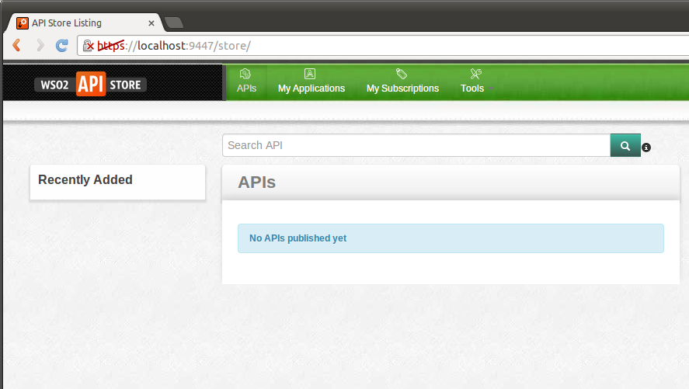
9. Now go back to the publisher system (<https://localhost:9447/publisher/>) and now log in as peter/password.
10. Click on the Coffee Icon.
11. You will see a different tab here: Lifecycle.
12. Set the lifecycle to Published. Make sure that the box “Propogate Changes to API Gateway” **is ticked** (default).
13. Click Update
14. You should now see a nice audit log of who has updated the API. You should see something similar to: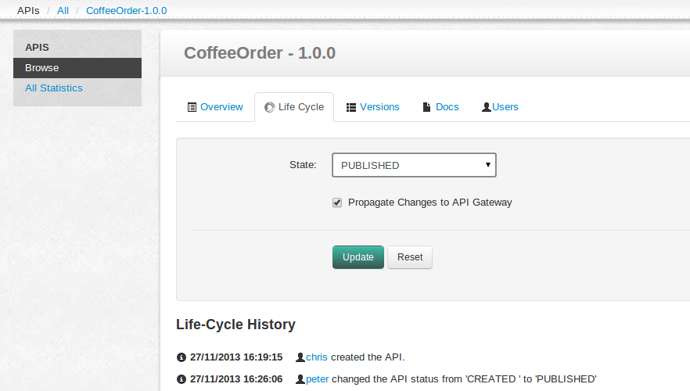
15. You can now log out (or use a different browser – such as Firefox) to look at the Portal/Store.
16. Now you should see the Coffee Order API visible to the third-party developers. You should see a URL that is published by the API Gateway.
17. Because the default authorization for OPTIONS was None, you should be able to access the Order API without any subscription. So start up the Chrome Advanced REST client, and using the URL from the page. Try calling OPTIONS. You should see similar to:  
    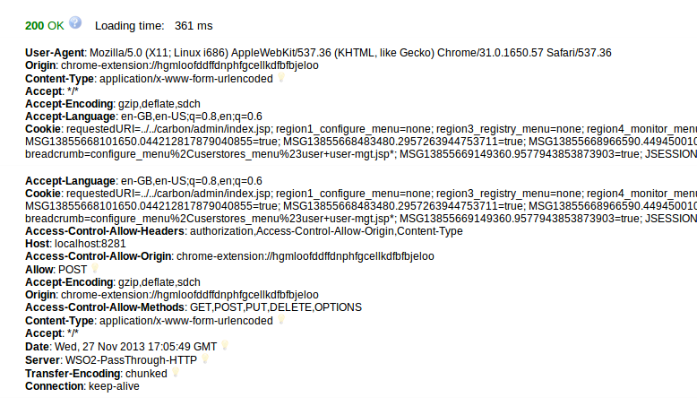
18. Now try a GET. You should see a 401 Unauthorized:  
    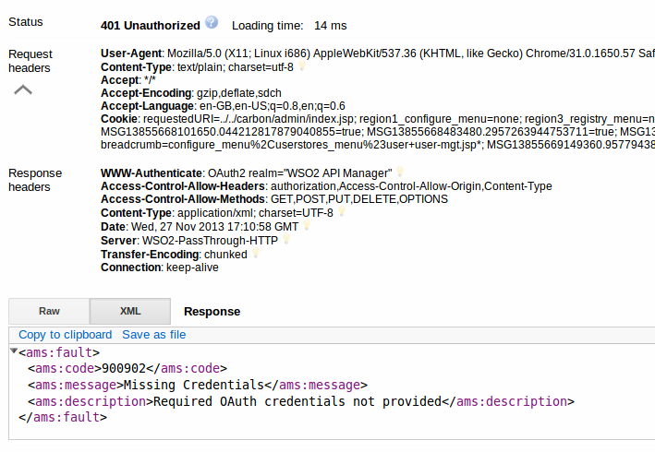

1. In order to subscribe to this, you need to be a registered user of the Store. Click on Sign-Up.
2. Create a user called *dave* (the developer). Or go wild. Its up to you.
3. Now log in as *dave*.
4. Before we subscribe, we need to create an “Application”. Basically, we are not subscribing to the API as sally, because this is a *machine-to-machine* interaction, not a user-to-machine interaction. Dave is creating an app (e.g. a web app or mobile app) that needs to use this API (or several APIs). Dave may create several apps, and each may need different APIs, different usage levels, etc. So Dave needs to tell the API Manager Store about his Apps.
5. Click on **My Applications** and create an App called “PhoneCoffee”. Choose the unlimited throttling level. Give it a nice description. Leave the callback URL blank.
6. Now go back to APIs and select the CoffeeOrder-1.0.0 API.   
   Select the PhoneCoffee application and the Silver throttling level.  
   Click Subscribe.
7. Go to My Subscriptions. Now you can see the subscription. Please note that the sandbox is not much use as we didn’t create and provide a sandbox API. This would be a good extension exercise.
8. Click Generate
9. You should see something similar to:  
   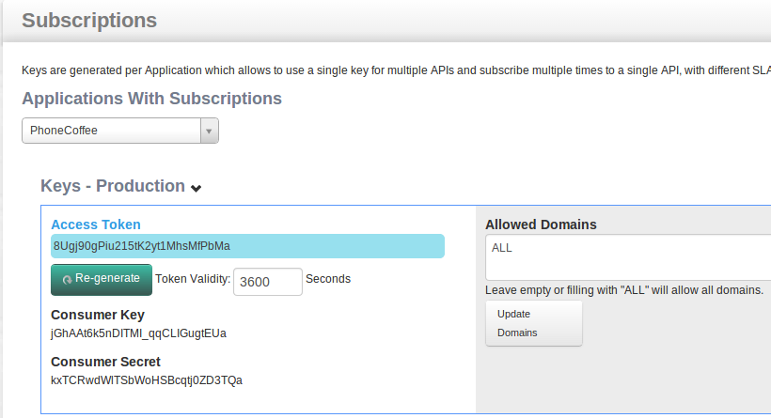
10. Copy the Access Token into the clipboard.
11. Now try an Advanced REST Client request again, but this time create a Header with the name **Authorization** and the value **Bearer** *YourTokenHere* like this:  
    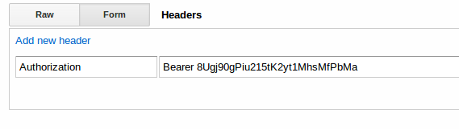
12. You should ideally construct a proper POST first, but a GET to the URL will test the API gateway (yes it’s a hack but an easy one). Try the request. It should work.   
    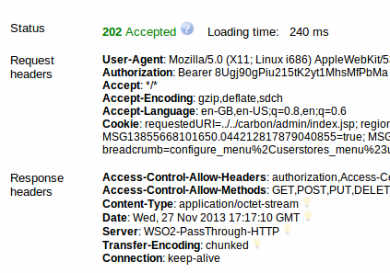
13. Now try again 5 more times within a minute. You should be blocked, because we subscribed with the Silver level and so the throttling will kick in:  
    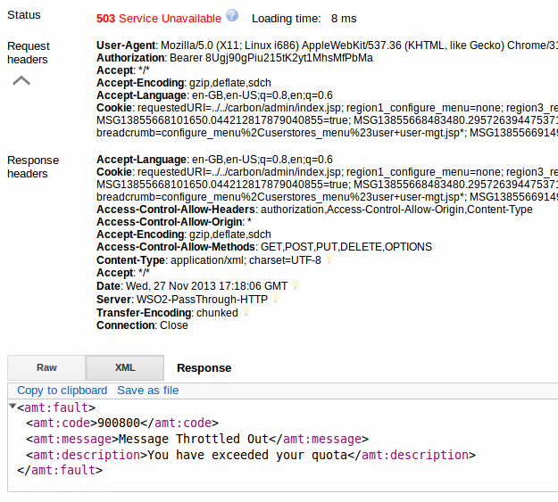
14. Wait a minute and then send some more requests through.
15. An important part of API Management is the monitoring of the runtime. We have configured the system to support monitoring via the Business Activity Monitor.
16. Log into the publisher portal as chris/password (or as admin/admin)
17. Look at the statistics: Select Statistics on the left hand side: 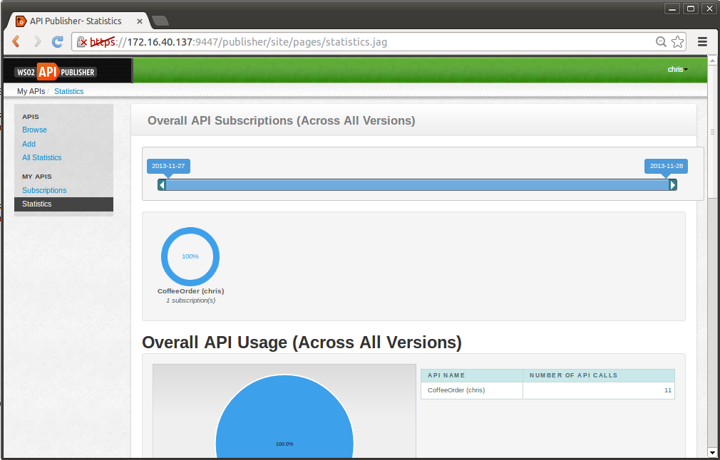
18. You can change the time period with the slider at the top. The statistics are a bit boring because we have only had a single subscriber call a single method on a single API! As an extension you could create a new version and some other subscribers in order to see more useful data.
19. You can also go to the subscriptions tab where you can block access, either to the production only (allowing a faulty app to be re-tested) or to both versions. Try that. Note that there might be a time-lapse on blocking / unblocking.
20. Congratulations!
21. Extensions:  
    You could define all the different Barista/Starbucks APIs.   
    You could add third-party APIs.  
    You could version the existing API.  
    You could create a second “sandbox” API and see how that works.
22. If you are feeling adventurous you could try to install and configure the BAM Toolbox for the ESB or AS from <http://wso2.com/products/business-activity-monitor/toolboxes/> and then monitor those in BAM (note that the BAM port offset is 5).