**Exercise 2**

*Creating a JAX-WS Service*

**Prior Knowledge**

*Basic understanding of SOAP and WSDL*

**Objectives**

*Understand how to create Web Services in Java*

**Software Requirements**

* Java Development Kit 7
* Tomcat 7.0.33 or later
* Eclipse JEE workbench
* Apache CXF 2.7.0 or later
* SOAPUI

1. Make sure Tomcat is installed (e.g. in ~/apache-tomcat-7.0.33)
2. Make sure Apache CXF is installed (unzip in ~ to create ~/apache-cxf-2.7.0)
3. Open up Eclipse
4. Create a new Dynamic Web Project (**File -> New -> Dynamic Web Project**)  
     
   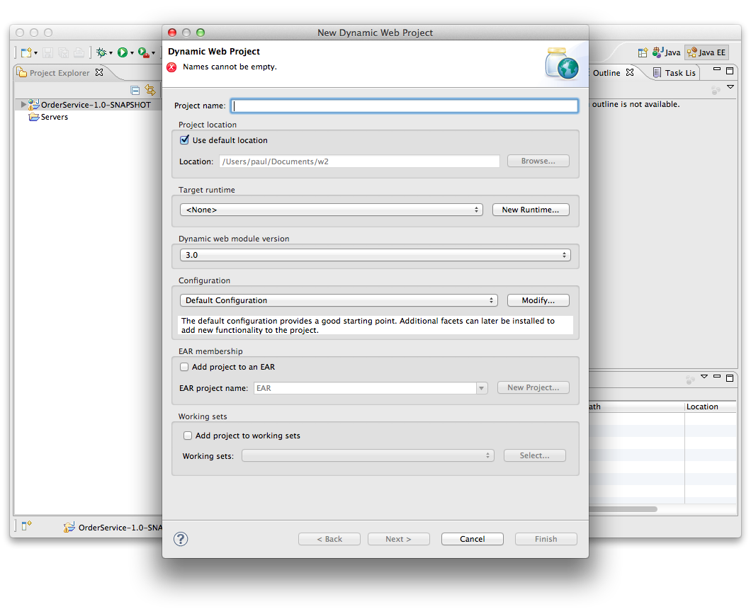
5. Now click **New Runtime** and choose Tomcat 7.0  
     
   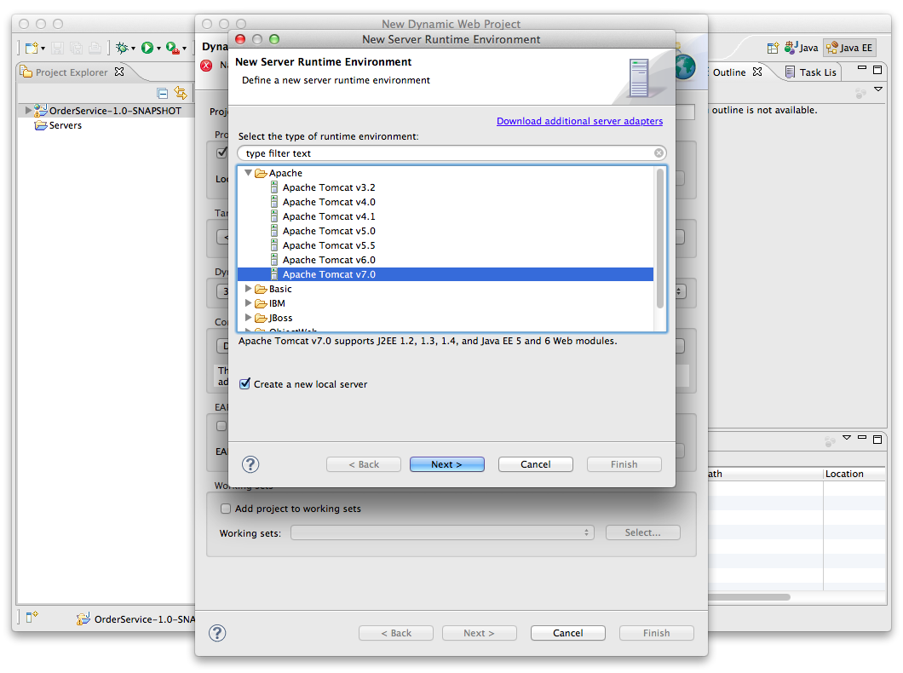
6. Click **Next >**
7. Browse to the directory where you have Apache Tomcat installed and select that:  
     
   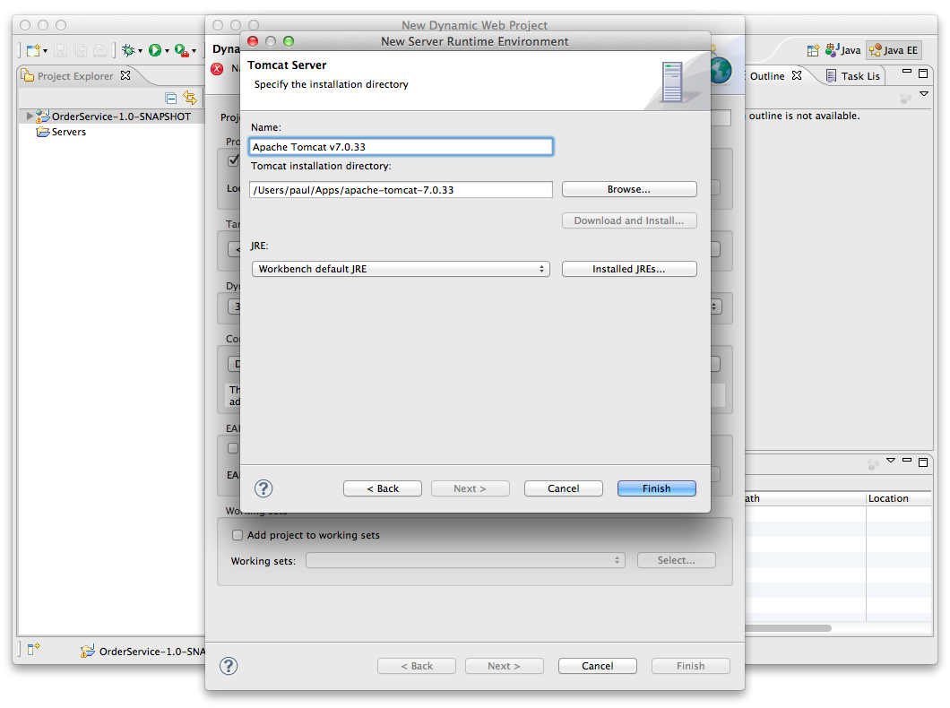
8. Now we need to modify the Tomcat configuration. Click on **Modify** next to Default Tomcat Configuration:  
     
   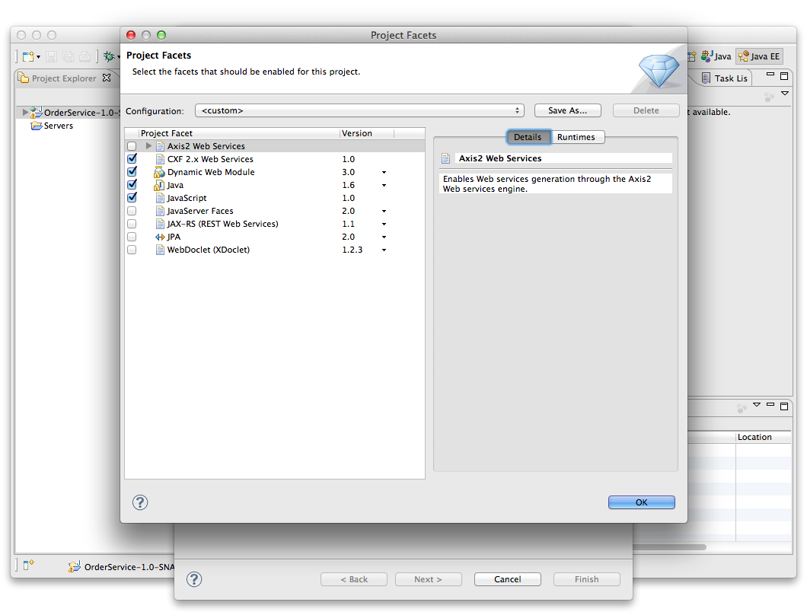  
     
   Enable the **CXF 2.x Web Services** section. Click **OK**
9. Now you should be back in the initial Dialog, so give the project a name, e.g. **JAXWSSample**
10. Click **Next, Next, Next** until you are at the CXF Facet configuration dialog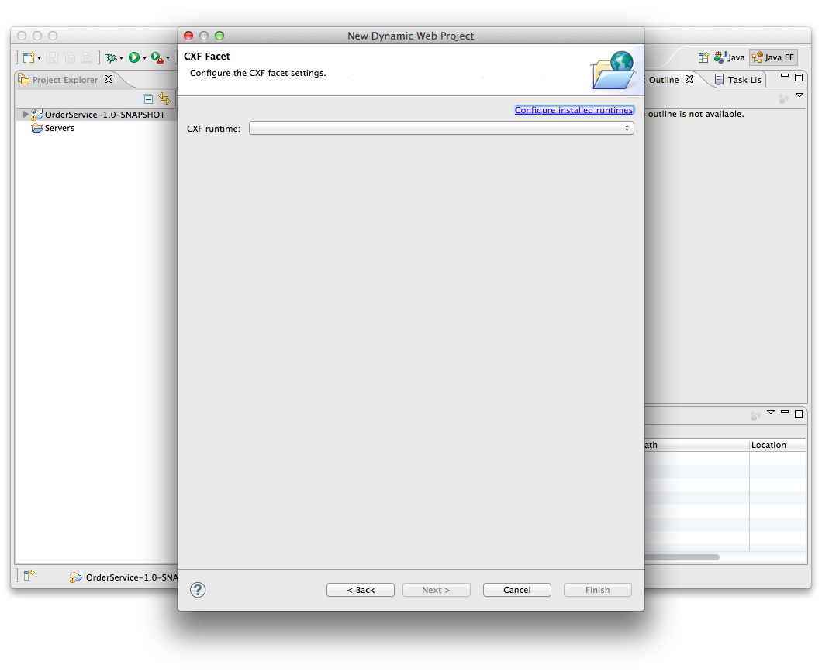
11. Click **Configure Installed Runtimes**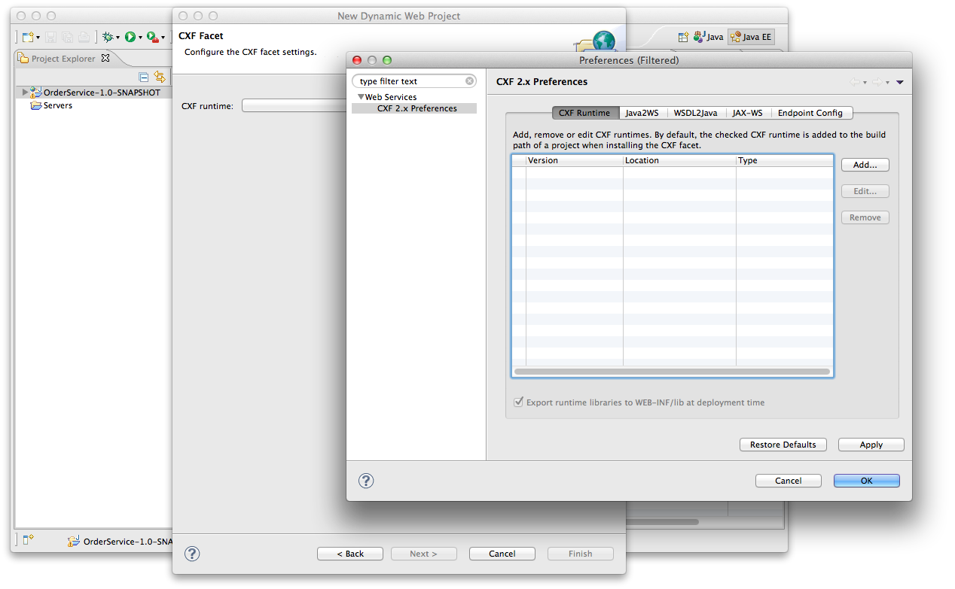
12. Now click **Add.** Browse to the CXF install directory. (Yours should be different to my screenshot)  
    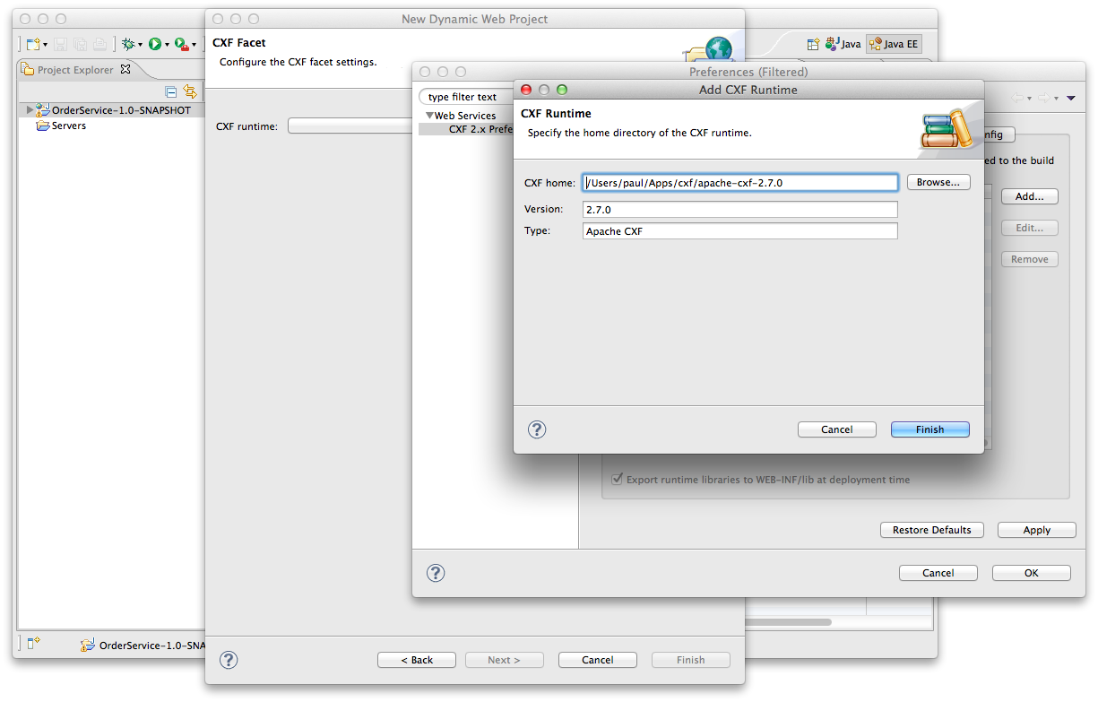  
      
    Now click **Finish**
13. Now select the tick box next to the CXF 2.7.0 version. Click **Finish** and **Finish** again. You should now have a project. Import the following four files into the project.   
      
    freo.me.jaxws.Order  
    freo.me.jaxws.OrderService  
    freo.me.jaxws.OrderServiceImpl  
    freo.me.jaxws.NotFoundException  
      
    From the following file  
    <https://raw.github.com/pzfreo/ox-soa/master/lab-exercises/source/jaxws-service-code.zip>  
      
    You can get the file using curl:  
      
    curl [https://raw.github.com/pzfreo/ox-soa/master/lab-exercises/source/jaxws-service-code.zip -o jaxws-service-code.zip](https://raw.github.com/pzfreo/ox-soa/master/lab-exercises/source/jaxws-service-code.zip%20-o%20jaxws-service-code.zip)
14. Take a good look at the code and understand it.  
      
    Now we can expose this code as a Web Service using the JAXWS wizard built into Eclipse.
15. Select the **OrderService** class and Right-Click on it. Now Select **Web Services**. Then **Create Web Service**.   
    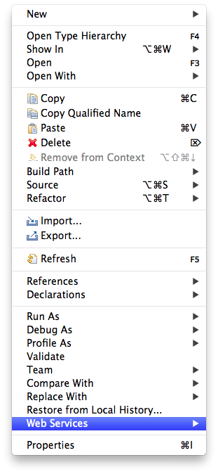
16. You will see the following dialo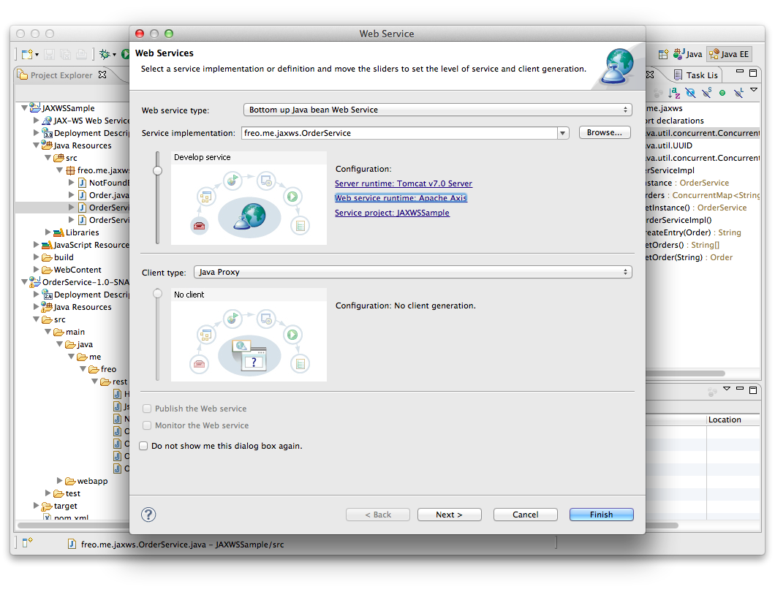
17. Now Click on the **Web Service Runtime** and change it to **Apache CXF v2.x.** Click **Next>**
18. Choose **freo.me.jaxws.OrderServiceImpl** as the Service Implementation.
19. Click **Next>**You will see a screen like this:  
      
    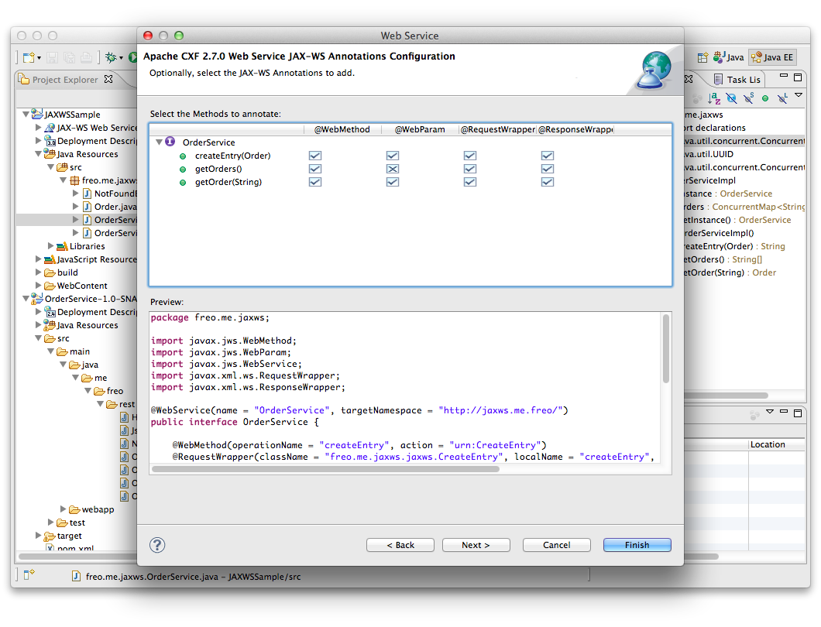  
    Keep everything the same and click Next.
20. You should see: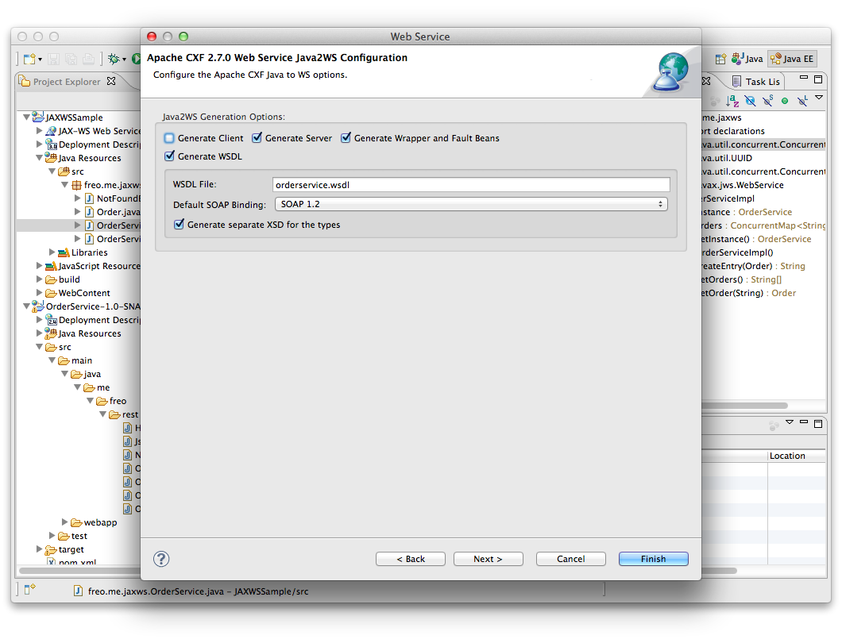  
    Now make sure Generate Server is clicked. Click **Next>**
21. Do **not** select either UDDI option:  
    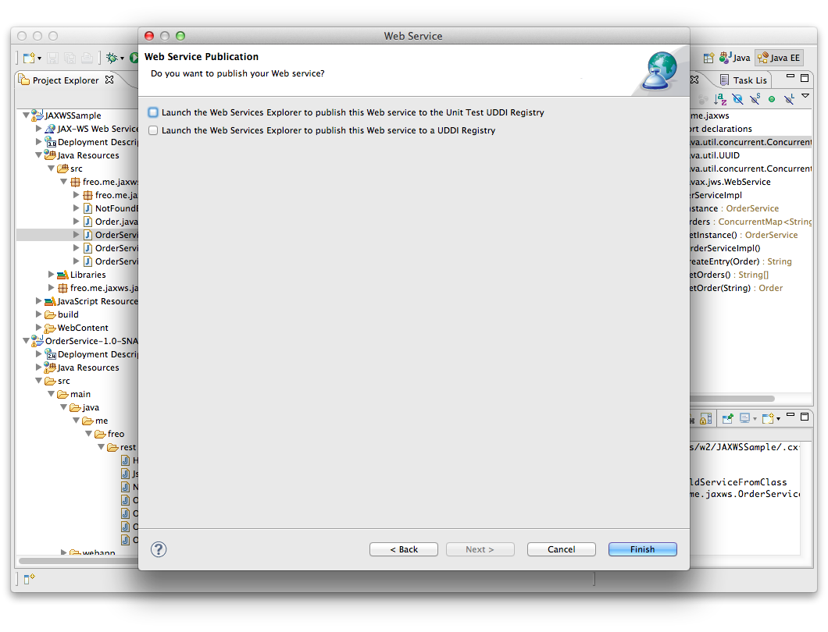
22. Click **Finish**
23. This will generate a number of additional classes.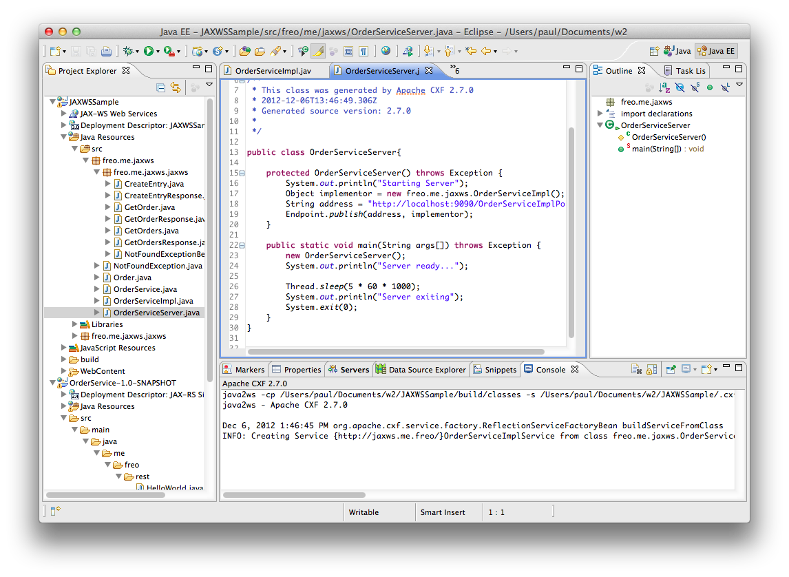  
    Firstly, it will create a set of classes to map XML types. Secondly it will create a set of annotations in your existing code. Finally it will create a Server class that can be used to run the service standalone.
24. Look through the code and identify all three parts. Take a look at the annotations.
25. You can now run this in one of two ways: