LuoLei “Larry” Zhao (netID: lzg431)

Tumblin

EECS 395

**Project A: Particle System Gallery**

**Introduction:**

Welcome to the particle system gallery. My name is Larry, and I will be your tour guide. This is an interactive highlight of 7 exhibits that highlight a variety of uses for particles. Included in this gallery are the following exhibits listed from left to right.

* **“The Rope”:** A fine companion to mankind since antiquity, the humble, storied, rope has helped many a fisherman, tight-rope walker, or tug-of war player with their various tensile-strength-needing activities. But now! You, too can experience wonders of spring-physics in the world of particle physics
* **“Dark Flame of the Abyss”:** Pick-pocketed right from the knapsack of the greatest pyromancer of Izalith, this mysterious flame glows an eerie, smoky, dark yellow, which shows off its unique rendering scheme. It makes you wonder what evil magic this flame is capable of.
* **“A Piece of Rainbow Cloth”:** At first, it appears to be a simple, rainbow colored cloth. But I kid you not, this isn’t any ordinary cloth. I purchased it from a strange old man who said he spent 40 years chasing a leprechaun for his pot of gold. Eventually, the leprechaun felt bad, and gave him a piece of his rainbow as a consolation prize. Yep, this cloth is made of 100% genuine rainbow, you can tell by it’s beautiful cloth physics. Only a cloth made of rainbow can look that smooth.
* **“Coulomb’s Law in action”**: This may look like a bunch of small red and blue dots squirming around, but those are actually electrons and protons scrambling around. You might not realize this, but there is actually a large Hadron collider going through this gallery, it smashes its particles right at this exact point for you to admire its attraction/repulsion action.
* **“Boids System”**: From here, it looks like a bunch of dots flocking together chasing a green dot. But that is nonsense! How can you expect a mere simple dot to exhibit such sophisticated cohesion, alignment, separation and avoidance behavior? In truth, we shrunk down the latest teen pop star, along with his most diehard fans and put them in this display.
* **“Black Hole (Gravitational Force)”**: So we messed up with the large Hadron collider a little while back and inadvertently create this black hole. Rather than try to get rid of it and save the world, we though that it looked pretty cool and made a display with it! Now, you can watch its gravitational forces as particles accelerate as they get closer and closer. Turns out, this black hole doesn’t absorb anything, and is content with just slinging them away.
* **“Bouncy Ball”**: Finally, we kept the original bouncy ball system! With this, you can compare the effects of the different solvers we have implemented.

I hope you enjoy your tour!

**User Guide:**

*1. Opening the program*

To begin your tour, simply **click** on the HTML file labeled “ZhaoLuoLeiprojA.html”. You will see a single screen with a Perspective viewport. Your will begin with a view of the Coulomb system (Figure 4). However, there are more systems on both sides, so you are free to move around.

*2. Moving around*

All movement functionalities are made with the keyboard and are identical to how they were in Project C. To move around the gallery, simply use the **W,A,S** and **D** keys. The **W** and **S** keys will make you walk forwards and backwards, while the S and D keys will make you strafe. To survey your surroundings by looking around. You can use the **U,H,J,K** keys, which function similarly to the WASD keys. All instructions are written underneath the Canvas screen.

*3. Move and adjust the center of mass of the black hole (movable black hole center)*

For the “Black Hole” system (Figure 7), you can move around the center of mass of the black hole using the **O,K,L and ;** keys, which are used in a similar manner to the W,A,S, and D keys. BY moving the center of mass to a black hole, you can get a good view of the acceleration of particles as they get closer to the center of mass.

*4. Changing the Solvers*  
  
To change the solvers for every one of the systems, you can simply scroll down and find a set of buttons that allow you to toggle between all 5 solvers included with this package: Explicit, Midpoint, Implicit, Implicit-Midpoint and AdamsBashforth. While many systems do not vary significantly between system and system, as they are fairly stable even with an explicit system, you can pay attention to the rope, cloth and bouncy ball systems, which are particularly unstable with an Explicit solver but slow down considerably with even an modest upgrade to a midpoint solver.

*5. Randomizing Particle Velocities*  
  
In order to better demonstrate the physics of other-wise mostly static particle systems, you can randomize the velocities of the particles of some systems and observe how it effects the particles. The following Systems have randomization features.

* In the **Bouncy Ball System**: you can press the **E** button to randomize the velocities of the balls of the system. This adds plenty of energy to the balls and allows you to view how they settle down due to inelastic collisions with the walls. Try changing the solver and watch the difference in settle speed, as well as the difference in “smoothness” of the ball physics.
* In the **Cloth System:** You can press the **R** button to randomize the velocities of all the individual cloth particles in the system. Observe how the balls will always return back to cloth formation, regardless of which way the ball velocities are sent. You can switch solvers and observe how better solvers generally keep the cloths tighter together.
* In the **Rope System:** You can press the **T** button to randomize the velocities of all the individual rope particles in the system. Observe how the balls will always return back to a straight line formation, regardless of which way the ball velocities are sent. You can switch solvers and notice how the rope gets back to formation faster with better solvers.

**Code Guide:**

**Particle System Structure:**

*1. General Structure*

All particle systems are instances of the general PartSys class, which houses information needed for all particles. Particle systems are initialized with little more information than how many particles are inside the system, as well as the colors of the particles. They start with no constraints nor forcers. Some special particle systems, such as fire, cloth and boids, require a special initializer due to more specific color and particle number requirements.

After instantiation, particles can then add forcers using the addForce function. This function takes any function-type variable and adds it to the particle’s “forceList” array. During runtime, the partSys will call all functions in their forceList and passes a reference to itself. The function returns the calculated forces for each individual particle, which the partSys then adds to its particles. Constraints work similarly with the “constraintList” array. This allows particle systems to be extremely adaptable, and allows functions to be added from anywhere. For organizations sake, all functions added are also saved as part of the partSys class, but this does not have to be the case, as any valid JavaScript function can be passed as a parameter.

Additional functions may be needed to modify certain forces. For example, you can call the setGravity function in order to change the effects of the gravity forcer function.

At runtime, you can simply call the PartSys_run function from your particle system object. This will apply all forces, constraints, and do all calculations necessary. Each particle system isolates all of it’s operations within it’s own separate arrays, to prevent all possibility of interference between particle systems (mainly due to issues with the swap operation). Upon rendertime, the appropriate data of the current timestep (array s0) is copied into the array buffer and drawn.

*2. Cloth/Rope System*

Forcers used: **fSpring/fCloth**, **gravity** and **damping**

Both the cloth and the rope system operate on a similar principle. Particles at a certain position will apply forces on particles in other systems, as well as be applied by other systems. In this system, individual particles will only “be pulled” and not directly modify the force properties of other particles, but with the implementation described below, the same effect is achieved

The main difference the two systems is that the rope system only operates in 1 dimension. A given particle will calculate the distance between the particle immediately before, and the particle immediately afterwards, with the exception of the very first, and last particles, which are constrained (see Constriants: Pinned objects) at a set point. The particles then use Hooke’s law to calculate the force based on the distance between the particles. The rope works similarly but every single particle is also connected to particles in the higher and lower rows, which helps it achieve a 2d rope effect.

*3. Fire*

Forcers used: **gravity,** also preset color and diameter decay.

All fire particles are rendered differently than the other particles, instead appearing as a transparent circle with no darkening as you approach the edges. When overlapped with each other, the transparent circles can combine to form a convincing flame effect. I colored the flames dark yellow as it looks great as a fantasy flame.

In addition, all fire particles are initialized with a set velocity, and is pulled down by gravity, leading the particle to have a clear trajectory. Particles also “decay” as their lifetime ends by growing smaller in size, and fading in color to dark “embers”.

*4. Boids*

*Forces Used:* ***Avoidance Force****,* ***Cohesion Force****,* ***Alignment Force****,* ***Seperation Force****,* ***Goal Force,*** *and* ***Damping***  
  
The boids particles are some of the most complicated particles, utilizing a variety of features.

The cohesion force tries to keep the boids flying at a precalculated center of mass of the entire flock. This center is calculated beforehand at every timestep and effects every bird. When the leading bird is present, the leading bird itself is the “Center of Mass” which the birds try to fly towards. The amount of force applied depends on the distance the bird is from the center, in a manner similar to Hooke’s law.

The Goal force works in a similar way as the Cohesion force but instead of flying towars the center of mass, the birds try to fly towards the position of the “leading bird”.

The alignment force also involved a precalculated value, with the average velocities of the entire flock being calculated. All birds will have a force applied that changes its currently velocity to more closely resemble the flock average. Similarly, the amount of force applied depends on the difference between the bird’s velocity and the flock average.

The separation and avoidance force work similarly in that it is sort of a “spring” force that can only push outwards. In the separation force, the birds iterate through all other bird particles and if the distance between them is lower than a certain threashold, it will push away with a force proportional to how close they are. The avoidance force works similarly with pre-set obstacles.

*5. “Coulomb’s Law”*

*Forcers Used:* ***Coulomb’s Law and Damping***

In this system, all particles are initialized with a “charge” value. If it is positive 1, the particle is red, if it is negative 1, the particles is blue. During each timestep, the particle will iterate through ALL other particles and calculate their distance. The particle will then follow coulomb’s law based off the distance, its own charge, and the other particle’s charge. This means that at any one point, every particle effects every other particle. However, only nearby particles are really effected significantly.

*4. “Black Hole”*

*Forcers Used:* ***Planetary Gravitational Force and Damping***  
  
In this simulation, all particles are drawn to a powerful “Black Hole” center based off of the gravitational equation. Since the gravitational equation is inverse-squared, far away particles will only be pulled slightly, before increasing significantly in mass as they approach the center of the black hole. Since this black hole is very high mass, it will accelerate to a tremendous speed, such that within a timestep they will be “catapulted” out and across the black hole to a far away location. Changing the “center” of the black hole changes the point that the particle will accelerate towards.

**Constraints**

1. Constraint: World Box

*Used in: All Systems*

All particles in the system are constrained by a visible ground plane, and 4 invisible, distant walls. This constraint is very simple and simply detects if a particle is outside each of the walls, and if so, returns back to the max position at the edge of the walls.

1. Constraint: Local Box

*Used in: All systems*

In addition to the world ground plane, individual particles are also constrained by the “glass boxes” that contain each particle system. This constraint is very similar to the world box constraint as it detects if a particle is outside each of the walls, and if so, returns back to the max position at the edge of the walls. However, this system also inverses the velocity of a particle and “bounces” it off with a lowered velocity, treating the ball as a particle with imperfectly elastic collisions. In addition, this system also tries to reduce unstable gravity particles by subtracting the velocities of particles that are in the process of “going through” the ground.

1. *Constraint: “Pinned” objects*

*Used in: Magnet System, Cloth System, Rope System*

In order to better demonstrate certain systems, it was needed for some particles of a system to only appear in a set location.

For the Rope system, not “pinning” particles will have the particle rope appear as nothing more than a tangled mess on the floor (quite similar to the cords in my room right now). While this may be realistic, it is not pretty. Thus, the two ends of the rope are essentially “pinned” to a point above the ceiling, so the rest of the rope hangs below. This is simply done by identifying the particles at the end and setting their position to a constant value.

Similarly, the cloth system, not “pinning” particles will have the particle rope appear as nothing more than a pile of rags on the floor (quite similar to the cloths in my room right now). While this also may be, perhaps even more so, realistic, it is certainly not pretty. Thus, the top row of particles are also “pinned” to a point above the ceiling, so the rest of the cloth hangs below. This is also done by identifying the particles at the end and setting their position to a constant value, though more particles are needed.

The magnetic system is already fairly chaotic, and without any set magnets, the particles will simply zip around without much pattern, which is very typical of an electrically neutral system. In order to better demonstrate the tendencies of the magnetic system, two rows of particles, one positive and one negative, were pinned to the top and bottom of the display case, representing charged magnetic strips. This allows you to observe the particles as they cluster around the opposite charge particle strip.

1. *Constraint: Boids Speed Limit*

*Used in: Boids*

In order to prevent the boids particles from every unrealistically being sent at an unnatural speed due to a combination of its forces, a hard speed limit is imposed on the boids. The constraint simply calculates the proportion of the max speed compared to the current speed. If current speed ever exceeds that of the max speed, the particle’s velocity is multiplied by the proportion, effectively slowing it down to max speed.

1. *Constraint: Boids Leading Bird*

*Used in Boids*

Without a leader, the boids particles, much like confused freshmen, often wander around aimlessly in a group but avoid getting too close for things to become “too awkward”. In order to better show off the abilities of the boids system, a leading bird was added, which all boids particles try to follow.

**Results:**

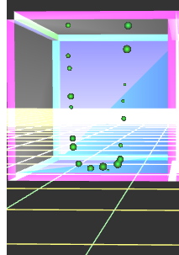

**Figure 1:** An Image of the rope particle system, with the two ends of the rope pinned above the top of the box.

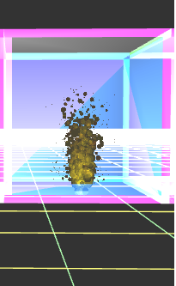

**Figure 2:** An image of the flame particle system.

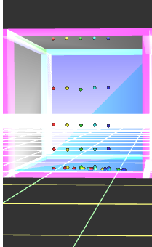

F**igure 3:** An image of the cloth particle system, with the top of the cloth pinned at the top of the box.

**Figure 4:** Scene graph of the project. Note, there are many duplicate objects that are virtually identical. Redundant objects are excluded, but the number of them is noted in the format (1-#).

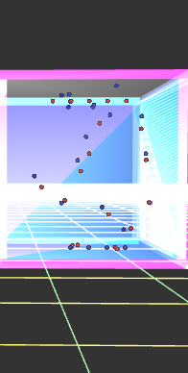

**Figure 5:** An image of the electromagnetic particle system. Here, you can clearly see the negatively charged particles hovering around the positive strip at the top and vice versa.

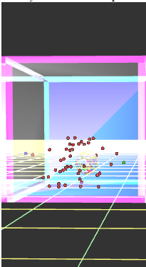

**Figure 6:** An image of the boids particle system. Here, you can see the red boids particles avoiding the sphere as they try to chase the green particle.

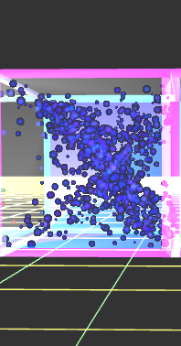

**Figure 7:** An image of the black hole particle system. The inverse squared properties of gravitational forces often result in interesting designs.

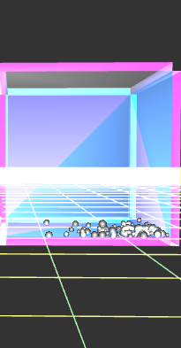

**Figure 8:**  An image of the simple bouncy ball particle system at rest.