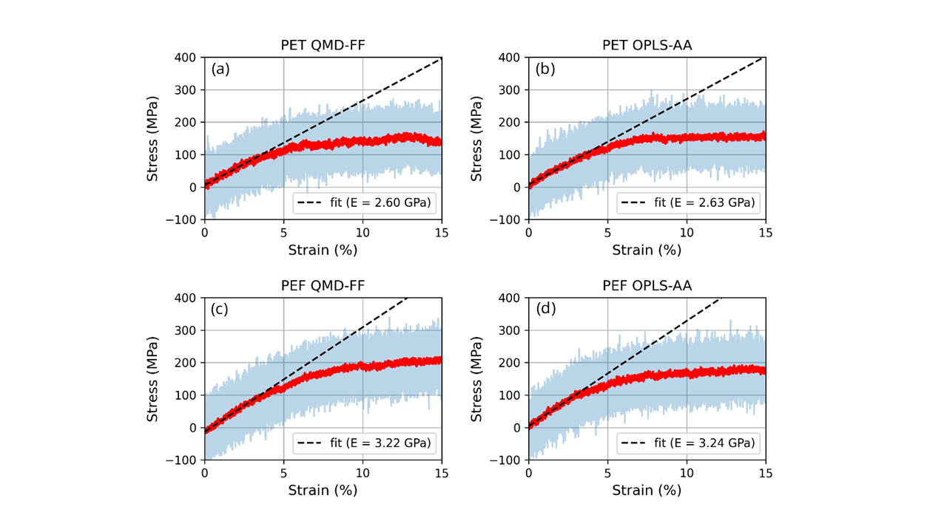
Figure (SuppStressStrain) Typical stress–strain curves for PET (a,b) and PEF (c,d), obtained using QMD-FF (a,c) and OPLS-AA (b,d) at T = 300 K and a strain rate of ε̇ = 10⁷ s⁻¹. The raw data are shown in grey and the red curves represent a running average over 100 adjacent points. The black dashed lines indicate linear fits in the elastic regime (ε < 3%).
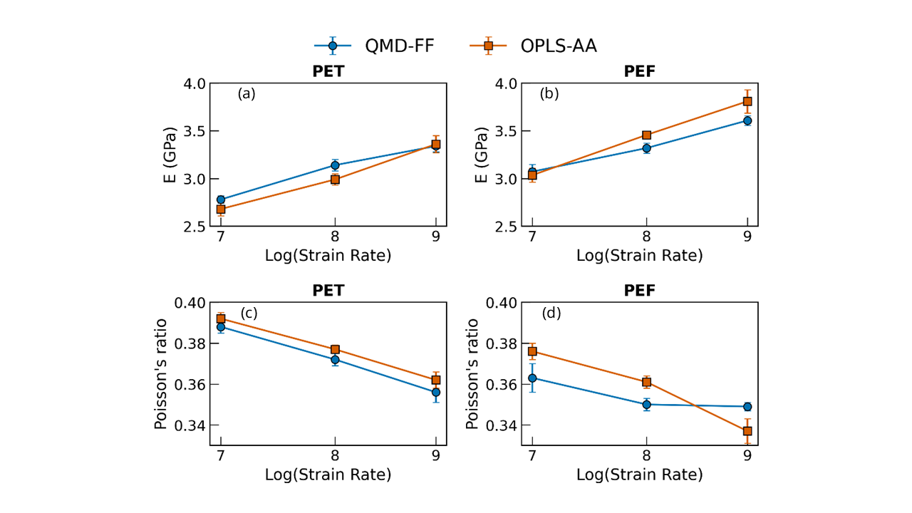
Figure (SuppStrain) (a,b) Young’s modulus and (c,d) Poisson’s ratio as a function of strain rate for PET (a,c) and PEF (b,d), computed using QMD-FF (blue circles) and OPLS-AA (orange squares).

