Diffusion coefficients for water and oxygen were extracted from the 1 μs production trajectories using the DiffusionGLS workflow. Unless otherwise noted, the discussion below refers to the pooled analysis, in which the 32 penetrant molecules from each of the three replicas were combined into a single data set for each system and the uncertainty was taken as the empirical SEM returned by the GLS analysis. The replica-averaged results, obtained by analyzing the three runs separately and then combining them as mean ± standard deviation, lead to the same qualitative picture and are reported together with the pooled values in Table DIFF. For context, the simulation results are compared below with representative room-temperature literature ranges reported for amorphous PET and PEF.
The literature benchmarks depict a consistent qualitative picture. Near room temperature, amorphous PET typically shows oxygen diffusivities of about 3–6 × 10^{–9} cm² s^{–1}, whereas amorphous PEF is usually reported around 0.3–1 × 10^{–9} cm² s^{–1}. For water, the corresponding ranges are about 2–3 × 10^{–9} cm² s^{–1} in PET and 0.5–1 × 10^{–9} cm² s^{–1} in PEF. Prior molecular modeling points to the same strong PET/PEF contrast for oxygen. Taken together, these studies indicate slower diffusion in PEF than in PET for both penetrants, with a markedly stronger PET/PEF contrast for oxygen than for water.
Within the OPLS-AA parametrization, water is consistently more mobile than oxygen in both polymer matrices. In PEF, D_{WAT} = 6.11 ± 0.68 × 10^{–9} cm² s^{–1}, whereas D_{O2} = 2.53 ± 0.32 × 10^{–9} cm² s^{–1}, corresponding to a water/oxygen ratio of 2.41. In PET, the same ordering is preserved, with D_{WAT} = 5.53 ± 0.53 × 10^{–9} cm² s^{–1} and D_{O2} = 3.22 ± 0.41 × 10^{–9} cm² s^{–1}, giving a water/oxygen ratio of 1.71. As shown in Figure DiffX, OPLS-AA reproduces the expected oxygen ordering (PET > PEF) and places PET oxygen diffusion close to the reported literature window, but it still predicts PEF oxygen diffusion that is much too high. Accordingly, the PET/PEF oxygen ratio is only 1.27 (Figure SI_DiffY), far below the roughly 5–10 range usually reported for amorphous PEF relative to PET. For water, the disagreement is stronger: diffusion is too fast in both matrices, and the model even predicts PEF water diffusion to be slightly faster than PET (PET/PEF = 0.90), opposite to the literature trend.
The QMD-FF force field produces a markedly different transport pattern. Water diffusivity decreases to 1.88 ± 0.27 × 10^{–9} cm² s^{–1} in PEF and 1.98 ± 0.28 × 10^{–9} cm² s^{–1} in PET, while oxygen becomes the faster penetrant, with D_{O2} = 7.92 ± 0.86 × 10^{–9} cm² s^{–1} in PEF and 4.75 ± 0.52 × 10^{–9} cm² s^{–1} in PET. Consequently, the water/oxygen ratio drops below unity, to 0.24 in PEF and 0.42 in PET, meaning that oxygen diffuses about 4.2 times faster than water in PEF and about 2.4 times faster in PET. Figure DiffX shows that QMD-FF yields water diffusivities that are closer to the PET experimental scale than OPLS-AA, but its oxygen prediction is qualitatively inconsistent with experiment because it reverses the PET/PEF ordering and makes oxygen diffuse about 40% faster in PEF than in PET. This loss of the expected matrix discrimination is also evident in Figure SI_DiffY, where the PET/PEF ratios are 1.05 for water and 0.60 for oxygen, instead of the literature-like suppression expected for PEF.
A direct comparison at fixed polymer highlights the magnitude of the force-field effect. Relative to OPLS-AA, QMD-FF reduces water diffusivity by about 69% in PEF and 64% in PET, while increasing oxygen diffusivity by a factor of 3.1 in PEF and by about 47% in PET. Because the oxygen and water models were kept unchanged, while the penetrant/polymer Lennard-Jones cross interactions were generated from the same OPLS-AA combination rules in both sets of simulations, the observed differences reflect both changes in the polymer description and the different effective unlike-pair interaction landscape induced by the two polymer force fields. This point is especially delicate for QMD-FF, whose nonbonded parameters were optimized to reproduce polymer-specific descriptors rather than transferability to external penetrants. In that sense, diffusion should be viewed as a stringent extrapolation test of the QMD-FF nonbonded model rather than as a pure validation of the neat-polymer parametrization alone.
Literature discussions of PET and PEF attribute the lower diffusivity of PEF mainly to reduced segmental mobility and hindered furan-ring motion rather than to a simple decrease in static free volume. Neither force field reproduces the experimentally expected simultaneous suppression of oxygen and water diffusion in PEF. OPLS-AA is closer for the oxygen ordering and for the absolute magnitude of oxygen diffusion in PET, whereas QMD-FF gives water diffusivities that are closer to the PET literature scale but largely removes the PET/PEF discrimination for water and reverses the oxygen trend altogether. Overall, the diffusivity results suggest that the absence of specifically optimized penetrant/polymer cross terms penalizes QMD-FF.
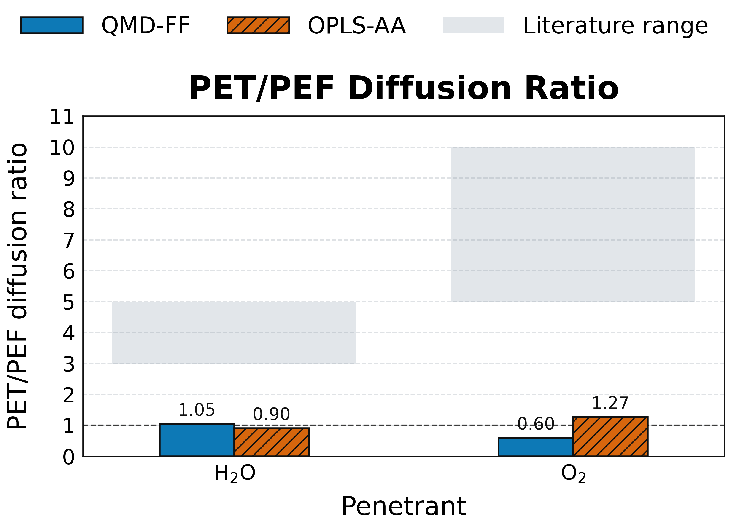
Figure SI_DiffY. PET/PEF diffusion ratios derived from the pooled DiffusionGLS estimates. Ratios above unity indicate slower diffusion in PEF than in PET, whereas ratios below unity indicate the opposite trend. Gray shaded bands indicate representative literature ranges for the expected PET/PEF contrast, highlighting the substantially stronger experimental suppression reported for oxygen than for water.

