Abstract

Introduction

Methods

FAMD Simulation Protocol
The initial polymer structures of PET and PEF were generated using the PolyParGen package [DOI:10.2477/jccjie.2018-0034]. Both systems, each consisting of 32 chains with a degree of polymerization (DP) of 100, were parameterized using the OPLS-AA and QMD-FF force fields and simulated with the GROMACS molecular dynamics package [DOI:10.1063/5.0018516]. Following initial energy minimization, the systems were equilibrated via an annealing protocol under constant pressure (1 atm), with temperatures ranging from 298 K to 1200 K. The protocol consisted of a 2 ns heating phase, followed by 2 ns of equilibration at high temperature and a 2 ns cooling phase. This cycle was then repeated, including a second heating step, equilibration, and a slower cooling phase of 10 ns. Finally, the systems were equilibrated in the NPT ensemble at 298 K and 1 atm for 20 ns to achieve a stable density. Simulations were performed using the leap-frog integration algorithm with a timestep of 1 fs, applying three-dimensional periodic boundary conditions. Temperature and pressure were controlled using the v-rescale thermostat [DOI:10.1063/1.2408420] and the C-rescale barostat [DOI:10.1063/5.0020514], respectively, with coupling time constants of τ_{T}=1 ps and τ_{P}=5 ps. The compressibility was set to β=1x10⁻⁵ bar⁻¹. Long-range electrostatic interactions were computed using the Particle Mesh Ewald (PME) method [DOI:10.1063/1.470117, DOI:10.1021/ct400314y]. Lennard–Jones and short-range electrostatic interactions were computed using a cutoff of 1.25 nm. The LINCS algorithm [DOI:10.1002/(SICI)1096-987X(199709)18:12<1463::AID-JCC4>3.0.CO;2-H] was employed to constrain all bonds involving hydrogen atoms.

Diffusion Simulations
…

Uniaxial Deformation Simulations
The mechanical properties of the polymers were determined from stress-strain curves under deformation. The simulation box was stretched along a single direction at a constant velocity. Along the two perpendicular directions relaxation was allowed via semi-isotropic pressure coupling with a coupling time constant of τ_{P} = 1 ps, while compressibility was set to zero in the deformation direction. As a result, the box contracts in the transverse directions under the applied external pressure of 1 atm. The strain, ε, is defined as:
$ε=\frac{L(t)-L_{0}}{L_{0}},$ (strain)
where L(t) is the length of the box along the deformation direction and L₀ is its value at t=0. The stress response is calculated as σ = P_{i}, where P_{i} is the diagonal component of the pressure tensor along the direction of applied strain. Typical stress-strain curves are shown in Figure (SuppStressStrain). At low strain values (ε < 3%), the stress response is linear, and the Young’s modulus, E, is determined from the relation σ = Eε by performing a linear fit. If residual stress is present at t = 0, the line is shifted accordingly. The Poisson’s ratio was evaluated in the elastic linear regime (ε < 3%) as the average negative ratio of the transverse strain ε_{T} (perpendicular to the deformation) to the axial strain. The Young’s modulus and Poisson’s ratio of the polymers were evaluated at different temperatures. Initial configurations at each temperature were prepared by gradually increasing or decreasing the temperature to the target value over 10 ns, followed by 10 ns of equilibration under NPT conditions. The reported values were estimated as the average of six independent measurements obtained by applying the strain along the three directions starting from two independent configurations.

Coarse Grained Simulation Protocol.
…

Results
Diffusion Properties from All-Atom Simulations
…
Mechanical Properties from All-Atom Simulations
The mechanical properties of PET and PEF were evaluated using the QMD-FF and OPLS-AA force fields. Figure (MecPropr) reports the Young’s modulus and Poisson’s ratio calculated at a strain rate of $\dot{ε}={10}^{7}s^{-1}$, within the typical range adopted in molecular dynamics simulations of amorphous polymers (${10}^{6}$-${10}^{10} s^{-1}$). In this regime, the mechanical response is known to exhibit strain-rate dependence. Higher strain rates generally lead to increased stiffness and reduced Poisson’s ratio due to limited structural relaxation [DOI:10.1016/j.polymer.2010.10.009, https://doi.org/10.1016/j.polymer.2012.08.045, DOI: 10.1039/c6sm00230g, DOI: 10.3390/nano9081088, DOI: 10.1016/j.mtcomm.2023.106529, DOI: 10.3390/polym14020345]. This behavior is consistently observed for both force fields, as shown in Fig. (SuppStrain). For this reason, the temperature-dependent analysis was performed at the lowest strain rate considered, providing a closer approximation to experimental conditions. Nevertheless, the simulated strain rates remain several orders of magnitude higher than experimental ones (e.g., $\dot{ε}=7×{10}^{-3}s^{-1}$ in for PET [DOI: 10.3390/ma14143833]). Both force fields predict a systematic decrease of Young’s modulus with increasing temperature, in agreement with previous molecular dynamics studies on amorphous polymers [DOI: 10.1088/0965-0393/21/6/065016, DOI: 10.3390/polym14020345, DOI: 10.1016/j.polymer.2010.10.009, DOI: 10.1039/c6sm00230g] and qualitatively consistent with experimental observations for PET [DOI: 10.3390/mi13101655, DOI: 10.1007/s11340-024-01039-z, DOI: 10.3390/ma14143833, 10.1002/9783527679973.ch10] and PEF [DOI: 10.3390/polym15030661]. For PET, the Young’s modulus decreases from approximately 4.1 GPa to 1.7 GPa over the range 150–400 K. The OPLS-AA results fall within the statistical uncertainty of the QMD-FF values at all temperatures, indicating strong consistency between the two force fields. For PEF, the modulus decreases from 3.87 GPa to 2.21 GPa over the same temperature range. In this case, OPLS-AA agrees well with QMD-FF at 300 K, while minor deviations are observed at 150 K and 400 K, although the overall trend is preserved. (?) These differences may reflect the fact that OPLS-AA is primarily parameterized for ambient conditions, which can introduce minor deviations when extrapolated outside this range. (?) Although the mismatch in strain rates and the intrinsic limitations of simulation time and length scales hinder a direct quantitative comparison with experimental data, the room-temperature values remain in reasonable agreement with experiments. For PET, Zarbali et al. report a Young’s modulus of 2.45 GPa [DOI: 10.1016/j.heliyon.2024.e26122], while other studies indicate values in the range 1.6-2.2 GPa [DOI: 10.3390/polym12092038, DOI: 10.3390/polym9100523]. The slightly higher simulated values can be attributed to the elevated strain rates employed. For PEF, experimental values at room conditions indicate a slightly higher stiffness compared to PET. This is qualitatively in agreement with our results at T=300 K. Moreover, the predicted Young’s modulus of PEF at this temperature falls within the reported experimental range of 3.1–3.3 GPa [DOI: 10.3390/polym9100523]. Finally, Figure (MecPropr) reports the Poisson’s ratio, obtained from lateral contraction under axial deformation in the elastic regime. The values predicted using both QMD-FF and OPLS-AA are consistent for PET and PEF and fall within the typical range for amorphous polymers (0.3 - 0.4).
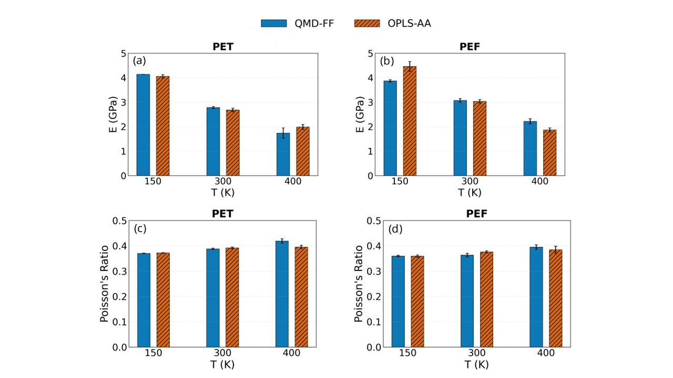
Figure 1. (a,b) Young’s modulus and (c,d) Poisson’s ratio of PET (a,c) and PEF (b,d), computed using the QMD-FF (blue, solid bars) and OPLS-AA (orange, hatched bars).

Acronyms
QMD-FF: Quantum-Mechanical Derived Force Field
DP: Degree of polymerization
PET: Polyethylene terephthalate
PEF: Polyethylene furanoate
FAMD: Full Atom Molecular Dynamics

