**Transient analysis- Confidence intervals coding**

**Ali Ghasemi - s289223**

**Used Functions**

The first function is the “**Arrival**” function. This function is used to simulate the arrival of a customer. This function uses the parameter “Lambda” and It’s a function of u(utilization). The randomly generated time is based on an exponential function and will not be modified through the simulation.

The other function is the “**Departure**” function. This function simulates the departures of customers. We compute the delay in this function, which is the current time, minus the arrival time of the customer. In other words, a delay time will randomly be generated for the next customer based on the service time of the current customer.

The other function that has been used in this simulation, is the “transient point function” which is used to find the end the of the warm-up transient and the beginning of the steady state of the simulation. This function, find the point “**K**” based on the variance of the cumulative mean of the delays. And we keep on looking for the point with the lowest amount of change in the variance and we choose the first point that has that characteristic and it’s computed as below:

Mean (cumulative delay) – std (cumulative delay)

It is important to mention that to find the point “K” the cumulative mean of the delays has been used, so each point is the sum of delays until that point divided by the number of points until there.

The other function is the “**confidence_interval_margin**” function which gives us the confidence interval. After the batching process, this function takes the mean of each batch (it is important to mention that a confidence interval cannot be computed inside each batch since the point are depended on each other) and then computes the mean of all the means and returns the confidence interval margin as well. The function computes the value for $2z/x$ and returns this value to be used for comparison to the value for the accuracy and also computing the confidence interval in the further steps. We use the t Student distribution to compute the confidence interval since it’s an estimation of the mean and the variance.

The other function is the “hyper_**expo**” which is a function used to generate random numbers based on the hyper-exponential distribution.

**Simulation process**

In the biggening, we perform the simulation to a specific time, for example 50000. There’s also another variable called the warmup simulation time which is a function of u. this variable is the point that we first run the simulation to, and then based on the information gained until that point we compute the “**K**”, then we forget about the data before the point “K” and keep on doing the simulation. The reason why the warmup simulation time is a function of “u” is the fact that based on the value of u, it will take longer or shorter to reach a steady state. The simulation will be performed for different distributions and different values for u (utilization).

The simulation after finding the point “**K**” and removing the data before this point, will be performed based on the pseudocode provided in the slides. The initial number of batches is equal to 10. And based on this and the data we have, we compute the batch size. We use the batch size based on the below formula:

$$N-k/10$$

And “**N**” is the last point of the simulation (the last point that we are in)

At this point, we compute the value $2z/x$ based on all the batches and will compare it to the value for P (accuracy) and we check if the condition is met or not, if yes, the simulation will be over and if not, we keep on adding batches and keep on performing the simulation until the condition is met.

You can see the output of the simulation in the below figure.

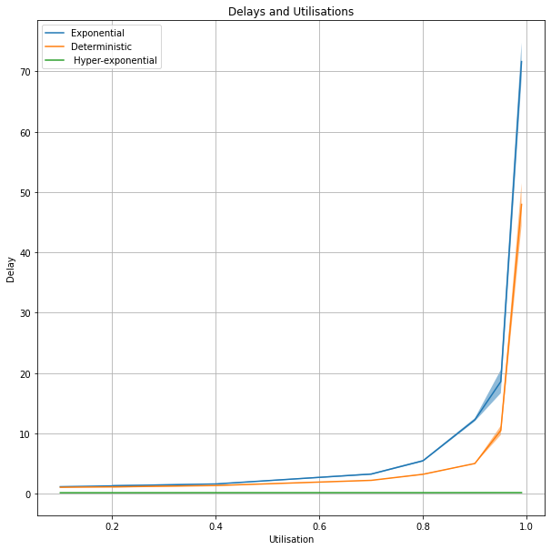You can also find the other plots attached to the code and the report.