**1.Installing virtualization software and creating VM**

First I downloaded virtualization software. I decided to download VirtualBox because we have used it before as part of a subject at my faculty. For Linux distribution i opted for MX Linux. I downloaded the ISO image for that Linux distribution and I Installed VirtualBox on my PC. After the installment of the software I created a new Virtual machine and I named it „Assigment“ and I chose ISO image for the OS which was MX Linux ISO file. After that I chose 12GB of RAM for my main memory and 6 CPU cores for processing power. For my virtual drive I went for 30GB of space. After I created new VM i went to settings and changed Advanced settings of „Drag and Drop“ and „Shared clipboard“ to Bidirectional so that I can copy and paste things from my PC to VM such as files or links. After that I clicked OK and I ran the VM. VM failed to start because my AMD CPU was stoping virtualization from happening so I had to change the settings for the CPU in the BIOS in order to allow VM to create itself. (SVM Mode -> Enabled). When I sucessfully changed the settings I went back and started up the VM, it started the process of installing the OS and setting up the password and name for the user and administrator.

**2.Configuring the VM and installing software**

First I had to update the Linux distribution with latest packages and security updates. I right clicked on desktop of the VM and ran the Command prompt or console. In console I ran „sudo apt update“ that is used to retrivie latest versions of packages available for the system. Then I ran „sudo apt upgrade“ that installed the packages to their latest versions. After it has finished installing I ran the command „sudo apt-get dist-upgrade“ that upgrades packages and ensures that system is up to date with latest security patches.

In order to install and enable SSH on my VM I ran Terminal from the desktop and ran „sudo apt-get install openssh-server“ command in order to install ssh server packages.

In order to setup SSH password authentification I had to first check if that option is enabled. I used comman „sudo nano /etc/ssh/sshd_config“ in order to open a file containing configurations for the ssh and scroll until I got to #PasswordAuthentification. PasswordAuthentification was already setup to #PasswordAuthentification yes so it was already setup.

In order to install Docker I had to follow Docker documentation for MX 21 Linux in order to download it. I followed installation instructions provided in <https://mxlinux.org/wiki/applications/docker/>. After sucessfully installing Docker I used command „sudo docker pull hello-world“ that pulls Hello,World Docker image from Docker Hub, then I used „sudo docker run hello-world“ to run the container on Hello World. 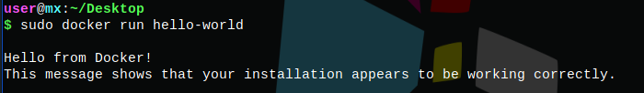

In order to install Minikube I had to follow Minikube installation from <https://minikube.sigs.k8s.io/docs/start/>. For downloading and installing Minikube I has to use curl and following commands „curl -LO <https://storage.googleapis.com/minikube/releases/latest/minikube-linux-amd64>“ and „sudo install minikube-linux-amd64 /usr/local/bin/minikube“. After sucessfully installing Minikube I started it with „minikube start“ and I tested if it was running properly by using command „minikube status“.

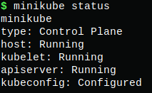

Now for the next part I had to select one of Docker Hub container imagese, I opted for MySQL. In order to pull MySQL from docker hub I used command „sudo docker pull mysql“. After that I ran „docker run -d -p 3306:3306 -e MYSQL_ROOT_PASSWORD=dominik mysql

„ where -d starts container in detached mode and -p that is a flag used to match ports from the container to my VM. MYSQL_ROOT_PASSWORD is just a password set up to my name when accessing the container. In order to execute the container I need a provided container ID that I can obtain by using „sudo docker ps“ 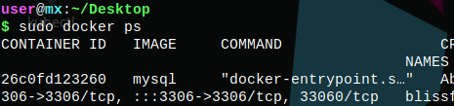

And with the command „sudo $ docker exec -it 26c0fd123260 mysql -u root -p“ I executed docker and was prompted to enter the password. After that I got following message: 