Dinky Corpus Project Report
Dr John Farrell
September 15, 2015

Objective
The objective of the project is to produce a phone app to assist in the teaching of information science students. The particular facet of information science chosen to focus on was web search. The plan is that the app will increase student engagement in this area of learning.

Deliverables
Deliverables of this project are:
- This documentation.
- An Android application written in Java, delivered as source code on Github. Note that Github allows projects to be hosted publicly for free, but requires payment of $US7 / month for private hosting. If the project sponsor requires private hosting of the code, a Github account with private hosting should be provided.
- A web site application written in Java, delivered as source code on Github. The same comment about public / private hosting applies.

Dinky Corpus
The project demonstrates the construction of a corpus and various implementations of search within that corpus. The “words” within the corpus are cute icons which the students can string together to form “documents”. The use of icons adds colour and a sense of play to the exercise, while avoiding the chance of the lesson being sabotaged by offensive documents.
The application consists of a web site built on a database, in which the corpus is stored. The Android app allows users to contribute documents to the corpus. The web site has facilities for the teacher to search the corpus in various ways.

Demonstration
The teacher opens the website. Students are given this URL and download the app by clicking on the Android App link. The teacher clicks on the NEW button. (Students might also click on the NEW button and create their own corpus, but that won't interfere with the teacher's corpus.)
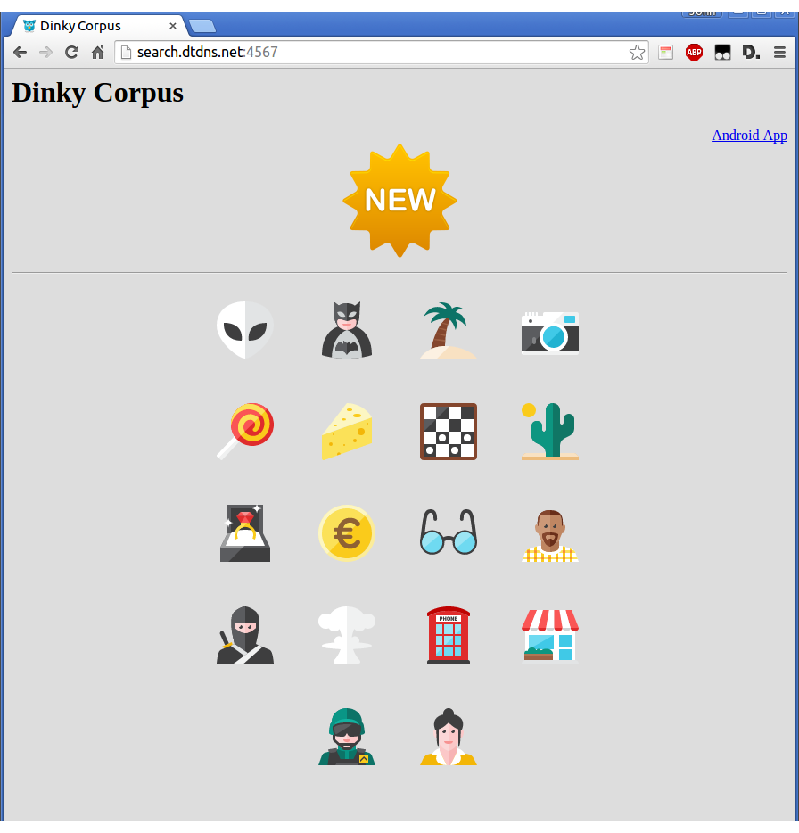
The teacher gets a new corpus with a number, in this case 939754. The teacher tells the number to the students.
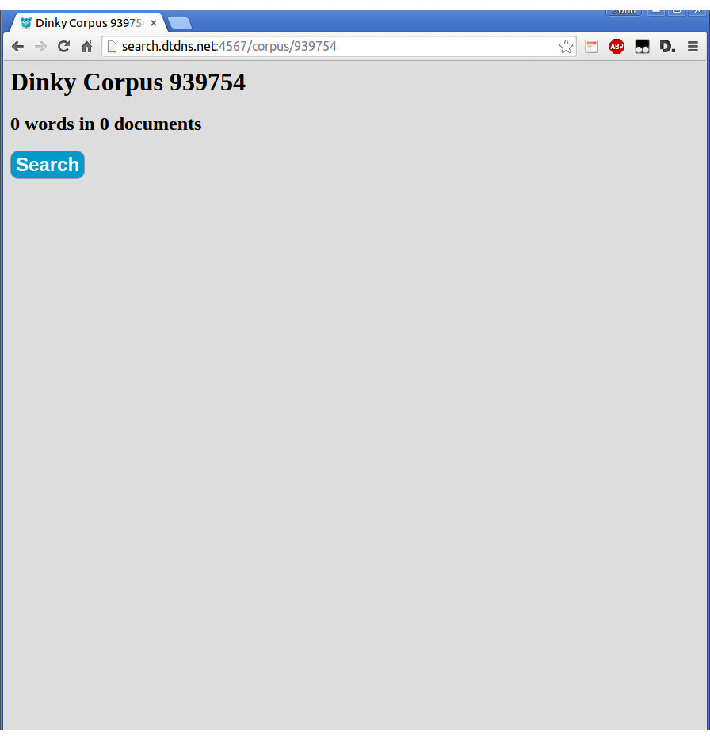
The students open up the app and type the number in. The students can then type in a document. To submit it to the corpus, they press the Submit button. The document then vanishes and a new document is started (there is no editing of documents in the corpus).
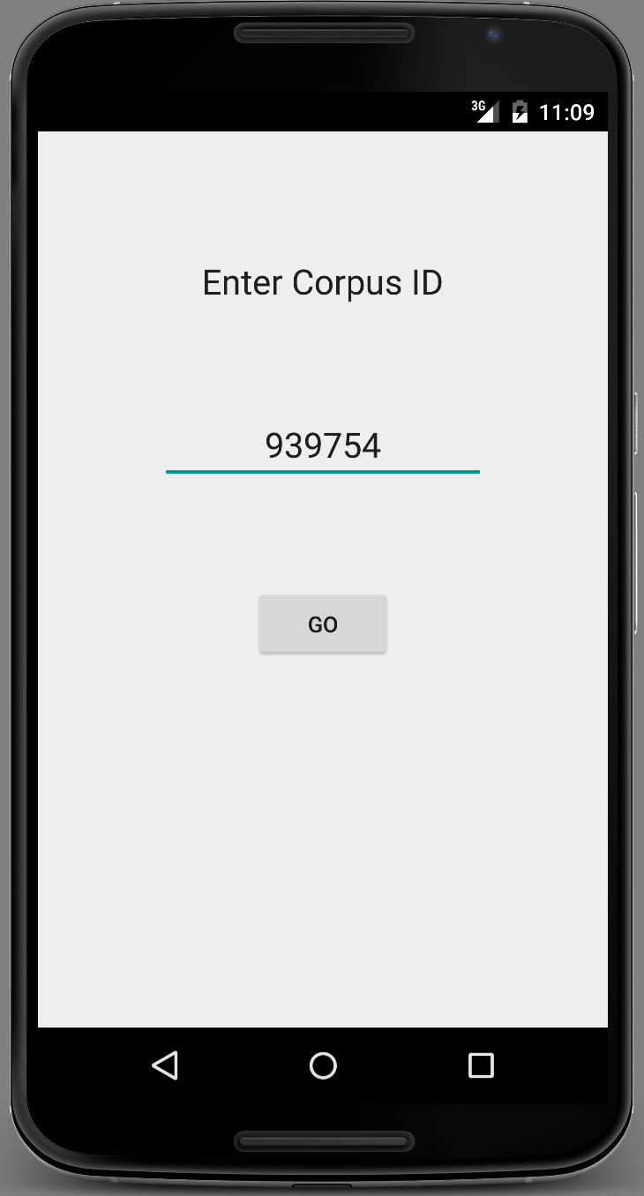
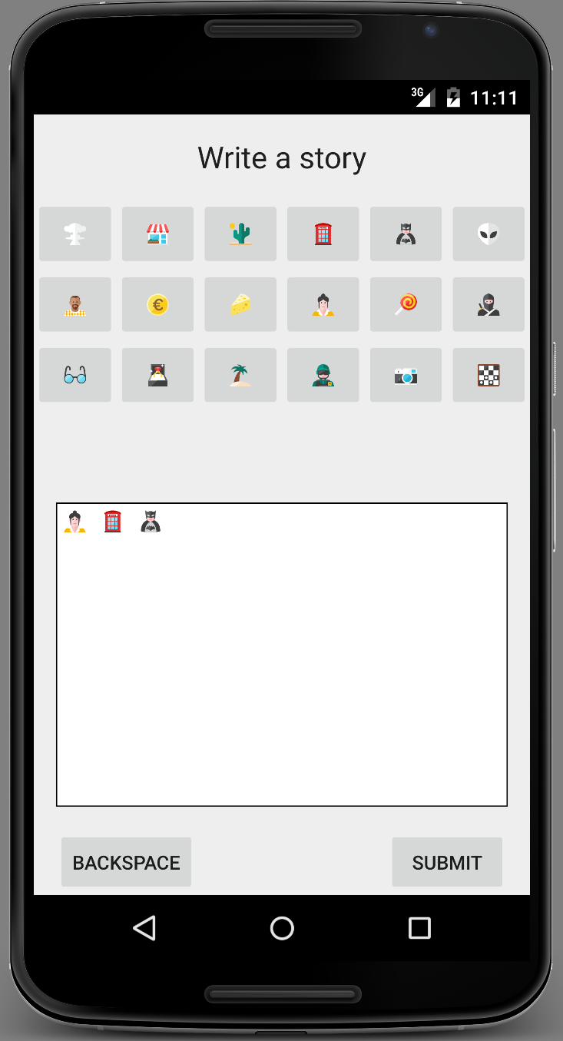

The teacher refreshes the corpus page and the documents the students have submitted are displayed.
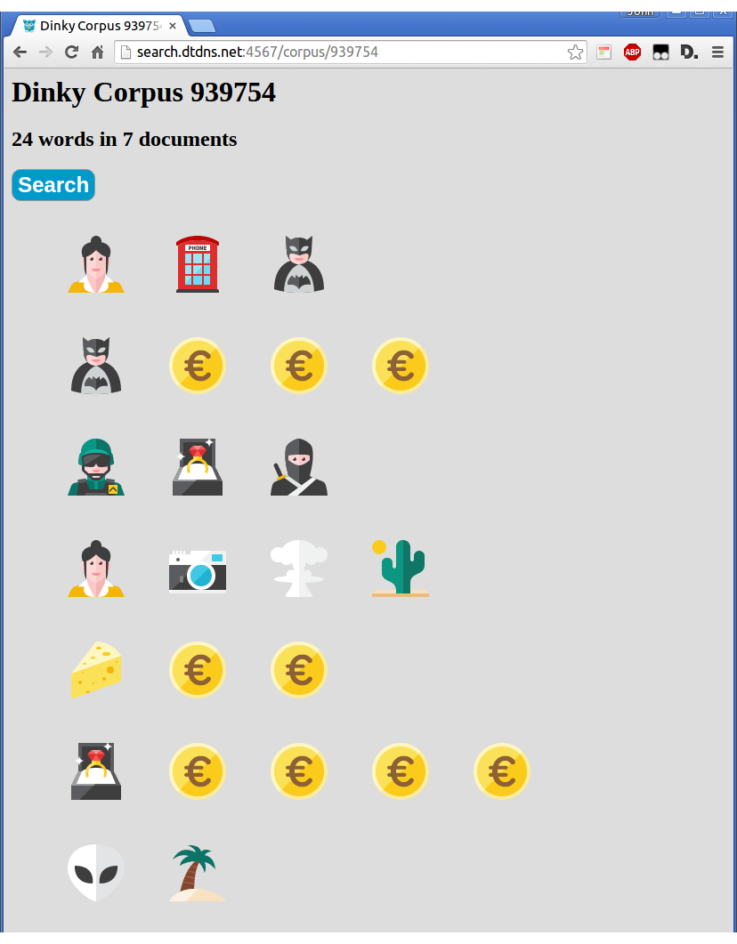
The teacher then clicks on the Search button to go to the Search page.
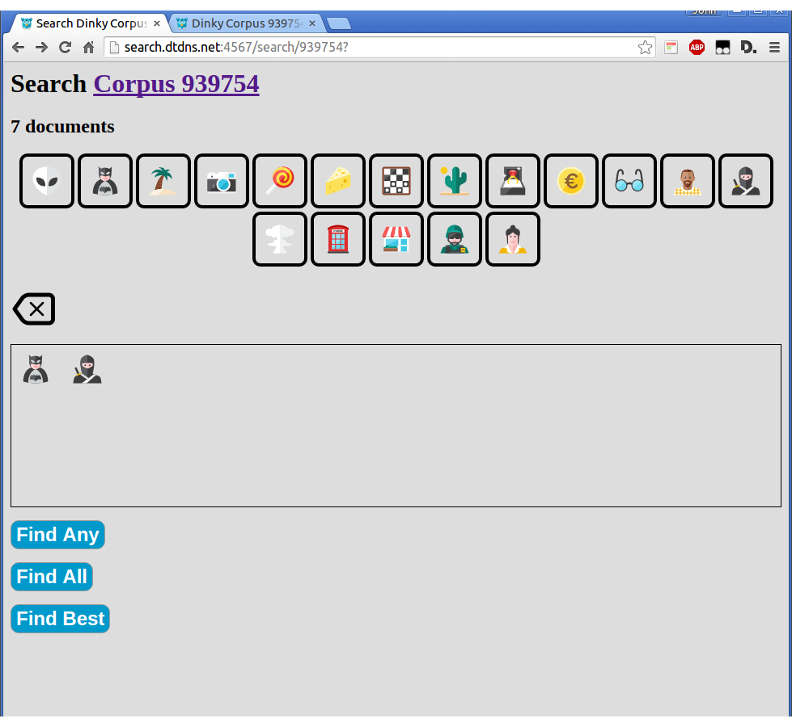
On the Search page the teacher enters some search terms then chooses the type of search.
- “Find Any” finds all documents containing any of the search terms.
- “Find All” finds documents containing all of the search terms.
- “Find Best” applies a more advanced searching technique. Each word is given a score equal to the total number of words in the corpus divided by the number of occurrences of that word. The score for a story is the product of the word score for each search term it contains divided by the length of the story.

Application Architecture
The app will be hosted on the web site so that it can be downloaded by students during the lesson. Students will need to configure their Android devices to allow it to be installed (apps which do not come from an app store are not trusted). The app is deployed as an APK file. This is the standard file type for Android apps, although the app store hides such details.
The database used by the application is MySQL. The schema for the database is in the file schema.sql in the web server codebase.
The hostname of the web site is built into the app. Hence changing the web site (or moving to a different one) will require changing the app and recompiling the APK. That APK will need to be placed into the public/app directory on the web site, so that students can download a version of the app which refers to the web site in use.

Running the Web Server
The main class of the web server is friendless.statisticallanguagemodelling.WebServer. This starts a web server on port 4567.

Licences
Icons: The icons in the app are the 120 free icons from www.kameleon.pics. Many other icons are available, but they're not free.
Apache Velocity: Apache Licence 2.0, http://velocity.apache.org/
SparkJava: Apache Licence 2.0, http://sparkjava.com/
MySQL JDBC: No client licence is necessary when using MySQL to connect to a licensed MySQL server.
GSON: Apache Licence 2.0, https://github.com/google/gson
SVGAndroid: Apache Licence 2.0, https://code.google.com/p/adet/

Compatibility
The app is designed to work with Android SDKs version 14 (Ice Cream Sandwich) and later. Ice Cream Sandwich was released in October 2011, so recent phones should be able to run the app. The app uses Java 7 syntax. The web server uses Java 8 syntax and libraries.

