

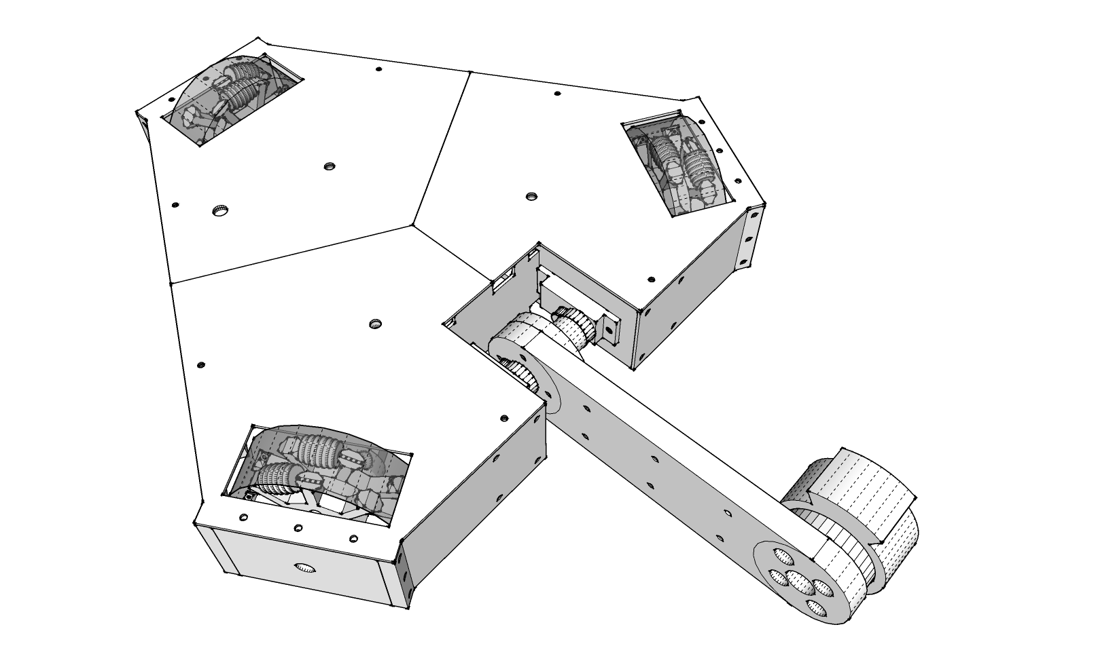

See this robot dump its truck on others like it on **3/23/2024** at **10:00 AM** in **Aspire Building A**. The event is free to watch!

At the 2024 Railside Robotics

Battlebot Brawl!

Root for Omni-Man!