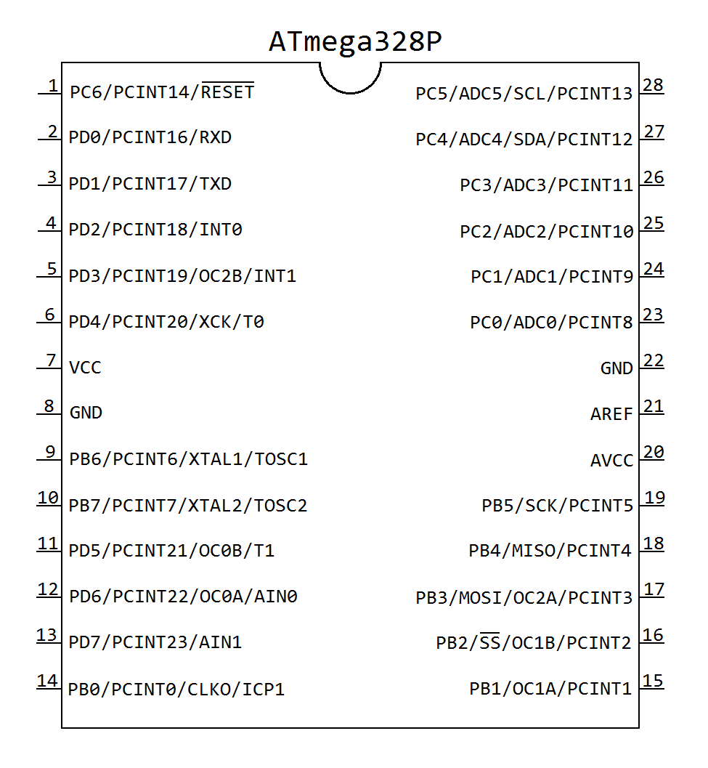PAx = Port A, bit # x

PBx = Port B, bit # x

PCx = Port C, bit # x

PDx = Port D, bit # x

----------------------------------------------

ADCx = Analog to Digital Converter channel x

AIN0 = Analog Comparator Input - Positive

AIN1 = Analog Comparator Input - Negative

AREF = Analog Reference

AVCC = Supply Voltage for the A/D Converter

CLK0 = Divided Clock Output

GND = Ground

ICP1 = Input Capture for Timer/Counter 1

INT0 = External Interrupt Request 0

INT1 = External Interrupt Request 1

MISO = SPI Master In / Slave Out

MOSI = SPI Master Out / Slave In

OC2A = Output Compare Timer/Counter 2 Match A Output

OC1B = Output Compare Timer/Counter 1 Match B Output

OC1A = Output Compare Timer/Counter 1 Match A Output

OC2B = Output Compare Timer/Counter 2 Match B Output

OC0B = Output Compare Timer/Counter 0 Match B Output

OC0A = Output Compare Timer/Counter 0 Match A Output

PCINTx = Pin Change Interrupt Request # x

= Reset (active low)

RXD = USART Receive (input)

SCK = SPI Bus Master Clock Input

SCL = I2C Serial Clock

SDA = I2C Serial Data

= SPI Slave Select (active low)

T0 = Timer/Counter 0 External Counter Input

T1 = Timer/Counter 1 External Counter Input

TOSC1 = Timer Oscillator pin 1

TOSC2 = Timer Oscillator pin 2

TXD = USART Transmit (input)

VCC = Digital Supply Voltage

XCK = USART External Clock Input/Output

XTAL1 = Crystal Oscillator pin 1

XTAL2 = Crystal Oscillator pin 2