Link for the GBD site
Website Link 1: https://vizhub.healthdata.org/gbd-compare/india
Note: To view the state-level dataset, select Detail=3, as shown in the picture below. After selecting this you can download the state-level dataset.
Make sure to create an account.
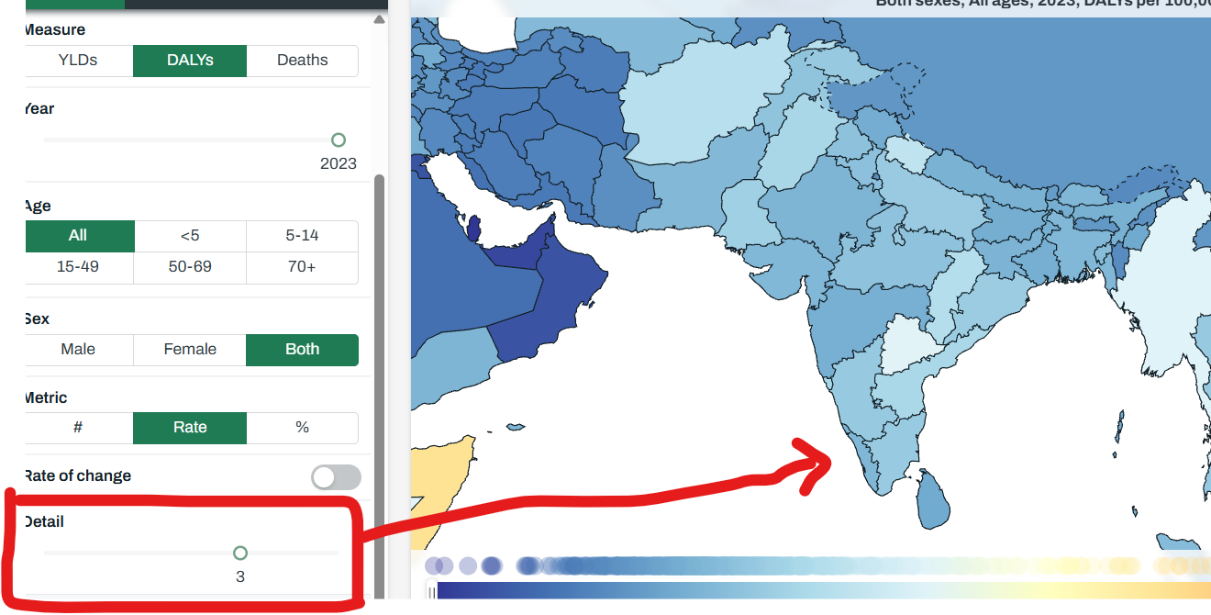

Link 2: https://vizhub.healthdata.org/gbd-results/
