placeholder_image .jpg |  | Image used in template  Created using windows Paint app.
friends_on_bikes.jpg | 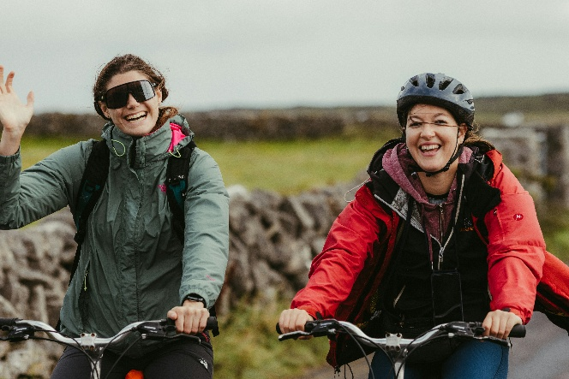 | Photo by Jonathan Borba on Unsplash  Photo by <a href="https://unsplash.com/@jonathanborba?utm_source=unsplash&utm_medium=referral&utm_content=creditCopyText">Jonathan Borba</a> on <a href="https://unsplash.com/photos/two-women-happily-riding-bicycles-outdoors-dRhkbOhQH70?utm_source=unsplash&utm_medium=referral&utm_content=creditCopyText">Unsplash</a>
Kids_on_bikes.jpg | 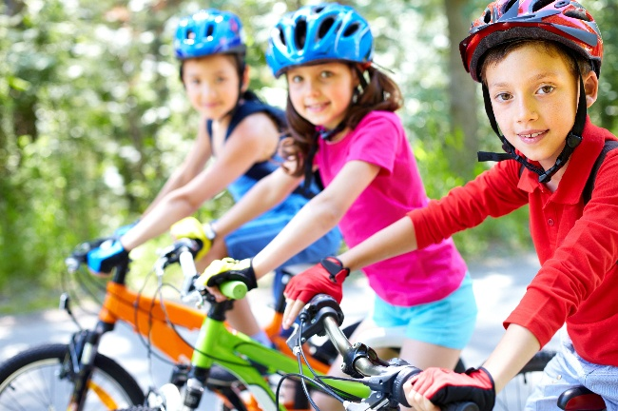 | Image by Sylwia Aptacy from Pixabay  Image by <a href="https://safesearch.pixabay.com/users/sylwiaaptacy-246079/?utm_source=link-attribution&utm_medium=referral&utm_campaign=image&utm_content=775799">Sylwia Aptacy</a> from <a href="https://safesearch.pixabay.com//?utm_source=link-attribution&utm_medium=referral&utm_campaign=image&utm_content=775799">Pixabay</a>
group_on_bikes.jpg | 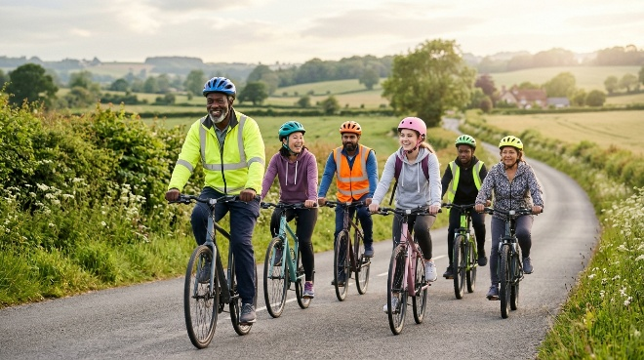 | AI generated using Gemini  prpmpt: barriers to cycling  Generate a photorealistic image of a diverse group (age, gender, ethnicity) riding bikes together for fun. They are wearing everyday casual clothes not racing gear. They should be wearing helmets and some of them may have hi-vis tops. They are riding on a country road. The camera should be eye-level. Lighting should be natural sunlight. It should have an ethereal feel, using soft textures and with lens flare. The image should be at least 1000px and have a 16/9 aspect ratio and suitable for use on a modern website

