GymHub – Smart Gym Management System

Software Development Plan

Version 1.0

Revision History
Date | Version | Description | Author
12/Jul/26 | 1.0 | Initial version of the Software Development Plan | Group 01

Table of Contents
1. Introduction 4
2. Project Overview 4
2.1 Project Purpose, Scope, and Objectives 4
2.2 Assumptions and Constraints 4
2.3 Project Deliverables 5
3. Project Organization 5
3.1 Organizational Structure 5
3.2 Roles and Responsibilities 5
4. Management Process 6
4.1 Project Estimates 6
4.2 Project Plan 6
4.2.1 Phase and Iteration Plan 6
4.2.2 Releases 6
4.2.3 Project Schedule 6
4.3 Project Monitoring and Control 7
4.3.1 Reporting 7
4.3.2 Risk Management 7
4.3.3 Configuration Management 8

Software Development Plan

Introduction
This Software Development Plan (SDP) describes the overall plan used by Group 01 (Class 24C07, Faculty of Information Technology, University of Science) to develop GymHub, a web-based Smart Gym Management System, for the course Introduction to Software Engineering.
The document defines the project purpose, scope and objectives, assumptions and constraints, project deliverables, the organization of the project team, and the management process, including project estimates, the phase and iteration plan, releases, the project schedule, monitoring and reporting, risk management, and configuration management.
The plan is based on the GymHub Project Proposal (22/Jun/26) and the GymHub Software Requirements Specification (10/Jun/26), and it will be updated at the end of each phase or whenever significant changes to scope, schedule, or resources occur.

Project Overview

Project Purpose, Scope, and Objectives
GymHub is a centralized, web-based gym management and fitness tracking platform for gym members and administrators. It replaces fragmented, manual workflows (spreadsheets, paper workout plans, untracked facility capacity) with a single unified digital ecosystem.
The main objectives of the project are to:
• Enhance operational efficiency by automating administrative workflows such as membership management, billing, and reporting.
• Empower member autonomy with smart, self-guided tools: automated workout plan generation, customization, and fitness progress tracking.
• Foster long-term retention through behavioral design patterns such as workout streaks and consistency metrics.
• Optimize facility management with real-time, QR-based gym occupancy monitoring and crowding alerts.
• Apply modern software engineering methodologies (hybrid RUP–Scrum), database design principles, and full-stack development practices to a real-world problem.
The scope covers authentication, membership management and online payment, smart workout plan generation, fitness progress tracking, workout streak management, gym occupancy monitoring, a notification system, and administrative dashboards with revenue reports and gym-wide announcements. Mobile applications, wearable integration, nutrition recommendation, AI fitness coaching, and multi-branch management are out of scope for this version.
The project is expected to deliver the project documentation set (proposal, SRS, SDP, analysis and design documents, test documentation) and a working web application (GymHub v1.0) deployed for the final course demonstration.

Assumptions and Constraints
The plan is based on the following assumptions and constraints:
• The project has a fixed academic schedule of approximately 12 weeks (June – September 2026); the final deadline cannot be extended.
• Zero-budget project: all services are used on their free tier, all labour is contributed by the student team, and all hardware is the members’ personal laptops. The total project cost is 0 VND.
• The team consists of 4 students; no additional members will be added during the project.
• The system is developed as a web application; internet connectivity is required and a relational database management system is used.
• Development follows a hybrid RUP–Scrum methodology: RUP phases and milestones combined with short Scrum-style iterations.
• Online payment is integrated through a sandbox/test environment of the payment provider; no real money is processed.

Project Deliverables
The following artifacts will be created during the project:
- Project Proposal – delivered on 22/Jun/2026.
- Software Requirements Specification (SRS) – delivered on 22/Jun/2026 and baselined at the end of the Inception phase.
- Software Development Plan (SDP) – initial version delivered on 11/Jul/2026 and updated at each RUP phase boundary.
- Analysis and Design Documentation – including the use-case model, software architecture, database design, and UI prototypes; completed by the end of the Elaboration phase on 06/Jul/2026.
- Test Plan and Test Cases – prepared during the Construction phase and updated as new features are implemented.
- Final Project Report and Presentation Materials – completed and delivered on 10/Aug/2026, together with the final system demonstration.

Project Organization

Organizational Structure
The project team is organized as a small, flat structure. The Project Manager (Khả Phước Lộc) leads the team, coordinates the plan, tracks progress, and is the contact point with the course instructor and teaching assistants, who act as the review authority for all major deliverables.
Under the Project Manager, the team is divided into a Frontend sub-team (Khả Phước Lộc, Nguyễn Thanh Phát Thịnh) and a Backend/Database sub-team (Hoàng Trung Hiếu, Trần Thái Vỹ). Testing responsibilities are shared by Hoàng Trung Hiếu and Trần Thái Vỹ. All members participate in requirements analysis, design reviews, and documentation for their assigned features.

Roles and Responsibilities
The table below lists each team member and their assigned roles and responsibilities:
Person | Role
Khả Phước Lộc (24127073)  Hoàng Trung Hiếu (24127041)  Nguyễn Thanh Phát Thịnh (24127125)  Trần Thái Vỹ (24127264) | Project Manager, Frontend Developer  Backend Developer, Database Management, Tester  Frontend Developer  Backend Developer, Tester

Management Process

Project Estimates
Cost estimate: the total monetary cost of the project is 0 VND. All development tools, hosting, and third-party services are used on free tiers, and all effort is contributed by the four team members using their own equipment.
Effort and schedule estimate: the project is planned for approximately 11 weeks (June – August 2026), with each member contributing an estimated 8–10 hours per week (roughly 400–480 person-hours in total). Estimates are based on the feature scope defined in the SRS (32 functional requirements), the team’s experience from previous coursework, and analogy with similar course projects.
Re-estimation occurs at the end of each phase and at the end of each iteration during the Construction phase (sprint review). If actual velocity is lower than planned, lower-priority features (e.g., occupancy threshold notifications, advanced statistics) are re-negotiated first, following the priorities in the SRS.

Project Plan
This section contains the schedule and resources for the project. The project follows the four RUP phases; the Construction phase is organized as Scrum-style iterations (sprints) of two weeks.

Phase and Iteration Plan
The project is divided into four phases:
• Inception (07/Jun/26 – 21/Jun/26): understand the problem domain, conduct user interviews, define scope, produce the SRS and the Project Proposal. Milestone: Lifecycle Objectives (LCO) – scope and requirements approved by the instructor.
• Elaboration (22/Jun/26 – 05/Jul/26): Define detailed system requirements and produce the Vision document; design the database schema and create GUI prototypes in Figma; develop the Project Plan document; build use-case models and write detailed use-case specifications; carry out UI prototyping; and define the test planning strategy. Milestone: Lifecycle Architecture (LCA) — a validated set of requirements, design, and planning artifacts establishing the project's architectural and functional baseline.
• Construction (06/Jul/2026 - 02/Jul/2026) implements the remaining features in prioritized iterations. Milestone: Initial Operational Capability (IOC) – feature-complete beta v0.9.
• Transition (03/Aug/26 – 16/Aug/26): system testing, bug fixing, performance and security checks, deployment, final documentation and demo. Milestone: Product Release (PR) – GymHub v1.0.
Construction iterations and objectives:
• Iteration C1: set-up environment, framework, source-code skeleton, login/signin.
• Iteration C2: membership management, online payment (sandbox), payment history, administrative dashboard.
• Iteration C3: smart workout plan generator, workout plan customization, notification management.
• Iteration C4: workout streaks and achievements, QR check-in/check-out, gym occupancy monitoring, notification system, integration and stabilization of the complete system.

Releases
• v0.5 – Internal demo: architectural prototype with authentication and basic membership viewing; used internally and for the Elaboration review.
• v0.9 – Beta: feature-complete build covering all functional requirements in the SRS; used for system testing and instructor feedback.
• v1.0 – Final release: tested, deployed product presented at the final course demonstration.

Project Schedule
Key milestones and target dates:

Inception: 07/Jun/2026 - 21/Jun/2026
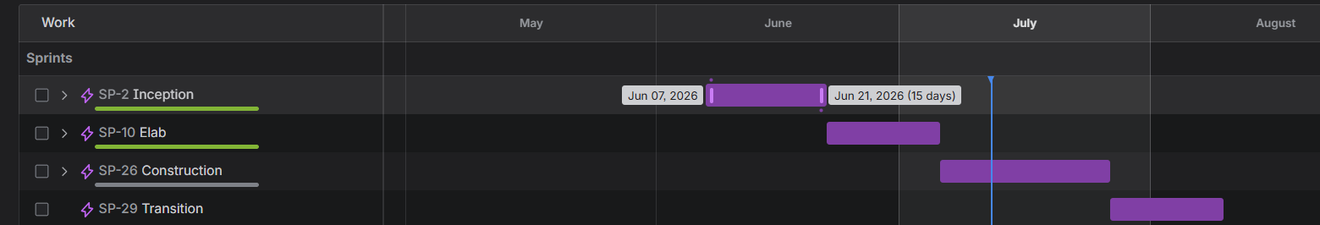
Elaboration: 22/Jun/2026 - 05/Jul/2026
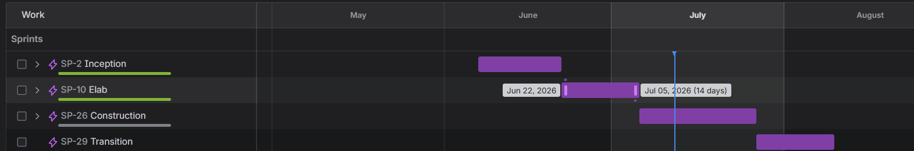
Construction: 06/Jul/2026 - 02/Aug/2026
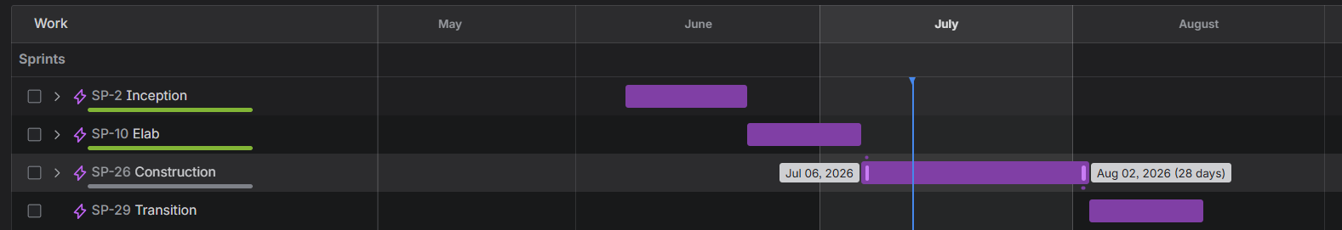
Transition: 03/Aug/2026 - 16/ Aug/2026
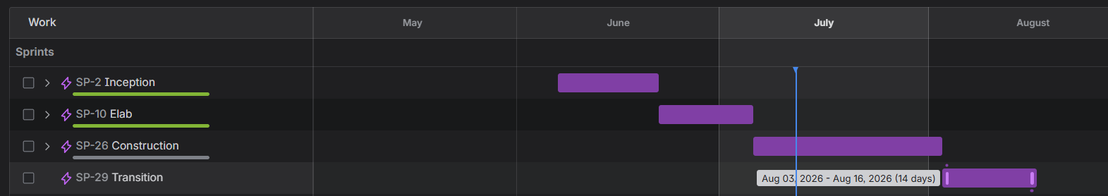
A detailed week-by-week Gantt chart is maintained in the team’s shared Google Drive and updated after every weekly meeting.

Project Monitoring and Control

Reporting
Project status is reported through the following mechanisms:
• Weekly team meeting (online or on campus) to review progress against the iteration plan, update the task board, and re-plan if needed.
• Weekly status summary written by the Project Manager and stored on the shared Google Drive.
• Daily informal communication through the team group chat for quick questions, blockers, and coordination.
• Sprint reviews at the end of each Construction iteration, with a short demo of completed features.
• Progress reports and demos to the course instructor at each phase milestone.

Risk Management

Configuration Management
The following tools are used for storage, sharing, and version control:
• Google Drive: storing and sharing all project documents (proposal, SRS, SDP, design documents, meeting notes, interview data). Each document is maintained by the member responsible for the corresponding task or deliverable.
• GitHub: hosting the source code repository. Work is done on feature branches and merged into the main branch through pull requests reviewed by at least one other member.
• Jira: Jira is used to manage the product backlog, epics, user stories, tasks, sprint assignments, priorities, responsible members, and project deadlines. The Jira roadmap is reviewed and updated during each weekly meeting and sprint review.

