GymHub – UI Design Revision
Group 01 — Introduction to Software Engineering

1. Overview
This report continues directly from PA3 – UI Design. In PA3, the team proposed two design options (Option A and Option B) for each of the two core screens of the GymHub system: the Dashboard (main screen) and the Workout Plan / Schedule screen (main use case, cited by 65.7% of surveyed members as the most-used feature).
As required, the team held a discussion to compare the two options for each screen, revised the chosen design based on the team's feedback and the current implementation of the system, and selected the final UI design to be used going forward. The final designs below are also cross-checked against screenshots of the actual GymHub web application to ensure the documentation matches what has been built.

2. Main Screen – Dashboard
PA3 proposed two navigation structures for the Dashboard: Option A used a top navigation bar (closer to the current site structure), while Option B used a persistent left sidebar (better suited for a growing, desktop/admin-heavy product).

2.1 Team Discussion – Option A vs Option B
Criteria | Option A | Option B
Navigation style | Top navigation bar; horizontal menu always visible at the top of the screen. | Fixed left sidebar; navigation items stacked vertically, profile pinned at the bottom.
Consistency with current site | Matches the current GymHub structure closely; low implementation risk. | Would require restructuring the existing layout; higher implementation cost.
Screen usage | Leaves more vertical space for content; works well on both desktop and smaller screens. | Uses horizontal space for the sidebar; better for very wide desktop/admin views but wastes space on smaller screens.
Scalability | Adequate for the current number of sections (Home, Train, Membership, Progress, Schedule, Admin Console). | Better if the product grows to many more sections in the future.
User familiarity | Familiar top-bar pattern members already recognize from the live site. | Common in admin dashboards but  less familiar to regular gym members.

Team decision: the team agreed that Option A (top navigation) should be chosen as the final direction, because it is what the current GymHub interface already follows, and the number of sections does not yet justify the overhead of a persistent sidebar. Option B remains a reasonable alternative only if the Admin Console grows into a much larger, separate module.

2.2 Revisions Made to Option A
After comparing the Option A mockup with the actual implemented Dashboard, the team revised the following details:
Element | PA3 Mockup (Option A) | Revised Final Design
Hero banner | Generic "Today's Workout" card with Start Workout / View Workout Plan actions. | Renamed to a gamified "Today's Challenge – Iron Warrior Challenge" banner with a glowing circular graphic; secondary action changed to "View Membership Plans".
Header area | Greeting header only ("Good morning, Alex"). | Added a breadcrumb link ("Home dashboard") below the greeting for clearer orientation.
Stat cards | Plain label + number, no icons. | Each stat card now has a small icon (activity, calendar, flame, trophy) to speed up scanning.
Weekly goal | M–S day strip only. | Added a numeric ratio and a percentage progress bar beneath the day strip.
Categories section | Listed as rows with workout counts. | Redesigned as cards with icon, short description, and a "See all" link; count moved inside each card.
Top navigation | Included Admin Console as a regular tab. | Admin Console kept only for the System Admin role view; layout otherwise unchanged.

2.3 Final UI Design – Dashboard
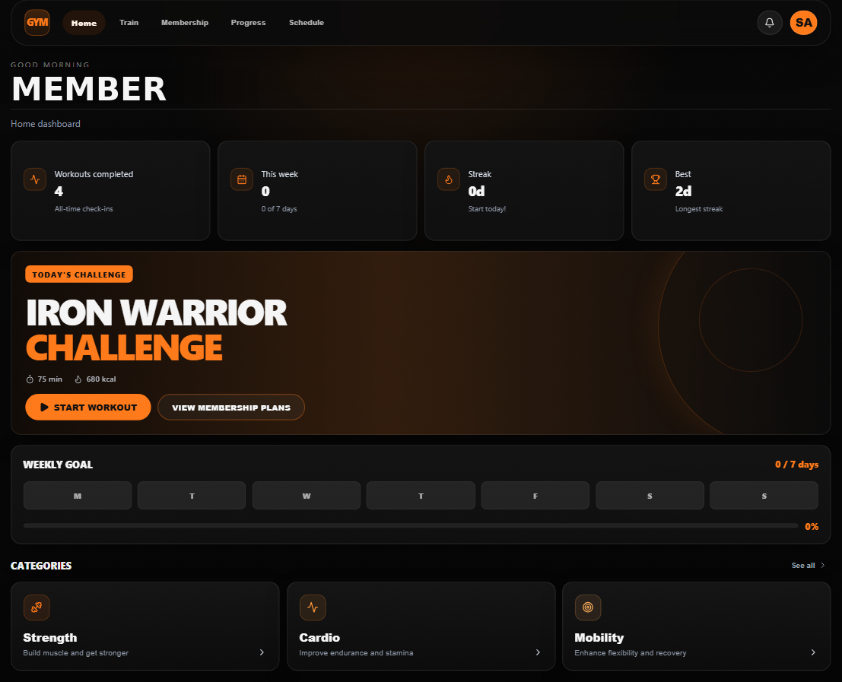
Figure 1. Final Dashboard design (revised Option A)

3. Main Use Case – Workout Plan (Schedule) Screen
PA3 proposed two ways for members to generate a workout plan: Option A used free-text / quick-suggestion AI prompting combined with a drag-and-drop weekly calendar, while Option B used a fully guided multi-field form (goal, level, equipment, days, duration).

3.1 Team Discussion – Option A vs Option B
Criteria | Option A | Option B
Input method | Free-text prompt plus quick-suggestion chips (e.g. "Build muscle mass"); fast for members who already know their goal. | Structured multi-step form with explicit fields for goal, level, equipment, days, and duration.
Speed of use | One prompt + Generate; fastest path to a filled calendar. | Requires filling multiple fields before generating; more steps but more explicit control.
Flexibility | Combines generation with a manual drag-and-drop calendar and exercise library for fine-tuning. | Generates a plan, then hands off to the same calendar view as Option A for adjustments.
Consistency with current site | Matches the current Schedule page exactly (Smart Plan Generator + weekly calendar + exercise library). | Would need an additional guided-form screen before reaching the calendar.
Learning curve | Very low — natural language input feels conversational. | Slightly higher — more fields to understand, but clearer for members unsure how to phrase a goal.
Team decision: the team chose Option A (AI-prompt generation with the weekly calendar) as the final design, since it is already implemented on the live Schedule page and directly supports the system's main use case — Smart Workout Plan Generation.

3.2 Revisions Made to Option A
Comparing the Option A mockup with the actual Schedule page, the team made the following revisions:
Element | PA3 Mockup (Option A) | Revised Final Design
Top stat cards | Catalog / Scheduled / Groups counters shown at the top of the page. | Replaced with a week navigator (◄ date range ►), a Schedule selector dropdown (e.g. "Schedule 1") to support multiple saved plans, plus SAVE and RESET actions.
Smart Plan Generator placement | Fixed panel pinned at the top of the page, always visible. | Converted into a floating, collapsible panel in the bottom-right corner, toggled by a round action button — keeps the calendar in full view when generation isn't needed.
Calendar cells | Static text only (exercise name, sets × reps, rest). | Each exercise card is now editable in place (sets, reps, rest fields), with reorder arrows and a delete icon per exercise.
Exercise library | Search bar with a single "All groups" filter dropdown. | Keep the search bar; difficulty badge (Beginner / Intermediate / Advanced) moved to the top-right corner of each exercise card for faster scanning; muscle-group filter kept as a separate dropdown.
Date context | Generic weekday labels (MON 20 … SUN 26). | Shows full date range at the top with the current day highlighted in the calendar header.

3.3 Final UI Design – Schedule
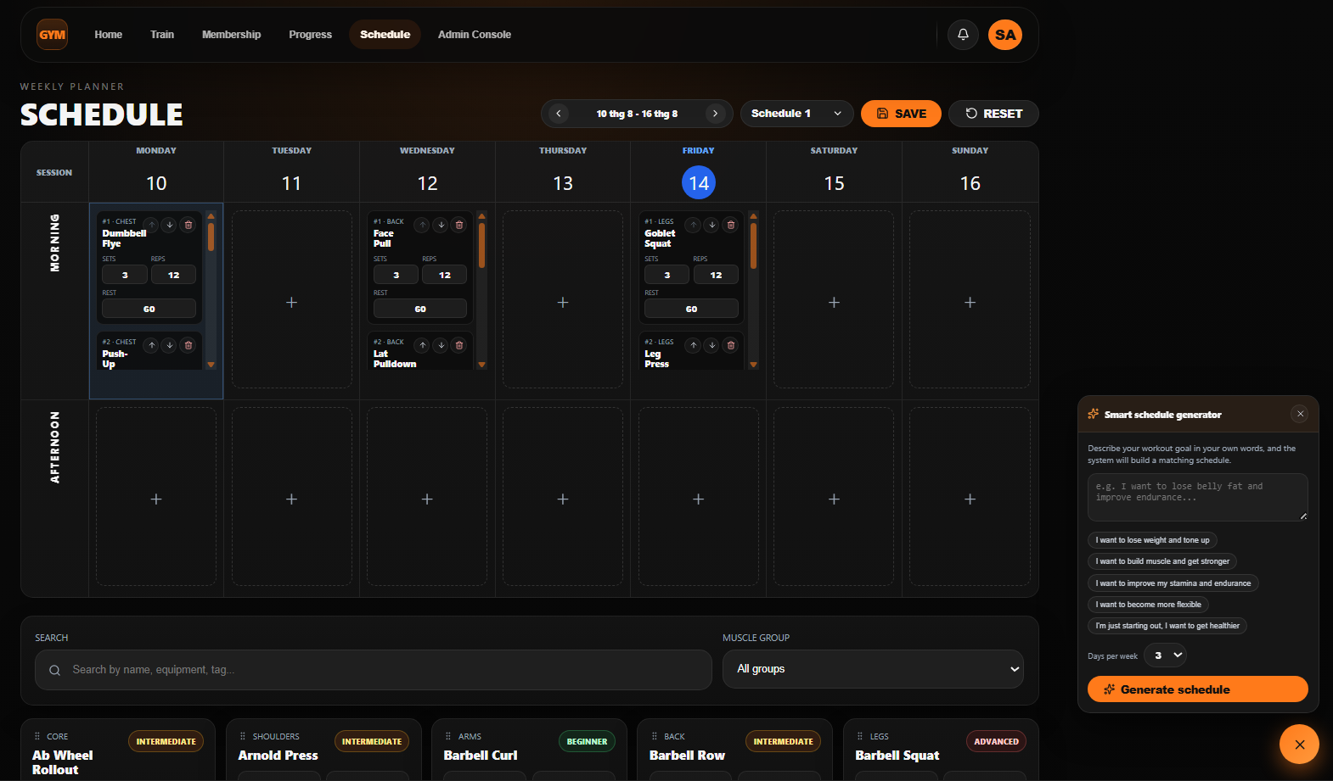
Figure 2. Final Schedule design (revised Option A)

4. Summary of Final UI Design Chosen
Screen | Option Chosen | Key Reason
Dashboard (Main) | Option A – Top navigation (revised) | Matches the current site structure; simpler and sufficient for the current number of sections.
Schedule (Workout Plan) | Option A – AI-prompt generation (revised) | Fastest path to a generated plan; directly supports the main use case (Smart Workout Plan Generation) already implemented on the live site.

