GymHub – Smart Gym Management System

Software Architecture Document

Version 2.0

Revision History
Date | Version | Description | Author
<23/07/2026> | <1.0> | Initial version of the Software Architecture Document | Trần Thái Vỹ, Khả Phước Lộc
<10/08/2026> | <2.0> | Updated Section 5 (Deployment) to describe the production deployment topology: frontend hosted on Render (static site), backend hosted on Render (web service), and PostgreSQL database hosted on Neon, replacing the previous local development topology (localhost frontend/backend and local PostgreSQL). Revised the Current Deployment Topology figure and description; Client Browser Node, Frontend Development Server Node, Backend Application Server Node, PostgreSQL Database Node, and External Service Nodes subsections; the Communication Paths table; Runtime Configuration | Khả Phước Lộc

Table of Contents

1. Introduction 5
2. Architectural Goals and Constraints 6
3. Use-Case Model 7
4. Logical View 7
4.1 Logical Architecture Overview 8
4.2 Presentation Component 8
4.2.1 Member Web Client 8
4.2.2 Administrator Web Client 8
4.2.3 QR Check-In/Check-Out Client 9
4.3 Application and Business Components 9
4.3.1 API and Cross-Cutting Services Component 9
4.3.2 Authentication and Account Management Component 9
4.3.3 Membership Management Component 9
4.3.4 Payment Management Component 10
4.3.5 Workout Planning Component 10
4.3.6 Fitness Progress Component 10
4.3.7 Occupancy and Gym Session Component 10
4.3.8 Workout Streak Component 11
4.3.9 Notification and Announcement Component 11
4.3.10 Administration and Reporting Component 11
4.4 Component Relationships 11
4.5 Persistence and Data Management Components 12
4.5.1 Repository and Data-Access Component 12
4.5.2 PostgreSQL Database Component 12
4.6 Key Logical Domain Model 13
4.7 External Integration Components 13
4.7.1 AI Goal-Classification Integration 13
4.7.2 Email Integration 13
4.7.3 Time Scheduler 13
4.8 Key Interaction Flows 14
5. Deployment 14
5.1 Current Deployment Topology 14
5.2 Deployment Nodes 15
5.2.1 Client Browser Node 15
5.2.2 Frontend Development Server Node 15
5.2.3 Backend Application Server Node 15
5.2.4 PostgreSQL Database Node 16
5.2.5 External Service Nodes 16
5.3 Communication Paths 16
5.4 Runtime Configuration 16
5.5 Security and Operational Considerations 17
6. Implementation View 17
6.1 Repository Structure 17
6.2 Frontend Implementation Structure 18
6.3 Backend Implementation Structure 19
6.4 Mapping of Logical Components to Code Folders 22
6.5 Cross-Cutting Implementation Files 23
6.6 Implementation Notes 23

Software Architecture Document

Introduction
1.1 Purpose

This Software Architecture Document describes the architecture of GymHub - Smart Gym Management System. The purpose of this document is to provide an architectural overview of the system, including its major software components, responsibilities, communication mechanisms, and technical decisions.

This document is intended for developers, testers, project stakeholders, and instructors who need to understand how the system is structured and how its main parts work together.

1.2 Scope

GymHub is a web-based gym management system that supports both gym members and administrators. The system provides features for user authentication, user profile management, QR code generation, membership plan management, workout plan management, fitness record tracking, gym occupancy tracking, payment request handling, notification management, workout streak tracking, and admin reporting.

The current system follows client-server architecture. The frontend is implemented as a React application using Vite and TypeScript. It communicates with the backend through HTTP-based REST APIs using JSON data. The backend is implemented with Node.js and Express.js, organized into feature-based modules such as Auth, Users, Memberships, Workouts, Payments, Occupancy, Notifications, Fitness Records, Streaks, and Admin. Persistent data is stored in a PostgreSQL database through backend repository modules.

1.3 Definitions, Acronyms, and Abbreviations

- GymHub: The smart gym management system being developed in this project.

- Member: A registered gym customer who can manage their profile, membership, workout plans, fitness records, payments, notifications, and streaks.

- Admin: A system user with management permissions for users, memberships, payments, occupancy, notifications, reports, and system statistics.

- Frontend: The client-side web application used by members and administrators.

- Backend: The server-side application that exposes APIs, handles business logic, performs validation, and communicates with the database.

- REST API: A set of HTTP endpoints used by the frontend to communicate with the backend.

- JWT: JSON Web Token, used for user authentication and authorization.

- QR Code: A generated code associated with a member and used to support gym check-in/check-out workflows.

- SPA: Single Page Application, the frontend application model used by the React client.

1.4 References
- Group 01, GymHub – Smart Gym Management System: Use-Case Specification 1.0
- Group 01, GymHub – Smart Gym Management System: Vision Document
- Group 01, GymHub – Smart Gym Management System: Project Proposal
- Group 01, GymHub – Smart Gym Management System: Software Requirements Specification
- React Official Documentation - https://react.dev/
- Node.js Official Documentation - https://nodejs.org/en/docs/

1.5 Overview

The remainder of this document describes the architectural goals and constraints of GymHub, the use-case model, the logical architecture of the system, deployment considerations, and the implementation view.

Section 2 presents the key architectural goals and constraints that affect the system design. Section 3 summarizes the use-case model. Section 4 describes the logical view, including the main components and their relationships. Section 5 describes deployment information. Section 6 presents the implementation view, including the organization of the project source code.

Architectural Goals and Constraints
- The system should be developed as a web-based application accessible through desktop and mobile browsers.
- The frontend shall be implemented using React, TypeScript, and Vite.
- The backend shall be implemented using Node.js and Express.js.
- The system shall use a client-server architecture, where the frontend communicates with the backend through RESTful HTTP APIs using JSON data.
- The system shall use a relational database management system, specifically PostgreSQL, for persistent data storage.
- The backend shall be organized into feature-based modules, such as Authentication, Users, Memberships, Workouts, Payments, Occupancy, Notifications, Fitness Records, Streaks, and Administration, to improve maintainability and separation of concerns.
- The system shall respond within 3 seconds under normal operating conditions.
- User passwords shall be stored securely using hashing algorithms.
- Protected resources shall only be accessible to authenticated and authorized users.
- The system should support role-based access control for member and administrator functions.
- Input data shall be validated before being processed by the backend to reduce invalid requests and improve system reliability.
- The system should provide clear navigation and feedback messages to support usability.
- The system shall maintain data consistency during important operations such as membership renewal, payment confirmation, and gym check-in/check-out.
- Payment handling shall follow the current system scope: members submit payment requests and administrators confirm, reject, or refund them through the system.
- The system shall support QR-code-based gym check-in/check-out workflows for occupancy tracking.
- The system shall support notification features such as workout reminders, membership-expiration alerts, streak-risk alerts, and administrator broadcast announcements.
- The project shall be developed with zero monetary cost, using free-tier services, open-source libraries, and team members’ personal development machines.

Use-Case Model
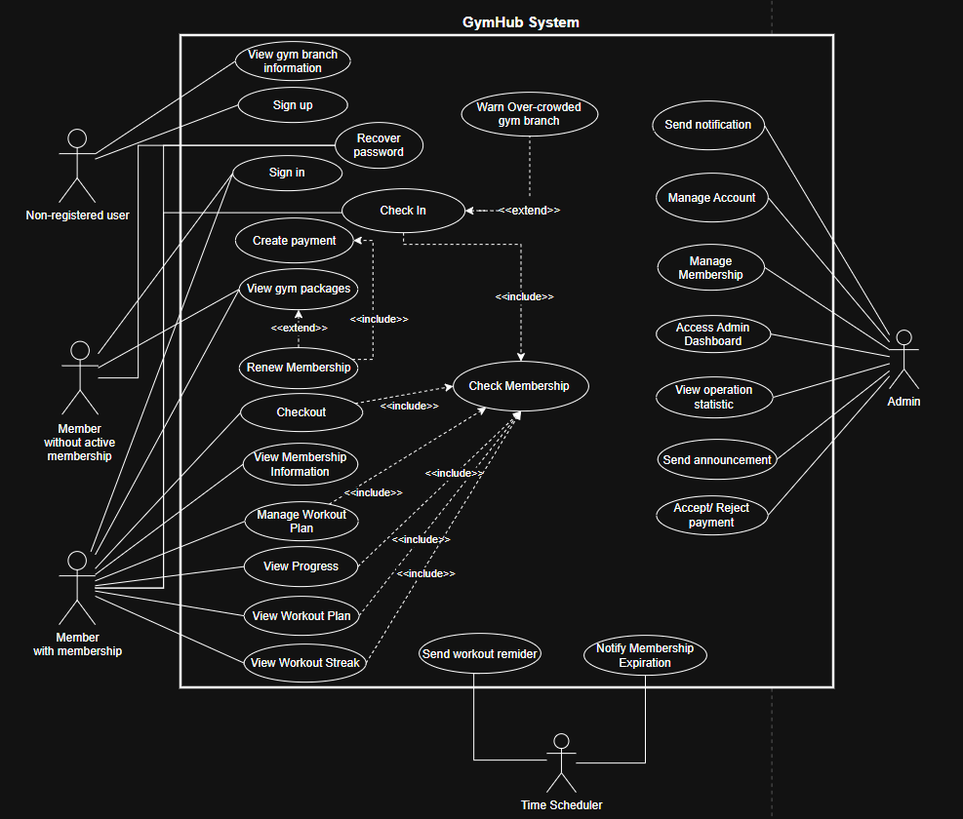

Logical View
GymHub follows an N-tier (multi-tier) layered client-server architecture, organized into four tiers: a Presentation tier (the Member, Administrator, and QR web clients), an Application/Business tier (the REST API and the feature-based business components), a Data/Persistence tier (the repository/data-access layer and PostgreSQL), and a set of External Integration components (the AI goal-classification service and the email service). The logical view separates user-facing presentation components, application and business components, persistence components, and external integration components. This separation makes the system easier to maintain and allows each component to evolve without changing unrelated responsibilities.
This N-tier style was chosen over a microservices architecture because GymHub is built by a four-member student team on a fixed academic schedule and deployed as a single backend process; a modularized monolith keeps deployment, cross-module transactions (for example membership renewal, payment confirmation, and QR check-in/check-out), and inter-component calls simple, while the feature-based module boundaries in Section 4.3 still keep business concerns separated. GymHub is also not a classic MVC application: it is a headless REST API consumed by a separate React single-page application, so there is no server-rendered View layer. Instead, each backend feature module (Section 4.3) is internally layered as Route -> Controller -> Service -> Repository, which plays the same separation-of-concerns role that Model-View-Controller plays in a server-rendered application.
All browser clients communicate with the application server through RESTful HTTP/HTTPS requests using JSON. The QR scanner or entrance kiosk also calls the occupancy endpoints through the local network or the Internet using HTTP/HTTPS and JSON. Internal application components collaborate through service calls, while the persistence component communicates with PostgreSQL through SQL over a database connection. The notification scheduler is time-triggered rather than invoked by a user request.

Logical Architecture Overview
Figure 4-1 presents the overall logical architecture. Members and administrators use the responsive web client. A QR scanner or kiosk uses a dedicated API path for check-in and check-out. All requests enter the application server through the API and cross-cutting services, then are handled by the appropriate business component. Business components access shared data through the repository/data-access layer. The application also integrates with an AI goal-classification service for workout-plan generation and an email service for password recovery.
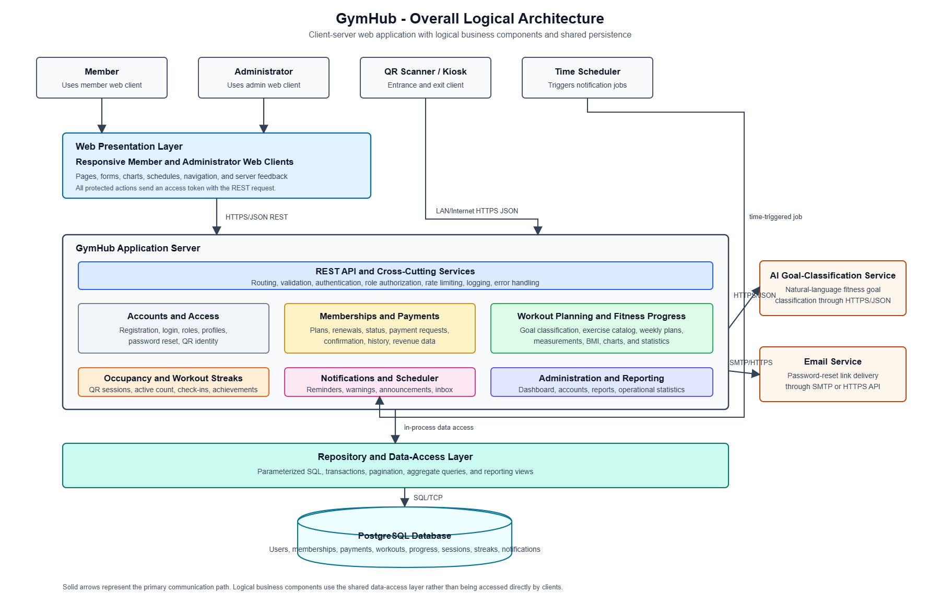

Presentation Component

Member Web Client
Responsibilities
- Provides responsive pages for account registration, sign-in, password recovery, profile management, membership information and renewal, workout plans, fitness progress, workout streaks, payment history, notifications, and current gym occupancy.
- Collects user input, performs basic client-side validation, displays server feedback, and renders charts, schedules, and status information.
- Stores and sends the authenticated session token when calling protected API endpoints.
Provided services and communication
- Sends REST requests and receives JSON responses through HTTP/HTTPS.
- Consumes the Authentication and Account, Membership, Workout Planning, Fitness Progress, Occupancy, Streak, Payment, and Notification components.
Technology: React 18, TypeScript, and Vite, with React Router (react-router-dom) for client-side routing; communicates over HTTP/HTTPS using JSON.
Requirements realized: FR-01 to FR-05, FR-07 to FR-18, FR-20 to FR-27; supports NFR-04 and NFR-05.

Administrator Web Client
Responsibilities
- Provides protected administration screens for user accounts, memberships, payment verification, exercise/workout catalog management, announcements, and operational reports.
- Displays active and expired memberships, pending payments, revenue information, session history, occupancy statistics, and notification results.
- Sends only authorized administrator requests; the server remains responsible for enforcing the role check.
Provided services and communication
- Sends REST requests and receives JSON responses through HTTP/HTTPS.
- Consumes the Administration and Reporting component and the protected management services of the domain components.
Technology: The same React/TypeScript/Vite frontend application as the Member Web Client, using role-protected routes and pages.
Requirements realized: FR-02, FR-06, FR-28 to FR-32; supports NFR-04 and NFR-05.

QR Check-In/Check-Out Client
Responsibilities
- Reads a member QR token at the entrance or exit and submits it to the check-in or check-out API.
- Displays the server response, such as a welcome/goodbye message, membership error, duplicate check-in warning, session duration, and current occupancy.
Provided services and communication
- Calls the Occupancy component through HTTP/HTTPS and JSON over the gym LAN or Internet.
- Does not require a normal browser session token; the QR token is validated by the server and must be treated as sensitive membership identity data.
Technology: A page within the same React/TypeScript frontend, called from the entrance/exit scanner device's browser.
Requirements realized: FR-17 to FR-20.

Application and Business Components

API and Cross-Cutting Services Component
Responsibilities
- Exposes REST endpoints and maps each request to the correct business component.
- Performs request validation, authentication, role-based authorization, rate limiting, error handling, request logging, and consistent JSON response formatting.
- Applies security rules before protected resources are accessed and returns clear success or error messages to the presentation layer.
Collaborations
- Delegates business operations to all domain components.
- Uses the Authentication and Account component to validate access tokens and user roles.
Technology: Node.js and Express.js 5 (JavaScript); CORS via the cors package, rate limiting via express-rate-limit, HTTP request logging via morgan, and application logging via winston; shared bootstrap/, config/, middlewares/, and utils/ folders described in Section 6.
Requirements supported: NFR-01 to NFR-03 and NFR-05.

Authentication and Account Management Component
Responsibilities
- Registers new member accounts and authenticates members and administrators.
- Hashes passwords, issues access and refresh tokens, supports logout, and manages password-reset tokens and email reset links.
- Maintains profile information, password changes, user roles, and QR identity tokens.
- Provides account search, account details, and account deletion operations for administrators.
Collaborations
- Uses the Persistence component for users and password_reset_tokens.
- Uses the Email Integration component for password recovery.
- Supplies identity and role information to the API and Cross-Cutting Services component.
Technology: Node.js/Express (JavaScript); password hashing via bcryptjs (utils/Hash.js) and tokens via jsonwebtoken (utils/Jwt.js); refresh tokens are read via cookie-parser.
Requirements realized: FR-01 to FR-03; supports protected access required by NFR-02 and NFR-03.

Membership Management Component
Responsibilities
- Manages membership plans and member memberships, including creation, viewing, renewal, expiration, suspension, cancellation, and status updates.
- Calculates membership dates and days remaining and checks whether a membership is active before granting gym and workout-plan access.
- Supports administrator monitoring of active and expired memberships.
Collaborations
- Uses the Persistence component for membership_plans and memberships.
- Is consulted by the Occupancy component before a QR check-in.
- Coordinates with the Payment component when a payment must be verified before activation or renewal is finalized.
- Supplies expiry information to the Notification component.
Technology: Node.js/Express (JavaScript); parameterized SQL through the module's repository file.
Requirements realized: FR-04 to FR-06 and FR-28.

Payment Management Component
Responsibilities
- Creates a payment request for a member's membership fee and records the selected payment method or banking reference.
- Prevents duplicate pending or completed payments for the same membership.
- Allows administrators to confirm or reject payments and records payment status, completion time, and audit information.
- Provides payment history and revenue data for members and administrators.
Collaborations
- Uses the Persistence component for payments and the associated memberships.
- Notifies the Membership Management component when a confirmed payment activates or extends a membership.
- Supplies completed-payment data to the Administration and Reporting component.
Technology: Node.js/Express (JavaScript); parameterized SQL through the module's repository file.
Requirements realized: FR-25 to FR-27, FR-29, and FR-30.

Workout Planning Component
Responsibilities
- Generates a personalized weekly workout plan from the member's goal, fitness level, and selected workout days.
- Uses an AI goal-classification service to interpret natural-language fitness goals when available, while rejecting non-fitness input.
- Allows a member to create a custom plan, change day labels or rest days, replace exercises, activate a saved plan, and delete a non-active plan.
- Maintains the exercise catalog and enforces that each member has only one active plan at a time.
Collaborations
- Uses the Persistence component for exercises, workout_plans, workout_days, and workout_day_exercises.
- Uses the Membership Management component to ensure that workout-plan features require an active membership.
- Calls the AI Goal-Classification Integration component through HTTPS when goal resolution is requested.
Technology: Node.js/Express (JavaScript); calls the external Groq AI API from workouts.generator.js over HTTPS/JSON.
Requirements realized: FR-07 to FR-09.

Fitness Progress Component
Responsibilities
- Records measurements such as weight, height, body-fat percentage, notes, and recorded date.
- Retrieves the latest measurement, historical records, and time-series data for charts.
- Calculates or exposes BMI, change over time, minimum, maximum, and average statistics.
Collaborations
- Uses the Persistence component for fitness_records.
- Uses the Membership Management component to restrict progress tracking to eligible members.
Technology: Node.js/Express (JavaScript); BMI and body-fat calculations in bmiCalculator.js and bodyFatCalculator.js.
Requirements realized: FR-10 to FR-12.

Occupancy and Gym Session Component
Responsibilities
- Validates a QR token, verifies an active membership, and opens or closes a gym session for check-in and check-out.
- Prevents an additional open session for a member who is already inside the gym.
- Calculates current active occupancy and session duration and exposes current occupancy information.
- Detects when occupancy exceeds a configured threshold and requests a notification.
Collaborations
- Uses the Authentication and Account Management component to resolve the QR token to a user.
- Uses the Membership Management component to validate gym access.
- Uses the Persistence component for gym_sessions and the current_occupancy view.
- Invokes the Workout Streak component after a successful first check-in of the day.
- Invokes the Notification component when the occupancy threshold is reached.
Technology: Node.js/Express (JavaScript); occupancy calculation in occupancyCalculator.js, QR code generation via the qrcode package (utils/Qrcode.js).
Requirements realized: FR-17 to FR-20 and FR-23.

Workout Streak Component
Responsibilities
- Records at most one workout check-in per member per day.
- Calculates and maintains current streak, longest streak, last active date, and achievement milestones.
- Provides a member's streak information and leaderboard/statistical information when requested.
- Identifies members whose streak may be broken and supplies that result to the Notification component.
Collaborations
- Is invoked by the Occupancy and Gym Session component after check-in.
- Uses the Persistence component for workout_checkins and workout_streaks.
- Supplies streak-risk information to the Notification component.
Technology: Node.js/Express (JavaScript); parameterized SQL through the module's repository file.
Requirements realized: FR-13 to FR-16.

Notification and Announcement Component
Responsibilities
- Stores, retrieves, marks as read, and deletes in-application notifications for members.
- Creates administrator announcements and distributes them to all members or selected recipients.
- Runs scheduled jobs that send workout reminders, membership-expiry warnings, and streak-risk warnings.
- Receives occupancy-threshold events and creates the appropriate occupancy alert.
Collaborations
- Uses the Persistence component for announcements and notifications.
- Queries the Membership Management and Workout Streak components when scheduled warnings are generated.
- Uses the Email Integration component only where an email delivery channel is required, such as password recovery.
Technology: Node.js/Express (JavaScript), implemented as two backend modules — notifications/ (scheduled jobs in notification.scheduler.js, templates in notification.templates.js) and announcements/ (admin-authored broadcasts). The backend's package.json has no cron/scheduling package (e.g., node-cron), so notification.scheduler.js most likely runs on Node's built-in setInterval/setTimeout timers rather than a cron-expression library.
Requirements realized: FR-16 and FR-21 to FR-24, FR-32.

Administration and Reporting Component
Responsibilities
- Provides an administrator dashboard and protected management/reporting operations.
- Aggregates membership status, completed-payment revenue, current occupancy, gym session history, user information, and notification activity.
- Exposes reports with filtering and pagination without duplicating the ownership of domain data.
Collaborations
- Reads data from the Authentication and Account, Membership, Payment, Occupancy, Workout, Streak, and Notification components through their services or repositories.
- Uses database reporting views such as revenue_report, current_occupancy, and membership_overview where appropriate.
Technology: Node.js/Express (JavaScript); SQL reporting views (revenue_report, current_occupancy, membership_overview).
Requirements realized: FR-28 to FR-32.

Component Relationships
Figure 4-4 shows the main logical dependencies. The arrows represent in-process service collaboration, not physical network calls. Every business component persists data through the shared repository/data-access layer. Direct database access from web clients is not permitted.
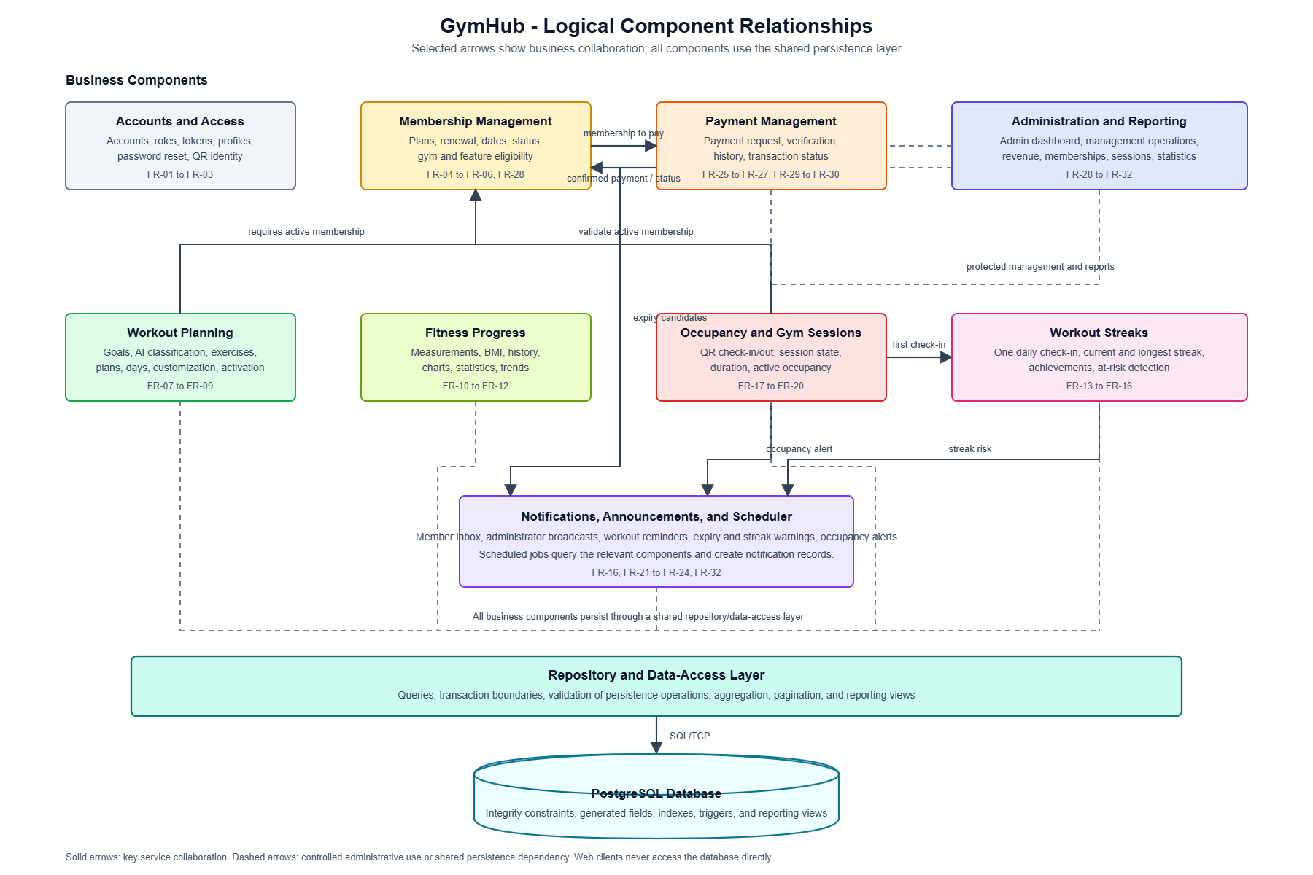

Persistence and Data Management Components

Database Entity Relationship model
Gymhub_ER_model

Repository and Data-Access Component
Responsibilities
- Encapsulates SQL queries and maps database records to the data required by business components.
- Provides pagination, filtering, aggregate queries, and transaction support.
- Ensures that the application server, rather than the browser client, controls all database access.
Communication
- Receives in-process calls from business components.
- Sends parameterized SQL commands to PostgreSQL over the database connection.
Technology: JavaScript (Node.js) using the pg (node-postgres) client; each module's *.repository.js file, with the shared transaction helper in utils/Transaction.js.

PostgreSQL Database Component
Responsibilities
- Stores persistent system data and protects integrity through primary keys, foreign keys, unique constraints, check constraints, indexes, generated fields, triggers, and reporting views.
- Stores identity and access data (users, password_reset_tokens); membership and payment data (membership_plans, memberships, payments); workout data (exercises, workout_plans, workout_days, workout_day_exercises); fitness and attendance data (fitness_records, gym_sessions, workout_checkins, workout_streaks); and messaging data (announcements, notifications).
- Provides calculated/reporting data through revenue_report, current_occupancy, and membership_overview.
Consistency rules
- Membership renewal, payment confirmation, and QR check-in/check-out must be performed in database transactions when more than one record is changed.
- Unique constraints prevent duplicate email addresses, duplicate QR tokens, more than one active workout plan per member, duplicate check-ins on the same day, and duplicate exercises within a workout day position.
- Foreign keys prevent orphaned records, and generated fields calculate BMI and completed gym-session duration consistently.
These rules directly support NFR-06 and NFR-07.
Technology: PostgreSQL (SQL / PL-pgSQL) for tables, constraints, generated columns, triggers, and reporting views.

External Integration Components

AI Goal-Classification Integration
The Workout Planning component calls the external Groq AI API through HTTPS and JSON to classify a member's natural-language fitness goal. The result is used to select a suitable workout profile. The application remains responsible for validating the result and for returning a friendly error when the input is not fitness-related or an AI response is unavailable.
Technology: External Groq API (hosted LLM service, not part of the GymHub codebase). This is a single stateless request/response call per goal-classification request, not an autonomous or stateful AI agent; the Workout Planning component keeps ownership of the resulting workout plan. Using the Agentic vs. Non-Agentic criteria from the course lecture (LN06), this integration is Non-Agentic: Autonomy — it only classifies the exact input it is given and never self-initiates an action; Context Retention — each call is independent, with no memory or state kept across requests; and Interaction with Environment — it returns a passive classification result rather than actively invoking tools or taking further actions in the system. A true agentic redesign would instead let the AI service itself call the Workout Planning, Exercise, and Membership repositories to plan and act autonomously, which is out of scope for GymHub.

Email Integration
The Authentication and Account Management component uses an email service through SMTP or an email-provider HTTPS API to deliver password-reset links. Password-reset tokens are stored only as secure hashes in the database; the plain token is sent only in the reset link.
Technology: External SMTP service, intended to be called from Node.js via utils/Mailer.js. The backend's package.json does not currently list a mail-transport package (e.g., nodemailer), so with the current dependency set the documented development fallback — logging the reset link instead of sending a real email — is the more likely active behavior.

Time Scheduler
The scheduler is a logical part of the Notification and Announcement component. It triggers daily or configured jobs to create workout reminders, membership-expiry notifications, and streak-risk warnings. It communicates with application services in-process and uses the same persistence and authorization rules as other server-side operations.
Technology: In-process Node.js scheduled jobs (notification.scheduler.js) started by server.js; no cron/scheduling library (e.g., node-cron) is listed in the backend's package.json, so jobs most likely use Node's built-in setInterval/setTimeout timers.

Key Interaction Flows
Interaction | Logical flow
Sign in | Web Client -> API and Cross-Cutting Services -> Authentication and Account Management -> Repository -> PostgreSQL -> token and role-aware JSON response.
Membership renewal and payment | Member Web Client -> Membership Management -> Payment Management -> Repository/Database. An administrator confirms or rejects a pending payment; confirmation updates the payment record and the applicable membership in one consistent business operation.
AI workout-plan generation | Member Web Client -> Workout Planning -> Membership check -> AI Goal-Classification Integration -> exercise/plan persistence -> JSON weekly plan response.
QR check-in | QR Client -> API -> Occupancy and Gym Session -> Account/QR lookup + Membership validation -> open gym session -> Workout Streak update -> occupancy calculation -> optional Notification. The related writes must be atomic.
Scheduled notification | Time Scheduler -> Notification and Announcement -> Membership/Streak/Occupancy data query -> create notification records -> Member Web Client reads notification inbox.
Administration report | Administrator Web Client -> API -> Administration and Reporting -> domain repositories/reporting views -> filtered JSON report.

Key Classes and Class Diagrams
This section elaborates the logical domain model in Figure 4-6 into object-oriented class diagrams. Classes are grouped by the business components defined in Section 4.3, and are shown together with their key attributes, key operations, and the relationships (generalization, association, aggregation, and dependency) that connect them. Each backend feature module in Section 6.3 realizes one or more of these classes through its *.controller.js, *.service.js, and *.repository.js files; the service-stereotyped classes below correspond directly to each module's *.service.js file.

Identity, Access, Membership, and Payment Classes
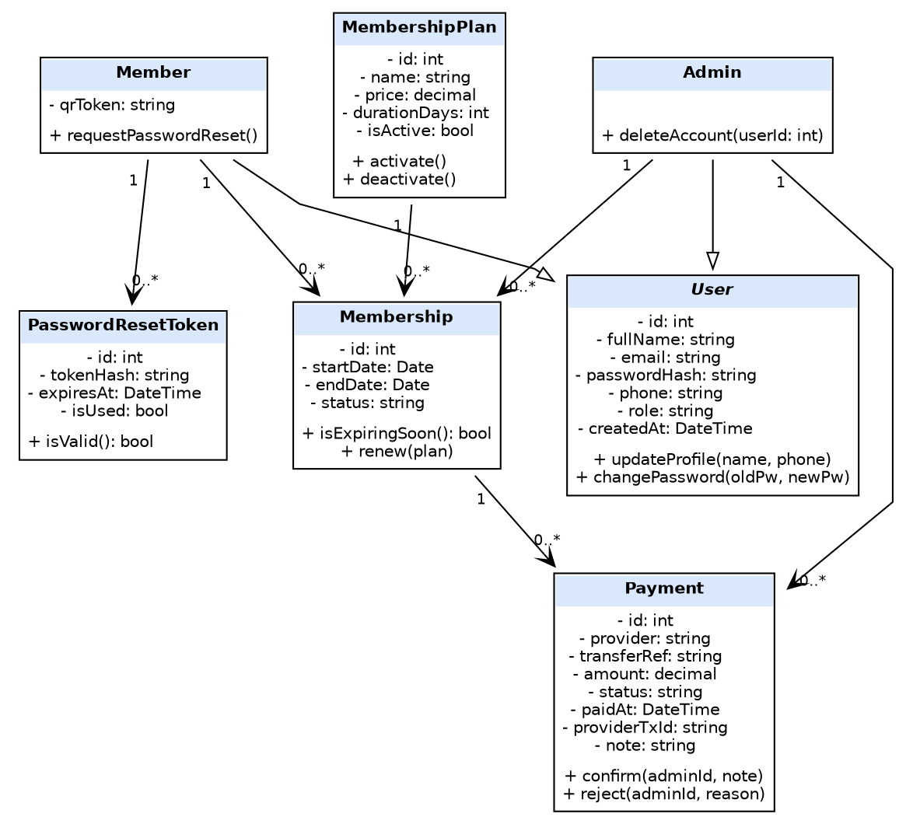
Figure 4-7: Class diagram for the Authentication and Account Management, Membership Management, and Payment Management components.
User is marked «abstract»: the system never creates a User directly, only a Member or an Admin. Member and Admin both generalize User, so they inherit its identity attributes and password/profile operations while adding their own responsibilities: Member holds the qrToken used for gym check-in, and Admin can delete accounts. Each Member has zero or more PasswordResetToken records issued during password recovery. A MembershipPlan is associated with zero or more Membership records; each Membership belongs to exactly one Member, is optionally created by an Admin (shown only as an association, not duplicated as a foreign-key attribute), and has zero or more Payment records that an Admin confirms or rejects. This matches FR-01 to FR-06 and FR-25 to FR-30 in the SRS.

Workout Planning, Occupancy, and Fitness Progress Classes
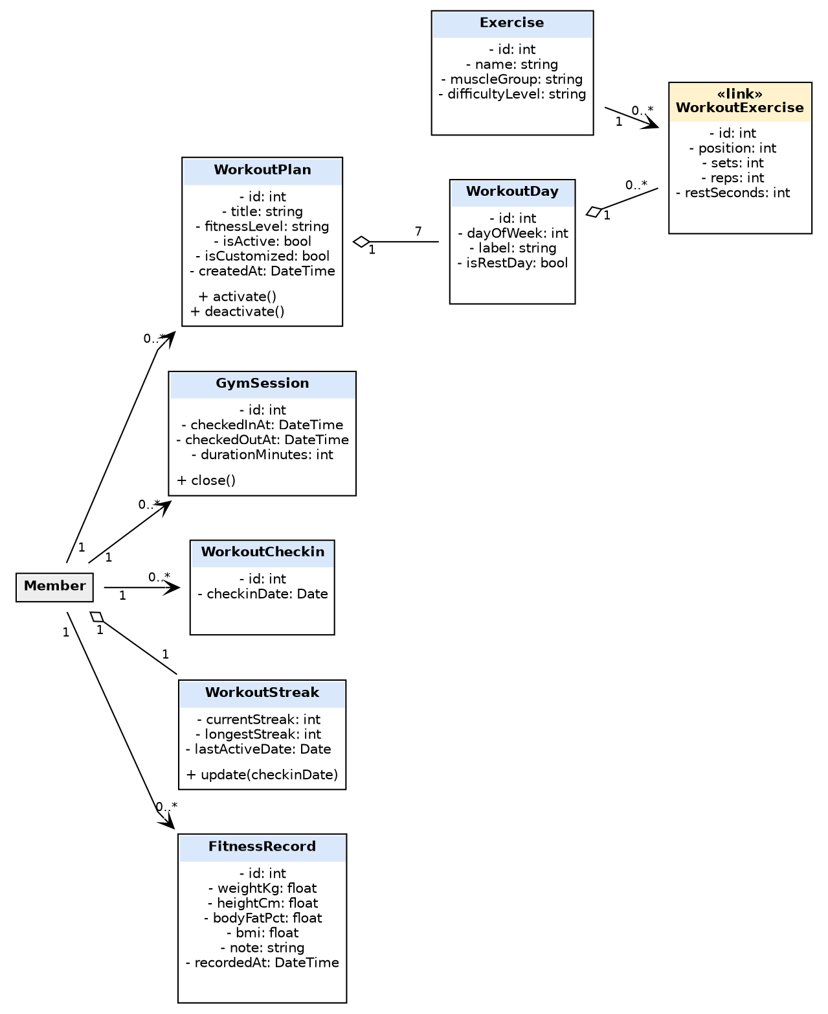
Figure 4-8: Class diagram for the Workout Planning, Occupancy and Gym Session, Workout Streak, and Fitness Progress components. Member is repeated (shaded) from Figure 4-7 as a reference.
A Member has zero or more WorkoutPlan records but only one is active at a time (enforced by the Workout Planning component, not shown as a multiplicity constraint here). Each WorkoutPlan aggregates exactly seven WorkoutDay instances; each WorkoutDay aggregates zero or more WorkoutExercise link-class instances, each of which associates one Exercise from the shared catalog with a position (ordering within the day) plus a sets/reps/rest configuration — position is what lets the unique-constraint rule in Section 4.5.2 ("no duplicate exercises within a workout day position") be expressed. A Member also has zero or more GymSession and WorkoutCheckin records, exactly one WorkoutStreak (aggregation, since the streak cannot exist independently of the member), and zero or more FitnessRecord entries. This matches FR-07 to FR-20 in the SRS.

Notification, Announcement, and Application Service Classes
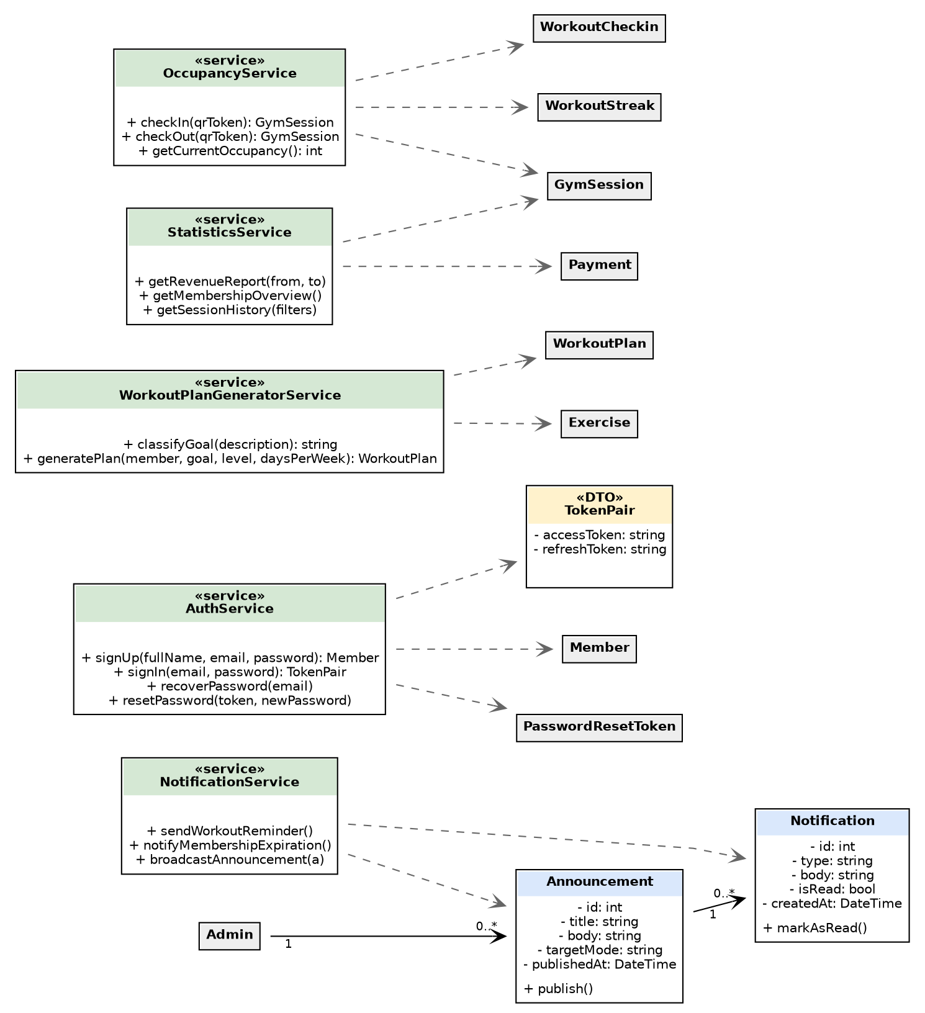
Figure 4-9: Class diagram for the Notification and Announcement component and the five application service classes that implement the business logic behind the API. Referenced classes from Figures 4-7 and 4-8 are shown shaded.
An Admin publishes zero or more Announcement records, each of which fans out to zero or more Notification records for members. The five service classes are stateless: AuthService depends on Member and PasswordResetToken to implement sign-up, sign-in, and password recovery, and creates a TokenPair (access/refresh token) value object on sign-in rather than persisting it as an entity; WorkoutPlanGeneratorService depends on WorkoutPlan and Exercise to classify a goal and generate a plan; OccupancyService depends on GymSession, WorkoutCheckin, and WorkoutStreak to implement check-in/check-out for the single gym location in the current scope (getCurrentOccupancy() takes no branch parameter, consistent with multi-branch support being a Future Enhancement in the Vision document); NotificationService depends on Notification and Announcement to run the scheduled and broadcast messaging described in Section 4.3.9; and StatisticsService depends on Payment and GymSession to build the Administration and Reporting views in Section 4.3.10. These dependency relationships mirror the Collaborations bullets already listed for each component earlier in Section 4.3.

Deployment
This deployment view describes the production deployment topology currently used to run the GymHub project. The React/Vite frontend is hosted as a static site on Render, the Node.js/Express backend runs as a separate Render web service, and the PostgreSQL database is hosted on Neon, a managed serverless PostgreSQL provider. All three nodes are independently deployed and communicate with each other over the public Internet through HTTPS/TLS. A browser anywhere with Internet access loads the frontend at https://gymhub-frontend.onrender.com and calls the REST API at https://gymhub-lrfv.onrender.com/api.

Current Deployment Topology
Figure 5-1 shows the physical nodes, runtime processes, communication paths, and external services used by the current production deployment. The frontend, backend, and database are three independently hosted managed services that communicate over the public Internet; there is no shared workstation or loopback interface in this topology. The notification scheduler is started by the backend process when ENABLE_NOTIFICATION_SCHEDULER is not set to false.
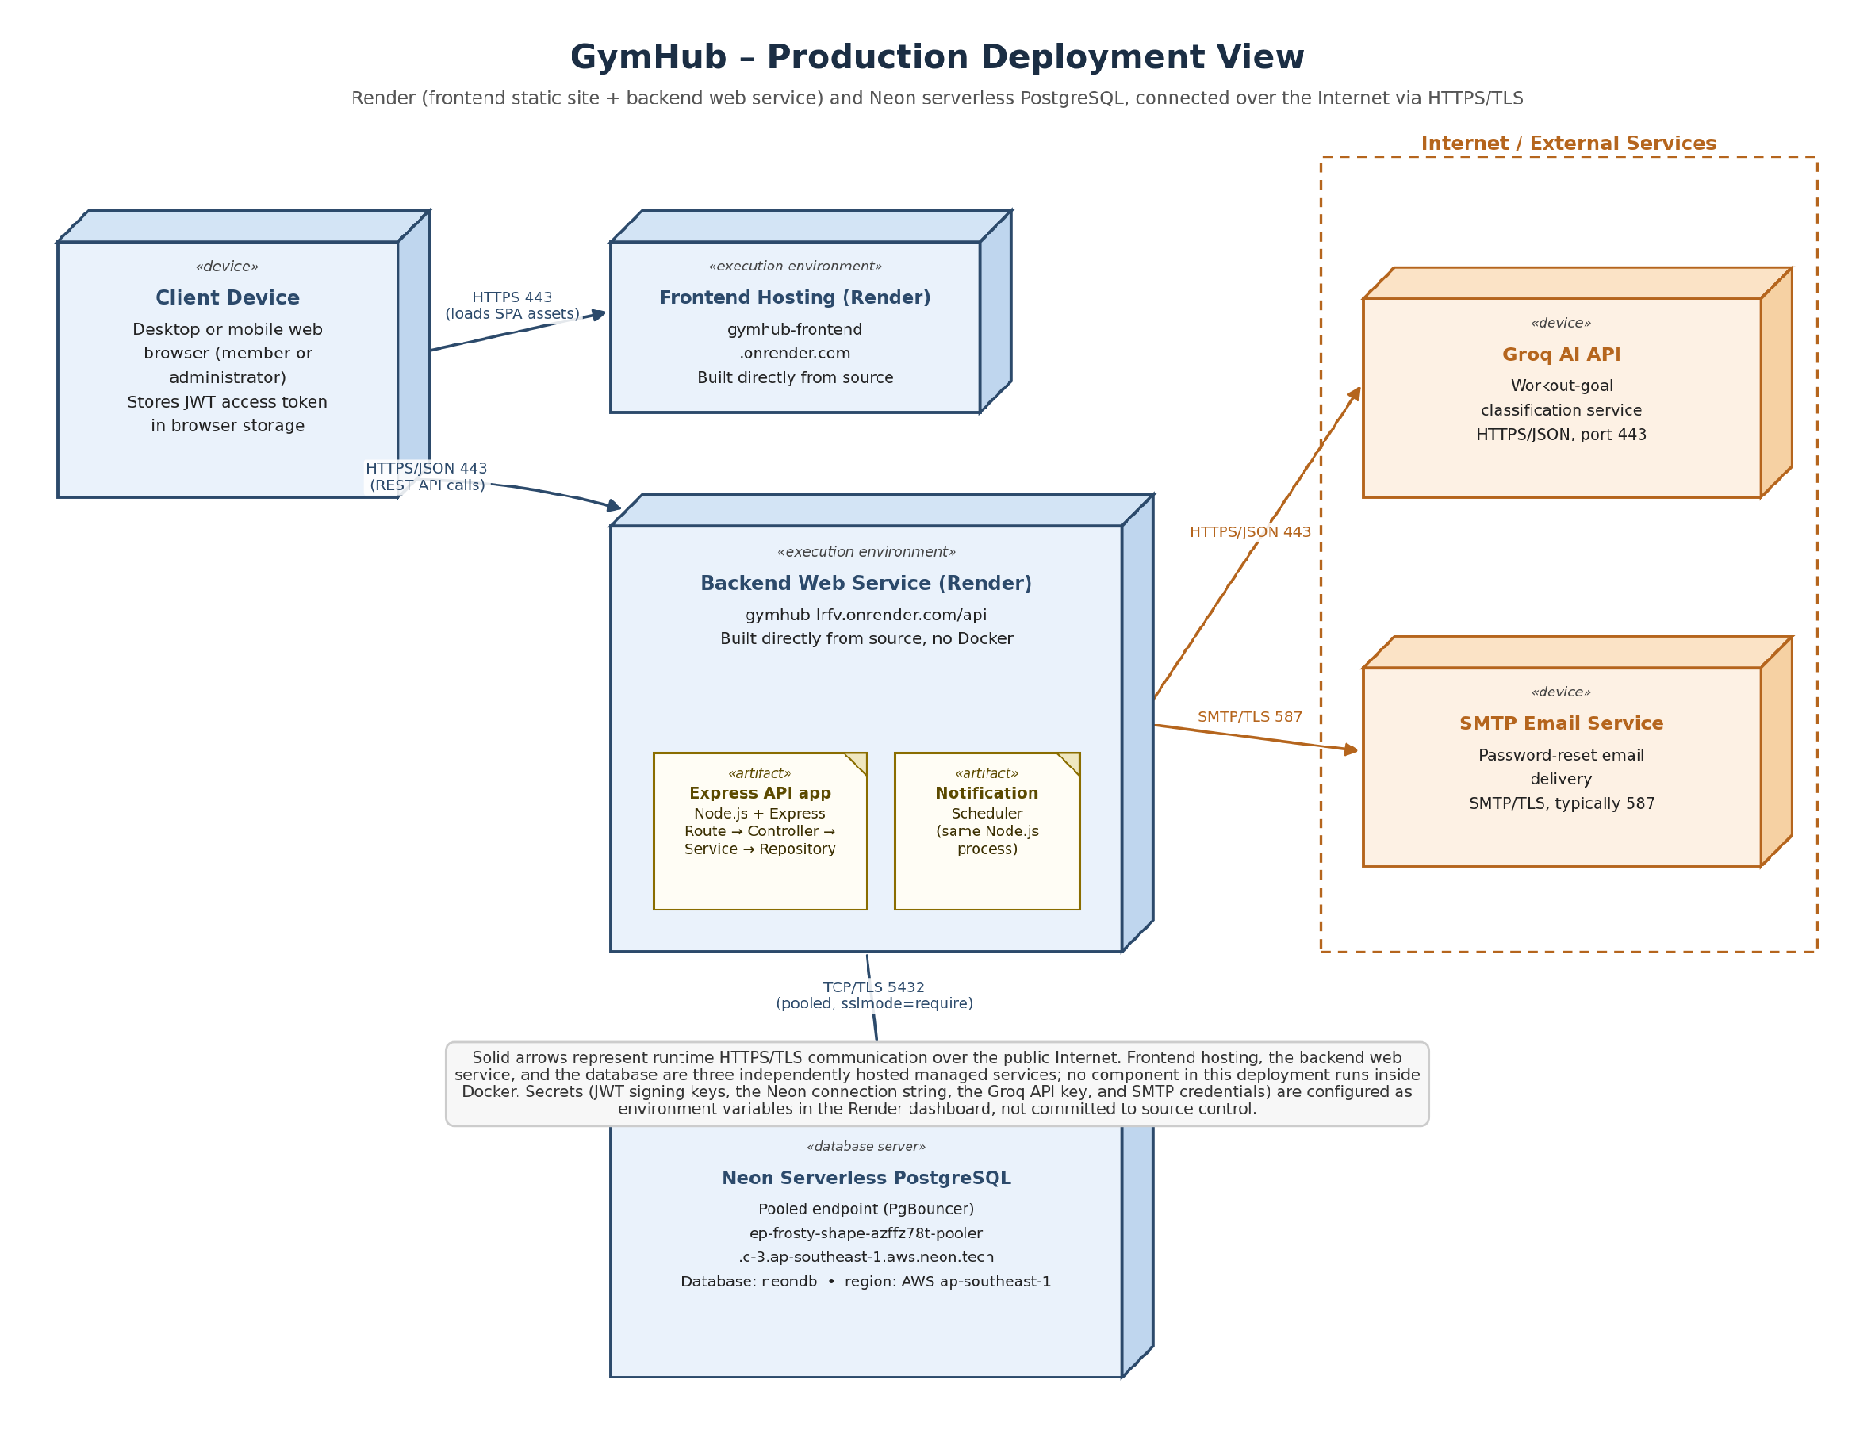

Deployment Nodes

Client Browser Node
The client browser is used by members and administrators anywhere with Internet access. It loads the GymHub web interface from the Render-hosted frontend, stores the authenticated session token in browser storage, and sends REST requests to the backend API over HTTPS. The browser, frontend, backend, and database are four physically separate nodes connected through the public Internet.
Deployed responsibilities
- Renders the React user interface served by the Render static site.
- Sends JSON requests to https://gymhub-lrfv.onrender.com/api over HTTPS.
- Sends the Authorization: Bearer <access-token> header for protected resources.
- Displays responsive member and administrator pages, server feedback, workout schedules, reports, and charts.

Frontend Development Server Node
The frontend is a React and TypeScript single-page application built with Vite and deployed to Render as a static site. Render builds the production bundle directly from the Git repository source (no Docker image is built) and serves it over HTTPS at https://gymhub-frontend.onrender.com. The frontend service layer uses the configured API base URL https://gymhub-lrfv.onrender.com/api.
Deployed responsibilities
- Hosts the production frontend build and serves it over HTTPS through Render's static-site hosting.
- Delivers JavaScript, CSS, and static assets to the browser using HTTPS.
- Does not access PostgreSQL directly; all business data is obtained through the backend REST API.

Backend Application Server Node
The backend is a Node.js process hosted as a separate Render web service, built and run directly from the Git repository source (no Docker image). It exposes the /api REST interface at https://gymhub-lrfv.onrender.com/api and contains the authentication, membership, workout, payment, occupancy, notification, fitness-record, streak, and administration modules.
Deployed responsibilities
- Processes HTTP requests and sends JSON responses.
- Applies CORS, request logging, rate limiting, input validation, authentication, role authorization, and error handling.
- Uses a pooled, TLS-encrypted connection to the Neon PostgreSQL database to read and update persistent data.
- Starts the notification scheduler in the same Node.js process when scheduling is enabled.
- Calls the Groq AI service when workout-goal classification is requested, with a local classifier fallback if the remote request fails.
- Sends password-reset email through SMTP only when the SMTP configuration is available; otherwise, the development fallback logs the reset link.

PostgreSQL Database Node
PostgreSQL is hosted on Neon, a managed serverless PostgreSQL provider, in the AWS ap-southeast-1 region. The backend connects to Neon's pooled endpoint (ep-frosty-shape-azffz78t-pooler.c-3.ap-southeast-1.aws.neon.tech, port 5432) over a TLS-encrypted connection (sslmode=require, channel_binding=require) using a single DATABASE_URL connection string supplied through a Render environment variable. The database is never exposed directly to the browser.
Deployed responsibilities
- Stores users, membership plans, memberships, payments, exercises, workout plans, fitness records, gym sessions, workout check-ins, workout streaks, announcements, notifications, and password-reset tokens.
- Enforces data integrity through keys, constraints, generated fields, triggers, indexes, and reporting views.
- Supports transaction boundaries for membership renewal, payment confirmation, and check-in/check-out operations.

External Service Nodes
The backend may communicate with the following external services over the Internet:
- Groq AI API: receives HTTPS/JSON requests for natural-language workout-goal classification. This integration requires GROQ_API_KEY; a local fallback is used if the service is unavailable.
- SMTP email server: receives SMTP or SMTP-over-TLS requests to send password-reset emails. This integration requires SMTP environment variables configured on Render and is optional; without them the backend falls back to logging the reset link instead of emailing it.

Communication Paths
Source node | Target node | Protocol and port | Purpose
Browser | Render frontend (static site) | HTTPS, port 443 (gymhub-frontend.onrender.com) | Loads the React web application and static assets.
Browser | Render backend (Express web service) | HTTPS/JSON, port 443 (gymhub-lrfv.onrender.com/api) | Sends REST requests for all system functions.
Express backend | PostgreSQL | TCP/TLS, port 5432 (Neon pooled endpoint, sslmode=require) | Executes parameterized queries, transactions, and reporting queries.
Express backend | Groq AI API | HTTPS/JSON, port 443 | Classifies a member's natural-language workout goal.
Express backend | SMTP service | SMTP or SMTP-over-TLS, commonly port 587 | Delivers password-reset emails when SMTP is configured.
Notification scheduler | Backend services and PostgreSQL | In-process calls and SQL | Runs configured reminder, membership-expiry, streak-risk, and cleanup jobs.

Runtime Configuration
In production, the backend reads its runtime configuration from environment variables configured in the Render service dashboard (apps/backend/.env is used only for local development). Sensitive values must not be hard-coded in source code or committed to a public repository. The important configuration groups are listed below.
Configuration group | Variables | Deployment purpose
Application runtime | NODE_ENV, PORT, LOG_LEVEL | Selects the environment, backend port, and logging behavior.
Frontend origin | FRONTEND_URL, APP_URL | Defines the frontend origin and password-reset link base URL.
Database connection | DATABASE_URL | Connects the Express backend to the Neon PostgreSQL pooled endpoint over TLS.
Authentication | JWT_ACCESS_SECRET, JWT_REFRESH_SECRET, JWT_ACCESS_EXPIRES_IN, JWT_REFRESH_EXPIRES_IN | Signs and validates access and refresh tokens.
Notification scheduler | ENABLE_NOTIFICATION_SCHEDULER, job interval variables, MEMBERSHIP_WARNING_DAYS | Enables and configures background notification jobs.
Occupancy | GYM_CAPACITY, GYM_OCCUPANCY_ALERT_THRESHOLD | Sets capacity and threshold values for occupancy alerts.
AI integration | GROQ_API_KEY | Authorizes calls to the goal-classification service.
Email integration | SMTP_HOST, SMTP_PORT, SMTP_SECURE, SMTP_USER, SMTP_PASS, EMAIL_FROM | Enables SMTP password-reset email delivery.

The current configuration is aligned for the production deployment:
- Frontend origin: https://gymhub-frontend.onrender.com
- Backend API: https://gymhub-lrfv.onrender.com/api
- PostgreSQL host and port: Neon pooled endpoint, port 5432 (TLS required)
- Database name: neondb
- Notification scheduler: enabled

Security and Operational Considerations
- The database is reachable only by the backend process; clients never connect directly to PostgreSQL.
- JWT signing secrets, database passwords, Groq API keys, and SMTP credentials are runtime secrets and must be kept outside source control.
- The backend's CORS policy is restricted to the production frontend origin https://gymhub-frontend.onrender.com; a leftover localhost origin or a wildcard origin would be a security gap in production.
- HTTPS termination and certificate management are handled automatically by Render for the frontend and backend services, and by Neon for database connections, which enforce TLS through sslmode=require and channel_binding=require. The project does not build or run Docker images in this deployment; Render builds and deploys both the frontend and backend directly from the Git repository source. Custom domain names beyond the default onrender.com subdomains, automated backups, and monitoring/alerting are not yet configured.
- The backend connection pool is configured with a maximum of 10 PostgreSQL connections and a 30-second idle timeout, on top of the connection pooling already provided by Neon's PgBouncer endpoint.

Implementation View
The GymHub source code is organized as an npm-workspace repository with separate frontend and backend applications. The implementation follows a feature-based structure: each backend business component is located in its own module folder and keeps its routes, controller, service, repository, validation rules, and tests together. This structure implements the logical components described in Section 4 while keeping feature ownership clear.

The folder trees below show the current source-code organization. Generated dependencies such as node_modules/, Git metadata, and build output are omitted for clarity.

Repository Structure
Project_SE/
|
|-- apps/
| |-- frontend/ # React/Vite presentation application
| | |-- src/
| | |-- index.html
| | |-- main.tsx
| | |-- package.json
| | |-- tsconfig.json
| | |-- vite.config.ts
| | `-- Dockerfile
|
| `-- backend/ # Node.js/Express REST API application
| |-- bootstrap/
| |-- config/
| |-- middlewares/
| |-- modules/
| |-- tests/
| |-- utils/
| |-- .env # Local runtime configuration; not source code
| |-- app.js # Express application composition
| |-- Dockerfile
| |-- server.js # HTTP server and scheduler startup
| `-- package.json
|
|-- data/
| `-- seeds/ # membersip.seed.json, schedules.seed.json, users.seed.json, workouts.seed.json
|
|-- docker/
| `-- postgres/
| `-- init.sql
|
|-- docs/ # SAD content, architecture diagrams, and file structure.md
|-- docker-compose.yml # Orchestrates the frontend, backend, and PostgreSQL containers
|-- package.json # npm workspaces and root scripts
|-- package-lock.json
|-- tsconfig.json
`-- README.md
The root package.json defines workspaces for the frontend and backend applications. The frontend is responsible for presentation and browser interaction; the backend owns all business rules, persistence access, external integrations, and scheduled tasks.

Frontend Implementation Structure
apps/frontend/
|
|-- src/
| |-- components/
| | |-- main-menu/ # MainMenu* components
| | |-- progress/ # Progress*/Fitness* components
| | |-- AdminTopBar.tsx
| | |-- Button.tsx
| | |-- Card.tsx
| | |-- Input.tsx
| | |-- Modal.tsx
| | |-- Navbar.tsx
| | |-- NotificationBell.tsx
| | |-- SegmentedTabs.tsx
| | |-- Sidebar.tsx
| | |-- Skeleton.tsx
| | |-- Toast.tsx
| | |-- TopBarActions.tsx
| | `-- UnifiedTopBar.tsx
| |
| |-- features/
| | |-- auth/ # LoginForm.tsx, RegisterForm.tsx
| | `-- membership/ # Membership* components, constants, types, utils
| |
| |-- layouts/
| | |-- AdminPageLayout.tsx
| | |-- AppShell.tsx
| | |-- AuthLayout.tsx
| | `-- DashboardLayout.tsx
| |
| |-- pages/
| | |-- AccountPage.tsx
| | |-- AdminAnnouncementsPage.tsx
| | |-- AdminOccupancyPage.tsx
| | |-- AdminPaymentsPage.tsx
| | |-- AdminReportsPage.tsx
| | |-- AdminUsersPage.tsx
| | |-- LoginPage.tsx
| | |-- MainMenuPage.tsx
| | |-- MembershipPage.tsx
| | |-- ProgressPage.tsx
| | |-- RegisterPage.tsx
| | |-- SchedulePage.tsx
| | `-- WorkoutPage.tsx
| |
| |-- services/ # one API client module per backend domain
| | |-- adminAnalyticsService.ts
| | |-- adminUserService.ts
| | |-- announcementService.ts
| | |-- apiClient.ts
| | |-- authService.ts
| | |-- fitnessRecordsService.ts
| | |-- membershipService.ts
| | |-- occupancyService.ts
| | |-- paymentService.ts
| | |-- progressService.ts
| | |-- scheduleService.ts
| | |-- userService.ts
| | `-- workoutService.ts
| |
| `-- vite-env.d.ts
|
|-- index.html
|-- main.tsx
|-- package.json
|-- tsconfig.json
|-- vite.config.ts
`-- Dockerfile
Frontend Responsibilities
- main.tsx configures the React entry point and client-side routing using React Router (react-router-dom), including route protection and redirects.
- pages/ contains route-level screens for both members (account, membership, workout, schedule, progress, main-menu) and administrators (users, payments, occupancy, announcements, reports).
- layouts/ provides reusable page shells: AppShell, AuthLayout, and DashboardLayout for authenticated/unauthenticated screens, plus a dedicated AdminPageLayout for administrator screens.
- components/ provides reusable presentation controls (buttons, cards, inputs, modals, navigation, notifications, tabs; icons via lucide-react) plus the main-menu and progress component groups.
- features/ groups feature-specific UI: auth/ (login and register forms) and membership/ (membership-specific components, constants, types, and utilities).
- services/ contains one API-facing client module per backend domain (auth, users, memberships, workouts, schedule, progress/fitness records, occupancy, payments, announcements, and admin). apiClient.ts centralizes JSON request handling and automatic bearer-token attachment.
The frontend now provides route-level screens for nearly all logical features in Section 4: authentication, membership, workout planning, schedule, fitness progress, gym occupancy (admin), payments, announcements (admin), and administration (users and reports). Workout-streak and notification information are currently surfaced through the MainMenuWeeklyGoal card and the NotificationBell component rather than as separate dedicated pages.

Backend Implementation Structure
apps/backend/
|
|-- bootstrap/
| `-- appInit.js
|
|-- config/
| |-- constants.js
| |-- db.js
| `-- env.js
|
|-- middlewares/
| |-- Auth.middleware.js
| |-- ErrorHandler.middleware.js
| |-- Membership.middleware.js
| |-- NotFound.middleware.js
| |-- rateLimiter.middleware.js
| |-- RequestLogger.middleware.js
| |-- Role.middleware.js
| `-- Validate.middleware.js
|
|-- modules/
| |-- admin/
| | |-- __test__/admin.test.js
| | |-- admin.controller.js
| | |-- admin.repository.js
| | |-- admin.routes.js
| | |-- admin.service.js
| | `-- admin.validation.js
| |
| |-- announcements/
| | |-- __test__/announcements.test.js
| | |-- announcements.controller.js
| | |-- announcements.repository.js
| | |-- announcements.routes.js
| | |-- announcements.service.js
| | `-- announcements.validation.js
| |
| |-- auth/
| | |-- __test__/auth.test.js
| | |-- __test__/rateLimiter.test.js
| | |-- auth.controller.js
| | |-- auth.repository.js
| | |-- auth.routes.js
| | |-- auth.service.js
| | `-- auth.validation.js
| |
| |-- users/
| | |-- __test__/users.test.js
| | |-- users.controller.js
| | |-- users.repository.js
| | |-- users.routes.js
| | |-- users.service.js
| | `-- users.validation.js
| |
| |-- memberships/
| | |-- __test__/memberships.test.js
| | |-- memberships.controller.js
| | |-- memberships.repository.js
| | |-- memberships.routes.js
| | |-- memberships.service.js
| | `-- memberships.validation.js
| |
| |-- workouts/
| | |-- __test__/workouts.test.js
| | |-- workouts.controller.js
| | |-- workouts.generator.js
| | |-- workouts.repository.js
| | |-- workouts.routes.js
| | |-- workouts.service.js
| | `-- workouts.validation.js
| |
| |-- fitness-records/
| | |-- __test__/fitness-records.test.js
| | |-- bmiCalculator.js
| | |-- bodyFatCalculator.js
| | |-- fitness-records.constants.js
| | |-- fitness-records.controller.js
| | |-- fitness-records.repository.js
| | |-- fitness-records.routes.js
| | |-- fitness-records.service.js
| | |-- fitness-records.validation.js
| | `-- progressAnalyzer.js
| |
| |-- occupancy/
| | |-- __test__/occupancy.test.js
| | |-- occupancy.constants.js
| | |-- occupancy.controller.js
| | |-- occupancy.repository.js
| | |-- occupancy.routes.js
| | |-- occupancy.scheduler.js
| | |-- occupancy.service.js
| | |-- occupancy.validation.js
| | `-- occupancyCalculator.js
| |
| |-- streaks/
| | |-- __test__/streaks.test.js
| | |-- streaks.constants.js
| | |-- streaks.controller.js
| | |-- streaks.repository.js
| | |-- streaks.routes.js
| | |-- streaks.service.js
| | `-- streaks.validation.js
| |
| |-- payments/
| | |-- __test__/payments.test.js
| | |-- payments.controller.js
| | |-- payments.repository.js
| | |-- payments.routes.js
| | |-- payments.service.js
| | `-- payments.validation.js
| |
| `-- notifications/
|-- __test__/notifications.test.js
|-- notification.scheduler.js
|-- notification.templates.js
|-- notifications.constants.js
|-- notifications.controller.js
|-- notifications.repository.js
|-- notifications.routes.js
|-- notifications.service.js
`-- notifications.validation.js
|
|-- tests/
| `-- setup.js
|
|-- utils/
| |-- Apierror.js
| |-- Apiresponse.js
| |-- Asynchandler.js
| |-- Date.js
| |-- Hash.js
| |-- Jwt.js
| |-- Logger.js
| |-- Mailer.js
| |-- Pagination.js
| |-- Qrcode.js
| `-- Transaction.js
|
|-- .env
|-- app.js
|-- Dockerfile
|-- server.js
`-- package.json

Mapping of Logical Components to Code Folders
Section 4 logical component | Main implementation location | Supporting implementation location
Member and Administrator Web Clients | apps/frontend/src/pages/, layouts/, components/ | main.tsx, services/
API and Cross-Cutting Services | apps/backend/app.js | config/, middlewares/, utils/
Authentication and Account Management | apps/backend/modules/auth/ | apps/backend/modules/users/, frontend features/auth/, authService.ts
Membership Management | apps/backend/modules/memberships/ | Membership.middleware.js, frontend MembershipPage.tsx, membershipService.ts
Payment Management | apps/backend/modules/payments/ | admin/ for payment monitoring and reports
Workout Planning | apps/backend/modules/workouts/ | frontend WorkoutPage.tsx, SchedulePage.tsx, workoutService.ts, scheduleService.ts
Fitness Progress | apps/backend/modules/fitness-records/ | bmiCalculator.js, bodyFatCalculator.js, progressAnalyzer.js
Occupancy and Gym Session | apps/backend/modules/occupancy/ | occupancyCalculator.js, occupancy.scheduler.js
Workout Streak | apps/backend/modules/streaks/ | streaks.constants.js
Notifications, Announcements, and Scheduler | apps/backend/modules/notifications/ and apps/backend/modules/announcements/ | notification.scheduler.js, notification.templates.js
Administration and Reporting | apps/backend/modules/admin/ | Domain repositories and PostgreSQL reporting views
Repository and Data Access | *.repository.js inside each feature module | apps/backend/config/db.js, utils/Transaction.js
PostgreSQL Database | Connection configuration in apps/backend/config/db.js | Physical schema is maintained separately in gym.sql
External AI and Email Integrations | workouts/workouts.generator.js and utils/Mailer.js | Environment variables in apps/backend/.env

Cross-Cutting Implementation Files
The following shared folders support every business component.
- config/ centralizes environment-variable loading, database-pool setup, and shared constants.
- middlewares/ implements authentication, role and membership guards, request validation (Validate.middleware.js applying each module's Joi schemas), rate limiting (express-rate-limit), HTTP request logging (morgan), not-found handling, and error handling.
- utils/ implements reusable response/error wrappers, asynchronous handler support, JWT and password helpers, QR-code generation, email support, pagination, date helpers, logging, and transaction helpers.
- tests/setup.js provides shared Jest test initialization; feature tests (Jest + Supertest) are co-located in each module's __test__/ folder.

Implementation Notes
- Backend modules own their data-access files. There is no single global repositories/ folder; this co-location keeps SQL related to a business feature close to its service and validation code.
- app.js registers all API routes and cross-cutting middleware, while server.js starts the HTTP listener and the notification scheduler.
- The physical PostgreSQL schema is supplied separately as gym.sql; it is not currently stored inside the project source tree. The backend references the database through environment-based configuration in config/db.js.
- Named JSON seed files exist in data/seeds/ (membersip.seed.json, schedules.seed.json, users.seed.json, workouts.seed.json) for local development and demo data; they are not required by the runtime implementation.
- The implementation structure supports independent testing and maintenance of the business modules described in Section 4.

