GYMHUB

Use-Case Specification

Version 2.0

Revision History
Date | Version | Description | Author
12/Jul/26 | 1.0 | Detail use-case from use-case diagram | Hoàng Trung Hiếu
23/Jun/26 | 2.0 | Fix syntaxes of use case model | Hoàng Trung Hiếu

Table of Contents
1. Use-case Model 4
2. Use-case Specifications 4
2.1 Use-case: Add a product to cart 4
2.2 Use-case: Create a new account 5

Use-case Model

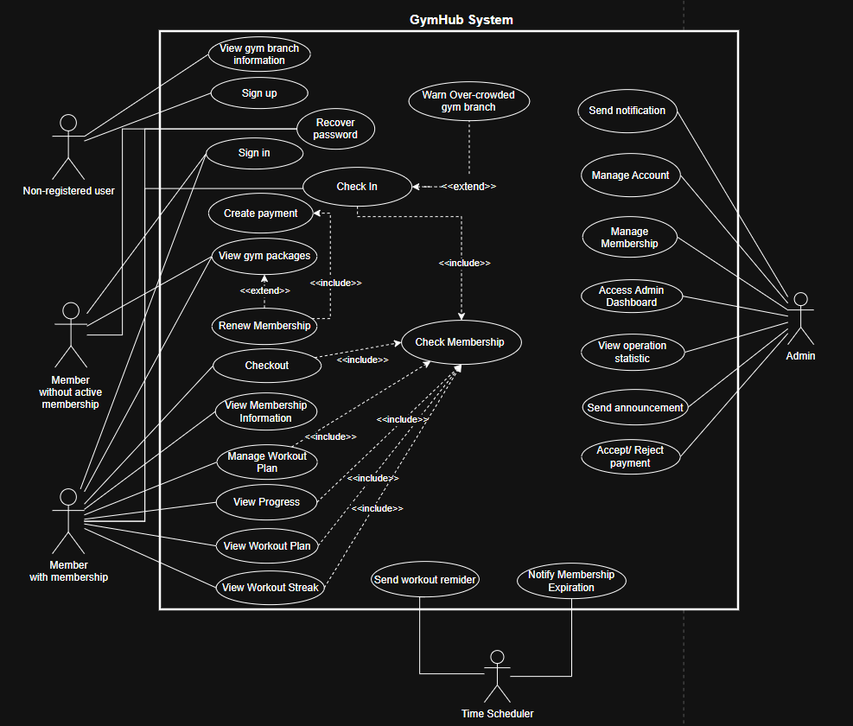

Use-case Specifications

Use-case: Sign up
Use case Name | Sign Up
Brief description | Allows a new user to create a GymHub account.
Actors | Member
Basic Flow | - User navigates to the Sign Up page.  - User enters full name, email, password.  - User confirms the password.  - User clicks the "Sign Up" button.  - System validates all input fields.  - System creates a new member account.  - System redirects the user to the login page with a success message.
Alternative Flows | Alternative flow 1: Email already registered  - From #5 of the basic flow, system detects the email is already in use.  - System displays an error message: "This email is already registered."  - User corrects the email and re-submits.  - Continue at #5  Alternative flow 2: Shopping cart has already had the product  - From #5, system detects the passwords do not match.  - System highlights the password fields and shows an error message.  - User re-enters matching passwords and re-submits.  - Continue at #5  Alternative flow 3: Invalid input format  - From #5, system detects invalid email format/ weak password/ missing required fields.  - System highlights invalid fields with descriptive error messages.  - User corrects the fields and re-submits.  - Continue at #5 of the basic flow.
Pre-conditions | User does not have an existing GymHub account.
Post-conditions | A new member account is created and stored in the system.

Use-case: Sign in
Use case Name | Sign In
Brief description | Allows a registered user to authenticate and access the system.
Actors | Member, Admin
Basic Flow | - User navigates to the Sign In page.  - User enters registered email and password.  - User clicks the "Sign In" button.  - System validates credentials against the database.  - System generates an access token and a refresh token.  - System redirects the user to the appropriate dashboard based on their role.
Alternative Flows | Alternative flow 1: Incorrect credentials  - From #4, system finds email or password does not match.  - System displays: "Invalid email or password."  - User re-enters credentials and tries again.  - Continue at #4 of the basic flow.  Alternative flow 2: Account does not exist  - From #4, system finds no account with the given email.  - System displays the same generic message to prevent user enumeration.  - User may choose to Sign Up instead.
Pre-conditions | User has a registered account in the system.
Post-conditions | User is authenticated and receives a valid session token. User is redirected to their dashboard.

Use-case: Recover Password

Use case Name | Recover Password
Brief description | Allows a user to reset their password when forgotten.
Actors | Member
Basic Flow | - User clicks "Forgot Password" on the Sign In page.  - User enters their registered email address.  - User clicks "Send Reset Link".  - System verifies the email exists in the database.  - System generates a secure one-time reset token and stores its hash.  - System sends a password reset link to the email.  - User opens the link and enters a new password.  - User confirms the new password.  - System validates the token (not expired, not already used).  - System hashes the new password and updates the record.  - System marks the token as used.  - System displays a success message and redirects to Sign In.
Alternative Flows | Alternative flow 1: Email is not registered  - From #4, system finds no account with that email.  - System displays the same generic message to prevent email enumeration.  - No email is sent. Use case ends.  Alternative flow 2: Account does not exist  - From #9, system finds the token has passed its 30-minute expiry.  - System displays: "Reset link has expired. Please request a new one."  - User returns to #1 to request a new link.  Alternative flow 3: Token already used  - From #9, system finds the token has already been used.  - System displays: "This reset link has already been used."  - User must request a new reset link.
Pre-conditions | User has a registered account and access to their email.
Post-conditions | User's password is updated. The reset token is invalidated. User can sign in with the new password.

Use-case: View Membership Information
Use case Name | View Membership Information
Brief description | Allows a member to view their current active membership details including plan name, start/end dates, days remaining, and expiry status.
Actors | Member
Basic Flow | 1. Member navigates to the "Membership" section.  2. System retrieves the member's active membership from the database.  3. System calculates remaining days and determines if the membership is expiring soon (within 7 days).  4. System displays membership details: plan name, price, start date, end date, status, days remaining, and expiry warning if applicable.
Alternative Flows | Alternative flow 1: No active membership  - From #2, system finds no active membership for the member.  - System displays a message: "You do not have an active membership. Please purchase or renew one."  - System shows a button to view available plans.
Pre-conditions | Member is authenticated.
Post-conditions | Member views their current membership details.

Use-case: Renew Membership
Use case Name | Renew Membership
Brief description | Allows a member to renew or extend their gym membership by selecting an available gym package plan.
Actors | Member
Basic Flow | 1. Member navigates to the "Renew Membership" section.  2. System displays all available active membership plans with name, price, and duration.  3. Member selects a desired plan.  4. Member clicks "Renew".  5. System checks if the member already has an active membership.  6. If active membership exists, system sets the new membership start date to the current membership's end date (stacking).  7. If no active membership, start date is today.  8. System creates a new membership record with status "active".  9. System confirms the renewal and displays updated membership details.
Alternative Flows | Alternative flow 1: Selected plan is inactive  1. From #3, the member selects a plan that has been deactivated.  2. System returns an error: "This membership plan is no longer available."  3. Use case returns to #2.
Pre-conditions | Member is authenticated. At least one active membership plan exists.
Post-conditions | A new membership record is created for the member. If the member had an existing active membership, the new one is stacked on top.

Use-case: Manage Membership (Admin)
Use case Name | Manage Membership (Admin)
Brief description | Allows an admin to create, update, suspend, or cancel a member's membership.
Actors | Admin
Basic Flow | 1. Admin navigates to the "Manage Memberships" section.  2. System displays a paginated list of all memberships with member names, plan names, statuses, and dates.  3. Admin selects a specific membership to manage.  4. Admin chooses an action: Create, Update Status (suspend/cancel/re-activate).  5. For Create: Admin selects a user, selects a plan, and optionally sets a start date. System creates the membership.  6. For Update Status: Admin selects the new status and confirms. System updates the membership and records which admin made the change.  7. System displays a success confirmation.
Alternative Flows | Alternative Flow 1: Re-activating an expired membership  1. From #6, admin attempts to set status to "active" for an expired membership.  2. System rejects the action: "Expired memberships cannot be re-activated. Please create a new one."  3. Admin must create a new membership instead.  Alternative Flow 2: Filter memberships  1. From #2, admin applies filters by status or expiry window.  2. System returns filtered results.  3. Admin continues at #3.
Pre-conditions | Admin is authenticated.
Post-conditions | The selected membership is created, updated, suspended, or cancelled. The action is recorded with the admin's ID.

Use-case: View Workout Plan
Use case Name | View Workout Plan
Brief description | Allows a member to renew or extend their gym membership by selecting an available plan.
Actors | Member
Basic Flow | 1. Member navigates to the "Workout Plan" section.  2. System checks the member has an active membership.  3. System retrieves the member's active workout plan from the database.  4. System fetches all 7 workout days with their exercises, sets, reps, and rest times.  5. System groups the data by day of week.  6. System displays the weekly schedule showing day labels (e.g. "Chest day"), exercises, muscle groups targeted, sets, reps, and rest periods.
Alternative Flows | Alternative flow 1: No active plan  1. From #3, system finds no active workout plan for the member.  2. System displays: "No active workout plan found. Generate or create one first."  3. System shows a button to generate or create a plan.
Pre-conditions | Member is authenticated and has an active membership.
Post-conditions | Member views their complete weekly workout schedule.

Use-case: Manage Workout Plan
Use case Name | Manage Workout Plan
Brief description | Allows a member to generate an AI-based workout plan, create a custom plan, customize days and exercises, activate saved plans, or delete plans.
Actors | Member
Basic Flow | 1. Member navigates to "Manage Workout Plan".  2. Member chooses an action: Generate, Create Custom, Edit, Activate, or Delete.  3. For Generate: Member describes their fitness goal in natural language (e.g. "I want to lose belly fat"). System calls Groq API to classify the goal. Member selects fitness level and days per week. System generates a 7-day plan with exercises selected based on the goal profile.  4. For Create Custom: Member provides a title and fitness level. System creates 7 blank rest days. Member fills each day manually.  5. For Edit: Member selects a specific day, changes its label or rest status, or replaces the exercises for that day. System marks the plan as customized.  6. For Activate: Member selects a previously saved plan. System deactivates the current active plan and activates the selected one.  7. For Delete: Member selects a non-active plan to delete. System removes it and all its days and exercises.  8. System confirms the action and displays the updated plan.
Alternative Flows | Alternative flow 1: Non-fitness input to goal resolver  1. From #3 (Generate), member types something unrelated to fitness (e.g. "How do I make pasta?").  2. Groq detects it is not fitness-related.  3. System returns HTTP 400 with a friendly redirect message. (Eg: "That's not a fitness goal! Tell me what you'd like to achieve at the gym.")  4. Member re-enters a fitness-related description.  Alternative flow 2: Not enough exercises in catalog  1. From #3 (Generate), system finds fewer than 5 exercises matching the fitness level.  2. System returns an error: "Not enough exercises in catalog. Please ask an admin to add more."  3. Use case ends.  Alternative flow 3: Deleting the active plan  1. From #7, member attempts to delete their currently active plan.  2. System rejects: "Cannot delete the active plan. Please activate another plan first."
Pre-conditions | Member is authenticated and has an active membership.
Post-conditions | Workout plan is generated, updated, or deleted. Only one plan is active at a time per member.

Use-case: View Progress
Use case Name | View Progress
Brief description | Allows a member to record fitness metrics, view their measurement history, and visualize progress through charts and statistics.
Actors | Member
Basic Flow | 1. Member navigates to "View Progress".  2. System displays a snapshot of the member's latest metrics: most recent weight, height, body fat %, and BMI.  3. Member can record a new measurement by entering one or more of: weight (kg), height (cm), body fat percentage, and an optional note.  4. System saves the record. BMI is auto-computed from weight and height by the database.  5. Member can view their history list, filtered by date range or metric type.  6. Member selects a metric (weight_kg, body_fat_pct, or BMI) to view as a chart.  7. System returns time-series data sorted oldest to newest, along with statistics: min, max, average, and total change.  8. System displays the chart, statistics and comments.
Alternative Flows | Alternative flow 1: No measurements recorded yet  1. From #2, system finds no records for the member.  2. System displays all snapshot values as null and an empty history.  3. Member is prompted to record their first measurement.
Pre-conditions | Member is authenticated and has an active membership.
Post-conditions | Fitness record is saved. BMI is computed and stored automatically. Member can view historical trends.

Use-case: Check In
Use case Name | Check In
Brief description | Allows a member to check into the gym by scanning their QR code at the entrance. Also triggers streak tracking for the day.
Actors | Member
Basic Flow | 1. Member presents their QR code (from the app) to the gym's QR scanner device.  2. Scanner reads the QR token and sends it to POST /api/occupancy/checkin (no JWT required).  3. System looks up the user by the QR token in the database.  4. System verifies the member has an active, non-expired membership.  5. System checks the member does not already have an open gym session (not already inside).  6. System creates a new gym_session row with checked_in_at = now().  7. System inserts a workout_checkins record for today (if not already present).  8. System updates the member's workout streak counter.  9. System calculate the number of active gym session at this gym branch and broadcast crowded warning if it exceeds gym branch’s capacity.  10. System returns a welcome message and the current gym occupancy count.  11. Display screen at entrance shows: "Welcome, [Name]!" and current gym count.
Alternative Flows | Alternative flow 1: QR token not recognized  1. From #3, system finds no user with the scanned token.  2. System returns 404.  3. Display shows: "QR code not recognized. Please contact the front desk."  Alternative flow 2: Member has no active membership  1. From #4, system finds no active membership.  2. System returns 403: "Member does not have an active membership."  3. Display shows: "Membership required. Please renew at the front desk."  Alternative flow 3: Member already checked in  1. From #5, system finds an existing open session.  2. System returns 409: "Member is already checked in. Please check out first."  Alternative flow 4: Second check-in same day (streak not double-counted)  1. From #8, system finds a workout_checkins record already exists for today.  2. System skips the streak update (ON CONFLICT DO NOTHING).
Pre-conditions | Member has a valid QR code displayed on their app. The QR scanner is connected to the system.
Post-conditions | A gym session is opened for the member. The gym occupancy count increments by 1. Streak is updated if this is the first check-in today.

Use-case: Checkout
Use case Name | Checkout
Brief description | Allows a member to check out of the gym by scanning their QR code at the exit.
Actors | Member
Basic Flow | 1. Member presents their QR code to the exit scanner.  2. Scanner sends the QR token to POST /api/occupancy/checkout.  3. System looks up the user by QR token.  4. System finds the member's open (unclosed) gym session.  5. System sets checked_out_at = now() on the session.  6. Database auto-computes duration_minutes from the time difference.  7. System returns a goodbye message with the session duration.
Alternative Flows | Alternative flow 1: Member not currently checked in  1. From #4, system finds no open session for this member.  2. System returns 409: "Member is not currently checked in."  3. Display shows: "No active check-in found. Please contact the front desk."
Pre-conditions | Member has previously checked in and has an open gym session.
Post-conditions | The gym session is closed with a checkout timestamp and computed duration. Gym occupancy count decrements by 1.

Use-case: View Workout Streak
Use case Name | View Workout Streak
Brief description | Allows a member to view their current workout streak, longest streak, and last active date.
Actors | Member
Basic Flow | 1. Member navigates to the "Workout Streak" section.  2. System retrieves the member's streak record from workout_streaks.  3. System displays: current streak (days), longest streak (days), and last active date.  4. System displays streak achievements if any milestones are reached (e.g. 7-day, 30-day streaks).
Alternative Flows | Alternative flow 1: No streak activity yet  1. From #2, member has never checked in.  2. System displays current streak = 0, longest streak = 0, last active date = null.  3. System shows an encouraging message to start their first workout.
Pre-conditions | Member is authenticated. A workout_streaks row exists for the member (created automatically on registration).
Post-conditions | Member views their streak statistics.

Use-case: Initial Payment
Use case Name | Initial Payment
Brief description | Allows a member to submit a payment request (banking transfer or cash) for a membership. The payment starts as pending until confirmed by an admin.
Actors | Member
Basic Flow | 1. Member navigates to "Payment".  2. System displays the member's memberships that require payment.  3. Member selects a membership and chooses a payment provider: "Banking" or "Cash".  4. For Banking: member optionally enters a bank transfer reference number.  5. Member clicks "Submit Payment Request".  6. System verifies the membership belongs to this member.  7. System checks there is no existing pending or completed payment for this membership.  8. System creates a payment record with status = "pending".  9. System displays: "Payment request submitted. An admin will verify shortly."
Alternative Flows | Alternative flow 1: Membership already paid  1. From #7, system finds a completed payment for this membership.  2. System returns 409: "This membership has already been paid for."  Alternative flow 2: Duplicate pending request  1. From #7, system finds an existing pending payment for this membership.  2. System returns 409: "A payment request is already pending admin confirmation."
Pre-conditions | Member is authenticated and has a membership that needs payment.
Post-conditions | A pending payment record is created. Admin is notified to verify and confirm or reject.

Use-case: Accept / Reject Payment
Use case Name | Accept / Reject Payment
Brief description | Allows an admin to confirm or reject a member's pending payment. Confirmation activates the membership.
Actors | Admin
Basic Flow | 1. Admin navigates to "Payment Management".  2. System displays all payment transactions. Admin filters by status = "pending".  3. Admin reviews a pending payment (member name, plan, amount, provider, transfer note).  4. Admin clicks "Confirm" or "Reject".  5. For Confirm: Admin optionally adds a note. System marks payment as "completed", sets paid_at = now(), and activates the associated membership.  6. For Reject: Admin provides a rejection reason. System marks payment as "failed". Membership remains unchanged. Member can resubmit.  7. System records the admin's ID and note/reason in the provider_tx_id field for audit trail.  8. System displays a success confirmation.
Alternative Flows | Alternative flow 1: Confirming a non-pending payment  1. From #5, admin tries to confirm an already-completed or failed payment.  2. System returns 400: "Only pending payments can be confirmed."  Alternative flow 2: Rejecting without a reason  1. From #4, admin clicks Reject but leaves the reason field empty.  2. System returns 400 validation error: "A rejection reason is required."  3. Admin enters a reason and resubmits.
Pre-conditions | Admin is authenticated. At least one payment with status "pending" exists.
Post-conditions | Payment is marked completed or failed. If confirmed, the membership is activated. Admin action is recorded in the audit trail.

Use-case: View List Account
Use case Name | View List Account
Brief description | Allows an admin to view and search all registered member accounts in the system.
Actors | Admin
Basic Flow | 1. Admin navigates to "User Management".  2. System displays a paginated list of all users with name, email, role, and registration date.  3. Admin can filter by role (member/admin) or search by name or email.  4. Admin selects a user to view full profile details.
Alternative Flows | Alternative flow 1: No users match filter  1. From #3, no users match the search or filter criteria.  2. System displays an empty list with a message: "No accounts found."
Pre-conditions | Admin is authenticated.
Post-conditions | Admin views the list of accounts. No data is modified.

Use-case: Manage Account
Use case Name | Manage Account
Brief description | Allows a member to update their profile information or change their password. Allows admin to delete a member account.
Actors | Member, Admin
Basic Flow | 1. User navigates to "Account Settings".  2. For Profile Update (Member): Member updates full name or phone number. System saves changes.  3. For Password Change (Member): Member enters current password, new password, and confirmation. System verifies the current password, checks the new one is different, and updates the hash.  4. For Account Deletion (Admin only): Admin selects a user and clicks "Delete Account". System permanently removes the user and all associated data via cascade.  5. System displays a success message.
Alternative Flows | Alternative flow 1: Wrong current password  1. From #3, system finds the current password does not match the stored hash.  2. System returns 400: "Current password is incorrect."  3. Member re-enters the correct current password.  Alternative flow 2: New password same as current  1. From #3, system finds the new password matches the current one.  2. System returns 400: "New password must be different from the current password."  Alternative flow 3: Admin tries to delete their own account  1. From #4, admin selects themselves for deletion.  2. System returns 400: "Admins cannot delete their own account."
Pre-conditions | User is authenticated.
Post-conditions | Profile is updated, password is changed, or account is deleted. All related records are removed on account deletion.

Use-case: Access Admin Dashboard
Use case Name | Access Admin Dashboard
Brief description | Allows an admin to access the central dashboard showing key operational statistics and navigation to all management features.
Actors | Admin
Basic Flow | 1. Admin signs in with an account of role "admin".  2. System redirects to the Admin Dashboard.  3. Dashboard displays: total active members, current gym occupancies, pending payments, recent revenue summary, and membership status breakdown.  4. Admin navigates to specific management sections from the dashboard.
Alternative Flows | Alternative flow 1: Member attempts to access admin dashboard  1. A member-role user navigates to an admin route.  2. System returns 403: "Forbidden."  3. User is redirected to the member dashboard.
Pre-conditions | User is authenticated with role = "admin".
Post-conditions | Admin views the dashboard with current system statistics.

Use-case: View Operation statistic
Use case Name | View Operation statistic
Brief description | Allows an admin to view detailed operational statistics including revenue reports, gym session history, and membership overviews.
Actors | Admin
Basic Flow | 1. Admin navigates to the "Statistics" section.  2. Admin selects a report type: Revenue Report, Membership Overview, or Session History with time span (from_date, to_date)  3. For Revenue Report: System queries completed payments grouped by day, returning transaction count and total revenue.  4. For Membership Overview: System returns a breakdown of memberships by status (active, expired, suspended, cancelled).  5. For Session History: Admin optionally filters by user, date range, or active-only sessions. System returns paginated gym session records.  6. System displays the selected report with relevant data.
Alternative Flows | Alternative flow 1: No data in selected range  1. From #3 or #5, system finds no records matching the selected date range.  2. System displays an empty result with: "No data found for this period."  Alternative flow 2: Invalid time span  - From #2, system detects invalid time span.  - System displays an empty result with: "Incorrect time span."
Pre-conditions | Admin is authenticated.
Post-conditions | Admin views the requested operational statistics. No data is modified.

Use-case: Send Announcement
Use case Name | Send Announcement
Brief description | Allows an admin to create and broadcast an announcement to all members. Each member receives a notification in their inbox.
Actors | Admin
Basic Flow | 1. Admin navigates to "Announcements".  2. Admin enters announcement title and body.  3. Admin choose some specific received members or “broadcast” mode.  4. Admin clicks "Publish".  5. System saves the announcement with published_at = now().  6. For broadcast mode: System fans out a notification row to every active member.  7. For sending to specific members: System filter and send notifications to received ones.  6. System confirms: "Successfully sent."
Alternative Flows | Alternative flow 1: No members to notify  1. From #6, system finds no member accounts in the database.  2. System saves the announcement but sends no notifications.  3. System displays: "Announcement saved but no members to notify."
Pre-conditions | Admin is authenticated.
Post-conditions | Announcement is saved. Members receive a notification linked to the announcement (announcement_id FK). Members can read it in their notification inbox.

Use-case: Send Workout Reminder
Use case Name | Send Workout Reminder
Brief description | System automatically sends workout reminder notifications to members who have not checked in today.
Actors | Time Scheduler
Basic Flow | 1. Time Scheduler triggers this job at a configured daily time (e.g. 00:00 AM).  2. System queries all members who have an active membership.  3. System checks which members have NOT yet created a workout_checkins record for today.  4. System creates a notification (type = "workout_reminder") for each qualifying member.  5. Notification body: "Don't forget your workout today! Keep your streak going."
Alternative Flows | Alternative flow 1: All members have already checked in  1. From #3, system finds all active members have already checked in today.  2. System sends no notifications. Job completes silently.
Pre-conditions | Time Scheduler job is configured and running. Members have active memberships.
Post-conditions | Workout reminder notifications are delivered to members who have not yet checked in today.

Use-case: Notify Membership Expiration
Use case Name | View Progress
Brief description | System automatically notifies members whose membership is expiring within 7 days.
Actors | Time scheduler
Basic Flow | 1. Time Scheduler triggers this job once daily.  2. System queries all active memberships with end_date between today and today + 7 days.  3. System creates a notification (type = "membership_expiry") for each qualifying member.  4. Notification body: "Your membership expires on [end_date]. Renew now to keep access."
Alternative Flows | Alternative flow 1: No memberships expiring soon  1. From #2, system finds no memberships in the 7-day window.  2. No notifications are sent. Job completes.
Pre-conditions | Time Scheduler is configured. Active memberships exist in the system.
Post-conditions | Members with memberships expiring within 7 days receive an expiry notification.

