Task 1

1) Log in to the system as root.



2) Use the passwd command to change the password. Examine the basic parameters of the command. What system file does it change *?  
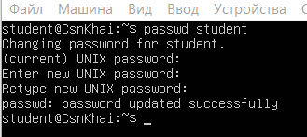  
etc/passwd and etc/shadow

3) Determine the users registered in the system, as well as what commands they execute. What additional information can be gleaned from the command execution?

We can use less /etc/passwd for list of users  
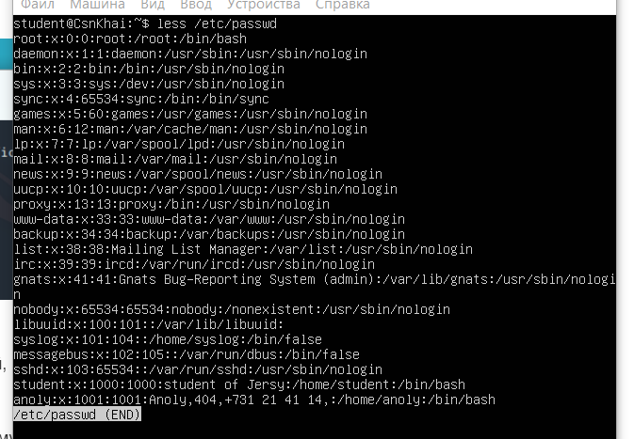

For check their bash history we can check .bash_history in their home catalog under root   
**sudo less /home/username/.bash_history**

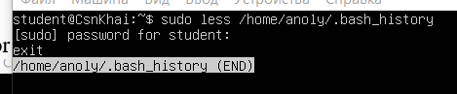

4)

5) Become familiar with the Linux help system and the man and info commands. Get help on the previously discussed commands, define and describe any two keys for these commands. Give examples

Using man for ls command

-a key – do not ignore entries starting with .

-r key – reverse order while sorting

Using man for passwd:

-d (--delete) – delete user’s password  
-l (--lock) - lock the password of the named account

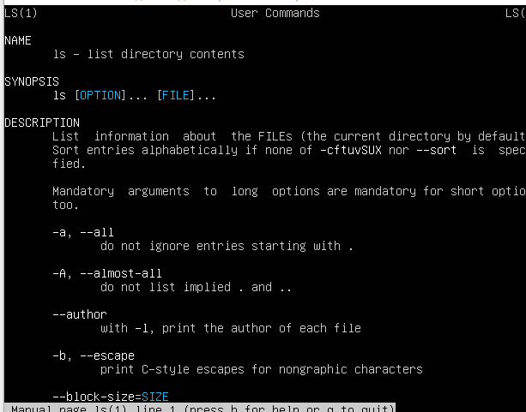

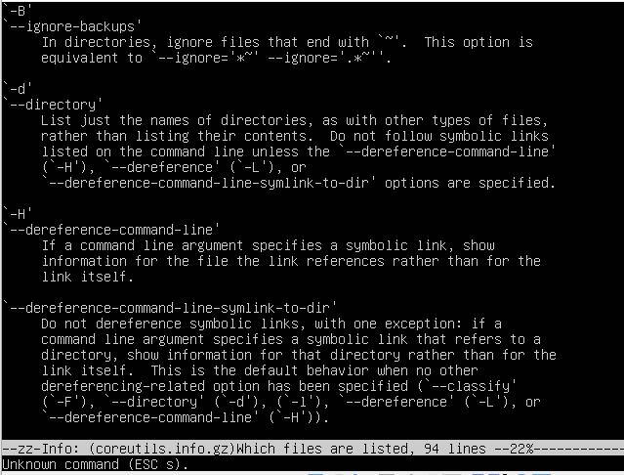

6) more .bash*

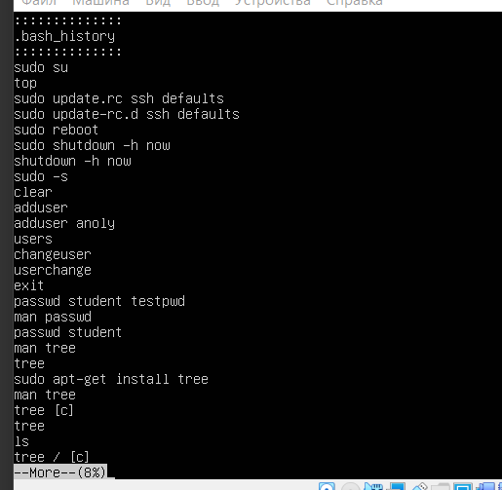

8) ls /home -Rla

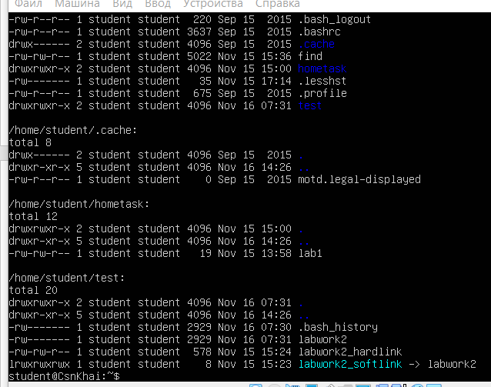

Part 2

1) Examine the tree command. Master the technique of applying a template, for example, display all files that contain a character c, or files that contain a specific sequence of characters. List subdirectories of the root directory up to and including the second nesting level

Display all files that contain a character c in root directory: tree –P ‘*c*’ /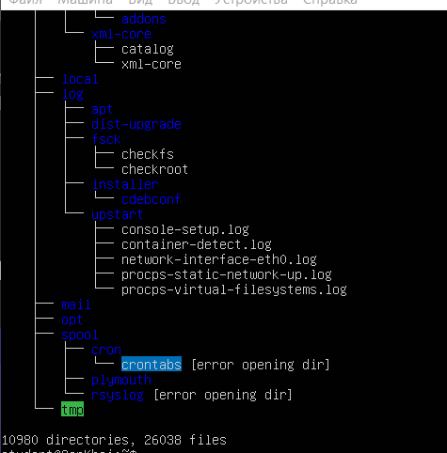  
List subdirectories of the root directory up to and including the second nesting level: tree -L 2 -d /

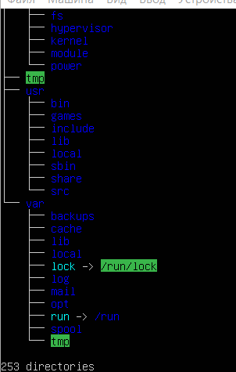

2) What command can be used to determine the type of file (for example, text or binary)? Give an example

For 1 file we can use command “file” and for several files we can use ls with -l switch. The first symbol will show us type of the file (-,d,l,c,s,p,b) 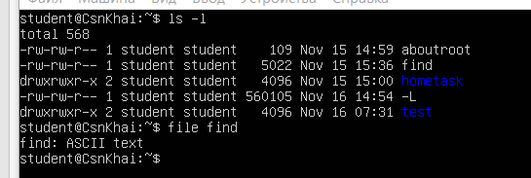

3) What command can be used to determine the type of file (for example, text or binary)? Give an example

using cd ~

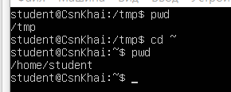

4) Become familiar with the various options for the ls command. Give examples of listing directories using different keys. Explain the information displayed on the terminal using the -l and -a switches.

flag -l displays details about files like: access rights, creator, owner. -a switch displays also hidden files

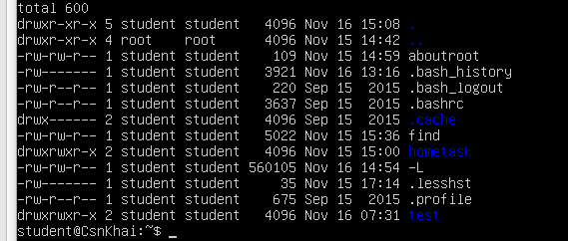

5) Perform the following sequence of operations:

- create a subdirectory in the home directory;

- in this subdirectory create a file containing information about directories located in the root directory (using I/O redirection operations);

- view the created file;

- copy the created file to your home directory using relative and absolute addressing.

- delete the previously created subdirectory with the file requesting removal;

- delete the file copied to the home directory.   
mkdir hometask

ls / > hometask/dirinfo

cat hometask/dirinfo  
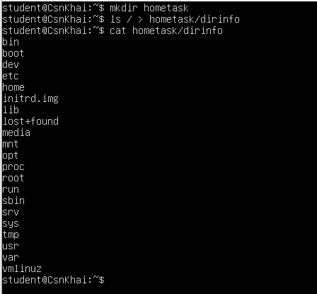

cp hometask/dirinfo ~

cp /home/student/hometask/dirinfo /home/student



rm -rfi hometask

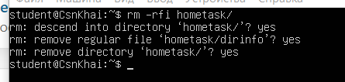

6) Perform the following sequence of operations:

- create a subdirectory test in the home directory;

- copy the .bash_history file to this directory while changing its name to labwork2;

- create a hard and soft link to the labwork2 file in the test subdirectory;

- how to define soft and hard link, what do these concepts;

- change the data by opening a symbolic link. What changes will happen and why

- rename the hard link file to hard_lnk_labwork2;

- rename the soft link file to symb_lnk_labwork2 file;

- then delete the labwork2. What changes have occurred and why

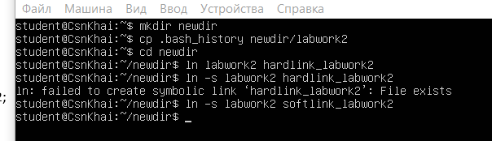

mkdir newdir

cp .bash_history newdir/labwork2

cd newdir

ln labowrk2 hardlink_labwork2

ln -s softlink_labwork2

nano softlink_labwork2

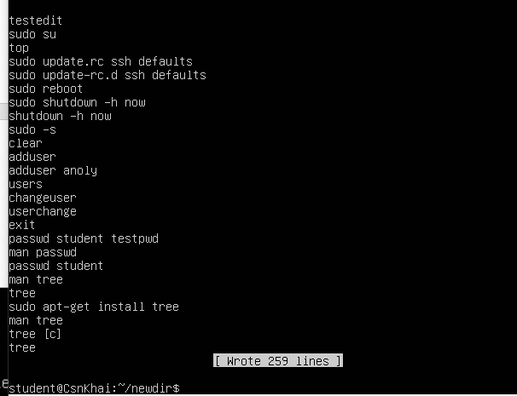

mv hardlink_labwork2 hard_lnk_labwork2

mv softlink_labwork2 symb_lnk_labwork2

rm labwork2

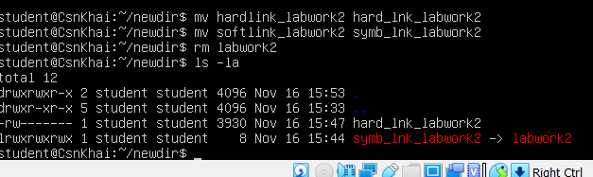

7) Using the locate utility, find all files that contain the squid and traceroute sequence.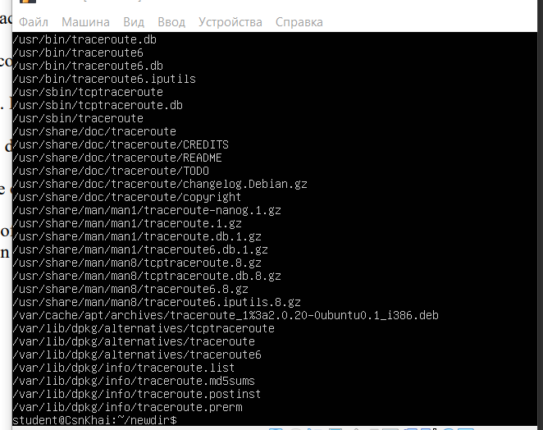

8) Determine which partitions are mounted in the system, as well as the types of these partitions

mount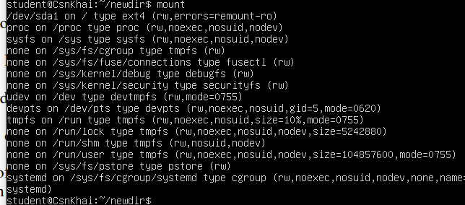

9) Count the number of lines containing a given sequence of characters in a given file.

grep “cp” newdir/hard_lnk_labwork2 -c

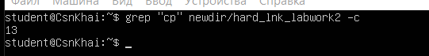

10) Using the find command, find all files in the /etc directory containing the host character sequence.

Find host /etc -type f

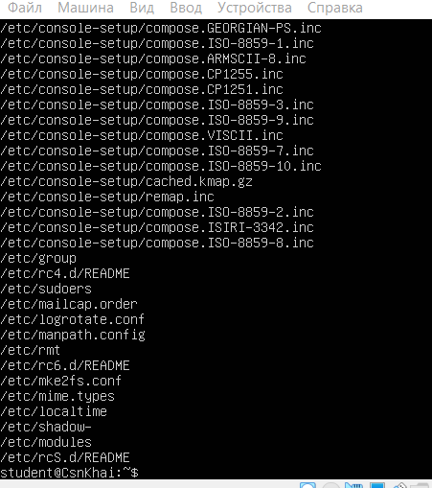

11) List all objects in /etc that contain the ss character sequence. How can I duplicate a similar command using a bunch of grep?

using find: find /etc -exec grep -rlw “ss” {} \;

Using grep: grep -rl “ss” /etc

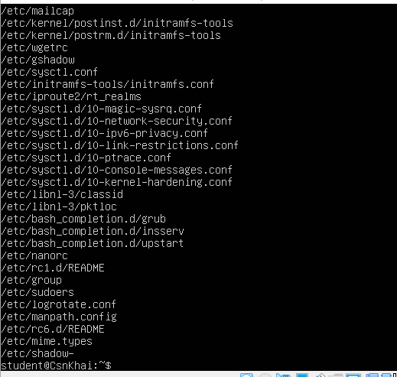

12) Organize a screen-by-screen print of the contents of the /etc directory. Hint: You must use stream redirection operations

ls /etc -la | less

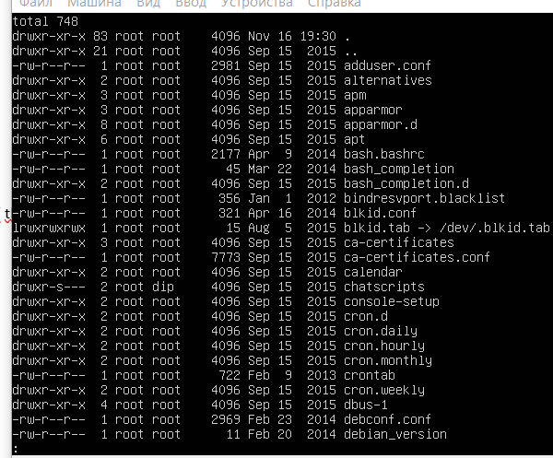

13) What are the types of devices and how to determine the type of device? Give examples

We can determine which devices are in the system using command mount. First column – type of device:

Example: /dev/sda – ssd drive; dev/fd – floppy disk, dev/had – ide hard disk

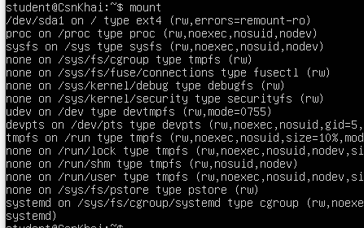

14) How to determine the type of file in the system, what types of files are there?

To determine the type of file we can use command “file”



Or we can use ls -l, first character in the first column will be type of the file

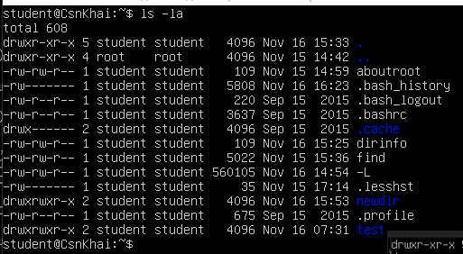

File can be: text,directory, block special, symbolled link, hard link, named pipe, character device file, regular file, socket

15) List the first 5 directory files that were recently accessed in the /etc directory

ls -lt /etc | tail -5

