Kruskal_analysis services questions

Ian Philips

2023-09-20

# parking / storage “secure e-bike parking in towns and villages in the Lake District”

## NARRATIVE FOR PAPER

The survey asked questions about how likely respondents would be to use particular facilities and services. There was strong support in both waves for secure e-bike storage (Figure 11). There was a high net likelihood of using secure storage and parking amongst the e-bike using segments (Figure 11 & Figure PARK). There were no significant differences within segments between 2020 and 2021 (cross section or panel). In the 2020 cross sectional data Male hirers and male resident e-bike owners were significantly less likely to use parking and storage facilities than female resident owners. There were no statistically significant differences in the panel data.

## Cross Section analysis

| segment | quite unlikely | quite likely | very likely | very unlikely | neutral | SUMCOL | net percent |
| --- | --- | --- | --- | --- | --- | --- | --- |
| Female Hirer 20 | 7 | 57 | 36 | 0 | 0 | 14 | 86 |
| Female Hirer 21 | 0 | 50 | 31 | 15 | 4 | 26 | 66 |
| Female Resident ebike owner 20 | 6 | 25 | 65 | 2 | 2 | 52 | 82 |
| Female Resident ebike owner 21 | 3 | 41 | 38 | 6 | 12 | 34 | 70 |
| Female Visitor ebike owner 20 | 0 | 24 | 61 | 8 | 8 | 38 | 77 |
| Female Visitor ebike owner 21 | 2 | 33 | 49 | 4 | 11 | 45 | 76 |
| Male Hirer 20 | 0 | 44 | 11 | 0 | 44 | 9 | 55 |
| Male Hirer 21 | 11 | 42 | 37 | 5 | 5 | 19 | 63 |
| Male Resident ebike owner 20 | 8 | 28 | 42 | 17 | 6 | 36 | 45 |
| Male Resident ebike owner 21 | 5 | 24 | 38 | 10 | 24 | 21 | 47 |
| Male Visitor ebike owner 20 | 2 | 31 | 60 | 2 | 4 | 48 | 87 |
| Male Visitor ebike owner 21 | 0 | 35 | 55 | 6 | 4 | 51 | 84 |

## run analysis on 2020 and 2021 cross section data

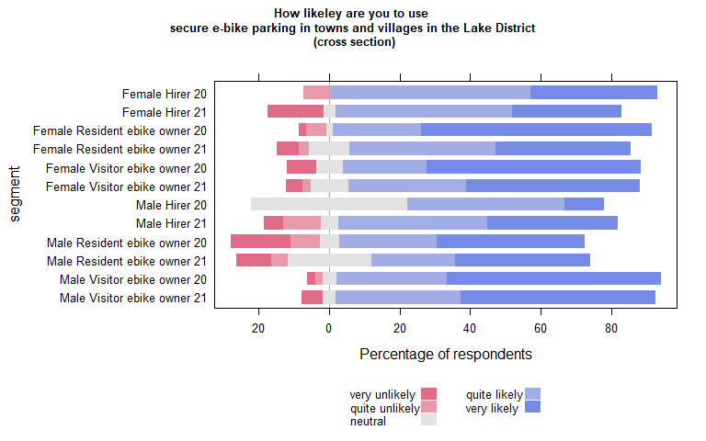

| Comparison | P.adj |
| --- | --- |

### Compare each segment in 2020 with the same segment in 2021

| segment2020 | segment2021 | pvalue |
| --- | --- | --- |

## Run the plot on B(2020) and C(2021) separately to carry out within year comparisons

## B (2020)

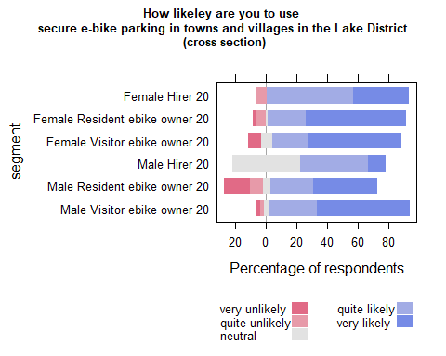

| Comparison | P.adj |
| --- | --- |
| Female Resident ebike owner 20 - Male Hirer 20 | 0.035 |
| Female Visitor ebike owner 20 - Male Hirer 20 | 0.034 |
| Female Resident ebike owner 20 - Male Resident ebike owner 20 | 0.033 |
| Male Hirer 20 - Male Visitor ebike owner 20 | 0.033 |

## C (2021)

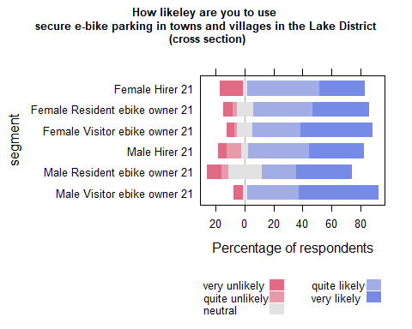

| Comparison | P.adj |
| --- | --- |

## Waves analysis

## run analysis on 2020 and 2021 PANEL data

| segment | quite likely | very likely | neutral | very unlikely | quite unlikely | SUMCOL | net percent |
| --- | --- | --- | --- | --- | --- | --- | --- |
| Female Hirer 20 | 67 | 33 | 0 | 0 | 0 | 3 | 100 |
| Female Hirer 21 | 60 | 20 | 20 | 0 | 0 | 5 | 80 |
| Female Resident ebike owner 20 | 38 | 44 | 0 | 6 | 12 | 16 | 64 |
| Female Resident ebike owner 21 | 22 | 56 | 11 | 6 | 6 | 18 | 66 |
| Female Visitor ebike owner 20 | 29 | 57 | 0 | 14 | 0 | 7 | 72 |
| Female Visitor ebike owner 21 | 40 | 40 | 0 | 20 | 0 | 5 | 60 |
| Male Hirer 20 | 50 | 0 | 50 | 0 | 0 | 2 | 50 |
| Male Hirer 21 | 50 | 17 | 0 | 17 | 17 | 6 | 33 |
| Male Resident ebike owner 20 | 0 | 62 | 15 | 15 | 8 | 13 | 39 |
| Male Resident ebike owner 21 | 27 | 33 | 20 | 13 | 7 | 15 | 40 |
| Male Visitor ebike owner 20 | 26 | 74 | 0 | 0 | 0 | 19 | 100 |
| Male Visitor ebike owner 21 | 30 | 65 | 0 | 5 | 0 | 20 | 90 |

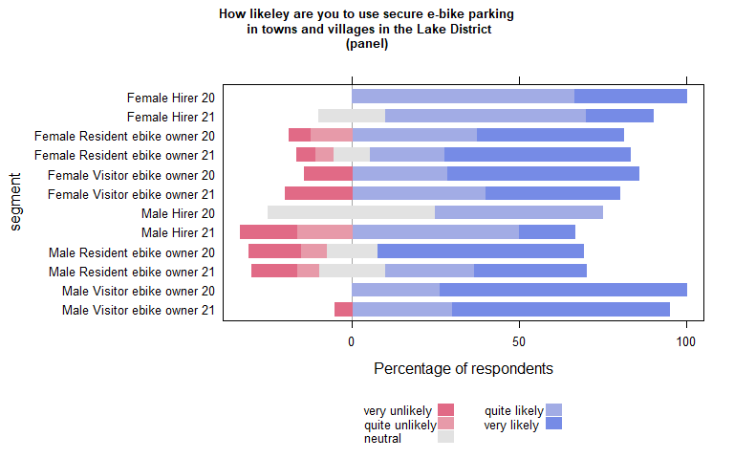

| Comparison | P.adj |
| --- | --- |

| segment2020 | segment2021 | pvalue |
| --- | --- | --- |

## wilcoxon paired test on panel data (if table empty non significant)

| estimate | statistic | p.value | conf.low | conf.high | method | alternative | segment |
| --- | --- | --- | --- | --- | --- | --- | --- |
| 1.000065 | 10 | 0.04448651 | 1.499993 | Inf | Wilcoxon signed rank test with continuity correction | greater | male Resident non ebike 21 |

## Run within year comparisons on the panel data

## B (2020) PANEL

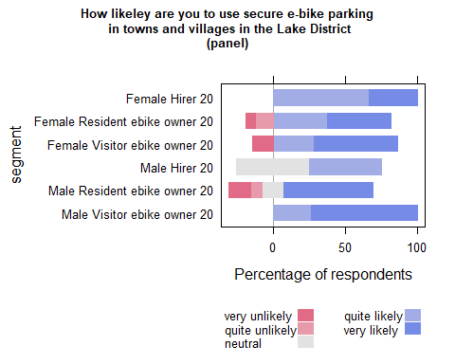

| Comparison | P.adj |
| --- | --- |

## C (2021) PANEL

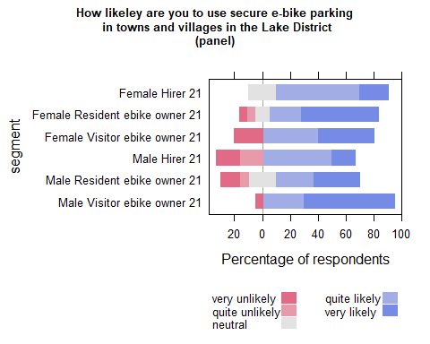

| Comparison | P.adj |
| --- | --- |

# Bike sharing “a scheme where you could pick up an e-bike in one place and drop it off in another (like a city bike share scheme)”

## NARRATIVE FOR PAPER

Attitudes towards using a district-wide e-bike sharing scheme (Figure 12). Support for a shared e-bike hire scheme is highest for hirers in 2020 but considerably lower in 2021, but it is not a statistically significant difference. Visitors who do not own e-bikes have a net positive view towards using an e-bike share scheme. E-bike owners have a low net likelihood of using shared e-bikes. Male e-bike owners are statistically significantly less likely to use a shared e-bike scheme. No segments were statistically significantly different between the two years in either the cross section or panel data.

## Cross Section analysis

| segment | quite unlikely | quite likely | very likely | very unlikely | neutral | SUMCOL | net percent |
| --- | --- | --- | --- | --- | --- | --- | --- |
| Female Hirer 20 | 7 | 71 | 21 | 0 | 0 | 14 | 85 |
| Female Hirer 21 | 12 | 38 | 8 | 8 | 35 | 26 | 26 |
| Female Resident ebike owner 20 | 8 | 23 | 25 | 27 | 17 | 52 | 13 |
| Female Resident ebike owner 21 | 21 | 26 | 6 | 35 | 12 | 34 | -24 |
| Female Resident non ebike 20 | 17 | 44 | 17 | 6 | 17 | 18 | 38 |
| Female Resident non ebike 21 | 0 | 23 | 23 | 8 | 46 | 13 | 38 |
| Female Visitor ebike owner 20 | 3 | 26 | 11 | 24 | 37 | 38 | 10 |
| Female Visitor ebike owner 21 | 13 | 27 | 20 | 24 | 16 | 45 | 10 |
| Female Visitor non ebike 20 | 12 | 39 | 17 | 22 | 11 | 133 | 22 |
| Female Visitor non ebike 21 | 8 | 40 | 11 | 20 | 22 | 184 | 23 |
| Male Hirer 20 | 11 | 33 | 33 | 11 | 11 | 9 | 44 |
| Male Hirer 21 | 5 | 32 | 32 | 16 | 16 | 19 | 43 |
| Male Resident ebike owner 20 | 17 | 22 | 3 | 50 | 8 | 36 | -42 |
| Male Resident ebike owner 21 | 19 | 19 | 5 | 29 | 29 | 21 | -24 |
| Male Resident non ebike 20 | 12 | 31 | 15 | 19 | 23 | 26 | 15 |
| Male Resident non ebike 21 | 7 | 29 | 7 | 36 | 21 | 14 | -7 |
| Male Visitor ebike owner 20 | 8 | 23 | 17 | 33 | 19 | 48 | -1 |
| Male Visitor ebike owner 21 | 6 | 31 | 14 | 33 | 16 | 51 | 6 |
| Male Visitor non ebike 20 | 19 | 33 | 13 | 20 | 15 | 145 | 7 |
| Male Visitor non ebike 21 | 11 | 42 | 9 | 16 | 22 | 149 | 24 |

## run analysis on 2020 and 2021 cross section data

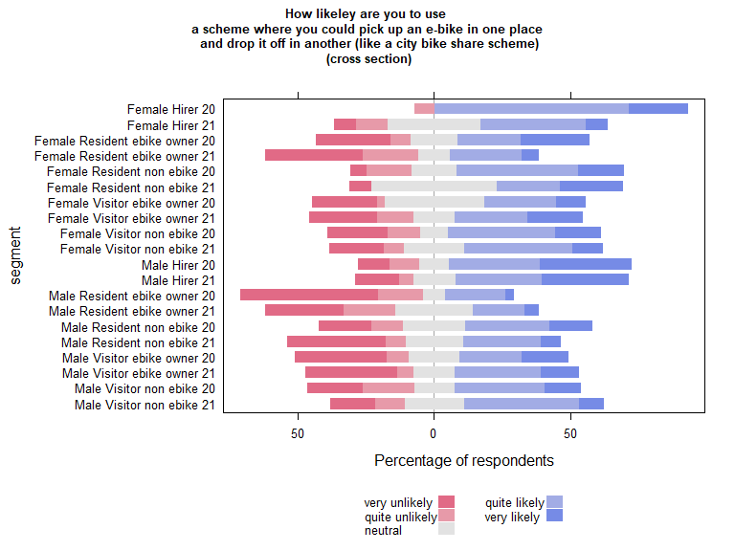

| Comparison | P.adj |
| --- | --- |
| Female Hirer 20 - Female Resident ebike owner 21 | 0.006 |
| Female Resident ebike owner 21 - Male Hirer 21 | 0.047 |
| Female Hirer 20 - Male Resident ebike owner 20 | 0.001 |
| Female Hirer 21 - Male Resident ebike owner 20 | 0.042 |
| Female Resident ebike owner 20 - Male Resident ebike owner 20 | 0.017 |
| Female Resident non ebike 20 - Male Resident ebike owner 20 | 0.020 |
| Female Resident non ebike 21 - Male Resident ebike owner 20 | 0.045 |
| Female Visitor ebike owner 21 - Male Resident ebike owner 20 | 0.046 |
| Female Visitor non ebike 20 - Male Resident ebike owner 20 | 0.006 |
| Female Visitor non ebike 21 - Male Resident ebike owner 20 | 0.007 |
| Male Hirer 20 - Male Resident ebike owner 20 | 0.039 |
| Male Hirer 21 - Male Resident ebike owner 20 | 0.007 |
| Female Hirer 20 - Male Resident ebike owner 21 | 0.016 |
| Female Hirer 20 - Male Resident non ebike 21 | 0.047 |
| Female Hirer 20 - Male Visitor ebike owner 20 | 0.038 |
| Female Hirer 20 - Male Visitor ebike owner 21 | 0.043 |
| Female Hirer 20 - Male Visitor non ebike 20 | 0.046 |
| Male Resident ebike owner 20 - Male Visitor non ebike 20 | 0.019 |
| Male Resident ebike owner 20 - Male Visitor non ebike 21 | 0.006 |

### Compare each segment in 2020 with the same segment in 2021

| segment2020 | segment2021 | pvalue |
| --- | --- | --- |

## Run the plot on B(2020) and C(2021) separately to carry out within year comparisons

## B (2020)

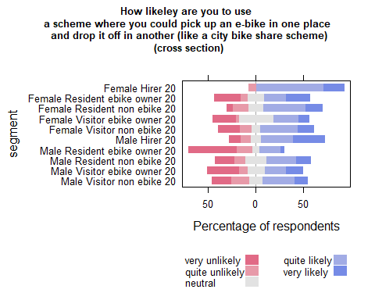

| Comparison | P.adj |
| --- | --- |
| Female Hirer 20 - Female Visitor ebike owner 20 | 0.041 |
| Female Hirer 20 - Male Resident ebike owner 20 | 0.001 |
| Female Resident ebike owner 20 - Male Resident ebike owner 20 | 0.011 |
| Female Resident non ebike 20 - Male Resident ebike owner 20 | 0.017 |
| Female Visitor non ebike 20 - Male Resident ebike owner 20 | 0.002 |
| Male Hirer 20 - Male Resident ebike owner 20 | 0.024 |
| Male Resident ebike owner 20 - Male Resident non ebike 20 | 0.041 |
| Female Hirer 20 - Male Visitor ebike owner 20 | 0.022 |
| Female Hirer 20 - Male Visitor non ebike 20 | 0.037 |
| Male Resident ebike owner 20 - Male Visitor non ebike 20 | 0.013 |

## C (2021)

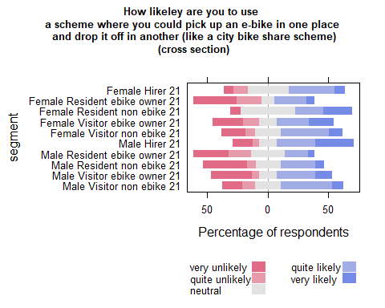

| Comparison | P.adj |
| --- | --- |

## Waves analysis

## run analysis on 2020 and 2021 PANEL data

| segment | quite likely | very unlikely | neutral | very likely | quite unlikely | SUMCOL | net percent |
| --- | --- | --- | --- | --- | --- | --- | --- |
| Female Hirer 20 | 100 | 0 | 0 | 0 | 0 | 3 | 100 |
| Female Hirer 21 | 60 | 20 | 20 | 0 | 0 | 5 | 40 |
| Female Resident ebike owner 20 | 31 | 38 | 12 | 19 | 0 | 16 | 12 |
| Female Resident ebike owner 21 | 28 | 28 | 11 | 6 | 28 | 18 | -22 |
| Female Resident non ebike 20 | 25 | 0 | 50 | 25 | 0 | 4 | 50 |
| Female Resident non ebike 21 | 25 | 25 | 50 | 0 | 0 | 4 | 0 |
| Female Visitor ebike owner 20 | 0 | 29 | 57 | 14 | 0 | 7 | -15 |
| Female Visitor ebike owner 21 | 20 | 0 | 40 | 0 | 40 | 5 | -20 |
| Female Visitor non ebike 20 | 43 | 29 | 0 | 21 | 7 | 14 | 28 |
| Female Visitor non ebike 21 | 31 | 23 | 38 | 8 | 0 | 13 | 16 |
| Male Hirer 20 | 50 | 0 | 0 | 50 | 0 | 2 | 100 |
| Male Hirer 21 | 17 | 33 | 17 | 33 | 0 | 6 | 17 |
| Male Resident ebike owner 20 | 15 | 54 | 15 | 0 | 15 | 13 | -54 |
| Male Resident ebike owner 21 | 13 | 27 | 33 | 7 | 20 | 15 | -27 |
| Male Resident non ebike 20 | 22 | 33 | 22 | 11 | 11 | 9 | -11 |
| Male Resident non ebike 21 | 33 | 17 | 33 | 0 | 17 | 6 | -1 |
| Male Visitor ebike owner 20 | 37 | 32 | 5 | 16 | 11 | 19 | 10 |
| Male Visitor ebike owner 21 | 30 | 25 | 10 | 20 | 15 | 20 | 10 |
| Male Visitor non ebike 20 | 38 | 15 | 12 | 15 | 19 | 26 | 19 |
| Male Visitor non ebike 21 | 62 | 19 | 5 | 10 | 5 | 21 | 48 |

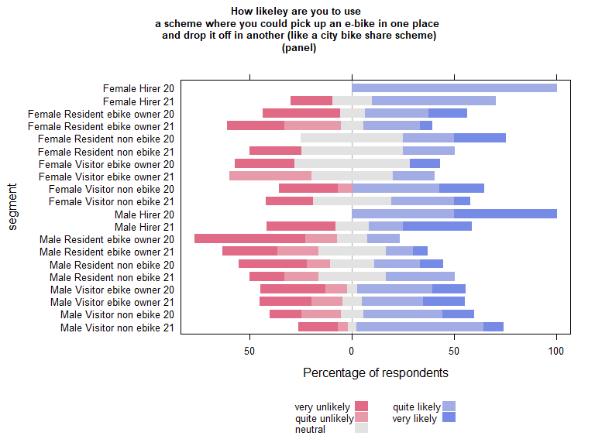

| Comparison | P.adj |
| --- | --- |

| segment2020 | segment2021 | pvalue |
| --- | --- | --- |

## wilcoxon paired test on panel data (if table empty non significant)

| estimate | statistic | p.value | conf.low | conf.high | method | alternative | segment |
| --- | --- | --- | --- | --- | --- | --- | --- |
| -0.9999203 | 16 | 0.03530538 | -Inf | -0.00001643752 | Wilcoxon signed rank test with continuity correction | less | female Resident ebike owner 21 |

## Run within year comparisons on the panel data

## B (2020) PANEL

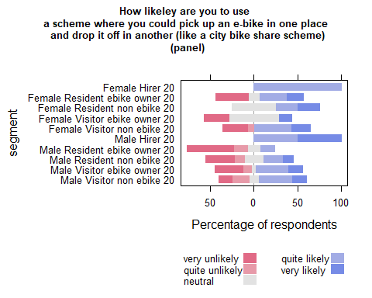

| Comparison | P.adj |
| --- | --- |

## C (2021) PANEL

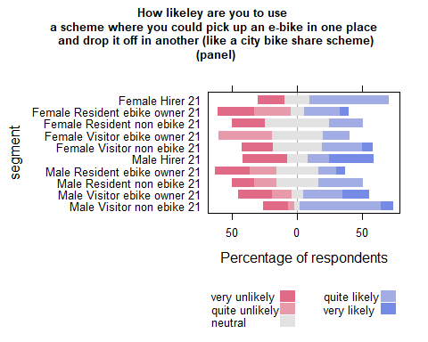

| Comparison | P.adj |
| --- | --- |

# Figure 13 Respondents’ self-reported likelihood of using e-bike hire in a Lakeland Valley with restricted motor vehicle access.

## NARRATIVE FOR PAPER

How likely are you to use e-bike hire in a Lakeland valley which has restricted access to cars e.g. Langdale, Borrowdale

## Cross Section analysis

| segment | quite unlikely | neutral | quite likely | very likely | very unlikely | SUMCOL | net percent |
| --- | --- | --- | --- | --- | --- | --- | --- |
| Female Hirer 20 | 7 | 14 | 50 | 29 | 0 | 14 | 72 |
| Female Hirer 21 | 8 | 8 | 42 | 27 | 15 | 26 | 46 |
| Female Resident ebike owner 20 | 8 | 17 | 17 | 29 | 29 | 52 | 9 |
| Female Resident ebike owner 21 | 0 | 100 | 0 | 0 | 0 | 34 | 0 |
| Female Resident non ebike 20 | 6 | 17 | 39 | 22 | 17 | 18 | 38 |
| Female Resident non ebike 21 | 0 | 31 | 46 | 23 | 0 | 13 | 69 |
| Female Visitor ebike owner 20 | 5 | 18 | 32 | 29 | 16 | 38 | 40 |
| Female Visitor ebike owner 21 | 0 | 93 | 2 | 0 | 4 | 45 | -2 |
| Female Visitor non ebike 20 | 8 | 13 | 41 | 23 | 14 | 133 | 42 |
| Female Visitor non ebike 21 | 4 | 22 | 35 | 23 | 16 | 184 | 38 |
| Male Hirer 20 | 0 | 11 | 44 | 44 | 0 | 9 | 88 |
| Male Hirer 21 | 11 | 11 | 26 | 42 | 11 | 19 | 46 |
| Male Resident ebike owner 20 | 14 | 19 | 19 | 8 | 39 | 36 | -26 |
| Male Resident ebike owner 21 | 0 | 100 | 0 | 0 | 0 | 21 | 0 |
| Male Resident non ebike 20 | 12 | 31 | 19 | 23 | 15 | 26 | 15 |
| Male Resident non ebike 21 | 14 | 0 | 50 | 0 | 36 | 14 | 0 |
| Male Visitor ebike owner 20 | 8 | 21 | 23 | 29 | 19 | 48 | 25 |
| Male Visitor ebike owner 21 | 0 | 94 | 4 | 2 | 0 | 51 | 6 |
| Male Visitor non ebike 20 | 12 | 13 | 33 | 18 | 23 | 145 | 16 |
| Male Visitor non ebike 21 | 9 | 25 | 39 | 14 | 13 | 149 | 31 |

## run analysis on 2020 and 2021 cross section data

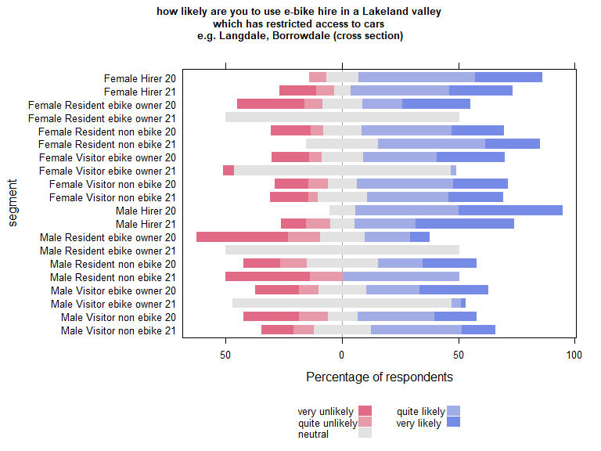

| Comparison | P.adj |
| --- | --- |
| Female Hirer 20 - Female Resident ebike owner 21 | 0.011 |
| Female Hirer 21 - Female Resident ebike owner 21 | 0.022 |
| Female Resident ebike owner 21 - Female Resident non ebike 21 | 0.023 |
| Female Resident ebike owner 21 - Female Visitor ebike owner 20 | 0.021 |
| Female Hirer 20 - Female Visitor ebike owner 21 | 0.009 |
| Female Hirer 21 - Female Visitor ebike owner 21 | 0.013 |
| Female Resident non ebike 21 - Female Visitor ebike owner 21 | 0.017 |
| Female Visitor ebike owner 20 - Female Visitor ebike owner 21 | 0.010 |
| Female Resident ebike owner 21 - Female Visitor non ebike 20 | 0.008 |
| Female Visitor ebike owner 21 - Female Visitor non ebike 20 | 0.003 |
| Female Resident ebike owner 21 - Female Visitor non ebike 21 | 0.009 |
| Female Visitor ebike owner 21 - Female Visitor non ebike 21 | 0.004 |
| Female Resident ebike owner 20 - Male Hirer 20 | 0.038 |
| Female Resident ebike owner 21 - Male Hirer 20 | 0.007 |
| Female Visitor ebike owner 21 - Male Hirer 20 | 0.007 |
| Female Resident ebike owner 21 - Male Hirer 21 | 0.013 |
| Female Visitor ebike owner 21 - Male Hirer 21 | 0.008 |
| Female Hirer 20 - Male Resident ebike owner 20 | 0.007 |
| Female Hirer 21 - Male Resident ebike owner 20 | 0.008 |
| Female Resident non ebike 20 - Male Resident ebike owner 20 | 0.036 |
| Female Resident non ebike 21 - Male Resident ebike owner 20 | 0.010 |
| Female Visitor ebike owner 20 - Male Resident ebike owner 20 | 0.007 |
| Female Visitor non ebike 20 - Male Resident ebike owner 20 | 0.003 |
| Female Visitor non ebike 21 - Male Resident ebike owner 20 | 0.004 |
| Male Hirer 20 - Male Resident ebike owner 20 | 0.005 |
| Male Hirer 21 - Male Resident ebike owner 20 | 0.006 |
| Female Hirer 20 - Male Resident ebike owner 21 | 0.019 |
| Female Hirer 21 - Male Resident ebike owner 21 | 0.040 |
| Female Resident non ebike 21 - Male Resident ebike owner 21 | 0.036 |
| Female Visitor ebike owner 20 - Male Resident ebike owner 21 | 0.042 |
| Female Visitor non ebike 20 - Male Resident ebike owner 21 | 0.022 |
| Female Visitor non ebike 21 - Male Resident ebike owner 21 | 0.032 |
| Male Hirer 20 - Male Resident ebike owner 21 | 0.009 |
| Male Hirer 21 - Male Resident ebike owner 21 | 0.023 |
| Female Hirer 20 - Male Resident non ebike 21 | 0.041 |
| Male Hirer 20 - Male Resident non ebike 21 | 0.019 |
| Female Visitor ebike owner 21 - Male Visitor ebike owner 20 | 0.027 |
| Male Resident ebike owner 20 - Male Visitor ebike owner 20 | 0.014 |
| Female Hirer 20 - Male Visitor ebike owner 21 | 0.013 |
| Female Hirer 21 - Male Visitor ebike owner 21 | 0.026 |
| Female Resident non ebike 21 - Male Visitor ebike owner 21 | 0.029 |
| Female Visitor ebike owner 20 - Male Visitor ebike owner 21 | 0.023 |
| Female Visitor non ebike 20 - Male Visitor ebike owner 21 | 0.006 |
| Female Visitor non ebike 21 - Male Visitor ebike owner 21 | 0.008 |
| Male Hirer 20 - Male Visitor ebike owner 21 | 0.008 |
| Male Hirer 21 - Male Visitor ebike owner 21 | 0.014 |
| Female Visitor non ebike 20 - Male Visitor non ebike 20 | 0.038 |
| Male Hirer 20 - Male Visitor non ebike 20 | 0.026 |
| Male Resident ebike owner 20 - Male Visitor non ebike 20 | 0.032 |
| Female Resident ebike owner 21 - Male Visitor non ebike 21 | 0.042 |
| Female Visitor ebike owner 21 - Male Visitor non ebike 21 | 0.018 |
| Male Resident ebike owner 20 - Male Visitor non ebike 21 | 0.010 |
| Male Visitor ebike owner 21 - Male Visitor non ebike 21 | 0.046 |

### Compare each segment in 2020 with the same segment in 2021

| segment2020 | segment2021 | pvalue |
| --- | --- | --- |
| Female Visitor ebike owner 20 | Female Visitor ebike owner 21 | 0 |
| Male Visitor ebike owner 20 | Male Visitor ebike owner 21 | 0 |

## Run the plot on B(2020) and C(2021) separately to carry out within year comparisons

## B (2020)

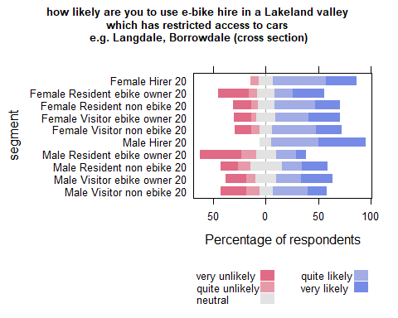

| Comparison | P.adj |
| --- | --- |
| Female Hirer 20 - Male Resident ebike owner 20 | 0.014 |
| Female Visitor ebike owner 20 - Male Resident ebike owner 20 | 0.015 |
| Female Visitor non ebike 20 - Male Resident ebike owner 20 | 0.005 |
| Male Hirer 20 - Male Resident ebike owner 20 | 0.009 |
| Male Resident ebike owner 20 - Male Visitor ebike owner 20 | 0.038 |

## C (2021)

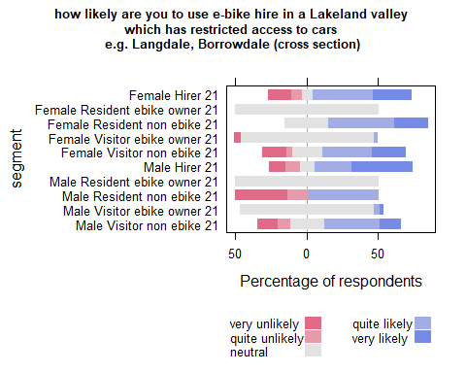

| Comparison | P.adj |
| --- | --- |
| Female Hirer 21 - Female Resident ebike owner 21 | 0.006 |
| Female Resident ebike owner 21 - Female Resident non ebike 21 | 0.005 |
| Female Hirer 21 - Female Visitor ebike owner 21 | 0.004 |
| Female Resident non ebike 21 - Female Visitor ebike owner 21 | 0.004 |
| Female Resident ebike owner 21 - Female Visitor non ebike 21 | 0.003 |
| Female Visitor ebike owner 21 - Female Visitor non ebike 21 | 0.001 |
| Female Resident ebike owner 21 - Male Hirer 21 | 0.005 |
| Female Visitor ebike owner 21 - Male Hirer 21 | 0.003 |
| Female Hirer 21 - Male Resident ebike owner 21 | 0.010 |
| Female Resident non ebike 21 - Male Resident ebike owner 21 | 0.008 |
| Female Visitor non ebike 21 - Male Resident ebike owner 21 | 0.007 |
| Male Hirer 21 - Male Resident ebike owner 21 | 0.007 |
| Female Resident non ebike 21 - Male Resident non ebike 21 | 0.030 |
| Male Hirer 21 - Male Resident non ebike 21 | 0.029 |
| Female Hirer 21 - Male Visitor ebike owner 21 | 0.007 |
| Female Resident non ebike 21 - Male Visitor ebike owner 21 | 0.006 |
| Female Visitor non ebike 21 - Male Visitor ebike owner 21 | 0.003 |
| Male Hirer 21 - Male Visitor ebike owner 21 | 0.005 |
| Female Resident ebike owner 21 - Male Visitor non ebike 21 | 0.010 |
| Female Visitor ebike owner 21 - Male Visitor non ebike 21 | 0.004 |
| Male Resident ebike owner 21 - Male Visitor non ebike 21 | 0.037 |
| Male Visitor ebike owner 21 - Male Visitor non ebike 21 | 0.010 |

## Waves analysis

## run analysis on 2020 and 2021 PANEL data

| segment | neutral | quite likely | very likely | very unlikely | quite unlikely | SUMCOL | net percent |
| --- | --- | --- | --- | --- | --- | --- | --- |
| Female Hirer 20 | 33 | 67 | 0 | 0 | 0 | 3 | 67 |
| Female Hirer 21 | 20 | 60 | 20 | 0 | 0 | 5 | 80 |
| Female Resident ebike owner 20 | 12 | 25 | 12 | 38 | 12 | 16 | -13 |
| Female Resident ebike owner 21 | 100 | 0 | 0 | 0 | 0 | 18 | 0 |
| Female Resident non ebike 20 | 0 | 50 | 25 | 0 | 25 | 4 | 50 |
| Female Resident non ebike 21 | 25 | 50 | 25 | 0 | 0 | 4 | 75 |
| Female Visitor ebike owner 20 | 29 | 0 | 57 | 14 | 0 | 7 | 43 |
| Female Visitor ebike owner 21 | 80 | 20 | 0 | 0 | 0 | 5 | 20 |
| Female Visitor non ebike 20 | 14 | 43 | 29 | 14 | 0 | 14 | 58 |
| Female Visitor non ebike 21 | 15 | 46 | 15 | 23 | 0 | 13 | 38 |
| Male Hirer 20 | 0 | 100 | 0 | 0 | 0 | 2 | 100 |
| Male Hirer 21 | 0 | 17 | 50 | 17 | 17 | 6 | 33 |
| Male Resident ebike owner 20 | 23 | 0 | 15 | 46 | 15 | 13 | -46 |
| Male Resident ebike owner 21 | 100 | 0 | 0 | 0 | 0 | 15 | 0 |
| Male Resident non ebike 20 | 22 | 11 | 33 | 11 | 22 | 9 | 11 |
| Male Resident non ebike 21 | 0 | 50 | 0 | 17 | 33 | 6 | 0 |
| Male Visitor ebike owner 20 | 11 | 37 | 26 | 21 | 5 | 19 | 37 |
| Male Visitor ebike owner 21 | 90 | 5 | 5 | 0 | 0 | 20 | 10 |
| Male Visitor non ebike 20 | 4 | 46 | 15 | 23 | 12 | 26 | 26 |
| Male Visitor non ebike 21 | 14 | 57 | 10 | 14 | 5 | 21 | 48 |

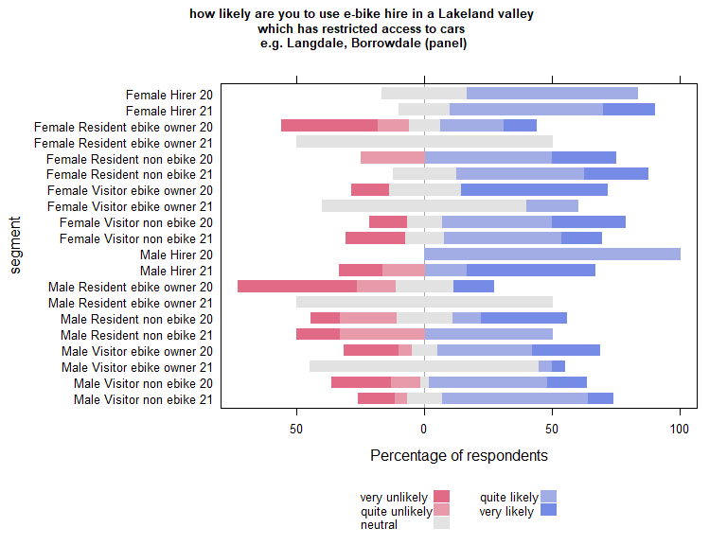

| Comparison | P.adj |
| --- | --- |

| segment2020 | segment2021 | pvalue |
| --- | --- | --- |
| Male Visitor ebike owner 20 | Male Visitor ebike owner 21 | 0 |

## wilcoxon paired test on panel data (if table empty non significant)

| estimate | statistic | p.value | conf.low | conf.high | method | alternative | segment |
| --- | --- | --- | --- | --- | --- | --- | --- |

## Run within year comparisons on the panel data

## B (2020) PANEL

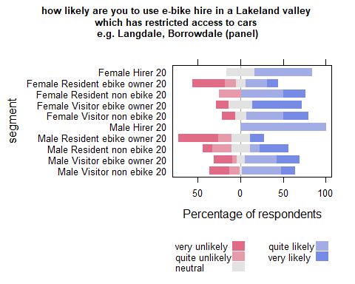

| Comparison | P.adj |
| --- | --- |

## C (2021) PANEL

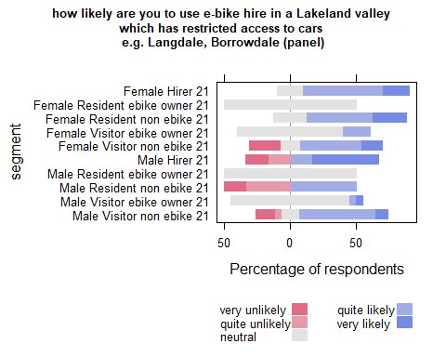

| Comparison | P.adj |
| --- | --- |

# “a daily or weekly pass whichgives you e-bike hire together with use of all the buses, trains and boats in the Lake District National Park”

## NARRATIVE FOR PAPER

In the cross sectional data visitors are statistically more likely to use this service than residents. Though the likert plot shows some similarities in the panel data, the differences are not statistically significant.

## Cross Section analysis

| segment | quite unlikely | neutral | quite likely | very likely | very unlikely | SUMCOL | net percent |
| --- | --- | --- | --- | --- | --- | --- | --- |
| Female Hirer 20 | 29 | 14 | 29 | 29 | 0 | 14 | 29 |
| Female Hirer 21 | 27 | 15 | 35 | 15 | 8 | 26 | 15 |
| Female Resident ebike owner 20 | 13 | 13 | 25 | 15 | 33 | 52 | -6 |
| Female Resident ebike owner 21 | 21 | 26 | 24 | 3 | 26 | 34 | -20 |
| Female Resident non ebike 20 | 17 | 17 | 28 | 22 | 17 | 18 | 16 |
| Female Resident non ebike 21 | 0 | 46 | 8 | 23 | 23 | 13 | 8 |
| Female Visitor ebike owner 20 | 8 | 24 | 32 | 13 | 24 | 38 | 13 |
| Female Visitor ebike owner 21 | 13 | 20 | 20 | 20 | 27 | 45 | 0 |
| Female Visitor non ebike 20 | 8 | 20 | 32 | 21 | 19 | 133 | 26 |
| Female Visitor non ebike 21 | 8 | 20 | 33 | 23 | 16 | 184 | 32 |
| Male Hirer 20 | 0 | 22 | 22 | 22 | 33 | 9 | 11 |
| Male Hirer 21 | 16 | 11 | 21 | 42 | 11 | 19 | 36 |
| Male Resident ebike owner 20 | 14 | 36 | 6 | 6 | 39 | 36 | -41 |
| Male Resident ebike owner 21 | 19 | 19 | 14 | 14 | 33 | 21 | -24 |
| Male Resident non ebike 20 | 23 | 27 | 19 | 15 | 15 | 26 | -4 |
| Male Resident non ebike 21 | 7 | 14 | 29 | 0 | 50 | 14 | -28 |
| Male Visitor ebike owner 20 | 10 | 21 | 29 | 19 | 21 | 48 | 17 |
| Male Visitor ebike owner 21 | 0 | 22 | 29 | 20 | 29 | 51 | 20 |
| Male Visitor non ebike 20 | 14 | 18 | 28 | 16 | 24 | 145 | 6 |
| Male Visitor non ebike 21 | 9 | 26 | 35 | 15 | 15 | 149 | 26 |

## run analysis on 2020 and 2021 cross section data

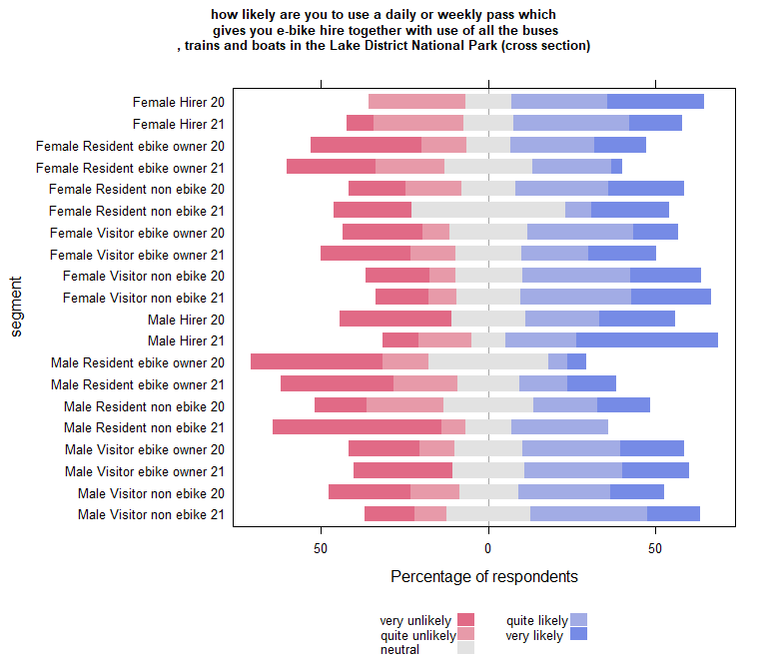

| Comparison | P.adj |
| --- | --- |
| Female Resident ebike owner 21 - Female Visitor non ebike 21 | 0.029 |
| Female Visitor non ebike 20 - Male Resident ebike owner 20 | 0.004 |
| Female Visitor non ebike 21 - Male Resident ebike owner 20 | 0.001 |
| Male Hirer 21 - Male Resident ebike owner 20 | 0.007 |
| Male Resident ebike owner 20 - Male Visitor non ebike 21 | 0.005 |

### Compare each segment in 2020 with the same segment in 2021

| segment2020 | segment2021 | pvalue |
| --- | --- | --- |

## Run the plot on B(2020) and C(2021) separately to carry out within year comparisons

## B (2020)

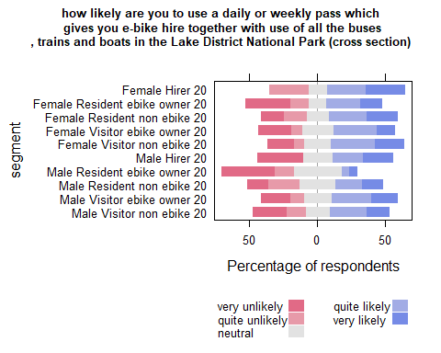

| Comparison | P.adj |
| --- | --- |
| Female Visitor non ebike 20 - Male Resident ebike owner 20 | 0.003 |
| Male Resident ebike owner 20 - Male Visitor ebike owner 20 | 0.047 |

## C (2021)

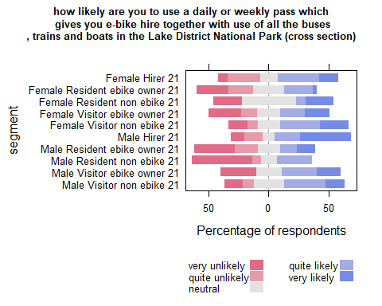

| Comparison | P.adj |
| --- | --- |
| Female Resident ebike owner 21 - Female Visitor non ebike 21 | 0.027 |
| Female Resident ebike owner 21 - Male Hirer 21 | 0.050 |
| Female Visitor non ebike 21 - Male Resident non ebike 21 | 0.032 |
| Male Hirer 21 - Male Resident non ebike 21 | 0.038 |

## Waves analysis

## run analysis on 2020 and 2021 PANEL data

| segment | neutral | very likely | quite likely | very unlikely | quite unlikely | SUMCOL | net percent |
| --- | --- | --- | --- | --- | --- | --- | --- |
| Female Hirer 20 | 33 | 67 | 0 | 0 | 0 | 3 | 67 |
| Female Hirer 21 | 20 | 20 | 60 | 0 | 0 | 5 | 80 |
| Female Resident ebike owner 20 | 25 | 12 | 19 | 44 | 0 | 16 | -13 |
| Female Resident ebike owner 21 | 17 | 6 | 22 | 28 | 28 | 18 | -28 |
| Female Resident non ebike 20 | 25 | 25 | 25 | 0 | 25 | 4 | 25 |
| Female Resident non ebike 21 | 25 | 25 | 25 | 25 | 0 | 4 | 25 |
| Female Visitor ebike owner 20 | 14 | 29 | 14 | 43 | 0 | 7 | 0 |
| Female Visitor ebike owner 21 | 40 | 0 | 20 | 20 | 20 | 5 | -20 |
| Female Visitor non ebike 20 | 14 | 43 | 29 | 14 | 0 | 14 | 58 |
| Female Visitor non ebike 21 | 15 | 31 | 31 | 23 | 0 | 13 | 39 |
| Male Hirer 20 | 0 | 0 | 50 | 50 | 0 | 2 | 0 |
| Male Hirer 21 | 0 | 33 | 17 | 17 | 33 | 6 | 0 |
| Male Resident ebike owner 20 | 46 | 0 | 0 | 38 | 15 | 13 | -53 |
| Male Resident ebike owner 21 | 20 | 20 | 13 | 33 | 13 | 15 | -13 |
| Male Resident non ebike 20 | 33 | 11 | 11 | 22 | 22 | 9 | -22 |
| Male Resident non ebike 21 | 0 | 0 | 50 | 33 | 17 | 6 | 0 |
| Male Visitor ebike owner 20 | 16 | 16 | 32 | 21 | 16 | 19 | 11 |
| Male Visitor ebike owner 21 | 20 | 30 | 35 | 15 | 0 | 20 | 50 |
| Male Visitor non ebike 20 | 8 | 12 | 38 | 31 | 12 | 26 | 7 |
| Male Visitor non ebike 21 | 19 | 0 | 67 | 10 | 5 | 21 | 52 |

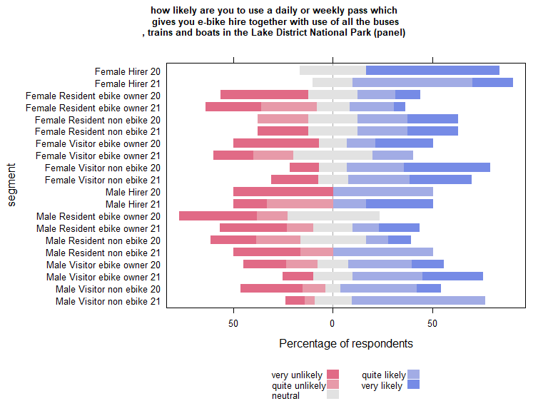

| Comparison | P.adj |
| --- | --- |

| segment2020 | segment2021 | pvalue |
| --- | --- | --- |

## wilcoxon paired test on panel data (if table empty non significant)

| estimate | statistic | p.value | conf.low | conf.high | method | alternative | segment |
| --- | --- | --- | --- | --- | --- | --- | --- |
| 1.000013 | 78.5 | 0.008289088 | 0.9999769 | Inf | Wilcoxon signed rank test with continuity correction | greater | male Visitor ebike owner 21 |

## Run within year comparisons on the panel data

## B (2020) PANEL

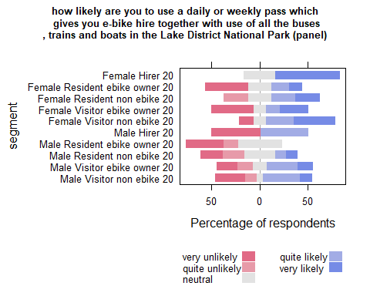

| Comparison | P.adj |
| --- | --- |

## C (2021) PANEL

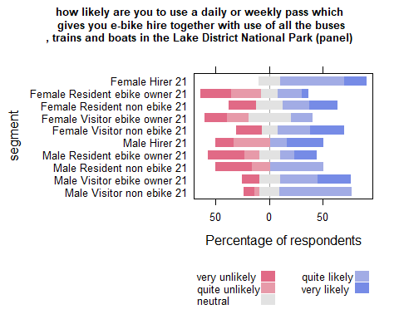

| Comparison | P.adj |
| --- | --- |

### notes

the code is a bit scrappy in places.

wilcoxon paired tests - sometimes run on segments that werent relevant to analysis - just easier to run code on all segments

the kruskall & dunn tests run on the data containing 2020 and 2021 data. agian just relic of devleloping the code. - for within year comparison of segments use “b” and “c” sections .