Kruskal_analysis

Ian Philips

2023-09-20

# Safety “Riding a bike on the road in the Lake District is safe most of the time”

## Cross Section analysis

| segment | disagree | neutral | agree | strongly agree | strongly disagree | SUMCOL | net percent |
| --- | --- | --- | --- | --- | --- | --- | --- |
| Female Hirer 20 | 7 | 36 | 50 | 7 | 0 | 14 | 50 |
| Female Hirer 21 | 23 | 19 | 42 | 12 | 4 | 26 | 27 |
| Female Visitor ebike owner 20 | 16 | 29 | 34 | 13 | 8 | 38 | 23 |
| Female Visitor ebike owner 21 | 18 | 38 | 29 | 9 | 7 | 45 | 13 |
| Male Hirer 20 | 11 | 44 | 22 | 22 | 0 | 9 | 33 |
| Male Hirer 21 | 5 | 37 | 42 | 5 | 11 | 19 | 31 |
| Male Visitor ebike owner 20 | 4 | 12 | 25 | 58 | 0 | 48 | 79 |
| Male Visitor ebike owner 21 | 12 | 25 | 41 | 20 | 2 | 51 | 47 |

## run analysis on 2020 and 2021 cross section data

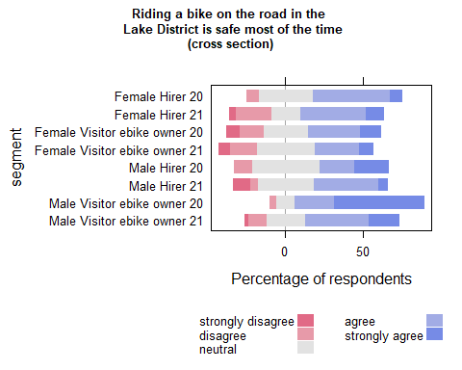

| Comparison | P.adj |
| --- | --- |
| Female Hirer 20 - Male Visitor ebike owner 20 | 0.029 |
| Female Hirer 21 - Male Visitor ebike owner 20 | 0.001 |
| Female Visitor ebike owner 20 - Male Visitor ebike owner 20 | 0.000 |
| Female Visitor ebike owner 21 - Male Visitor ebike owner 20 | 0.000 |
| Male Hirer 21 - Male Visitor ebike owner 20 | 0.001 |
| Male Visitor ebike owner 20 - Male Visitor ebike owner 21 | 0.002 |

### Compare each segment in 2020 with the same segment in 2021

| segment2020 | segment2021 | pvalue |
| --- | --- | --- |
| Male Visitor ebike owner 20 | Male Visitor ebike owner 21 | 0.003 |

## Run the plot on B(2020) and C(2021) separately to carry out within year comparisons

## B (2020)

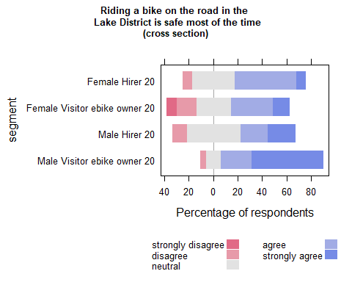

| Comparison | P.adj |
| --- | --- |
| Female Hirer 20 - Male Visitor ebike owner 20 | 0.013 |
| Female Visitor ebike owner 20 - Male Visitor ebike owner 20 | 0.000 |
| Male Hirer 20 - Male Visitor ebike owner 20 | 0.041 |

## C (2021)

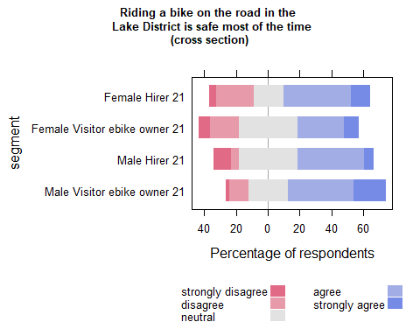

| Comparison | P.adj |
| --- | --- |

## Waves analysis (Safety)

## run analysis on 2020 and 2021 PANEL data safety question

| segment | agree | neutral | strongly disagree | disagree | strongly agree | SUMCOL | net percent |
| --- | --- | --- | --- | --- | --- | --- | --- |
| Female Hirer 20 | 100 | 0 | 0 | 0 | 0 | 3 | 100 |
| Female Hirer 21 | 60 | 40 | 0 | 0 | 0 | 5 | 60 |
| Female Visitor ebike owner 20 | 43 | 14 | 14 | 29 | 0 | 7 | 0 |
| Female Visitor ebike owner 21 | 20 | 0 | 0 | 80 | 0 | 5 | -60 |
| Male Hirer 20 | 50 | 50 | 0 | 0 | 0 | 2 | 50 |
| Male Hirer 21 | 50 | 17 | 33 | 0 | 0 | 6 | 17 |
| Male Visitor ebike owner 20 | 21 | 21 | 0 | 0 | 58 | 19 | 79 |
| Male Visitor ebike owner 21 | 25 | 30 | 5 | 15 | 25 | 20 | 30 |

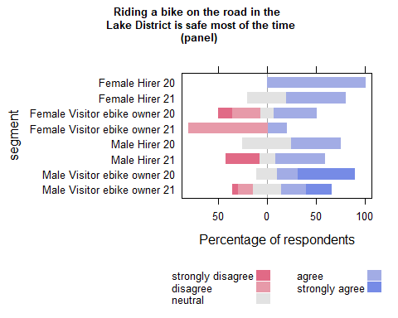

| Comparison | P.adj |
| --- | --- |
| Female Visitor ebike owner 21 - Male Visitor ebike owner 20 | 0.019 |

| segment2020 | segment2021 | pvalue |
| --- | --- | --- |

## wilcoxon paired test on panel data (if table empty non significant)

| estimate | statistic | p.value | conf.low | conf.high | method | alternative | segment |
| --- | --- | --- | --- | --- | --- | --- | --- |

## Run within year comparisons on the panel data

## B (2020) PANEL

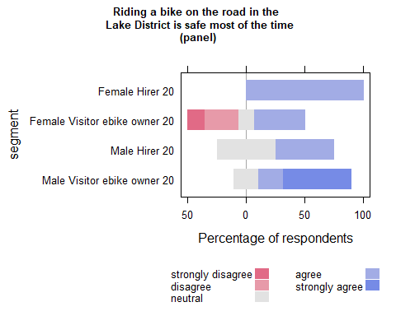

| Comparison | P.adj |
| --- | --- |
| Female Visitor ebike owner 20 - Male Visitor ebike owner 20 | 0.018 |

## C (2021) PANEL

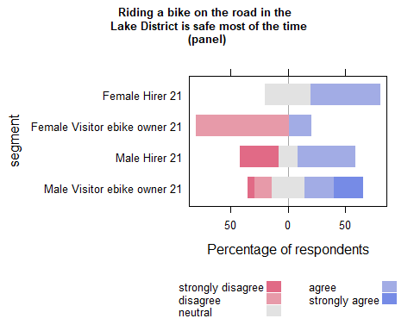

| Comparison | P.adj |
| --- | --- |

# Hills “I have ridden to places on the e-bike that I could not have ridden to on an ordinary bike”

## Cross Section analysis

| segment | neutral | agree | strongly agree | strongly disagree | disagree | SUMCOL | net percent |
| --- | --- | --- | --- | --- | --- | --- | --- |
| Female Hirer 20 | 29 | 36 | 36 | 0 | 0 | 14 | 72 |
| Female Hirer 21 | 8 | 35 | 50 | 8 | 0 | 26 | 77 |
| Female Resident ebike owner 20 | 100 | 0 | 0 | 0 | 0 | 52 | 0 |
| Female Resident ebike owner 21 | 6 | 38 | 50 | 0 | 6 | 34 | 82 |
| Female Visitor ebike owner 20 | 5 | 32 | 61 | 3 | 0 | 38 | 90 |
| Female Visitor ebike owner 21 | 18 | 22 | 56 | 0 | 4 | 45 | 74 |
| Male Hirer 20 | 44 | 22 | 22 | 0 | 11 | 9 | 33 |
| Male Hirer 21 | 5 | 26 | 37 | 16 | 16 | 19 | 31 |
| Male Resident ebike owner 20 | 100 | 0 | 0 | 0 | 0 | 36 | 0 |
| Male Resident ebike owner 21 | 10 | 19 | 62 | 0 | 10 | 21 | 71 |
| Male Visitor ebike owner 20 | 12 | 25 | 58 | 0 | 4 | 48 | 79 |
| Male Visitor ebike owner 21 | 14 | 25 | 51 | 0 | 10 | 51 | 66 |

## run analysis on 2020 and 2021 cross section data

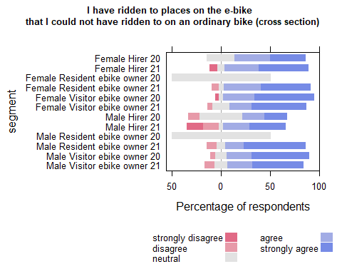

| Comparison | P.adj |
| --- | --- |
| Female Hirer 20 - Female Resident ebike owner 20 | 0.001 |
| Female Hirer 21 - Female Resident ebike owner 20 | 0.000 |
| Female Resident ebike owner 20 - Female Resident ebike owner 21 | 0.000 |
| Female Resident ebike owner 20 - Female Visitor ebike owner 20 | 0.000 |
| Female Resident ebike owner 20 - Female Visitor ebike owner 21 | 0.000 |
| Female Visitor ebike owner 20 - Male Hirer 20 | 0.032 |
| Female Resident ebike owner 20 - Male Hirer 21 | 0.009 |
| Female Visitor ebike owner 20 - Male Hirer 21 | 0.023 |
| Female Hirer 20 - Male Resident ebike owner 20 | 0.002 |
| Female Hirer 21 - Male Resident ebike owner 20 | 0.000 |
| Female Resident ebike owner 21 - Male Resident ebike owner 20 | 0.000 |
| Female Visitor ebike owner 20 - Male Resident ebike owner 20 | 0.000 |
| Female Visitor ebike owner 21 - Male Resident ebike owner 20 | 0.000 |
| Male Hirer 21 - Male Resident ebike owner 20 | 0.015 |
| Female Resident ebike owner 20 - Male Resident ebike owner 21 | 0.000 |
| Male Resident ebike owner 20 - Male Resident ebike owner 21 | 0.000 |
| Female Resident ebike owner 20 - Male Visitor ebike owner 20 | 0.000 |
| Male Resident ebike owner 20 - Male Visitor ebike owner 20 | 0.000 |
| Female Resident ebike owner 20 - Male Visitor ebike owner 21 | 0.000 |
| Male Resident ebike owner 20 - Male Visitor ebike owner 21 | 0.000 |

### not Comparing each segment in 2020 with the same segment in 2021 for waves because not enough data

| segment2020 | segment2021 | pvalue |
| --- | --- | --- |

## Run the plot on B(2020) and C(2021) separately to carry out within year comparisons

## B (2020)

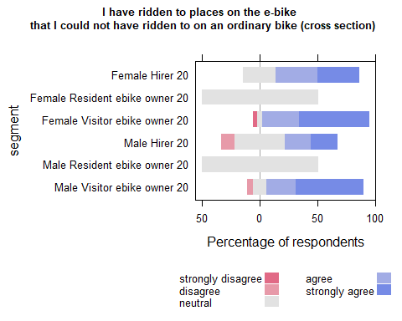

| Comparison | P.adj |
| --- | --- |
| Female Hirer 20 - Female Resident ebike owner 20 | 0.000 |
| Female Resident ebike owner 20 - Female Visitor ebike owner 20 | 0.000 |
| Female Visitor ebike owner 20 - Male Hirer 20 | 0.011 |
| Female Hirer 20 - Male Resident ebike owner 20 | 0.000 |
| Female Visitor ebike owner 20 - Male Resident ebike owner 20 | 0.000 |
| Female Resident ebike owner 20 - Male Visitor ebike owner 20 | 0.000 |
| Male Hirer 20 - Male Visitor ebike owner 20 | 0.027 |
| Male Resident ebike owner 20 - Male Visitor ebike owner 20 | 0.000 |

## C (2021)

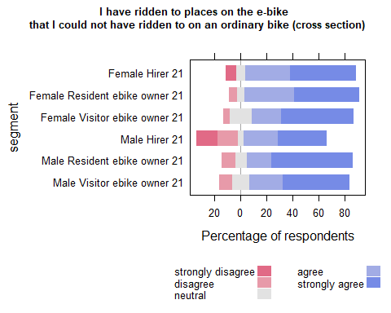

| Comparison | P.adj |
| --- | --- |

## Waves analysis (hills)

## run analysis on 2020 and 2021 PANEL data hills question

| segment | agree | strongly agree | neutral | disagree | strongly disagree | SUMCOL | net percent |
| --- | --- | --- | --- | --- | --- | --- | --- |
| Female Hirer 20 | 33 | 67 | 0 | 0 | 0 | 3 | 100 |
| Female Hirer 21 | 40 | 40 | 20 | 0 | 0 | 5 | 80 |
| Female Resident ebike owner 20 | 0 | 0 | 100 | 0 | 0 | 16 | 0 |
| Female Resident ebike owner 21 | 28 | 61 | 6 | 6 | 0 | 18 | 83 |
| Female Visitor ebike owner 20 | 14 | 86 | 0 | 0 | 0 | 7 | 100 |
| Female Visitor ebike owner 21 | 20 | 80 | 0 | 0 | 0 | 5 | 100 |
| Male Hirer 20 | 50 | 0 | 50 | 0 | 0 | 2 | 50 |
| Male Hirer 21 | 17 | 17 | 0 | 17 | 50 | 6 | -33 |
| Male Resident ebike owner 20 | 0 | 0 | 100 | 0 | 0 | 13 | 0 |
| Male Resident ebike owner 21 | 13 | 67 | 7 | 13 | 0 | 15 | 67 |
| Male Visitor ebike owner 20 | 21 | 58 | 21 | 0 | 0 | 19 | 79 |
| Male Visitor ebike owner 21 | 30 | 50 | 15 | 5 | 0 | 20 | 75 |

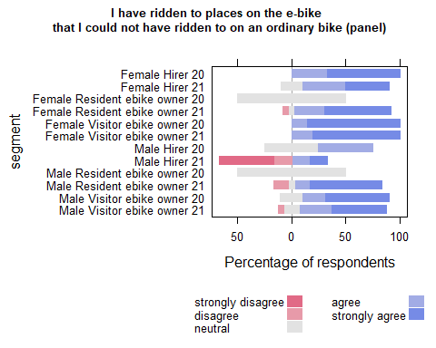

| Comparison | P.adj |
| --- | --- |
| Female Hirer 20 - Female Resident ebike owner 20 | 0.026 |
| Female Resident ebike owner 20 - Female Resident ebike owner 21 | 0.001 |
| Female Resident ebike owner 20 - Female Visitor ebike owner 20 | 0.001 |
| Female Resident ebike owner 20 - Female Visitor ebike owner 21 | 0.002 |
| Female Resident ebike owner 21 - Male Hirer 21 | 0.008 |
| Female Visitor ebike owner 20 - Male Hirer 21 | 0.003 |
| Female Visitor ebike owner 21 - Male Hirer 21 | 0.011 |
| Female Hirer 20 - Male Resident ebike owner 20 | 0.028 |
| Female Resident ebike owner 21 - Male Resident ebike owner 20 | 0.001 |
| Female Visitor ebike owner 20 - Male Resident ebike owner 20 | 0.001 |
| Female Visitor ebike owner 21 - Male Resident ebike owner 20 | 0.003 |
| Female Resident ebike owner 20 - Male Resident ebike owner 21 | 0.001 |
| Male Hirer 21 - Male Resident ebike owner 21 | 0.014 |
| Male Resident ebike owner 20 - Male Resident ebike owner 21 | 0.001 |
| Female Resident ebike owner 20 - Male Visitor ebike owner 20 | 0.001 |
| Male Hirer 21 - Male Visitor ebike owner 20 | 0.013 |
| Male Resident ebike owner 20 - Male Visitor ebike owner 20 | 0.001 |
| Female Resident ebike owner 20 - Male Visitor ebike owner 21 | 0.001 |
| Male Hirer 21 - Male Visitor ebike owner 21 | 0.024 |
| Male Resident ebike owner 20 - Male Visitor ebike owner 21 | 0.002 |

| segment2020 | segment2021 | pvalue |
| --- | --- | --- |

## wilcoxon paired test on panel data (if table empty non significant)

some segments may show sig diff here because question only asked of some segments in one of the years.

| estimate | statistic | p.value | conf.low | conf.high | method | alternative | segment |
| --- | --- | --- | --- | --- | --- | --- | --- |
| 1.500029 | 120 | 0.002985622 | 1.4999735 | Inf | Wilcoxon signed rank test with continuity correction | greater | female Resident ebike owner 21 |
| 1.500007 | 73 | 0.003181628 | 0.5000446 | Inf | Wilcoxon signed rank test with continuity correction | greater | male Resident ebike owner 21 |

## Run within year comparisons on the panel data

## B (2020) PANEL

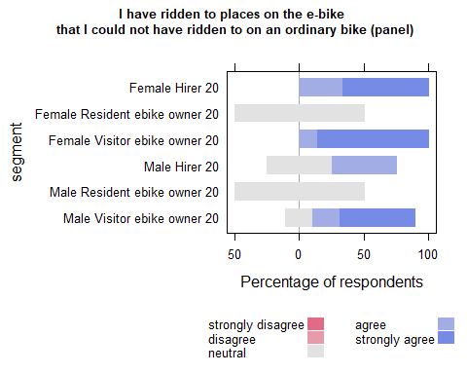

| Comparison | P.adj |
| --- | --- |
| Female Hirer 20 - Female Resident ebike owner 20 | 0.008 |
| Female Resident ebike owner 20 - Female Visitor ebike owner 20 | 0.000 |
| Female Hirer 20 - Male Resident ebike owner 20 | 0.008 |
| Female Visitor ebike owner 20 - Male Resident ebike owner 20 | 0.000 |
| Female Resident ebike owner 20 - Male Visitor ebike owner 20 | 0.000 |
| Male Resident ebike owner 20 - Male Visitor ebike owner 20 | 0.000 |

## C (2021) PANEL

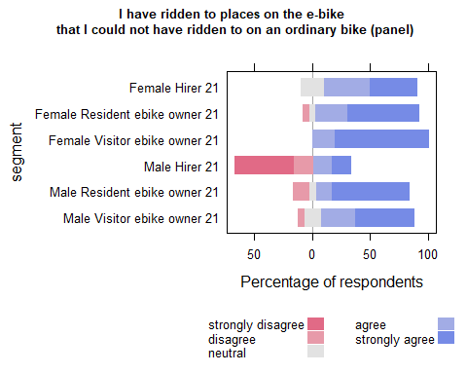

| Comparison | P.adj |
| --- | --- |
| Female Visitor ebike owner 21 - Male Hirer 21 | 0.038 |
| Male Hirer 21 - Male Resident ebike owner 21 | 0.030 |