kruskall attitudes 200923

Ian Philips

2023-09-20

# Attitudes: GENERAL

## “After Covid, transport and tourism should be greener”

## Cross section analysis

| segment | strongly disagree | neutral | agree | strongly agree | disagree | SUMCOL | net percent |
| --- | --- | --- | --- | --- | --- | --- | --- |
| Female Hirer 20 | 7 | 7 | 43 | 43 | 0 | 14 | 79 |
| Female Hirer 21 | 4 | 4 | 54 | 38 | 0 | 26 | 88 |
| Female Resident ebike owner 20 | 2 | 8 | 23 | 67 | 0 | 52 | 88 |
| Female Resident ebike owner 21 | 6 | 12 | 18 | 65 | 0 | 34 | 77 |
| Female Resident non ebike 20 | 6 | 6 | 28 | 61 | 0 | 18 | 83 |
| Female Resident non ebike 21 | 0 | 8 | 31 | 62 | 0 | 13 | 93 |
| Female Visitor ebike owner 20 | 5 | 26 | 32 | 37 | 0 | 38 | 64 |
| Female Visitor ebike owner 21 | 0 | 16 | 29 | 51 | 4 | 45 | 76 |
| Female Visitor non ebike 20 | 1 | 24 | 37 | 38 | 1 | 133 | 73 |
| Female Visitor non ebike 21 | 2 | 17 | 46 | 33 | 3 | 184 | 74 |
| Male Hirer 20 | 0 | 0 | 33 | 67 | 0 | 9 | 100 |
| Male Hirer 21 | 0 | 16 | 42 | 37 | 5 | 19 | 74 |
| Male Resident ebike owner 20 | 3 | 6 | 36 | 47 | 8 | 36 | 72 |
| Male Resident ebike owner 21 | 10 | 0 | 38 | 38 | 14 | 21 | 52 |
| Male Resident non ebike 20 | 4 | 19 | 35 | 42 | 0 | 26 | 73 |
| Male Resident non ebike 21 | 7 | 14 | 36 | 43 | 0 | 14 | 72 |
| Male Visitor ebike owner 20 | 0 | 6 | 33 | 58 | 2 | 48 | 89 |
| Male Visitor ebike owner 21 | 0 | 16 | 31 | 49 | 4 | 51 | 76 |
| Male Visitor non ebike 20 | 2 | 20 | 39 | 35 | 3 | 145 | 69 |
| Male Visitor non ebike 21 | 1 | 24 | 44 | 26 | 5 | 149 | 64 |

## run analysis on 2020 and 2021 cross section data

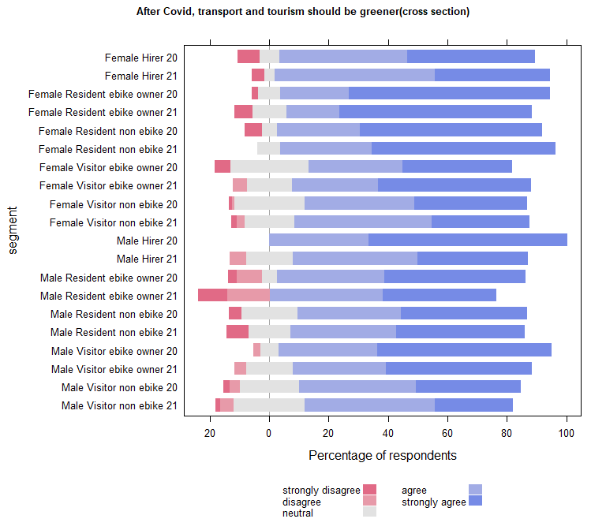

| Comparison | P.adj |
| --- | --- |
| Female Resident ebike owner 20 - Female Visitor ebike owner 20 | 0.040 |
| Female Resident ebike owner 20 - Female Visitor non ebike 20 | 0.012 |
| Female Resident ebike owner 20 - Female Visitor non ebike 21 | 0.004 |
| Female Visitor non ebike 21 - Male Visitor ebike owner 20 | 0.037 |
| Female Resident ebike owner 20 - Male Visitor non ebike 20 | 0.004 |
| Male Visitor ebike owner 20 - Male Visitor non ebike 20 | 0.035 |
| Female Resident ebike owner 20 - Male Visitor non ebike 21 | 0.000 |
| Female Resident ebike owner 21 - Male Visitor non ebike 21 | 0.010 |
| Male Visitor ebike owner 20 - Male Visitor non ebike 21 | 0.002 |

### Compare each segment in 2020 with the same segment in 2021

| segment2020 | segment2021 | pvalue |
| --- | --- | --- |

## Run the plot on B(2020) and C(2021) separately to carry out within year comparisons

## B (2020)

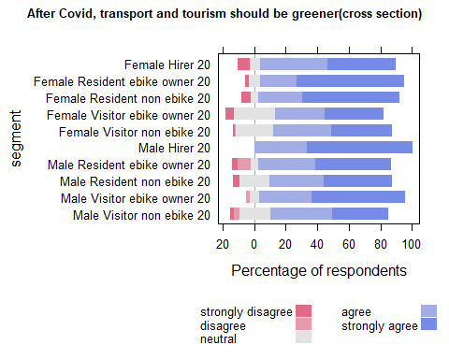

| Comparison | P.adj |
| --- | --- |
| Female Resident ebike owner 20 - Female Visitor ebike owner 20 | 0.024 |
| Female Resident ebike owner 20 - Female Visitor non ebike 20 | 0.007 |
| Female Visitor non ebike 20 - Male Visitor ebike owner 20 | 0.047 |
| Female Resident ebike owner 20 - Male Visitor non ebike 20 | 0.003 |
| Male Visitor ebike owner 20 - Male Visitor non ebike 20 | 0.020 |

## C (2021)

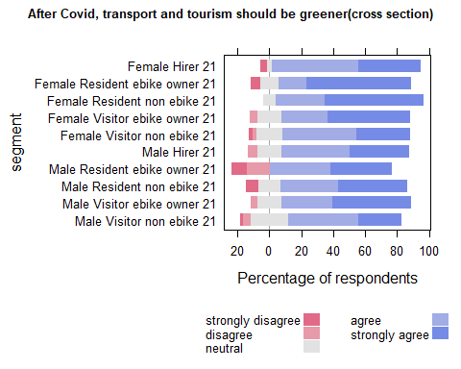

| Comparison | P.adj |
| --- | --- |
| Female Resident ebike owner 21 - Male Visitor non ebike 21 | 0.015 |

## Waves analysis

## run analysis on 2020 and 2021 PANEL data

| segment | agree | strongly agree | neutral | strongly disagree | disagree | SUMCOL | net percent |
| --- | --- | --- | --- | --- | --- | --- | --- |
| Female Hirer 20 | 100 | 0 | 0 | 0 | 0 | 3 | 100 |
| Female Hirer 21 | 60 | 40 | 0 | 0 | 0 | 5 | 100 |
| Female Resident ebike owner 20 | 12 | 81 | 6 | 0 | 0 | 16 | 93 |
| Female Resident ebike owner 21 | 17 | 78 | 0 | 6 | 0 | 18 | 89 |
| Female Resident non ebike 20 | 25 | 75 | 0 | 0 | 0 | 4 | 100 |
| Female Resident non ebike 21 | 0 | 100 | 0 | 0 | 0 | 4 | 100 |
| Female Visitor ebike owner 20 | 14 | 57 | 14 | 14 | 0 | 7 | 57 |
| Female Visitor ebike owner 21 | 40 | 60 | 0 | 0 | 0 | 5 | 100 |
| Female Visitor non ebike 20 | 36 | 57 | 7 | 0 | 0 | 14 | 93 |
| Female Visitor non ebike 21 | 38 | 54 | 0 | 8 | 0 | 13 | 84 |
| Male Hirer 20 | 50 | 50 | 0 | 0 | 0 | 2 | 100 |
| Male Hirer 21 | 50 | 17 | 17 | 0 | 17 | 6 | 50 |
| Male Resident ebike owner 20 | 31 | 46 | 0 | 0 | 23 | 13 | 54 |
| Male Resident ebike owner 21 | 33 | 33 | 0 | 13 | 20 | 15 | 33 |
| Male Resident non ebike 20 | 22 | 56 | 22 | 0 | 0 | 9 | 78 |
| Male Resident non ebike 21 | 33 | 67 | 0 | 0 | 0 | 6 | 100 |
| Male Visitor ebike owner 20 | 32 | 58 | 11 | 0 | 0 | 19 | 90 |
| Male Visitor ebike owner 21 | 20 | 70 | 10 | 0 | 0 | 20 | 90 |
| Male Visitor non ebike 20 | 38 | 38 | 12 | 12 | 0 | 26 | 64 |
| Male Visitor non ebike 21 | 43 | 33 | 14 | 0 | 10 | 21 | 66 |

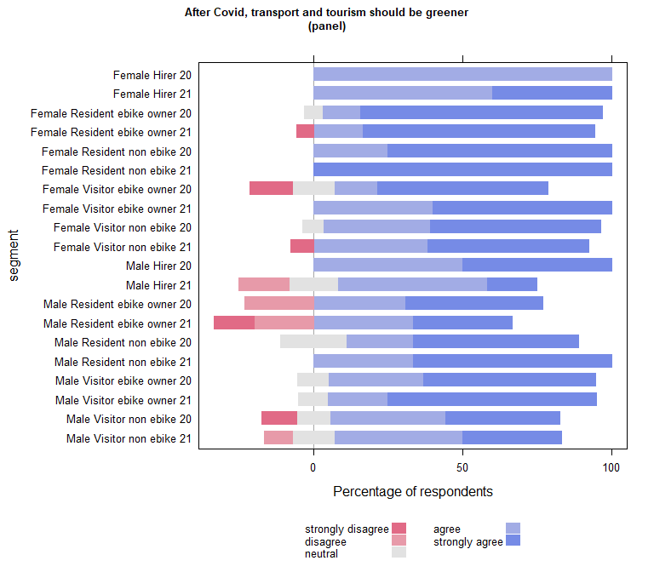

| Comparison | P.adj |
| --- | --- |

| segment2020 | segment2021 | pvalue |
| --- | --- | --- |

## wilcoxon paired test on panel data (if table empty non significant)

| estimate | statistic | p.value | conf.low | conf.high | method | alternative | segment |
| --- | --- | --- | --- | --- | --- | --- | --- |

## Run within year comparisons on the panel data

## B (2020) PANEL

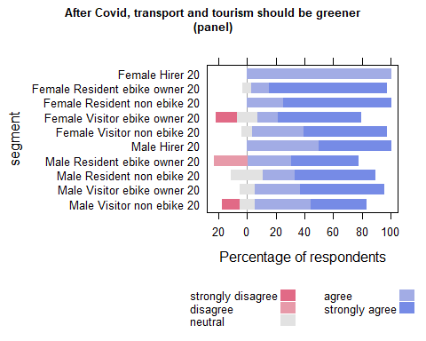

| Comparison | P.adj |
| --- | --- |

## C (2021) PANEL

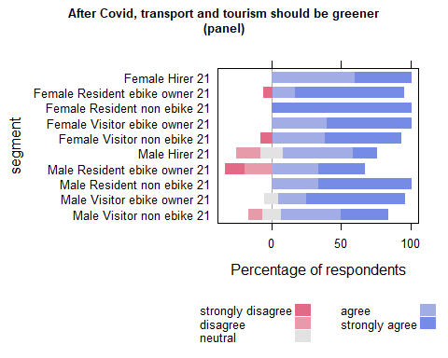

| Comparison | P.adj |
| --- | --- |

## “The Lake District national park would be more beautiful ifmore people travelled by bike or e-bikeand fewer people travelled by car/van”

## Cross section analysis

| segment | strongly disagree | neutral | agree | strongly agree | disagree | SUMCOL | net percent |
| --- | --- | --- | --- | --- | --- | --- | --- |
| Female Hirer 20 | 14 | 14 | 36 | 36 | 0 | 14 | 58 |
| Female Hirer 21 | 4 | 8 | 50 | 35 | 4 | 26 | 77 |
| Female Resident ebike owner 20 | 2 | 0 | 19 | 77 | 2 | 52 | 92 |
| Female Resident ebike owner 21 | 6 | 6 | 12 | 74 | 3 | 34 | 77 |
| Female Resident non ebike 20 | 6 | 11 | 11 | 72 | 0 | 18 | 77 |
| Female Resident non ebike 21 | 0 | 15 | 31 | 54 | 0 | 13 | 85 |
| Female Visitor ebike owner 20 | 3 | 11 | 45 | 37 | 5 | 38 | 74 |
| Female Visitor ebike owner 21 | 0 | 18 | 29 | 49 | 4 | 45 | 74 |
| Female Visitor non ebike 20 | 1 | 29 | 35 | 30 | 6 | 133 | 58 |
| Female Visitor non ebike 21 | 2 | 21 | 40 | 33 | 5 | 184 | 66 |
| Male Hirer 20 | 0 | 11 | 33 | 44 | 11 | 9 | 66 |
| Male Hirer 21 | 0 | 37 | 16 | 47 | 0 | 19 | 63 |
| Male Resident ebike owner 20 | 6 | 6 | 28 | 61 | 0 | 36 | 83 |
| Male Resident ebike owner 21 | 14 | 0 | 33 | 52 | 0 | 21 | 71 |
| Male Resident non ebike 20 | 0 | 12 | 27 | 54 | 8 | 26 | 73 |
| Male Resident non ebike 21 | 0 | 21 | 29 | 36 | 14 | 14 | 51 |
| Male Visitor ebike owner 20 | 0 | 6 | 27 | 62 | 4 | 48 | 85 |
| Male Visitor ebike owner 21 | 0 | 8 | 31 | 59 | 2 | 51 | 88 |
| Male Visitor non ebike 20 | 5 | 21 | 40 | 24 | 10 | 145 | 49 |
| Male Visitor non ebike 21 | 0 | 30 | 43 | 21 | 6 | 149 | 58 |

## run analysis on 2020 and 2021 cross section data

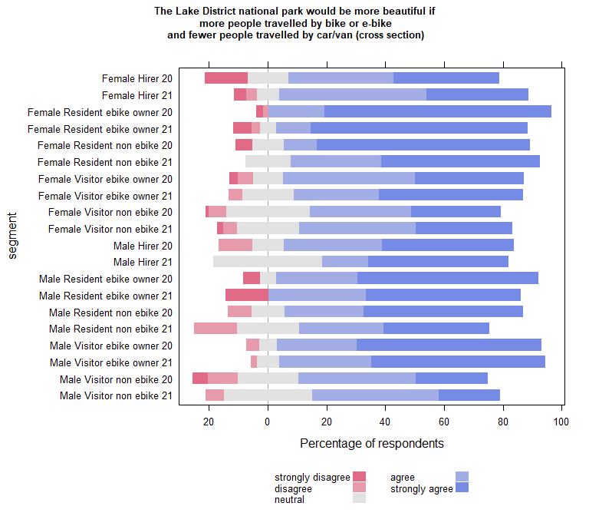

| Comparison | P.adj |
| --- | --- |
| Female Hirer 20 - Female Resident ebike owner 20 | 0.027 |
| Female Hirer 21 - Female Resident ebike owner 20 | 0.022 |
| Female Resident ebike owner 20 - Female Visitor ebike owner 20 | 0.008 |
| Female Resident ebike owner 20 - Female Visitor ebike owner 21 | 0.035 |
| Female Resident ebike owner 20 - Female Visitor non ebike 20 | 0.000 |
| Female Resident ebike owner 21 - Female Visitor non ebike 20 | 0.001 |
| Female Resident non ebike 20 - Female Visitor non ebike 20 | 0.019 |
| Female Resident ebike owner 20 - Female Visitor non ebike 21 | 0.000 |
| Female Resident ebike owner 21 - Female Visitor non ebike 21 | 0.004 |
| Female Resident non ebike 20 - Female Visitor non ebike 21 | 0.050 |
| Female Resident ebike owner 20 - Male Hirer 21 | 0.050 |
| Female Visitor non ebike 20 - Male Resident ebike owner 20 | 0.004 |
| Female Visitor non ebike 21 - Male Resident ebike owner 20 | 0.019 |
| Female Resident ebike owner 20 - Male Resident non ebike 21 | 0.018 |
| Female Visitor non ebike 20 - Male Visitor ebike owner 20 | 0.001 |
| Female Visitor non ebike 21 - Male Visitor ebike owner 20 | 0.003 |
| Female Visitor non ebike 20 - Male Visitor ebike owner 21 | 0.001 |
| Female Visitor non ebike 21 - Male Visitor ebike owner 21 | 0.004 |
| Female Resident ebike owner 20 - Male Visitor non ebike 20 | 0.000 |
| Female Resident ebike owner 21 - Male Visitor non ebike 20 | 0.000 |
| Female Resident non ebike 20 - Male Visitor non ebike 20 | 0.004 |
| Female Visitor ebike owner 21 - Male Visitor non ebike 20 | 0.017 |
| Male Resident ebike owner 20 - Male Visitor non ebike 20 | 0.000 |
| Male Resident non ebike 20 - Male Visitor non ebike 20 | 0.028 |
| Male Visitor ebike owner 20 - Male Visitor non ebike 20 | 0.000 |
| Male Visitor ebike owner 21 - Male Visitor non ebike 20 | 0.000 |
| Female Resident ebike owner 20 - Male Visitor non ebike 21 | 0.000 |
| Female Resident ebike owner 21 - Male Visitor non ebike 21 | 0.000 |
| Female Resident non ebike 20 - Male Visitor non ebike 21 | 0.004 |
| Female Visitor ebike owner 21 - Male Visitor non ebike 21 | 0.017 |
| Male Resident ebike owner 20 - Male Visitor non ebike 21 | 0.000 |
| Male Resident non ebike 20 - Male Visitor non ebike 21 | 0.027 |
| Male Visitor ebike owner 20 - Male Visitor non ebike 21 | 0.000 |
| Male Visitor ebike owner 21 - Male Visitor non ebike 21 | 0.000 |

### Compare each segment in 2020 with the same segment in 2021

| segment2020 | segment2021 | pvalue |
| --- | --- | --- |

## Run the plot on B(2020) and C(2021) separately to carry out within year comparisons

## B (2020)

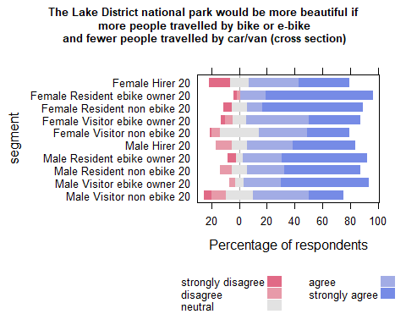

| Comparison | P.adj |
| --- | --- |
| Female Hirer 20 - Female Resident ebike owner 20 | 0.021 |
| Female Resident ebike owner 20 - Female Visitor ebike owner 20 | 0.006 |
| Female Resident ebike owner 20 - Female Visitor non ebike 20 | 0.000 |
| Female Resident non ebike 20 - Female Visitor non ebike 20 | 0.015 |
| Female Visitor non ebike 20 - Male Resident ebike owner 20 | 0.004 |
| Female Visitor non ebike 20 - Male Visitor ebike owner 20 | 0.000 |
| Female Resident ebike owner 20 - Male Visitor non ebike 20 | 0.000 |
| Female Resident non ebike 20 - Male Visitor non ebike 20 | 0.004 |
| Male Resident ebike owner 20 - Male Visitor non ebike 20 | 0.000 |
| Male Resident non ebike 20 - Male Visitor non ebike 20 | 0.021 |
| Male Visitor ebike owner 20 - Male Visitor non ebike 20 | 0.000 |

## C (2021)

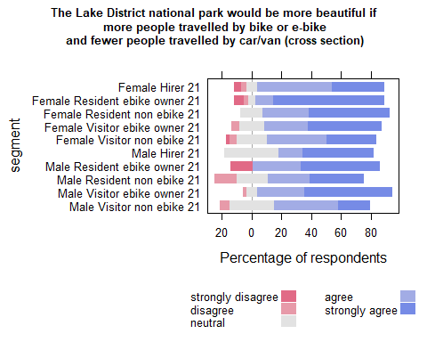

| Comparison | P.adj |
| --- | --- |
| Female Resident ebike owner 21 - Female Visitor non ebike 21 | 0.005 |
| Female Visitor non ebike 21 - Male Visitor ebike owner 21 | 0.004 |
| Female Resident ebike owner 21 - Male Visitor non ebike 21 | 0.000 |
| Female Visitor ebike owner 21 - Male Visitor non ebike 21 | 0.016 |
| Male Visitor ebike owner 21 - Male Visitor non ebike 21 | 0.000 |

## Waves analysis

## run analysis on 2020 and 2021 PANEL data

| segment | agree | neutral | strongly agree | strongly disagree | disagree | SUMCOL | net percent |
| --- | --- | --- | --- | --- | --- | --- | --- |
| Female Hirer 20 | 100 | 0 | 0 | 0 | 0 | 3 | 100 |
| Female Hirer 21 | 60 | 20 | 20 | 0 | 0 | 5 | 80 |
| Female Resident ebike owner 20 | 12 | 0 | 88 | 0 | 0 | 16 | 100 |
| Female Resident ebike owner 21 | 6 | 0 | 83 | 6 | 6 | 18 | 77 |
| Female Resident non ebike 20 | 0 | 0 | 100 | 0 | 0 | 4 | 100 |
| Female Resident non ebike 21 | 50 | 0 | 50 | 0 | 0 | 4 | 100 |
| Female Visitor ebike owner 20 | 43 | 0 | 43 | 14 | 0 | 7 | 72 |
| Female Visitor ebike owner 21 | 20 | 0 | 80 | 0 | 0 | 5 | 100 |
| Female Visitor non ebike 20 | 43 | 7 | 50 | 0 | 0 | 14 | 93 |
| Female Visitor non ebike 21 | 31 | 0 | 46 | 8 | 15 | 13 | 54 |
| Male Hirer 20 | 0 | 0 | 50 | 0 | 50 | 2 | 0 |
| Male Hirer 21 | 0 | 33 | 67 | 0 | 0 | 6 | 67 |
| Male Resident ebike owner 20 | 31 | 8 | 54 | 8 | 0 | 13 | 77 |
| Male Resident ebike owner 21 | 27 | 0 | 53 | 20 | 0 | 15 | 60 |
| Male Resident non ebike 20 | 22 | 11 | 56 | 0 | 11 | 9 | 67 |
| Male Resident non ebike 21 | 17 | 17 | 50 | 0 | 17 | 6 | 50 |
| Male Visitor ebike owner 20 | 26 | 5 | 63 | 0 | 5 | 19 | 84 |
| Male Visitor ebike owner 21 | 25 | 0 | 75 | 0 | 0 | 20 | 100 |
| Male Visitor non ebike 20 | 42 | 15 | 27 | 12 | 4 | 26 | 53 |
| Male Visitor non ebike 21 | 52 | 24 | 14 | 0 | 10 | 21 | 56 |

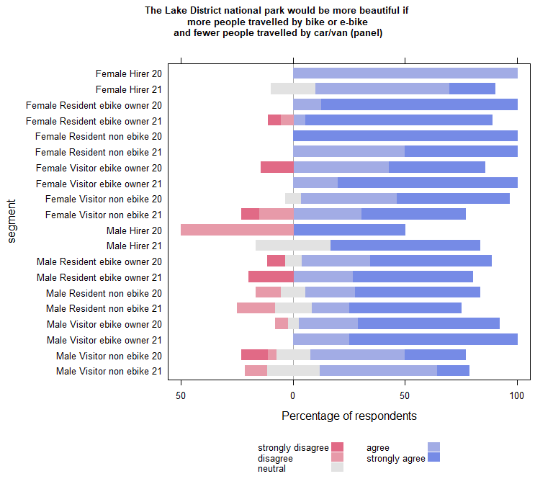

| Comparison | P.adj |
| --- | --- |
| Female Resident ebike owner 20 - Male Visitor non ebike 20 | 0.006 |
| Female Resident ebike owner 21 - Male Visitor non ebike 20 | 0.017 |
| Male Visitor ebike owner 21 - Male Visitor non ebike 20 | 0.017 |
| Female Resident ebike owner 20 - Male Visitor non ebike 21 | 0.003 |
| Female Resident ebike owner 21 - Male Visitor non ebike 21 | 0.005 |
| Male Visitor ebike owner 21 - Male Visitor non ebike 21 | 0.008 |

## wilcoxon paired test on panel data (if table empty non significant)

| estimate | statistic | p.value | conf.low | conf.high | method | alternative | segment |
| --- | --- | --- | --- | --- | --- | --- | --- |

| segment2020 | segment2021 | pvalue |
| --- | --- | --- |

## Run within year comparisons on the panel data

## B (2020) PANEL

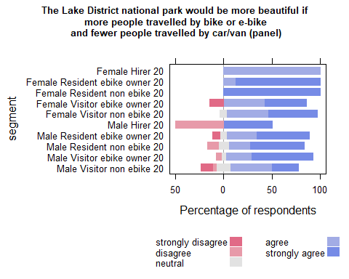

| Comparison | P.adj |
| --- | --- |
| Female Resident ebike owner 20 - Male Visitor non ebike 20 | 0.003 |

## C (2021) PANEL

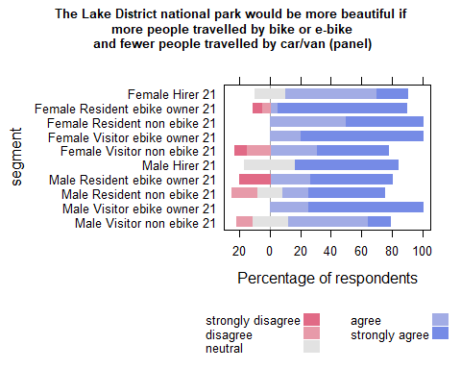

| Comparison | P.adj |
| --- | --- |
| Female Resident ebike owner 21 - Male Visitor non ebike 21 | 0.003 |
| Male Visitor ebike owner 21 - Male Visitor non ebike 21 | 0.005 |

# e-bikes are a good way to replace some car journeys

## Cross section analysis

| segment | strongly disagree | disagree | neutral | agree | strongly agree | SUMCOL | net percent |
| --- | --- | --- | --- | --- | --- | --- | --- |
| Female Hirer 20 | 7 | 7 | 14 | 36 | 36 | 14 | 58 |
| Female Hirer 21 | 0 | 0 | 12 | 69 | 19 | 26 | 88 |
| Female Resident ebike owner 20 | 4 | 0 | 2 | 19 | 75 | 52 | 90 |
| Female Resident ebike owner 21 | 6 | 0 | 6 | 21 | 68 | 34 | 83 |
| Female Resident non ebike 20 | 6 | 0 | 17 | 17 | 61 | 18 | 72 |
| Female Resident non ebike 21 | 0 | 0 | 8 | 54 | 38 | 13 | 92 |
| Female Visitor ebike owner 20 | 3 | 0 | 13 | 42 | 42 | 38 | 81 |
| Female Visitor ebike owner 21 | 2 | 4 | 9 | 36 | 49 | 45 | 79 |
| Female Visitor non ebike 20 | 2 | 5 | 23 | 44 | 27 | 133 | 64 |
| Female Visitor non ebike 21 | 2 | 6 | 19 | 47 | 26 | 184 | 65 |
| Male Hirer 20 | 0 | 0 | 0 | 44 | 56 | 9 | 100 |
| Male Hirer 21 | 5 | 0 | 21 | 26 | 47 | 19 | 68 |
| Male Resident ebike owner 20 | 0 | 0 | 3 | 42 | 56 | 36 | 98 |
| Male Resident ebike owner 21 | 10 | 5 | 14 | 38 | 33 | 21 | 56 |
| Male Resident non ebike 20 | 0 | 4 | 19 | 42 | 35 | 26 | 73 |
| Male Resident non ebike 21 | 0 | 0 | 21 | 43 | 36 | 14 | 79 |
| Male Visitor ebike owner 20 | 0 | 0 | 6 | 25 | 69 | 48 | 94 |
| Male Visitor ebike owner 21 | 0 | 0 | 10 | 45 | 45 | 51 | 90 |
| Male Visitor non ebike 20 | 3 | 11 | 22 | 44 | 19 | 145 | 49 |
| Male Visitor non ebike 21 | 2 | 8 | 26 | 44 | 20 | 149 | 54 |

## run analysis on 2020 and 2021 cross section data

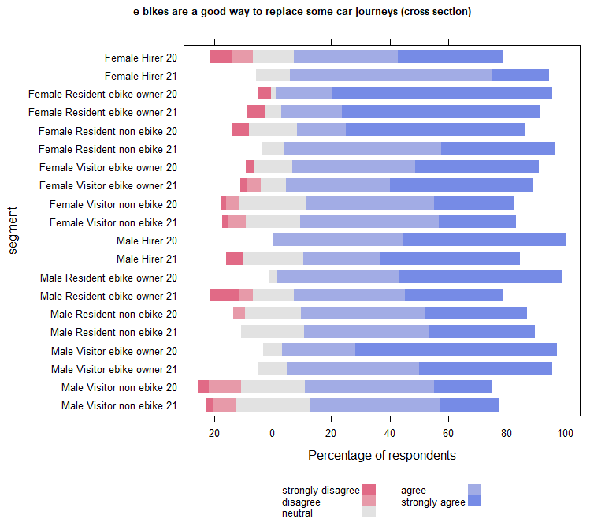

| Comparison | P.adj |
| --- | --- |
| Female Hirer 20 - Female Resident ebike owner 20 | 0.030 |
| Female Hirer 21 - Female Resident ebike owner 20 | 0.005 |
| Female Resident ebike owner 20 - Female Visitor ebike owner 20 | 0.043 |
| Female Resident ebike owner 20 - Female Visitor non ebike 20 | 0.000 |
| Female Resident ebike owner 21 - Female Visitor non ebike 20 | 0.001 |
| Female Visitor ebike owner 21 - Female Visitor non ebike 20 | 0.045 |
| Female Resident ebike owner 20 - Female Visitor non ebike 21 | 0.000 |
| Female Resident ebike owner 21 - Female Visitor non ebike 21 | 0.001 |
| Female Visitor ebike owner 21 - Female Visitor non ebike 21 | 0.042 |
| Female Visitor non ebike 20 - Male Resident ebike owner 20 | 0.002 |
| Female Visitor non ebike 21 - Male Resident ebike owner 20 | 0.001 |
| Female Resident ebike owner 20 - Male Resident ebike owner 21 | 0.006 |
| Female Resident ebike owner 20 - Male Resident non ebike 20 | 0.015 |
| Female Hirer 21 - Male Visitor ebike owner 20 | 0.015 |
| Female Visitor non ebike 20 - Male Visitor ebike owner 20 | 0.000 |
| Female Visitor non ebike 21 - Male Visitor ebike owner 20 | 0.000 |
| Male Resident ebike owner 21 - Male Visitor ebike owner 20 | 0.015 |
| Male Resident non ebike 20 - Male Visitor ebike owner 20 | 0.031 |
| Female Visitor non ebike 20 - Male Visitor ebike owner 21 | 0.020 |
| Female Visitor non ebike 21 - Male Visitor ebike owner 21 | 0.017 |
| Female Resident ebike owner 20 - Male Visitor non ebike 20 | 0.000 |
| Female Resident ebike owner 21 - Male Visitor non ebike 20 | 0.000 |
| Female Resident non ebike 20 - Male Visitor non ebike 20 | 0.015 |
| Female Visitor ebike owner 20 - Male Visitor non ebike 20 | 0.010 |
| Female Visitor ebike owner 21 - Male Visitor non ebike 20 | 0.001 |
| Male Hirer 20 - Male Visitor non ebike 20 | 0.031 |
| Male Resident ebike owner 20 - Male Visitor non ebike 20 | 0.000 |
| Male Visitor ebike owner 20 - Male Visitor non ebike 20 | 0.000 |
| Male Visitor ebike owner 21 - Male Visitor non ebike 20 | 0.000 |
| Female Resident ebike owner 20 - Male Visitor non ebike 21 | 0.000 |
| Female Resident ebike owner 21 - Male Visitor non ebike 21 | 0.000 |
| Female Resident non ebike 20 - Male Visitor non ebike 21 | 0.021 |
| Female Visitor ebike owner 20 - Male Visitor non ebike 21 | 0.017 |
| Female Visitor ebike owner 21 - Male Visitor non ebike 21 | 0.002 |
| Male Hirer 20 - Male Visitor non ebike 21 | 0.040 |
| Male Resident ebike owner 20 - Male Visitor non ebike 21 | 0.000 |
| Male Visitor ebike owner 20 - Male Visitor non ebike 21 | 0.000 |
| Male Visitor ebike owner 21 - Male Visitor non ebike 21 | 0.001 |

### Compare each segment in 2020 with the same segment in 2021

| segment2020 | segment2021 | pvalue |
| --- | --- | --- |

## Run the plot on B(2020) and C(2021) separately to carry out within year comparisons

## B (2020)

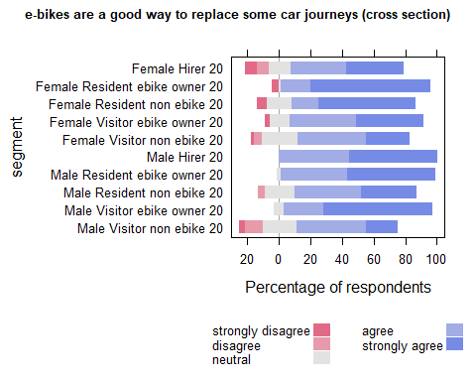

| Comparison | P.adj |
| --- | --- |
| Female Hirer 20 - Female Resident ebike owner 20 | 0.026 |
| Female Resident ebike owner 20 - Female Visitor ebike owner 20 | 0.030 |
| Female Resident ebike owner 20 - Female Visitor non ebike 20 | 0.000 |
| Female Visitor non ebike 20 - Male Resident ebike owner 20 | 0.002 |
| Female Resident ebike owner 20 - Male Resident non ebike 20 | 0.011 |
| Female Hirer 20 - Male Visitor ebike owner 20 | 0.041 |
| Female Visitor non ebike 20 - Male Visitor ebike owner 20 | 0.000 |
| Male Resident non ebike 20 - Male Visitor ebike owner 20 | 0.025 |
| Female Resident ebike owner 20 - Male Visitor non ebike 20 | 0.000 |
| Female Resident non ebike 20 - Male Visitor non ebike 20 | 0.011 |
| Female Visitor ebike owner 20 - Male Visitor non ebike 20 | 0.010 |
| Male Hirer 20 - Male Visitor non ebike 20 | 0.023 |
| Male Resident ebike owner 20 - Male Visitor non ebike 20 | 0.000 |
| Male Visitor ebike owner 20 - Male Visitor non ebike 20 | 0.000 |

## C (2021)

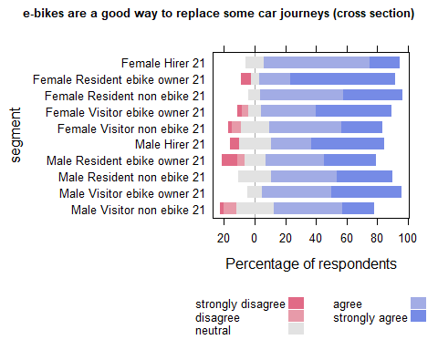

| Comparison | P.adj |
| --- | --- |
| Female Resident ebike owner 21 - Female Visitor non ebike 21 | 0.001 |
| Female Visitor non ebike 21 - Male Visitor ebike owner 21 | 0.018 |
| Female Resident ebike owner 21 - Male Visitor non ebike 21 | 0.000 |
| Female Visitor ebike owner 21 - Male Visitor non ebike 21 | 0.002 |
| Male Visitor ebike owner 21 - Male Visitor non ebike 21 | 0.001 |

## Waves analysis

## run analysis on 2020 and 2021 PANEL data

| segment | agree | neutral | strongly agree | strongly disagree | disagree | SUMCOL | net percent |
| --- | --- | --- | --- | --- | --- | --- | --- |
| Female Hirer 20 | 100 | 0 | 0 | 0 | 0 | 3 | 100 |
| Female Hirer 21 | 80 | 20 | 0 | 0 | 0 | 5 | 80 |
| Female Resident ebike owner 20 | 19 | 0 | 81 | 0 | 0 | 16 | 100 |
| Female Resident ebike owner 21 | 11 | 0 | 78 | 11 | 0 | 18 | 78 |
| Female Resident non ebike 20 | 25 | 25 | 50 | 0 | 0 | 4 | 75 |
| Female Resident non ebike 21 | 50 | 0 | 50 | 0 | 0 | 4 | 100 |
| Female Visitor ebike owner 20 | 29 | 0 | 57 | 14 | 0 | 7 | 72 |
| Female Visitor ebike owner 21 | 40 | 0 | 60 | 0 | 0 | 5 | 100 |
| Female Visitor non ebike 20 | 36 | 14 | 50 | 0 | 0 | 14 | 86 |
| Female Visitor non ebike 21 | 62 | 0 | 31 | 8 | 0 | 13 | 85 |
| Male Hirer 20 | 50 | 0 | 50 | 0 | 0 | 2 | 100 |
| Male Hirer 21 | 17 | 0 | 67 | 17 | 0 | 6 | 67 |
| Male Resident ebike owner 20 | 54 | 0 | 46 | 0 | 0 | 13 | 100 |
| Male Resident ebike owner 21 | 33 | 20 | 33 | 13 | 0 | 15 | 53 |
| Male Resident non ebike 20 | 22 | 33 | 44 | 0 | 0 | 9 | 66 |
| Male Resident non ebike 21 | 50 | 0 | 50 | 0 | 0 | 6 | 100 |
| Male Visitor ebike owner 20 | 16 | 5 | 79 | 0 | 0 | 19 | 95 |
| Male Visitor ebike owner 21 | 30 | 5 | 65 | 0 | 0 | 20 | 95 |
| Male Visitor non ebike 20 | 38 | 15 | 19 | 8 | 19 | 26 | 30 |
| Male Visitor non ebike 21 | 67 | 0 | 14 | 0 | 19 | 21 | 62 |

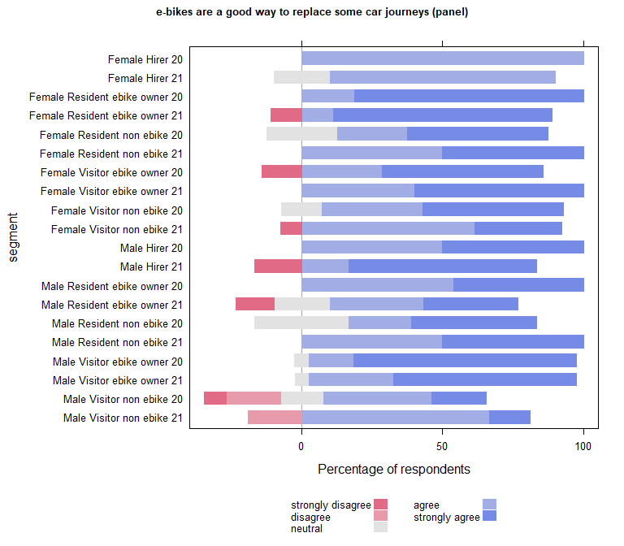

| Comparison | P.adj |
| --- | --- |
| Female Resident ebike owner 20 - Male Resident ebike owner 21 | 0.049 |
| Female Resident ebike owner 20 - Male Visitor non ebike 20 | 0.002 |
| Female Resident ebike owner 21 - Male Visitor non ebike 20 | 0.004 |
| Male Visitor ebike owner 20 - Male Visitor non ebike 20 | 0.001 |
| Male Visitor ebike owner 21 - Male Visitor non ebike 20 | 0.006 |
| Female Resident ebike owner 20 - Male Visitor non ebike 21 | 0.006 |
| Female Resident ebike owner 21 - Male Visitor non ebike 21 | 0.020 |
| Male Visitor ebike owner 20 - Male Visitor non ebike 21 | 0.006 |
| Male Visitor ebike owner 21 - Male Visitor non ebike 21 | 0.045 |

## wilcoxon paired test on panel data (if table empty non significant)

| estimate | statistic | p.value | conf.low | conf.high | method | alternative | segment |
| --- | --- | --- | --- | --- | --- | --- | --- |

| segment2020 | segment2021 | pvalue |
| --- | --- | --- |

## Run within year comparisons on the panel data

## B (2020) PANEL

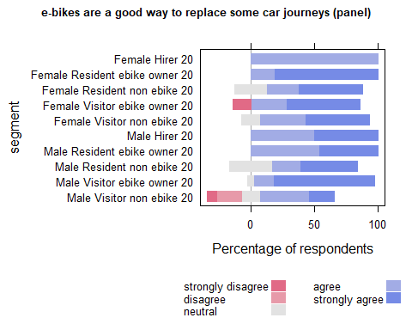

| Comparison | P.adj |
| --- | --- |
| Female Resident ebike owner 20 - Male Visitor non ebike 20 | 0.001 |
| Male Visitor ebike owner 20 - Male Visitor non ebike 20 | 0.000 |

## C (2021) PANEL

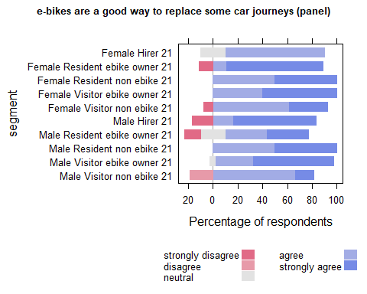

| Comparison | P.adj |
| --- | --- |
| Female Resident ebike owner 21 - Male Visitor non ebike 21 | 0.027 |
| Male Visitor ebike owner 21 - Male Visitor non ebike 21 | 0.038 |

# Personal aspiration around potential behaviour change

## I would like to travel by car less in the Lake District

## Cross section analysis

| segment | strongly disagree | disagree | neutral | agree | strongly agree | SUMCOL | net percent |
| --- | --- | --- | --- | --- | --- | --- | --- |
| Female Hirer 20 | 7 | 7 | 29 | 36 | 21 | 14 | 43 |
| Female Hirer 21 | 0 | 8 | 19 | 46 | 27 | 26 | 65 |
| Female Resident ebike owner 20 | 4 | 2 | 12 | 23 | 60 | 52 | 77 |
| Female Resident ebike owner 21 | 3 | 3 | 24 | 24 | 47 | 34 | 65 |
| Female Resident non ebike 20 | 6 | 0 | 22 | 33 | 39 | 18 | 66 |
| Female Resident non ebike 21 | 0 | 0 | 15 | 46 | 38 | 13 | 84 |
| Female Visitor ebike owner 20 | 3 | 16 | 18 | 32 | 32 | 38 | 45 |
| Female Visitor ebike owner 21 | 2 | 9 | 22 | 31 | 36 | 45 | 56 |
| Female Visitor non ebike 20 | 4 | 11 | 29 | 35 | 22 | 133 | 42 |
| Female Visitor non ebike 21 | 3 | 8 | 32 | 36 | 21 | 184 | 46 |
| Male Hirer 20 | 0 | 0 | 22 | 33 | 44 | 9 | 77 |
| Male Hirer 21 | 0 | 0 | 42 | 37 | 21 | 19 | 58 |
| Male Resident ebike owner 20 | 3 | 6 | 22 | 44 | 25 | 36 | 60 |
| Male Resident ebike owner 21 | 14 | 10 | 19 | 38 | 19 | 21 | 33 |
| Male Resident non ebike 20 | 0 | 4 | 38 | 35 | 23 | 26 | 54 |
| Male Resident non ebike 21 | 14 | 14 | 29 | 7 | 36 | 14 | 15 |
| Male Visitor ebike owner 20 | 4 | 4 | 15 | 33 | 44 | 48 | 69 |
| Male Visitor ebike owner 21 | 2 | 8 | 12 | 51 | 27 | 51 | 68 |
| Male Visitor non ebike 20 | 7 | 14 | 30 | 37 | 13 | 145 | 29 |
| Male Visitor non ebike 21 | 7 | 10 | 34 | 42 | 8 | 149 | 33 |

## run analysis on 2020 and 2021 cross section data

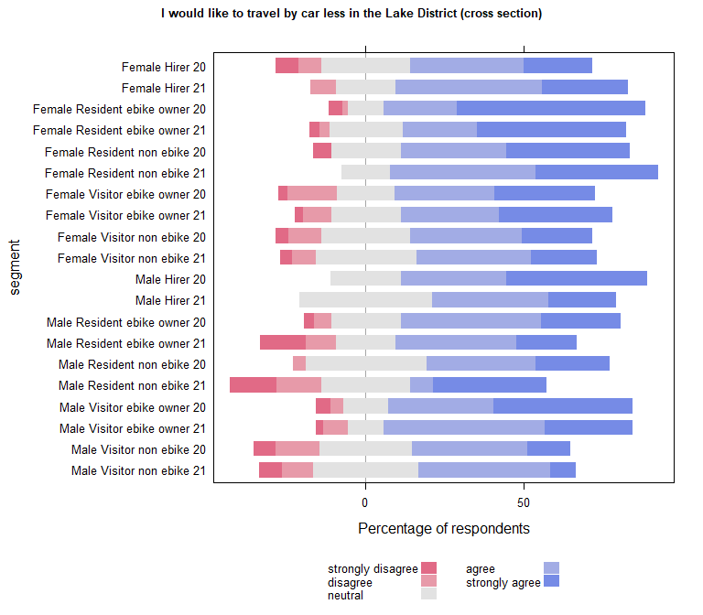

| Comparison | P.adj |
| --- | --- |
| Female Resident ebike owner 20 - Female Visitor ebike owner 20 | 0.048 |
| Female Resident ebike owner 20 - Female Visitor non ebike 20 | 0.000 |
| Female Resident ebike owner 20 - Female Visitor non ebike 21 | 0.000 |
| Female Resident ebike owner 20 - Male Resident ebike owner 21 | 0.013 |
| Female Resident ebike owner 20 - Male Resident non ebike 21 | 0.038 |
| Female Visitor non ebike 20 - Male Visitor ebike owner 20 | 0.035 |
| Female Visitor non ebike 21 - Male Visitor ebike owner 20 | 0.034 |
| Female Resident ebike owner 20 - Male Visitor non ebike 20 | 0.000 |
| Female Resident ebike owner 21 - Male Visitor non ebike 20 | 0.004 |
| Female Resident non ebike 21 - Male Visitor non ebike 20 | 0.046 |
| Female Visitor ebike owner 21 - Male Visitor non ebike 20 | 0.038 |
| Male Visitor ebike owner 20 - Male Visitor non ebike 20 | 0.000 |
| Male Visitor ebike owner 21 - Male Visitor non ebike 20 | 0.010 |
| Female Resident ebike owner 20 - Male Visitor non ebike 21 | 0.000 |
| Female Resident ebike owner 21 - Male Visitor non ebike 21 | 0.003 |
| Female Resident non ebike 21 - Male Visitor non ebike 21 | 0.039 |
| Female Visitor ebike owner 21 - Male Visitor non ebike 21 | 0.024 |
| Male Visitor ebike owner 20 - Male Visitor non ebike 21 | 0.000 |
| Male Visitor ebike owner 21 - Male Visitor non ebike 21 | 0.005 |

### Compare each segment in 2020 with the same segment in 2021

| segment2020 | segment2021 | pvalue |
| --- | --- | --- |

## Run the plot on B(2020) and C(2021) separately to carry out within year comparisons

## B (2020)

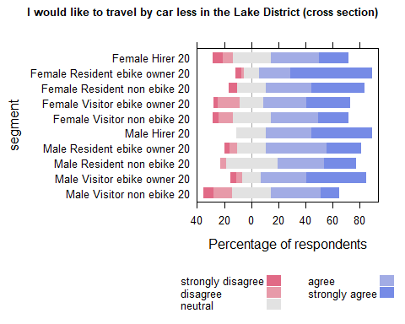

| Comparison | P.adj |
| --- | --- |
| Female Resident ebike owner 20 - Female Visitor ebike owner 20 | 0.048 |
| Female Resident ebike owner 20 - Female Visitor non ebike 20 | 0.000 |
| Female Resident ebike owner 20 - Male Resident non ebike 20 | 0.050 |
| Female Visitor non ebike 20 - Male Visitor ebike owner 20 | 0.039 |
| Female Resident ebike owner 20 - Male Visitor non ebike 20 | 0.000 |
| Male Visitor ebike owner 20 - Male Visitor non ebike 20 | 0.000 |

## C (2021)

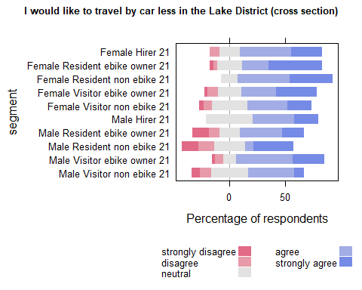

| Comparison | P.adj |
| --- | --- |
| Female Resident ebike owner 21 - Male Visitor non ebike 21 | 0.003 |
| Female Resident non ebike 21 - Male Visitor non ebike 21 | 0.029 |
| Female Visitor ebike owner 21 - Male Visitor non ebike 21 | 0.019 |
| Male Visitor ebike owner 21 - Male Visitor non ebike 21 | 0.004 |

## Waves analysis

## run analysis on 2020 and 2021 PANEL data

| segment | agree | disagree | neutral | strongly agree | strongly disagree | SUMCOL | net percent |
| --- | --- | --- | --- | --- | --- | --- | --- |
| Female Hirer 20 | 100 | 0 | 0 | 0 | 0 | 3 | 100 |
| Female Hirer 21 | 40 | 20 | 40 | 0 | 0 | 5 | 20 |
| Female Resident ebike owner 20 | 25 | 0 | 12 | 62 | 0 | 16 | 87 |
| Female Resident ebike owner 21 | 17 | 0 | 22 | 56 | 6 | 18 | 67 |
| Female Resident non ebike 20 | 25 | 0 | 25 | 50 | 0 | 4 | 75 |
| Female Resident non ebike 21 | 50 | 0 | 0 | 50 | 0 | 4 | 100 |
| Female Visitor ebike owner 20 | 14 | 14 | 14 | 43 | 14 | 7 | 29 |
| Female Visitor ebike owner 21 | 20 | 0 | 20 | 60 | 0 | 5 | 80 |
| Female Visitor non ebike 20 | 43 | 0 | 14 | 43 | 0 | 14 | 86 |
| Female Visitor non ebike 21 | 46 | 8 | 15 | 23 | 8 | 13 | 53 |
| Male Hirer 20 | 50 | 0 | 0 | 50 | 0 | 2 | 100 |
| Male Hirer 21 | 33 | 0 | 50 | 17 | 0 | 6 | 50 |
| Male Resident ebike owner 20 | 46 | 15 | 23 | 15 | 0 | 13 | 46 |
| Male Resident ebike owner 21 | 27 | 7 | 27 | 20 | 20 | 15 | 20 |
| Male Resident non ebike 20 | 33 | 0 | 44 | 22 | 0 | 9 | 55 |
| Male Resident non ebike 21 | 0 | 0 | 50 | 50 | 0 | 6 | 50 |
| Male Visitor ebike owner 20 | 37 | 0 | 16 | 42 | 5 | 19 | 74 |
| Male Visitor ebike owner 21 | 35 | 0 | 10 | 55 | 0 | 20 | 90 |
| Male Visitor non ebike 20 | 27 | 19 | 27 | 19 | 8 | 26 | 19 |
| Male Visitor non ebike 21 | 48 | 19 | 29 | 0 | 5 | 21 | 24 |

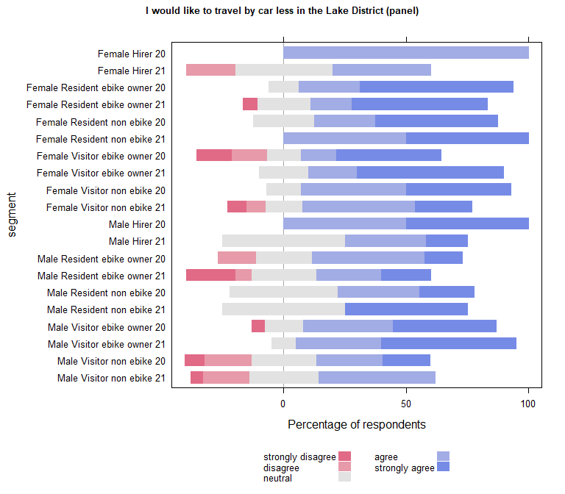

| Comparison | P.adj |
| --- | --- |
| Female Resident ebike owner 20 - Male Visitor non ebike 20 | 0.027 |
| Male Visitor ebike owner 21 - Male Visitor non ebike 20 | 0.034 |
| Female Resident ebike owner 20 - Male Visitor non ebike 21 | 0.010 |
| Male Visitor ebike owner 21 - Male Visitor non ebike 21 | 0.017 |

| segment2020 | segment2021 | pvalue |
| --- | --- | --- |

## wilcoxon paired test on panel data (if table empty non significant)

| estimate | statistic | p.value | conf.low | conf.high | method | alternative | segment |
| --- | --- | --- | --- | --- | --- | --- | --- |
| -1.000065 | 0 | 0.04448651 | -Inf | -1 | Wilcoxon signed rank test with continuity correction | less | female Hirer 21 |

## Run within year comparisons on the panel data

## B (2020) PANEL

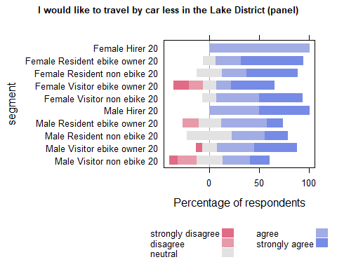

| Comparison | P.adj |
| --- | --- |
| Female Resident ebike owner 20 - Male Visitor non ebike 20 | 0.024 |

## C (2021) PANEL

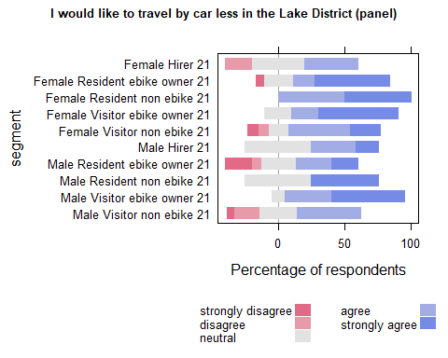

| Comparison | P.adj |
| --- | --- |
| Male Resident ebike owner 21 - Male Visitor ebike owner 21 | 0.037 |
| Female Resident ebike owner 21 - Male Visitor non ebike 21 | 0.045 |
| Male Visitor ebike owner 21 - Male Visitor non ebike 21 | 0.005 |

## I would consider visiting the Lake District without a car if public transport were improved between my home ant the Lake District

## Cross section analysis

| segment | strongly disagree | disagree | neutral | agree | strongly agree | SUMCOL | net percent |
| --- | --- | --- | --- | --- | --- | --- | --- |
| Female Hirer 20 | 21 | 21 | 21 | 21 | 14 | 14 | -7 |
| Female Hirer 21 | 8 | 27 | 35 | 19 | 12 | 26 | -4 |
| Female Visitor ebike owner 20 | 18 | 21 | 18 | 18 | 24 | 38 | 3 |
| Female Visitor ebike owner 21 | 7 | 27 | 20 | 11 | 36 | 45 | 13 |
| Female Visitor non ebike 20 | 15 | 17 | 18 | 27 | 23 | 133 | 18 |
| Female Visitor non ebike 21 | 7 | 18 | 18 | 29 | 29 | 184 | 33 |
| Male Hirer 20 | 22 | 0 | 22 | 22 | 33 | 9 | 33 |
| Male Hirer 21 | 21 | 5 | 32 | 16 | 26 | 19 | 16 |
| Male Visitor ebike owner 20 | 8 | 19 | 10 | 25 | 38 | 48 | 36 |
| Male Visitor ebike owner 21 | 8 | 16 | 20 | 25 | 31 | 51 | 32 |
| Male Visitor non ebike 20 | 13 | 27 | 18 | 27 | 15 | 145 | 2 |
| Male Visitor non ebike 21 | 11 | 17 | 26 | 28 | 17 | 149 | 17 |

## run analysis on 2020 and 2021 cross section data

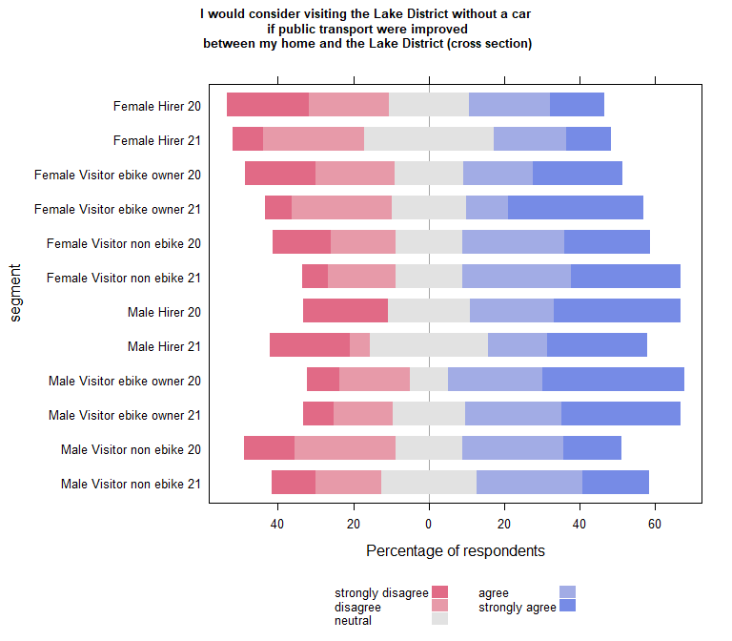

| Comparison | P.adj |
| --- | --- |
| Female Visitor non ebike 21 - Male Visitor non ebike 20 | 0.03 |

### Compare each segment in 2020 with the same segment in 2021

| segment2020 | segment2021 | pvalue |
| --- | --- | --- |

## Run the plot on B(2020) and C(2021) separately to carry out within year comparisons

## B (2020)

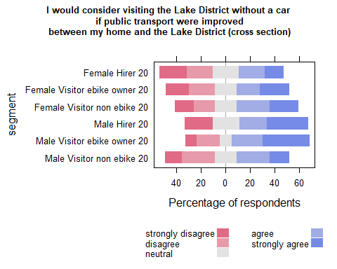

| Comparison | P.adj |
| --- | --- |

## C (2021)

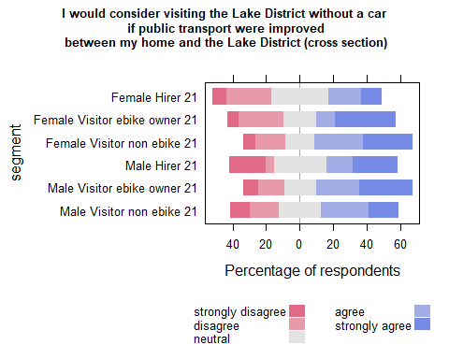

| Comparison | P.adj |
| --- | --- |

## Waves analysis

## run analysis on 2020 and 2021 PANEL data

| segment | strongly disagree | agree | strongly agree | disagree | neutral | SUMCOL | net percent |
| --- | --- | --- | --- | --- | --- | --- | --- |
| Female Hirer 20 | 33 | 33 | 33 | 0 | 0 | 3 | 33 |
| Female Hirer 21 | 0 | 20 | 0 | 20 | 60 | 5 | 0 |
| Female Visitor ebike owner 20 | 29 | 0 | 29 | 14 | 29 | 7 | -14 |
| Female Visitor ebike owner 21 | 0 | 20 | 60 | 20 | 0 | 5 | 60 |
| Female Visitor non ebike 20 | 0 | 29 | 43 | 14 | 14 | 14 | 58 |
| Female Visitor non ebike 21 | 8 | 62 | 23 | 0 | 8 | 13 | 77 |
| Male Hirer 20 | 0 | 0 | 50 | 0 | 50 | 2 | 50 |
| Male Hirer 21 | 17 | 17 | 0 | 17 | 50 | 6 | -17 |
| Male Visitor ebike owner 20 | 0 | 26 | 37 | 26 | 11 | 19 | 37 |
| Male Visitor ebike owner 21 | 0 | 25 | 45 | 20 | 10 | 20 | 50 |
| Male Visitor non ebike 20 | 19 | 27 | 19 | 31 | 4 | 26 | -4 |
| Male Visitor non ebike 21 | 19 | 43 | 10 | 24 | 5 | 21 | 10 |

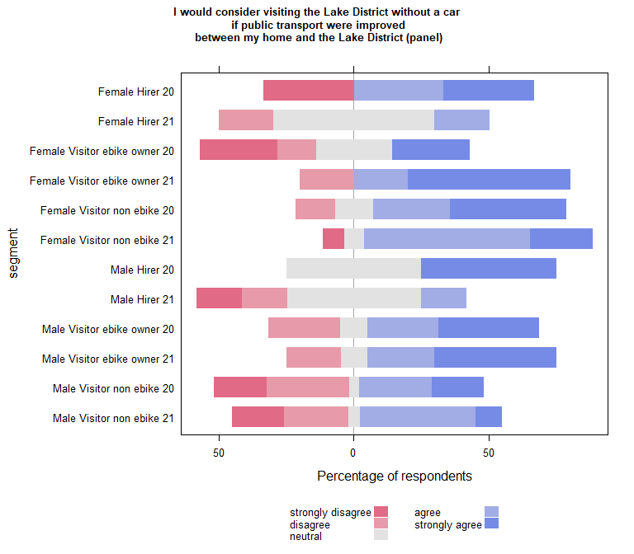

| Comparison | P.adj |
| --- | --- |

| segment2020 | segment2021 | pvalue |
| --- | --- | --- |

## wilcoxon paired test on panel data (if table empty non significant)

| estimate | statistic | p.value | conf.low | conf.high | method | alternative | segment |
| --- | --- | --- | --- | --- | --- | --- | --- |
| 1.530844 | 10 | 0.04875627 | 1 | Inf | Wilcoxon signed rank test with continuity correction | greater | female Visitor ebike owner 21 |

## Run within year comparisons on the panel data

## B (2020) PANEL

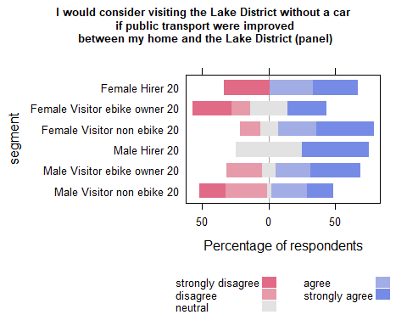

| Comparison | P.adj |
| --- | --- |

## C (2021) PANEL

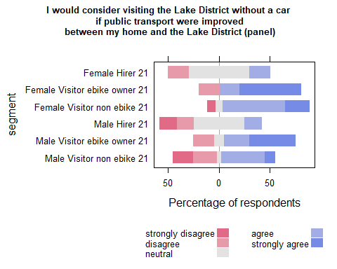

| Comparison | P.adj |
| --- | --- |

# Car Restraint

## Restricting tourist cars and vans in some Lakeland valleys (e.g. Langdale, Borrowdale) would make the Lake District more beautiful

## Cross section analysis

| segment | strongly disagree | disagree | neutral | agree | strongly agree | SUMCOL | net percent |
| --- | --- | --- | --- | --- | --- | --- | --- |
| Female Hirer 20 | 14 | 7 | 7 | 36 | 36 | 14 | 51 |
| Female Hirer 21 | 0 | 12 | 15 | 42 | 31 | 26 | 61 |
| Female Resident ebike owner 20 | 4 | 2 | 4 | 21 | 69 | 52 | 84 |
| Female Resident ebike owner 21 | 3 | 0 | 18 | 12 | 68 | 34 | 77 |
| Female Resident non ebike 20 | 6 | 0 | 0 | 22 | 72 | 18 | 88 |
| Female Resident non ebike 21 | 0 | 0 | 15 | 23 | 62 | 13 | 85 |
| Female Visitor ebike owner 20 | 5 | 5 | 21 | 37 | 32 | 38 | 59 |
| Female Visitor ebike owner 21 | 2 | 9 | 29 | 31 | 29 | 45 | 49 |
| Female Visitor non ebike 20 | 3 | 10 | 24 | 37 | 26 | 133 | 50 |
| Female Visitor non ebike 21 | 3 | 7 | 25 | 42 | 24 | 184 | 56 |
| Male Hirer 20 | 0 | 11 | 22 | 11 | 56 | 9 | 56 |
| Male Hirer 21 | 0 | 11 | 21 | 32 | 37 | 19 | 58 |
| Male Resident ebike owner 20 | 6 | 0 | 14 | 42 | 39 | 36 | 75 |
| Male Resident ebike owner 21 | 14 | 14 | 5 | 38 | 29 | 21 | 39 |
| Male Resident non ebike 20 | 0 | 4 | 19 | 23 | 54 | 26 | 73 |
| Male Resident non ebike 21 | 0 | 0 | 21 | 43 | 36 | 14 | 79 |
| Male Visitor ebike owner 20 | 6 | 8 | 8 | 17 | 60 | 48 | 63 |
| Male Visitor ebike owner 21 | 2 | 4 | 14 | 31 | 49 | 51 | 74 |
| Male Visitor non ebike 20 | 6 | 17 | 15 | 39 | 23 | 145 | 39 |
| Male Visitor non ebike 21 | 4 | 8 | 32 | 38 | 18 | 149 | 44 |

## run analysis on 2020 and 2021 cross section data

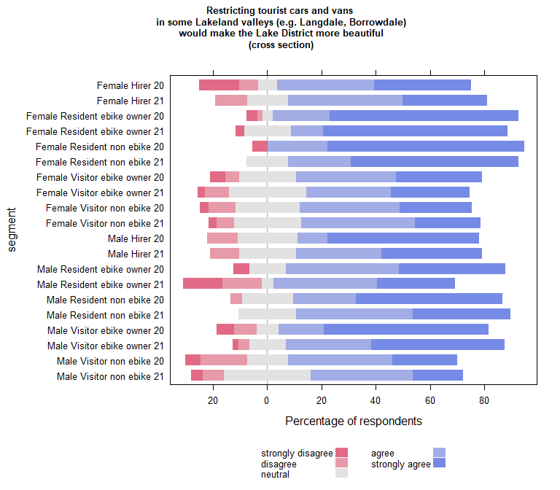

| Comparison | P.adj |
| --- | --- |
| Female Hirer 21 - Female Resident ebike owner 20 | 0.033 |
| Female Resident ebike owner 20 - Female Visitor ebike owner 20 | 0.009 |
| Female Resident non ebike 20 - Female Visitor ebike owner 20 | 0.034 |
| Female Resident ebike owner 20 - Female Visitor ebike owner 21 | 0.001 |
| Female Resident ebike owner 21 - Female Visitor ebike owner 21 | 0.014 |
| Female Resident non ebike 20 - Female Visitor ebike owner 21 | 0.011 |
| Female Resident ebike owner 20 - Female Visitor non ebike 20 | 0.000 |
| Female Resident ebike owner 21 - Female Visitor non ebike 20 | 0.002 |
| Female Resident non ebike 20 - Female Visitor non ebike 20 | 0.003 |
| Female Resident ebike owner 20 - Female Visitor non ebike 21 | 0.000 |
| Female Resident ebike owner 21 - Female Visitor non ebike 21 | 0.002 |
| Female Resident non ebike 20 - Female Visitor non ebike 21 | 0.004 |
| Female Resident ebike owner 20 - Male Resident ebike owner 21 | 0.008 |
| Female Resident ebike owner 21 - Male Resident ebike owner 21 | 0.034 |
| Female Resident non ebike 20 - Male Resident ebike owner 21 | 0.021 |
| Female Visitor non ebike 20 - Male Visitor ebike owner 20 | 0.011 |
| Female Visitor non ebike 21 - Male Visitor ebike owner 20 | 0.010 |
| Female Visitor non ebike 20 - Male Visitor ebike owner 21 | 0.021 |
| Female Visitor non ebike 21 - Male Visitor ebike owner 21 | 0.020 |
| Female Resident ebike owner 20 - Male Visitor non ebike 20 | 0.000 |
| Female Resident ebike owner 21 - Male Visitor non ebike 20 | 0.000 |
| Female Resident non ebike 20 - Male Visitor non ebike 20 | 0.001 |
| Female Resident non ebike 21 - Male Visitor non ebike 20 | 0.028 |
| Male Resident non ebike 20 - Male Visitor non ebike 20 | 0.021 |
| Male Visitor ebike owner 20 - Male Visitor non ebike 20 | 0.002 |
| Male Visitor ebike owner 21 - Male Visitor non ebike 20 | 0.004 |
| Female Resident ebike owner 20 - Male Visitor non ebike 21 | 0.000 |
| Female Resident ebike owner 21 - Male Visitor non ebike 21 | 0.000 |
| Female Resident non ebike 20 - Male Visitor non ebike 21 | 0.000 |
| Female Resident non ebike 21 - Male Visitor non ebike 21 | 0.016 |
| Male Resident ebike owner 20 - Male Visitor non ebike 21 | 0.027 |
| Male Resident non ebike 20 - Male Visitor non ebike 21 | 0.009 |
| Male Visitor ebike owner 20 - Male Visitor non ebike 21 | 0.000 |
| Male Visitor ebike owner 21 - Male Visitor non ebike 21 | 0.001 |

### Compare each segment in 2020 with the same segment in 2021

| segment2020 | segment2021 | pvalue |
| --- | --- | --- |

## Run the plot on B(2020) and C(2021) separately to carry out within year comparisons

## B (2020)

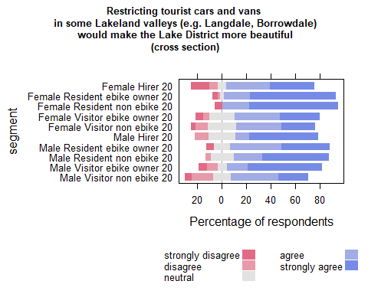

| Comparison | P.adj |
| --- | --- |
| Female Resident ebike owner 20 - Female Visitor ebike owner 20 | 0.008 |
| Female Resident non ebike 20 - Female Visitor ebike owner 20 | 0.035 |
| Female Resident ebike owner 20 - Female Visitor non ebike 20 | 0.000 |
| Female Resident non ebike 20 - Female Visitor non ebike 20 | 0.004 |
| Female Visitor non ebike 20 - Male Visitor ebike owner 20 | 0.008 |
| Female Resident ebike owner 20 - Male Visitor non ebike 20 | 0.000 |
| Female Resident non ebike 20 - Male Visitor non ebike 20 | 0.001 |
| Male Resident non ebike 20 - Male Visitor non ebike 20 | 0.021 |
| Male Visitor ebike owner 20 - Male Visitor non ebike 20 | 0.001 |

## C (2021)

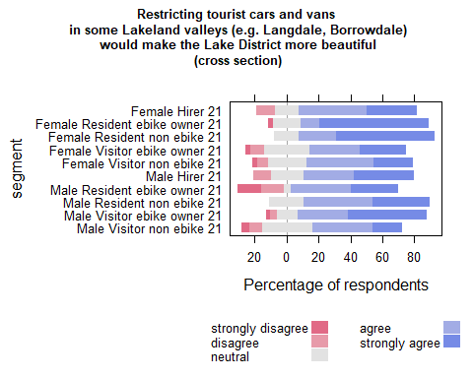

| Comparison | P.adj |
| --- | --- |
| Female Resident ebike owner 21 - Female Visitor ebike owner 21 | 0.017 |
| Female Resident ebike owner 21 - Female Visitor non ebike 21 | 0.002 |
| Female Resident ebike owner 21 - Male Resident ebike owner 21 | 0.035 |
| Female Visitor non ebike 21 - Male Visitor ebike owner 21 | 0.018 |
| Female Resident ebike owner 21 - Male Visitor non ebike 21 | 0.000 |
| Female Resident non ebike 21 - Male Visitor non ebike 21 | 0.015 |
| Male Visitor ebike owner 21 - Male Visitor non ebike 21 | 0.001 |

## Waves analysis

## run analysis on 2020 and 2021 PANEL data

| segment | agree | disagree | neutral | strongly agree | strongly disagree | SUMCOL | net percent |
| --- | --- | --- | --- | --- | --- | --- | --- |
| Female Hirer 20 | 100 | 0 | 0 | 0 | 0 | 3 | 100 |
| Female Hirer 21 | 60 | 20 | 20 | 0 | 0 | 5 | 40 |
| Female Resident ebike owner 20 | 12 | 0 | 0 | 88 | 0 | 16 | 100 |
| Female Resident ebike owner 21 | 6 | 0 | 6 | 83 | 6 | 18 | 83 |
| Female Resident non ebike 20 | 25 | 0 | 0 | 75 | 0 | 4 | 100 |
| Female Resident non ebike 21 | 0 | 0 | 0 | 100 | 0 | 4 | 100 |
| Female Visitor ebike owner 20 | 29 | 0 | 14 | 43 | 14 | 7 | 58 |
| Female Visitor ebike owner 21 | 40 | 0 | 0 | 60 | 0 | 5 | 100 |
| Female Visitor non ebike 20 | 29 | 7 | 21 | 36 | 7 | 14 | 51 |
| Female Visitor non ebike 21 | 46 | 0 | 23 | 15 | 15 | 13 | 46 |
| Male Hirer 20 | 0 | 50 | 0 | 50 | 0 | 2 | 0 |
| Male Hirer 21 | 17 | 17 | 0 | 67 | 0 | 6 | 67 |
| Male Resident ebike owner 20 | 38 | 0 | 23 | 31 | 8 | 13 | 61 |
| Male Resident ebike owner 21 | 40 | 13 | 0 | 27 | 20 | 15 | 34 |
| Male Resident non ebike 20 | 33 | 0 | 22 | 44 | 0 | 9 | 77 |
| Male Resident non ebike 21 | 33 | 0 | 17 | 50 | 0 | 6 | 83 |
| Male Visitor ebike owner 20 | 5 | 11 | 0 | 79 | 5 | 19 | 68 |
| Male Visitor ebike owner 21 | 30 | 0 | 10 | 60 | 0 | 20 | 90 |
| Male Visitor non ebike 20 | 54 | 12 | 4 | 19 | 12 | 26 | 49 |
| Male Visitor non ebike 21 | 57 | 14 | 14 | 10 | 5 | 21 | 48 |

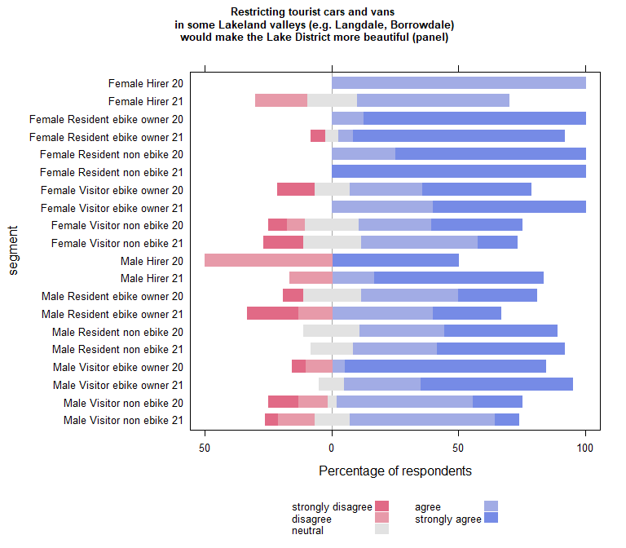

| Comparison | P.adj |
| --- | --- |
| Female Hirer 21 - Female Resident ebike owner 20 | 0.026 |
| Female Hirer 21 - Female Resident ebike owner 21 | 0.042 |
| Female Resident ebike owner 20 - Female Visitor non ebike 20 | 0.037 |
| Female Resident ebike owner 20 - Female Visitor non ebike 21 | 0.006 |
| Female Resident ebike owner 21 - Female Visitor non ebike 21 | 0.014 |
| Female Resident non ebike 21 - Female Visitor non ebike 21 | 0.049 |
| Female Resident ebike owner 20 - Male Resident ebike owner 20 | 0.037 |
| Female Resident ebike owner 20 - Male Resident ebike owner 21 | 0.010 |
| Female Resident ebike owner 21 - Male Resident ebike owner 21 | 0.026 |
| Female Visitor non ebike 21 - Male Visitor ebike owner 20 | 0.027 |
| Male Resident ebike owner 21 - Male Visitor ebike owner 20 | 0.048 |
| Female Resident ebike owner 20 - Male Visitor non ebike 20 | 0.004 |
| Female Resident ebike owner 21 - Male Visitor non ebike 20 | 0.010 |
| Male Visitor ebike owner 20 - Male Visitor non ebike 20 | 0.022 |
| Female Resident ebike owner 20 - Male Visitor non ebike 21 | 0.002 |
| Female Resident ebike owner 21 - Male Visitor non ebike 21 | 0.004 |
| Female Resident non ebike 21 - Male Visitor non ebike 21 | 0.036 |
| Male Visitor ebike owner 20 - Male Visitor non ebike 21 | 0.009 |
| Male Visitor ebike owner 21 - Male Visitor non ebike 21 | 0.027 |

| segment2020 | segment2021 | pvalue |
| --- | --- | --- |

## wilcoxon paired test on panel data (if table empty non significant)

| estimate | statistic | p.value | conf.low | conf.high | method | alternative | segment |
| --- | --- | --- | --- | --- | --- | --- | --- |
| -1.000065 | 0 | 0.04448651 | -Inf | -1 | Wilcoxon signed rank test with continuity correction | less | female Hirer 21 |

## Run within year comparisons on the panel data

## B (2020) PANEL

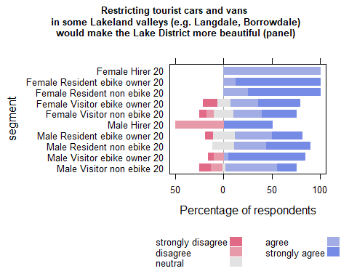

| Comparison | P.adj |
| --- | --- |
| Female Resident ebike owner 20 - Female Visitor non ebike 20 | 0.048 |
| Female Resident ebike owner 20 - Male Resident ebike owner 20 | 0.037 |
| Female Resident ebike owner 20 - Male Visitor non ebike 20 | 0.002 |
| Male Visitor ebike owner 20 - Male Visitor non ebike 20 | 0.023 |

## C (2021) PANEL

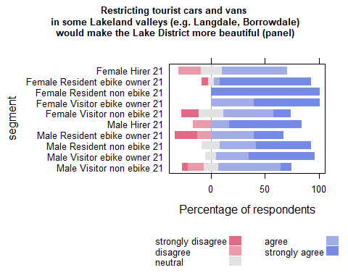

| Comparison | P.adj |
| --- | --- |
| Female Hirer 21 - Female Resident ebike owner 21 | 0.029 |
| Female Hirer 21 - Female Resident non ebike 21 | 0.038 |
| Female Resident ebike owner 21 - Female Visitor non ebike 21 | 0.013 |
| Female Resident non ebike 21 - Female Visitor non ebike 21 | 0.032 |
| Female Resident ebike owner 21 - Male Resident ebike owner 21 | 0.023 |
| Female Resident non ebike 21 - Male Resident ebike owner 21 | 0.041 |
| Female Visitor non ebike 21 - Male Visitor ebike owner 21 | 0.038 |
| Female Resident ebike owner 21 - Male Visitor non ebike 21 | 0.003 |
| Female Resident non ebike 21 - Male Visitor non ebike 21 | 0.024 |
| Male Visitor ebike owner 21 - Male Visitor non ebike 21 | 0.019 |

## Restricting tourist cars and vans in some Lakeland valleys (e.g. Langdale, Borrowdale) would be good for the tourism industry

## Cross section analysis

| segment | strongly disagree | disagree | neutral | agree | strongly agree | SUMCOL | net percent |
| --- | --- | --- | --- | --- | --- | --- | --- |
| Female Resident ebike owner 20 | 6 | 4 | 19 | 33 | 38 | 52 | 61 |
| Female Resident ebike owner 21 | 12 | 9 | 21 | 21 | 38 | 34 | 38 |
| Female Resident non ebike 20 | 6 | 0 | 22 | 39 | 33 | 18 | 66 |
| Female Resident non ebike 21 | 0 | 0 | 38 | 31 | 31 | 13 | 62 |
| Male Resident ebike owner 20 | 8 | 17 | 22 | 28 | 25 | 36 | 28 |
| Male Resident ebike owner 21 | 14 | 29 | 29 | 19 | 10 | 21 | -14 |
| Male Resident non ebike 20 | 0 | 15 | 42 | 23 | 19 | 26 | 27 |
| Male Resident non ebike 21 | 0 | 21 | 29 | 21 | 29 | 14 | 29 |

## run analysis on 2020 and 2021 cross section data

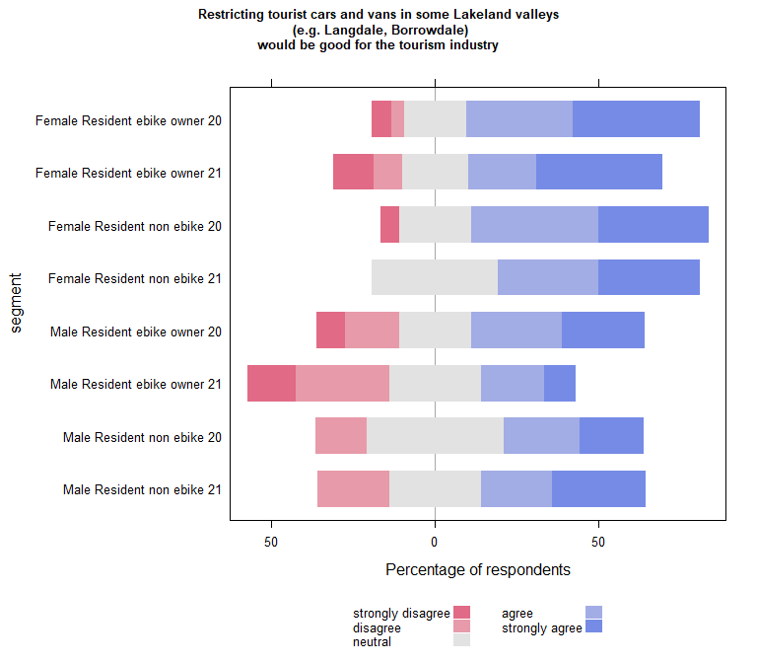

| Comparison | P.adj |
| --- | --- |
| Female Resident ebike owner 20 - Male Resident ebike owner 21 | 0.008 |

### Compare each segment in 2020 with the same segment in 2021

| segment2020 | segment2021 | pvalue |
| --- | --- | --- |

## Run the plot on B(2020) and C(2021) separately to carry out within year comparisons

## B (2020)

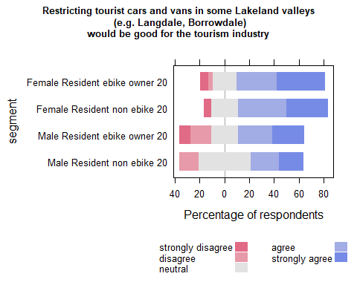

| Comparison | P.adj |
| --- | --- |

## C (2021)

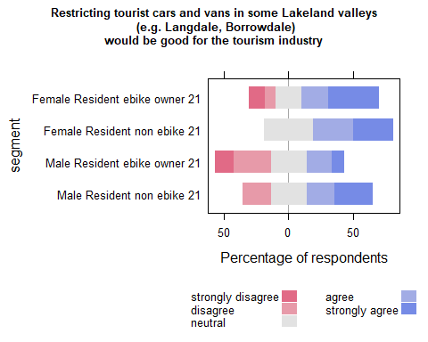

| Comparison | P.adj |
| --- | --- |
| Female Resident non ebike 21 - Male Resident ebike owner 21 | 0.049 |

## Waves analysis

## run analysis on 2020 and 2021 PANEL data

| segment | disagree | neutral | agree | strongly agree | strongly disagree | SUMCOL | net percent |
| --- | --- | --- | --- | --- | --- | --- | --- |
| Female Resident ebike owner 20 | 6 | 19 | 19 | 56 | 0 | 16 | 69 |
| Female Resident ebike owner 21 | 0 | 22 | 28 | 44 | 6 | 18 | 66 |
| Female Resident non ebike 20 | 0 | 50 | 25 | 25 | 0 | 4 | 50 |
| Female Resident non ebike 21 | 0 | 50 | 25 | 25 | 0 | 4 | 50 |
| Male Resident ebike owner 20 | 23 | 23 | 38 | 15 | 0 | 13 | 30 |
| Male Resident ebike owner 21 | 27 | 27 | 20 | 7 | 20 | 15 | -20 |
| Male Resident non ebike 20 | 0 | 56 | 22 | 22 | 0 | 9 | 44 |
| Male Resident non ebike 21 | 17 | 17 | 33 | 33 | 0 | 6 | 49 |

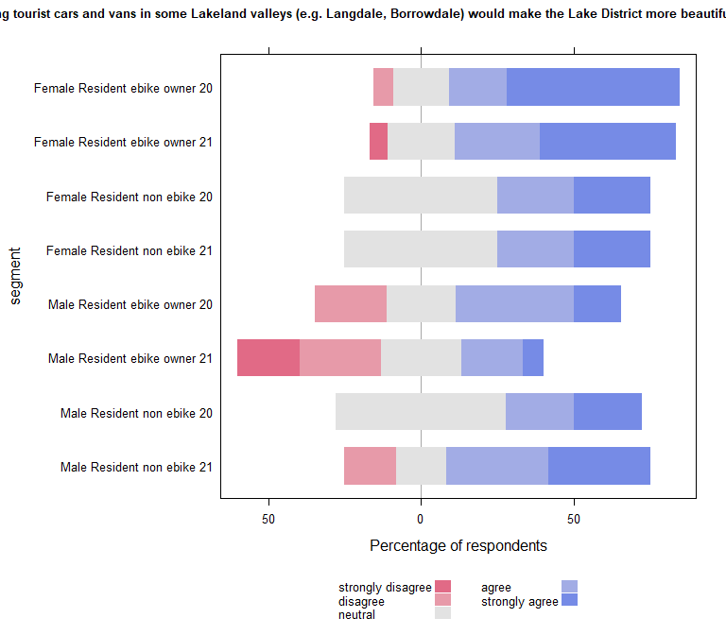

| Comparison | P.adj |
| --- | --- |
| Female Resident ebike owner 20 - Male Resident ebike owner 21 | 0.008 |
| Female Resident ebike owner 21 - Male Resident ebike owner 21 | 0.015 |

| segment2020 | segment2021 | pvalue |
| --- | --- | --- |

## wilcoxon paired test on panel data (if table empty non significant)

| estimate | statistic | p.value | conf.low | conf.high | method | alternative | segment |
| --- | --- | --- | --- | --- | --- | --- | --- |
| -1.000041 | 9.5 | 0.03375745 | -Inf | -0.9999239 | Wilcoxon signed rank test with continuity correction | less | male Resident ebike owner 21 |

## Run within year comparisons on the panel data

## B (2020) PANEL

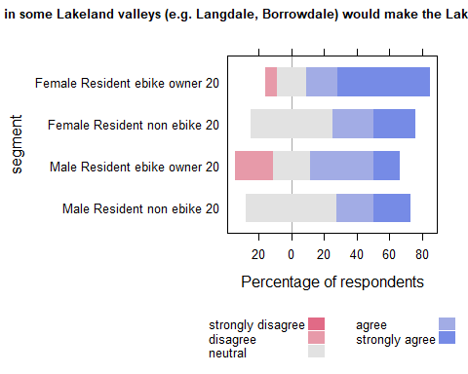

| Comparison | P.adj |
| --- | --- |

## C (2021) PANEL

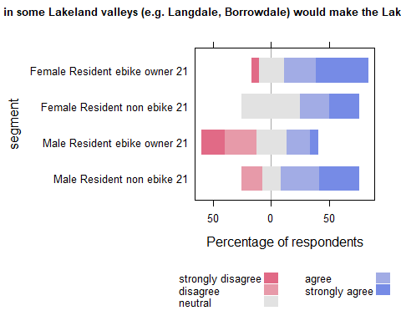

| Comparison | P.adj |
| --- | --- |
| Female Resident ebike owner 21 - Male Resident ebike owner 21 | 0.011 |

## “Restricting tourist cars and vans in some Lakeland valleys(e.g. Langdale, Borrowdale)would be good for non-tourist businesses (cross section)”

## Cross section analysis

| segment | strongly disagree | disagree | neutral | agree | strongly agree | SUMCOL | net percent |
| --- | --- | --- | --- | --- | --- | --- | --- |
| Female Resident ebike owner 20 | 6 | 8 | 29 | 27 | 31 | 52 | 44 |
| Female Resident ebike owner 21 | 9 | 15 | 26 | 24 | 26 | 34 | 26 |
| Female Resident non ebike 20 | 6 | 11 | 17 | 28 | 39 | 18 | 50 |
| Female Resident non ebike 21 | 0 | 0 | 31 | 46 | 23 | 13 | 69 |
| Male Resident ebike owner 20 | 11 | 14 | 28 | 25 | 22 | 36 | 22 |
| Male Resident ebike owner 21 | 19 | 14 | 19 | 38 | 10 | 21 | 15 |
| Male Resident non ebike 20 | 0 | 8 | 42 | 19 | 31 | 26 | 42 |
| Male Resident non ebike 21 | 7 | 14 | 43 | 14 | 21 | 14 | 14 |

## run analysis on 2020 and 2021 cross section data

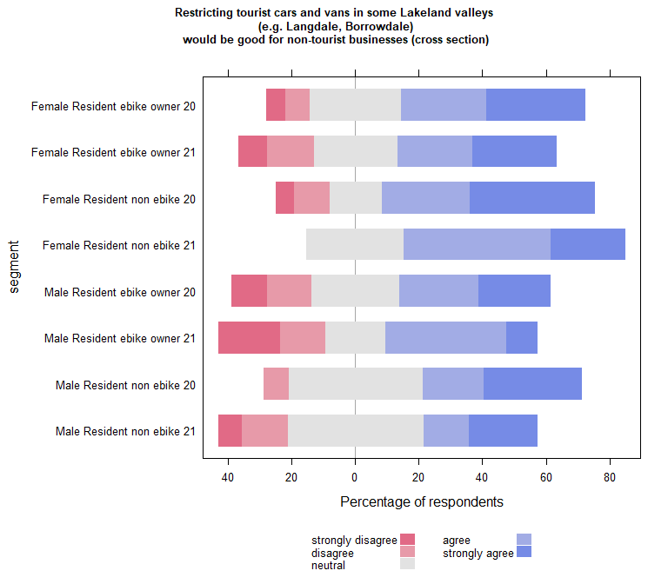

| Comparison | P.adj |
| --- | --- |

### Compare each segment in 2020 with the same segment in 2021

| segment2020 | segment2021 | pvalue |
| --- | --- | --- |

## Run the plot on B(2020) and C(2021) separately to carry out within year comparisons

## B (2020)

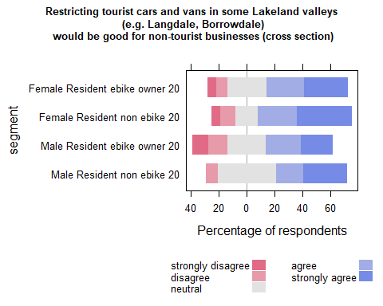

| Comparison | P.adj |
| --- | --- |

## C (2021)

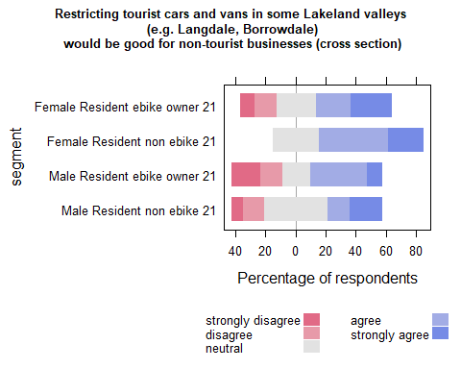

| Comparison | P.adj |
| --- | --- |

## Waves analysis

## run analysis on 2020 and 2021 PANEL data

| segment | disagree | neutral | agree | strongly agree | strongly disagree | SUMCOL | net percent |
| --- | --- | --- | --- | --- | --- | --- | --- |
| Female Resident ebike owner 20 | 6 | 31 | 19 | 44 | 0 | 16 | 57 |
| Female Resident ebike owner 21 | 6 | 33 | 28 | 28 | 6 | 18 | 44 |
| Female Resident non ebike 20 | 0 | 50 | 0 | 50 | 0 | 4 | 50 |
| Female Resident non ebike 21 | 0 | 25 | 75 | 0 | 0 | 4 | 75 |
| Male Resident ebike owner 20 | 8 | 31 | 38 | 15 | 8 | 13 | 37 |
| Male Resident ebike owner 21 | 7 | 27 | 33 | 7 | 27 | 15 | 6 |
| Male Resident non ebike 20 | 0 | 33 | 22 | 44 | 0 | 9 | 66 |
| Male Resident non ebike 21 | 17 | 33 | 17 | 33 | 0 | 6 | 33 |

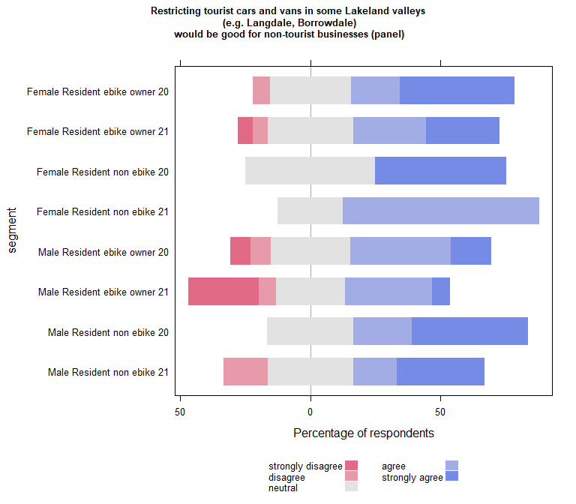

| Comparison | P.adj |
| --- | --- |

| segment2020 | segment2021 | pvalue |
| --- | --- | --- |

## wilcoxon paired test on panel data (if table empty non significant)

| estimate | statistic | p.value | conf.low | conf.high | method | alternative | segment |
| --- | --- | --- | --- | --- | --- | --- | --- |
| -0.9999608 | 15 | 0.04872962 | -Inf | 0.00005628834 | Wilcoxon signed rank test with continuity correction | less | male Resident ebike owner 21 |

## Run within year comparisons on the panel data

## B (2020) PANEL

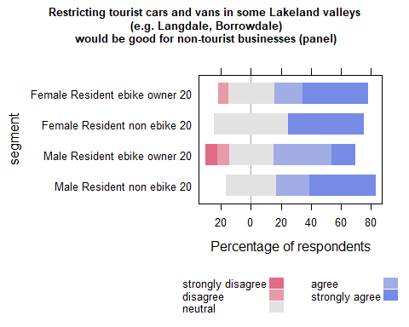

| Comparison | P.adj |
| --- | --- |

## C (2021) PANEL

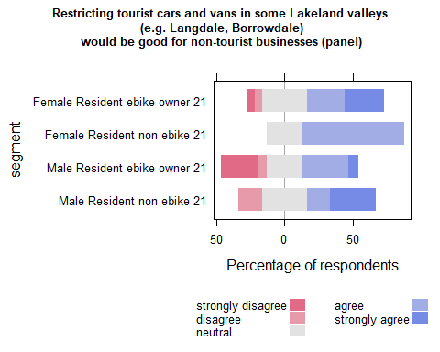

| Comparison | P.adj |
| --- | --- |