The predictive value of NTproBNP on postoperative outcome in patients undergoing offpump CABG
Thesis
Submitted for partial fulfillment of Doctorate Degree
In Critical Care Medicine,

By
IBRAHIM ABUBAKR ELSEDEEQ
Msc.
Faculty of Medicine, Ain Shams University

Under supervision of
Professor Dr. GAMAL HAMID
Professor of critical care medicine
Cairo University

Dr. AMAL RIZQ
Consultant of clinical pathology
critical care department
Cairo University

Dr. Mohamed Fawzy Abd ELAleem
Assistant Professor of critical care medicine
Cairo University

Faculty of Medicine
Cairo University
2020

Patients and Methods
This study was reviewed and approved by IRB, ethics committee or audit department of Critical care department of the faculty of medicine, Cairo University. The study runs in concordance with international ethical standards and applicable local regulatory guidelines. The study does not have any physical, psychological, social, legal, economic, or any other anticipated risks to study’s participants. The study conserves participants’ privacy. Investigators are responsible for keeping the security of the data. Also, the participants’ data were not used for any other purpose outside this study. Personal data (e.g. Name, Contact info) were not entered in our data entry software to conserve the participants' privacy, however, each subject got a unique identifier code.
Study Design and Setting:
65 consecutive cases registered for elective off-pump coronary artery bypass grafting OPCAB were recruited from 3 cardiothoracic surgery centers in this study constrained by the following inclusion and exclusion criteria:
Inclusion criteria:
- Patients undergoing elective OPCAB.
- Age group between 18 and 80 years old.
Exclusion criteria:
- Patients with signicant valvular heart disease, dilated or hypertophic cardiomyopathy, NYHA III or IV, EF < 40 %, need for inotropic support or intra-aortic balloon pump before surgery
- preoperative atrial fibrillation
- creatinine clearance < 60 ml/min/1.73 m2
- hyperthyoidism and hypothyroidism (serum TSH levels above or below reference ranges respectively. It was measured only upon clinical suspicion.)
- moderate to severe COPD (Shortness of breath at own pace on the level, FEV1 < 80% of predicted, or continuous use of bronchodilators for > 2 weeks).
Study’s Procedure and Data Collection:
Beta-blocking agents and statins were given to all patients until the morning of surgery. Oral antiplatelets were stopped 5-7 days before surgery. Euroscore II was calculated. Venous samples for measuring NT-proBNP were collected on the day of surgery before induction. Samples were sent for analysis in Cairo University Clinical Pathology department. No specific attempts were made to standardize the anesthetic and surgical management. After conclusion of the surgery, all patients were transferred to the intensive care unit ICU intubated and mechanically ventilated. The patients were assessed for extubation within 4-8 hours of arrival in the ICU. All patients received intravenous nitroglycerin infusions for the first 24hr unless they were hypotensive. Inotropic agents were used when the patient’s mean arterial pressure was below 60 mmHg and adequate perfusion could not be achieved. Potassium deficiency was promptly treated as necessary to maintain electrolyte balance within 4-5mEq/L. Beta-blocking agents and statins were given as soon as possible postoperatively. Clinicians resposnsible for patient care were blinded to the preoperative NtproBNP levels. All data were also collected by individuals blinded to these levels.
The following data were collected :
- Full history taking and clinical examination.
- Echocardiography pre-operative.
- Laboratory pre-operative & post-operative.
- Calcualtion of EUROSCORE II
- Data collection to evaluate incidence of complications postoperative ICU stay and till discharge from hospital including:
  - prolonged intubation
  - ischemic stroke
  - timing, duration and dose of inotropic support
  - use of intra-aortic ballon pump
  - myocardial infarction
  - arrhythmias
  - daily evaluation of renal functions.
  - Length of postoperative ICU and hospital stay
  - death

Study’s Outcomes:
Primary outcomes:
  - low output heart failure (inotropic support at second post-operative day, adrenaline > 50ng/kg/min or dobutamine > 10mcg/kg/minat any time and/or need for intra-aortic balloon pump)
Secondary outcome parameters:
  - mortality
  - arrhythmias
  - perioperative myocardial Infarction
  - length of ICU
  - length of postoperative hospital stay
  - prolonged intubation (Intubation more than 24 hours postoperatively and/or reintubation following planned extubation).
Data Analysis and Statistical Methods:
An Excel spreadsheet was established for the entry of data. We used validation checks on numerical variables and option-based data entry method for categorical variables to reduce potential errors. Data were coded and entered using the statistical package SPSS (Statistical Package for the Social Sciences) version 24. Data was summarized using mean, standard deviation, median, minimum, maximum and interquartile ranage in quantitative data and using frequency (count) and relative frequency (percentage) for categorical data. Comparisons between quantitative variables were done using the non-parametric Mann-Whitney test [Chan, 2003a]. Correlations between quantitative variables were done using Spearman correlation coefficient [Chan, 2003b]. ROC curve was constructed with area under curve analysis performed to detect best cutoff value of NTproBNP for detection of outcomes. P-values less than 0.05 were considered as statistically significant.

Results
Sixty-six patients were recruited in this study. One patient didn't undergo surgery; due to failure to obtain consent, thus rendering the number enrolled in the sutdy N=65.

Preoperative demographics and risk factors
Table 1 shows the demographic characteristics and preoperative risk factors of patients included in the study. The average age was 57.62 ±7.21. Most of the patients were males 56 (86.15%). 10 (15.38%) had diabetes mellitus, 42 (64.62%) were hypertensive and only one had peripheral vascular disease in the form of 70% stenosis of right carotid artery.

Table 1: demographic characteristics* of patients
Variables | Patients (N =65)
Age in years  - Mean ±SD  - Median (Range) | 57.62 ±7.21  57 (44 -73)
Gender, No (%)
- Male | 56 (86.15%)
- Female | 9 (13.85%)
Comorbidities, No (%)
- DM | 10 (15.38%)
- HTN | 42 (64.62%)
- Peripheral vascualr disease | 1 (1.54%)
Figure 1 shows the distribution of preoperative risk factors, while figure 2 is a histogram showing the distribution of age in the study group.
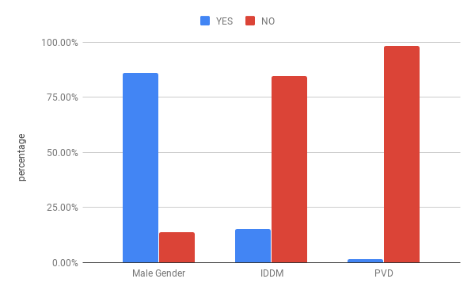Figure 1: Distribution of demographic variables and risk factors

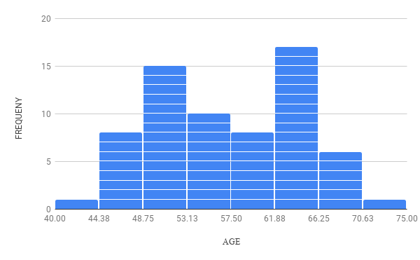Figure 2: Distribution of Age

Table 2 shows that preoperative ejection fraction of patients averaged 50.91±8.13. The calculated EuroscoreII averaged 0.76±0.34. Its median was 0.68 with an interquartile range of [0.55-0.82]. Histograms of their distribution are shown in figures 3 and 4.
Table 2: Measured preoperative ejection fraction and calculated EuroScoreII
Variables | Patients (N=65)
Ejection Fraction  - mean ±SD  - median(range) | 50.91±8.13  49(40-67)
EuroScore II  - mean±SD  - median(range)  - [interquartile range] | 0.76±0.34  0.68(0.50-2.94)  [0.55-0.82]

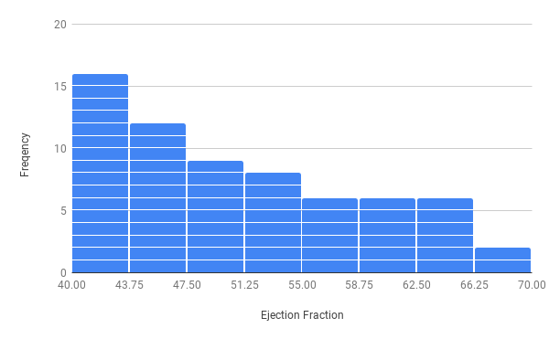Figure 3: Distribution of Ejection Fraction

Figure 4: Distribution of EuroscoreII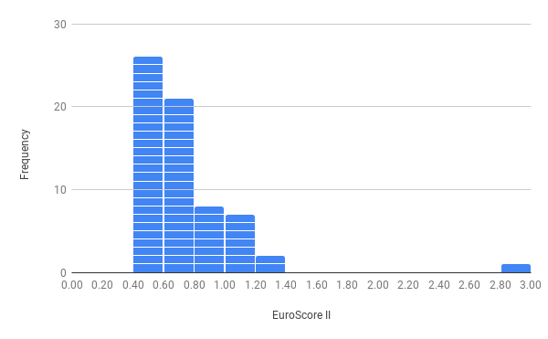

The preoperative NTproBNP levels averaged 312.41± 329.93pg/mL. The median was 160 with interquartile range of [80-397.5]. Table 3 summarizes these data and figure 5 shows a histogram of its distribution.

Table 3: summary of statistical discription of measured preoperative NTproBNP values
 | Mean | Standard Deviation | Median | Min | 1st quartile | 3rd quartile | Max
NTBNP (pg/mL) | 312.41 | 329.93 | 160 | 10 | 80 | 397.5 | 1440

Figure 5: Distribution of NtproBNP
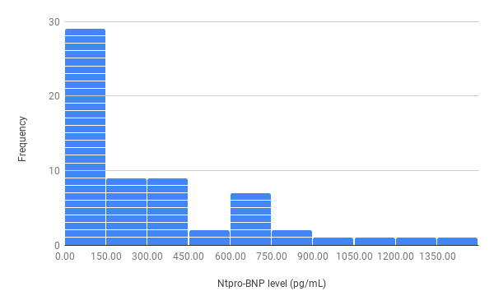

Postoperative outcomes
Only two patients died; one of sepsis and the other of respiratory failure. Three required prolonged mechanical ventilation, one of whom was due to delayed recovery from anaesthesia (the only patient suffering from such complication). Three suffered recent onset arrhythmia (3 Atrial fibrillation, One Ventricular Tachycardia) during their ICU stay. One patient was re-admitted to the ICU for atrial fibrillation. Five patients had low output heart failure, and four had perioperative myocardial infarction. The mean ICU stay was 3.37±0.84 days and mean hospital stay was 6.38±1.3 ( 3-12) days. Tables 4and 5 summarizes such data and figures 6, 7and 8 show their distibution across the study group.

Table 4: Summary of categorical outcomes
 |  | Count | %
low CO | yes | 5 | 7.7%
low CO | no | 60 | 92.3%
arrhythmia | yes | 4 | 6.2%
arrhythmia | no | 61 | 93.8%
perioperative MI | yes | 4 | 6.2%
perioperative MI | no | 61 | 93.8%
prolonged vent | yes | 3 | 4.6%
prolonged vent | no | 62 | 95.4%
Delayed Recovery | yes | 1 | 1.5%
Delayed Recovery | no | 64 | 98.5%
mortality | yes | 2 | 3.1%
mortality | no | 63 | 96.9%

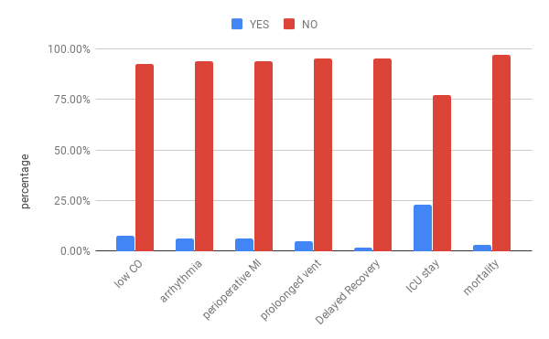Figure 6: Distribution of primary and secondary outcomes

Table 5: Summary of quantitative outcomes
 | Mean | Standard Deviation | Median | Minimum | Maximum
ICU stay | 3.37 | 0.84 | 3.00 | 2.00 | 7.00
in-hospital stay | 6.38 | 1.33 | 6.00 | 3.00 | 12.00

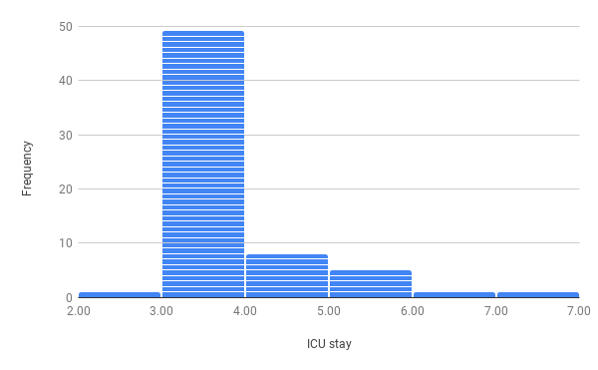Figure 7: Distribution of length of ICU stay
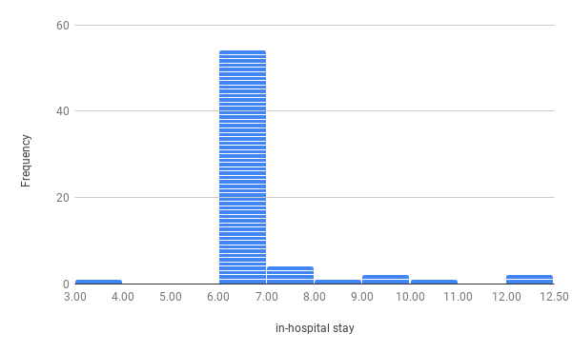Figure 8: Distribution of length of in-hospital stay

Relation between NTproBNP and study outcomes

Table 6 shows a comparison between the distribution of measured NtproBNP values in patient with and without low cardiac output. The mean NTproBNP was 490 pg/ml (median 650) in patients who had low cardiac output vs 296.84pg/ml (and 160 pg/ml) for patient who did not. P value was 0.168. ie the results were statistically insignificant.

Table 6: relation between NTproBNP and low cardiac output
 |  | NtproBNP (pg/mL)
 |  | Mean | Standard Deviation | Median | Minimum | Maximum | P value
low CO | yes | 490 | 307.97 | 650 | 60 | 750 | 0.168
low CO | no | 296.84 | 329.75 | 160 | 10 | 1440 | 0.168

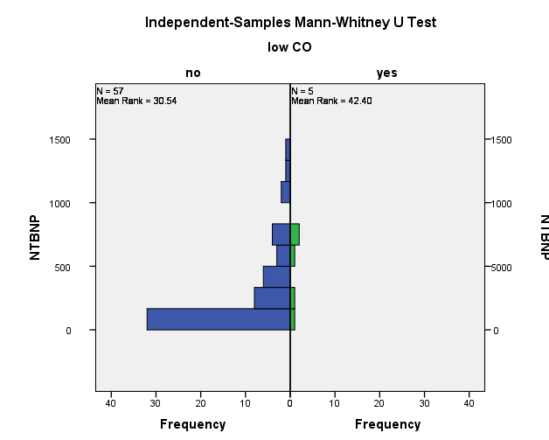
Table 7 shows a comparison between the distribution of measured NtproBNP values in patient with and without postoperative arrhythmia. The mean NTproBNP was 400 pg/ml (median 410) in patients who had postoperative arrhythmia vs 306.37pg/ml (and 160 pg/ml) for patient who did not. P value was 0.462. ie the results were statistically insignificant.
Table 7: disctribution of NTproBNP levels across patient who did and did not develop postoperative arrhythmia
 |  | NtproBNP (pg/mL)
 |  | Mean | Standard Deviation | Median | Minimum | Maximum | P value
arrhythmia | yes | 400 | 292.91 | 410 | 60 | 720 | 0.462
arrhythmia | no | 306.37 | 333.77 | 160 | 10 | 1440 | 0.462

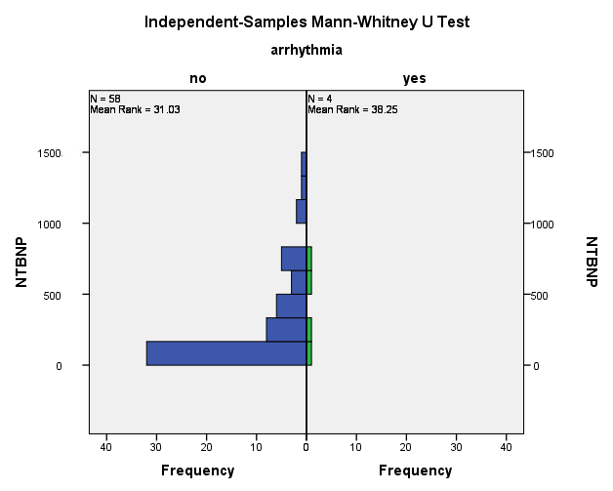
Table 8 shows a comparison between the distribution of measured NtproBNP values in patient with and without perioperative myocardial infarction. The mean NTproBNP was 437.5 pg/ml (median 485) in patients who had MI vs 303.79pg/ml (and 160 pg/ml) for patient who did not. P value was 0.397. ie the results were statistically insignificant.

Table 8: distribution of NTproBNP levels across patients who did and did not suffer perioperative mycardial infarction
 |  | NtproBNP (pg/mL)
 |  | Mean | Standard Deviation | Median | Minimum | Maximum | P value
perioperative MI | yes | 437.5 | 326.22 | 485 | 60 | 720 | 0.397
perioperative MI | no | 303.79 | 331.23 | 160 | 10 | 1440 | 0.397

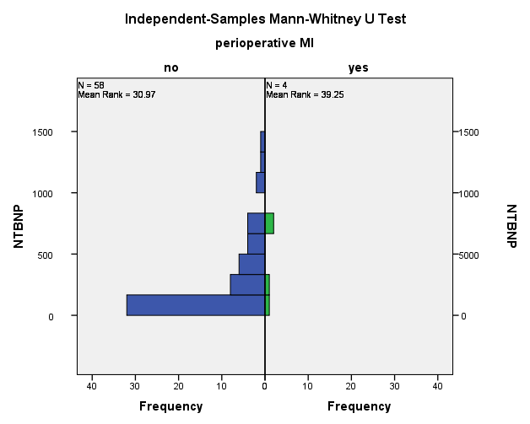

Table 9 shows a comparison between the distribution of measured NtproBNP values in patient with and without require prolonged mechanical ventilation. The mean NTproBNP was 550 pg/ml (median 660) in patients who required prolonged mechanical ventilation vs 300.33pg/ml (and 160 pg/ml) for patient who did not. P value was 0.121. ie the results were statistically insignificant.

Table 9: distribution of NTproBNP levels across patients who did and did not require prolonged mechanical ventilation
 |  | NtproBNP (pg/mL)
 |  | Mean | Standard Deviation | Median | Minimum | Maximum | P value
proloonged vent | yes | 550 | 244.33 | 660 | 270 | 720 | 0.121
proloonged vent | no | 300.33 | 330.69 | 160 | 10 | 1440 | 0.121

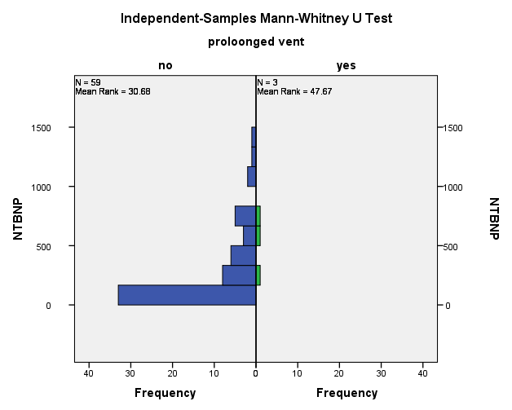

 |  | NtproBNP (pg/mL)
 |  | Mean | Standard Deviation | Median | Minimum | Maximum | P value
Delayed Recovery | yes | 1030 | - | 1030 | 1030 | 1030 | 0.129
Delayed Recovery | no | 300.65 | 319.29 | 160 | 10 | 1440 | 0.129

Table 10 shows a comparison between the distribution of measured NtproBNP values in patients who survived till discharge and those who died before discharge from the hospital. The mean NTproBNP was 495 pg/ml (median 495) in patients who died vs 306.33pg/ml (and 160 pg/ml) for patient who did not. P value was 0.306. ie the results were statistically insignificant.
Table 10: distribution of NTproBNP levels across patients who did and did not die before discharge from the hospital
 |  | NtproBNP (pg/mL)
 |  | Mean | Standard Deviation | Median | Minimum | Maximum | P value
Mortality | yes | 495 | 318.19 | 495 | 270 | 720 | 0.306
Mortality | no | 306.33 | 331.15 | 160 | 10 | 1440 | 0.306

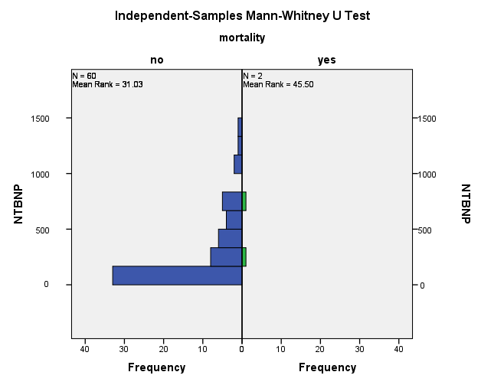

Table 11 shows that there was poor correlation between NtproBNP and length of ICU stay and hospital stay, as the correlation coofficient for NtproBNP and ICU stay was -0.02 and for NtproBNP and hospital stay, it was -0.017.

Table 11: correlation between NTproBNP and continuous outcome variables
 |  | NTBNP
ICU stay | Correlation Coefficient | -.022-
ICU stay | P value | 0.861
ICU stay | N | 65
in-hospital stay | Correlation Coefficient | -.017-
in-hospital stay | P value | 0.896
in-hospital stay | N | 65

* In all tables data are presented as mean ±SD, median (Range) [IQR] , or number (%).

