The predictive value of NTproBNP on postoperative outcome in patients undergoing offpump CABG
Thesis
Submitted for partial fulfillment of Doctorate Degree
In Critical Care Medicine,

By
IBRAHIM ABUBAKR ELSEDEEQ
Msc.
Faculty of Medicine, Ain Shams University

Under supervision of
Professor Dr. GAMAL HAMID
Professor of critical care medicine
Cairo University

Dr. AMAL RIZQ
Consultant of clinical pathology
critical care department
Cairo University

Dr. Mohamed Fawzy Abd ELAleem
Assistant Professor of critical care medicine
Cairo University

Faculty of Medicine
Cairo University
2020

Patients and Methods
This study was reviewed and approved by IRB, ethics committee or audit department of Critical care department of the faculty of medicine, Cairo University. The study runs in concordance with international ethical standards and applicable local regulatory guidelines. The study does not have any physical, psychological, social, legal, economic, or any other anticipated risks to study’s participants. The study conserves participants’ privacy. Investigators are responsible for keeping the security of the data. Also, the participants’ data were not used for any other purpose outside this study. Personal data (e.g. Name, Contact info) were not entered in our data entry software to conserve the participants' privacy, however, each subject got a unique identifier code.

Study Design and Setting:
65 cases registered for elective off-pump coronary artery bypass grafting OPCAB were recruited in this study.
Inclusion and Exclusion Criteria:
We included patients who fulfilled the following criteria:
- Patients undergoing elective OPCAB.
- Age group between 18 and 60 years old.
We excluded
- Patients with signicant valvular heart disease, dilated or hypertophic cardiomyopathy, NYHA III or IV, EF < 40 %, inotropic support or intra-aortic balloon pump
- preoperative atrial fibrillation
- creatinine clearance < 60 ml/min/1.73 m2
- hyperthyoidism and hypothyroidism (serum TSH levels above or below reference ranges respectively. It was measured only upon clinical suspicion.)
- moderate to severe COPD (Shortness of breath at own pace on the level, FEV1 < 80% of predicted, or continuous use of bronchodilators for > 2 weeks).

Sample Size and Sampling:
Using PASS program, setting alpha error at 5% and power 80%. Results from previous study (Ducceschi et al., 1999) showed that four-component primary end point occurred in patients assigned to receive levosimendan and in patients assigned to receive conventional drugs. Based on this, the needed sample was 100 case undergoing CABG (50 per each group). We utilized a consecutive sampling technique within the time of the study to collect the predetermined sample size.
Study’s Procedure and Data Collection:
The following data were collected from every eligible participants.
- Full history taking and clinical examination.
- Echocardiography pre-operative.
- Laboratory pre-operative & post-operative.
- Calcualtion of EUROSCORE II
- Data collection to evaluate incidence of complications postoperative ICU stay and till discharge from hospital including:
  - prolonged intubation
  - ischemic stroke
  - low output heart failure
  - myocardial infarction
  - arrhythmias
  - daily evaluation of renal functions.
  - death

Venous samples for measuring NT-proBNP were collected on the day of surgery before induction. Samples were sent for analysis in Cairo University Clinical Pathology department.

Study’s Outcomes:
Primary outcomes:
  - low output heart failure (inotropes at 48 hours post-operatively and/or need for intra-aortic balloon pump) and myocardial infarction
Secondary outcome parameters:
  - mortality
  - arrhythmias
  - length of ICU
  - length of postoperative hospital stay
  - prolonged intubation (Intubation more than 24 hours postoperatively and/or reintubation following planned extubation).
Data Analysis and Statistical Methods:
An Excel spreadsheet was established for the entry of data. We used validation checks on numerical variables and option-based data entry method for categorical variables to reduce potential errors. Data were coded and entered using the statistical package SPSS (Statistical Package for the Social Sciences) version 24. Data was summarized using mean, standard deviation, median, minimum and maximum in quantitative data and using frequency (count) and relative frequency (percentage) for categorical data. Comparisons between quantitative variables were done using the non-parametric Mann-Whitney test [Chan, 2003a]. Correlations between quantitative variables were done using Spearman correlation coefficient [Chan, 2003b]. ROC curve was constructed with area under curve analysis performed to detect best cutoff value of NTproBNP for detection of outcomes. P-values less than 0.05 were considered as statistically significant.

Results

Sixty-six patients were recruited in this study. One patient didn't undergo surgery; due to failure to obtain consent, thus rendering the number enrolled in the sutdy N=65.

Preoperative demographics and risk factors
Table 1 shows the demographic characteristics and preoperative risk factors of patients included in the study. The average age was 57.62 ±7.21. Most of the patients were males 56 (86.15%). 10 (15.38%) had diabetes mellitus, 42 (64.62%) were hypertensive and only one had peripheral vascular disease in the form of 70% stenosis of right carotid artery.

Figure 2 is a histogram showing the distribution of age in the study group, while figure 1 shows the distribution of preoperative risk factors.

Table 2 shows that preoperative ejection fraction of patients averaged 50.91±8.13. The calculated EuroscoreII averaged 0.76±0.34. Its median was 0.68 with and interquartile range of [0.55-0.82]. A histogram of their distribution are shown in figures 3 and 4.

Table 1: demographic characteristics* of patients
Variables | Patients (N =65)
Age in years  - Mean ±SD  - Median (Range) | 57.62 ±7.21  57 (44 -73)
Gender, No (%)
- Male | 56 (86.15%)
- Female | 9 (13.85%)
Comorbidities, No (%)
- DM | 10 (15.38%)
- HTN | 42 (64.62%)
- Peripheral vascualr disease | 1 (1.54%)

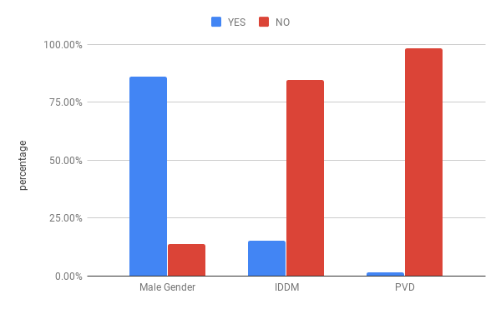Figure 1: Distribution of demographic variables and risk factors

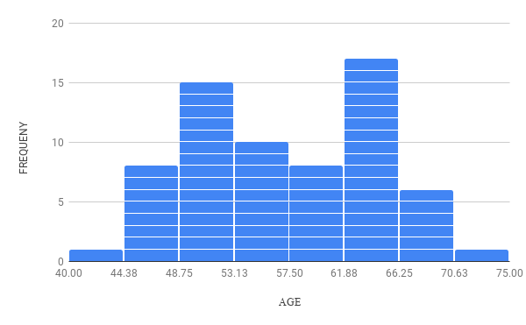Figure 2: Distribution of Age

Table 2: Measured preoperative ejection fraction and calculated EuroScoreII
Variables | Patients (N=65)
Ejection Fraction  - mean ±SD  - median(range) | 50.91±8.13  49(40-67)
EuroScore II  - mean±SD  - median(range)  - [interquartile range] | 0.76±0.34  0.68(0.50-2.94)  [0.55-0.82]

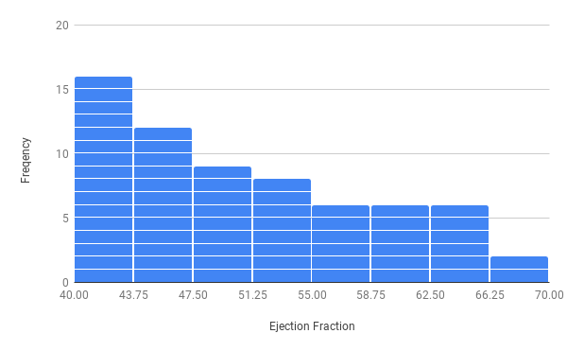Figure 3: Distribution of Ejection Fraction

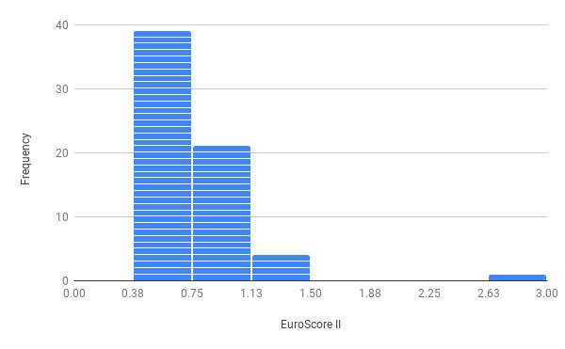Figure 4: Distribution of EuroscoreII

The preoperative NTproBNP levels averaged 312.41± 329.93. The median was 160 with interquartile range of [80-397.5]. Table 3 summarizes these data and figure 5 shows a histogram of its distribution.

Table 3: summary of statistical discription of measured preoperative NTproBNP values
 | Mean | Standard Deviation | Median | Min | 1st quartile | 3rd quartile | Max
NTBNP | 312.41 | 329.93 | 160 | 100 | 80 | 397.5 | 1440

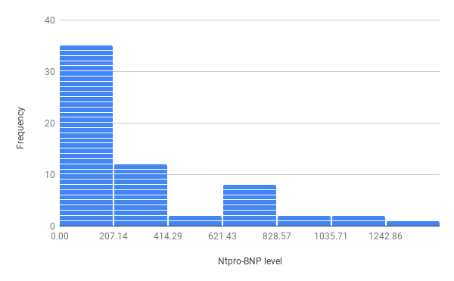Figure 5: Distribution of NTproBNP

Postoperative outcomes
Only two patients died; one of sepsis and the other of respiratory failure. Three required prolonged mechanical ventilation, one of whom was due to delayed recovery from anaesthesia (the only patient suffering from such complication). Three suffered recent onset arrhythmia (3 Atrial fibrillation, One Ventricular Tachycardia) during their ICU stay. One patient was re-admitted to the ICU for atrial fibrillation. Five patients had low output heart failure, and four had perioperative myocardial infarction. The mean ICU stay was 3.37±0.84 days and mean hospital stay was 6.38±1.3 ( 3-12) days. Tables 4and 5 summarizes such data and figures 6, 7and 8 show their distibution across the study group.

Table 4: Summary of categorical outcomes
 |  | Count | %
low CO | yes | 5 | 7.7%
low CO | no | 60 | 92.3%
arrhythmia | yes | 4 | 6.2%
arrhythmia | no | 61 | 93.8%
perioperative MI | yes | 4 | 6.2%
perioperative MI | no | 61 | 93.8%
prolonged vent | yes | 3 | 4.6%
prolonged vent | no | 62 | 95.4%
Delayed Recovery | yes | 1 | 1.5%
Delayed Recovery | no | 64 | 98.5%
mortality | yes | 2 | 3.1%
mortality | no | 63 | 96.9%

Table 5: Summary of quantitative outcomes
 | Mean | Standard Deviation | Median | Minimum | Maximum
ICU stay | 3.37 | .84 | 3.00 | 2.00 | 7.00
in-hospital stay | 6.38 | 1.33 | 6.00 | 3.00 | 12.00

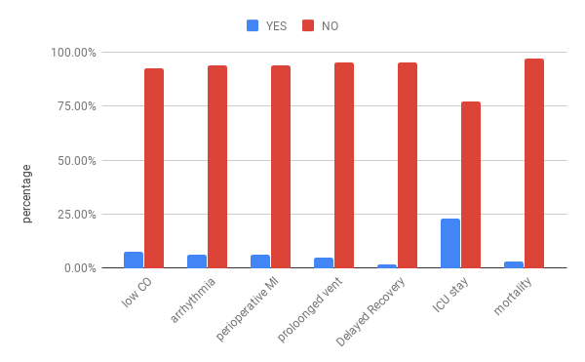Figure 6: Distribution of primary and secondary outcomes

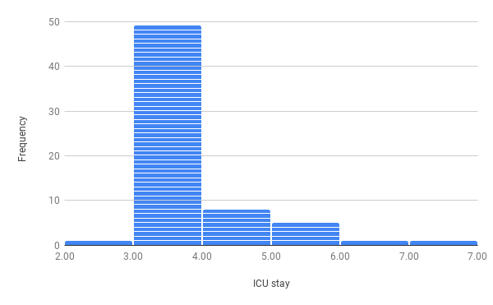Figure 7: Distribution of length of ICU stay

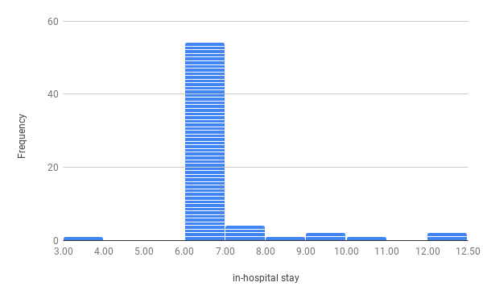Figure 8: Distribution of length of in-hospital stay

* In all tables data are presented as mean ±SD, median (Range) [IQR] , or number (%).

