** **

**Predictive value of NT-proBNP on Postoperative Outcome of Isolated Coronary Artery Bypass Patients**

Thesis

submitted in partial fulfillment of the degree of MD

in

Critical Care Medicine

by

**Ibrahim AbuBakr Elsedeeq**

MSc

under the supervision of

**Prof. Dr. Gamal Hamid Ahmed**

professor of critical care medicine

**Prof. Dr. Tarek El Tawil**

professor of cardiothoracic surgery

**Prof. Dr. Amal Rizk**

consultant of clinical pathology

critical care department

**Dr. Mohamed Fawzy Abdel-Aleem**

assistant professor of critical care medicine

Cairo University

2021

# Acknowledgment

First of all, I would like to express my deep gratitude and thanks to ALLAH, the most merciful.

I have great honor that my work under the supervision of **Dr Gamal Hamid Ahmed,** *Professor of Critical care Medicine, Faculty of Medicine, Cairo University*. I would like to express my profound gratitude and sincere appreciation for his kind supervision, continuous encouragement and unlimited support in every step throughout this work.

I would like to express my deepest thanks and sincere appreciation to **Dr Tarek El Tawil** professor of cardiothoracic surgery*, Faculty of Medicine, Cairo University*, for his continuous support, great encouragement, great help, his patience and valuable advisement in every step throughout this work.

I am grateful for **Dr. Amal Rizk,** consultant of clinical pathology, critcal care medicine department, Faculty of medicine Cairo university for her great support and encouragment through out this work.

I would like also to thank **Dr. Mohamed Fawzy Abdel-Aleem** Assistant Professor of *Critical care Medicine, Faculty of Medicine, Cairo University*, for his valuable advice and encouragement throughout this work.

Last but not least, I would like to express all my feelings of love and appreciation to all my senior staff and my colleagues for their lovely help throughout this work.

Ibrahim AbuBakr Elsedeeq

**Table of Contents**

Acknowledgment 2

List of Abbreviations 6

Introduction 7

Aim of the Work 10

Review of Literature 11

Physiology of Natriuretic Peptides 11

History 11

Structure and Release 12

NPRs structure and function 24

Physiologic Functions 27

Cardiovascular Functions 27

Non Cardiovascular Functions 32

NPs in disease states 35

Clinical applications 39

Utility in diagnosis 39

In heart failure 39

In primary care and screening 46

Cost-effectiveness 50

Utility in prognosis 52

In acute coronary syndrome 59

Postoperative complications 63

NP guided treatment 64

Natiuretic peptides therapeutics 73

Anaritide 73

Nesiritde 75

Neprilysin inhibitors 78

Limitations 82

Patients and Methods 89

Study Design and Setting 89

Inclusion criteria 89

Exclusion criteria 90

Study’s Procedure and Data Collection 90

Lab and sample analysis methods 91

Test pricniple 92

Machine used for reading 92

Samples 92

Standard curve preparation for calculation of results 92

Calculation of results 93

Study’s Outcomes 94

Data Analysis and Statistical Methods 95

Results 96

Preoperative demographics and risk factors 96

Postoperative outcomes 100

Relation between NTproBNP and study outcomes 103

Discussion 110

Conclusion 124

Summary 127

Table of Figures

Figure 1: Structure of the human natriuretic peptides. 18

Figure 2: ANP and BNP physiology21

Figure 3: Secretion of BNP and NTproBNP 22

Figure 4: The causes and mechanisms of elevated natriuretic peptides levels. 22

Figure 5: Schematic representation of natriuretic receptors 26

Figure 6: Representation of the effects of elevated plasma natriuretic peptides 32

Figure 7: ROC curves for BNP in the diagnosis of heart failure at ER 44

Figure 8: ROC curves for NTproBNP in the diagnosis of heart failure at ER 45

Figure 9: Risk of primary endpoint after 1 month NT proBNP > 1000 pg/mL 58

Figure 10: Forest plot of mortality in trials of marker-guided treatment of CHF 71

Figure 11: 94

Figure 12: standard curve for calculation of NTproBNP results,. 95

Figure 13: Distribution of demographic variables and risk factors 98

Figure 14: Distribution of Age 98

Figure 15: Distribution of Ejection Fraction 99

Figure 16: Distribution of EuroscoreII 100

Figure 17: Distribution of NTproBNP 101

Figure 18: Distribution of primary and secondary outcomes 102

Figure 19: Distribution of length of ICU stay 103

Figure 20: Distribution of length of in-hospital stay 104

List of Tables

Table 1: Biochemical properties of BNP and NT-proBNP. a) Intra-individual, day-to-day biologic variation in patients with established HF. [16] 21

Table 2: Optimal NT-proBNP cutpoints for the diagnosis or exclusion of acute heart failure among dyspneic patients 42

Table 3: Median plasma concentrations of NT-proBNP in acute and chronic HFrEF and HFpEF 43

Table 4: Impact of renal disease on the diagnosis of acute decompensated heart failiure in patients presenting with dyspnea 82

Table 5: optical density fo r standard dilutions 89

Table 6: demographic characteristics of patients 92

Table 7: Measured preoperative ejection fraction and calculated EuroScoreII 94

Table 8: summary of statistical discription of measured preoperative NTproBNP values 95

Table 9: Summary of categorical outcomes 97

Table 10: Summary of quantitative outcomes 98

Table 11: relation between NTproBNP and low cardiac output 99

Table 12: disctribution of NTproBNP levels across patient who did and did not develop postoperative arrhythmia 100

Table 13: distribution of NTproBNP levels across patients who did and did not suffer perioperative mycardial infarction 101

Table 14: distribution of NTproBNP levels across patients who did and did not require prolonged mechanical ventilation 102

Table 15: distribution of NTproBNP levels across patients who did and did not suffer delayed neurological recovery 103

Table 16: distribution of NTproBNP levels across patients who did and did not die before discharge from the hospital 104

Table 17: correlation between NTproBNP and continuous outcome variables 105

# List of Abbreviations

**ADHF** acute decompensated heart failure

**AF** atrial fibrillation

**AKI** acute kidney injury

**ANP** atrial natriuretic peptide

**ARF** acute renal failure

**AUROC** area under receiver operating characteristics curve

**BNP** brain (B-type) natriuretic peptide

**CABG** coronary artery bypass grafting

**CNH** cardiac natriuretic hormones

**CNP** C-type natriuretic peptide

**COPD** chronic obstructive pulmonary disease

**CRF** chronic renal failure

**DM** diabetes mellitus

**ED** emergency department

**EF** ejection fraction

**ET-1** endothelin-1

**HFpEF** heart failure with preserved ejection fraction

**HFrEF** heart failure with reduced ejection fraction

**HTN** hypertension or hypertensive

**iNOS** inducible nitric oxide synthesis

**MACEs** major adverse cardiac events

**NEP** neutral endopeptidase

**NO** nitric oxide

**NPR** natriuretic peptide receptors

**NPs** natriuretic peptides

**NTproBNP** N-terminal proBNP

**OPCAB** off-pump CABG

**POAF** postoperative atrial fibraillation

**PPM** permanent pacemaker

**PVD** peripheral vascular disease

**ROC** receiver operating characteristics curve

**cGMP** cyclic guanosine monophosphate

# Introduction

The major stimulus for NP release is increased atrial wall stretch reflecting increased intravascular volume. Other stimuli for release include catecholamines, arginine vasopressin, and endothelin. These stimuli reflect the counter-regulatory role ANP plays against volume overload and hypertension.1 However, Other pathologies such as exacerbated chronic obstructive pulmonary disease, atrial fibrillation and myocarditis can cause eleveted BNP levels. Additionaly, higher NP levels are associated with: female gender, impaired renal function, and older age. 2

BNP is produced in both atria and ventricles, and is upregulated in failing ventricular myocardium. In response to increased myocardial stretch and wall stress, ventricular myocytes secret the pro-hormone pre-proBNP, which is then cleaved into biologically active BNP and the inactive byproduct N-terminal-proBNP (NTproBNP) 3. BNP and NTproBNP are secreted in equimolar quantites into the circulation. BNP has a serum half-life of 20 minutes, whereas NTproBNP has a half-life of 120 minutes 4. Absolute values of BNP are significantly lower than values of NTproBNP, despite equimolar secretion. The reference ranges for BNP and NTproBNP vary depending on the assay that is used and the nature of the control population. In general, the suggested normal range for circulating BNP is 0.5-30 pg/ml and for circulating NTproBNP the suggested normal range is 68-112 pg/ml 5. Both BNP and NTproBNP are established markers for cardiac failure. NTproBNP is also more stable, which makes its measurement more reliable. 6

Circulating NPs acts as an antagonist of the renin angiotensine aldosterone system, inducing diuresis, natriuresis, vascular dilatation and inhibition of the sympathetic nervous system 7. These actions reduce cardiac preload and afterload to counteract the detrimental effects of pressure and volume overload seen in HF. These physiologic processes are counter-regulatory to the detrimental neurohormonal activation of the sympathetic nervous system and RAAS in HF and are why ANP and BNP levels reflect HF severity. 8 It is well known that changes in hemodynamic parameters (such as left ventricular ejection fraction, EF) and plasma NPs levels (expressed in a log scale) are closely related in patients with cardiovascular diseases. Yet the NPs system activation is modulated not only by hemodynamic factors, but also by the activity of the counteregulatory neurohormonal system. Consequently, it is likely that very small changes in hemodynamics, not assessable by echocardiographic examination, may produce significant (and measurable) variations in plasma concentrations of NPs 9.

Several well-designed and conducted studies suggested that the Nps assay may be useful as a prognostic marker in HF and acute coronary artery syndromes. In all these studies, NPs concentrations were always found to be independent risk markers for morbidity (increased future major cardiovascular events and/or hospitalization) and/or mortality in patients with acute or chronic HF. In some studies NPs levels were stronger predictors of mortality and/or major cardiovascular events than left ventricular EF, NYHA class, and/or presence of diabetes or hypertension, as well as sex and age in patients with chronic HF. 10

In patients hospitalized for acute exacerbation of heart failure (with reduced or preserved ejection fraction), a single elevated BNP value correlated with increased in-hospital mortality; in addition, there was a direct relationship between quartiles of BNP concentration and mortality even after adjusting for multiple confounders including age, gender, vital signs, renal function, and sodium. 11

In heart failure patients, plasma NTproBNP concentrations were related to outcomes, including all-cause death, cardiovascular admission, and HF deaths/HF admissions. NTproBNP was the strongest independent predictor of outcomes at 3 years of follow-up and provided fine-grained prediction of clinical outcomes from low to very high risk 12. Failure of NP levels to decrease during an HF hospitalization while undergoing treatment is associated with worse prognosis in NYHA class III to IV HF and followed them for 30 days after discharge 13. A baseline serum BNP level greater than 130 pg/mL in ambulatory patients with EF less than 35% predicts higher rates of sudden cardiac death. 14

Coronary heart disease is the main cause of morbidity and mortality in developed countries and the prevalence is increasing in developing countries. Several studies have reported biomarker clusters which are associated with coronary heart disease. The assessment of these biomarkers, alone or in combination, may improve the long-term prediction of mortality of first major cardiovascular event to conventional risk markers. 15

Several clinical trials have measured BNP or NTproBNP in patients presenting with acute coronary syndrome and consistently found that elevated NP values revealed important prognostic information. Both BNP and NTproBNP have been shown to be predictive of adverse outcomes independent of other biomarkers, including the cardiac troponins. 16

In patients undergoing cardiac surgery, accurate risk adjustment is of paramount importance for clinical audit, benchmarking and research and to identify high-risk patients that may benefit from prophylactic interventions to reduce post-operative adverse outcomes. Although many existing clinical prognostic models such as EuroSCORE are very useful, further refinement, update or recalibration are needed to maintain their utility. Most of these clinical prognostic scores for cardiac surgery are only useful in predicting mortality but not adverse events such as AF or cardiogenic shock requiring IABP. Elevated levels of BNP and NT pro-BNP have been shown to be associated with adverse outcomes in a number of settings, including patients undergoing major non-cardiac surgery. The strength of associations between pre- operative natriuretic peptide levels and adverse outcomes after cardiac surgery varied between different studies 17.

# Aim of the Work

The aim of our study is to investigate whether preoperative NTproBNP levels are associated with in-hospital mortality and post-operative outcome variables in patients undergoing elective offpump coronary artery bypass grafting.

# Review of Literature

# Physiology of Natriuretic Peptides

## History

The history of the NP class of biomarkers dates back to 1950s when early electron microscopy studies reported dense granules in the atrial myocardium similar to glandular tissue from endocrine organs. Soon, the close interplay between atria and intravascular volume was revealed; stretching of canine left atrium increased urine output and injection of atrial tissue into rats caused diuresis and natriuresis. Atrial natriuretic peptide (ANP) was subsequently purified, sequenced, and reproduced. 16

B-Type natriuretic peptide was discovered in 1988. Proof of the existence of aminoerminal pro–B-type natriuretic peptide (NTproBNP) in the human circulation and its relationship to cardiac function were first reported by Hunt and colleagues in 1995. 18

Although BNP was first isolated from the brain, that it is predominantly expressed in the ventricle. ANP and BNP were therefore renamed A-type and B-type natriuretic peptide, respectively, to better reflect their position in the family and to also lessen the misleading nature of the nomenclature of BNP as a cardiovascular and not a neural factor. ANP and BNP are the natriuretic peptides which are expressed predominantly in the atria and ventricle, respectively, and are referred to as the cardiac natriuretic peptides. 19

Other NPs that share a common biochemical structural feature, a 17amino-acid ring and a disulfide bridge between cysteine molecules, have been discovered since: urodilantin (an isoform of ANP), C-type natriuretic peptide, and Dendroaspis natriuretic peptide. 16

CNP is differentially expressed mainly in the nervous system and vasculature (e.g. endothelial cells, monocyte / macrophages) and is involved mainly in neural regulation as well as vascular control although its role is unclear. 19

## Structure and Release

Each natriuretic peptide is coded by a separate gene. In humans, the ANP and BNP genes are located 8 kilobases apart on chromosome 1 and the CNP gene is located on chromosome 2. Each natriuretic peptide gene produces a prohormone or precursor protein. 19

All NPs derive from pre-pro-hormones (i.e., preproANP and preproBNP), containing a signal peptide sequence at the amino-terminal end. The pro-hormones (i.e., proANP and proBNP) are produced by cleavage of signal peptide, and then are further split into inactive longer NH-2 -terminal fragments (i.e., NT-proANP or NT proBNP), and a biologically active shorter COOH-terminal peptide (i.e., ANP or BNP), which are secreted in the blood in equimolar amounts. However, ANP and BNP have a shorter plasma half-life and consequently lower plasma concentration, compared to NTroANP and NTproBNP 10

ANP is encoded by the NPAA gene on chromosome 1. It is translated into a 151mino-acid pre-prohormone (preproANP) that is cleaved in the sarcoplasmic reticulum to a 126-amino-acid prohormone (proANP), which is stored in intracellular granules. When stimulated and released, proANP is further cleaved into a 28-amino-acid bioactive form (ANP) and a 98-amino-acid N-terminal fragment (NT-proANP). The half-life of ANP is approximately 2 minutes, whereas NT-proANP halflife is variable depending on the fragment measured. 20

Transcription of the BNP gene first results in a 134-amino-acid intracellular pre-p ropeptide, which is rapidly processed to a 108-aminoacid precursor peptide, proBNP 108 . This peptide is cleaved into the biologically active 32-amino-acid BNP and a biologically inert 76amino-acid, NTproBNP, before being released into circulation within minutes of their production. The degree of peripheral conversion of proBNP 1-108 is not known, but it is clear that a certain percentage of uncleaved proeptide is also released, particularly in those with more advanced HF. 16

CNP produces 22 and 53 amino acid fragments. The 22 amino acid fragment is the mature and more active form, and is expressed in the nervous system and endothelial cells. The common property of the natriuretic peptides is the formation of a disulfide bond which results in a ringed structure.19

Processing of proCNP to its mature form may occur through the action of the intracellular serine endoprotease, furin. In vitro, furin cleaves the 103 amino acid proCNP into a 53 amino acid carboxyl-terminal biologically active peptide 21

This 53 amino acid form of CNP (CNP-53) is the major active form of CNP, at the tissue level. However, in the systemic circulation, a shorter 22 amino acid form dominates (CNP-22). The protease responsible for this cleavage is not known. Importantly, CNP-53 and CNP-22 appear to bind and activate their cognate receptor, NPR-B, equally well. ANP is presynthesized and stored in granules before being released by a stimulus,whereas the B-type peptides’ release into circulation is largely regulated at the level of the BNP gene expression. 16

The major stimulus for ANP release is increased atrial wall stretch reflecting increased intravascular volume. Other stimuli for release include catecholamines, arginine vasopressin, and endothelin. These stimuli reflect the counter-regulatory role ANP plays against volume overload and hypertension. 1

ANP’s rapid response to changing hemodynamics is because it is premade and stored in the myocardium, which contrasts to the B-type peptides. However, the half-life of ANP is extremely short at 2 to 5 minutes, which makes its reliable detection difficult and dilutes its clinical value. Recently, a renewed focus has been placed on ANP as its immediate precursor protein, proANP, appears to have a longer half-life. A novel assay that detects the midregion of proANP (MRproANP) has been developed and evaluated for its role in HF. 16

BNP can be produced in both atria and ventricles, and is upregulated in failing ventricular myocardium. In response to increased myocardial stretch and wall stress, ventricular myocytes secret the pro-hormone pre-proBNP, which is then cleaved into biologically active BNP and the inactive byproduct N-terminal-proBNP (NTproBNP). Elevated BNP levels have been demonstrated to be a response to increased angiotensin II and sympathetic tones. 3

Data suggest that the major part of proBNP produced in myocardiocytes is apparently processed prior to release; however, intact proBNP peptide was also found in plasma of patients with HF as well as healthy adult subjects 22

BNP and NTproBNP are secreted in equimolar quantites into the circulation. BNP has a serum half-life of 20 minutes, whereas NTproBNP has a half-life of 120 minutes. 4

The BNP gene is strongly induced in response to myocardial stretch, predominantly from elevated left ventricular (LV) volume or pressures, and the stretch is thought to be the principal stimulus for BNP production. However, other processes also contribute to the activation of the BNP gene, such as inflammation, activation of the sympathetic nervous system, and the renin-angiotensin-aldosterone system as well as myocardial ischemia. Some suggest that there may be an alternative mechanism of rapid BNP release because BNP levels can increase faster than expected from the gene induction pathway in the setting of acute coronary syndrome (ACS), but the exact mechanism remains elusive. 16

CNP is not stored in granules and its secretion is increased by growth factors and sheer stress in cultured endothelial cells. CNP expression in neo-intimal vascular smooth muscle cells is increased in response to vascular injury. In normal human subjects, mean CNP concentration is very low (1 fmol/ml). It is elevated in patients with congestive heart failure, although to a much lower extent than ANP and BNP 23

Studies on structure-activity relationships have shown the importance for the binding to the specific receptors of the central ring structure of NPs, formed by a disulfide bridge between the two cysteine residues. For this reason, only ANP and BNP, which present the disulfide bridge in the peptide chain, share the typical hormonal activity of NPs, while the NT-proANP and NTproBNP do not 10

The circulating levels of NPs are regulated or modified by several physiological factors (such as circadian variations, age, gender, exercise, body posture, and water immersion), eating habits (especially sodium intake), clinical conditions, and drugs (including corticosteroids, sex steroid hormones, thyroid hormones, diuretics, angiotensin-converting enzyme [ACE] inhibitors, and adrenergic agonists and antagonists) 10

The increase in NPs with aging may be due to the decline in myocardial function and other organs (including kidney), typical of senescence. In this case, the NPs assay may be considered as a biochemical marker of increased risk of cardiac morbidity in old age 24. The increase in NPs with aging may also be due to a decrease in their clearance rate. Indeed, an age modulation of maximum binding capacity of clearance (C-type) receptors for NPs was reported in platelets of elderly persons 25

The possible influence of sex steroid hormones on the NPs system, as well as the modification of the cardiovascular system with aging, should be taken into account. According to these mechanisms, the higher Nps values of women during the fertile adult period could be explained by the physiological stimulation of female sex steroid hormones. In particular, the BNP concentration is on average 36% higher in women than in men aged less than 50 years 26

Studies showed that both BNP and NTproBNP levels are influenced by biological variation, with the biological variation of BNP being higher compared to NTproBNP (up to 44% and up to 35% respectively). 27

Absolute values of BNP are significantly lower than values of NTproBNP, despite equimolar secretion. The reference ranges for BNP and NTproBNP vary depending on the assay that is used and the nature of the control population. In general, the suggested normal range for circulating BNP is 0.5-30 pg/ml and for circulating NTproBNP the suggested normal range is 68-112 pg/ml. 5

BNP is eliminated by binding to the NPR-C or degradation by NEP on endothelial cells, smooth muscle cells, cardiac myocytes, renal epithelium, and fibroblasts. NTproBNP is cleared mainly by the kidney. Compared to ANP, circulating BNP has a significantly longer half-life of around 20 min in humans; the half-life of NTproBNP is about 60-90 minutes and would be expected to be longer in the setting of renal dysfunction. 28

Unlike ANP, BNP is not initially cleaved by NEP. Instead, the first six aminoerminal amino acids of BNP are first cleaved by the metalloprotease, meprin A in the kidney brush border, which then allows further degradation by NEP. 28

While NEP enzymes are mainly involved in natriuretic peptide inactivation in vivo, the degradation of BNP seen in vitro is most likely due to other enzymes, such as peptyl arginine aldehyde proteases, kallikrein, and serine proteases 29

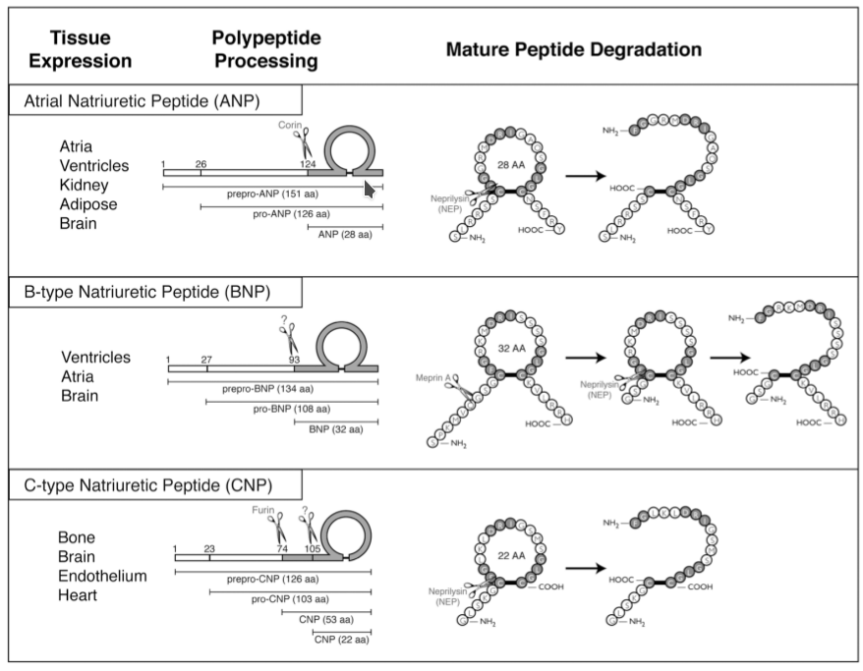Figure 1: Structure of the human natriuretic peptides. The structure of the preprohormones for ANP, BNP and CNP are outlined on the left of each panel. The final amino acid sequence and structure of the mature peptides along with the major degradation product are shown on the right. The sites of cleavage are indicated with scissors. 0

Obese patients tend to have lower BNP levels than others. Neural endopeptidases that can be secreted by adipose tissue may be related to increased BNP clearance in obese patients.. A very small amount of immunoreactive BNP has been found in urine, but the precisemechanism of renal excretion has not yet been fully clarified. 30

NTproBNP is accepted to be more biochemically stable than BNP. BNP, when left at room temperature or when without a protease inhibitor such as ethylenediaminetetraacetic acid (EDTA) added, is prone to degradation, with rapid loss of immunoreactive peptide. BNP should be drawn into plastic rather than glass tubes because of degradation. NTproBNP, on the other hand, is much more flexible; it can be drawn into glass or plastic tubes and does not require an addition of protease inhibitors such as EDTA. NTproBNP can be drawn into serum, heparin plasma, or EDTA. The intra-individual, day-to-day biologic variation in stable HF patients is about 38% for BNP and 28% for NTproBNP; in patients without HF, these figures are considerably larger, but it is worth noting that substantially higher biologic variation in patients with extremely low concentrations is rarely of clinical importance. 16

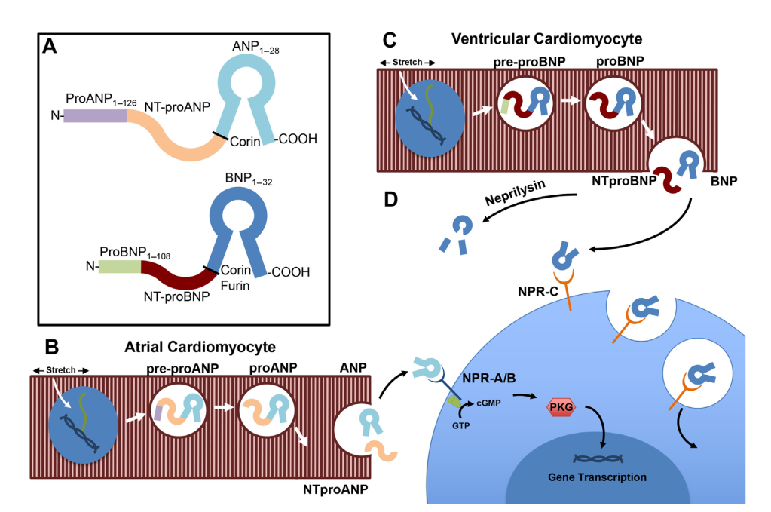Figure 2: ANP and BNP physiology. (A) Molecular structure of ANP (top) and BNP (bottom) showing enzymatic cleavage sites and end-product fragments. (B) Production and processing of ANP by atrial cardiac myocyte in response to mechanical stretch stimulus. (C) Production and processing of BNP by ventricular cardiac myocyte in response to mechanical stimulus. (D) Effects of ANP and BNP on target tissues. Both ANP and BNP bind NP receptor (NPR)A and NPRon target cells, inducing cleavage of guanosine triphosphate (GTP) to cyclic guanosine monophosphate (cGMP) by cytoplasmic G proteins, initiating an intracellular cGMP signaling cascade involving protein kinase G (PKG), ultimately leading to downstream transcription of genes involving smooth muscle cell relaxation, diuresis and natriuresis (depending on target tissue). Both ANP and BNP are broken down in serum by circulating endogenous peptidases, including neprilysin. ANP and BNP are also degraded (to a lesser extent) by cellular uptake through binding NPR-C, undergoing receptor mediated endocytosis and intracellular breakdown by lysosomes. 1

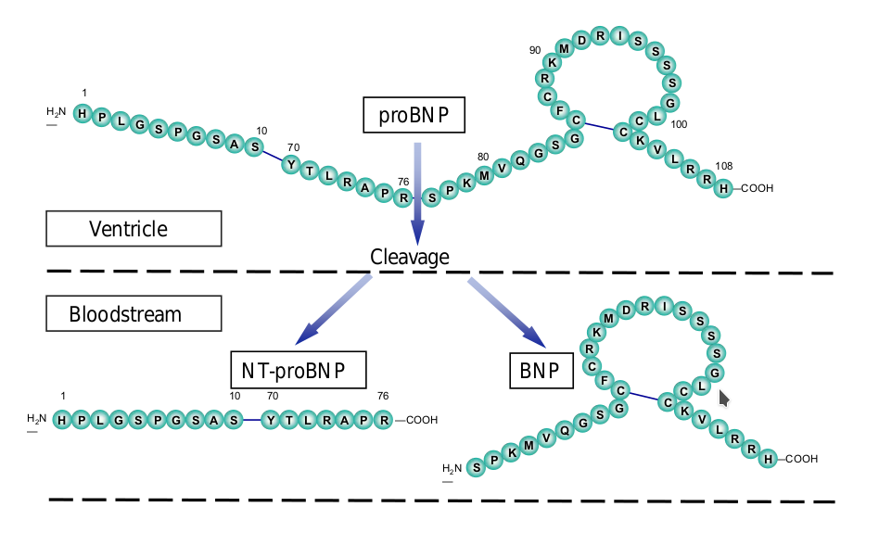Figure 3: Secretion of BNP and NTproBNP 16

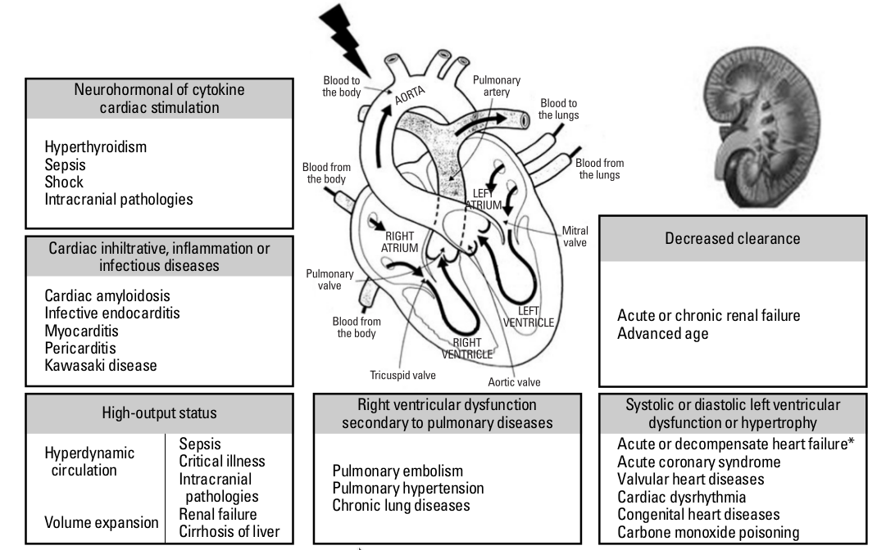Figure 4: The causes and mechanisms of elevated natriuretic peptides levels.

BNP is removed from circulation by both receptor-mediated mechaims (NPR type C) and enzymatic processes (neutral endopeptidases, meprin-A, and dipeptidylpeptidase IV present in various tissues). On the other hand, NTproBNP is passively cleared by multiple organs with high blood flows, including the kidneys. About a quarter of both BNP and NTproBNP are cleared by renal mechanisms, down to an estimated glomerular filtration rate of less than 15 mL/min/1.73 m2 . Because of the above-mentioned differences in the mechanism of clearance, the circulating half-life of BNP is much shorter at about 20 minutes, whereas that for NTproBNP is longer at about 70 minutes. 16

The assay of the inactive propeptides better fits the definition of disease marker than the assay of circulating levels of ANP or BNP, which, on the other hand, may be considered a more reliable index of the activation status of the NPs system. Considering the biochemical and physiological characteristics of the different peptides, it is conceivable that ANP is a better marker of acute overload and/or rapid cardiovascular hemodynamic changes than BNP and, especially, than NT-proANP or NTproBNP 10

Table 1: Biochemical properties of BNP and NT-proBNP. a) Intra-individual, day-to-day biologic variation in patients with established HF. 16

|  |  |  |  |  |  |  |  |  |
| --- | --- | --- | --- | --- | --- | --- | --- | --- |
|  | Size  (KDa) | Half-Life  (min) | Normal Ranges  Male(pg/mL) | Normal Ranges  Female(pg/mL) | Clearance | Biologic Actvity | In vitro Stability at Room Temperature | Biologic Variability(%)a |
| BNP | 3.5 | 21 | 8.0 | 13.9 | NPR type C, NEPs, meprin-A and dipeptidylpeptidase IV | Active | 6h | 38 |
| NT-proBNP | 8.5 | 60-120 | 46.9 | 64.3 | Passively cleared through multiple organs | Inactive | > 3d | 28 |

Theoretically, setting up an immunoassay for NT-proANP and NTproBNP should be easier because their plasma concentrations are higher than ANP and BNP. On the other hand, NT-proANP and NTproBNP immunoassays may be affected by several analytical problems, mainly concerning the different assay specificities; consequently, very different results are produced by different methods with a large bias. The different analytical performance might affect the diagnostic accuracy of the assays, in discriminating between subjects with or without cardiac disease 10

Most of the commercially available assays for BNP and NTproBNP are sandwich immunoassays, which considerably improved the specificity as well as sensitivity of enzyme-linked immunosorbent assays. Although there is no cross-reactivity between BNP and NTproBNP assays, recent evidence suggests that a substantial percentage of what is detected as ”BNP” or ”NTproBNP” by available immunoassays for each may in fact be a mixture of the targeted protein as well as uncleaved proBNP 1-108 ; in the case of BNP, various degraded fragments are also detected. The mechanism explaining the release of proBNP 1-108 is not known, but studies have shown that circulating proBNP 1-108 concentrations are elevated in patients with more advanced HF. Importantly, proBNP 1-108 has reduced or absent biologic activity relative to BNP; the lack of a diuretic and natriuretic effect is clearly deleterious to the patient with HF and implies a potential therapeutic target for future therapies that may address the handicap in cleavage of this important cardiac hormone. 16

Plastic tubes containing ethylenedinitrolotetraacetic acid (EDTA) are desirable for BNP determination and refrigeration is required if the interval between blood collection and analysis is over 4 hours; whereas NTproBNP can be measured in both serum or plasma, collected in glass or plastic tubes, and has no significant loss of immunoreactivity after 48 hours at room temperature.

## NPRs structure and function

There are three known natriuretic peptide binding proteins (natriuretic peptide receptors NPRs). All members contain a relatively large ( 450 amino acid) extracellular ligand binding domain and a single membranespanning region of about 20 residues. Natriuretic peptide receptors A and B contain an equally large intracellular domain consisting of a so-called kinase homology domain, dimerization domain, and carboxylterminal guanylyl cyclase domain. Thus, NPR-A and NPR-B signal by catalyzing the synthesis of the intracellular signaling molecule cGMP. In contrast, NPR-C only contains a 37 residue intracellular domain and lacks guanylyl cyclase activity. It primarily controls local natriuretic peptide concentrations via receptor-mediated internalization and degradation. see fig.6 31

NPR-A and NPR-B are generally considered to mediate all known biological actions throughout the guanylate cyclase (GC) intracellular domain, while the third member of the natriuretic peptide receptor family, the NPR-C receptor, does not have a GC domain. The GC receptors for ANP/BNP (NPR-GC-A) and CNP (NPR-GC-B) belong to a family of seven isoforms of transmembrane enzymes (from GC-A to GC), which all convert guanosine triphosphate into the second messenger cyclic 3’,5’-guanosine monophos phate (cGMP). The physi ological expression of NPR-A and NPR-B differs quite significantly in human tissues. NPR-A is found in abundance in larger, conduit blood vessels, whereas the NPR-B is found predominantly in the central nervous system. Both receptors have been localized in adrenal glands and kidney 32

The affinity for ANP, BNP and CNP also varies greatly among the different NPRs. ANP shows a greater affinity for NPR-A and NPR-C, and CNP for NPR-B, while BNP shows a lower affinity for all NPRs compared to the other two peptides. Activation of the GC-linked NPRs is incompletely understood 33.

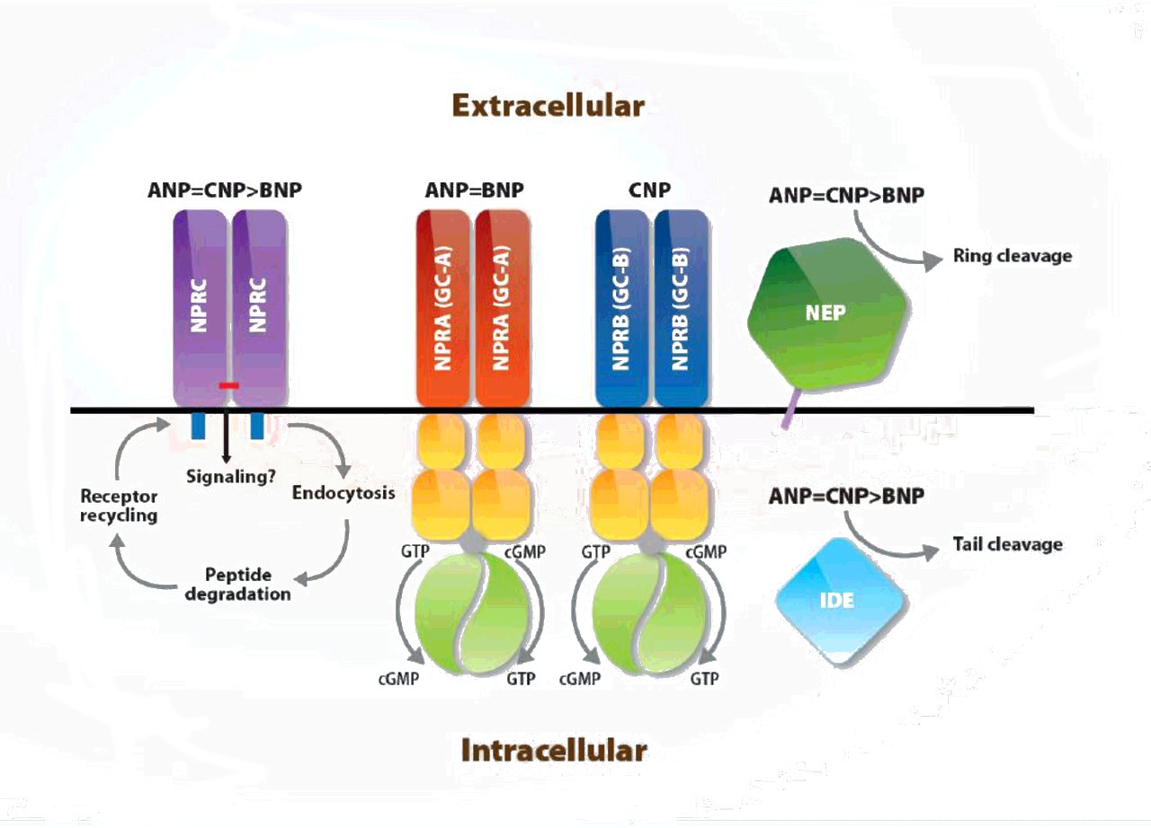Figure 5: Schematic representation of natriuretic receptors

ANP and BNP interact with these NPRS (A,B and C) with their main physiologic effects exerted through the NPR-A receptor. The NPR-A is the predominant form on the blood vessels, with a smaller amount of NPR-B, and both receptors are found in the kidneys and adrenal glands. ANP and BNP binding to NPR-A and NPR-B leads to activation of guanylyl cyclase GC and downstream signaling through cyclic guanosine monophgosphate (cGMP). NPR-C clears ANP, and to a lesser extent, BNP by binding and internalizing the receptor and degrading the hormone. see fig.2 1

Although ligand-dependent internalization and degradation of NPR-A has been intensely studied by several groups for many years, a consensus understanding of the importance of this process in the regulation of NPRs has not emerged. Early studies conducted on pheochromocytoma cells suggested that both NPR-A and NPR-C internalize ANP and that both receptors are recycled back to the cell surface. Other studies, have reported that ANP binding to NPR-A stimulates its internalization, which results in the majority of the receptors being degraded with a smaller portion being recycled to the plasma membrane. In contrast, other studies reported that NPR-A is a constitutively membrane resident protein that neither undergoes endocytosis nor mediates lysosomal hydrolysis of ANP. These studies did not support the hypothesis that down-regulation is responsible for NPR desensitization observed in response to various physiological or pathological stimuli 34

NPR-A internalization and degradation is also controversial. One group consistently reports that the majority of internalized ANP-NPRA complexes are degraded via a lysosomal pathway with a small portion returning intact to the plasma membrane [Pandey, 2002]. Meanwhile,studies in primary kidney and Chinese Hamster ovary indicate that NPR-A is a membrane resident protein that does not undergo acute internalization and degradation 33

It is generally thought that the NPR-C is not linked to GC and so serves as a clearance receptor 10 NPR-C is present in higher concentration than NPR-A or NPR-B in several tissues (especially vascular tissue),and it is known constitutively to internalize NPs 33.

However, the NPR-C receptor could be coupled to a G-protein that inhibits cyclic AMP synthesis. These receptors, which are present in great amount especially on the endothelial cell wall, may mediate some paracrine effects of CNP on vascular tissue 32

## Physiologic Functions

### Cardiovascular Functions

Cardiac natriuretic hormones have powerful physiological effects on the cardiovascular system, body fluid, and electrolyte homeostasis. Nps share a direct diuretic, natriuretic and vasodilator effect and an inhibitory action on ventricular myocyte contraction as well as remodeling and inflammatory processes of myocardium and smooth muscle cells 10

NPs induce actions that reduce cardiac preload and afterload to counteract the detrimental effects of pressure and volume overload, as seen in HF. These physiologic processes are counter-regulatory to the detrimental neurohormonal activation of the sympathetic nervous system and RAAS in HF and are why ANP and BNP levels reflect HF severity. 8

Circulating BNP acts as an antagonist of the renin angiotensine aldosterone system, and protects the body from plasma overload by inducing diuresis, natriuresis, vascular dilatation and inhibition of the sympathetic nervous system. 7

Mice with reduced cardiomyocyte expression of NPR-A exhibited moderate hypertrophy even though they were slightly hypotensive 35 Targeted deletion of BNP resulted in normotensive mice with normal heart size but with increased ventricular fibrosis especially when subjected to pressure overload 36.

Although prolonged hypertension can cause hypertrophy, the level of hypertrophy in NPR-A deficient mice is significantly greater than that observed in other genetic models that cause similar levels of hypertension, suggesting that NPR-A elicits a local growth inhibitory signal in the heart. Data for this idea was initially shown in NPR-A knockout mice, which have enlarged hearts even when effectively treated with antihypertensive drugs from birth 37

Transgenic rats expressing a dominant negative form of NPR-B exhibit mild blood pressure-independent cardiac hypertrophy and increased heart rate 38

The ability of the ANP/NPR-A pathway to increase endothelial permeability is supported by the observation that hematocrit levels are elevated prior to urination and are preserved in nephrectomized animals. Furthermore, mice with genetically engineered reductions of NPR-A in vascular endothelium exhibit volume expansion, hypertension, and reduced albumin clearance from the vascular system 39

Physiological experiments involving mice with severe reductions of NPR-A in vascular smooth muscle cells demonstrated that while smooth muscle NPR-A is required for acute ANPor BNP-dependent vasorelaxation, this response does not play a significant role in controlling chronic blood pressure 40

The function of natriuretic peptides was also studied after induction of myocardial infarction in KO mice lacking the NPR-A, the receptor for ANP and BNP. KO and wild-type mice were subjected to left coronary artery ligation and then followed-up for 4 weeks. KO mice showed significantly higher mortality because of a higher incidence of acute HF, which was associated with diminished water and sodium excretion and with higher cardiac levels of mRNAs encoding ANP, BNP, TGF-b1, and type I collagen. By 4 weeks after infarction, left ventricular remodeling, including myocardial hypertrophy and fibrosis, and impairment of left ventricular systolic function were significantly more severe in KO than wild-type mice. These data confirm that the NPs system has powerful anti-remodeling properties on ventricular cardiomyocytes.41

In transgenic mice with overexpression of ANP and BNP in liver, plasma ANP and BNP levels are from 10to 100-fold higher than in control mice, with a blood pressure of 20-25 mmHg lower. These mice also have lighter hearts, but with the same cardiac output and rate, than controls. On the other hand, ANP KO mice develop NaClsensitive hypertension. Transgenic mice overexpressing the NPRA gene have a lower blood pressure than wild-type mice. NPR-A KO mice show an increase in blood pressure compared with controls (on average 10 mmHg in heterozygous and 30 mmHg in homozygous animals), which is not affected by NaCl intake. These data suggest a different pathophysiological mechanism for hypertension between KO mice for the ANP gene and its specific receptor; this difference does not yet have an explanation. NPRC heterozygous KO mice do not show blood pressure variation, whereas homozygous mice show on average a decrease in blood pressure of about 8 mmHg 42

It is theoretically conceivable that ANP and BNP act like hormones in vascular tissue by reaching the smooth muscle cells from the circulation after secretion by the heart, while CNP shows a paracrine action, being secreted by endothelial cells 43

The endocrine action, shared by plasma ANP and BNP, can be enhanced by natriuretic peptides produced locally in target tissues (paracrine action). Endothelial cells synthesize CNP, which in turn exerts a paracrine action on vessels 44

In addition, CNP infusion was shown to reduce cardiac remodeling in response to experimentally induced myocardial infarction in rats, and transgenic expression of CNP improved outcomes in mice subjected to ischemia/reperfusion injury or myocardial infarction 45

Evidence from cellular, animal, and human studies suggests that all NPs are able to stimulate NO production by endothelial NO synthase (eNOS); this effect is probably mediated by clearance receptor NPR-C. Stimulation of this NPR-C receptor results in decreased cAMP levels by adenyl cyclase inhibition through an inhibitory guanine nucleotideregulating protein 46

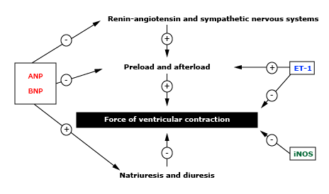Figure 6: Representation of the effects of elevated plasma atrial natriuretic peptide (ANP) and brain natriuretic peptide (BNP) in severe heart failure. ANP and BNP may increase (+) the rate of sodium excretion and reduce (-) the effects of the renin-angiotensin (RAS), sympathetic nervous systems (NS), and endothelin (ET)-1; the net effect of these actions is reduced preload and afterload. A similar elevation in inducible nitric oxide synthase (iNOS) is seen in humans with severe heart failure. These initially homeostatic mechanisms paradoxically contribute to the pathophysiology of the failing myocardium. 0

ANP expression is markedly upregulated in eNOS -/- mice, and exogenous ANP restores ventricular relaxation in wild-type mice treated with NOS inhibitors. These data suggest that the NPs and NO systems are linked by a negative feedback mechanism. 47

NPs exert a protective effect on endothelial function by decreasing shear stress, modulating coagulation and fibrinolysis pathways, and inhibiting platelet activation. They can also inhibit vascular remodeling process as well as coronary restenosis post-angioplasty 41

CNP has little natriuretic and diuretic action compared to ANP or BNP, it is capable of modulating the vascular effects of the local RAAS by opposing potent vasoconstriction to angiotensin II 48

On the other hand, endothelin-1 (ET-1) induces an increase in the number of endothelial cells that secrete CNP. Therefore, the parallel production and activity of vasodilator CNP and vasoconstrictors such as ET-1 and angiotensin II allows for tight local regulation of these vasoactive peptides and thus blood flow 49

Thrombus formation is suppressed significantly in the presence of CNP, which indicates that inhibition of coagulation might contribute to the vasoprotective properties of this peptide. Observations that CNP blocks platelet aggregation, induced by thrombin, confirm that endotheliumderived CNP also exerts an anti-thrombotic effect 50

Renal tubular cells produce urodilatin, another member of the peptide natriuretic family, which has powerful diuretic and natriuretic properties. 51

### Non Cardiovascular Functions

Humans with two loss-of-function alleles for NPR-B suffer from a rare type of autosomal recessive dwarfism, called acromesomelic dysplasia, type Maroteaux. These individuals are characterized by disproportionate limb to torso ratios that are only obvious a year or more after birth. 52

Single copy carriers of a nonfunctional NPR-B allele do not suffer from disease but, they are statistically shorter than comparable individuals with two wild type NPR-B alleles 53

The most obvious function of the CNP/NPR-B pathway is to stimulate long bone growth. Though undetectable at birth, mice lacking functional CNP or NPR-B develop dwarfism due to impaired endochondrial ossification 54

NPR-B dominant negative mutant transgenic rats, in addition to mild growth retardation of the long bones, displayed progressive, blood pressure-independent cardiac hypertrophy and an elevated heart rate 38

NPR-B and/or its mRNA is expressed in bone, brain, fibroblasts, heart, kidney, liver, lung, uterine, and vascular smooth muscle tissue. 55

Transgenic CNP overexpression or reduced degradation of CNP due to loss-ofunction mutations in NPR-C result in skeletal overgrowth 56

Furthermore, the inter-relationships between the NPs system and proinflammatory cytokines suggest that NPs play an important role in mechanisms responsible for cardiac and vascular adaptation, maladaptation and remodeling in response to various physiological and pathological stimuli 57

Huge amount of data strongly supports the hypothesis that NPs are active components of the body integrative network that includes nervous, endocrine and immune systems. This hypothesis implies that there are two counteracting systems in the body: one has sodium-retaining, vasoconstrictive, thrombophylic, pro-inflamma tory and hypertrophic actions, while the second one promotes natriuresis and vasodi latation, and inhibits thrombosis, inflammation and hypertrophy. NPs are the main effectors of the latter system, and work in concert with NO, some prostaglandins, and other vasodilator peptides 58

Several reports have shown that NPs stimulate the synthesis and release of testosterone in a dose-dependent manner in isolated and purified normal Leydig cells. It has been suggested that this effect on normal Leydig cell steroidogenesis does not involve classical mechanisms of cAMP-mediated regulation of steroidogenic activ ity by gonadotropins. The stimulated levels of testosterone production by ANP, BNP, and gonadotropins were comparable, whereas CNP has been found to be a weak stimulator of testosterone production in Leydig cells. Moreover, testicular cells contain immunoreactive ANP-like materials and a high density of natriuretic peptide receptor-A (NRP-A). These findings suggest that NPs play paracrine and/or autocrine roles in testis and testicular cells. Furthermore, the presence of ANP and its receptors has been reported in ovarian cells, too. Increasing evidence strongly support that NPs are present and probably locally synthesized in ovarian cells of different mammalian species and also play an important physiological role in stimulating estradiol synthesis and secretion in the female gonad 59

A review by Waschek, 60 has highlighted a possible major role for NPs in the development of certain systems, in particular skeleton, brain, and vessels. This review cites studies showing severe skeletal defects and impaired recovery after vascular and renal injury in Nps transgenic and knockout mice. In addition, NPs may have a role in the regulation of proliferation, survival, and neurite outgrowth of cultured neuronal and/or glial cells.

Genes for natriuretic peptides (including ANP, BNP and CNP) are also expressed in the central nervous system, where they likely act as neurotransmitters and/or neuromodulators 51.

It was demonstrated that intranasal ANP acts as central nervous inhibitor of the hypothalamus pituitary-adrenal stress system in humans 61.

Co-expression of NPs and of their receptors was observed in rat thymus cells and macrophages,suggesting that NPs may have immunomodulatory and antinflammatory functions in mammals62.

Evidence for a role of NPs in the immune system is given by the fact that peptide hormones and their receptors are expressed in various immune organs. Furthermore, several studies indicated that the Nps system in immune cells underlies specific regulatory mechanisms by affecting the innate as well as the adaptive immune response. In particular, ANP increases phagocytotic activity and production of reactive oxygen species of phagocytes. ANP affects the induced innate immune response by regulating the activation of macrophages at various stages. It also reduces production of pro-inflammatory medi ators by inhibition of iNOS and COX-2 as well as TNF-α synthesis. ANP also affects TNF-α action, i.e. it interferes with the inflammatory effects of TNF-α on the endothe lium. The peptide hormone counteracts TNF-α-induced endothelial permeability and adhesion and attraction of inflammatory cells. Finally, it affects thymopoesis and T cell maturation by acting on dendritic cells and regulates the balance between TH1 and TH2 responses 63

## NPs in disease states

It is well known that changes in hemodynamic parameters (such as left ventricular ejection fraction, EF) and plasma NPs levels (expressed in a log scale) are closely related in patients with cardiovascular diseases 64.

The NPs system activation is modulated not only by hemodynamic factors, but also by the activity of the counter-regulatory neuro-hormonal system. Consequently, it is likely that very small changes in hemodynamics, not assessable by echocardiographic examination, may produce significant (and measurable) variations in plasma concentrations of NPs 9.

On average, the response of the NPs system to the increasing challenge of disease severity may not be linear. The curve reported in Figure 4 suggests that the Nps system responds with a sharp increase in BNP plasma concentration in the early phase of HF (NYHA class I-II patients), followed, with the clinical progression of the disease, by a blunted increase (NYHA class III), and finally by a plateau (NYHA class IV) 65.

Patients with HF show a progressive and parallel increase in NPs levels and in some neuro-hormones and cytokines. This increase can be closely related to disease severity, as assessed by functional NYHA class. Plasma BNP values, normalized by mean values found in healthy subjects, are significantly higher than other normalized neuro-hormone and cytokine values in HF 9

Patients with chronic HF show increased NPs plasma levels compared to normal subjects. These findings have been defined the ”endocrine paradox” in HF, i.e., extremely high circulating levels of hormones with powerful natriuretic activity in patients with congestive HF, who show physical signs of fluid retention and vasoconstriction due to a relatively poor biological activity of the NPs system 22.

A blunted natriuretic response after pharmacological doses of ANP and BNP has been observed in experimental models and in patients with chronic HF, suggesting a resistance to the biological effects of NPs, principally natriuresis. This resistance syndrome was also demonstrated by in vivo turnover studies using radioactive tracers in patients with HF 65

Studies demonstrated that the activation of the neuro-hormonal system accelerates the left ventricular functional impairment in patients with HF. Drugs that contrast the detrimental effects of the neuro-hormonal system activation play a key role for the current pharmacological treatment of HF. Some of these, such as ACE inhibitors, angiotensin II receptor blockers, β-blockers, and spironolactone decrease the circulating levels of Nps, normalize their kinetics, and increase their biological activity 10.

Furthermore, they enhance the natriuretic effect of ANP or BNP analogs administered to patients. In other words, the treatment with this type of pharmacological agents decreases the systemic resistance to the biological effects of NPs 65

Individual differences in the ability of heart tissue to mature the precursor of Nps peptides, or of peripheral tissues to degrade them, may help to explain why there are some differences in the clinical presentation among patients with HF with similar clinical severity and ventricular function 22

A resistance to the biological action of NPs may be theoretically due to an increase in degradation (turnover) of circulating biologically active peptides. NPs are degraded in vivo and in vitro by several types of proteolytic enzymes, including serinroteases, peptidyl arginine aldehyde proteases, kallikrein like proteases, and neutral endopeptidases (NEP) 66

Some peptides, derived in vivo or in vitro from degradation of intact proBNP, are biologically inactive, although they can be measured by immunoassay methods. Since the circulating levels of intact proBNP and of its derived peptides increase progressively with severity of HF, immunoassay methods can greatly overestimate the true biological activity of NPs in patients with severe HF. Unfortunately, at present, it is not possible to estimate the inaccuracy of NPs immunoassays because these methods use different, not standardized antibodies and calibrators, leading to highly different clinical results 22

Another well-characterized deactivation mechanism is the process by which an activated receptor is turned off, commonly referred to as ”desensitization”. Phosphorylation of the intracellular kinase homology domain of NRP-A and NPR-B is required for hormone-dependent activation of the receptor, while dephosphorylation at this site causes desensitization. Deactivation of the NPs system via desensitization of NRP-A and NPR-B can occur in response to various pathophysiological stimuli 33

NPR-B dephosphorylation has been shown to mediate desensitization in response to prolonged CNP exposure, protein kinase C activation, and intracellular calcium elevations 67

ome studies suggest that the resistance to biological effects of Nps in HF may be due,in part,to variations in the relative amount of the three different types of natriuretic peptide-specific receptors.In particular,there could be an upregulation of type C receptors (NPR-C) with a parallel down regulation of type A and B receptors (NPR-A and NPR-B) 68

NPR-A and NPR-B mediate all known hormonal actions of NPs, therefore their down-regulation should induce a deactivation of the NPs system. The upregulation of NPR-C receptors that strongly contribute to the clearance of biologically active peptides could further increase the resistance to NPs in patients with HF 69

Reversal of cardiomyocyte hypertrophy during left ventricular assist device support was accompanied by normalization of ANP, BNP and NPR-C mRNA levels and a significant recovery of responsiveness to ANP 68.

However, Fan et al. 33 found that neither NPR-A nor NPR-B were internalized or degraded in response to natriuretic peptide binding in cultured cells. It is important to note that renal function can affect the biological action of NPs in different ways. NPs are small peptides freely filtrated by renal glomerulus; the kidneys are probably responsible for about 50% of metabolic clerance rate of plasma ANP and BNP and in this way renal diseases can affect the circulating levels of NPs. Indeed,a decreased renal function greatly increases the plasma NPs concentration and consequently more peptide hormones are available for other target tissues (such as brain,vascular tissue,adrenal gland and so on) 10

Luminal perfusion with ANP has been shown to reduce sodium efflux from the inner medullar collecting duct, suggesting that this hormone has also luminal sites of action. As a consequence, a reduction in the filtration can potentially induce renal hypo-responsiveness to NPs 70

A peripheral resistance to the biological effects of NPs may play an important role inother clinical conditions, besides HF. For example, NPR-C is also present on cellular membranes of adipose tissue. It was suggested that the increase in NPR-C receptors observed in obese subjects can in turn increase the peripheral degradation of NPs and consequently blunt the action of the NPs system. This reduced activity of the NPs system may increase the risk of developing arterial hypertension and other cardiovascular diseases due to the non-contrasted and therefore prevailing effects of the counter regulatory system with sodium-retentive and vasoconstrictive properties 71

# Clinical applications

## Utility in diagnosis

### In heart failure

NTproBNP is correlated with several echocardiographic indicators of cardiac structure and function including:18

* Left ventricular (LV) end-diastolic wall stress
* LV ejection fraction (LVEF)
* E/e’
* LV longitudinal strain
* LV circumferential strain
* Left atrial dimensions
* Right ventricular ejection fraction
* Right ventricular pressures

Iwanaga et al.]3 measured systolic and diastolic wall stress by echocardiography and cardiac catheterization, and related this key measurement to plasma concentrations of NP in patients with HF. A striking correlation between plasma BNP with end-diastolic wall stress (r = 0.887; P < 0.001) seemed to be far stronger than the correlation with LV end-diastolic pressure (r = 0.296; P < 0.001). NP levels seem to reflect LV wall stress more closely than other ventricular parameters in HF, and this relationship may better account for interindividual differences in plasma NP values than other measures.

It is well known that changes in hemodynamic parameters (such as left ventricular ejection fraction, EF) and plasma NPs levels (expressed in a log scale) are closely related in patients with cardiovascular diseases. Yet the NPs system activation is modulated not only by hemodynamic factors, but also by the activity of the counteregulatory neurohormonal system. Consequently, it is likely that very small changes in hemodynamics, not assessable by echocardiographic examination, may produce significant (and measurable) variations in plasma concentrations of NPs 9.

The relationship between cardiac structure and function and associated cardiac transmural distending pressures and myocyte stretch on the one hand with cardiac release and plasma concentrations of NTproBNP on the other underpins the strength of NTproBNP as a biomarker in HF. NTproBNP has good diagnostic performance for discrimination of acute heart failure among patients presenting with new-onset dyspnea. 18

In a study of 305 patients assessed by 92 family doctors for suspected incipient heart failure (on the basis of exertional dyspnea and/or peripheral edema), the addition of plasma NTproBNP measurements to clinical history and examination, significantly improved diagnostic accuracy by 10 patients per 100 assessed. 72

The Breathing Not Properly Multinational Study published in 2002 was the first large study to evaluate the efficacy of BNP as a cardiac biomarker for diagnosis of HF in the ED setting. This study evaluated 1586 patients presenting to EDs with the chief complaint of dyspnea at different medical centers around the world. Serum BNP levels were higher in patients presenting with dyspnea caused by AHF than in dyspnea from a noncardiac cause (mean 675 ± 450 vs 110 ± 225 pg/mL, P < 0.001). Serum BNP levels were positively correlated with severity of HF using the New York Heart Association (NYHA) classification. In addition, BNP concentrations were directly associated with increasing severity of HF symptoms. The diagnostic accuracy of a BNP measurement surpassed any other single findings from routine evaluation including history and physical examination, chest x-ray, or laboratory tests in identifying HF as the cause of dyspnea. BNP performed better than established clinical HF criteria and added independent information to the traditional evaluation of these patients. By means of receiver operating characteristics analyses, a BNP value of 100 pg/ml was the optimal value to differentiate patients with dyspnoea caused by HF from dyspnoea due to pulmonary pathology (area under the curve (AUC) was 0.91, sensitivity 90%, specificity 76%, and accuracy 85%) Fig. 7. This value of 100 pg/ml also discriminated non-systolic HF (LVEF <45%) from non-HF patients at the emergency department. Using a cutoff of 50 pg/mL, BNP had a negative predictive value of 96%. 73

In a cohort of 600 patients presenting with dyspnea to the emergency department, the ProBNP Investigation of Dyspnea in the Emergency Department (PRIDE) Study showed that patients with ADHF had much higher NTproBNP concentrations compared with patients without HF (median 4054 vs 131 pg/mL, P <.001) and higher NTproBNP concentrations were also directly associated with increasing severity of HF (P=0.001). Of all single traditional HF evaluation techniques, NTproBNP was the strongest predictor of the diagnosis of ADHF. The diagnostic accuracy of NTproBNP was stronger than that of clinical judgment alone (AUC of 0.94 vs 0.90), but the best way to accurately diagnose ADHF was by using a combination of NTproBNP and clinical judgment (AUC 0.96). Using a cutoff level of 300 pg/mL, and NTproBNP was 90% sensitive and 85% specific for diagnosis of AHF. A single NTproBNP cutoff value of 900 pg/mL provided identical performance to that reported for a BNP value of 100 pg/mL.74 Fig. 8

In their subsequent study (The International Collaboration on NTproBNP study (ICON)) Januzzi et al.]75 included data on 1256 patients presenting with newnset shortness of breath. ICON data defined the sensitivity, specificity, negative predictive value, positive predictive value, and overall accuracy of NTproBNP for the diagnosis of acute HF in acutely symptomatic patients. Plasma NTproBNP of 300 pg/mL acts as an excellent rule-out threshold with a sensitivity for ADHF consistently greater than 90% and a negative predictive value of 98%. Specificity is improved by using a 3-tiered age-stratification approach for cutoff points with 450, 900, and 1800 pg/mL performing well for age groups less than 50, 50 to 75, and greater than 75 years, respectively with 90% sensitivity and 84% specificity for acute HF. Fig. 9

The typical elevation of plasma NTproBNP in the setting of severe symptomatic acute decompensated heart failure (ADHF) is so pronounced (median values are >5000 pg/mL and are typically >40fold greater than the levels observed in controls without HF) that this marker achieves an excellent ”signal-to-noise ratio” for ADHF.18

The evidence is now overwhelming that early measurement of serum BNP levels should be used to diagnose acute heart failure (AHF), and it is a class I indication in the American Heart Association (AHA)/American College of Cardiology (ACC) guidelines for the management of HF that BNP levels should be measured in all hospital admissions for AHF. Cardiac-specific biomarkers are particularly useful in the emergency department (ED) setting when evaluating dyspneic patients, because it is difficult to distinguish between shortness of breath caused by HF versus that caused by pulmonary disease. 1

Cardiac chamber wall stress, the prime driver of NP synthesis and release, in accord with the law of Laplace, is directly related to intrachamber pressure and chamber radius and inversely related to wall thickness. In concentrically hypertrophied hearts, as commonly observed in patients with HF with preserved ejection fraction (HfpEF), unit wall stress is less than in those patients with HF with reduced ejection fraction (HFrEF) and dilated left ventricles. Accordingly, plasma NP in acute decompensated HF (ADHF) are lower in HFpEF compared with HFrEF. 18

Plasma NP concentrations reflect aspects of diastolic dysfunction independent of age, sex, renal function, body mass index, and LVEF. Plasma NTproBNP (>600 pg/mL) and BNP (>100 pg/mL) are strong, albeit relatively nonspecific, independent predictors of restrictive filling the most severe grade diastolic dysfunction. In HF, plasma NTproBNP correlates with E/e’, a well-validated index of LV filling pressures, in addition to measures of LV compliance, myocardial relaxation, and left atrial dimensions. With respect to right heart function, plasma concentrations of B-type NPs are inversely related to right ventricular ejection fraction and directly related to right ventricular dimensions and estimated intraventricular pressures. 76

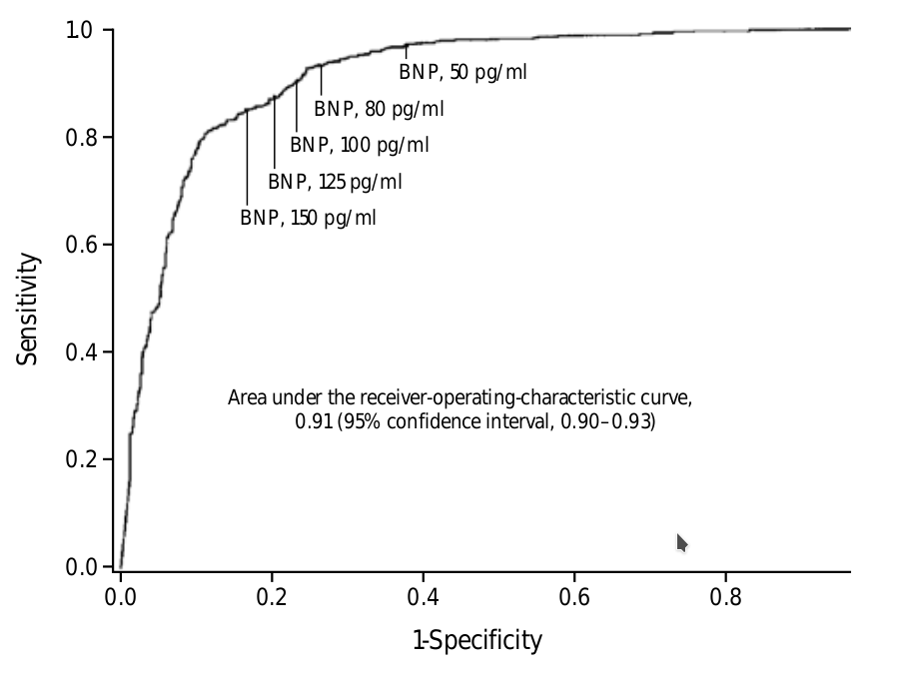Figure 7: ROC curves for BNP in the diagnosis of heart failure at the emergency department [Januzzi et al., 2005].

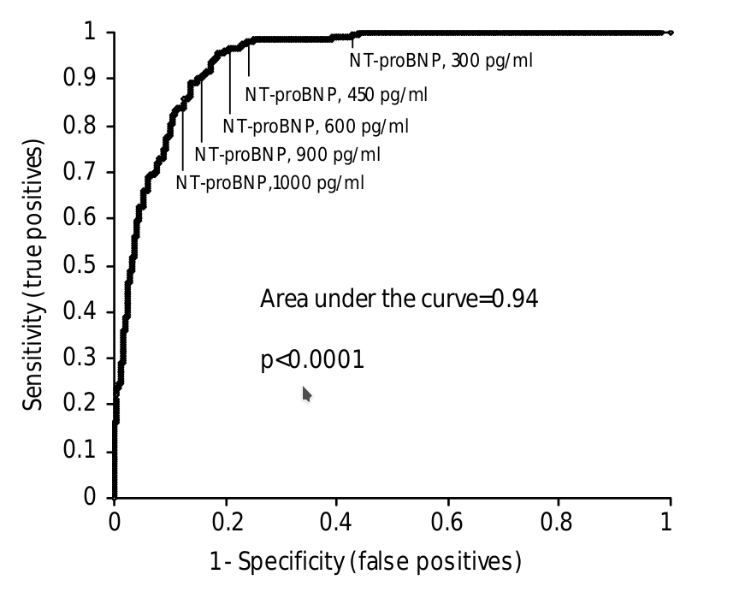Figure 8: ROC curves for NTproBNP in the diagnosis of heart failure at the emergency department.74

Table 2: Optimal NT-proBNP cutpoints for the diagnosis or exclusion of acute heart failure among dyspneic patients

Abbreviations: NTproBNP, amino-terminal pro–B-type natriuretic peptide; NPV, negative predictive value; PPV, positive predictive value. 75

|  |  |  |  |  |  |  |
| --- | --- | --- | --- | --- | --- | --- |
| Category | Optimal cutpoint  (pg/mL) | Sensitivity (%) | Specificity (%) | PPV (%) | NPV (%) | Accuracy (%) |
| Exclusionay “rule out” cutpoint all patients  (n = 1256) | 300 | 99 | 60 | 77 | 99 | 83 |
| Confirmatory “rule in” cutpoints | | | | | |  |
| <50y (n = 184) | 450 | 97 | 93 | 76 | 99 | 94 |
| 50-75y (n = 537) | 900 | 90 | 82 | 83 | 88 | 85 |
| >75y (n = 535) | 1800 | 85 | 73 | 92 | 55 | 83 |
| Rule in, overall (n = 1256) | - | 90 | 84 | 88 | 66 | 85 |

An echocardiographic substudy of the phase II PARAMOUNT trial (LCZ696 Compared to Valsartan in Patients With Chronic Heart Failure and Preserved Leftentricular Ejection Fraction) of valsartansacubitril therapy in HFpEF, demonstrated decreases in LV systolic longitudinal and circumferential strain that were significantly related to plasma NTproBNP independent of age, sex, systolic and diastolic blood pressures, body mass index, LVEF, left atrial volume index, E/E’, atrial fibrillation (AF), or renal function. 77

Table 3: Median plasma concentrations of NT-proBNP in acute and chronic HFrEF and HFpEF

Abbreviations: HFpEF, heart failure with preserved left ventricular ejection fraction; HFrEF, heart failure with reduced left ventricular ejection fraction. 18

|  |  |  |  |  |
| --- | --- | --- | --- | --- |
| Category of Heart Failure | NT-proBNP median  (pg/mL) | N | Study/Trial | Ref |
| Acute decompensated heart failure | | | | |
| HFrEF | 6356 | 358 | ICON | 75 |
| HFpEF | 3070 | 295 | ICON | 75 |
| Chronic decompensated eart failure | | | | |
| HFrEF | 895 | 3916 | ValHeFT | 78 |
| HFpEF | 339 | 3480 | I-PRESERVE | 12 |

Despite BNP and NTproBNP concentrations being typically lower in HF patients with preserved ejection fraction (HFpEF) compared with HF patients with reduced EF (HFrEF), the same respective cutoff points for BNP and NTproBNP have been shown to diagnose ADHF accurately regardless of EF, albeit with a slightly reduced sensitivity for HFpEF. Clinicians should be aware of the potential for a ”false negative” result for both peptides in this setting, therefore. 79

In the setting of incipient or treated HF, NP values often fall into the subdiagnostic range and this is particularly so in HFpEF. This emphasizes the need to apply the recommended cutpoint values for acute HF in the appropriate setting; that is, with new onset of distressing breathlessness where acute HF is likely. When NPs fall into the ”gray zone” between rule out and rule in values for acute HF echocardiography is an invaluable diagnostic adjunct with elevated E/e’ and/or the presence of a restrictive filling pattern helping securing the diagnosis of HF. 18

### In primary care and screening

Most studies evaluating the use of BNP and NTproBNP in the outpatient setting have focused on the negative predictive value of either peptide to exclude HF. Using lower optimal cutoff points of less than 40 pg/mL for BNP, and less than 50 pg/mL for age less than 50 years, less than 75 pg/mL for ages 50–75 years, and less than 250 pg/mL for age greater than 75 years for NTproBNP, negative predictive values approach 95% to 99%. In those with elevated values, to determine a diagnosis of HF, however, further evaluation such as echocardiography is needed. In patients without any symptoms, BNP or NTproBNP may potentially be used for the purpose of screening at-risk patients for the presence of underlying structural heart disease; they have been found to be useful for both reduced LV function and diastolic ventricular dysfunction. 16

In patients with chronic HF, the NTproBNP assay reflects functional cardiac impairment and decreased exercise capacity (measured by peak exercise oxygen consumption) better than the left ventricular EF. 80

However diagnostic sensitivity of BNP/NTproBNP assays in detecting left ventricular systolic dysfunction could be suboptimal in asymptomatic or low-risk individuals, especially in women 81.

Wright et al.]72 evaluated the effect of NTproBNP assay on the clinical diagnostic accuracy of HF in primary care by means of a prospective, randomized controlled trial in 305 patients. Each patient was randomized in two groups, one in which the general practioner had at their disposal the NTproBNP assay results (NTproBNP assay group), while the other did not (control group). The diagnostic accuracy improved by 21% in the NTproBNP assay group and by 8% in the control group (p = 0.002). This study indicates that NTproBNP measurement significantly improves the clinical diagnostic accuracy of HF in general practice.

Vasan et al. 81analyzed the Framingham Heart Study cohort (3,177 individuals) using BNP and NT-proANP in the evaluation of left ventricular hypertrophy and systolic dysfunction in a community population. The presence of the disease was evaluated by using echocardiographic findings (the prevalence of left ventricular systolic dysfunction was 9.3% in the 1,470 men and 2.5% in the 1,707 women tested, respectively). The area under the curve (AUC) of receiver operating characteristic (ROC) analysis for NPs assay for identifying both left ventricular hypertrophy and systolic dysfunction was on average about 0.75, with a good specificity (assumed 95% both for men and women) and negative predictive value (NPV, on average ranging from 92% to 97% in men, and from 91% to 98% in women), but a poor sensitivity (i.e., ranging from 27% to 28% in men, and from 13% to 40% in women) and positive predictive value (PPV, from 22% to 38% in men, and from 5% to 40% in women), using gender-related BNP cut-off values, indicating that the NPs assay may have only a limited usefulness as a screening method for HF in a general population, owing to the poor sensitivity and PPV but, may be used to rule out HF in an asymptomatic individual.

A meta-analysis showed that the odds ratio for diagnostic accuracy of BNP assay in different groups of patients with suspected HF is highly significant. In particular, the pooled diagnostic odds ratio, when clinical criteria were used as gold standard for HF, was 30.9 (95% confidence interval 27.0-35.4), while it fell to 11.9 (8.4-16.1) when a value ≤40% of left ventricular EF, was used as reference standard. In populations with a higher prevalence of cardiac diseases, including only individuals with a clinical suspicion of HF, the diagnostic sensitivity of BNP can improve up to 95%, or even more, as long as appropriate cut-off values are selected 82

Heart failure is primarily a disease of old age; chronic HF increases in prevalence with aging from <1% in people aged <65 years to >5% in 41those >65 years of age, and this clinical condition is the first cause of morbidity and mortality in older people.. Baruch et al.83demonstrated that elderly patients present with more advanced HF, as evidenced by their higher morbidity and mortality rate along with greater neurohormonal activation . According to these findings, elderly people should be considered to be a population with high risk for developing HF and so theBNP/NTproBNP assay may be useful as a screening test for HF in older age.

Hutcheon et al.]84 in a prospective study specifically evaluated the diagnostic accuracy for HF of BNP assay in 299 consecutive patients (mean age 79 years, 65% women) attending day-hospital over aperiod of 13 months. This study suggested that both BNP assay andECG were sensitive in detecting left ventricular systolic dysfunction, but lacked specificity (but the combination of the two tests improved diagnostic accuracy).

Ng et al. 85suggested that BNP assay together with the presence of major ECG abnormalities and history reduced by a factor of six the number of subjects requiring echocardiography to detect one case of myocardial dysfunction in a large population screening (1,360 patients tested).

In their study, Nakamura et al.,86 could identify several types of structural heart disease, in particular valvular heart disease, exclusively by BNP testing, suggesting that BNP measurement can make a significant contribution to screening for CHF precursors when used in combination with ECG in elderly populations (856 subjects enrolled, with age ≥ 65 years).

Hedberg et al.,]87 reported that both the ECG and the plasma concentration of BNP were highly efficient in excluding left ventricular systolic dysfunction in 407 75-year-old subjects. However, compared with the BNP assay, the ECG yielded a lower number of false positive cases. In screening for left ventricular systolic dysfunction, the BNPhas a diagnostic value in addition to the ECG, but only in individuals with abnormal ECG.

Ray et al. 88 indicated that the BNP assay may be particularly useful in elderly patients, especially in differentiating cardiogenic pulmonary edema from respiratory causes of dyspnea.

Screening of populations with more than 1% prevalence of HF (such as people with age more than 60 years) with BNP followed by echocardiography should provide a health benefit at a cost that is comparable to or less than other accepted health interventions89 Valle et al.90 demonstrated that NTproBNP assay was useful for detecting HF among people living in elderly nursing homes. Another example of the clinical relevance of BNP assay is the possibility of identifying HF caused by drug cardiotoxicity. Cardiotoxicity is a potential side-effect of some chemotherapeutic agents. The anthracycline class of cytotoxic antibiotics are the most famous, but other chemotherapeutic agents can also cause serious cardiotoxicity and are not so well recognized (including cyclophosphamide and fluorouracil)91

Sandri et al.92 suggested that BNP/NTproBNP assay is a predictive marker of cardiac dysfunction in patients affected by aggressive malignancies and treated with high-dose chemotherapy. The acuterelease of circulating levels of troponin should be only a mirror of the death of myocardiocytes, while the persistent increase in BNP, after several days or weeks from the administration of cardiotoxic drug, should be specifically related to ventricular remodeling and myocardial dysfunction.

BNP measurement may exclude normal heart with high probability owing to its high degree of sensitivity and NPV when used in screening high-risk populations, therefore reducing the echocardiographic diagnostic burden; this is the rationale for considering the BNP assay in the first step of an algorithm for the differential diagnosis of heart failure 93

### Cost-effectiveness

Because of the speed and ease of measuring serum biomarkers, use of BNP in Eds has the potential to greatly reduce hospital stay and overall treatment costs associated with HF. Mueller et al.]94 evaluated 452 patients presenting to the ED with acute dyspnea and found that measurement of BNP led to more rapid HF diagnosis, which reduced time to discharge and decreased overall cost of treatment associated with the ED visit.

The Canadian Multicenter Improved Management of Patients With Congestive Heart Failure (IMPROVE-CHF) study showed similar findings using NTproBNP in a population of 500 patients presenting to 7 different EDs in Canada. Measurement of serum NTproBNP level to aid in the diagnosis of HF reduced duration of ED visits by 21%, reduced the rate of rehospitalization after 60 days by 45%, and similarly reduced the overall cost of treatment of these patients. 95

Beyond an improvement in diagnostic performance, adding information derived from these NP measurements appears to improve costeffectiveness and resources utilization. Several studies including the B-type natriuretic peptide for Acute Shortness of breath EvaLuation (BASEL) study, the IMPROVE-CHF, study and the PRIDE study, all showed cost savings with a diagnostic evaluation that included BNP or NTproBNP measurement. The BASEL study showed that the group with a diagnostic strategy involving BNP measurement had a decreased need for hospitalization and intensive care without excess hazard. In the IMPROVE-CHF study, NTproBNP supplemented evaluation strategy was associated with better clinical outcomes as well.16

Nielsen et al. 96 sought to assess the cost-effectiveness of using plasma BNP as a pre-echocardiographic screening test for left ventricular systolic dysfunction in the general population. Screening high-risk subjects by BNP before echocardiography could reduce the cost per detected case of left ventricular systolic dysfunction by 26% for the cost ratio of 1/20 (BNP/echocardiogram). Greater reduced costs (up to 50%) can be predicted for the group of low-risk subjects.

Mueller et al.94 conducted a prospective, randomized, controlled study of 452 patients who presented to the emergency department with acute dyspnea: 225 patients were randomly assigned to a diagnostic strategy involving the measurement of BNP, and 227 were assessed in a standard manner. This study indicated that BNP assay improved the evaluation and treatment of patients with acute dyspnea and therebyreduced the time to discharge and the total cost of treatment in the emergency department.

Morimoto et al.97 conducted a cost-effectiveness analysis of regular BNP measurement in the outpatient setting. The target population was symptomatic CHF patients aged 35-85 years, discharged from the hospital. Intervention was BNP measurement once every 3 months (BNP group) or no BNP measurement (clinical group). The baseline analysis during the 9-month period after hospitalization suggested thatthe introduction of BNP measurement in heart failure management is not only cost-effective by reducing hospitalization, but also improves the outcome of patients, as assessed by (quality-adjusted life year) analysis [Morimoto et al., 2004].

However, the cost-effectiveness analysis strongly depends on the relative cost of the BNP test compared to that of echocardiograms and/or hospitalization, as well as on the prevalence of HF in the population screened. Unfortunately, these parameters can vary considerably among departments, countries, and health-care systems; so that each laboratory/clinical department should analyze the cost-effectiveness in its own economical framework. Furthermore, cost-effectiveness analysis is also dependent on the sensitivity of BNP assay for detecting HF. Cost-effectiveness will improve if more specific assays are used: this would decrease the number of subjects with falseositive results, and consequently the number of further useless investigations. 97

## Utility in prognosis

Several well-designed and conducted studies suggested that the Nps assay may be useful as a prognostic marker mainly in two clinical conditions: HF and acute coronary artery syndromes (ACS) 10

In all these studies, NPs concentrations were always found to be independent risk markers for morbidity (increased future major cardiovascular events and/or hospitalization) and/or mortality in patients with acute or chronic HF. In some studies NPs levels were stronger predictors of mortality and/or major cardiovascular events than left ventricular EF, NYHA class, and/or presence of diabetes or hypertension, as well as sex and age in patients with chronic HF.10

On average, a systematic analysis of the most important studies suggested an odds ratio of about 2 for the risk of mortality in patients with BNP values above the cut-off10

Concentrations of BNP or NTproBNP have been shown to be strongly predictive of clinical outcomes in a wide range of populations including patients at high risk for developing HF, asymptomatic patients with LV dysfunction, and symptomatic and/or advanced HF patients. Polled data from 19 HF studies including 5 studies with patients with asymptomatic LV dysfunction show that each 100 pg/mL increase in BNP was associated with a 35% increase in relative risk of death.98

In the Acute Decompensated Heart Failure National Registry (ADHERE) database, in patients hospitalized for acute exacerbation of HFpEF or HFrEF, a single elevated BNP value correlated with increased in-hospital mortality; in addition, there was a direct relationship between quartiles of BNP concentration and mortality even after adjusting for multiple confounders including age, gender, vital signs, renal function, and sodium.11

NTproBNP values at the time of admission also strongly predict shortand long-term clinical outcomes. For example, Januzzi et al., 99 in an analysis of the PRIDE trial examined 1-year outcomes of patients presenting to the ED with acute dyspneaand showed that the optimal NTproBNP cutoff point for 1-year mortality was 986 pg/mL (sensitivity=79% and specificity=68%, P<.001). In a multivariable model that included traditional risk factors for HF outcomes, NTproBNP greater than 86 pg/mL was the strongest predictor with a hazard ratio of 2.88.

A substudy of the A Randomized Trial of the Angiotensin-Receptor Blocker Valsartan in Chronic Heart Failure (Val-HeFT) trial also evaluated the prognostic value of BNP. This analysis was of 4300 patients who had serial serum BNP levels drawn at baseline, 4 months, and 12 months after enrollment. Patients with the largest percentage decline in BNP level from baseline during follow-up had the lowest morbidity and mortality. In contrast, patients with the highest percentage increase in BNP from baseline had the worst morbidity and mortality. BNP was the single strongest predictor of mortality among traditional risk factors; a single plasma BNP value ≥ 238 pg/mL predicted mortality at 2 years better than a low BNP value less than 41 pg/mL (32.4 vs 9.7%).100

Similar findings are seen with NTproBNP. [Masson et al., 2006] showed that BNP and NTproBNP performed almost identically in predicting all-cause mortality in chronic HF (AUC was 0.665 for BNP vs 0.679 for NTproBNP, P=0.07). NTproBNPwas superior to BNP for predicting mortality and morbidity (P=0.03) or hospitalization for HF (P=0.01). 78

Several large, clinical trials have measured BNP or NTproBNP in patients presenting with ACS and either non-ST elevation MI or STelevation MI and consistently found that elevated NP values revealed important prognostic information. Both BNP and NTproBNP have been shown to be predictive of future adverse outcomes independent of other biomarkers, including the cardiac troponins. On a more detailed examination, it should be noted that elevated BNP or NTproBNP values typically predict future onset of HF or death, rather than ischemic events, whereas troponins typically predict recurrent ischemic events.16

The ValHeFT therapeutic trial (Valsartan Heart Failure Trial) in chronic HfrEF generated a large neurohormonal substudy providing data on the prognostic performance of both NTproBNP and BNP in chronic heart failure with reduced LVEF. After comprehensive adjustment for demographic, biochemical, clinical, and imaging predictors, NTroBNP remained an independent predictor of all-cause death and of readmission for HF. NTproBNP performed more strongly than endothelin,aldosterone, or norepinephrine. Median plasma NTproBNP concentrations of 895 pg/mL corresponded with an unadjusted crude annual mortality of approximately 10.1%. Increments of 500 pg/mL in NTproBNP conferred a 3.0% to 3.8% increment in risk of all-cause death or HF readmission. From first to tenth deciles of NTproBNP, the ValHeFT population exhibited a 10-fold increase in risk of all-cause death, HF readmission and the composite endpoint.101

A large number of HF patients (n=4128) participated in the marker substudy from the Irbesartan in Heart Failure With Preserved Systolic Function (I-PRESERVE) in HFpEF. Plasma NTproBNP concentrations were related to outcomes, including allause death, cardiovascular admission, and HF deaths/HF admissions. A median NTproBNP of 339 pg/mL conferred a crude unadjusted annual mortality of 5.1%. Incomprehensive multivariate modeling, NTproBNP was the strongest independent predictor of outcomes at 3 years of follow-up. Across septiles of NTproBNP, risk extended over 7to 20-fold ranges from 8.1% to 59.9% for the primary endpoint, 2.7% to 36.5% for death and 2.1% to 38.9% for HF death/HF admission. NTproBNP, independent of multiple other accepted predictors, provided fine-grained prediction of clinical outcomes from low to very high risk. 12

In the PARADIGM trial comparing sacubitril/valsartan with enalapril in the treatment of HFrEF, plasma NTproBNP was measured in a subgroup (n=2080) of participants. Those with baseline levels of greater than 1000 pg/mL (n=1292) who achieved a decreases in NTproBNP to less than 1000 pg/mL at 1 month (24%) after randomization incurred 59% fewer deaths or admissions with HF compared with patients with NTproBNP remaining above this concentration.102

Risk calculators would likely be improved by incorporation of markers such as NTproBNP. May et al.]103 assessed the performance of the Seattle Heart Failure Model in ambulant chronic heart failure and found, in a subgroup of 544 out of 4077 registered patients with BNP results available, that the marker modestly augmentedthe c-statistic for prediction of the composite endpoint of survival free from death, transplantation, or LV assist device implantation from 0.73 to 0.78 for events at 1 year.

Berger et al.104 evaluated 452 ambulatory patients to determine whether serum BNP levels were predictive of future sudden cardiac death (SCD) in patients with a left ventricular ejection fraction (LVEF) less than 35% within a 3-year follow-up period. Patients with a baseline serum BNP level greater than 130 pg/mL had higherrates of SCD, and the investigators suggested that patients with an increased BNP level at baseline should be evaluated for implantable cardiac defibrillator therapy.

The 2004 Rapid Emergency Department Heart FailureOutpatients Trial (REDHOT) trial evaluated 464 patients presenting to the ED with dyspnea and with NYHA class II to IV HF with baseline BNP greater than 100 pg mL. The investigators found that baseline BNP levels greater than 200 pg/mL were strongly predictive of 90-day outcomes (combined HF visits, admissions, and mortality). 105

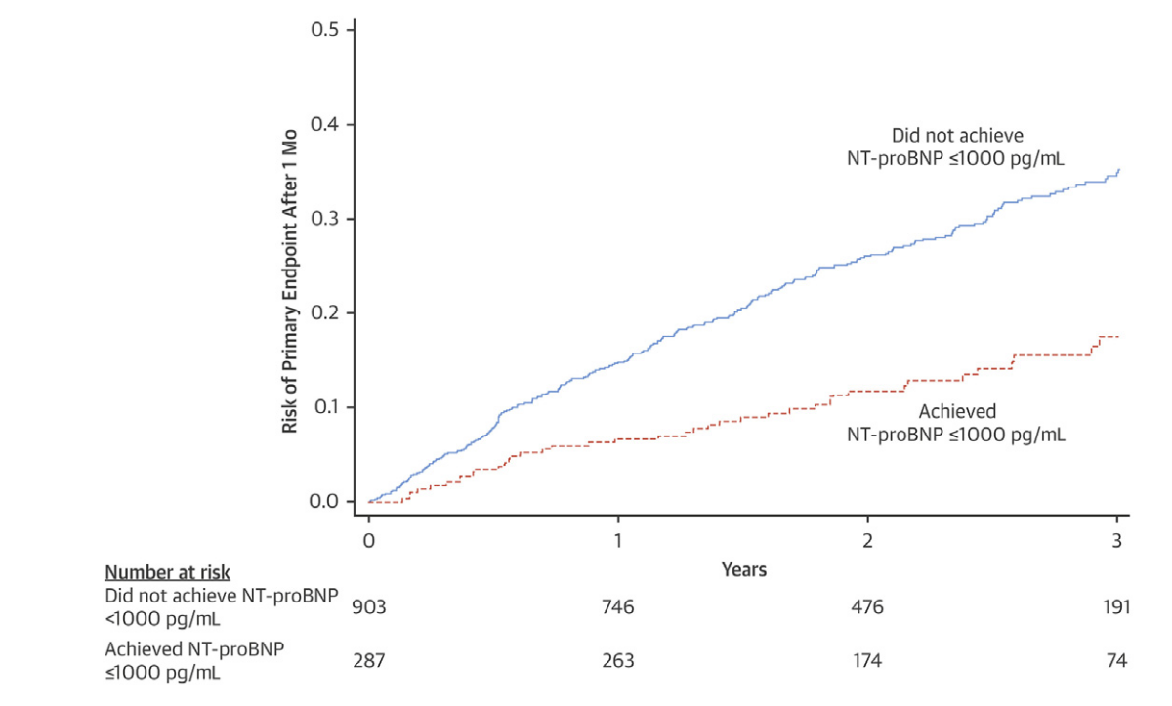Figure 9: Risk of primary endpoint after 1 month of randomization in patients with a baseline amino terminal pro B-type natriuretic peptide (NT proBNP) of greater than 1000 pg/mL. The risk at 3 years of follow-up was 50% less in those who achieved an NTproBNP of less than 1000 pg/mL than in those who did not.102

Failure of NP levels to decrease during an HF hospitalization while undergoing treatment is associated with worse prognosis and suggests a potential role for serial BNP measurement during HF hospitalization. Cheng et al.]13 evaluated 72 male veterans admitted with decompensated NYHA class III to IV HF and followed them for 30 days after discharge. Serial BNP levels were followed, starting with baseline values drawn within 24 hours of admission. Of these patients, 13 died and 9 were readmitted during the study period. Patients who died or were readmitted had increasing BNP levels during hospitalization. Patients who survived and were not readmitted showed decreasing BNP levels during admission.

In a study of 50 patients admitted for AHF, Bettencourt et al.]106 measured BNP levels at admission and then serially throughout hospitalization. Patients were followed for 6 months after discharge to determine whether BNP trends during the index hospitalization werepredictive of end points including readmission for cardiovascular causes and death. Patients who died or were readmitted had less marked decline in BNP levels during hospitalization (770 ± 608 pg/mL to 643± 465 pg/mL; P=0.08), whereas increasing BNP levels during hospi51talization were associated with increased event rate (hazard ratio=3.3; 95% confidence interval, 1.3– .8).

In a study of the Get With the Guidelines Heart Failure Registry, 99,930 patients with AHF were stratified into subgroups based on gender and LVEF (reduced, < 40%; borderline, 40%–49%; preserved, ≥ 50%). Regardless of gender or LVEF, patients with BNP levels greater than the median had a higher mortality than those less than the me dian serum BNP level. 107

A substudy of the Framingham Offspring Study evaluated 3346 asymptomatic patients in the ambulatory setting and measured their serum BNP values over time. An increased BNP level greater than the 80th percentile was associated with an increased risk of death, first major cardiovascular event, atrial fibrillation (AF), stroke or transient ischemic attack, and HF. 108

Hartmann et al.109 in a substudy of the COPERNICUS trial(n=1011) revealed that NTproBNP was consistently associated with an increased risk for all-causemortality and hospitalisation for HF inpatients with severe HF (LVEF <25%). Gardner et al.110 studying 142 patients with advanced HF also reported that NTproBNP was an independent predictor of all cause mortality.

Several studies indicate that BNP and NTproBNP are powerful and independent risk markers of cardiovascular events (especially mortality) not only in patients with HF,but also in those with acute coronary syndrome . Some studies also suggested that the cardiovascular risk increases progressively to NPs concentration; that is, there is no threshold that actually identifies patients with null risk. 111 Several studies reported that NPs assay (in particular BNP and NT-proBNP) provides valuable prognostic information in patients with ACS. A meta-analysis confirmed the powerful prognostic value of BNP/NTproBNP in patients with ACS for death both in the short term (<50 days, mean odds ratio 3.38, CI 95% 2.44-4.68) and long term (>10months, mean odds ratio 4.31, 3.77-4.94) 112

In a cohort of 236 patients with AMI a single measurement of plasma natriuretic peptide levels during the hospital admission provides limited prognostic information, while NTproBNP measured in the 30 days after AMI identifies a cohortof patients at increased risk of adverse outcome thereafter 113

In patients with clinically stable, angiographically documented coronary artery disease, plasma NTproBNP levels are independently related to long term survival in a multivariate model. NTproBNP is a marker of long term mortality even in patients with stable coronary disease and add prognostic information above and beyond that provided by conventional cardiovascular risk factors and the degree of left ventricular systolic dysfunction 114.

In order to explain these clinical findings, it is important to note that experimental studies in animals reported that myocardial ischemia or even hypoxia per se could induce the synthesis/secretion of NPs (in particular BNP) from the intact heart in vivo as well as ventricular cells in culture. Furthermore, these experimental data are also in accordance with clinical studies indicating that transient myocardial ischemia in patients with stable coronary artery disease is associated with an immediate rise in circulating BNP levels, and that the magnitude of rise is proportional to the severity of ischemia 115

### In acute coronary syndrome

Elevated levels of BNP and NTproBNP, traditionally thought of as HF biomarkers, have been detected in patients with ACS. Morita et al.,116 examined BNP levels in patients presenting with suspected ACS and found that BNP concentrations were elevated in patients with MI compared with those without (mean 92 vs 5.2 pg/mL on presentation, P< 0.01) and peaking at a mean level of 319 pg/mL about 16 hours after admission. The extent of BNP or NTproBNP elevation seemed to be related to the degree of infarct size and myocardial dysfunction.

Circulating levels of NPs increase after acute myocardial infarction (AMI); the extent of the increase is related to the size of the infarct. Patients with smaller infarcts tend to have a monophasic increase in plasma BNP, peaking at 20 hours after the onset of symptoms; on the other hand, those with larger infarcts, lower EF, and clinical signs of HF may present a further peak at 5 days after admission. Other studies are less convincing regarding the ability of the NPs assay to identify patients with significant myocardial dysfunction after AMI 117

These conflicting results could be due to the differences in sample collection time, type of NPs (ANP, BNP, or NTproBNP) measured, type of assay, and inclusion criteria adopted. However, persisting elevation of NPs levels at 1 or 2 months after AMI usually suggests a high risk of adverse remodeling and subsequent HF 10

The diagnostic accuracy of the BNP assay in patients with myocardial infarction was evaluated in the meta-analysis by Doust et al.,82 taking into account only two studies.They found the pooled odds ratio to be 9.4 (95% confidence interval 4.59.4).

The predictive value of BNP was best illustrated in a study of 2525 such patients in whom BNP was measured at a mean of 40 hours after the onset of symptoms 118. The base-line level of B-type natriuretic peptide was correlated with the risk of death, heart failure, and myocardial infarction at 30 days and 10 months. The unadjusted rate of death increased in a stepwise fashion among patients in increasing quartiles of base-line B-type natriuretic peptide levels. This association remained significant in subgroups of patients who had STEMI, NSTEMI, unstable angina. After adjusting for other predictors of risk, the odds ratios for death at 10 months were 3.8, 4, and 5.8 for concentrations in the second, third, or fourth quartiles compared to those in the lowest quartile; higher BNP was also associated with an increased risk of new or recurrent myocardial infarction and new or worsening heart failure.

N-terminal pro-BNP (N-pro-BNP) has similar predictive value. The largest study of this issue is an analysis of data on 6809 patients from the GUSTO-IV ACS trial 119. Blood samples obtained at a median of 9.5 hours of symptom onset in patients with an NSTEACS were retrospectively assayed for NTproBNP. Increasing quartiles of NT-proBNP were related to short- and long-term mortality that reached 1.8%, 3.9%, 7.7%, and 19.2%, respectively, at 1 year. N-pro-BNP had a stronger correlation with mortality than any other marker studied, including cTnT and CRP. The combination of NT-proBNP and creatinine clearance provided the best prediction, with a 1-year mortality of 25.7% with both markers in the top quartile vs 0.3% with both markers in the bottom quartile.

Plasma BNP concentrations have prognostic value in patients with stable angina. The magnitude of this effect was illustrated in a review of 1085 such patients who had plasma BNP measured at baseline and were then prospectively followed for a mean of 2.5 years 120. There was a stepwise decrease in event-free survival across quartiles of plasma BNP. After adjustment for confounders including left ventricular ejection fraction (LVEF), patients in the highest quartile (plasma BNP >100 pg/mL) had a significant 6.1-fold increase in risk compared with those in the lowest quartile (plasma BNP <12 pg/mL); the HR was 4.4 for plasma BNP values >100 pg/mL.

The predictive value of NT-proBNP in patients with stable angina was evaluated in a report of 1034 patients who were referred for coronary angiography and then followed for nine years 114. At follow-up, 288 patients (28 percent) had died. The patients who died had significantly higher NT-proBNP values at presentation (386 versus 120 pg/mL). Patients with NT-proBNP values in the highest quartile were older, had a lower LVEF, and were more likely to have diabetes and a prior MI. In a multivariable model, these patients had an HR for death of 2.4 compared with those in the lowest quartile.

Similar findings were noted in a review of 1059 patients with chronic stable angina 121. At a median of 3.6 years, the five-year mortality progressively increased from 4.7 percent in patients in the lowest quartile of NT-proBNP to 7.8 percent, 11.4 percent, and 32.7 percent in the second, third, and highest quintiles, respectively (adjusted HR 6.0, 95% CI 1.6-23 for the highest compared with lowest quintile). A similar prognostic value was noted for cardiovascular mortality. However, as in the previous study, patients in the highest NT-proBNP quartile had other major comorbidities including highest rates of diabetes, atrial fibrillation, and New York Heart Association class III or IV (18.5 versus 0.8 percent in the lowest quartile).

Foote et al.122, measured NT proBNP and BNP in blood samples from a group of normal volunteers, and two groups of patients, one with and the other without coronary artery disease, before and after maximal exercise. Post-exercise increases in NTproBNP and BNP were approximately 4-fold higher in the ischemic group thanin the nonischemic group; while in volunteers, the increase was almost identical to that of the non-ischemic patient group. At equal specificity to the ECG (58.8%), the sensitivities of the BNP/NTproBNP assayin detecting ischemia were 90 and 80%, respectively; in contrast, the sensitivity of the exercise ECG was only 37.5%.

In the study by Sabatine et al.115, transient myocardial ischemia was associated with an immediate rise in circulating BNP levels, and the magnitude of the rise was proportional to the severity of ischemia. These findings demonstrate an importan tlink between the severity of an acute ischemic insult and the circulating levels of BNP.

The diagnostic use of NTproBNP in patients presenting with acute chest pain was evaluated in 328 patients from the Rule Out Myocardial Infarction using Computer Assisted Tomography (ROMICAT) trial. Patients with ACS had higher concentrations of NTproBNP, conventional cardiac troponin T (cTnT), highly sensitive cardiac troponin T (hsTnT), and MR-proANP; adding NTproBNP to either cardiac troponin improved diagnostic performance for ACS by correctly reclassifying events. The best approach was in a dual-negative marker strategy with improved sensitivity and negative predictive value for ACS on presentation with a single time measurement (sensitivity: cTnT from 38% to 83%–86%, hsTnT from 59% to 86%– 0%; all P <.01 and negative predictive value: cTnT from 94% to 97%–98%, hsTnT from 96% to 97%–98%).123

The widely accepted reason behind NP elevation is increased wall tension due to LV systolic or diastolic dysfunction caused by myocardial ischemia through rapid induction of BNP gene expression. However, there are data to suggest that BNP and NTproBNP may be directly released from cardiomyocytes in response to myocardial ischemia regardless of ventricular wall stress. Theories abound regarding cause, including the activation of the inflammatory pathway; similar to some of the acute phase reactants. Most studies for NP in ACS have been with regards to risk stratification, whereas few studies have evaluated its role in diagnosis of ACS in combination with the standard of care biomarker, cardiac troponins. 16

### Postoperative complications

Pre- and postoperative elevations in plasma BNP are associated with an increased risk of adverse cardiovascular events at 30 days. In a 2009 meta-analysis that included seven studies of 2841 patients who had a serum BNP measurement before non-cardiac surgery, there was a statistically significant association between a preoperative elevation in serum BNP and the cardiovascular outcomes of death, cardiac death, and nonfatal MI at 30 days (adjusted odds ratio 19.3) 124

A 2011 meta-analysis that evaluated postoperative mortality at six months or later came to a similar conclusion 125. After cardiac surgery, the diagnostic odds ratio of NP was 4.11 (95% confidence interval, 2.22-7.60) for≥6-month mortality, the PPV 0.17 (95% Bayesian confidence interval, 0.07-0.36), and the NPV 0.96 (0.90-0.98). After non-cardiac surgery, the diagnostic odds ratio of NP was 4.97 (3.06-8.07) for≥6-month mortality. The corresponding PPV was 0.24 (0.14-0.38) and the NPV 0.94 (0.88-0.97). Results were similar for≤90-day mortality.

The relationship between pre- and postoperative natriuretic peptide levels and cardiovascular outcomes was evaluated in a meta-analysis of 18 studies (n = 2179) in which natriuretic peptide was sampled preoperatively and within seven days after surgery 126. An elevated preoperative natriuretic peptide level (>92 pg/mL for BNP or >300 pg/mL for NT-proBNP) predicted the primary composite outcome of death or nonfatal MI at 30 days (odds ratio 3.4) and at ≥180 days (odds ratio 2.6). The addition of postoperative natriuretic peptide to a risk-prediction model containing preoperative natriuretic peptide improved risk classification at 30 and ≥180 days. Elevated postoperative natriuretic peptide was the strongest independent predictor of the primary outcome at both time points.

## NP guided treatment

Shortly after studies reported that change in BNP or NTproBNP was associated with a change in prognosis and that therapies for HF may lower NP concentrations, it was not long before investigators began to examine the role of NP-guided HF management. Conceptually, the use of either peptide to guide therapy is based on the concept that BNP and NTproBNP inform a broad array of pathophysiology and do so in a manner that augments clinical judgment. That therapies with salutary effects in HF (such as b-blockers, angiotensin converting enzyme inhibitors, angiotensin II receptor blockers, mineralocorticoid receptor antagonists, as well as cardiac resynchronization therapy) all reduce NP concentrations 41 has given further enthusiasm to explore this strategy in depth. 127

The fact that changes in NP levels reflect changes in outcomes seems to be well-established in patients with bothacute and chronic HF. What remains uncertain is theextent to which a strategy of care targeting a specificdecrease in NP level can actually improve outcomes. 128

Several studies have evaluated the role of BNP or NTproBNP-guided HF management with mixed results. However, there was great heterogeneity in study designs (in particular, target biomarker concentrations, study population characteristics, and resulting biomarker changes with biomarker-guided care) and many of the studies were underpowered. When results from available randomized trials were pooled, a 20% to 30% mortality reduction with biomarker-guided HF management over standard HF care has been observed. 129

Natriuretic peptide levels have prognostic value in patients with acute HF but the available evidence does not support targeting lower levels as a means of improving outcomes in this setting. Since natriuretic peptides have relatively short half-lives, it has been postulated that serial measurements may help guide management of acute HF 130.

A systematic review including one randomized trial, three experimental studies, and 40 observational studies found low-quality evidence supporting an association between achievement of natriuretic predischarge thresholds (eg, BNP ≤250 pg/mL or NT-proBNP decline of at least 30 percent) and reduced likelihood of all-cause mortality and the combined end point of cardiovascular mortality and re-hospitalization. 131

However, the BOT-AcuteHF found no improvement in outcomes with a natriuretic peptide-guided strategy. This was a randomized controlled trial studying 271 consecutive patients, admitted for acute heart failure and randomized to NT-proBNP-guided therapy or control group. The NT-proBNP-guided therapy group underwent medical treatment intensification when predischarge NT-proBNP was at least 3000 pg/ml. The primary endpoint was cardiovascular death or cardiovascular rehospitalization at day 182. The secondary endpoints were all-cause death, cardiovascular death, cardiovascular rehospitalization, heart failure rehospitalization, and cardiovascular death or heart failure rehospitalization at day 182. Treatment intensification in the NT-proBNP-guided therapy group regarded mainly diuretics. The NT-proBNP strategy was not associated with a significant reduction of the primary endpoint or any secondary endpoint, although patients who achieved the natriuretic peptide target had better outcomes than those who failed to achieve the target 132

It is not clear whether patients who do not achieve target NP levels during hospitalizationfail to do so due to inadequate treatment (in either intensity or duration) or because their underlying HF is too severe to respond adequately to standard interven-tions. In addition, it is notclear what “intensified treatment” in the face of failureto achieve NP goals should entail—more diuretics? Higher doses of neurohormonal drugs or vasodilators? Longer length of stay or intensified post-discharge follow-up? At present, our limited options for treating hospitalized patients with HF significantly limit our ability to intensify therapy even in patients identified as being at higher risk128

Randomized trials studying the effect of BNP- or NT-proBNP guided therapy on clinical outcomes in chronic heart failure have shown mixed results, although the weight of the evidence suggests modest or no clinical benefit from use of natriuretic peptide levels to aid optimization of HF drug doses. Although earlier trials found improved outcomes, the largest randomized trial (in which medical therapy was intensified similarly with or without natriuretic peptide level guidance) found no benefit.

A meta-analysis included 11 randomized trials (nine which provided individual patient data and two studies which provided aggregate data) comparing natriuretic peptide-guided treatment with usual care 133. All-cause mortality was significantly reduced by natriuretic peptide-guided care (hazard ratio [HR] 0.62; 95% CI 0.45-0.86) based on individual patient data from 2000 patients. With the addition of aggregate data from two additional studies (with 431 patients), the reduction in mortality rate was borderline significant (HR 0.82; 95% CI 0.67-1.00, p = 0.045). Hospitalization due to HF (HR 0.80; 95% CI 0.67–0.94) was lower in natriuretic peptide-guided patients based on individual patient data from 2151 patients. Increasing doses of guideline directed medical therapy (angiotensin converting enzyme [ACE] inhibitor/angiotensin II receptor blocker [ARB], beta blocker, and mineralocorticoid receptor antagonist) were associated with reduced all-cause mortality. At study end, there was a higher percentage of patients receiving target ACE inhibitor/ARB doses in the natriuretic peptide guided group compared to the clinically guided group.

Despite the promising results of this meta-analysis, the subsequent GUIDE-IT trial (the largest randomized trial evaluating this strategy to date) found that NT-proBNP–guided therapy was not more effective than usual in improving outcomes in high-risk patients with HFrEF when managed by heart failure specialists at multiple high level medical centers 134. This study assigned 894 patients with HFrEF (ejection fraction ≤40 percent), elevated natriuretic peptide levels within the prior 30 days, and a history of a prior HF event (HF hospitalization or equivalent) to either an NT-proBNP-guided strategy or usual care. The trial was stopped for futility when 894 of the planned 1100 patients had been enrolled with follow-up for a median of 15 months. The primary end point, composite of time-to-first HF hospitalization or cardiovascular mortality occurred in 164 patients (37 percent) in the NT-proBNP guided group and 164 patients (37 percent) in the usual care group (adjusted HR 0.98; 95% CI 0.79-1.22). Cardiovascular mortality was 12 percent in the NT-proBNP guided group and 13 percent in the usual care group (HR 0.94; 95% CI 0.65-1.37). None of the secondary end points nor the decreases in the NT-proBNP levels achieved differed significantly between groups. There were modest increases in HF drug doses in both groups.

The associations between plasma BNPs and prognosis has provided the rationale for a series of controlled trials of hormone-guided therapy in chronic HF. Although individual trials have variously yielded positive or neutral results, serial meta-analyses have consistently indicated benefit from guided therapy with greater than 20% reductions in total mortality and HF hospitalizations. Meta-analyses of trials of NTproBNP–guided therapy in chronic heart failure suggest improved outcomes and confirm achievement of NTproBNP of less than 1000 pg/mL confers a better prognosis. All trials of marker-guided therapy have consistently confirmed thestrong association between achieved plasma B-type peptide levels and outcome regardlessof allocated treatment strategy. In addition, BNP-guided treatment reduced all-cause mortality in patients less than 75 years old. BNP-guided treatment reduced hospitalizations caused by HF and cardiovascular disorders in all patients regardless of age or LVEF. 133

Troughton et al.135, conducted a study including 69 patients with impaired systolic function (EF <40%) and symptomatic HF (NYHA class II-IV). Half of the patients received therapy guided by plasma NTproBNP, therapy in the remainingpatients was guided by clinical monitoring at the same frequency, but with the physician blinded to the NTproBNP result. During the follow-up (minimum 6 months, median 9.5 months), there were fewer total cardiovascular events (death, hospital admission, or HF decompensation) in the NTproBNP-guided group than in the clinical group (19 vs 54, p = 0.02) (target 1680 pg/ml). Changes in left ventricularfunction, quality of life, renal function, and adverse events were similar in both groups.

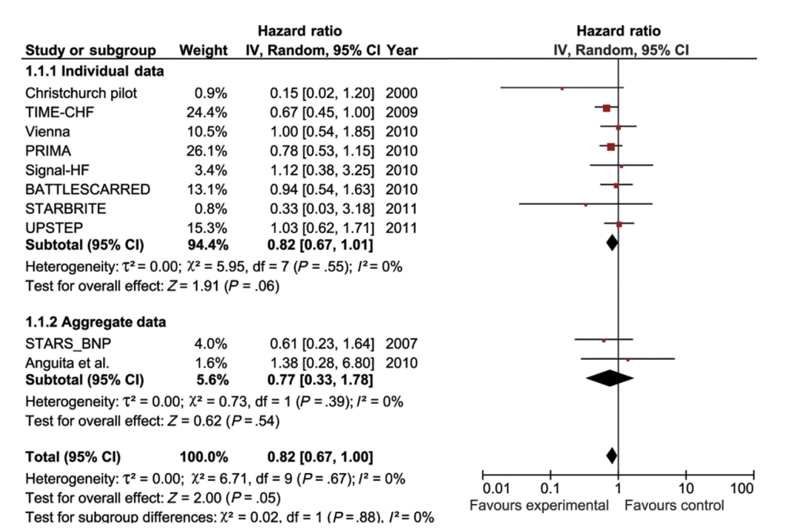Figure 10: Forest plot of mortality among participants in trials of marker-guided treatment of chronic heart failure showing unadjusted individual and mean hazards ratios with 95% confidence intervals (CIs) for 8 studies providing individual patient data and 2 studies providing aggregate data. 133

Kazanegra et al.136, measured serial serum BNP levels and pulmonary capillary wedge pressures using Swan-Ganz catheters in patients admitted to the hospital for an AHF exacerbation. Treatmentrelated decreases in pulmonary capillary wedge pressures corresponded with declining serum BNP levels, suggesting that BNP levels should decline with diuresis.

The Plasma Brain Natriuretic Peptide-Guided Therapy to Improve Outcome in Heart Failure (STARS-BNP) trial published in 2007 evaluated the use of BNP-guided treatment strategies compared with standard clinical therapy in 220 patients with NYHA class II to III HF who were taking optimal medical management (angiotensinonverting enzyme [ACE] inhibitors, b-blockers, and diuretics). Patients were randomized to receive BNP-guided treatment with a goal BNP level of less than 100 pg/mL or treatment guided by clinical and symptomatic improvement. By 15-month follow-up, patients in the BNP-guided treatment arm had a significantly lower primary outcome of HF-related death or readmission (24% vs 52%; P<.001). 137

The NTproBNP–Assisted Treatment To Lessen Serial Cardiac Readmissions and Death (BATTLESCARRED) trial found similar results using NTproBNP– uided clinical management. In this trial, 364 patients admitted for HF exacerbation were assigned to NTproBNP guided therapy, intensive clinical management (using aggressive uptitration of HF medications to optimal clinical trial doses), or usual care using symptom-guided management. At 1-year follow-up, mortality was significantly lower in the NTproBNP guided treatment arm versus usual care (9.1% vs 18.9%; P=.03). By 3-year follow-up, mortality was significantly lower in the NTproBNP guided group (15.5%) compared with the intensive clinical management group (30.9%; P=0.048) and usual care group (31.3%; P=0.021).138

The Trial of Intensified versus Standard Medical Therapy in Elderly Patients With Congestive Heart Failure (TIME-CHF) study also evaluated NTproBNP–guided therapy.This trial included 499 patients with chronic HF who were older than 60 years, NYHA class greater than II, hospitalized for HF within the last year, and had a baseline NTproBNP level greater than twice the upper limit of normal. These patients were followed for 18 months after initial admission, and theNTproBNP–guidedtherapy arm had higher rates of survival and lower rates of all-cause hospitalizations in patients aged 60 to 75 years but not in patients older than 75 years (P<0.02).139

At matched echocardiographic alterations, patients in whom BNP levels drop in response to therapy have a reduced rate of major cardiac events or mortality,compared to untreated hypertensive pa-tients, who could have similar echocardiographic abnormalities. This represents the rationale for using the NPs assay for therapy decision making and for monitoring HF patients10

Medical therapy for HF is based on improving the symptoms and signs of fluid retention (change in dyspnea, edemas, and body weight are the usual markers of response to treatment) and titrating the dosage of drugs (such as diuretics, ACEinhibitors, β-blockers, and spironolactone) following the evidence from randomized clinical trials. There is no specific surrogate end-point for treating patients with HF that can be used to fine-tune therapy. The results of NPs assay(especially BNP/NTproBNP assay) may be useful in monitoring and tailoring the medical therapy in HF patients, and in providing a practical objective indicator o optimal therapy93

NPs usually respond to effective treatment with drugs or left ventricular assist device with a prompt reduction of their circulating levels. ACE inhibitors, valsartan, diuretics, nitrates, and endothelin receptor antagonists have been shown to reduce plasma NPs levels in parallelwith hemodynamic and clinical improvement. More variable effects on plasma NPs levels have been reported after therapy with βlockers. Some authors suggested that these variable effects may be at least in part attributable to different specificities or to ancillary properties of β-blockers 140

It could be assumed that an acute administration of β-blockers causes an early rise in plasma NPs, while sustained treatment, significantly improving cardiac function and clinical conditions, induces a significant fall in hormone levels141

A randomized clinical trial compared the titration of β-blocker therapy with bisoprolol according to plasma levels of BNP wih empiric clinical therapy based on signs and symptoms. Forty-one patients with heart failure were randomized into a clinical trial. The clinical group had β-blocker dosage increased according to standard care, whereas the BNP group had β-blocker dosage up-titrated according to plasma BNP levels plus standard care. The primary outcome was mean β-blocker dose achieved after 3 months. BNP-guided up-titration of β-blocker in ambulatory patients withheart failure did not result significantly different doses of β-blocker at the end of 3 months. However, 45% of patients in the clinical group were on the maximum dose of β-locker vs. only 19% of patients in the BNP group, although left ventricular ejection fraction was significantly improved in both groups by 7.3%. The slightly lower doses in the BNP group were possibly better tolerated than the doses achieved in the clinical group. Furthermore, a trend toward better quality of life was seen in the BNP group 142

## Natiuretic peptides therapeutics

### Anaritide

ANP has been evaluated in several major trials with variable results. The initial study with 53 patients suggested a positive outcome for patients receiving anaritide because they had increased creatinine clearance and a decreased need for dialysis 143.

This led to the formation of a multicenter placebo-controlled clinical trial in 504 patients with acute tubular necrosis. While 24-h infusion of anaritide did not improve the overall survival of the patients without dialysis, it appeared that a subset of patients might have benefited. However, whereas patients who were nonoliguric appeared to do worse with anaritide (48 versus 59 percent dialysis-free survival with placebo), oliguric patients did better with anaritide (27 versus 8 percent dialysis-free survival with placebo). As in other studies, the outcome was worse in patients with oliguric versus nonoliguric ATN.144

Given the observation that oliguric patients may have had a better outcome than nonoliguric individuals when administered anaritide, a randomized, prospective trial was performed that evaluated anaritide in oliguric ATN. Among 222 such patients, a 24-hour infusion of anaritide (200 ng/kg per minute) provided no statistically significant benefit compared to dialysis in dialysis-free survival. Both trials remarked on the severe hypotension that often occurred as a result of the anaritide infusion. In fact, it is this severe hypotension that appears to be limiting the utility of anaritide or nesiritide as a therapy for either heart failure or renal disease. The authors stated in their discussion, it is possible that if this hypotension could have been avoided, anaritide would have been efficacious 145

Low-dose ANP may provide some benefit. The prolonged administration of low-dose ANP (50 ng/kg per minute) was suggested to provide benefit in a study of 61 patients with postoperative ATN. ANP or placebo was continued until RRT was required or the serum creatinine concentration had decreased below the study inclusion value. Prior to, or at, day 21, ANP resulted in a decreased frequency of RRT (6 versus 14 patients, hazard ratio [HR] 0.28, 95% CI 0.10-0.73). Despite these positive results, the study was small and underpowered. 146

Studies conducted in Sweden compared the ability of the loop diuretic, furosemide, or mature ANP (1-28) to increase GFR, renal blood flow, and reduce renal oxygen consumption in patients with acute renal failure. They concluded that furosemide was a more effective agent 147

A meta-analysis 148 suggested that ANP may be associated with improved outcomes when used in low doses for preventing AKI and in managing postsurgery AKI. There were no significant adverse events in the prevention studies, however in the high dose ANP treatment studies there were significant increases hypotension and arrhythmias. Analysis of the existing literature suggests ANP might be associated with beneficial clinical effects when administered in patients undergoing major surgery such as cardiovascular surgery. Its use, in low doses, should be explored further in this setting. However, study heterogeneity, design weaknesses, and There are an insufficient number of high-quality studies to make any definite statement about the role of ANP in AKI.

### Nesiritde

Nesiritide (recombinant human brain natriuretic peptide, BNP 1-32) is a vasodilator that has undergone clinical trials in patients with acute HF. Nesiritide is a balanced vasodilator that acts on arteries to decrease systemic vascular resistance and thereby lowers left ventricular afterload, and acts on veins to increase venous capacitance and thereby lowers left and right heart filling pressures. The rationale for the use of nesiritide is based on these hemodynamic effects. Infusion of nesiritide at doses of up to 0.1 mcg/kg per min in patients with HF can raise the mean plasma BNP concentration to values in excess of 10,000 pg/mL with associated arterial and venous vasodilation 149

Mills et al.150, examined the effectiveness of 24-h infusion of nesiritide to patients with congestive heart failure in a multicenter, placebo-controlled trial. The peptide resulted in a reduction of both preload and afterload resulting in an increase in stroke volume and cardiac output.

In the VMAC study 151, 489 patients, including 246 who underwent pulmonary artery catheterization, were assigned to nesiritide, intravenous nitroglycerin, or placebo for three hours, followed by nesiritide or intravenous nitroglycerin for 24 hours. Nesiritide decreased the mean pulmonary capillary wedge pressure significantly more than either intravenous nitroglycerin or placebo at three hours (5.8 versus 3.8 and 2.0 mmHg) and significantly more than nitroglycerin at 24 hours (8.2 versus 6.3 mmHg). However, the dose of nitroglycerin given tended to be less than that used clinically. Dyspnea was reduced and global clinical status was improved when compared with placebo, but there was no significant difference for either parameter compared with intravenous nitroglycerin.

Additionally, patients receiving nesiritide had less adverse cardiovascular effects at either the 0.015 or 0.03mcg/kg/min infusion rate compared to patients receiving dobutamine as determined by the PRECEDENT Trial (n=246) 152

In the largest randomized placebo-controlled trial of nesiritide in acute HF (Acute Study of Clinical Effectiveness of Nesiritide and Decompensated Heart Failure [ASCEND-HF], n = 7141), nesiritide produced only a small improvement in dyspnea 153. Nesiritide was administered as 0.010 mcg/kg/min for 24 hours or more for up to seven days (preceded by an initial recommended but optional bolus of 2 mcg/kg). Findings included the following:

* Nesiritide slightly increased the frequency of markedly or moderately improved dyspnea at six hours (44.5 versus 42.1 percent, p = 0.03) and 24 hours (68.2 versus 66.1 percent, p = 0.007). This small improvement was significant according to the prespecified level required by the European Medicine Agency (p≤0.05 for both assessments or p≤0.025 for either) but did not meet the prespecified level for significance required by United States regulators because of the multiple comparisons performed in the trial (p≤0.005 for both assessments or p≤0.0025 for either).
* Hypotension was significantly more frequent in the nesiritide group compared with the placebo group (26.6 versus 15.3 percent). Symptomatic (7.2 versus 4.0 percent) as well as asymptomatic (21.4 versus 12.4 percent) hypotension was increased.
* Analysis of data from 4881 patients enrolled in the ASCEND-HF trial found that nesiritide did not increase urine output 154. Independent predictors of urine output included diuretic dose, higher diastolic blood pressure, elevated jugular venous pressure, and lower blood urea nitrogen.

Similar results were obtained in the smaller Renal Optimization Strategies Evaluation (ROSE) trial, which randomly assigned 360 patients with acute HF to low-dose nesiritide (0.005 mcg/kg/min without bolus for 72 h), low-dose dopamine (2 mcg/kg/min for 72 h), or placebo 155. All patients received intravenous loop diuretic therapy. Neither nesiritide nor dopamine had any significant effect on 72-hour cumulative urine volume or symptoms compared with placebo.

The results of a 75-person study (BNP-CARDS study), however, suggest nesiritide has no detrimental effect on renal function, when cohorts of similar baseline renal function were compared 156

Nesiritide use in acute decompensated HF does not improve or worsen the 30-day mortality rate. A trend toward increase in 30-day mortality among patients receiving nesiritide was observed in a meta-analysis of three randomized controlled trials by Sackner 157 but not in a later meta-analysis of seven randomized controlled trials 158. Subsequently, the ASCEND-HF trial of 7141 patients with acute HF found that nesiritide had no effect on 30-day mortality 153.

Concern for risk of renal dysfunction was raised by a meta-analysis that included 1269 patients with HF treated with nesiritide [Sackner-Bernstein et al., 2005], but no effect on renal function was found in the ASCEND-HF trial. The ASCEND-HF trial found that nesiritide therapy did not increase or decrease the risk of worsening renal function 153. Similarly, the ROSE trial found no significant effect on renal function (as assessed by change in cystatin C level) with low-dose nesiritide (0.005 mcg/kg/min without bolus for 72 h) or low-dose dopamine (2 mcg/kg/min for 72 h) compared with placebo155

Plasma brain natriuretic peptide (BNP) should NOT be used for clinical assessment during the administration of nesiritide (BNP 1-32), since nesiritide will be detected as an increase in plasma BNP concentration. On the other hand, the assay for the N-terminal fragment of pro-BNP does not detect nesiritide 159

### **Neprilysin inhibitors**

Detrimental neurohormonal activation involving the RAAS and sympathetic nervous system is a key target for HF therapy. Augmentation of beneficial counter-regulatory systems such as natriuretic peptides is an additional strategy to treat HF. Inhibition of neprilysin (a neutral endopeptidase) raises levels of several endogenous vasoactive peptides, including natriuretic peptides, bradykinin, and adrenomedullin, and may thus have beneficial effects in patients with HF.

Two pharmacologic strategies have been undertaken to inhibit both neprilysin and the RAAS system; omapatrilat and sacubitril-valsartan:

Omapatrilat inhibites neprilysin, angiotensin converting enzyme (ACE), and aminopeptidase P. The Omapatrilat Cardiovascular Treatment vs. Enalapril (OCTAVE) trial (a multicenter, randomized, double-blind, active-controlled trial) compared omapatrilat to enalapril over a period of 24-week in 25,302 patients with untreated or uncontrolled hypertension. Omapatrilat provided broadly superior antihypertensive efficacy, but angioedema was 3-folds more frequent with omapatrilat than enalapril (2.17% vs 0.68%). 160

The commercial development of this compound was halted due to the unacceptably high rate of angioedema, attributed to an increase in bradykinin levels, which occurred since neprilysin, ACE, and aminopeptidase P each degrade bradykinin 161.

The strategy that ultimately proved successful in improving outcomes in HFrEF was to combine a neprilysin inhibitor with an angiotensin receptor blocker (ARB) to create an angiotensin receptor-neprilysin inhibitor (ARNI). This was proven by the PARADIGM-HF and PIONEER-HF trials.

The 2014 Angiotensin–Neprilysin Inhibition versus Enalapril in Heart Failure (PARADIGM-HF) trial compared the novel neprilysin-angiotensin inhibitor LCZ696, a combination of the salt form of valsartan combined with sacubitril (an inhibitor of neprilysin, a circulating neutral endopeptidase involved in the degradation of NPs),with the ACE in-hibitor enalapril. In this trial, 8442 patients with an HFrEF (predominantly New York Heart Association [NYHA] functional class II or III) were randomly assigned to receive either sacubitril-valsartan (referred to as 200 mg twice daily, which is sacubitril 97 mg and valsartan 103 mg; ARB component equivalent to 160 mg of valsartan twice daily) or enalapril (10 mg twice daily) following a run-in phase for tolerability to enalapril and then to sacubitril-valsartan. At baseline, most patients in both treatment groups were receiving recommended pharmacologic treatment for chronic HF (including over 90 percent receiving beta blockers). The trial was stopped early after a median follow-up of 27 months because the prespecified boundary for early termination for benefit was crossed.162

Further analysis of the trial data showed that:

* Sacubitril-valsartan reduced the risk of death compared with enalapril (17.0 versus 19.8 percent; HR 0.84; 95% CI 0.76-0.93). Sacubitril-valsartan versus enalapril reduced the risk of death from both progressive HF and sudden cardiac death 163
* Sacubitril-valsartan reduced the death from cardiovascular causes or hospitalization for HF (21.8 versus 26.5 percent; HR 0.80; 95% CI 0.73-0.87). Sacubitril-valsartan also reduced the risk of death from cardiovascular causes (13.3 versus 16.5 percent; HR 0.80; 95% CI 0.71-0.89) and the risk of hospitalization for HF (12.8 versus 15.6 percent; HR 0.79; 95% CI 0.71-0.89). Subjects randomized to ARNI therapy in the PARADIGM-HF trial were also at reduced risk of 30- and 60-day all-cause readmission [Desai et al., 2016]
* Benefits of ARNI therapy were rapid, with a reduction of HF hospitalization evident within the first 30 days post-randomization 164
* The benefits of ARNI therapy were consistent throughout the LVEF spectrum (range 5 to 42 percent; median 30 percent) among subjects enrolled in PARADIGM-HF 165
* were independent of baseline medical therapies or prior coronary revascularization 166
* and were consistent across all baseline blood pressures, including lower blood pressures 167

The safety and efficacy of sacubitril-valsartan initiation during hospitalization for acute HF was evaluated in the PIONEER-HF trial, in which 881 patients hospitalized with acute HF were randomly assigned to receive either sacubitril-valsartan or enalapril following hemodynamic stabilization and followed for eight weeks. This trial demonstrated greater reduction of NT-proBNP and high-sensitivity troponin with sacubitril-valsartan compared with enalapril with similar adverse outcomes. While not designed to test clinical outcomes, exploratory analyses showed a significant reduction in rehospitalization for HF. 168

A short-term (12-week) randomized trial (EVALUATE-HF) in 464 patients with HFrEF found no significant between-group difference in change from baseline was seen in left ventricular ejection fraction. However, greater reductions from baseline were seen with sacubitril-valsartan than with enalapril in left atrial volume, LVEDVI, LVESVI and mitral E/e' ratio. Rates of adverse events including hypotension (1.7% vs 3.9%) were similar in both groups. 169

Neprilysin mediates cleavage of the biologically active carboxy-terminals of ANP, BNP, and C-type NP, and prolongation of the circulating and tissue half-lives of these powerful effectors is presumed to underlie a significant proportion of the benefit offered by ARNI. 170

In the PARADIGM-HF trial, patients randomized to ARNI had higher BNP levels but lower NT-proBNP levels (which is not cleaved by neprilysin, reflecting impaired metabolism of carboxy-terminal BNP and decreased cardiac release of NP, respectively) at four weeks and eight months compared with those in the ACE inhibitor group 164

Similarly, in the PIONEER-HF trial, there were smaller reductions in BNP but greater reductions in NT-proBNP group (as described above), in the patients treated with ARNI compared with those treated with ACE inhibitor. 168

Emerging preclinical and clinical data suggests that ARNI therapy may have beneficial effects on renal function and glucose control in diabetes mellitus. The following was shown in analyses of PARADIGM-HF patients:

* Patients treated with sacubitril-valsartan compared with enalapril had slower decline in estimated glomerular filtration rate, and the magnitude of the benefit was greater in patients with diabetes. The greater effect of neprilysin inhibition in patients with diabetes could not be explained by the effects of treatment on the course of heart failure or on HbA1c. Thus, in patients in whom the renin-angiotensin system is already maximally blocked, the addition of neprilysin inhibition attenuates the effect of diabetes to accelerate the deterioration of renal function that occurs in patients with chronic heart failure. 171
* Patients with type 2 diabetes and HFrEF enrolled in PARADIGM-HF had no significant differences in HbA1c concentrations between randomised groups at screening. Hemoglobin A1c levels decreased by 0.16 percent over the first year in the enalapril group compared with 0.26 percent in the sacubitril-valsartan group. HbA1c concentrations were persistently lower in the sacubitril/valsartan group than in the enalapril group over the 3-year follow-up. New use of insulin was 29% lower in patients receiving sacubitril/valsartan compared with patients receiving enalapril. These data suggest that sacubitril/valsartan might enhance glycaemic control in patients with diabetes and HFrEF. 172

## Limitations

There are some important caveats to be cognizant of when interpreting BNP or NTproBNP results; both advanced age and male sex can lead to higher than expectedBNP or NTproBNP values, for example, whereas other factors can lead to lower than expected results. Clinicians should have a good understanding of the broad factors that may influence both peptides either upwards or downwards.16

Elevation of plasma NTproBNP is not specific for ADHF. AF, renal failure, pulmonary embolism, and a number of other causes increaseNTproBNP. NTproBNP level should be considered in concert with the clinical history, examination findings, and data from other tests, including a standard laboratoryworkup and cardiac imaging. Age, obesity, preserved ejection fraction, renal dysfunction, and AF may affect the diagnostic performance of NTproBNP. Age is a strong determinant of NTproBNP. This relationship is independent of kidney and cardiac function, and the exact underlying mechanisms remain unclear. 18

Many pulmonary disorders that result in elevated right ventricularpressures are also associated with elevated levels of these NPs: pulmonary embolism, pulmonary hypertension, congenital heart disease, and sleep apnea. Inaddition, mostcritical illnesses are associated with increased NP levels, although the exact mechanism is less clear: acute stroke, severe anemia, bacterial sepsis, severe burn, and acute respiratory distress syndrome. In most of these cases, the extent of BNP or NTproBNP elevation is not quite as high as the cutoff points used to diagnose ADHF, but clinical judgment is crucial in correctly inter-preting NP concentrations in such patients. In addition, even in these”non-HF” causes of BNP or NTproBNP elevation, the prognostic value of the peptides hold. 16

Renal dysfunction may cause increases in baseline serum NP levels, but the reasonfor this is not clearly understood. BNP is primarily cleared from circulation through degradation by circulating endogenous peptidases rather than by renal clearance. The mechanism behind this observation is probably multifactorial. 1

In addition, patients with renal dysfunction tend to have comorbid cardiovascular disorders that are associated with elevated BNP or NTproBNP values including LV hypertrophy andchronic volume overload state. In patients with renal dysfunction, a slightly higher BNP cutoff of 200 pg/mL or NTproBNP of 1200 pg/mL can be used with a good accuracy. Alternatively, the age-stratified NTproBNP values, as used in patients without renal dysfunction, can be used as the cutoff with similar results. 16

Estimated glomerular filtration fraction rate are inversely related to plasma concentrations of BNP and NTproBNP. For BNP, this has led to the recommendation that the BNP threshold be increased to 200 pg/mL for an estimated glomerular filtration rate of less than 60 mL/min/1.73 m. No specific corresponding change in cut-point is gen-erally applied to NTproBNP values and the performance of age specific NTproBNP diagnostic thresholds seem to be less affected.173

On the other hand, certain states are associated with lower than expected BNP or NTproBNP concentrations. Patients with elevated body mass index (BMI) tend to have lower BNP or NTproBNP valuescompared with leaner counterparts. This occurrence is thought to be due to suppression of synthesis or release of NPs in obese patients.170

Obesity lowers plasma NP concentrations through poorly understood mechanisms. Body mass index is actually inversely related to plasma NTproBNP concentrations in both health and HF. Unlike renal impairment or AF, which irretrievably impair the specificity and accuracy of plasma NTproBNP, obesity shifts the optimal threshold but preserves discriminatory performance. The effect on the diagnostic performance of BNP at 100 pg/mL is pronounced, with a clear loss of sensitivity that has led to the recommendation to reduce the cutpoint to 50 pg/mL for those with a BMI greater than of 30 kg/m 2. 174

Nevertheless, the diagnostic accuracy of NP cutoff points (age-stratified cutoff points for NTproBNP) used to diagnose ADHF remained accept-able regardless of BMI (AUC of 0.94 for lean, 0.95 for overweight, and 0.94 for obese patients), although BNP shows slightly lower sensitivity in those with high BMI and lower cut-offs have been advocated. 175

Higher baseline levels of BNP have been observed with increasing age; however, the exact mechanism is unknown. This age-related increase was independent of ageelated diastolic dysfunction. Some investigators have hypothesized that this is caused by reduced expression of NPRs with age, which could result in decreased clearance of circulating BNPs in older patients. 1

Age-adjusted values enhance the specificity and accuracy of NTproBNP in diagnosis of ADHF at the cost of some loss of sensitivity. An NTproBNP level of 450 pg/mL or more in the presence of new onsetdyspnea is highly discriminating for ADHF (AUC, 0.99) in those less than 50 years of age. Most HF patients are older and theAUC falls progressively to 0.93 and then 0.86 in patients aged 50 to 75 years (optimal threshold of 900 pg/mL) and those older than 75 years (1800 pg/mL), respectively. Age-adjusted values have been calculated for NTproBNP but not BNP. 75

AF increases plasma NTproBNP whether HF is present or not. AF is a common complication of HF, and occurs in approximately 30% of populations with ADHF. AF reduces the discriminative performance NTproBNP for newly symptomatic ADHF, reducing the AUC on receiver operator analysis to approximately 0.7, which is well below the approximately 0.9 observed in HF cases with preserved sinus rhythm. The sensitivity of the standard thresholds of NTproBNP are preserved in the face of overall increases in plasma peptide concentrations, butspecificity and accuracy are clearly reduced and cannot be improved solely by selection of an alternative cut point. Empirical observation indicates that between 65% and 85% of acutely breathless patients with AF and NTproBNP levels of greater than 300 pg/mL will receive a final diagnosis of acute HF and they should be managed as such until an alternative diagnosis is proven. 176

Several studies have shown that women have higher levels of BNP and NTproBNP. These studies evaluated age matched cohorts in which serum BNP and NTproBNP levels were higher in women than in men at any age, although the reason for this finding was not clear. Some have proposed that estrogen levels may play a role in this observation, because women on hormone replacement therapy had higher baseline serum BNP levels than those not taking hormone therapy. 1

Although obesity is a well-documented factor that can decrease baseline serum BNP level, the exact mechanism behind this remains unclear. Adipocytes are known to have increased concentration of NPRs,thus obese patients may have greater clearance of BNP by adipocytes. However, other studies have shown a correlation between BNP levels and lean mass rather than fat, which contradicts this hypothesis. It is less clear whether serum NTproBNP level is similarly decreased in obese patients, and, unlike BNP, NTproBNP is not cleared by NPRs (natriuretic peptide receptors). 1

Table 4: Impact of renal disease on the diagnosis of acute decompensated heart failiure in patients presenting with dyspnea

Abbreviations: BNP, B-type natriuretic peptide; GFR, glomerular filtration rate; NTproBNP, amino-terminal pro–B-type natriuretic peptide. 173

|  |  |  |  |
| --- | --- | --- | --- |
|  | GFR (mL/min/173m2) | Area Under the Curve | Cutpoint (pg/mL) |
| BNP | > 90  60-90  30-59  <30 | 0.91  0.90  0.81  0.86 | 70.7  104.3  201.2  225 |
| NTproBNP | >60  <60 | 0.95  0.88 | 900/450  1200 |

As the clinical use of sacubitril-valsartan becomes more widespread, there is a growing concern that the measurement of serum NP levels in patients taking this drug may be problematic. In patients taking the neprilysin inhibitor, levels of BNP, which is broken down by neprilysin among other enzymes, may be increased because of decreased serum breakdown rather than because of change in underlying disease state (such as volume overload in AHF), potentially interfering with the prognostic and diagnostic utility of BNP. 177

In this setting the relationship of NTproBNP to intracardiac pressures and HF status, plasma is undistorted, whereas BNP is no longer a reliable marker. NTproBNP but not BNP remains a valid marker during ARNI therapy. Where ARNI therapy is contemplated or already in place, NTproBNP is the marker of choice in assessment of possible incident ADHF and for serial monitoring. 18

Results from the PARADIGM-HF trial did show that plasma BNP concentrations were significantly increased in patients taking sacubitrilvalsartan versus enalapril, whereas NTproBNP levels were significantly lower in the sacubitril-valsartan group. However, the decreases were only modest and, although significantly different between the two treatment arms, the mean serum values in each group decreased to well within the anticipated variation of these biomarkers. 1

Although more studies will be needed to determine the exact effect of neprilysin inhibition on BNP, there are some data to support that NTproBNP may be more reliable in patients taking sacubitril. The earlier Angiotensin Receptor Neprilysin Inhibitor LCZ696 in Heart Failure with Preserved Ejection Fraction (PARAMOUNT) trial examined effects of sacubitril-valsartan compared with valsartan alone in patients with chronic HF with preserved ejection fraction. Although significant early declines in NTproBNP were observed at 12 weeks, NTproBNPlevels were no longersignificantly different between the two groups after 36 weeks. Serum BNP was not measured in this trial. 1

A large number of patients with only mild HF (NYHA classes I and II) may have values slightly above or even under the 99th percentile of distribution values of BNP concentration in healthy subjects. In these patients, successful treatment and consequent improvement in cardiac function and exercise capacity, and reduction in filling pressure and cardiac volumes, is usually associated with a marked fall in Nps levels: thus, a larger number of patients could have BNP values within the reference range values 10

The variability of measured plasma concentrations of many substances is due to three different sources: pre-analytical, analytical and inherent biological variation. The latter is usually described as a random variation around a homeostatic setting point, and defined as the intraindividual or within-subject biological variation 178

In order to achieve a correct interpretation of serial test results that are collected for follow-up or tailored treatment of HF patients, several studies evaluated the biological variation of BNP and its related peptides, in both healthy subjects and cardiac patients. Due to secretory bursts and its rapid turnover (half-life about 15-20 min), intraindividual biological variations of plasma BNP levels were found to be very large, in both healthy subjects and patients with heart failure (ranging from 30 to 50%). According to this, only a decrease of more than 50% or a more than 2-fold increase in plasma BNP should be assumed to be statistically significant in an individual patient. 179

In contrast with this ass umption, a clinical trial by Takeda et al.,141 has suggested that a BNP decrease inferior to this calculated reference change could be clinically relevant in patients with heart failure. In this study, only the group of patients treated with the β-blocker agent carvedilol, who respond on average with a decrease of only 38% in plasma BNP, showed a clinical improvement.

Furthermore, several studies have demonstrated that cardiovascular risk (mortality or major cardiovascular events) increases continuously and progressively throughout thewhole range of BNP concentrations in patients with cardiovascular diseases 10.

In order to explain these coflicting findings, it should be taken into account that BNP secretion is closely regulated by specific pathophys-iological mechanisms. Accordingly the clinician should consider all changes in BNP concentration as potentially clinically relevant, even when narrower than the calculated intrandividual biological variation In other words, BNP variations should be interpreted and considered by physicians, as the variability of heart rhythm and blood pressure, by taking into account clinical history and examination, comprehensive of the response to specific treatments, as well as of laboratory and instrumental test findings.180

# Patients and Methods

This study was reviewed and approved by IRB, ethics committee or audit department of Critical care department of the faculty of medicine, Cairo University. The study runs in concordance with international ethical standards and applicable local regulatory guidelines. The study does not have any physical, psychological, social, legal, economic, or any other anticipated risks to study’s participants. The study conserves participants’ privacy. Investigators are responsible for keeping the security of the data. Also, the participants’ data were not used for any other purpose outside this study. Personal data (e.g. Name, Contact info) were not entered in our data entry software to conserve the participants' privacy, however, each subject got a unique identifier code.

# Study Design and Setting

65 consecutive cases registered for elective off-pump coronary artery bypass grafting OPCAB were recruited from 3 cardiothoracic surgery centers in this study constrained by the following inclusion and exclusion criteria:

## Inclusion criteria

* Patients undergoing elective OPCAB.
* Age group between 18 and 80 years old.

## Exclusion criteria

* Patients with signicant valvular heart disease, dilated or hypertophic cardiomyopathy, NYHA III or IV, EF < 40 %, need for inotropic support or intra-aortic balloon pump before surgery
* preoperative atrial fibrillation
* creatinine clearance < 60 ml/min/1.73 m2
* hyperthyoidism and hypothyroidism (serum TSH levels above or below reference ranges respectively. It was measured only upon clinical suspicion.)
* moderate to severe COPD (Shortness of breath at own pace on the level, FEV1 < 80% of predicted, or continuous use of bronchodilators for > 2 weeks).

# Study’s Procedure and Data Collection

Beta-blocking agents and statins were given to all patients until the morning of surgery. Oral antiplatelets were stopped 5-7 days before surgery. Euroscore II was calculated. Venous samples for measuring NT-proBNP were collected on the day of surgery before induction. Samples were sent for analysis in at critical care department laboratories, Cairo University hospitals. No specific attempts were made to standardize the anesthetic and surgical management. After conclusion of the surgery, all patients were transferred to the intensive care unit ICU intubated and mechanically ventilated. The patients were assessed for extubation within 4-8 hours of arrival in the ICU. All patients received intravenous nitroglycerin infusions for the first 24hr unless they were hypotensive. Inotropic agents were used when the patient’s mean arterial pressure was below 60 mmHg and adequate perfusion could not be achieved. Potassium deficiency was promptly treated as necessary to maintain electrolyte balance within 4-5mEq/L. Beta-blocking agents and statins were given as soon as possible postoperatively. All samples were blindly analysed. Lab staff were blinded to the clinical conditions and dlinicians were blinded to the preoperative NTproBNP sample results.

The following data were collected :

* Full history taking and clinical examination.
* Echocardiography pre-operative.
* Labs:
  + routine pre-operative labs: CBC, coagulation profile, liver and kidney functions test
  + specific: pre-operative NTproBNP
* Calcualtion of EUROSCORE II
* Data collection to evaluate incidence of complications postoperative ICU stay and till discharge from hospital including:
  + prolonged intubation
  + ischemic stroke
  + timing, duration and dose of inotropic support
  + use of intra-aortic ballon pump
  + myocardial infarction
  + arrhythmias
  + Length of postoperative ICU and hospital stay
  + death

# **Lab and sample analysis methods**

We used ELISA immunoassay technique that allows in vitro quantitative determination of human NTproBNP concentrations in serum, plasma and biological fluids.

### Test principle

ELISA (Enzyme-Linked Imuunosorbent Assay) is based on the competitive binding enzyme immunoassay technique. The microtiter plate provided in the kit has been pre-coated with an antibody specific to NTproBNP. During the reaction, NTproBNP in the sample or standard competes with a fixed amount of biotin-labeled for sites on a precoated monoclonal antibody (Ab) specific to NTproBNP.

Excess conjugate and unbound sample or standard are washed from the plate. Next, Avidin conjugated to Horseradish Peroxidase (HRP) is added to each microplate well and incubated. Then a TMB substrate solution is added to each well. The enzyme subtrate reaction is ended by the addition of a sulphuric acid solution and the colour change is measured spectrophotometrically at a wavelength of 450±2 nm

### Machine used for reading

ELISA SET (Tecan) comprises 3 compartments:

* ELISA plate reader (spectrophotometer)
* ELISA washer (for plate well wash)
* ELISA shaker incubator (for shaking & incubating plate wells)

### Samples

EDTA samples were collected and plasma samples were stored in deep freezer till measured once.

### Standard curve preparation for calculation of results

Standard was reconstituted with 1 ml of sample diluent. This produces a stock standard of 20ng/mL. The standard is allowed to rest for 15 min with gentle agitation prior to serial dilutions. The undiluted standard serves as high standard concentration (20ng/mL) and the sample diluent serves as zero standard concentration. (Fig.11)

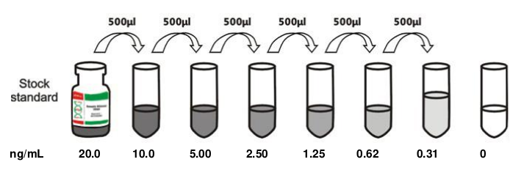Figure 11:

A curve is plotted with serial standard dilutions log graph, plotting the mean absorbance for each standard on the X-axis against the concentration on the Y-axis and draw a best fit curve through the points on the graph. (Table5 & Fig.12 )

Table 5: *optical density fo r standard dilutions*

|  |  |  |  |  |  |  |  |  |
| --- | --- | --- | --- | --- | --- | --- | --- | --- |
| Concentration ng/mL | 20 | 10 | 5 | 2.5 | 1.25 | 0.625 | 0.312 | 0 |
| OD(absorbance) | 2.622 | 2.36 | 1.63 | 1.048 | 0.658 | 0.4 | 0.258 | 0.06 |

### Calculation of results

The concentration of NTproBNP in the samples is then determined by plotting the OD (optical density) of the samples on the standard curve.

# **Study’s Outcomes**

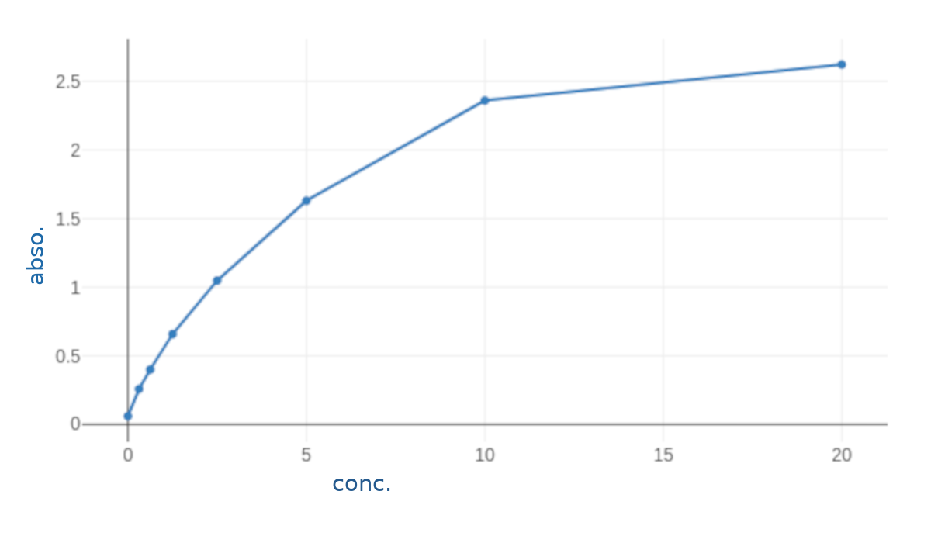Figure 12: standard curve for calculation of NTproBNP results,.

range 0312-20 ng/mL

Primary outcomes:

* low output heart failure (inotropic support at second post-operative day, adrenaline > 50ng/kg/min or dobutamine > 10mcg/kg/minat any time and/or need for intra-aortic balloon pump)

Secondary outcome parameters:

* mortality
* arrhythmias
* perioperative myocardial Infarction
* length of ICU
* length of postoperative hospital stay
* prolonged intubation (Intubation more than 24 hours postoperatively and/or reintubation following planned extubation).

# **Data Analysis and Statistical Methods**

*An Excel spreadsheet was established for the entry of data. We used validation checks on numerical variables and option-based data entry method for categorical variables to reduce potential errors. Data were coded and entered using the statistical package SPSS (Statistical Package for the Social Sciences) version 24. Data was summarized using mean, standard deviation, median, minimum, maximum and interquartile ranage in quantitative data and using frequency (count) and relative frequency (percentage) for categorical data. Comparisons between quantitative variables were done using the non-parametric Mann-Whitney test . Correlations between quantitative variables were done using Spearman correlation coefficient . ROC curve was constructed with area under curve analysis performed to detect best cutoff value of NTproBNP for detection of outcomes. P-values less than 0.05 were considered as statistically significant.*

# Results

# Preoperative demographics and risk factors

*Sixty-five patients were recruited in this study.* The average age was 57.62 ±7.21. Most of the patients were males 56 (86.15%). 10 (15.38%) had diabetes mellitus, 42 (64.62%) were hypertensive and only one had peripheral vascular disease in the form of 70% stenosis of right carotid artery.

Table 6 shows the demographic characteristics and preoperative risk factors of patients included in the study.

Table 6: demographic characteristics[1]* of patients

|  |  |
| --- | --- |
| **Variables** | **Patients (N =65)** |
| **Age in years**   * Mean ±SD * Median (Range) | 57.62 ±7.21  57 (44 -73) |
| **Gender, No (%)** |  |
| * Male | 56 (86.15%) |
| * Female | 9 (13.85%) |
| **Comorbidities, No (%)** |  |
| * DM | 10 (15.38%) |
| * HTN | 42 (64.62%) |
| * Peripheral vascualr disease | 1 (1.54%) |

Figure 13 shows the distribution of preoperative risk factors, while figure 14 is a histogram showing the distribution of age in the study group.

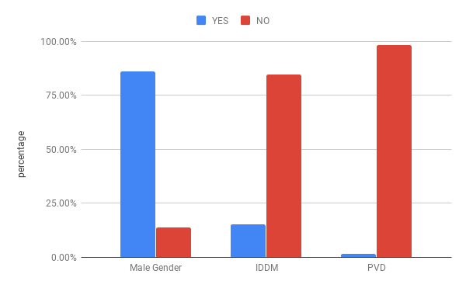Figure 13: Distribution of demographic variables and risk factors

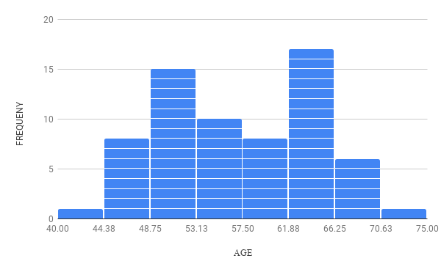Figure 14: Distribution of Age

Table 7 shows that preoperative ejection fraction of patients averaged 50.91±8.13. The calculated EuroscoreII averaged 0.76±0.34. Its median was 0.68 with an interquartile range of [0.55-0.82]. Histograms of their distribution are shown in figures 15 and 16.

Table 7: Measured preoperative ejection fraction and calculated EuroScoreII

|  |  |
| --- | --- |
| **Variables** | **Patients (N=65)** |
| **Ejection Fraction**   * mean ±SD * median(range) | 50.91±8.13  49(40-67) |
| **EuroScore II**   * mean±SD * median(range) * [interquartile range] | 0.76±0.34  0.68(0.50-2.94)  [0.55-0.82] |

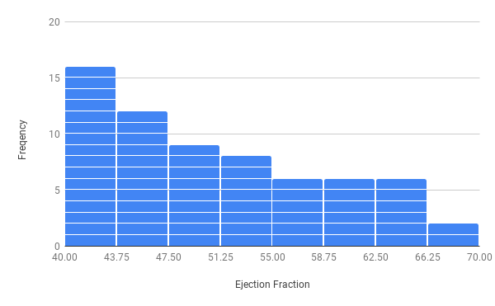Figure 15: Distribution of Ejection Fraction

Figure 16: Distribution of EuroscoreII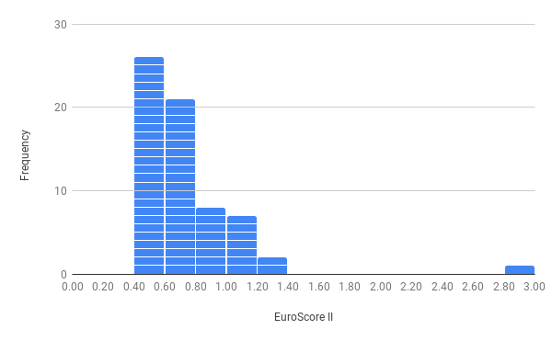

The preoperative NTproBNP levels averaged 312.41± 329.93pg/mL. The median was 160 with interquartile range of [80-397.5]. Table 8 summarizes these data and figure 17 shows a histogram of its distribution.

Table 8: summary of statistical discription of measured preoperative NTproBNP values

|  |  |  |  |  |  |  |  |
| --- | --- | --- | --- | --- | --- | --- | --- |
|  | Mean | *Standard Deviation* | *Median* | *Min* | 1st quartile | 3rd quartile | *Max* |
| NTBNP (pg/mL) | 312.41 | *3*29.93 | *160* | *10* | 80 | 397.5 | *1440* |

Figure 17: Distribution of NTproBNP

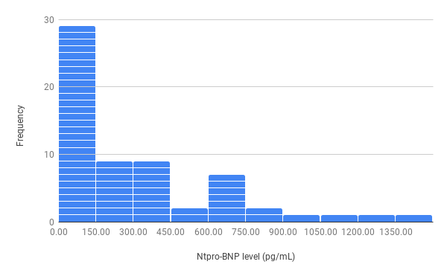

## Postoperative outcomes

Only two patients died; one of sepsis and the other of respiratory failure. Three required prolonged mechanical ventilation, one of whom was due to delayed recovery from anaesthesia (the only patient suffering from such complication). Three suffered recent onset arrhythmia (3 Atrial fibrillation, One Ventricular Tachycardia) during their ICU stay. One patient was re-admitted to the ICU for atrial fibrillation. Five patients had low output heart failure, and four had perioperative myocardial infarction. The mean ICU stay was 3.37±0.84 days and mean hospital stay was 6.38±1.3 ( 3-12) days. Tables 9and 10 summarizes such data and figures 18, 19and 20 show their distibution across the study group.

Table 9: Summary of categorical outcomes

|  |  |  |  |
| --- | --- | --- | --- |
|  |  | **Count** | **%** |
| **low CO** | **yes** | *5* | *7.7%* |
| **no** | *60* | *92.3%* |
| **arrhythmia** | **yes** | *4* | *6.2%* |
| **no** | *61* | *93.8%* |
| **perioperative MI** | **yes** | *4* | *6.2%* |
| **no** | *61* | *93.8%* |
| **prolonged vent** | **yes** | *3* | *4.6%* |
| **no** | *62* | *95.4%* |
| **Delayed Recovery** | **yes** | *1* | *1.5%* |
| **no** | *64* | *98.5%* |
| **mortality** | **yes** | *2* | *3.1%* |
| **no** | *63* | *96.9%* |

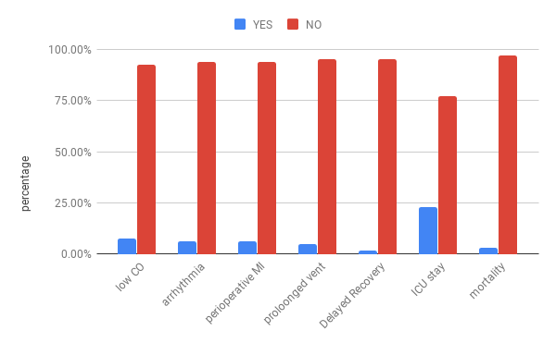Figure 18: Distribution of primary and secondary outcomes

Table 10: Summary of quantitative outcomes

|  |  |  |  |  |  |
| --- | --- | --- | --- | --- | --- |
|  | Mean | Standard Deviation | Median | Minimum | Maximum |
| ICU stay | *3.37* | *0.84* | *3.00* | *2.00* | *7.00* |
| in-hospital stay | *6.38* | *1.33* | *6.00* | *3.00* | *12.00* |

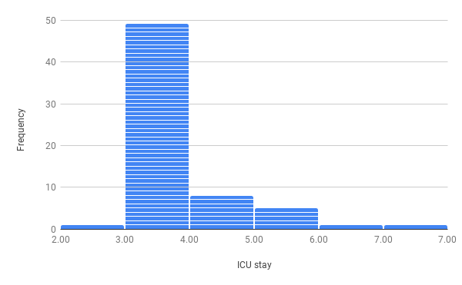  
Figure 19: Distribution of length of ICU stay

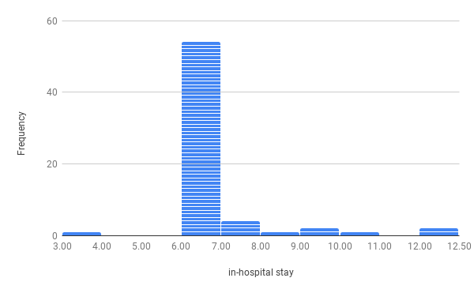  
Figure 20: Distribution of length of in-hospital stay

## Relation between NTproBNP and **study outcomes**

Table 11 shows a comparison between the distribution of measured NTproBNP values in patient with and without low cardiac output. The mean NTproBNP was 490 pg/ml (median 650) in patients who had low cardiac output vs 296.84pg/ml (and 160 pg/ml) for patient who did not. P value was 0.168. ie the results were statistically insignificant.

Table 11: relation between NTproBNP and low cardiac output

|  |  |  |  |  |  |  |  |
| --- | --- | --- | --- | --- | --- | --- | --- |
|  | | **NTproBNP** (pg/mL) | | | | |  |
| **Mean** | **Standard Deviation** | **Median** | **Minimum** | **Maximum** | **P value** |
| **low CO** | **yes** | *490* | *307.97* | *650* | *60* | *750* | *0.168* |
| **no** | *296.84* | *329.75* | *160* | *10* | *1440* |

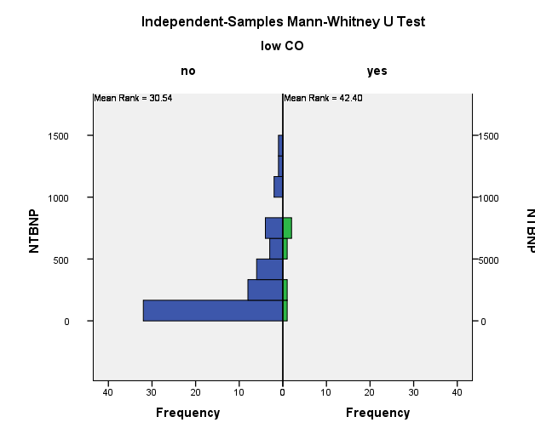

Table 12 shows a comparison between the distribution of measured NTproBNP values in patient with and without postoperative arrhythmia. The mean NTproBNP was 400 pg/ml (median 410) in patients who had postoperative arrhythmia vs 306.37pg/ml (and 160 pg/ml) for patient who did not. P value was 0.462. ie the results were statistically insignificant.

Table 12: disctribution of NTproBNP levels across patient who did and did not develop postoperative arrhythmia

|  |  |  |  |  |  |  |  |
| --- | --- | --- | --- | --- | --- | --- | --- |
|  | | **NTproBNP** (pg/mL) | | | | |  |
| **Mean** | **Standard Deviation** | **Median** | **Minimum** | **Maximum** | **P value** |
| **arrhythmia** | **yes** | *400* | *292.91* | *410* | *60* | *720* | *0.462* |
| **no** | *306.37* | *333.77* | *160* | *10* | *1440* |

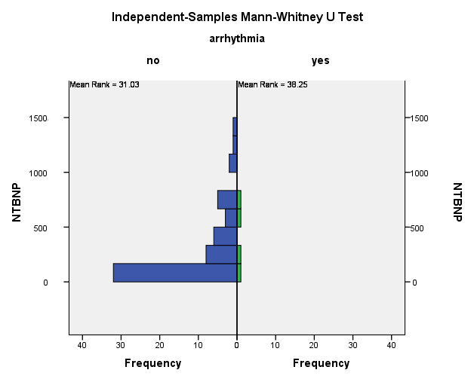

Table 13 shows a comparison between the distribution of measured NTproBNP values in patient with and without perioperative myocardial infarction. The mean NTproBNP was 437.5 pg/ml (median 485) in patients who had MI vs 303.79pg/ml (and 160 pg/ml) for patient who did not. P value was 0.397. ie the results were statistically insignificant.

Table 13: distribution of NTproBNP levels across patients who did and did not suffer perioperative mycardial infarction

|  |  |  |  |  |  |  |  |
| --- | --- | --- | --- | --- | --- | --- | --- |
|  | | **NTproBNP** (pg/mL) | | | | |  |
| **Mean** | **Standard Deviation** | **Median** | **Minimum** | **Maximum** | **P value** |
| **perioperative MI** | **yes** | *437.5* | *326.22* | *485* | *60* | *720* | *0.397* |
| **No** | *303.79* | *331.23* | *160* | *10* | *1440* |

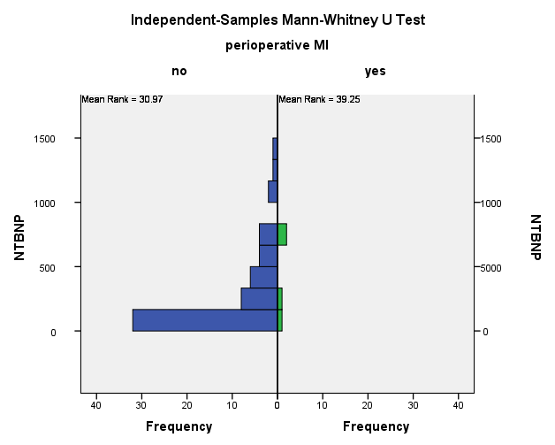

Table 14 shows a comparison between the distribution of measured NTproBNP values in patient did and didn’t require prolonged mechanical ventilation. The mean NTproBNP was 550 pg/ml (median 660) in patients who required prolonged mechanical ventilation vs 300.33pg/ml (and 160 pg/ml) for patient who did not. P value was 0.121. ie the results were statistically insignificant.

Table 14: distribution of NTproBNP levels across patients who did and did not require prolonged mechanical ventilation

|  |  |  |  |  |  |  |  |
| --- | --- | --- | --- | --- | --- | --- | --- |
|  | | **NTproBNP** (pg/mL) | | | | |  |
| **Mean** | **Standard Deviation** | **Median** | **Minimum** | **Maximum** | **P value** |
| **proloonged vent** | **yes** | *550* | *244.33* | *660* | *270* | *720* | *0.121* |
| **no** | *300.33* | *330.69* | *160* | *10* | *1440* |

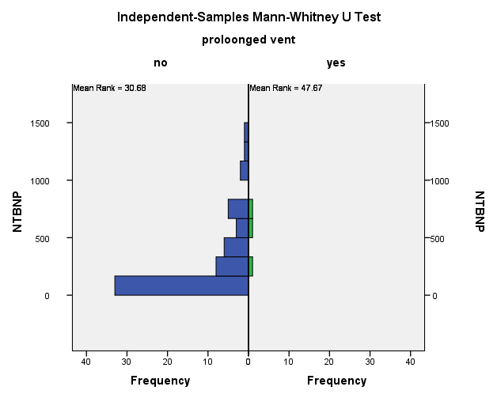

Table 15 shows a comparison between the distribution of measured NTproBNP values in patient with and without delayed neurological recovery. Only one patient suffered of such complication with NTproBNP 1030pg/mL vs 300.65 pg/ml (and median 160 pg/ml) for patient who did not. P value was 0.129. ie the results were statistically insignificant.

Table 15: distribution of NTproBNP levels across patients who did and did not suffer delayed neurological recovery

|  |  |  |  |  |  |  |  |
| --- | --- | --- | --- | --- | --- | --- | --- |
|  | | **NTproBNP** (pg/mL) | | | | |  |
| **Mean** | **Standard Deviation** | **Median** | **Minimum** | **Maximum** | **P value** |
| **Delayed Recovery** | **yes** | *1030* | *-* | *1030* | *1030* | *1030* | *0.129* |
| **no** | *300.65* | *319.29* | *160* | *10* | *1440* |

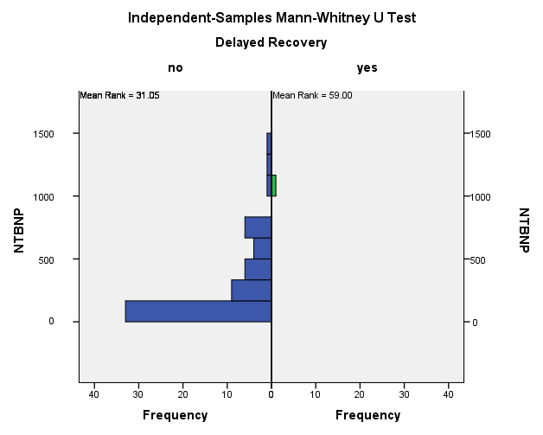

Table 16 shows a comparison between the distribution of measured NTproBNP values in patients who survived till discharge and those who died before discharge from the hospital. The mean NTproBNP was 495 pg/ml (median 495) in patients who died vs 306.33pg/ml (and 160 pg/ml) for patient who did not. P value was 0.306. ie the results were statistically insignificant.

Table 16: distribution of NTproBNP levels across patients who did and did not die before discharge from the hospital

|  |  |  |  |  |  |  |  |
| --- | --- | --- | --- | --- | --- | --- | --- |
|  | | **NTproBNP** (pg/mL) | | | | |  |
| **Mean** | **Standard Deviation** | **Median** | **Minimum** | **Maximum** | **P value** |
| **Mortality** | **yes** | *495* | *318.19* | *495* | *270* | *720* | *0.306* |
| **No** | *306.33* | *331.15* | *160* | *10* | *1440* |

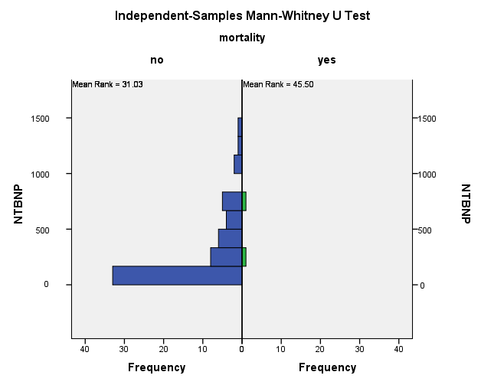

Table 17 shows that there was poor correlation between NTproBNP and length of ICU stay and hospital stay, as the correlation coofficient for NTproBNP and ICU stay was -0.02 and for NTproBNP and hospital stay, it was -0.017.

Table 17: correlation between NTproBNP and continuous outcome variables

|  |  |  |
| --- | --- | --- |
|  |  | **NTBNP** |
| **ICU stay** | **Correlation Coefficient** | *-.022-* |
| **P value** | *0.861* |
| **N** | *65* |
| **in-hospital stay** | **Correlation Coefficient** | *-.017-* |
| **P value** | *0.896* |
| **N** | *65* |

# Discussion

A lot of studies have investigated the value of perioperative BNP181182183184185 and NTproBNP184186187188189190191192193194195196 in predicting the prognosis and outocome of cardiac surgery. Yet the studies are very heterogenous in design: the peptide used, the time and frequency of sampling, the clinical end-points, the duration of follow-up .. etc., and results.

The aim of our study was to investigate the value of pre-operative natriuretic peptides in predicting clinical outcomes following off-pump coronary artery bypass grafting. We’ve chosen NTproBNP over BNP because it is accepted to be more biochemically stable than BNP. It can be drawn into glass or plastic tubes and does not require an addition of protease inhibitors such as EDTA. NTproBNP can be drawn into serum, heparin plasma, or EDTA. The intra-individual, day-to-day biologic variation in stable HF patients is about 38% for BNP and 28% for NTproBNP; in patients without HF127.

Steady-state levels of NT-proBNP are as much as four-to six-fold higher than BNP192. [Cuthbertson et al., 2009]190 assumed that a conversion factor of four to one between NT-proBNP and BNP is appropriate in the NTproBNP range < 400pg/mL (according to local data in their lab, n=735, Pearson’s correlation coefficient=0.82, P,0.001). [Chen et al., 2013]184 used in their study both BNP and NTproBNP with pre-operative levels 103.8±184pgmL and 621.3±1050.7pg/mL, suggesting a factor of conversion aournd six. While this might not result in accurate estimates under all conditions and in all levels, it is helpful to keep that in mind while comparing different studies using different peptides.

We decided to exclude from the study population patients with factors that may influence NTproBNP levels and the post-operative morbidity. Thus extremes of age, morbid obesity, severe chronic obstructive pulmonary disease, renal impairment, ejection fraction < 40%, pre-operative artrial fibrillation and NYHA III/IV were among the exclusion criteria.

Our study showed no significant differences in NTproBNP between patients with and without post-operative myocardial infarction. This is similar to reports by [Eliasdottir et al., 2008]189 (N=135), [Schachner et al., 2010]191 (N=819) and [Akhmedova et al., 2020]196(N=28[2]). [Attaran et al., 2009]181 (N=141) also showed similar results but, they used BNP in their study. Post-operative myocardial infarction is likely caused by intra-operative variables and are thus not captured by pre-operative natriuretic peptide levels.

Both our study and [Schachner et al., 2010]197 showed no significant differences in NTproBNP between patients with and without neurological complications. To our knowledge these are the only studies that looked into such relation.

This may be due to the fact that despite cerebrovascular events and coronary artery disease sharing common etiology, other factors, such as aortic calcification and intraoperative hemodynamics heavily influence the incidence of post-operative cerebral infarctions, and these can’t be reflected in pre-operative natriuretic peptide levels.

Our study showed no siginificant correlation between pre-operative NTproBNP and ICU stay (correlation coeffecient r=0.22, p=0.861). This is in accordance with [Chen et al., 2013]184 , who found no significant pre-operative BNP and NTproBNP in patients with ICU stay >4 days, in a population very similar to ours; [Öztekin et al., 2017]193 (N=51), who found no signicant differences in ICU stay duration among patients with low (<100pg/mL), moderately elevated (between 100 and 500 pg/mL) and high (> 500pg/mL) NTproBNP levels. [Akhmedova et al., 2020]196 also found no significant differences in ICU stay between patients with pre-operative NTproBNP more and less than 430 pg/L (the cutoff determined by [Schachner et al., 2010]191 for 30-day mortality).

[Fellahi et al., 2011]182(N=208) who found that ‘[pre-operative BNP levels] *descrimination to predict a prolonged length of stay in the ICU was of ... limited value’* since their reciever operator characteristics curve ROC analysis for ICU stay > 4 days had an area under curve AUC of 0.6 (CI 0.49-0.71, p=0.036) denoting poor diagnostic performance.

[Jogia et al., 2007]187 (N=118) reported some statisically significant correlation with pre-operative NTproBNP and length of stay in ICU. This might be due to the fact that they have included in their study patients with EF< 35% (11% of their patients), patients with NYHA III/IV (76.2%) and valve surgery patients (21.1%) while these were exclusion criteria in our study. This was reflected on the NTproBNP levels in both studies. eg. their aortic valve replacement AVR patients had levels 584±305pg/mL and the combined procedure patients had levels of 1057±796pg/mL (they didn’t report the values for the whole population), while these were 312.4±329.9pg/mL in our patients.

Also they 187 reported ICU stay as 27±18hr, meaning that patients were allowed to stay at ICU for less than a day. By contrast, the centers in which we performed our study would routinely admit patients in the ICU for at least 2 post-operative days. This might have allowed their data to reflect more precisely the time needed for the patient in the ICU.

It is also important to notice that the numbers they reported were modest (r=0.59, p=0.001 and area under ROC cuve of 0.66). In fact they described them as ‘not strong enough to be clinically useful predictors’.

[Eliasdottir et al., 2008]189  also reported predictive value for NTproBNP on post-operative ICU stay. This might be due to patients’ baseline characteristics. 32% of their patients had valve surgery with or without cornary artery bypass grafting CABG, and they had a mean logistic euroSCORE of 8.15% while our patinets had EuroScoreII of 0.76.[3]* Mean pre-operative NTproBNP level for their cohort was 1223 pg/mL and the mean for patients with prolonged ICU stay was even higher (3118 pg/mL), way outside the whole range of NTproBNP level in our study [10-1440 pg/mL].

Also the value they provided for accuracy indices (with sensitivity 82%, specificity 69% and area under ROC curve of 0.82) are not derived from ROC analysis for prolonged ICU stay alone, nor are the significant differences in levels of NTproBNP, but are actually for ‘*ICU stay > 2days and/or death*’ which may have augmented and over-estimated those indices.

[Cuthbertson et al., 2009]190 (N=1010) also reported pre-operative NTproBNP levels to be predictive of prolonged ICU stay. Again characteristics of studied population differes greatly. 12.5% of the patients had EF < 40%, 11.5% NHYA III/IV, 28% had valve surgery with or without CABG and 12.5% had pre-operative intra-aortic ballon pump IABP. Pre-operative NTproBNP median(inter-quartile range IQR) were for patients who didn’t die 279(119-833) pg/mL, in patients who died 624(190-1368) pg/mL and in patients with severe systolic dysfunction 818(565-9098) pg/mL. In our study those were 160(80-397.5).

They 190 defined prolonged ICU stay as longer than a day, so the same argument as with [Jogia et al., 2007]187 applies here. Also the the numbers [Cuthbertson et al., 2009]190  provided for the predictive performance of NTproBNP for prolonged are actually very weak (odds ratio OR 1.03(1.01-1.05) as per 250pg/mL increase in NTproBNP). Indeed, they190 concluded that ‘*NTproBNP levels predict early outcome after cardiac surgery*’ and that ‘*it appears to be independent of other widely utilized methods of risk stratifications’. Yet they noted that ‘the predictive utility is modest’* and *‘its clinical validity is moderate due to its modest sensitivity and specificity it demonstrates for the outcome’.*

[Schachner et al., 2010]197 reported statistically significant difference in ICU stay in patients who had NTproBNP levels >502pg/mL, 22(12-1919)h; vs NTproBNP <502pg/mL, 22(7-1268); p=0.001. That number, 502pg/mL; is the cutoff levels derived from their ROC curve analysis for long-term mortality. Despite the authors’ note that ‘In general, those patients exhibited a higher rate of comorbidities, resulting in an increased risk score’, they didn’t provide any multivariable analysis to determine whether NTproBNP is and independent factor for prolonged ICU stay.

Moreover, while they197 only included in their study patients undergoing isolated CABG; many differences still exist between our patients. Their patients were as old as 89 yrs, had creatinine levels spanning 0.5-6.2mg/dL, 17% had urgent operations and they had a logarithmic EuroSCORE of 2.5[1-63] resulting in NTproBNP levels [6-65998 pg/mL].

[Liu et al., 2013]192 (N=225) reported that ‘*preoperative NT-proBNP was closely related to … length of stay in ICU (P = 0.004)’* but the correlation is actually weak (r=0.194). Thier study included 128 patients with NHYA III/IV and NTproBNP levels were 728.4(213.5-2551). length of ICU stay was 3.45 ± 8.17 days in their study vs 3.37±0.84 days in our study.

The fact that inclusion of valve surgery can dramatically alter the diagnostic performance of pre-opreative natriuretic peptide is most clearly shown in [Fellahi et al., 2012]183 (N=189). In there first study [Fellahi et al., 2011]182 , in which only 45% of the patients had isolated CABG; they revealed good diagnostic performance of pre-operative BNP for predicting MACEs/death: AUC 0.76 (CI 0.68-0.85, p<0.001), sens. 0.77, spec. 0.75)

This was further confirmed in their second study [Fellahi et al., 2012]183 where they included 100 CABG and 89 AVR patients. Again ROC curve analysis of pre-operative BNP revealed AUC of 0.67 (p= 0.002) for predicting MACEs.

However, when they re-analysed the data after dividing the patients into two groups, CABG group and AVR group; preoperative BNP levels were significantly different between the groups (CABG 104 [8-5,017] pg/mL vs AVR 235 [8-2,018] pg/mL, p<0.001) despite other demographic data (including renal functions, EF and BMI) being comparable, and preoperative values of BNP were more accurate in predicting MACEs after AVR (area under ROC 0.78 for pre-op BNP, p<0.001), whereas no *significant* discrimination was found for BNP values in predicting long-term adverse cardiac outcome after *CABG surgery* (area under ROC 0.54, p=0.32).

Also [Attaran et al., 2009]181 found significant differences in pre-operative BNP levels in patients undergoing AVR/MVR vs CABG (273 vs 125pg/mL, p=0.0018). And [Cuthbertson et al., 2009]190, according to multivariable analysis of pre-operative variables affecting mortality, valve/aortic surgery±CABG had OR 3.38 (1.60 – 7.12) p= 0.001. In their 190 regression models, valve/aortic surgery was an independent factor predicting hospital stay > 1week with OR 1.67(1.19-2.35) p=0.003.

Our study showed no significant differences in NTproBNP between patients with and without post-operative atrial fibrillation AF. This is similar to reports by [Jogia et al., 2007]187, and [Attaran et al., 2009]181.

[Cuthbertson et al., 2009]190 reported an odds ratio of 1.02(1-1.03) per 250pg/mL increase in pre-operative NTproBNP and the development of post-operative AF (p=0.02). Apart from the fact that the value itself is of very poor diagnostic performance, the 95% confidence interval CI included 1, undermining its statistical significance.

Other studies182183186 report AF as part of a composite endpoint in the form of ‘cardiac complications’ or ‘major adverse cardiac events’ so these can’t be fairly compared.

Another matter worth discussing is the incidence of AF in our study. While the incidence of post-cardiac surgey AF is reported to be as high as 35%198, only 4 (6.2%) of our patients developed post-operative AF. This is likely due to the lower risk factors found in our patient (patients with pre-operative AF, valvular disease and severe COPD were excluded from our study). Our patients were relatively young with good EF (mean age 57.62, EF 50.9). All had their beta-blockers on the morning of surgery and resumed them on the second post-operative day. In fact, [Chen et al., 2013]184 reported even lower incidence of ‘new onset arrhythmia’ 3/76 patients (3.9%), in a population similar to ours.

Our study showed no significant differences in NTproBNP levels in patients who required or not prolonged mechanical ventilation >24hr (300 vs 550pg/mL, p=0.121). [Öztekin et al., 2017]193 and [Akhmedova et al., 2020]196 found no significant difference in ventilation time in patients with high vs low NTproBNP levels. Similarly [Sindhvananda et al., 2019]195 found no significant differences in NTproBNP (pre-operative, at time of weaning, or the difference between both levels) in patients who had simple, difficult, or prolonged weaning. Area under ROC curve for predicting difficult, prolonged weaning an need for re-intubation were 0.59, 0.62, and 0.58 respectively.

This is in contrast to [Liu et al., 2013]192 and [Jogia et al., 2007]187 who reported ‘good’ correlation between ventilation time and NTproBNP levels. Yet the coefficients they calculated are rather modest, (r=0.177, p=0.009) and (r=0.46, p=0.015) respectively. [Cuthbertson et al., 2009]190 also reported weak performance of NTproBNP in predicting the need for mechanical ventilation >24hr postoperative (OR=1.03).

[Schachner et al., 2010]197 also reported significant differences in time on mechanical ventilation in patinets with NTproBNP levels more than and less than 502pg/mL (the cutoff level for predicting mortality in their study) 8(0-1900)hr vs 8(0-767)hr, p=0.005. This is likely due to the differences already mentioned between our study populations in demographics and NTproBNP levels.

[Attaran et al., 2009]181 claimed that higher BNP levels predict, among other outcomes; longer ventilation time but, they mention neither quantitative nor qualitative values for it in their text, tables or figures, so we can’t really comment on it.

Thus, earlier studies showed significant, but weak correlation between pre-oeprative natriuretic peptides and ventilation time, while more recent studies seem to lack that finding. While one can argue that [Öztekin et al., 2017]193(N=51) and [Akhmedova et al.,2020]196(N=28) had very had very small number of patients in their studies, this can’t be said of [Sindhvananda et al., 2019]195 who included a number (N=135) comparable to other studies e.g. Jogia187 (N=118), Attaran181 (N=141). One can speculate that since the correlation was weak to begin with, even minor improvements in mechanical ventilation technologies and protocols might have rendered it invalid.

Our study showed no significant differences in NTproBNP levels in patient who did or didn’t die. This is similar to what [Jogia et al., 2007]187 reported in their study. This might be due to the very low mortality count in our study (2/65 patients) and Jogia’s187 (2/118). Also most of the other studies were looking into correlations with 1month mortality 189197190192185 or long-term197194 mortality, whereas we were looking into in-hospital mortality.

In contrast [Eliasdottir et al., 2008]189 who found significant difference in NTproBNP levels in patients with 28-day mortality 2184pg/mL vs 1163pg/mL (p=0.001) in patients who survived. [Cuthbertson et al., 2009]190 reported for 30-day mortality OR 1.03 per 250pg/mL increase in NTproBNP level.

[Liu et al., 2013]09 (N=225) found in their ROC curve analysis for prediction of 30 day mortality (4.89% in their study) the best cutoff of pre-operative NTproBNP to be 2773.5 pg/mL, a level that is totally outside the range of NTproBNP levels found in our study. This level was associated with sensitivity of 63.6% and specificity of 80.8%. AUC was 0.738 (95% CI 0.58-0.89, p=0.008).

[Schachner et al., 2010]197 (N=819) found that NT-proBNP >502pg/mL[4]* predicted overall (they followed patients survival for 3 years) mortality(p<0.001). Multivariate analysis identified NTproBNP as an independent risk factor for mortality, OR = 3.079 (CI =1.149-8.247), p = 0.025. That 502 pg/mL cutoff was determined by the ROC analysis for overall mortality. The authors never stated the area under the curve but the sensitivity (66.7%) and the specificity (63.9) could be read from the figure they provided.

Recently, two large studies194185 looked into the predictive performance of pre-operative natriuretic peptides on mortality, in comparison with EuroSCORE II. [Brynildsen et al., 2018]194 (N=640) found that pre-operative NTproBNP >1170 pg/mL predicted with sensitivity 66%, specificity 73% and area under ROC curve 0.73, while EuroSCORE II had an area under ROC curve 0.74. Combining EuroSCORE II and NTproBNP had an area under ROC curve 0.76.

[Suc et al., 2020]185 (N=4980) found poor performance of pre-operative BNP in predicting mortality with area under ROC curve 0.66 compared to EuroSCORE II which had area under ROC curve 0.82. In univariate analysis, BNP was associated with mortality with an unadjusted OR of 1.06 (1.03–1.09), p-value < 0.001 (per 1,000 unit-increase). In a multivariable analysis, however, BNP was not associated with mortality anymore.

The differences between the performance of natriuretic peptides in the two studies might be explained by the duration of follow-up. While [Suc et al., 2020]185 were looking into in-hospital mortality, [Brynildsen et al., 2018]194 were looking into long-term mortality (961 days of follow-up). This is also explained the better performance of EuroSCORE II in [Suc et al., 2020]185 since it is actually designed and calibrated for in-hospital mortality. Also, [Brynildsen et al., 2018] had more patients with NYHA III/IV (62% vs 21.6%), and less elective surgeries (59.2% vs 81.2%).

Our study showed no significant differences in NTproBNP levels in patients who did or didn’t developed post-operative low output heart failure. This was defined as inotropic support at second post-operative day, adrenaline >50ng.kg-1.min-1 or dobutamine > 10µg.kg-1.min-1 at any time and/or need for intra-aortic balloon pump. This is because many of our surgical and anaesthesia teams would use “low dose” inotropic support routinely for at least 12 hours post-operatively. Since no patient in our study needed IABP, this can be considered synonymous with need for inotropic support.

Similarly [Öztekin et al., 2017]193 found no differences in inotropic support among patients with low, moderately elevated and high pre-operative levels of NTproBNP in throughout a post-operative 3-day period. This is despite having relatively equal numbers in the three groups (15 in low, 15 in moderate and 21 in high groups), and having relatively wide range of NTproBNP levels [20.6-7249 pg/mL].

[Jogia et al., 2007]187 found significant, but modest correlation pre-operative NTproBNP and total perioperative noradrenaline dose (r=0.55, p=0.003). That correlation was ‘not useful as a predictor with the error of calssification almost 50%’.

[Cerrahoglu et al., 2007]199 (N=52) found significantly higher number of patients requiring inotropic support and significantly higher doses (P<0.05) in the group with NTproBNP>220pg/mL than the group with NTproBNP < 220pg/mL. Moreover NTproBNP levels were 886.25±655.26 pg/mL in patients requiring inotropes vs 183.07±224.97 pg/mL in those not requiring inotropes (p<0.001). Those findings are very different from ours, depsite the cohorts being similar. This might be attributed to our definitions of inotropic support ( Our defenition and the explanation for its adoption has been discussed before.). They accounted for use of inotropes at any time within 16 hours postoperative. In fact they gave very detailed discription of the hemodynamic parameters of the patients, obtained by Swan-Ganz catheter. This no doubt reflected the true inotropic requirements for patients in their study. Actually, the durations of inotropic support are short 0.46±1.13h and 5.92±6.4h in both groups of the study. It is worth noting that no multivariate analysis was done, so it is not known whether NTproBNP was an independent factor or it was the EF and other pre-operative factors that caused such effects. The cutoff used in their study is simply the median level in their cohort, it was not decided according to ROC curves, nor did they give any accuracy indices for the predictive performance of pre-operative NTproBNP.

[Eliasdottir et al., 2008]189 found significant differences in NTproBNP levels in patients who required inotropic support and those who didn’t (2628 pg/mL vs 548 pg/mL, p<0.001). Area under ROC curve was 0.84, sensitivity 79% and specificity 75% at cutoff 376pg/mL. [Attaran et al., 2009]181 also found significant differences in BNP levels in patients requiring inotropes and/or IABP (452 vs 120 pg/mL, p=0.0015).

[Cuthbertson et al.,2009]190 (N=1010) found NTproBNP to be predictive of need for inotropic support with an odds ratio of 1.03.

While [Krzych et al., 2011]200 report no significant correlation between NTproBNP and low cardiac output syndrome, they didn’t define it and the numbers challenge a classical textbook definition of it. They report that 9% of their patients had low cardiac output syndrome, 7% needed IABP, while 61% needed inotropic support.

However, they report good diagnostic performance of pre-operative NTproBNP on the need for inotropic support according to ROC curve analysis. These were further categorised according to the inotropic agent used. For the need of any inotropic drug area under ROC curve was 0.73(p<0.001), sensitivity 55.7%, specificity 82.1% at cutoff 684pg/mL. The numbers were similar for dopamine (the inotropic agent they used the most, but they didn’t declare any protocol for their inotrope choice). For adrenaline area under ROC was 0.69(p=0.04), sensitivity 70% specificity 75.6% at cutoff 1032pg/mL. For milrinone area under ROC was an excellent 0.92(p<0.001), sensitivity 100%, specificity 85.7% at cutoff >1340pg/mL, but there were only two patients in their study that required its use. Also notice the cutoffs compared to our NTproBNP levels median(IQR) 160(80-397.5).

[Akhmedova et al., 2020]196 found significant difference in inotropic requirement between patients with NTproBNP more than and less than 430pg/mL. Further they found good correlation between pre-operative NTproBNP level and post-operative inotropic needs (r=0.62).

Similar to our study [Öztekin et al., 2017]193 found no significant difference between patinets with low and high levels of NTproBNP in ICU or hospital stay, duration of intubation and need for inotropes. His study had relatively low number of patients (N=51), but the levels of NTproBNP were wide [20.6-7249 pg/mL, mean 920.6±1497.1].

[Hamed et al., 2019]201 measured in their study pre and post-operative NTproBNP levels. They found positive correlation between post-operative NTproBNP levles and many of the clinical outcome, However, they didn’t mention whether or not those outcomes correlated with pre-operative levels. Whether this mean that they didn’t find significant correlation with pre-operative levels, or they only performed the calculations on post-operative levels only is not clear.

The study most similar to ours is that by [Chen et al., 2013]184. In their study, average age was 64±10.2yr, 85.5% were males and EF was 61±11.2 in pre-operative evaluation. These were: age 57.62±7.21, male 86.15%, EF 50.9±8.13 in our study. Like in our study they report higher, but non-significant levels of pre-operative NTproBNP in patients with prolonged ICU stay, prolonged hospitalization and major complications. They stated that ‘Because elective CABG surgery was a prerequisite for enrollment … our preoperative BNP and NT-proBNP concentrations were lower than those in previous studies. This may explain why preoperative BNP and NT- proBNP are not significantly associated with outcomes.’184

# Conclusion

BNP is produced in both atria and ventricles, and is upregulated in failing ventricular myocardium in response to increased myocardial stretch and wall stress, together with the inactive byproduct N-terminal-proBNP (NTproBNP)3.

Changes in hemodynamic parameters and plasma NPs levels are closely related in patients with cardiovascular diseases.The NPs system activation is modulated also by the activity of the counteregulatory neurohormonal system. Consequently, even very small changes in hemodynamics may produce significant variations in plasma concentrations of NPs9.

The physiologic actions natriuretic peptides reduce cardiac preload and afterload to counteract the detrimental effects of pressure and volume overload seen in HF. These physiologic processes are counter-regulatory to the detrimental neurohormonal activation of the sympathetic nervous system and RAAS in HF and are why ANP and BNP levels reflect HF severity202.

BNP concentrations were found to be independent risk markers for morbidity and mortality in patients with heart failure. In some studies NPs levels were stronger predictors of mortality and/or major cardiovascular events than left ventricular EF, NYHA class10.

Several clinical trials have measured BNP or NTproBNP in patients presenting with acute coronary syndrome and consistently found that elevated NP values revealed important prognostic information16.

In patients undergoing cardiac surgery, accurate risk adjustment is of paramount importance for clinical audit, benchmarking and research and to identify high-risk patients that may benefit from prophylactic interventions to reduce post-operative adverse outcomes. Although many existing clinical prognostic models such as EuroSCORE are very useful, further refinement, update or recalibration are needed to maintain their utility. Most of these clinical prognostic scores for cardiac surgery are only useful in predicting mortality but not adverse events such as AF or cardiogenic shock requiring IABP. The strength of associations between pre- operative natriuretic peptide levels and adverse outcomes after cardiac surgery varied between different studies203.

Our study didn’t show significant correlation between pre-operative NTproBNP and post-operative heart failure, arrhythmias, perioperative myocardial infarction, length of ICU stay, prolonged intubation, hospital stay or mortality. This is likely due to the low incidence of complications and low NTproBNP levels secondary to the predicted favorable outcomes in our patients given that they had very low risk factor.

However, through reviewing other studies we’ve come to the conclusion that pre-operative NTproBNP can’t predict post-operative neurological complications191 and peri-operative myocardial infarction189191181. This is likely because they are more dependent on intra-operative variable that can’t be captured by pre-operative natriuretic peptide levels.

Pre-operative natriuretic peptides has moderate to weak190192 correlation with different post-operative variables. Their diagnostic performance on predicting MACEs182183186 and/or mid to long-term mortality is better and more consistent across studies than with individual outcome variables. Diagnostic accuracy indices suggest that natriuretic peptides are better used as exclusion tests (low positive predictve value vs good negative predictive value).

Whether or not pre-operative natriuretic peptides are independent predictors of poor outcome has also been inconclusive. And while this is valid research questions, it might be of less clinical importance.

Predictive performance is better in valvular surgery than in CABG183 this is likely because post-operative outcome is more affected by intra-operative variables (eg. ischemia and myocardial protection) in coronary surgery.

The predictive value of natriuretic peptides on length of ICU stay and post-operative inotropic support might be of more clinical value in centers that adopt fast-track protocols.

# Summary

B-type natriuretic peptide BNP is produced in both atria and ventricles, and is upregulated in failing ventricular myocardium. In response to increased myocardial stretch and wall stress, ventricular myocytes secret the pro-hormone pre-proBNP, which is then cleaved into biologically active BNP and the inactive byproduct N-terminal-proBNP (NTproBNP) 3. BNP and NTproBNP are secreted in equimolar quantites into the circulation. BNP has a serum half-life of 20 minutes, whereas NTproBNP has a half-life of 120 minutes4.

Circulating natriuretic peptides NPs acts as an antagonist of the renin angiotensine aldosterone system, inducing diuresis, natriuresis, vascular dilatation and inhibition of the sympathetic nervous system 7. These actions reduce cardiac preload and afterload to counteract the detrimental effects of pressure and volume overload and detrimental neurohormonal activation of the sympathetic nervous system and RAAS in HF. 202 Consequently, it is likely that very small changes in hemodynamics, not assessable by echocardiographic examination, may produce significant (and measurable) variations in plasma concentrations of NPs 9.

Studies suggest that the NPs level may be useful as a prognostic marker in HF and acute coronary artery syndromes. NPs concentrations were found to be independent risk markers for morbidity (increased future major cardiovascular events and/or hospitalization) and/or mortality in patients with acute /chronic HF. In some studies NPs levels were stronger predictors of mortality and/or major cardiovascular events than left ventricular EF, NYHA class, and/or presence of diabetes or hypertension, as well as sex and age in patients with chronic HF. 204

In patients hospitalized for acute exacerbation of heart failure (with reduced or preserved ejection fraction), elevated BNP correlated with increased in-hospital mortality and there was a direct relationship between quartiles of BNP concentration and mortality even after adjusting for multiple confounders including age, gender, vital signs, renal function, and sodium. 11

In heart failure patients, plasma NTproBNP concentrations were related to outcomes, including all-cause death, cardiovascular admission, and HF deaths/HF admissions. NTproBNP was the strongest independent predictor of outcomes at 3 years of follow-up 205. Failure of NP levels to decrease during an HF hospitalization while undergoing treatment is associated with worse prognosis in NYHA class III to IV HF 13. A baseline serum BNP level greater than 130 pg/mL in ambulatory patients with EF less than 35% predicts higher rates of sudden cardiac death. 14

Coronary heart disease is the main cause of morbidity and mortality in developed countries and the prevalence is increasing in developing countries. Studies have reported biomarker clusters which are associated with coronary heart disease. The assessment of these biomarkers, alone or in combination, may improve the long-term prediction of mortality of first major cardiovascular event to conventional risk markers. 206

Both BNP and NTproBNP have been shown to be predictive of adverse outcomes independent of other biomarkers, including the cardiac troponins in patients with coronay artery disease. 16

Elevated levels of BNP and NT pro-BNP have been shown to be associated with adverse outcomes in a number of settings, including patients undergoing major non-cardiac surgery. The strength of associations between pre- operative natriuretic peptide levels and adverse outcomes after cardiac surgery varied between different studies 17.

The aim of our study was to investigate the value of pre-operative natriuretic peptides in predicting clinical outcomes following off-pump coronary artery bypass grafting. We’ve chosen NTproBNP over BNP because it is accepted to be more biochemically stable than BNP and can be drawn into glass or plastic tubes and does not require an addition of protease inhibitors such as EDTA.

In order to minimize influence from other factors that may contribute to poor post-operative outcomes, we decided to exclude from the study patients at extremes of age, and patients with morbid obesity, severe chronic obstructive pulmonary disease, thyroid disturbances, renal impairment, ejection fraction < 40%, valvular heart disease, pre-operative artrial fibrillation and NYHA III/IV.

65 patients undergoing elective off-pump coronary artery bypass grafting OPCAB were recruited from 3 cardiothoracic surgery centers. The clinical endpoints were post-operative low output heart failure, in-hospital mortality, arrhythmias, perioperative myocardial Infarction, prolonged intubation, length of ICU, and length of postoperative hospital stay.

The average age was 57.62 ±7.21, ejectoin fraction 50.91±8.13, EuroSCORE II 0.76±0.34. This resulted in low pre-operative NTproBNP levels (median was 160 with interquartile range of [80-397.5] pg/mL), and low rate of complications relative to those found in most studies.

Thus, our study showed no statistically significant correlation with any of the mentioned clinical complications. While comparing this with the body of research on the performance of pre-operative natriuretic peptides in predicting poor post-operative outcome, we noticed some trends. For example, Pre-operative natriuretic peptides can’t predict post-operative neurological complications and peri-operative myocardial infarction , probably because they are more dependent on intra-operative variable that can’t be reflected on pre-operative natriuretic peptide levels.

Pre-operative natriuretic peptides has moderate to weak correlation with different post-operative variables, even in large (N>600) studies185190191194. Their diagnostic performance on predicting MACEs and/or mid to long-term mortality is better and more consistent across studies than with individual outcome variables. Diagnostic accuracy indices suggest that natriuretic peptides are better used as exclusion tests (low positive predictve value vs good negative predictive value).

Predictive performance is better in valvular surgery than in CABG this is likely because post-operative outcome is more affected by intra-operative variables (eg. ischemia and myocardial protection) in coronary surgery.

Different researchers came to different conclusions concerning pre-operative natriuretic peptides as independent predictors of poor post-operative outcome. While this is a valid and interesting research question, it might be of less clinical relevance. Altough many existing clinical prognostic models such as EuroSCORE are very useful, most of these clinical prognostic scores for cardiac surgery are primarily useful in predicting mortality. The predictive value of natriuretic peptides on length of ICU stay and post-operative inotropic support was more consistent in centers adopting ‘fast-track’ protocols. An established scoring system for the prediction of morbidity and lengths of stay following cardiac surgeyr will be invaluable in resource allocation. A relatively cheap, simple, reproducible test, like natriuretic peptide measurement, we imagine; will be part of such a scoring system.

References

[1] Maisel and Nicholas Wettersten. Natriuretic peptides in heart failure. Atrial and B-type natriuretic peptides. Heart Failure Clin,2018;14:13-25

[2] Rodseth RN. B-type natriuretic peptide – a diagnostic breakthrough in perioperative cardiac risk?. Anaesthesia,2009;64:165-78

[3] Iwanaga, I Nishi, S Furuichi, T Noguchi, K Sase, and Y Kihara. B-type natriuretic peptide strongly reflects diastolic wall stress in patients with chronic heart failure: comparison between systolic and diastolic heart failure. Journal of American College of Cardiology,2006;47:742-748

[4] Daniels and AS Maisel. Natriuretics peptides. Journal of American College of Cardiology,2007;50:2357–68

[5] Cowie, P Jourdain, A Maisel, U Dahlstrom, F Follath, R Isnard, A Luchner, T McDonagh, J Mair, M Nieminen, and G Francis. . Clinical applications of B-type natriuretic peptide (BNP) testing. Eur Heart J,2003;24:1710-8

[6] Thay-Hsiung C, Ching-Ling L, Joseph JS, James YS, Chung-Huo c, Mei-Ling C and Chih-Hui C. . Plasma B-type natriuretic peptide in predicting outcomes of elective coronary artery bypass surgery. Kaohsiung journal of medical sciences,2013;29:254-258

[7] Hall. NT-proBNP: the mechanism behind the marker. J Card Fail,2005;11:S81-3

[8] Potter. Natriuretic peptide metabolism, clearance and degradation. FEBS J,2011;278:1808-17

[9] Emdin, Passino C, and Prontera C et al. Cardiac natriuretic hormones, neuroormones, thyroid hormones and cytokines in normal subjects and patients with heart failure. Clin Chem Lab Med,2004;42:627–636

[10] Clerico and Emdin. Diagnostic accuracy and prognostic relevance of the measurement of the cardiac natriuretic peptides: a review. Clin Chem,2004;50:33-50

[11] Fonarow, Peacock, Phillips, et al, ADHERE Scientific Advisory Committee, and Investigators. Admission B-type natriuretic peptide levels and in-hospital mortality in acute decompensated heart failure. J Am Coll Cardio,2007;49:1943-50

[12] Komajda, Carson, and Hetzel et al. Factors associated with outcome in heart failure with preserved ejection fraction findings from the irbesartan in heart failure with preserved ejection fraction study (i- preserve). Circ Heart Fail,2011;4:27-35

[13] Cheng, Kazanagra, Garcia, and et al. A rapid bedside test for B- type peptide predicts treatment outcomes in patients admitted for decompensated heart failure: a pilot study. J Am Coll Cardiol,2001;37:386-91

[14] Berger, M Huelsman, K Strecker, A Bojic, P Moser, B Stanek, and R Pacher. B-type natriuretic peptide predicts sudden death in patients with chronic heart failure. Circulation,2002;105:2392-7

[15] Zethelius B, Berglud L, Sundstrom J, Ingelsson E, Basu S, et al.. Use of multiple biomarkers to improve the prediction of death from cardiovascular causes. N Eng J Med,2008;358:2107-2116

[16] Gaggin and James L Januzzi. Natriuretic peptides in heart failure syndrome. Clin Lab Med,2014;34:43-58

[17] Edward Litton and Kwok M. Ho. The use of pre-operative brain natriuretic peptides as a predictorof adverse outcomes after cardiac surgery: a systematic reviewand meta-analysis. European Journal of Cardio-Thoracic Surgery,2012;41:525–534

[18] Richards AM.. N-terminal B-type natriuretic peptide in heart failure. Heart Failure Clin,2018;14:27-39

[19] Suzuki T,Yamazaki T, and Yazaki Y. The role of natriuretic peptides in the cardiovascular system. Cardiovascular Research,2001;51:489-494

[20] Volpe, M Carnovali, and V Mastromarino.. The natriuretic peptides system in the pathophysiology of heart failure: from molecular basis to treatment. Clin Sci,2016;130:57-77

[21] Wu, F Wu, J Pan, J Morser, and Q Wu. Furin-mediated processing of pro-C-type natriuretic peptide. J Biol Chem,2003;278:25847-52

[22] Goetze. Biochemistry of pro-B-type natriuretic peptide-derived peptides the endocrine heart revisited. Clin Chem,2004;9:1503-1510

[23] Charles, TC Prickett, EA Espiner, MT Rademaker, AM Richards, and TG Yandle. Regional sampling and the effects of experimental heart failure in sheep: differential responses in A, B and C-type natriuretic peptides. Peptides,2006;27:62-68

[24] Giannessi, Andreassi MG, and Del Ry S et al.. Possibility of age regulation of the natriuretic peptide c-receptor in human platelets. J Endocrinol Invest,2001;24:8-16

[25] Clerico, Del Ry S, and Maffei S et al.. Circulating levels of cardiac natriuretic hormones in healthy adult subjects: effects of aging and sex. Clin Chem Lb Med,2002;40:371-377

[26] Bruins, MR Fokkema, JW Romer, MJ Dejongste, FP van der Dijs, JM van den Ouweland, and FA Muskiet. High intraindividual variation of B-type natriuretic peptide (BNP) and amino-terminal proBNP in patients with stable chronic heart failure. Clin Chem,2004;50:2052-8

[0] Potter, Andrea R. Yoder, Darcy R. Flora, Laura K. Antos, and Deborah M. Dickey. Natriuretic Peptides: Their Structures, Receptors, Physiologic Functions and Therapeutic Applications. Handb Exp Pharmacol,2009;191:341-366

[27] Pankow, Y Wang, F Gembardt, E Krause, X Sun, G Krause, HP Schultheiss, WE Siems, and T Walther. Successive action of meprin a and neprilysin catabolizes b- ype natriuretic peptide. Circ Res,2007;101:875-882

[28] Belenky, Smith, and Zhang. . The effect of class-specific protease inhibitors on the stabilization of B-type natriuretic peptide in human plasma. Clin Chim Acta,2004;340:163-172

[29] Ng, Geeranavor, Jennings, Loki, and O’Brien. Diagnosis of heart failure using urinary natriuretic peptides. Clin Sci,2004;106:129-133

[30] Rose and WR Giles. Natriuretic peptide C receptor signalling in the heart and vasculature. J Physiol,2008;586:353-366

[31] Ahluwalia, MacAllister RJ, and Hobbs AJ. Vascular actions of natriuretic peptides. cyclic gmp-dependent and -independent mechanisms. Basic Res Cardiol,2004;99:83-89

[32] Fan, Bryan PM, and Antos LK et al. . Downregulation does not mediate natriuretic peptide dependent desensitization of NPR-A or NPR-B: guanylyl cyclase-linked natriuretic peptide receptors do not internalize. Mol Pharmacol,2004;61:1-10

[33] Joubert, Labrecque, and De Lean. Reduced activity of the NPR-A kinase triggers dephosphorylation and homologous desensitization of the receptor. Biochemistry,2001;40:11096-11105

[34] Patel, ML Valencik, AM Pritchett, JC Burnett, JA McDonald, and MM Redfield. Cardiac-specific attenuation of natriuretic peptide a receptor activity accentuates adverse cardiac remodeling and mortality in response to pressure overload. Am J Physiol Heart Circ Physiol,2005;289:H777-H784

[35] Tamura, Y Ogawa, H Chusho, K Nakamura, K Nakao, M Suda, M Kasahara, R Hashimoto, G Katsuura, M Mukoyama, H Itoh, Y Saito, I Tanaka, H Otani, and M Katsuki. Cardiac fibrosis in mice lacking brain natriuretic peptide. . Proc Natl Acad Sci U S A,2000;97:4239-4244

[36] Knowles, G Esposito, L Mao, JR Hagaman, JE Fox, O Smithies, HA Rockman, and N Maeda. Pressure-independent enhancement of cardiac hypertrophy in natriuretic peptide receptor-A deficient mice. J Clin Invest,2001;107:975-984

[37] Langenickel, J Buttgereit, I Pagel-Langenickel, M Lindner, J Monti, K Beuerlein, N Al-Saadi, R Plehm, E Popova, J Tank, R Dietz, R Willenbrock, and M Bader. Cardiac hypertrophy in transgenic rats expressing a dominant-negative mutant of the natriuretic peptide receptor B. Proc Natl Acad Sci U S A,2006;103:4735-4740

[38] Sabrane, MN Kruse, L Fabritz, B Zetsche, D Mitko, BV Skryabin, M Zwiener, HA Baba, M Yanagisawa, and M Kuhn. Vascular endothelium is critically involved in the hypotensive and hypovolemic actions of atrial natriuretic peptide. J Clin Invest,2005;115:1666-1674

[39] Holtwick, M Gotthardt, B Skryabin, M Steinmetz, R Potthast, B Zetsche, RE Hammer, J Herz, and M Kuhn. Smooth muscle- selective deletion of guanylyl cyclase-A prevents the acute but not chronic effects of ANP on blood pressure. Proc Natl Acad Sci U S A,2002;99:7142-7147

[40] Nakanishi, Saito, and Kishimoto. Role of natriuretic peptide receptor guanylyl cyclase-a in myocardial infarction evaluated using genetically engineered mice. Hypertension,2005;46:1-7

[41] Nakayama. The genetic contribution of the natriuretic peptide system to cardiovascular diseases. Endocr J,2005;52:11-21

[42] Woodard, Rosado, and Brown. Expression and control of C-type natriuretic peptide in rat vascular smooth muscle cells. Am J Physiol Reg Int Comp Physiol,2002;282:R156-165

[0] Baig M, Mahon N, McKenna WJ, et al. The pathophysiology of advanced heart failure. Am Heart J,1998;135:S217

[43] Qian, Haruno, and Asada. Local expression of C-type natriuretic peptide suppresses inflammation, eliminates shear stress-induced thrombosis, and prevents neointima formation through enhanced nitric oxide production in rabbit injured carotid arteries. Circ Res,2002;91:1063=1069

[44] Wang, MC deWaard, A Sterner-Kock, H Stepan, HP Schultheiss, DJ Duncker, and T Walther. Cardiomyocyte-restricted overexpression of c-type natriuretic peptide prevents cardiac hypertrophy induced by myocardial infarction in mice. Eur J Heart Fail,2007;9:548-557

[45] Houben, van der Zander, and de Leeuw PW. . Vascular and renal actions of brain natriuretic peptide in man physiology and pharmacology. Fundam Clin Pharmacol,2005;19:411-19

[46] Gyurko, Kuhlencordt, Fishman, and Huang OL. Modulation of mouse cardiac function in vivo by eNOS and ANP. Am J Physiol,2000;278:H971-981

[47] Han and Hasin. Cardiovascular effects of natriuretic peptides and their interrelation with endothelin-1. Cardiovasc Drugs Ther,2003;17:41-52

[48] Evans, Youssef, and Yandle TG. . Effects of endothelin-1 on release of adrenomedullin and C-type natriuretic peptide from individual human vascular endothelial cells. J Endocrinol,2002;175:225-232

[49] Ahluwalia and Hobbs AJ. Endothelium-derived c-type natriuretic peptide more than just a hyperpolarized factor. Trends Pharmacol Sci,2005;26:162-167

[50] Vesely. Natriuretic peptides and acute renal failure. Am J Physiol Renal Physiol,2003;285:F167-177

[51] Bartels, H Bukulmez, P Padayatti, DK Rhee, C van RavenswaaijArts, RM Pauli, S Mundlos, D Chitayat, LY Shih, LI Al-Gazali, S Kant, T Cole, J Morton, V Cormier-Daire, L Faivre, M Lees, J Kirk, GR Mortier, J Leroy, B Zabel, CA Kim, Y Crow, NE Braverman, F van-den Akker, and MLA Warman. Mutations in the transmembrane natriuretic peptide receptor NPR-B impair skeletal growth and cause acromesomelic dysplasia, type maroteaux. Am J Hum Genet,2004;75:27-34

[52] Olney, H Bukulmez, CF Bartels, TC Prickett, EA Espiner, LR Potter, and ML Warman. . Heterozygous mutations in natriuretic peptide receptor-B (NPR-2) are associated with short stature. J Clin Endocrinol Metab,2006;91:1229-1232

[53] Tsuji and T Kunieda. . A loss-of-function mutation in natriuretic peptide receptor 2 (NPR2) gene is responsible for disproportionate dwarfism in cn/cn mouse. J Biol Chem,2005;280:14288-14292

[54] Dickey, DR Flora, PM Bryan, X Xu, Y Chen, and LR Potter. . Differential regulation of membrane guanylyl cyclases in congestive heart failure: natriuretic peptide receptor (NPR)-B, not NPR-A, is the predominant natriuretic peptide receptor in the failing heart. Endocrinology,2007;148:351-352

[55] Yasoda, Y Komatsu, H Chusho, T Miyazawa, A Ozasa, M Miura, T Kurihara, T Rogi, S Tanaka, M Suda, N Tamura, Y Ogawa, and K Nakao. Overexpression of CNP in chondrocytes rescues achondroplasia through a mapk-dependent pathway. Nat Med,2004;10:80-86

[56] Walther, Klostermann, and Hering-Walther. Fibrosis rather than blood pressure determines cardiac BNP expression in mice. Regul Pept,2003;116:95-100

[57] Booz. Putting the brakes on cardiac hypertrophy exploiting the no- cGMP counter-regulatory system. Hypertension,2005;45:341-346

[58] Pandey. Biology of natriuretic peptides and their receptors. Peptides,2005;26:901-932

[59] Waschek. Developmental actions of natriuretic peptides in the brain and skeleton. Cell Mol Life Sci,2004;61:2332-2342

[60] Perras, Schultes, and Behn. Intranasal atrial natriuretic peptide acts as central nervous inhibitor of the hypothalamo-pituitary-adrenal stress system in humans. J Clin Endocrinol Metab,2004;89:4642-8

[61] Vollmar and Kiemer AK. Immunomodulatory and cytoprotective function of atrial natriuretic peptide. Crit Rev Immunol,2001;21:473-485

[62] Vollmar. The role of atrial natriuretic peptide in the immune system. Peptides,2005;26:1086-1094

[63] Bettencourt. NT-proBNP and BNP: biomarkers for heart failure management. Eur J Heart Fail,2004;6:359-363

[64] Clerico, Iervasi G, and Pilo A. . Turnover studies on cardiac natriuretic peptides: methodological, pathophysiological and therapeutical considerations. Curr Drug Metab,2000;1:85-105

[65] Panteghini and Clerico. Understanding the clinical biochemistry of N-terminal pro-B-type natriuretic peptide: the prerequisite for its optimal clinical use. Clin Lab,2004;50:325-331

[66] Potthast, SE Abbey-Hosch, LK Antos, JS Marchant, M Kuhn, and LR Potter. Calcium-dependent dephosphorylation mediates the hyperosmotic and lysophosphatidic acid-dependent inhibition of natriuretic peptide receptor-B/guanylyl cyclase-B. J Biol Chem,2004;279:48513-48519

[67] Kuhn, Voss M, and Mitko D et al. . Left ventricular assist device support reverses altered cardiac expression and function of natriuretic peptides and receptors in end- tage heart failure. Cardiovasc Res,2004;64:308-314

[68] Andreassi, Del Ry S, and Palmieri C et al.. Up-regulation of ‘clearance’ receptors in patients with chronic heart failure: a possible explanation for the resistance to biological effects of cardiac natriuretic hormones. Eur J Hear Fail,2001;3:407-414

[69] Charloux, Piquard F, and Doutreleau S et al.. Mechanisms of renal hyporesponsiveness to anp in heart failure. Eur J Clin Invest,2003;33:769-778

[70] Sarzani, Strazzullo P, and Salvi F et al.. Natriuretic peptide clearance receptor alleles and susceptibility to abdominal adiposity. Obes Res,2004;12:351-356

[71] Wright, Doughty, and Pearl et al. . Plasma amino-terminal pro-brain natriuretic peptide and accuracy of heart-failure diagnosis in primary care: a randomized, controlled trial. J Am Coll Cardiol,2003;42:1793-1800

[72] Maisel, P Krishnaswamy, RM Nowak, J McCord, JE Hollander, P Duc, T Omland, AB Storrow, WT Abraham, AH Wu, P Clopton, PG Steg, A Westheim, CW Knudsen, A Perez, R Kazanegra, HC Herrmann, and Investigators of Breathing Not Properly Multi- national Study. Rapid measurement of B-type natriuretic peptide in the emergency diagnosis of heart failure. N Engl J Med,2002;347:161-7

[73] Januzzi, CA Camargo, S Anwaruddin, AL Baggish, AA Chen, DG Krauser, R Tung, R Cameron, JT Nagurney, CU Chae, DM Lloyd-Jones, DF Brown, S Foranelanson, PM Sluss, E Lee- Lewandrowski, and KB Lewandrowski. The N-terminal pro-BNP investigation of dyspnea in the emergency department (pride) study. Am J Cardiol,2005;95:948-54

[74] Januzzi, van Kimmenade, Lainchbury, Bayes-Genis, Ordonez-Llanos, Santalo-Bel, Pinto, and Richards. NT-proBNP testing for diagnosis and short-term prognosis in acute destabilized heart failure: an international pooled analysis of 1256 patients: the international collaborative of NT-proBNP (icon) study. Eur Heart J,2006;27:330-7

[75] Troughton and Richards. . B-type natriuretic peptides and echocardiographic measures of cardiac structure and function. JACC Cardiovasc Imaging,2009;2:216-25

[76] Kraigher-Krainer, Shah, and Gupta et al.. Impaired systolic function by strain imaging in heart failure with preserved ejection fraction. J Am Coll Cardiol,2014;63:447-56

[77] Masson, R Latini, IS Anand, T Vago, L Angelici, S Barlera, ED Missov, A Clerico, G Tognoni, and JN Cohn (on behalf of the Val-HeFT Investigators).. Direct comparison of B-type natriuretic peptide (BNP) and amino-terminal proBNP in a larger population of patients with chronic and symptomatic heart failure: the valsartan heart failure data. Clin Chem,2006;52:1528-1538

[78] Maisel, J McCord, RM Nowak, JE Hollander, AH Wu, P Duc, T Omland, AB Storrow, P Krishnaswamy, WT Abraham, P Clopton, G Steg, MC Aumont, A Westheim, CW Knudsen, A Perez, R Kamin, R Kazanegra, HC Herrmann, and PA McCullough. Bed- side B-type natriuretic peptide in the emergency diagnosis of heart failure with reduced or preserved ejection fraction: Results from the breathing not properly multinational study. J Am Coll Cardiol,2003;41:2010-7

[79] Williams, Ng, and O’Brien et al.. Comparison of plasma n-brain natriuretic peptide, peak oxygen consumption, and left ventricular ejection fraction for severity of chronic heart failure. Am J Cardiol,2004;93:1560-1561

[80] Vasan, Benjamin, and Larson et al.. Plasma natriuretic peptides for community screening for left ventricular hypertrophy and systolic dysfunction. JAMA,2002;288:1252-1259

[81] Doust, Glasziou PP, Pietrzak E, and Dobson AJ. A systematic review of the diagnostic accuracy of natriuretic peptides for heart failure. Arch Intern Med,2004;164:1978-1984

[82] Baruch, Glazer RD, and Aknay N et al.. Morbidity, mortality, physiologic and functional parameters in elderly and non-elderly patients in the valsartan heart failure trial (valheft). Am Heart J,2004;148:951-957

[83] Hutcheon, Gillespie ND, Struthers AD, and McMurdo ME. B-type natriuretic peptide in the diagnosis of elderly day hospital patients. Age Ageing,2002;31:295-301

[84] Ng, Loke I, and Davies JE et al.. Identification of previously undiagnosed left ventricular systolic dysfunction: community screening using natriuretic peptides and electrocardiography. Eur J Heart Fail,2003;5:775-782

[85] Nakamura, Sakai T, and Osawa M et al.. Comparison of positive cases for B-type natriuretic peptide and ECG testing for identification of precursor forms of heart failure in an elderly population. Int Heart J,2005;46:477-487

[86] Hedberg, Lonnberg I, and Jonason T et al. Electrocardiogram and B-type natriuretic peptide as screening tools for left ventricular systolic dysfunction in a populationased sample of 75-year-old men and women. Am Heart J,2004;148:524-529

[87] Ray, Arthaud M, and Lefort Y et al.. Usefulness of B-type natriuretic peptide in elderly patients with acute dyspnea. Intensive Care Med,2004;30:2230-2236

[88] Heidenreich, Gubens MA, and Fonarow GC et al. . Cost-effectiveness of screening with B-type natriuretic peptide to identify patients with reduced left ventricular ejection fraction. J Am Coll Cardiol,2004;43:1019-1026

[89] Valle, Aspromonte N, and Barro S et al.. The NT-proBNP assay identifies very elderly nursing home residents suffering from pre-clinical heart failure. Eur J Heart Fail,2005;7:542-551

[90] Gharib and Burnett AK. Chemotherapy-induced cardiotoxicity: current practice and prospects of prophylaxis. Eur J Heart Fail,2002;4:235-242

[91] Sandri, Salvatici M, and Cardinale D et al.. N-terminal pro-B-type natriuretic peptide after high-dose chemotherapy: a marker predictive of cardiac dysfunction?. Clin Chem,2005;51:1405-1410

[92] Cowie and Mendez GF.. BNP and congestive heart failure. Prog Cardiovasc Dis,2002;44:293-321

[93] Mueller, A Scholer, and K Laule-Kilian et al.. Use of B-type natriuretic peptide in the evaluation and management of acute dyspnea. N Engl J Med,2004;350:647-54

[94] Moe, J Howlett, Januzzi et al, and Canadian Multicenter Improved Management of Patients With Congestive Heart Failure (IMPROVE-CHF) Study Investigators. N-terminal pro-B-type natriuretic peptide testing improves the management of patients with suspected acute heart failure: primary results of the canadian prospective randomized multicenter improve-chf study. Circularion,2007;115:3103-10

[95] Nielsen, McDonagh TA, Robb SD, and Dargie HJ. Retrospective analysis of the costeffectiveness of using plasma brain natriuretic peptide in screening for left ventricular systolic dysfunction in the general population. J Am Coll Cardiol,2003;41:113-120

[96] Morimoto, Hayashino Y, and Shimbo T et al.. Is B-type natriuretic peptide-guided heart failure management cost-effective?. Int J Cardiol,2004;96:177-181

[97] Doust, Pietrzak E, Dobson A, and Glasziou P. How well does B-type natriuretic peptide predict death and cardiac events in patients with heart failure: systematic review. BMJ,2005;330:625-633

[98] Januzzi, Sakhuja, O’Donoghue, and et al.. Utility of amino-terminal pro-brain natriuretic peptide testing for prediction of 1-year mortality in patients with dyspnea treated in the emergency department. Arch Intern Med,2006;166:315-20

[99] Anand, Fisher, Chiang, and et al.. Changes in brain natriuretic peptide and norepinephrine over time and mortality and morbidity in the valsartan heart failure trial (Val-Heft). Circulation,2003;107:1278-83

[100] Latini, Masson, and Anand I et al. The comparative prognostic value of plasma neurohormones at baseline in patients with heart failure enrolled in Val-HeFT. Eur Heart J,2004;25:292-299

[101] Zile, Claggert, Prescott, and et al.. Prognostic implications of changes in N-terminal pro-B-type natriuretic peptide in patients with heart failure. J Am Coll Cardiol,2016;68:2425-36

[102] May, Horne, Levy, and et al.. Validation of the seattle heart failure model in a community-based heart failure population and enhancement by adding B-type natriuretic peptide. Am J Cardiol,2007;100:697-700

[103] Berger, M Huelsman, K Strecker, A Bojic, P Moser, B Stanek, and R Pacher. B-type natriuretic peptide predicts sudden death in patients with chronic heart failure. Circulation,2002;105:2392-7

[104] Maisel, Hollander, Guss, and Rapid Emergency Department Heart Failure Outpatient Trial Investigators. et al.. Primary results of the rapid emergency department heart failure outpatient trial (redhot). a multicenter study of B-type natriuretic peptide levels, emergency department decision making, and outcomes in patients presenting with shortness of breath. J Am Coll Cardiol,2004;44:1328-33

[105] Bettencourt, Ferreira, Azevedo, and et al.. Preliminary data on the potential usefulness of B-type natriuretic peptide levels in predicting outcome after hospital discharge in patients with heart failure. Am J Med,2002;113:

[106] Hsich, Grau-Sepulveda, Hernandez, and et al.. Relationship between sex, ejection fraction, and B-type natriuretic peptide levels in patients hospitalized with heart failure and associations with inhospital outcomes: findings from the get with the guideline-heart failure registry. Am Heart J,2013;166:1062-71

[107] Wang, Larson, Levy, and et al.. Plasma natriuretic peptide levels and the risk of cardiovascular events and death. N Engl J Med,2004;350:

[108] Hartmann, M Packer, AJ Coats, MB Fowler, H Krum, P Mohacsi, JL Rouleau, M Tendera, A Castaigne, SD Anker, I Amann-Zalan, S Hoersch, and HA Katus. Prognostic impact of plasma n-terminal pro-brain natriuretic peptide in severe chronic congestive heart failure: a substudy of the carvedilol prospective randomized cumulative survival (COPERNICUS) trial. Circulation,2004;110:1780-6

[109] Gardner, F Ozalp, AJ Murday, SD Robb, and TA McDonagh. . N- terminal probrain natriuretic peptide a new gold standard in predicting mortality in patients with advanced heart failure. Eur Heart J,2003;24:1735-43

[110] Wiviott, de Lemos JA, and Morrow DA. Pathophysiology, prognostic significance and clinical utility of B-type natriuretic peptide in acute coronary syndromes. Clin Chim Acta,2004;346:119-128

[111] Galvani, Ferrini D, and Ottani T. Natriuretic peptides for risk stratification of patients with acute coronary syndromes. Eur J Heart Fail,2004;6:327-333

[112] Squire, Orn S, and Ng LL et al. . Plasma natriuretic peptides up to 2 years after acute myocardial infarction and relation to orognosis: an optimaal substudy. J Card Fail,2005;11:492-497

[113] Kragelund C, Grønning B, Køber L, et al.. N-terminal pro-B-type natriuretic peptide and long-term mortality in stable coronary heart disease. N Engl J Med,2005;352:666

[114] Sabatine, Morrow DA, and de Lemos JA et al. TIMI Study Group. Acute changes in circulating natriuretic peptide levels in relation to myocardial ischemia. J Am Coll Cardiol,2004;44:1988-1995

[115] Morita, Yasue, and Yoshimura et al.. Increased plasma levels of brain natriuretic peptide in patients with acute myocardial infarction. Circulation,1993;88:82-91

[116] Panteghini, Cuccia C, and Bonetti G et al.. Rapid determination of brain natriuretic peptide in patients with acute myocardial infarction. Clin Chem Lab Med,2003;41:164-68

[117] De Lemos JA, Morrow DA, Bentley JH, et al. . The prognostic value of B-type natriuretic peptide in patients with acute coronary syndromes. N Engl J Med,2001;345:1014

[118] James SK, Lindahl B, Siegbahn A, et al.. N-terminal pro-brain natriuretic peptide and other risk markers for the separate prediction of mortality and subsequent myocardial infarction in patients with unstable coronary artery disease: a Global Utilization of Strategies To Open occluded arteries (GUSTO)-IV substudy. Circulation,2003;108:275

[119] Schnabel R, Lubos E, Rupprecht HJ, et al.. B-type natriuretic peptide and the risk of cardiovascular events and death in patients with stable angina: results from the AtheroGene study. J Am Coll Cardiol,2006;47:552

[120] Ndrepepa G, Braun S, Niemöller K, et al.. Prognostic value of N-terminal pro-brain natriuretic peptide in patients with chronic stable angina. Circulation,2005;112:2102

[121] Foote, Pearlman JD, and Siegel AH and Yeo KT. Detection of exercise- induced ischemia by changes in B-type natriuretic peptide. J Am Coll Cardiol,2004;44:1980-1987

[122] Quynh Troung, James Bayley, Udo Hoffman, Fabian Bamberg, Christopher Schlett, John Nagurney, Wolfgang Koenig, and James Januzzi. Multi-marker strategy of natriuretic peptide with eiter conventional or high-sensitivity troponin-t for acute coronary syndrome diagnosis in emergency department patients with chest pain: from the romicat trial. Am Heart J,2012;163(6):972-9

[123] Karthikeyan G, Moncur RA, Levine O, et al.. Is a pre-operative brain natriuretic peptide or N-terminal pro-B-type natriuretic peptide measurement an independent predictor of adverse cardiovascular outcomes within 30 days of noncardiac surgery? A systematic review and meta-analysis of observational studies. J Am Coll Cardiol,2009;54:1599

[124] Lurati Buse GA, Koller MT, Burkhart C, et al.. The predictive value of preoperative natriuretic peptide concentrations in adults undergoing surgery: a systematic review and meta-analysis. Anesth Analg,2011;112:1019

[125] Rodseth RN, Biccard BM, Le Manach Y, et al.. The prognostic value of pre-operative and post-operative B-type natriuretic peptides in patients undergoing noncardiac surgery: B-type natriuretic peptide and N-terminal fragment of pro-B-type natriuretic peptide: a systematic review and individual patient data meta-analysis. J Am Coll Cardiol,2014;63:170

[126] Gaggin and Januzzi. Biomarkers and diagnostics in heart failure. Biochem Biophys Acta,2013;1832(12):2442-245-

[127] Felker GM, Whellan DJ. . Inpatient Management of Heart Failure: Are We Shooting at the Right Target?. Ann Intern Med,2017;166:223

[128] Porapakkham, Zimmet, Billah, and et al.. B-type natriuretic peptide- guided heart failure therapy: a meta-analysis. Arch Intern Med,2010;170:507-14

[129] Bhardwaj A, Januzzi JL Jr. Natriuretic peptide-guided management of acutely destabilized heart failure: rationale and treatment algorithm. Crit Pathw Cardiol,2009;8:146

[130] McQuade CN, Mizus M, Wald JW, et al.. Brain-Type Natriuretic Peptide and Amino-Terminal Pro-Brain-Type Natriuretic Peptide Discharge Thresholds for Acute Decompensated Heart Failure: A Systematic Review. Ann Intern Med,2017;166:180

[131] Carubelli V, Lombardi C, Lazzarini V, et al.. N-terminal pro-B-type natriuretic peptide-guided therapy in patients hospitalized for acute heart failure. J Cardiovasc Med (Hagerstown),2016;17:

[132] Troughton, CM Frampton, and HP Brunner-La Rocca et al.. Effect of B-type natriuretic peptide-guided treatment of chronic heart failure on total mortality and hospitalization: an individual patient meta-analysis. Eur Heart J,2014;35:1559-67

[133] Felker GM, Anstrom KJ, Adams KF, et al. . Effect of Natriuretic Peptide-Guided Therapy on Hospitalization or Cardiovascular Mortality in High-Risk Patients With Heart Failure and Reduced Ejection Fraction: A Randomized Clinical Trial. JAMA,2017;318:713

[134] Troughton, CM Frampton, TG Yandle, EA Espiner, MG Nicholls, and AM Richards. . Treatment of heart failure guided by plasma aminoterminal brain natriuretic peptide (N-BNP) concentrations. Lancet,2000;355:1126-30

[135] Kazanegra, V Cheng, and A Garcia et al.. A rapid test for B-type natriuretic peptide correlates with falling wedge pressures in patients treated for decompensated heart failure: a pilot study. J Card Fail,2001;7:21-9

[136] Jourdain, Jondeau, and Funck et al.. Plasma brain natriuretic peptide- guided therapy to improve outcome in heart failure: the stars-BNP multicenter study. J Am Coll Cardiol,2007;49:

[137] Lainchbury, RW Troughton, and KM Strangman et al.. N-terminal pro-B-type natriuretic peptide-guided treatment for chronic heart failure: results from the battlescarred (NT-proBNP-assisted treatment to lessen serial cardiac readmissions and death) trial. J Am Coll Cardiol,2009;55:53-60

[138] Pfisterer, P Buser, and H Rickli et al.. BNP-guided vs symptom- guided heart failure therapy: the trial of intensified vs standard medical therapy in elderly patients with congestive heart failure (time- chf) randomized trial. JAMA,2009;301:383

[139] Latini, Masson S, De Angelis N, and Anand I. Role of brain natriuretic peptide in the diagnosis and management of heart failure: current concepts. J Card Fail,2002;8:288-299

[140] Takeda, Fukutomi, and Suzuki et al.. Effects of carvedilol on plasma B-type natriuretic peptide concentration and symptoms in patients with heart failure and preserved ejection fraction. Am J Cardiol,2004;94:448-453

[141] Luís Beck-da-Silva , Adolfo de Bold, Margaret Fraser, Kathryn Williams, Haissam Haddad. BNP-guided therapy not better than expert's clinical assessment for beta-blocker titration in patients with heart failure . Congest Heart Fail.,2005;11(5):248-53

[142] Rahman, GE Kim, AS Mathew, CA Goldberg, R Allgren, RW Schrier, and JD Conger. Effects of atrial natriuretic peptide in clinical acute renal failure. Kidney Int,1994;45:1731-1738

[143] Allgren RL, TC Marbury TC, SN Rahman, LS Weisberg, AZ Fenves, RA Lafayette, RM Sweet, FC Genter, BR Kurnik, JD Conger, and MH Sayegh. Anaritide in acute tubular necrosis; auriculin anaritide acute renal failure study group. N Engl J Med,1997;336:828-834

[144] Lewis, MM Salem, GM Chertow, LS Weisberg, F McGrew, TC Marbury, and RL Allgren. Atrial natriuretic factor in oliguric acute renal failure; anaritide acute renal failure study group. Am J Kidney Dis,2000;36:767-774

[145] Swärd K, Valsson F, Odencrants P, Samuelsson O, Ricksten SE. Recombinant human atrial natriuretic peptide in ischemic acute renal failure: a randomized placebo-controlled trial. Crit Care Med,2004;32(6):1310

[146] Sward, F Valsson, J Sellgren, and SE Ricksten. Differential effects of human atrial natriuretic peptide and furosemide on glomerular filtration rate and renal oxygen consumption in humans. Intensive Care Med,2005;31:79-85

[147] Nigwekar SU, Navaneethan SD, Parikh CR, Hix JK. Atrial natriuretic peptide for management of acute kidney injury: a systematic review and meta-analysis. . Clin J Am Soc Nephro,2009;4(2):261

[148] Marcus LS, Hart D, Packer M, Yushak M, Medina N, Danziger RS, Heitjan DF, Katz SD. Hemodynamic and renal excretory effects of human brain natriuretic peptide infusion in patients with congestive heart failure. A double-blind, placebo-controlled, randomized crossover trial. Circularion,1996;94(12):3184

[149] Mills, TH LeJemtel, DP Horton, C Liang, R Lang, MA Silver, C Lui, and K Chatterjee. Sustained hemodynamic effects of an infusion of nesiritide (human B-type natriuretic peptide) in heart failure: a randomized, double-blind, placebo-controlled clinical trial; natrecor study group. J Am Coll Cardiol,1999;34:155-162

[150] Young, William T. Abraham, Lynne Warner Stevenson, Darlene P. Horton, Robert C. Bourge; Publication Committee for the VMAC Investigators (Vasodilatation in the Management of Acute CHF). Intravenous nesiritide vs nitroglycerin for treatment of decompensated congestive heart failure: a randomized controlled trial. JAMA,2002;287(12):1521

[151] De Lissovoy, DM Stier, G Ciesla, M Munger, and AJ Burger. Economic implications of nesiritide versus dobutamine in the treatment of patients with acutely decompensated congestive heart failure. Am J Cardiol,2003;92:631-633

[152] O'Connor CM, Starling RC, Hernandez AF, Armstrong PW, Dickstein K, Hasselblad V, Heizer GM, Komajda M, Massie BM, McMurray JJ, Nieminen MS, Reist CJ, Rouleau JL, Swedberg K, Adams KF Jr, Anker SD, Atar D, Battler A, Botero R, Bohidar NR, Butler J, Clausell N, Corbalán R, Costanzo MR, Dahlstrom U, Deckelbaum LI, Diaz R, Dunlap ME, Ezekowitz JA, Feldman D, Felker GM, Fonarow GC, Gennevois D, Gottlieb SS, Hill JA, Hollander JE, Howlett JG, Hudson MP, Kociol RD, Krum H, Laucevicius A, Levy WC, Méndez GF, Metra M, Mittal S, Oh BH, Pereira NL, Ponikowski P, Tang WH, Wilson WH, Tanomsup S, Teerlink JR, Triposkiadis F, Troughton RW, Voors AA, Whellan DJ, Zannad F, Califf RM. Effect of nesiritide in patients with acute decompensated heart failure. N Engl J Med,2011;361(1):32

[153] Gottlieb SS, Stebbins A, Voors AA, Hasselblad V, Ezekowitz JA, Califf RM, O'Connor CM, Starling RC, Hernandez AF. Effects of nesiritide and predictors of urine output in acute decompensated heart failure: results from ASCEND-HF (acute study of clinical effectiveness of nesiritide and decompensated heart failure). J Am Coll Cardiol,2013;62(13):1177-83

[154] Chen HH, Anstrom KJ, Givertz MM, Stevenson LW, Semigran MJ, Goldsmith SR, Bart BA, Bull DA, Stehlik J, LeWinter MM, Konstam MA, Huggins GS, Rouleau JL, O'Meara E, Tang WH, Starling RC, Butler J, Deswal A, Felker GM, O'Connor CM, Bonita RE, Margulies KB, Cappola TP, Ofili EO, Mann DL, Dávila-Román VG, McNulty SE, Borlaug BA, Velazquez EJ, Lee KL, Shah MR, Hernandez AF, Braunwald E, Redfield MM, NHLBI Heart Failure Clinical Research Network. . Low-dose dopamine or low-dose nesiritide in acute heart failure with renal dysfunction: the ROSE acute heart failure randomized trial. JAMA,2013;310(23):2533

[155] Witteles, D Kao, D Christopherson, K Matsuda, RH Vagelos, D Schreiber, and MB Fowler. Impact of nesiritide on renal function in patients with acute decompensated heart failure and pre-existing renal dysfunction a randomized, double-blind, placebo-controlled clinical trial. J Am Coll Cardiol,2007;50:1835-1840

[156] Sackner-Bernstein JD, Kowalski M, Fox M, Aaronson K. Short-term risk of death after treatment with nesiritide for decompensated heart failure: a pooled analysis of randomized controlled trials. JAMA,2005;293(15):1900

[157] Arora RR, Venkatesh PK, Molnar J. . Short and long-term mortality with nesiritide. Am Heart J,2006;152(6):1084

[158] Heublein DM, Huntley BK, Boerrigter G, Cataliotti A, Sandberg SM, Redfield MM, Burnett JC Jr. . Immunoreactivity and guanosine 3',5'-cyclic monophosphate activating actions of various molecular forms of human B-type natriuretic peptide. Hypertension,2007;49(5):1114

[159] Kostis JB, Packer M, Black HR, et al.. Omapatrilat and enalapril in patients with hypertension: the Omapatrilat Cardiovascular Treatment vs. Enalapril (OCTAVE) trial. Am J Hypertens,2004;17:103

[160] Fryer RM, Segreti J, Banfor PN, Widomski DL, Backes BJ, Lin CW, Ballaron SJ, Cox BF, Trevillyan JM, Reinhart GA, von Geldern TW. Effect of bradykinin metabolism inhibitors on evoked hypotension in rats: rank efficacy of enzymes associated with bradykinin-mediated angioedema. Br J Pharmacol,2008;153(5):947-55

[161] John J V McMurray , Milton Packer, Akshay S Desai, Jianjian Gong, Martin P Lefkowitz, Adel R Rizkala, Jean L Rouleau, Victor C Shi, Scott D Solomon, Karl Swedberg, Michael R Zile, PARADIGM-HF Investigators and Committees. Angiotensin-neprilysin inhibition versus enalapril in heart failure . N Engl J Med,2014;371(11):993-1004

[162] Desai AS, McMurray JJ, Packer M, Swedberg K, Rouleau JL, Chen F, Gong J, Rizkala AR, Brahimi A, Claggett B, Finn PV, Hartley LH, Liu J, Lefkowitz M, Shi V, Zile MR, Solomon SD. Effect of the angiotensin-receptor-neprilysin inhibitor LCZ696 compared with enalapril on mode of death in heart failure patients. Eur Heart J,2015;36(30):1990

[163] Packer, McMurray, PARADIGM-HF Investigators Desai et al, and Coordinators. Angiotensin receptor neprilysin inhibition comparedwith enalapril on the risk of clinical progression in surviving patients with heart failure. Circulation,2015;131:54-61

[164] Solomon SD, Claggett B, Desai AS, Packer M, Zile M, Swedberg K, Rouleau JL, Shi VC, Starling RC, KozanÖ, Dukat A, Lefkowitz MP, McMurray JJ. Influence of Ejection Fraction on Outcomes and Efficacy of Sacubitril/Valsartan (LCZ696) in Heart Failure with Reduced Ejection Fraction: The Prospective Comparison of ARNI with ACEI to Determine Impact on Global Mortality and Morbidity in Heart Failure (PARADIGM-HF) Trial. Circ Heart Fail,2016;:

[165] Okumura N, Jhund PS, Gong J, Lefkowitz MP, Rizkala AR, Rouleau JL, Shi VC, Swedberg K, Zile MR, Solomon SD, Packer M, McMurray JJ, PARADIGM-HF Investigators and Committees. Effects of Sacubitril/Valsartan in the PARADIGM-HF Trial (Prospective Comparison of ARNI with ACEI to Determine Impact on Global Mortality and Morbidity in Heart Failure) According to Background Therapy. Circ Heart Fail,2016;9(9):

[166] Böhm M, Young R, Jhund PS, Solomon SD, Gong J, Lefkowitz MP, Rizkala AR, Rouleau JL, Shi VC, Swedberg K, Zile MR, Packer M, McMurray JJV. Systolic blood pressure, cardiovascular outcomes and efficacy and safety of sacubitril/valsartan (LCZ696) in patients with chronic heart failure and reduced ejection fraction: results from PARADIGM-HF. Eur Heart J,2017;38(15):1132

[167] Velazquez EJ, Morrow DA, DeVore AD, Duffy CI, Ambrosy AP, McCague K, Rocha R, Braunwald E, PIONEER-HF Investigators.. Angiotensin-Neprilysin Inhibition in Acute Decompensated Heart Failure. N Engl J Med,2019;380(6):530

[168] Desai AS, Solomon SD, Shah AM, Claggett BL, Fang JC, Izzo J, McCague K, Abbas CA, Rocha R, Mitchell GF, EVALUATE-HF Investigators. Effect of Sacubitril-Valsartan vs Enalapril on Aortic Stiffness in Patients With Heart Failure and Reduced Ejection Fraction: A Randomized Clinical Trial. JAMA,2019;:

[169] Bayes-Genis, Barallat, and Richards. A test in context. Neprilysin: function, inhibition and biomarker. J Am Coll Cardiol,2016;68:639-53

[170] Packer M, Claggett B, Lefkowitz MP, McMurray JJV, Rouleau JL, Solomon SD, Zile MR. Effect of neprilysin inhibition on renal function in patients with type 2 diabetes and chronic heart failure who are receiving target doses of inhibitors of the renin-angiotensin system: a secondary analysis of the PARADIGM-HF trial. Lancet Diabetes Endocrinol,2018;6(7):547

[171] Seferovic JP, Claggett B, Seidelmann SB, Seely EW, Packer M, Zile MR, Rouleau JL, Swedberg K, Lefkowitz M, Shi VC, Desai AS, McMurray JJV, Solomon SD. Effect of sacubitril/valsartan versus enalapril on glycaemic control in patients with heart failure and diabetes: a post-hoc analysis from the PARADIGM-HF trial. Lancet Diabetes Endocrinol,2017;5(5):333

[172] De Filippi, van Kimmenade, and Pinto. Amino- erminal pro-B-type natriuretic peptide testing in renal disease. Am J Cardiol,2008;101:82

[173] Daniels, Clopton, and Bhalla et al.. How obesity affects the cut-points for B-type natriuretic peptide in the diagnosis of acute heart failure. Results from the breathing not properly multinational study. Am Heart J,2006;151:999-1005

[174] Bayes-Genis, Lloyd-Jones, van Kimmenade, and et al.. Effect of body mass index on diagnostic and prognostic usefulness of amino- terminal pro-brain natriuretic peptide in patients with acute dyspnea. Arch Intern Med,2007;167:400-7

[175] Richards, Di Somma, and Mueller et al. Atrial fibrillation impairs the diagnostic performance of cardiac natriuretic peptides in dyspneic patients: results from the biomarkers in acute heart failure (bach) study. JACC Heart Fail,2013;1:192-9

[176] McKie and JC Burnett. NT-proBNP: the gold standard biomarker in heart failure. J Am Coll Cardiol,2016;68:2437-9

[177] Fraser. Inherent biological variation and reference values. Clin Chem Lab Med,2004;42:758-764

[178] Wu, Smith A, and Wieczorek S et al.. Biological variation for N-terminal pro and B-type natriuretic peptides and implications for therapeutic monitoring of patients with congestive heart failure. Am J Cardiol,2003;92:628-631

[179] Clerico, Zucchelli GC, Pilo A, and Emdin M.. Clinical relevance of biological variation of B-type natriuretic peptide. Clin Chem,2005;51:925-926

[180] Attaran S, Sherwood R, Desai J, Langworthy R, Mhandu R, John L, El-Gamel A. Brain natriuretic peptide a predictive marker in cardiac surgery. ,2009;9:662-666

[181] Fellahi JL, Daccache G, Rubes D, Massetti M, Gérard JL, Hanouz JL. Does Preoperative B-Type Natriuretic Peptide Better Predict Adverse Outcome and Prolonged Length of Stay Than the Standard European System for Cardiac Operative Risk Evaluation After Cardiac Surgery?. ,2011;25(2):256-262

[182] Fellahi JL, Daccache G, Makroum Y, Massetti M, Gérard JL, Hanouz JL. The Prognostic Value of B-Type Natriuretic Peptide After Cardiac Surgery: A Comparative Study Between Coronary Artery Bypass Graft Surgery and Aortic Valve Replacement. Journal of Cardiothoracic and Vascular Anesthesia,2012;26(4):624-30

[183] Chen TH, Ching-Ling Lin, Joseph Jaey-Ming Shih, James Yao-Ming Shih, Chung-Huo Chen, Mei-Ling Chang, Chih-Hui Chin. Plasma B-type natriuretic peptide in predicting outcomes of elective coronary artery bypass surgery. Kaohsiung Journal of Medical Sciences,2013;29:254-258

[184] Gaspard Suc, Philippe Estagnasie, Alain Brusset, Niki Procopi, Pierre Squara &Lee S. Nguyen. Effect of BNP on risk assessmentin cardiac surgery patients,in addition to EuroScore II. Scientific Reports,2020;10:10865

[185] Kerbaul F, Collart F, Giorgi R, Oddoze C, Lejeune PJ, Guidon C, Caus T, Bellezza M, Gouin F. Increased plasma levels of pro=brain natriuretic peptide in patients with cardiovascular complications following off-pump coronary artery surgery. Intensive Care Med,2004;30:1799-1806

[186] Jogia PM, Kakoff M, Sleigh JW, Bertinelli A, LaPine M, Richards AM, Devlin G. NTproBNP secretion and clinical endpoints in cardiac surgery intensive care patients. Anaesth Intensive Care,2007;35:363-369

[187] Cerrahoglu M, Iskesen I, Tekin C, Onur E, Yildirim F, Sirin BH. N-terminal proBNP levels can predict cardiac failure after cardiac surgery. Circulation Journal,2007;71:79-83

[188] Eliasdottir SB, Klemenzson G, Torfason B, Valsson F. Brian natriuretic peptide is a good predictor for outcome in cardiac surgery. Acta Anaesthesiol Scan,2008;52:182-187

[189] Cuthbertson BH, Croal BL, Rae D, Gibson PH, McNeilly JD, Jeffrey RR, Cairns Smith W, Prescott GJ, Buchan KG, El-Shafei H, Gibson GA and Hillis GS. N-terminal pro-B-type natriuretic peptide levels and early outcome after cardiac surgery: a prospective cohort study. Br J Anaesth,2009;103:647-653

[190] Schachner T, Wiedemann D, Fetz H, Laufer G, Kocher A, Bonaros N. Influence of preoperative serum N-terminal pro-brain type natriuretic peptide on the postoperative outcome and survival rates of coronary artery bypass patients. Clinics,2010;65(12):1239-1245

[191] Liu H, Wang C, Liu L, Zhuang Y, Zhang Y. Perioperative application of N-terminal pro-brain natriuretic peptide in patients undergoing cardiac surgery. Journal of Cardiothoracic Surgery,2013;8:1-5

[192] Ahmet Öztekin, Mehmet Erdem Memetoðlu , Rasim Kutlu, Ali Ihsan Tekin, Ozan Erbasan, ÜmitArslan, Ozan Erdem, Özgür Akkaya, Mustafa Simsek, Murataliev Tolkun Muratalievic. The Predictive Value of Preoperative Serum NT-proBNP Levels for the Need for Inotropic Supportin the Postoperative Period in PatientsUndergoing Coronary Artery Bypass Grafting. Cardiovasc. j.,2017;9(2):90-96

[193] Jon Brynildsen, Liisa Petäjä, Ville Pettilä, Ståle Nygård, Suvi T.Vaara, Rita Linko, Marjatta Okkonen, Tor-Arne Hagve, LeenaSoininen, Raili Suojaranta-Ylinen, Magnus Nakrem Lyngbakken,Torbjørn Omland, Helge Røsjø. The predictive value of NT-proBNP and hs-TnT for risk of deathin cardiac surgical patients. Clinical Biochemistry,2018;53:65-71

[194] Sindhvananda W, Bunpeth C, Chareonkulnawanun N. N-Terminal Pro-Brain NatriureticPeptide in Post Cardiac Surgery as a Predictor of Ventilator-Weaning Outcomes. Int J AnestheticAnesthesiol,2019;6:085

[195] Irina A. Akhmedova, Taalaibek Z. Kudaiberdiev, Damirbek A. Abibillaev, Akylbek A. Zhooshev, Dolonbek E. Zaripov,Kaiyrnisa T. Tilemanbetova, Guliza N. Naizabekova. Relationship of preoperative NT-pro-BNP with clinical, perioperative and prognostic markers in cardiacsurgery: Preliminary study results. Heart Vessels Transplant,2020;4:

[196] Gaggin and Januzzi. Biomarkers and diagnostics in heart failure. Biochem Biophys Acta,2013;1832(12):2442-245-

[197] Schachner T, Wiedemann D, Fetz H, Laufer G, Kocher A, Bonaros N. Influence of preoperative serum N-terminal pro-brain type natriuretic peptide on the postoperative outcome and survival rates of coronary artery bypass patients. Clinics,2010;65(12):1239-1245

[198] Greenberg JW, Lancaster TS, Schuessler RB, Melby SJ. Postoperative atrial fibrillation following cardiac surgery: a persistent complication. Eur J Cardiothorac Surg,2017;52:665-672

[199] Cerrahoglu M, Iskesen I, Tekin C, Onur E, Yildirim F, Sirin BH. N-terminal proBNP levels can predict cardiac failure after cardiac surgery. Circulation Journal,2007;71:79-83

[200] Krzych Ł, Szurlej D, Kołodziej T, Machej L, Węglarzy A, Błach A, Wilczyński M, Woś S , Bochenek A. Diagnostic accuracy of pre−operative NT−proBNP level in predicting short−term outcomes in coronary surgery: a pilot study. Kardiologia Polska,2011;69(11):1121–1127

[201] AHMED M.M. HAMED; MOHAMED M. ABO EL-NASR; EL-ATAFY E. EL-ATAFY andABD EL-HADY M. TAHA. Perioperative Prognostic Value of N-Terminal Pro-Brain NatriureticPeptide (NT- proBNP) Level in Patients Undergoing Open HeartSurgery. Med. J. Cairo Univ.,2019;87(1):107-111

[202] Iwanaga, I Nishi, S Furuichi, T Noguchi, K Sase, and Y Kihara. B-type natriuretic peptide strongly reflects diastolic wall stress in patients with chronic heart failure: comparison between systolic and diastolic heart failure. Journal of American College of Cardiology,2006;47:742-748

[203] Emdin, Passino C, and Prontera C et al. Cardiac natriuretic hormones, neuroormones, thyroid hormones and cytokines in normal subjects and patients with heart failure. Clin Chem Lab Med,2004;42:627–636

[204] Potter. Natriuretic peptide metabolism, clearance and degradation. FEBS J,2011;278:1808–1817

[205] Clerico and Emdin. Diagnostic accuracy and prognostic relevance of the measurement of the cardiac natriuretic peptides: a review. Clin Chem,2004;50:33-50

[206] Gaggin and James L Januzzi. Natriuretic peptides in heart failure syndrome. Clin Lab Med,2014;34:43-58

[207] Litton E and Ho KM. The use of pre-operative brain natriuretic peptides as a predictor of adverse outcones after cardiac surgery: a systematic review and meta-analysis. European Journal of Cardio-thoracic Surgery,2012;41:525-534

[208] Daniels and AS Maisel. Natriuretics peptides. Journal of American College of Cardiology,2007;50:2357–68

[209] Hall. NT-proBNP: the mechanism behind the marker. J Card Fail,2005;11:S81-3

[210] Clerico and Emdin. Diagnostic accuracy and prognostic relevance of the measurement of the cardiac natriuretic peptides: a review. Clin Chem,2004;50:33–50

[211] Fonarow, Peacock, Phillips, et al, ADHERE Scientific Advisory Committee, and Investigators. Admission B-type natriuretic peptide levels and in-hospital mortality in acute decompensated heart failure. J Am Coll Cardio,2007;49:1943-50

[212] Komajda, Carson, and Hetzel et al. Factors associated with outcome in heart failure with preserved ejection fraction findings from the irbesartan in heart failure with preserved ejection fraction study (i- preserve). Circ Heart Fail,2011;4:27-35

[213] Cheng, Kazanagra, Garcia, and et al. A rapid bedside test for B- type peptide predicts treatment outcomes in patients admitted for decompensated heart failure: a pilot study. J Am Coll Cardiol,2001;37:386-91

[214] Berger, M Huelsman, K Strecker, A Bojic, P Moser, B Stanek, and R Pacher. B-type natriuretic peptide predicts sudden death in patients with chronic heart failure. Circulation,2002;105:2392-7

[215] Zethelius B, Berglud L, Sundstrom J, Ingelsson E, Basu S, et al. Use of multiple biomarkers to improve the prediction of death from cardiovascular causes. N Eng J Med,2008;358:2107-2116

[216] Edward Litton and Kwok M. Ho. The use of pre-operative brain natriuretic peptides as a predictorof adverse outcomes after cardiac surgery: a systematic reviewand meta-analysis. European Journal of Cardio-Thoracic Surgery,2012;41:525–534

1. * In all tables data are presented as mean ±SD, median (Range) [IQR] , or number (%).
2. Their study included 28 adults and 20 pediatric patients summing up to 48 patients. Since each group was analyzed separately and we’re interested in the adult group only, we thought it fair to mention the number of adult patients only.
3. * EuroSCOREII, used in our study; was not available at the time of the compared study yet, logistic euroSCORE and Euroscore II are compared here for lack of a better alternative.
4. * The unit was reported in the ‘abstract’ as ng/mL, we believe it to be an error since the numbers would be extreme and the unit used through the rest of the paper is ng/L which is equivalent to pg/mL. We opted to use pg/mL in order to avoid confusion since it is the unit used by most of the other papers