** **

**Predictive value of NT-proBNP on Postoperative Outcome of Isolated Coronary Artery Bypass Patients**

Thesis

submitted in partial fulfillment of the degree of MD

in

Critical Care Medicine

by

**Ibrahim AbuBakr Elsedeeq**

MSc

under the supervision of

**Prof. Dr. Gamal Hamid Ahmed**

professor of critical care medicine

**Prof. Dr. Tarek El Tawil**

professor of cardiothoracic surgery

**Prof. Dr. Amal Rizk**

consultant of clinical pathology

critical care department

**Dr. Mohamed Fawzy Abdel-Aleem**

assistant professor of critical care medicine

Cairo University

2021

# Patients and Methods

This study was reviewed and approved by IRB, ethics committee or audit department of Critical care department of the faculty of medicine, Cairo University. The study runs in concordance with international ethical standards and applicable local regulatory guidelines. The study does not have any physical, psychological, social, legal, economic, or any other anticipated risks to study’s participants. The study conserves participants’ privacy. Investigators are responsible for keeping the security of the data. Also, the participants’ data were not used for any other purpose outside this study. Personal data (e.g. Name, Contact info) were not entered in our data entry software to conserve the participants' privacy, however, each subject got a unique identifier code.

# Study Design and Setting

65 consecutive cases registered for elective off-pump coronary artery bypass grafting OPCAB were recruited from 3 cardiothoracic surgery centers in this study constrained by the following inclusion and exclusion criteria:

## Inclusion criteria

* Patients undergoing elective OPCAB.
* Age group between 18 and 80 years old.

## Exclusion criteria

* Patients with signicant valvular heart disease, dilated or hypertophic cardiomyopathy, NYHA III or IV, EF < 40 %, need for inotropic support or intra-aortic balloon pump before surgery
* preoperative atrial fibrillation
* creatinine clearance < 60 ml/min/1.73 m2
* hyperthyoidism and hypothyroidism (serum TSH levels above or below reference ranges respectively. It was measured only upon clinical suspicion.)
* moderate to severe COPD (Shortness of breath at own pace on the level, FEV1 < 80% of predicted, or continuous use of bronchodilators for > 2 weeks).

# Study’s Procedure and Data Collection

Beta-blocking agents and statins were given to all patients until the morning of surgery. Oral antiplatelets were stopped 5-7 days before surgery. Euroscore II was calculated. Venous samples for measuring NT-proBNP were collected on the day of surgery before induction. Samples were sent for analysis in at critical care department laboratories, Cairo University hospitals. No specific attempts were made to standardize the anesthetic and surgical management. After conclusion of the surgery, all patients were transferred to the intensive care unit ICU intubated and mechanically ventilated. The patients were assessed for extubation within 4-8 hours of arrival in the ICU. All patients received intravenous nitroglycerin infusions for the first 24hr unless they were hypotensive. Inotropic agents were used when the patient’s mean arterial pressure was below 60 mmHg and adequate perfusion could not be achieved. Potassium deficiency was promptly treated as necessary to maintain electrolyte balance within 4-5mEq/L. Beta-blocking agents and statins were given as soon as possible postoperatively. All samples were blindly analysed. Lab staff were blinded to the clinical conditions and dlinicians were blinded to the preoperative NTproBNP sample results.

The following data were collected :

* Full history taking and clinical examination.
* Echocardiography pre-operative.
* Labs:
  + routine pre-operative labs: CBC, coagulation profile, liver and kidney functions test
  + specific: pre-operative NTproBNP
* Calcualtion of EUROSCORE II
* Data collection to evaluate incidence of complications postoperative ICU stay and till discharge from hospital including:
  + prolonged intubation
  + ischemic stroke
  + timing, duration and dose of inotropic support
  + use of intra-aortic ballon pump
  + myocardial infarction
  + arrhythmias
  + Length of postoperative ICU and hospital stay
  + death

# **Lab and sample analysis methods**

We used ELISA immunoassay technique that allows in vitro quantitative determination of human NTproBNP concentrations in serum, plasma and biological fluids.

### Test principle

ELISA (Enzyme-Linked Imuunosorbent Assay) is based on the competitive binding enzyme immunoassay technique. The microtiter plate provided in the kit has been pre-coated with an antibody specific to NTproBNP. During the reaction, NTproBNP in the sample or standard competes with a fixed amount of biotin-labeled for sites on a precoated monoclonal antibody (Ab) specific to NTproBNP.

Excess conjugate and unbound sample or standard are washed from the plate. Next, Avidin conjugated to Horseradish Peroxidase (HRP) is added to each microplate well and incubated. Then a TMB substrate solution is added to each well. The enzyme subtrate reaction is ended by the addition of a sulphuric acid solution and the colour change is measured spectrophotometrically at a wavelength of 450±2 nm

### Machine used for reading

ELISA SET (Tecan) comprises 3 compartments:

* ELISA plate reader (spectrophotometer)
* ELISA washer (for plate well wash)
* ELISA shaker incubator (for shaking & incubating plate wells)

### Samples

EDTA samples were collected and plasma samples were stored in deep freezer till measured once.

### Standard curve preparation for calculation of results

Standard was reconstituted with 1 ml of sample diluent. This produces a stock standard of 20ng/mL. The standard is allowed to rest for 15 min with gentle agitation prior to serial dilutions. The undiluted standard serves as high standard concentration (20ng/mL) and the sample diluent serves as zero standard concentration. (Fig.1)

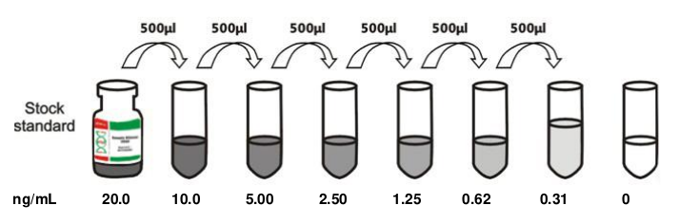Figure 1:

A curve is plotted with serial standard dilutions log graph, plotting the mean absorbance for each standard on the X-axis against the concentration on the Y-axis and draw a best fit curve through the points on the graph. (Table1 & Fig.2 )

Table 1: *optical density fo r standard dilutions*

|  |  |  |  |  |  |  |  |  |
| --- | --- | --- | --- | --- | --- | --- | --- | --- |
| Concentration ng/mL | 20 | 10 | 5 | 2.5 | 1.25 | 0.625 | 0.312 | 0 |
| OD(absorbance) | 2.622 | 2.36 | 1.63 | 1.048 | 0.658 | 0.4 | 0.258 | 0.06 |

### Calculation of results

The concentration of NTproBNP in the samples is then determined by plotting the OD (optical density) of the samples on the standard curve.

# **Study’s Outcomes**

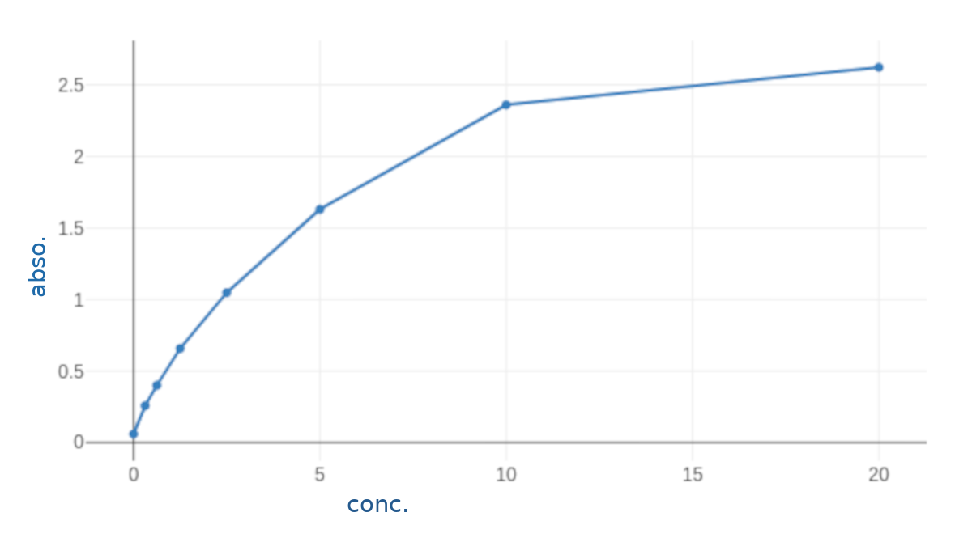Figure 2: standard curve for calculation of NTproBNP results,.

range 0312-20 ng/mL

Primary outcomes:

* low output heart failure (inotropic support at second post-operative day, adrenaline > 50ng/kg/min or dobutamine > 10mcg/kg/minat any time and/or need for intra-aortic balloon pump)

Secondary outcome parameters:

* mortality
* arrhythmias
* perioperative myocardial Infarction
* length of ICU
* length of postoperative hospital stay
* prolonged intubation (Intubation more than 24 hours postoperatively and/or reintubation following planned extubation).

# **Data Analysis and Statistical Methods**

*An Excel spreadsheet was established for the entry of data. We used validation checks on numerical variables and option-based data entry method for categorical variables to reduce potential errors. Data were coded and entered using the statistical package SPSS (Statistical Package for the Social Sciences) version 24. Data was summarized using mean, standard deviation, median, minimum, maximum and interquartile ranage in quantitative data and using frequency (count) and relative frequency (percentage) for categorical data. Comparisons between quantitative variables were done using the non-parametric Mann-Whitney test . Correlations between quantitative variables were done using Spearman correlation coefficient . ROC curve was constructed with area under curve analysis performed to detect best cutoff value of NTproBNP for detection of outcomes. P-values less than 0.05 were considered as statistically significant.*

# Results

# Preoperative demographics and risk factors

*Sixty-five patients were recruited in this study.* The average age was 57.62 ±7.21. Most of the patients were males 56 (86.15%). 10 (15.38%) had diabetes mellitus, 42 (64.62%) were hypertensive and only one had peripheral vascular disease in the form of 70% stenosis of right carotid artery.

Table 2 shows the demographic characteristics and preoperative risk factors of patients included in the study.

Table 2: demographic characteristics[1]* of patients

|  |  |
| --- | --- |
| **Variables** | **Patients (N =65)** |
| **Age in years**   * Mean ±SD * Median (Range) | 57.62 ±7.21  57 (44 -73) |
| **Gender, No (%)** |  |
| * Male | 56 (86.15%) |
| * Female | 9 (13.85%) |
| **Comorbidities, No (%)** |  |
| * DM | 10 (15.38%) |
| * HTN | 42 (64.62%) |
| * Peripheral vascualr disease | 1 (1.54%) |

Figure 3 shows the distribution of preoperative risk factors, while figure 4 is a histogram showing the distribution of age in the study group.

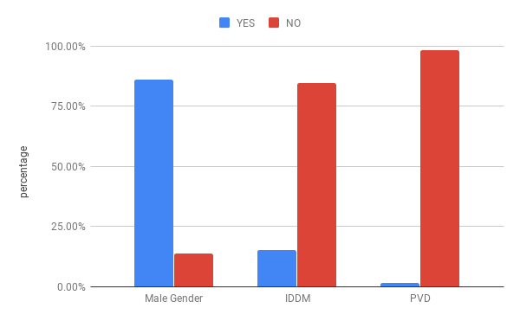Figure 3: Distribution of demographic variables and risk factors

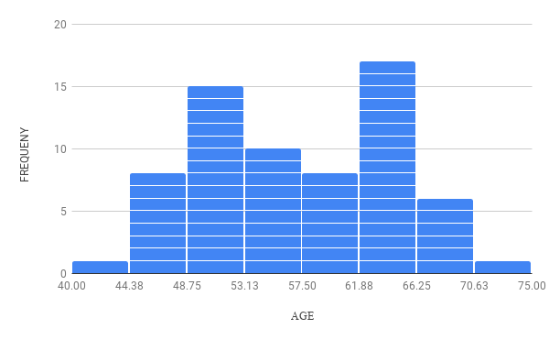Figure 4: Distribution of Age

Table 3 shows that preoperative ejection fraction of patients averaged 50.91±8.13. The calculated EuroscoreII averaged 0.76±0.34. Its median was 0.68 with an interquartile range of [0.55-0.82]. Histograms of their distribution are shown in figures 5 and 6.

Table 3: Measured preoperative ejection fraction and calculated EuroScoreII

|  |  |
| --- | --- |
| **Variables** | **Patients (N=65)** |
| **Ejection Fraction**   * mean ±SD * median(range) | 50.91±8.13  49(40-67) |
| **EuroScore II**   * mean±SD * median(range) * [interquartile range] | 0.76±0.34  0.68(0.50-2.94)  [0.55-0.82] |

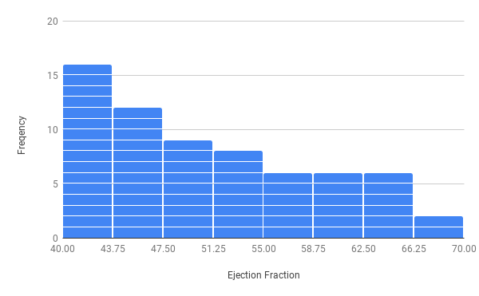Figure 5: Distribution of Ejection Fraction

Figure 6: Distribution of EuroscoreII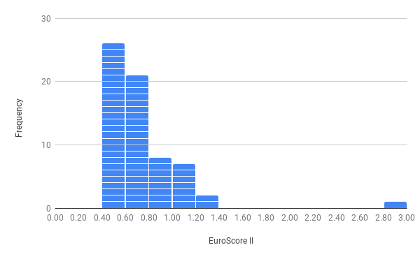

The preoperative NTproBNP levels averaged 312.41± 329.93pg/mL. The median was 160 with interquartile range of [80-397.5]. Table 4 summarizes these data and figure 7 shows a histogram of its distribution.

Table 4: summary of statistical discription of measured preoperative NTproBNP values

|  |  |  |  |  |  |  |  |
| --- | --- | --- | --- | --- | --- | --- | --- |
|  | Mean | *Standard Deviation* | *Median* | *Min* | 1st quartile | 3rd quartile | *Max* |
| NTBNP (pg/mL) | 312.41 | *3*29.93 | *160* | *10* | 80 | 397.5 | *1440* |

Figure 7: Distribution of NTproBNP

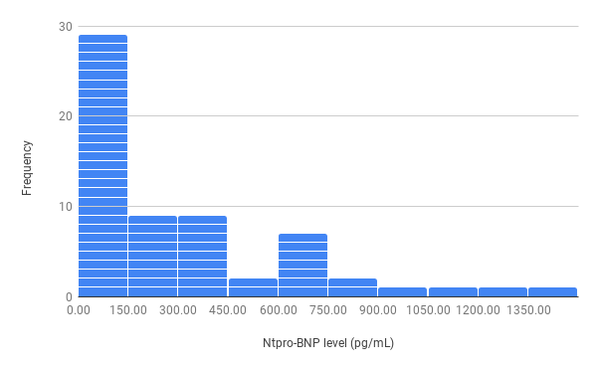

## Postoperative outcomes

Only two patients died; one of sepsis and the other of respiratory failure. Three required prolonged mechanical ventilation, one of whom was due to delayed recovery from anaesthesia (the only patient suffering from such complication). Three suffered recent onset arrhythmia (3 Atrial fibrillation, One Ventricular Tachycardia) during their ICU stay. One patient was re-admitted to the ICU for atrial fibrillation. Five patients had low output heart failure, and four had perioperative myocardial infarction. The mean ICU stay was 3.37±0.84 days and mean hospital stay was 6.38±1.3 ( 3-12) days. Tables 5and 6 summarizes such data and figures 8, 9and 10 show their distibution across the study group.

Table 5: Summary of categorical outcomes

|  |  |  |  |
| --- | --- | --- | --- |
|  |  | **Count** | **%** |
| **low CO** | **yes** | *5* | *7.7%* |
| **no** | *60* | *92.3%* |
| **arrhythmia** | **yes** | *4* | *6.2%* |
| **no** | *61* | *93.8%* |
| **perioperative MI** | **yes** | *4* | *6.2%* |
| **no** | *61* | *93.8%* |
| **prolonged vent** | **yes** | *3* | *4.6%* |
| **no** | *62* | *95.4%* |
| **Delayed Recovery** | **yes** | *1* | *1.5%* |
| **no** | *64* | *98.5%* |
| **mortality** | **yes** | *2* | *3.1%* |
| **no** | *63* | *96.9%* |

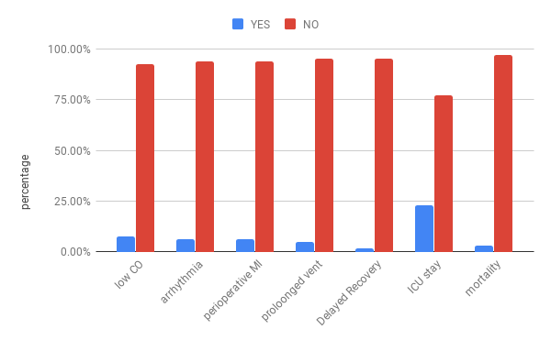Figure 8: Distribution of primary and secondary outcomes

Table 6: Summary of quantitative outcomes

|  |  |  |  |  |  |
| --- | --- | --- | --- | --- | --- |
|  | Mean | Standard Deviation | Median | Minimum | Maximum |
| ICU stay | *3.37* | *0.84* | *3.00* | *2.00* | *7.00* |
| in-hospital stay | *6.38* | *1.33* | *6.00* | *3.00* | *12.00* |

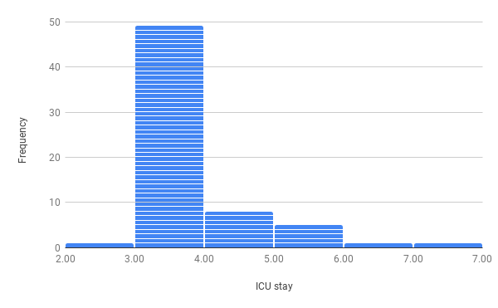  
Figure 9: Distribution of length of ICU stay

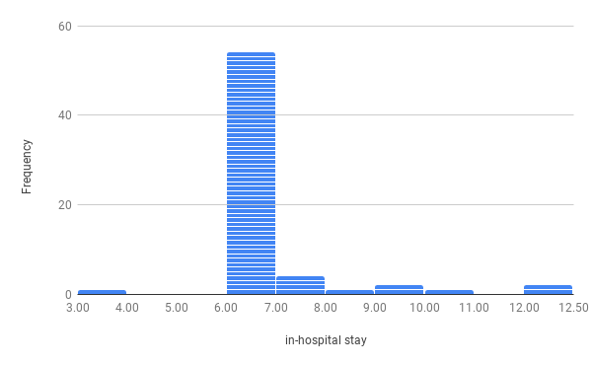  
Figure 10: Distribution of length of in-hospital stay

## Relation between NTproBNP and **study outcomes**

Table 7 shows a comparison between the distribution of measured NTproBNP values in patient with and without low cardiac output. The mean NTproBNP was 490 pg/ml (median 650) in patients who had low cardiac output vs 296.84pg/ml (and 160 pg/ml) for patient who did not. P value was 0.168. ie the results were statistically insignificant.

Table 7: relation between NTproBNP and low cardiac output

|  |  |  |  |  |  |  |  |
| --- | --- | --- | --- | --- | --- | --- | --- |
|  | | **NTproBNP** (pg/mL) | | | | |  |
| **Mean** | **Standard Deviation** | **Median** | **Minimum** | **Maximum** | **P value** |
| **low CO** | **yes** | *490* | *307.97* | *650* | *60* | *750* | *0.168* |
| **no** | *296.84* | *329.75* | *160* | *10* | *1440* |

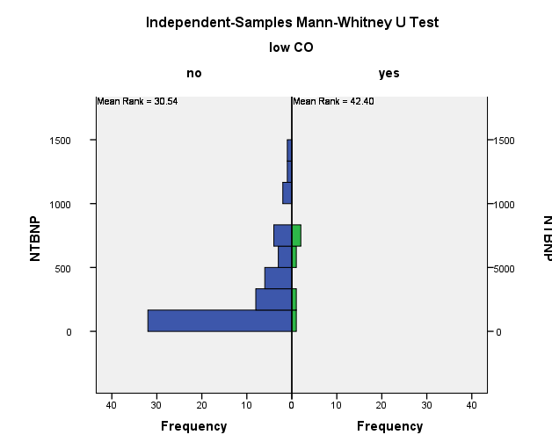

Table 8 shows a comparison between the distribution of measured NTproBNP values in patient with and without postoperative arrhythmia. The mean NTproBNP was 400 pg/ml (median 410) in patients who had postoperative arrhythmia vs 306.37pg/ml (and 160 pg/ml) for patient who did not. P value was 0.462. ie the results were statistically insignificant.

Table 8: disctribution of NTproBNP levels across patient who did and did not develop postoperative arrhythmia

|  |  |  |  |  |  |  |  |
| --- | --- | --- | --- | --- | --- | --- | --- |
|  | | **NTproBNP** (pg/mL) | | | | |  |
| **Mean** | **Standard Deviation** | **Median** | **Minimum** | **Maximum** | **P value** |
| **arrhythmia** | **yes** | *400* | *292.91* | *410* | *60* | *720* | *0.462* |
| **no** | *306.37* | *333.77* | *160* | *10* | *1440* |

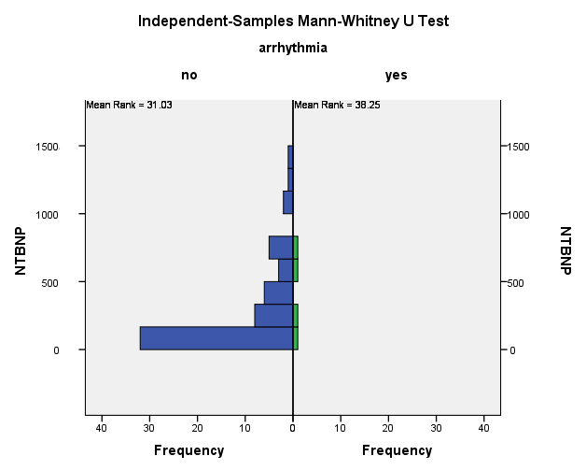

Table 9 shows a comparison between the distribution of measured NTproBNP values in patient with and without perioperative myocardial infarction. The mean NTproBNP was 437.5 pg/ml (median 485) in patients who had MI vs 303.79pg/ml (and 160 pg/ml) for patient who did not. P value was 0.397. ie the results were statistically insignificant.

Table 9: distribution of NTproBNP levels across patients who did and did not suffer perioperative mycardial infarction

|  |  |  |  |  |  |  |  |
| --- | --- | --- | --- | --- | --- | --- | --- |
|  | | **NTproBNP** (pg/mL) | | | | |  |
| **Mean** | **Standard Deviation** | **Median** | **Minimum** | **Maximum** | **P value** |
| **perioperative MI** | **yes** | *437.5* | *326.22* | *485* | *60* | *720* | *0.397* |
| **No** | *303.79* | *331.23* | *160* | *10* | *1440* |

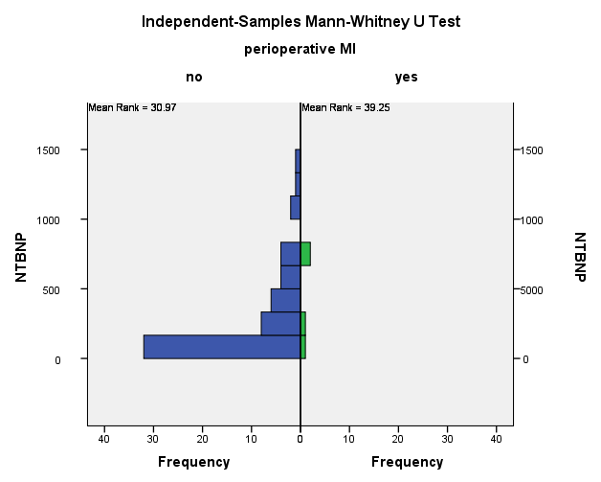

Table 10 shows a comparison between the distribution of measured NTproBNP values in patient did and didn’t require prolonged mechanical ventilation. The mean NTproBNP was 550 pg/ml (median 660) in patients who required prolonged mechanical ventilation vs 300.33pg/ml (and 160 pg/ml) for patient who did not. P value was 0.121. ie the results were statistically insignificant.

Table 10: distribution of NTproBNP levels across patients who did and did not require prolonged mechanical ventilation

|  |  |  |  |  |  |  |  |
| --- | --- | --- | --- | --- | --- | --- | --- |
|  | | **NTproBNP** (pg/mL) | | | | |  |
| **Mean** | **Standard Deviation** | **Median** | **Minimum** | **Maximum** | **P value** |
| **proloonged vent** | **yes** | *550* | *244.33* | *660* | *270* | *720* | *0.121* |
| **no** | *300.33* | *330.69* | *160* | *10* | *1440* |

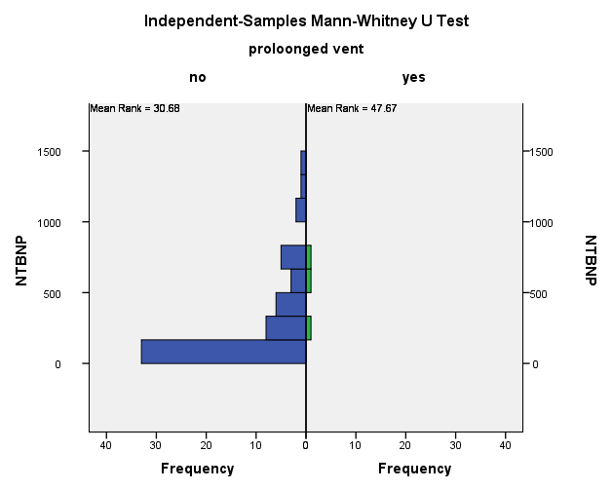

Table 11 shows a comparison between the distribution of measured NTproBNP values in patient with and without delayed neurological recovery. Only one patient suffered of such complication with NTproBNP 1030pg/mL vs 300.65 pg/ml (and median 160 pg/ml) for patient who did not. P value was 0.129. ie the results were statistically insignificant.

Table 11: distribution of NTproBNP levels across patients who did and did not suffer delayed neurological recovery

|  |  |  |  |  |  |  |  |
| --- | --- | --- | --- | --- | --- | --- | --- |
|  | | **NTproBNP** (pg/mL) | | | | |  |
| **Mean** | **Standard Deviation** | **Median** | **Minimum** | **Maximum** | **P value** |
| **Delayed Recovery** | **yes** | *1030* | *-* | *1030* | *1030* | *1030* | *0.129* |
| **no** | *300.65* | *319.29* | *160* | *10* | *1440* |

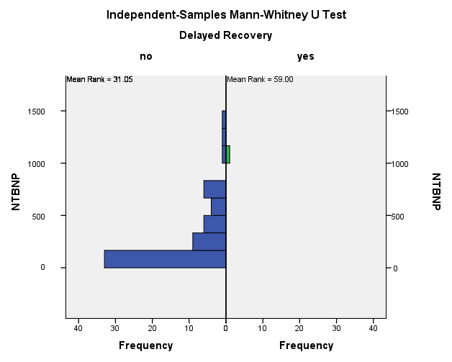

Table 12 shows a comparison between the distribution of measured NTproBNP values in patients who survived till discharge and those who died before discharge from the hospital. The mean NTproBNP was 495 pg/ml (median 495) in patients who died vs 306.33pg/ml (and 160 pg/ml) for patient who did not. P value was 0.306. ie the results were statistically insignificant.

Table 12: distribution of NTproBNP levels across patients who did and did not die before discharge from the hospital

|  |  |  |  |  |  |  |  |
| --- | --- | --- | --- | --- | --- | --- | --- |
|  | | **NTproBNP** (pg/mL) | | | | |  |
| **Mean** | **Standard Deviation** | **Median** | **Minimum** | **Maximum** | **P value** |
| **Mortality** | **yes** | *495* | *318.19* | *495* | *270* | *720* | *0.306* |
| **No** | *306.33* | *331.15* | *160* | *10* | *1440* |

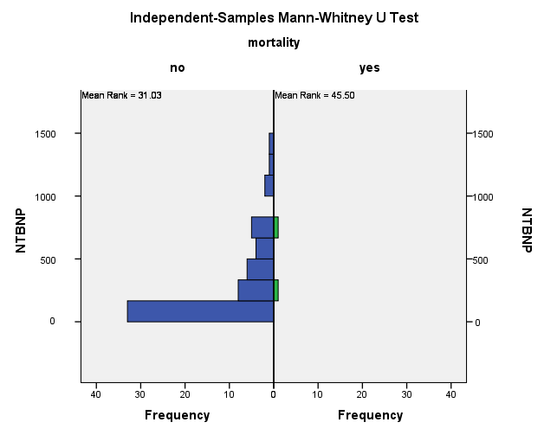

Table 13 shows that there was poor correlation between NTproBNP and length of ICU stay and hospital stay, as the correlation coofficient for NTproBNP and ICU stay was -0.02 and for NTproBNP and hospital stay, it was -0.017.

Table 13: correlation between NTproBNP and continuous outcome variables

|  |  |  |
| --- | --- | --- |
|  |  | **NTBNP** |
| **ICU stay** | **Correlation Coefficient** | *-.022-* |
| **P value** | *0.861* |
| **N** | *65* |
| **in-hospital stay** | **Correlation Coefficient** | *-.017-* |
| **P value** | *0.896* |
| **N** | *65* |

# Discussion

A lot of studies have investigated the value of perioperative BNP12345 and NTproBNP4678910111213141516 in predicting the prognosis and outocome of cardiac surgery. Yet the studies are very heterogenous in design: the peptide used, the time and frequency of sampling, the clinical end-points, the duration of follow-up .. etc., and results.

The aim of our study was to investigate the value of pre-operative natriuretic peptides in predicting clinical outcomes following off-pump coronary artery bypass grafting. We’ve chosen NTproBNP over BNP because it is accepted to be more biochemically stable than BNP. It can be drawn into glass or plastic tubes and does not require an addition of protease inhibitors such as EDTA. NTproBNP can be drawn into serum, heparin plasma, or EDTA. The intra-individual, day-to-day biologic variation in stable HF patients is about 38% for BNP and 28% for NTproBNP; in patients without HF17.

Steady-state levels of NT-proBNP are as much as four-to six-fold higher than BNP12. [Cuthbertson et al., 2009]10 assumed that a conversion factor of four to one between NT-proBNP and BNP is appropriate in the NTproBNP range < 400pg/mL (according to local data in their lab, n=735, Pearson’s correlation coefficient=0.82, P,0.001). [Chen et al., 2013]4 used in their study both BNP and NTproBNP with pre-operative levels 103.8±184pgmL and 621.3±1050.7pg/mL, suggesting a factor of conversion aournd six. While this might not result in accurate estimates under all conditions and in all levels, it is helpful to keep that in mind while comparing different studies using different peptides.

We decided to exclude from the study population patients with factors that may influence NTproBNP levels and the post-operative morbidity. Thus extremes of age, morbid obesity, severe chronic obstructive pulmonary disease, renal impairment, ejection fraction < 40%, pre-operative artrial fibrillation and NYHA III/IV were among the exclusion criteria.

Our study showed no significant differences in NTproBNP between patients with and without post-operative myocardial infarction. This is similar to reports by [Eliasdottir et al., 2008]9 (N=135), [Schachner et al., 2010]11 (N=819) and [Akhmedova et al., 2020]16(N=28[2]). [Attaran et al., 2009]1 (N=141) also showed similar results but, they used BNP in their study. Post-operative myocardial infarction is likely caused by intra-operative variables and are thus not captured by pre-operative natriuretic peptide levels.

Both our study and [Schachner et al., 2010]18 showed no significant differences in NTproBNP between patients with and without neurological complications. To our knowledge these are the only studies that looked into such relation.

This may be due to the fact that despite cerebrovascular events and coronary artery disease sharing common etiology, other factors, such as aortic calcification and intraoperative hemodynamics heavily influence the incidence of post-operative cerebral infarctions, and these can’t be reflected in pre-operative natriuretic peptide levels.

Our study showed no siginificant correlation between pre-operative NTproBNP and ICU stay (correlation coeffecient r=0.22, p=0.861). This is in accordance with [Chen et al., 2013]4 , who found no significant pre-operative BNP and NTproBNP in patients with ICU stay >4 days, in a population very similar to ours; [Öztekin et al., 2017]13 (N=51), who found no signicant differences in ICU stay duration among patients with low (<100pg/mL), moderately elevated (between 100 and 500 pg/mL) and high (> 500pg/mL) NTproBNP levels. [Akhmedova et al., 2020]16 also found no significant differences in ICU stay between patients with pre-operative NTproBNP more and less than 430 pg/L (the cutoff determined by [Schachner et al., 2010]11 for 30-day mortality).

[Fellahi et al., 2011]2(N=208) who found that ‘[pre-operative BNP levels] *descrimination to predict a prolonged length of stay in the ICU was of ... limited value’* since their reciever operator characteristics curve ROC analysis for ICU stay > 4 days had an area under curve AUC of 0.6 (CI 0.49-0.71, p=0.036) denoting poor diagnostic performance.

[Jogia et al., 2007]7 (N=118) reported some statisically significant correlation with pre-operative NTproBNP and length of stay in ICU. This might be due to the fact that they have included in their study patients with EF< 35% (11% of their patients), patients with NYHA III/IV (76.2%) and valve surgery patients (21.1%) while these were exclusion criteria in our study. This was reflected on the NTproBNP levels in both studies. eg. their aortic valve replacement AVR patients had levels 584±305pg/mL and the combined procedure patients had levels of 1057±796pg/mL (they didn’t report the values for the whole population), while these were 312.4±329.9pg/mL in our patients.

Also they 7 reported ICU stay as 27±18hr, meaning that patients were allowed to stay at ICU for less than a day. By contrast, the centers in which we performed our study would routinely admit patients in the ICU for at least 2 post-operative days. This might have allowed their data to reflect more precisely the time needed for the patient in the ICU.

It is also important to notice that the numbers they reported were modest (r=0.59, p=0.001 and area under ROC cuve of 0.66). In fact they described them as ‘not strong enough to be clinically useful predictors’.

[Eliasdottir et al., 2008]9  also reported predictive value for NTproBNP on post-operative ICU stay. This might be due to patients’ baseline characteristics. 32% of their patients had valve surgery with or without cornary artery bypass grafting CABG, and they had a mean logistic euroSCORE of 8.15% while our patinets had EuroScoreII of 0.76.[3]* Mean pre-operative NTproBNP level for their cohort was 1223 pg/mL and the mean for patients with prolonged ICU stay was even higher (3118 pg/mL), way outside the whole range of NTproBNP level in our study [10-1440 pg/mL].

Also the value they provided for accuracy indices (with sensitivity 82%, specificity 69% and area under ROC curve of 0.82) are not derived from ROC analysis for prolonged ICU stay alone, nor are the significant differences in levels of NTproBNP, but are actually for ‘*ICU stay > 2days and/or death*’ which may have augmented and over-estimated those indices.

[Cuthbertson et al., 2009]10 (N=1010) also reported pre-operative NTproBNP levels to be predictive of prolonged ICU stay. Again characteristics of studied population differes greatly. 12.5% of the patients had EF < 40%, 11.5% NHYA III/IV, 28% had valve surgery with or without CABG and 12.5% had pre-operative intra-aortic ballon pump IABP. Pre-operative NTproBNP median(inter-quartile range IQR) were for patients who didn’t die 279(119-833) pg/mL, in patients who died 624(190-1368) pg/mL and in patients with severe systolic dysfunction 818(565-9098) pg/mL. In our study those were 160(80-397.5).

They 10 defined prolonged ICU stay as longer than a day, so the same argument as with [Jogia et al., 2007]7 applies here. Also the the numbers [Cuthbertson et al., 2009]10  provided for the predictive performance of NTproBNP for prolonged are actually very weak (odds ratio OR 1.03(1.01-1.05) as per 250pg/mL increase in NTproBNP). Indeed, they10 concluded that ‘*NTproBNP levels predict early outcome after cardiac surgery*’ and that ‘*it appears to be independent of other widely utilized methods of risk stratifications’. Yet they noted that ‘the predictive utility is modest’* and *‘its clinical validity is moderate due to its modest sensitivity and specificity it demonstrates for the outcome’.*

[Schachner et al., 2010]18 reported statistically significant difference in ICU stay in patients who had NTproBNP levels >502pg/mL, 22(12-1919)h; vs NTproBNP <502pg/mL, 22(7-1268); p=0.001. That number, 502pg/mL; is the cutoff levels derived from their ROC curve analysis for long-term mortality. Despite the authors’ note that ‘In general, those patients exhibited a higher rate of comorbidities, resulting in an increased risk score’, they didn’t provide any multivariable analysis to determine whether NTproBNP is and independent factor for prolonged ICU stay.

Moreover, while they18 only included in their study patients undergoing isolated CABG; many differences still exist between our patients. Their patients were as old as 89 yrs, had creatinine levels spanning 0.5-6.2mg/dL, 17% had urgent operations and they had a logarithmic EuroSCORE of 2.5[1-63] resulting in NTproBNP levels [6-65998 pg/mL].

[Liu et al., 2013]12 (N=225) reported that ‘*preoperative NT-proBNP was closely related to … length of stay in ICU (P = 0.004)’* but the correlation is actually weak (r=0.194). Thier study included 128 patients with NHYA III/IV and NTproBNP levels were 728.4(213.5-2551). length of ICU stay was 3.45 ± 8.17 days in their study vs 3.37±0.84 days in our study.

The fact that inclusion of valve surgery can dramatically alter the diagnostic performance of pre-opreative natriuretic peptide is most clearly shown in [Fellahi et al., 2012]3 (N=189). In there first study [Fellahi et al., 2011]2 , in which only 45% of the patients had isolated CABG; they revealed good diagnostic performance of pre-operative BNP for predicting MACEs/death: AUC 0.76 (CI 0.68-0.85, p<0.001), sens. 0.77, spec. 0.75)

This was further confirmed in their second study [Fellahi et al., 2012]3 where they included 100 CABG and 89 AVR patients. Again ROC curve analysis of pre-operative BNP revealed AUC of 0.67 (p= 0.002) for predicting MACEs.

However, when they re-analysed the data after dividing the patients into two groups, CABG group and AVR group; preoperative BNP levels were significantly different between the groups (CABG 104 [8-5,017] pg/mL vs AVR 235 [8-2,018] pg/mL, p<0.001) despite other demographic data (including renal functions, EF and BMI) being comparable, and preoperative values of BNP were more accurate in predicting MACEs after AVR (area under ROC 0.78 for pre-op BNP, p<0.001), whereas no *significant* discrimination was found for BNP values in predicting long-term adverse cardiac outcome after *CABG surgery* (area under ROC 0.54, p=0.32).

Also [Attaran et al., 2009]1 found significant differences in pre-operative BNP levels in patients undergoing AVR/MVR vs CABG (273 vs 125pg/mL, p=0.0018). And [Cuthbertson et al., 2009]10, according to multivariable analysis of pre-operative variables affecting mortality, valve/aortic surgery±CABG had OR 3.38 (1.60 – 7.12) p= 0.001. In their 10 regression models, valve/aortic surgery was an independent factor predicting hospital stay > 1week with OR 1.67(1.19-2.35) p=0.003.

Our study showed no significant differences in NTproBNP between patients with and without post-operative atrial fibrillation AF. This is similar to reports by [Jogia et al., 2007]7, and [Attaran et al., 2009]1.

[Cuthbertson et al., 2009]10 reported an odds ratio of 1.02(1-1.03) per 250pg/mL increase in pre-operative NTproBNP and the development of post-operative AF (p=0.02). Apart from the fact that the value itself is of very poor diagnostic performance, the 95% confidence interval CI included 1, undermining its statistical significance.

Other studies236 report AF as part of a composite endpoint in the form of ‘cardiac complications’ or ‘major adverse cardiac events’ so these can’t be fairly compared.

Another matter worth discussing is the incidence of AF in our study. While the incidence of post-cardiac surgey AF is reported to be as high as 35%19, only 4 (6.2%) of our patients developed post-operative AF. This is likely due to the lower risk factors found in our patient (patients with pre-operative AF, valvular disease and severe COPD were excluded from our study). Our patients were relatively young with good EF (mean age 57.62, EF 50.9). All had their beta-blockers on the morning of surgery and resumed them on the second post-operative day. In fact, [Chen et al., 2013]4 reported even lower incidence of ‘new onset arrhythmia’ 3/76 patients (3.9%), in a population similar to ours.

Our study showed no significant differences in NTproBNP levels in patients who required or not prolonged mechanical ventilation >24hr (300 vs 550pg/mL, p=0.121). [Öztekin et al., 2017]13 and [Akhmedova et al., 2020]16 found no significant difference in ventilation time in patients with high vs low NTproBNP levels. Similarly [Sindhvananda et al., 2019]15 found no significant differences in NTproBNP (pre-operative, at time of weaning, or the difference between both levels) in patients who had simple, difficult, or prolonged weaning. Area under ROC curve for predicting difficult, prolonged weaning an need for re-intubation were 0.59, 0.62, and 0.58 respectively.

This is in contrast to [Liu et al., 2013]12 and [Jogia et al., 2007]7 who reported ‘good’ correlation between ventilation time and NTproBNP levels. Yet the coefficients they calculated are rather modest, (r=0.177, p=0.009) and (r=0.46, p=0.015) respectively. [Cuthbertson et al., 2009]10 also reported weak performance of NTproBNP in predicting the need for mechanical ventilation >24hr postoperative (OR=1.03).

[Schachner et al., 2010]18 also reported significant differences in time on mechanical ventilation in patinets with NTproBNP levels more than and less than 502pg/mL (the cutoff level for predicting mortality in their study) 8(0-1900)hr vs 8(0-767)hr, p=0.005. This is likely due to the differences already mentioned between our study populations in demographics and NTproBNP levels.

[Attaran et al., 2009]1 claimed that higher BNP levels predict, among other outcomes; longer ventilation time but, they mention neither quantitative nor qualitative values for it in their text, tables or figures, so we can’t really comment on it.

Thus, earlier studies showed significant, but weak correlation between pre-oeprative natriuretic peptides and ventilation time, while more recent studies seem to lack that finding. While one can argue that [Öztekin et al., 2017]13(N=51) and [Akhmedova et al.,2020]16(N=28) had very had very small number of patients in their studies, this can’t be said of [Sindhvananda et al., 2019]15 who included a number (N=135) comparable to other studies e.g. Jogia7 (N=118), Attaran1 (N=141). One can speculate that since the correlation was weak to begin with, even minor improvements in mechanical ventilation technologies and protocols might have rendered it invalid.

Our study showed no significant differences in NTproBNP levels in patient who did or didn’t die. This is similar to what [Jogia et al., 2007]7 reported in their study. This might be due to the very low mortality count in our study (2/65 patients) and Jogia’s7 (2/118). Also most of the other studies were looking into correlations with 1month mortality 91810125 or long-term1814 mortality, whereas we were looking into in-hospital mortality.

In contrast [Eliasdottir et al., 2008]9 who found significant difference in NTproBNP levels in patients with 28-day mortality 2184pg/mL vs 1163pg/mL (p=0.001) in patients who survived. [Cuthbertson et al., 2009]10 reported for 30-day mortality OR 1.03 per 250pg/mL increase in NTproBNP level.

[Liu et al., 2013]09 (N=225) found in their ROC curve analysis for prediction of 30 day mortality (4.89% in their study) the best cutoff of pre-operative NTproBNP to be 2773.5 pg/mL, a level that is totally outside the range of NTproBNP levels found in our study. This level was associated with sensitivity of 63.6% and specificity of 80.8%. AUC was 0.738 (95% CI 0.58-0.89, p=0.008).

[Schachner et al., 2010]18 (N=819) found that NT-proBNP >502pg/mL[4]* predicted overall (they followed patients survival for 3 years) mortality(p<0.001). Multivariate analysis identified NTproBNP as an independent risk factor for mortality, OR = 3.079 (CI =1.149-8.247), p = 0.025. That 502 pg/mL cutoff was determined by the ROC analysis for overall mortality. The authors never stated the area under the curve but the sensitivity (66.7%) and the specificity (63.9) could be read from the figure they provided.

Recently, two large studies145 looked into the predictive performance of pre-operative natriuretic peptides on mortality, in comparison with EuroSCORE II. [Brynildsen et al., 2018]14 (N=640) found that pre-operative NTproBNP >1170 pg/mL predicted with sensitivity 66%, specificity 73% and area under ROC curve 0.73, while EuroSCORE II had an area under ROC curve 0.74. Combining EuroSCORE II and NTproBNP had an area under ROC curve 0.76.

[Suc et al., 2020]5 (N=4980) found poor performance of pre-operative BNP in predicting mortality with area under ROC curve 0.66 compared to EuroSCORE II which had area under ROC curve 0.82. In univariate analysis, BNP was associated with mortality with an unadjusted OR of 1.06 (1.03–1.09), p-value < 0.001 (per 1,000 unit-increase). In a multivariable analysis, however, BNP was not associated with mortality anymore.

The differences between the performance of natriuretic peptides in the two studies might be explained by the duration of follow-up. While [Suc et al., 2020]5 were looking into in-hospital mortality, [Brynildsen et al., 2018]14 were looking into long-term mortality (961 days of follow-up). This is also explained the better performance of EuroSCORE II in [Suc et al., 2020]5 since it is actually designed and calibrated for in-hospital mortality. Also, [Brynildsen et al., 2018] had more patients with NYHA III/IV (62% vs 21.6%), and less elective surgeries (59.2% vs 81.2%).

Our study showed no significant differences in NTproBNP levels in patients who did or didn’t developed post-operative low output heart failure. This was defined as inotropic support at second post-operative day, adrenaline >50ng.kg-1.min-1 or dobutamine > 10µg.kg-1.min-1 at any time and/or need for intra-aortic balloon pump. This is because many of our surgical and anaesthesia teams would use “low dose” inotropic support routinely for at least 12 hours post-operatively. Since no patient in our study needed IABP, this can be considered synonymous with need for inotropic support.

Similarly [Öztekin et al., 2017]13 found no differences in inotropic support among patients with low, moderately elevated and high pre-operative levels of NTproBNP in throughout a post-operative 3-day period. This is despite having relatively equal numbers in the three groups (15 in low, 15 in moderate and 21 in high groups), and having relatively wide range of NTproBNP levels [20.6-7249 pg/mL].

[Jogia et al., 2007]7 found significant, but modest correlation pre-operative NTproBNP and total perioperative noradrenaline dose (r=0.55, p=0.003). That correlation was ‘not useful as a predictor with the error of calssification almost 50%’.

[Cerrahoglu et al., 2007]20 (N=52) found significantly higher number of patients requiring inotropic support and significantly higher doses (P<0.05) in the group with NTproBNP>220pg/mL than the group with NTproBNP < 220pg/mL. Moreover NTproBNP levels were 886.25±655.26 pg/mL in patients requiring inotropes vs 183.07±224.97 pg/mL in those not requiring inotropes (p<0.001). Those findings are very different from ours, depsite the cohorts being similar. This might be attributed to our definitions of inotropic support ( Our defenition and the explanation for its adoption has been discussed before.). They accounted for use of inotropes at any time within 16 hours postoperative. In fact they gave very detailed discription of the hemodynamic parameters of the patients, obtained by Swan-Ganz catheter. This no doubt reflected the true inotropic requirements for patients in their study. Actually, the durations of inotropic support are short 0.46±1.13h and 5.92±6.4h in both groups of the study. It is worth noting that no multivariate analysis was done, so it is not known whether NTproBNP was an independent factor or it was the EF and other pre-operative factors that caused such effects. The cutoff used in their study is simply the median level in their cohort, it was not decided according to ROC curves, nor did they give any accuracy indices for the predictive performance of pre-operative NTproBNP.

[Eliasdottir et al., 2008]9 found significant differences in NTproBNP levels in patients who required inotropic support and those who didn’t (2628 pg/mL vs 548 pg/mL, p<0.001). Area under ROC curve was 0.84, sensitivity 79% and specificity 75% at cutoff 376pg/mL. [Attaran et al., 2009]1 also found significant differences in BNP levels in patients requiring inotropes and/or IABP (452 vs 120 pg/mL, p=0.0015).

[Cuthbertson et al.,2009]10 (N=1010) found NTproBNP to be predictive of need for inotropic support with an odds ratio of 1.03.

While [Krzych et al., 2011]21 report no significant correlation between NTproBNP and low cardiac output syndrome, they didn’t define it and the numbers challenge a classical textbook definition of it. They report that 9% of their patients had low cardiac output syndrome, 7% needed IABP, while 61% needed inotropic support.

However, they report good diagnostic performance of pre-operative NTproBNP on the need for inotropic support according to ROC curve analysis. These were further categorised according to the inotropic agent used. For the need of any inotropic drug area under ROC curve was 0.73(p<0.001), sensitivity 55.7%, specificity 82.1% at cutoff 684pg/mL. The numbers were similar for dopamine (the inotropic agent they used the most, but they didn’t declare any protocol for their inotrope choice). For adrenaline area under ROC was 0.69(p=0.04), sensitivity 70% specificity 75.6% at cutoff 1032pg/mL. For milrinone area under ROC was an excellent 0.92(p<0.001), sensitivity 100%, specificity 85.7% at cutoff >1340pg/mL, but there were only two patients in their study that required its use. Also notice the cutoffs compared to our NTproBNP levels median(IQR) 160(80-397.5).

[Akhmedova et al., 2020]16 found significant difference in inotropic requirement between patients with NTproBNP more than and less than 430pg/mL. Further they found good correlation between pre-operative NTproBNP level and post-operative inotropic needs (r=0.62).

Similar to our study [Öztekin et al., 2017]13 found no significant difference between patinets with low and high levels of NTproBNP in ICU or hospital stay, duration of intubation and need for inotropes. His study had relatively low number of patients (N=51), but the levels of NTproBNP were wide [20.6-7249 pg/mL, mean 920.6±1497.1].

[Hamed et al., 2019]22 measured in their study pre and post-operative NTproBNP levels. They found positive correlation between post-operative NTproBNP levles and many of the clinical outcome, However, they didn’t mention whether or not those outcomes correlated with pre-operative levels. Whether this mean that they didn’t find significant correlation with pre-operative levels, or they only performed the calculations on post-operative levels only is not clear.

The study most similar to ours is that by [Chen et al., 2013]4. In their study, average age was 64±10.2yr, 85.5% were males and EF was 61±11.2 in pre-operative evaluation. These were: age 57.62±7.21, male 86.15%, EF 50.9±8.13 in our study. Like in our study they report higher, but non-significant levels of pre-operative NTproBNP in patients with prolonged ICU stay, prolonged hospitalization and major complications. They stated that ‘Because elective CABG surgery was a prerequisite for enrollment … our preoperative BNP and NT-proBNP concentrations were lower than those in previous studies. This may explain why preoperative BNP and NT- proBNP are not significantly associated with outcomes.’4

# Conclusion

BNP is produced in both atria and ventricles, and is upregulated in failing ventricular myocardium in response to increased myocardial stretch and wall stress, together with the inactive byproduct N-terminal-proBNP (NTproBNP)23.

Changes in hemodynamic parameters and plasma NPs levels are closely related in patients with cardiovascular diseases.The NPs system activation is modulated also by the activity of the counteregulatory neurohormonal system. Consequently, even very small changes in hemodynamics may produce significant variations in plasma concentrations of NPs24.

The physiologic actions natriuretic peptides reduce cardiac preload and afterload to counteract the detrimental effects of pressure and volume overload seen in HF. These physiologic processes are counter-regulatory to the detrimental neurohormonal activation of the sympathetic nervous system and RAAS in HF and are why ANP and BNP levels reflect HF severity25.

BNP concentrations were found to be independent risk markers for morbidity and mortality in patients with heart failure. In some studies NPs levels were stronger predictors of mortality and/or major cardiovascular events than left ventricular EF, NYHA class26.

Several clinical trials have measured BNP or NTproBNP in patients presenting with acute coronary syndrome and consistently found that elevated NP values revealed important prognostic information27.

In patients undergoing cardiac surgery, accurate risk adjustment is of paramount importance for clinical audit, benchmarking and research and to identify high-risk patients that may benefit from prophylactic interventions to reduce post-operative adverse outcomes. Although many existing clinical prognostic models such as EuroSCORE are very useful, further refinement, update or recalibration are needed to maintain their utility. Most of these clinical prognostic scores for cardiac surgery are only useful in predicting mortality but not adverse events such as AF or cardiogenic shock requiring IABP. The strength of associations between pre- operative natriuretic peptide levels and adverse outcomes after cardiac surgery varied between different studies28.

Our study didn’t show significant correlation between pre-operative NTproBNP and post-operative heart failure, arrhythmias, perioperative myocardial infarction, length of ICU stay, prolonged intubation, hospital stay or mortality. This is likely due to the low incidence of complications and low NTproBNP levels secondary to the predicted favorable outcomes in our patients given that they had very low risk factor.

However, through reviewing other studies we’ve come to the conclusion that pre-operative NTproBNP can’t predict post-operative neurological complications11 and peri-operative myocardial infarction9111. This is likely because they are more dependent on intra-operative variable that can’t be captured by pre-operative natriuretic peptide levels.

Pre-operative natriuretic peptides has moderate to weak1012 correlation with different post-operative variables. Their diagnostic performance on predicting MACEs236 and/or mid to long-term mortality is better and more consistent across studies than with individual outcome variables. Diagnostic accuracy indices suggest that natriuretic peptides are better used as exclusion tests (low positive predictve value vs good negative predictive value).

Whether or not pre-operative natriuretic peptides are independent predictors of poor outcome has also been inconclusive. And while this is valid research questions, it might be of less clinical importance.

Predictive performance is better in valvular surgery than in CABG3 this is likely because post-operative outcome is more affected by intra-operative variables (eg. ischemia and myocardial protection) in coronary surgery.

The predictive value of natriuretic peptides on length of ICU stay and post-operative inotropic support might be of more clinical value in centers that adopt fast-track protocols.

# Summary

B-type natriuretic peptide BNP is produced in both atria and ventricles, and is upregulated in failing ventricular myocardium. In response to increased myocardial stretch and wall stress, ventricular myocytes secret the pro-hormone pre-proBNP, which is then cleaved into biologically active BNP and the inactive byproduct N-terminal-proBNP (NTproBNP) 23. BNP and NTproBNP are secreted in equimolar quantites into the circulation. BNP has a serum half-life of 20 minutes, whereas NTproBNP has a half-life of 120 minutes29.

Circulating natriuretic peptides NPs acts as an antagonist of the renin angiotensine aldosterone system, inducing diuresis, natriuresis, vascular dilatation and inhibition of the sympathetic nervous system 30. These actions reduce cardiac preload and afterload to counteract the detrimental effects of pressure and volume overload and detrimental neurohormonal activation of the sympathetic nervous system and RAAS in HF. 25 Consequently, it is likely that very small changes in hemodynamics, not assessable by echocardiographic examination, may produce significant (and measurable) variations in plasma concentrations of NPs 24.

Studies suggest that the NPs level may be useful as a prognostic marker in HF and acute coronary artery syndromes. NPs concentrations were found to be independent risk markers for morbidity (increased future major cardiovascular events and/or hospitalization) and/or mortality in patients with acute /chronic HF. In some studies NPs levels were stronger predictors of mortality and/or major cardiovascular events than left ventricular EF, NYHA class, and/or presence of diabetes or hypertension, as well as sex and age in patients with chronic HF. 31

In patients hospitalized for acute exacerbation of heart failure (with reduced or preserved ejection fraction), elevated BNP correlated with increased in-hospital mortality and there was a direct relationship between quartiles of BNP concentration and mortality even after adjusting for multiple confounders including age, gender, vital signs, renal function, and sodium. 32

In heart failure patients, plasma NTproBNP concentrations were related to outcomes, including all-cause death, cardiovascular admission, and HF deaths/HF admissions. NTproBNP was the strongest independent predictor of outcomes at 3 years of follow-up 33. Failure of NP levels to decrease during an HF hospitalization while undergoing treatment is associated with worse prognosis in NYHA class III to IV HF 34. A baseline serum BNP level greater than 130 pg/mL in ambulatory patients with EF less than 35% predicts higher rates of sudden cardiac death. 35

Coronary heart disease is the main cause of morbidity and mortality in developed countries and the prevalence is increasing in developing countries. Studies have reported biomarker clusters which are associated with coronary heart disease. The assessment of these biomarkers, alone or in combination, may improve the long-term prediction of mortality of first major cardiovascular event to conventional risk markers. 36

Both BNP and NTproBNP have been shown to be predictive of adverse outcomes independent of other biomarkers, including the cardiac troponins in patients with coronay artery disease. 27

Elevated levels of BNP and NT pro-BNP have been shown to be associated with adverse outcomes in a number of settings, including patients undergoing major non-cardiac surgery. The strength of associations between pre- operative natriuretic peptide levels and adverse outcomes after cardiac surgery varied between different studies 37.

The aim of our study was to investigate the value of pre-operative natriuretic peptides in predicting clinical outcomes following off-pump coronary artery bypass grafting. We’ve chosen NTproBNP over BNP because it is accepted to be more biochemically stable than BNP and can be drawn into glass or plastic tubes and does not require an addition of protease inhibitors such as EDTA.

In order to minimize influence from other factors that may contribute to poor post-operative outcomes, we decided to exclude from the study patients at extremes of age, and patients with morbid obesity, severe chronic obstructive pulmonary disease, thyroid disturbances, renal impairment, ejection fraction < 40%, valvular heart disease, pre-operative artrial fibrillation and NYHA III/IV.

65 patients undergoing elective off-pump coronary artery bypass grafting OPCAB were recruited from 3 cardiothoracic surgery centers. The clinical endpoints were post-operative low output heart failure, in-hospital mortality, arrhythmias, perioperative myocardial Infarction, prolonged intubation, length of ICU, and length of postoperative hospital stay.

The average age was 57.62 ±7.21, ejectoin fraction 50.91±8.13, EuroSCORE II 0.76±0.34. This resulted in low pre-operative NTproBNP levels (median was 160 with interquartile range of [80-397.5] pg/mL), and low rate of complications relative to those found in most studies.

Thus, our study showed no statistically significant correlation with any of the mentioned clinical complications. While comparing this with the body of research on the performance of pre-operative natriuretic peptides in predicting poor post-operative outcome, we noticed some trends. For example, Pre-operative natriuretic peptides can’t predict post-operative neurological complications and peri-operative myocardial infarction , probably because they are more dependent on intra-operative variable that can’t be reflected on pre-operative natriuretic peptide levels.

Pre-operative natriuretic peptides has moderate to weak correlation with different post-operative variables, even in large (N>600) studies5101114. Their diagnostic performance on predicting MACEs and/or mid to long-term mortality is better and more consistent across studies than with individual outcome variables. Diagnostic accuracy indices suggest that natriuretic peptides are better used as exclusion tests (low positive predictve value vs good negative predictive value).

Predictive performance is better in valvular surgery than in CABG this is likely because post-operative outcome is more affected by intra-operative variables (eg. ischemia and myocardial protection) in coronary surgery.

Different researchers came to different conclusions concerning pre-operative natriuretic peptides as independent predictors of poor post-operative outcome. While this is a valid and interesting research question, it might be of less clinical relevance. Altough many existing clinical prognostic models such as EuroSCORE are very useful, most of these clinical prognostic scores for cardiac surgery are primarily useful in predicting mortality. The predictive value of natriuretic peptides on length of ICU stay and post-operative inotropic support was more consistent in centers adopting ‘fast-track’ protocols. An established scoring system for the prediction of morbidity and lengths of stay following cardiac surgeyr will be invaluable in resource allocation. A relatively cheap, simple, reproducible test, like natriuretic peptide measurement, we imagine; will be part of such a scoring system.

References

[1] Maisel and Nicholas Wettersten. Natriuretic peptides in heart failure. Atrial and B-type natriuretic peptides. Heart Failure Clin,2018;14:13-25

[2] Rodseth RN. B-type natriuretic peptide – a diagnostic breakthrough in perioperative cardiac risk?. Anaesthesia,2009;64:165-78

[3] Iwanaga, I Nishi, S Furuichi, T Noguchi, K Sase, and Y Kihara. B-type natriuretic peptide strongly reflects diastolic wall stress in patients with chronic heart failure: comparison between systolic and diastolic heart failure. Journal of American College of Cardiology,2006;47:742-748

[4] Daniels and AS Maisel. Natriuretics peptides. Journal of American College of Cardiology,2007;50:2357–68

[5] Cowie, P Jourdain, A Maisel, U Dahlstrom, F Follath, R Isnard, A Luchner, T McDonagh, J Mair, M Nieminen, and G Francis. . Clinical applications of B-type natriuretic peptide (BNP) testing. Eur Heart J,2003;24:1710-8

[6] Thay-Hsiung C, Ching-Ling L, Joseph JS, James YS, Chung-Huo c, Mei-Ling C and Chih-Hui C. . Plasma B-type natriuretic peptide in predicting outcomes of elective coronary artery bypass surgery. Kaohsiung journal of medical sciences,2013;29:254-258

[7] Hall. NT-proBNP: the mechanism behind the marker. J Card Fail,2005;11:S81-3

[8] Potter. Natriuretic peptide metabolism, clearance and degradation. FEBS J,2011;278:1808-17

[9] Emdin, Passino C, and Prontera C et al. Cardiac natriuretic hormones, neuroormones, thyroid hormones and cytokines in normal subjects and patients with heart failure. Clin Chem Lab Med,2004;42:627–636

[10] Clerico and Emdin. Diagnostic accuracy and prognostic relevance of the measurement of the cardiac natriuretic peptides: a review. Clin Chem,2004;50:33-50

[11] Fonarow, Peacock, Phillips, et al, ADHERE Scientific Advisory Committee, and Investigators. Admission B-type natriuretic peptide levels and in-hospital mortality in acute decompensated heart failure. J Am Coll Cardio,2007;49:1943-50

[12] Komajda, Carson, and Hetzel et al. Factors associated with outcome in heart failure with preserved ejection fraction findings from the irbesartan in heart failure with preserved ejection fraction study (i- preserve). Circ Heart Fail,2011;4:27-35

[13] Cheng, Kazanagra, Garcia, and et al. A rapid bedside test for B- type peptide predicts treatment outcomes in patients admitted for decompensated heart failure: a pilot study. J Am Coll Cardiol,2001;37:386-91

[14] Berger, M Huelsman, K Strecker, A Bojic, P Moser, B Stanek, and R Pacher. B-type natriuretic peptide predicts sudden death in patients with chronic heart failure. Circulation,2002;105:2392-7

[15] Zethelius B, Berglud L, Sundstrom J, Ingelsson E, Basu S, et al.. Use of multiple biomarkers to improve the prediction of death from cardiovascular causes. N Eng J Med,2008;358:2107-2116

[16] Gaggin and James L Januzzi. Natriuretic peptides in heart failure syndrome. Clin Lab Med,2014;34:43-58

[17] Edward Litton and Kwok M. Ho. The use of pre-operative brain natriuretic peptides as a predictorof adverse outcomes after cardiac surgery: a systematic reviewand meta-analysis. European Journal of Cardio-Thoracic Surgery,2012;41:525–534

[18] Richards AM.. N-terminal B-type natriuretic peptide in heart failure. Heart Failure Clin,2018;14:27-39

[19] Suzuki T,Yamazaki T, and Yazaki Y. The role of natriuretic peptides in the cardiovascular system. Cardiovascular Research,2001;51:489-494

[20] Volpe, M Carnovali, and V Mastromarino.. The natriuretic peptides system in the pathophysiology of heart failure: from molecular basis to treatment. Clin Sci,2016;130:57-77

[21] Wu, F Wu, J Pan, J Morser, and Q Wu. Furin-mediated processing of pro-C-type natriuretic peptide. J Biol Chem,2003;278:25847-52

[22] Goetze. Biochemistry of pro-B-type natriuretic peptide-derived peptides the endocrine heart revisited. Clin Chem,2004;9:1503-1510

[23] Charles, TC Prickett, EA Espiner, MT Rademaker, AM Richards, and TG Yandle. Regional sampling and the effects of experimental heart failure in sheep: differential responses in A, B and C-type natriuretic peptides. Peptides,2006;27:62-68

[24] Giannessi, Andreassi MG, and Del Ry S et al.. Possibility of age regulation of the natriuretic peptide c-receptor in human platelets. J Endocrinol Invest,2001;24:8-16

[25] Clerico, Del Ry S, and Maffei S et al.. Circulating levels of cardiac natriuretic hormones in healthy adult subjects: effects of aging and sex. Clin Chem Lb Med,2002;40:371-377

[26] Bruins, MR Fokkema, JW Romer, MJ Dejongste, FP van der Dijs, JM van den Ouweland, and FA Muskiet. High intraindividual variation of B-type natriuretic peptide (BNP) and amino-terminal proBNP in patients with stable chronic heart failure. Clin Chem,2004;50:2052-8

[0] Potter, Andrea R. Yoder, Darcy R. Flora, Laura K. Antos, and Deborah M. Dickey. Natriuretic Peptides: Their Structures, Receptors, Physiologic Functions and Therapeutic Applications. Handb Exp Pharmacol,2009;191:341-366

[27] Pankow, Y Wang, F Gembardt, E Krause, X Sun, G Krause, HP Schultheiss, WE Siems, and T Walther. Successive action of meprin a and neprilysin catabolizes b- ype natriuretic peptide. Circ Res,2007;101:875-882

[28] Belenky, Smith, and Zhang. . The effect of class-specific protease inhibitors on the stabilization of B-type natriuretic peptide in human plasma. Clin Chim Acta,2004;340:163-172

[29] Ng, Geeranavor, Jennings, Loki, and O’Brien. Diagnosis of heart failure using urinary natriuretic peptides. Clin Sci,2004;106:129-133

[30] Rose and WR Giles. Natriuretic peptide C receptor signalling in the heart and vasculature. J Physiol,2008;586:353-366

[31] Ahluwalia, MacAllister RJ, and Hobbs AJ. Vascular actions of natriuretic peptides. cyclic gmp-dependent and -independent mechanisms. Basic Res Cardiol,2004;99:83-89

[32] Fan, Bryan PM, and Antos LK et al. . Downregulation does not mediate natriuretic peptide dependent desensitization of NPR-A or NPR-B: guanylyl cyclase-linked natriuretic peptide receptors do not internalize. Mol Pharmacol,2004;61:1-10

[33] Joubert, Labrecque, and De Lean. Reduced activity of the NPR-A kinase triggers dephosphorylation and homologous desensitization of the receptor. Biochemistry,2001;40:11096-11105

[34] Patel, ML Valencik, AM Pritchett, JC Burnett, JA McDonald, and MM Redfield. Cardiac-specific attenuation of natriuretic peptide a receptor activity accentuates adverse cardiac remodeling and mortality in response to pressure overload. Am J Physiol Heart Circ Physiol,2005;289:H777-H784

[35] Tamura, Y Ogawa, H Chusho, K Nakamura, K Nakao, M Suda, M Kasahara, R Hashimoto, G Katsuura, M Mukoyama, H Itoh, Y Saito, I Tanaka, H Otani, and M Katsuki. Cardiac fibrosis in mice lacking brain natriuretic peptide. . Proc Natl Acad Sci U S A,2000;97:4239-4244

[36] Knowles, G Esposito, L Mao, JR Hagaman, JE Fox, O Smithies, HA Rockman, and N Maeda. Pressure-independent enhancement of cardiac hypertrophy in natriuretic peptide receptor-A deficient mice. J Clin Invest,2001;107:975-984

[37] Langenickel, J Buttgereit, I Pagel-Langenickel, M Lindner, J Monti, K Beuerlein, N Al-Saadi, R Plehm, E Popova, J Tank, R Dietz, R Willenbrock, and M Bader. Cardiac hypertrophy in transgenic rats expressing a dominant-negative mutant of the natriuretic peptide receptor B. Proc Natl Acad Sci U S A,2006;103:4735-4740

[38] Sabrane, MN Kruse, L Fabritz, B Zetsche, D Mitko, BV Skryabin, M Zwiener, HA Baba, M Yanagisawa, and M Kuhn. Vascular endothelium is critically involved in the hypotensive and hypovolemic actions of atrial natriuretic peptide. J Clin Invest,2005;115:1666-1674

[39] Holtwick, M Gotthardt, B Skryabin, M Steinmetz, R Potthast, B Zetsche, RE Hammer, J Herz, and M Kuhn. Smooth muscle- selective deletion of guanylyl cyclase-A prevents the acute but not chronic effects of ANP on blood pressure. Proc Natl Acad Sci U S A,2002;99:7142-7147

[40] Nakanishi, Saito, and Kishimoto. Role of natriuretic peptide receptor guanylyl cyclase-a in myocardial infarction evaluated using genetically engineered mice. Hypertension,2005;46:1-7

[41] Nakayama. The genetic contribution of the natriuretic peptide system to cardiovascular diseases. Endocr J,2005;52:11-21

[42] Woodard, Rosado, and Brown. Expression and control of C-type natriuretic peptide in rat vascular smooth muscle cells. Am J Physiol Reg Int Comp Physiol,2002;282:R156-165

[0] Baig M, Mahon N, McKenna WJ, et al. The pathophysiology of advanced heart failure. Am Heart J,1998;135:S217

[43] Qian, Haruno, and Asada. Local expression of C-type natriuretic peptide suppresses inflammation, eliminates shear stress-induced thrombosis, and prevents neointima formation through enhanced nitric oxide production in rabbit injured carotid arteries. Circ Res,2002;91:1063=1069

[44] Wang, MC deWaard, A Sterner-Kock, H Stepan, HP Schultheiss, DJ Duncker, and T Walther. Cardiomyocyte-restricted overexpression of c-type natriuretic peptide prevents cardiac hypertrophy induced by myocardial infarction in mice. Eur J Heart Fail,2007;9:548-557

[45] Houben, van der Zander, and de Leeuw PW. . Vascular and renal actions of brain natriuretic peptide in man physiology and pharmacology. Fundam Clin Pharmacol,2005;19:411-19

[46] Gyurko, Kuhlencordt, Fishman, and Huang OL. Modulation of mouse cardiac function in vivo by eNOS and ANP. Am J Physiol,2000;278:H971-981

[47] Han and Hasin. Cardiovascular effects of natriuretic peptides and their interrelation with endothelin-1. Cardiovasc Drugs Ther,2003;17:41-52

[48] Evans, Youssef, and Yandle TG. . Effects of endothelin-1 on release of adrenomedullin and C-type natriuretic peptide from individual human vascular endothelial cells. J Endocrinol,2002;175:225-232

[49] Ahluwalia and Hobbs AJ. Endothelium-derived c-type natriuretic peptide more than just a hyperpolarized factor. Trends Pharmacol Sci,2005;26:162-167

[50] Vesely. Natriuretic peptides and acute renal failure. Am J Physiol Renal Physiol,2003;285:F167-177

[51] Bartels, H Bukulmez, P Padayatti, DK Rhee, C van RavenswaaijArts, RM Pauli, S Mundlos, D Chitayat, LY Shih, LI Al-Gazali, S Kant, T Cole, J Morton, V Cormier-Daire, L Faivre, M Lees, J Kirk, GR Mortier, J Leroy, B Zabel, CA Kim, Y Crow, NE Braverman, F van-den Akker, and MLA Warman. Mutations in the transmembrane natriuretic peptide receptor NPR-B impair skeletal growth and cause acromesomelic dysplasia, type maroteaux. Am J Hum Genet,2004;75:27-34

[52] Olney, H Bukulmez, CF Bartels, TC Prickett, EA Espiner, LR Potter, and ML Warman. . Heterozygous mutations in natriuretic peptide receptor-B (NPR-2) are associated with short stature. J Clin Endocrinol Metab,2006;91:1229-1232

[53] Tsuji and T Kunieda. . A loss-of-function mutation in natriuretic peptide receptor 2 (NPR2) gene is responsible for disproportionate dwarfism in cn/cn mouse. J Biol Chem,2005;280:14288-14292

[54] Dickey, DR Flora, PM Bryan, X Xu, Y Chen, and LR Potter. . Differential regulation of membrane guanylyl cyclases in congestive heart failure: natriuretic peptide receptor (NPR)-B, not NPR-A, is the predominant natriuretic peptide receptor in the failing heart. Endocrinology,2007;148:351-352

[55] Yasoda, Y Komatsu, H Chusho, T Miyazawa, A Ozasa, M Miura, T Kurihara, T Rogi, S Tanaka, M Suda, N Tamura, Y Ogawa, and K Nakao. Overexpression of CNP in chondrocytes rescues achondroplasia through a mapk-dependent pathway. Nat Med,2004;10:80-86

[56] Walther, Klostermann, and Hering-Walther. Fibrosis rather than blood pressure determines cardiac BNP expression in mice. Regul Pept,2003;116:95-100

[57] Booz. Putting the brakes on cardiac hypertrophy exploiting the no- cGMP counter-regulatory system. Hypertension,2005;45:341-346

[58] Pandey. Biology of natriuretic peptides and their receptors. Peptides,2005;26:901-932

[59] Waschek. Developmental actions of natriuretic peptides in the brain and skeleton. Cell Mol Life Sci,2004;61:2332-2342

[60] Perras, Schultes, and Behn. Intranasal atrial natriuretic peptide acts as central nervous inhibitor of the hypothalamo-pituitary-adrenal stress system in humans. J Clin Endocrinol Metab,2004;89:4642-8

[61] Vollmar and Kiemer AK. Immunomodulatory and cytoprotective function of atrial natriuretic peptide. Crit Rev Immunol,2001;21:473-485

[62] Vollmar. The role of atrial natriuretic peptide in the immune system. Peptides,2005;26:1086-1094

[63] Bettencourt. NT-proBNP and BNP: biomarkers for heart failure management. Eur J Heart Fail,2004;6:359-363

[64] Clerico, Iervasi G, and Pilo A. . Turnover studies on cardiac natriuretic peptides: methodological, pathophysiological and therapeutical considerations. Curr Drug Metab,2000;1:85-105

[65] Panteghini and Clerico. Understanding the clinical biochemistry of N-terminal pro-B-type natriuretic peptide: the prerequisite for its optimal clinical use. Clin Lab,2004;50:325-331

[66] Potthast, SE Abbey-Hosch, LK Antos, JS Marchant, M Kuhn, and LR Potter. Calcium-dependent dephosphorylation mediates the hyperosmotic and lysophosphatidic acid-dependent inhibition of natriuretic peptide receptor-B/guanylyl cyclase-B. J Biol Chem,2004;279:48513-48519

[67] Kuhn, Voss M, and Mitko D et al. . Left ventricular assist device support reverses altered cardiac expression and function of natriuretic peptides and receptors in end- tage heart failure. Cardiovasc Res,2004;64:308-314

[68] Andreassi, Del Ry S, and Palmieri C et al.. Up-regulation of ‘clearance’ receptors in patients with chronic heart failure: a possible explanation for the resistance to biological effects of cardiac natriuretic hormones. Eur J Hear Fail,2001;3:407-414

[69] Charloux, Piquard F, and Doutreleau S et al.. Mechanisms of renal hyporesponsiveness to anp in heart failure. Eur J Clin Invest,2003;33:769-778

[70] Sarzani, Strazzullo P, and Salvi F et al.. Natriuretic peptide clearance receptor alleles and susceptibility to abdominal adiposity. Obes Res,2004;12:351-356

[71] Wright, Doughty, and Pearl et al. . Plasma amino-terminal pro-brain natriuretic peptide and accuracy of heart-failure diagnosis in primary care: a randomized, controlled trial. J Am Coll Cardiol,2003;42:1793-1800

[72] Maisel, P Krishnaswamy, RM Nowak, J McCord, JE Hollander, P Duc, T Omland, AB Storrow, WT Abraham, AH Wu, P Clopton, PG Steg, A Westheim, CW Knudsen, A Perez, R Kazanegra, HC Herrmann, and Investigators of Breathing Not Properly Multi- national Study. Rapid measurement of B-type natriuretic peptide in the emergency diagnosis of heart failure. N Engl J Med,2002;347:161-7

[73] Januzzi, CA Camargo, S Anwaruddin, AL Baggish, AA Chen, DG Krauser, R Tung, R Cameron, JT Nagurney, CU Chae, DM Lloyd-Jones, DF Brown, S Foranelanson, PM Sluss, E Lee- Lewandrowski, and KB Lewandrowski. The N-terminal pro-BNP investigation of dyspnea in the emergency department (pride) study. Am J Cardiol,2005;95:948-54

[74] Januzzi, van Kimmenade, Lainchbury, Bayes-Genis, Ordonez-Llanos, Santalo-Bel, Pinto, and Richards. NT-proBNP testing for diagnosis and short-term prognosis in acute destabilized heart failure: an international pooled analysis of 1256 patients: the international collaborative of NT-proBNP (icon) study. Eur Heart J,2006;27:330-7

[75] Troughton and Richards. . B-type natriuretic peptides and echocardiographic measures of cardiac structure and function. JACC Cardiovasc Imaging,2009;2:216-25

[76] Kraigher-Krainer, Shah, and Gupta et al.. Impaired systolic function by strain imaging in heart failure with preserved ejection fraction. J Am Coll Cardiol,2014;63:447-56

[77] Masson, R Latini, IS Anand, T Vago, L Angelici, S Barlera, ED Missov, A Clerico, G Tognoni, and JN Cohn (on behalf of the Val-HeFT Investigators).. Direct comparison of B-type natriuretic peptide (BNP) and amino-terminal proBNP in a larger population of patients with chronic and symptomatic heart failure: the valsartan heart failure data. Clin Chem,2006;52:1528-1538

[78] Maisel, J McCord, RM Nowak, JE Hollander, AH Wu, P Duc, T Omland, AB Storrow, P Krishnaswamy, WT Abraham, P Clopton, G Steg, MC Aumont, A Westheim, CW Knudsen, A Perez, R Kamin, R Kazanegra, HC Herrmann, and PA McCullough. Bed- side B-type natriuretic peptide in the emergency diagnosis of heart failure with reduced or preserved ejection fraction: Results from the breathing not properly multinational study. J Am Coll Cardiol,2003;41:2010-7

[79] Williams, Ng, and O’Brien et al.. Comparison of plasma n-brain natriuretic peptide, peak oxygen consumption, and left ventricular ejection fraction for severity of chronic heart failure. Am J Cardiol,2004;93:1560-1561

[80] Vasan, Benjamin, and Larson et al.. Plasma natriuretic peptides for community screening for left ventricular hypertrophy and systolic dysfunction. JAMA,2002;288:1252-1259

[81] Doust, Glasziou PP, Pietrzak E, and Dobson AJ. A systematic review of the diagnostic accuracy of natriuretic peptides for heart failure. Arch Intern Med,2004;164:1978-1984

[82] Baruch, Glazer RD, and Aknay N et al.. Morbidity, mortality, physiologic and functional parameters in elderly and non-elderly patients in the valsartan heart failure trial (valheft). Am Heart J,2004;148:951-957

[83] Hutcheon, Gillespie ND, Struthers AD, and McMurdo ME. B-type natriuretic peptide in the diagnosis of elderly day hospital patients. Age Ageing,2002;31:295-301

[84] Ng, Loke I, and Davies JE et al.. Identification of previously undiagnosed left ventricular systolic dysfunction: community screening using natriuretic peptides and electrocardiography. Eur J Heart Fail,2003;5:775-782

[85] Nakamura, Sakai T, and Osawa M et al.. Comparison of positive cases for B-type natriuretic peptide and ECG testing for identification of precursor forms of heart failure in an elderly population. Int Heart J,2005;46:477-487

[86] Hedberg, Lonnberg I, and Jonason T et al. Electrocardiogram and B-type natriuretic peptide as screening tools for left ventricular systolic dysfunction in a populationased sample of 75-year-old men and women. Am Heart J,2004;148:524-529

[87] Ray, Arthaud M, and Lefort Y et al.. Usefulness of B-type natriuretic peptide in elderly patients with acute dyspnea. Intensive Care Med,2004;30:2230-2236

[88] Heidenreich, Gubens MA, and Fonarow GC et al. . Cost-effectiveness of screening with B-type natriuretic peptide to identify patients with reduced left ventricular ejection fraction. J Am Coll Cardiol,2004;43:1019-1026

[89] Valle, Aspromonte N, and Barro S et al.. The NT-proBNP assay identifies very elderly nursing home residents suffering from pre-clinical heart failure. Eur J Heart Fail,2005;7:542-551

[90] Gharib and Burnett AK. Chemotherapy-induced cardiotoxicity: current practice and prospects of prophylaxis. Eur J Heart Fail,2002;4:235-242

[91] Sandri, Salvatici M, and Cardinale D et al.. N-terminal pro-B-type natriuretic peptide after high-dose chemotherapy: a marker predictive of cardiac dysfunction?. Clin Chem,2005;51:1405-1410

[92] Cowie and Mendez GF.. BNP and congestive heart failure. Prog Cardiovasc Dis,2002;44:293-321

[93] Mueller, A Scholer, and K Laule-Kilian et al.. Use of B-type natriuretic peptide in the evaluation and management of acute dyspnea. N Engl J Med,2004;350:647-54

[94] Moe, J Howlett, Januzzi et al, and Canadian Multicenter Improved Management of Patients With Congestive Heart Failure (IMPROVE-CHF) Study Investigators. N-terminal pro-B-type natriuretic peptide testing improves the management of patients with suspected acute heart failure: primary results of the canadian prospective randomized multicenter improve-chf study. Circularion,2007;115:3103-10

[95] Nielsen, McDonagh TA, Robb SD, and Dargie HJ. Retrospective analysis of the costeffectiveness of using plasma brain natriuretic peptide in screening for left ventricular systolic dysfunction in the general population. J Am Coll Cardiol,2003;41:113-120

[96] Morimoto, Hayashino Y, and Shimbo T et al.. Is B-type natriuretic peptide-guided heart failure management cost-effective?. Int J Cardiol,2004;96:177-181

[97] Doust, Pietrzak E, Dobson A, and Glasziou P. How well does B-type natriuretic peptide predict death and cardiac events in patients with heart failure: systematic review. BMJ,2005;330:625-633

[98] Januzzi, Sakhuja, O’Donoghue, and et al.. Utility of amino-terminal pro-brain natriuretic peptide testing for prediction of 1-year mortality in patients with dyspnea treated in the emergency department. Arch Intern Med,2006;166:315-20

[99] Anand, Fisher, Chiang, and et al.. Changes in brain natriuretic peptide and norepinephrine over time and mortality and morbidity in the valsartan heart failure trial (Val-Heft). Circulation,2003;107:1278-83

[100] Latini, Masson, and Anand I et al. The comparative prognostic value of plasma neurohormones at baseline in patients with heart failure enrolled in Val-HeFT. Eur Heart J,2004;25:292-299

[101] Zile, Claggert, Prescott, and et al.. Prognostic implications of changes in N-terminal pro-B-type natriuretic peptide in patients with heart failure. J Am Coll Cardiol,2016;68:2425-36

[102] May, Horne, Levy, and et al.. Validation of the seattle heart failure model in a community-based heart failure population and enhancement by adding B-type natriuretic peptide. Am J Cardiol,2007;100:697-700

[103] Berger, M Huelsman, K Strecker, A Bojic, P Moser, B Stanek, and R Pacher. B-type natriuretic peptide predicts sudden death in patients with chronic heart failure. Circulation,2002;105:2392-7

[104] Maisel, Hollander, Guss, and Rapid Emergency Department Heart Failure Outpatient Trial Investigators. et al.. Primary results of the rapid emergency department heart failure outpatient trial (redhot). a multicenter study of B-type natriuretic peptide levels, emergency department decision making, and outcomes in patients presenting with shortness of breath. J Am Coll Cardiol,2004;44:1328-33

[105] Bettencourt, Ferreira, Azevedo, and et al.. Preliminary data on the potential usefulness of B-type natriuretic peptide levels in predicting outcome after hospital discharge in patients with heart failure. Am J Med,2002;113:

[106] Hsich, Grau-Sepulveda, Hernandez, and et al.. Relationship between sex, ejection fraction, and B-type natriuretic peptide levels in patients hospitalized with heart failure and associations with inhospital outcomes: findings from the get with the guideline-heart failure registry. Am Heart J,2013;166:1062-71

[107] Wang, Larson, Levy, and et al.. Plasma natriuretic peptide levels and the risk of cardiovascular events and death. N Engl J Med,2004;350:

[108] Hartmann, M Packer, AJ Coats, MB Fowler, H Krum, P Mohacsi, JL Rouleau, M Tendera, A Castaigne, SD Anker, I Amann-Zalan, S Hoersch, and HA Katus. Prognostic impact of plasma n-terminal pro-brain natriuretic peptide in severe chronic congestive heart failure: a substudy of the carvedilol prospective randomized cumulative survival (COPERNICUS) trial. Circulation,2004;110:1780-6

[109] Gardner, F Ozalp, AJ Murday, SD Robb, and TA McDonagh. . N- terminal probrain natriuretic peptide a new gold standard in predicting mortality in patients with advanced heart failure. Eur Heart J,2003;24:1735-43

[110] Wiviott, de Lemos JA, and Morrow DA. Pathophysiology, prognostic significance and clinical utility of B-type natriuretic peptide in acute coronary syndromes. Clin Chim Acta,2004;346:119-128

[111] Galvani, Ferrini D, and Ottani T. Natriuretic peptides for risk stratification of patients with acute coronary syndromes. Eur J Heart Fail,2004;6:327-333

[112] Squire, Orn S, and Ng LL et al. . Plasma natriuretic peptides up to 2 years after acute myocardial infarction and relation to orognosis: an optimaal substudy. J Card Fail,2005;11:492-497

[113] Kragelund C, Grønning B, Køber L, et al.. N-terminal pro-B-type natriuretic peptide and long-term mortality in stable coronary heart disease. N Engl J Med,2005;352:666

[114] Sabatine, Morrow DA, and de Lemos JA et al. TIMI Study Group. Acute changes in circulating natriuretic peptide levels in relation to myocardial ischemia. J Am Coll Cardiol,2004;44:1988-1995

[115] Morita, Yasue, and Yoshimura et al.. Increased plasma levels of brain natriuretic peptide in patients with acute myocardial infarction. Circulation,1993;88:82-91

[116] Panteghini, Cuccia C, and Bonetti G et al.. Rapid determination of brain natriuretic peptide in patients with acute myocardial infarction. Clin Chem Lab Med,2003;41:164-68

[117] De Lemos JA, Morrow DA, Bentley JH, et al. . The prognostic value of B-type natriuretic peptide in patients with acute coronary syndromes. N Engl J Med,2001;345:1014

[118] James SK, Lindahl B, Siegbahn A, et al.. N-terminal pro-brain natriuretic peptide and other risk markers for the separate prediction of mortality and subsequent myocardial infarction in patients with unstable coronary artery disease: a Global Utilization of Strategies To Open occluded arteries (GUSTO)-IV substudy. Circulation,2003;108:275

[119] Schnabel R, Lubos E, Rupprecht HJ, et al.. B-type natriuretic peptide and the risk of cardiovascular events and death in patients with stable angina: results from the AtheroGene study. J Am Coll Cardiol,2006;47:552

[120] Ndrepepa G, Braun S, Niemöller K, et al.. Prognostic value of N-terminal pro-brain natriuretic peptide in patients with chronic stable angina. Circulation,2005;112:2102

[121] Foote, Pearlman JD, and Siegel AH and Yeo KT. Detection of exercise- induced ischemia by changes in B-type natriuretic peptide. J Am Coll Cardiol,2004;44:1980-1987

[122] Quynh Troung, James Bayley, Udo Hoffman, Fabian Bamberg, Christopher Schlett, John Nagurney, Wolfgang Koenig, and James Januzzi. Multi-marker strategy of natriuretic peptide with eiter conventional or high-sensitivity troponin-t for acute coronary syndrome diagnosis in emergency department patients with chest pain: from the romicat trial. Am Heart J,2012;163(6):972-9

[123] Karthikeyan G, Moncur RA, Levine O, et al.. Is a pre-operative brain natriuretic peptide or N-terminal pro-B-type natriuretic peptide measurement an independent predictor of adverse cardiovascular outcomes within 30 days of noncardiac surgery? A systematic review and meta-analysis of observational studies. J Am Coll Cardiol,2009;54:1599

[124] Lurati Buse GA, Koller MT, Burkhart C, et al.. The predictive value of preoperative natriuretic peptide concentrations in adults undergoing surgery: a systematic review and meta-analysis. Anesth Analg,2011;112:1019

[125] Rodseth RN, Biccard BM, Le Manach Y, et al.. The prognostic value of pre-operative and post-operative B-type natriuretic peptides in patients undergoing noncardiac surgery: B-type natriuretic peptide and N-terminal fragment of pro-B-type natriuretic peptide: a systematic review and individual patient data meta-analysis. J Am Coll Cardiol,2014;63:170

[126] Gaggin and Januzzi. Biomarkers and diagnostics in heart failure. Biochem Biophys Acta,2013;1832(12):2442-245-

[127] Felker GM, Whellan DJ. . Inpatient Management of Heart Failure: Are We Shooting at the Right Target?. Ann Intern Med,2017;166:223

[128] Porapakkham, Zimmet, Billah, and et al.. B-type natriuretic peptide- guided heart failure therapy: a meta-analysis. Arch Intern Med,2010;170:507-14

[129] Bhardwaj A, Januzzi JL Jr. Natriuretic peptide-guided management of acutely destabilized heart failure: rationale and treatment algorithm. Crit Pathw Cardiol,2009;8:146

[130] McQuade CN, Mizus M, Wald JW, et al.. Brain-Type Natriuretic Peptide and Amino-Terminal Pro-Brain-Type Natriuretic Peptide Discharge Thresholds for Acute Decompensated Heart Failure: A Systematic Review. Ann Intern Med,2017;166:180

[131] Carubelli V, Lombardi C, Lazzarini V, et al.. N-terminal pro-B-type natriuretic peptide-guided therapy in patients hospitalized for acute heart failure. J Cardiovasc Med (Hagerstown),2016;17:

[132] Troughton, CM Frampton, and HP Brunner-La Rocca et al.. Effect of B-type natriuretic peptide-guided treatment of chronic heart failure on total mortality and hospitalization: an individual patient meta-analysis. Eur Heart J,2014;35:1559-67

[133] Felker GM, Anstrom KJ, Adams KF, et al. . Effect of Natriuretic Peptide-Guided Therapy on Hospitalization or Cardiovascular Mortality in High-Risk Patients With Heart Failure and Reduced Ejection Fraction: A Randomized Clinical Trial. JAMA,2017;318:713

[134] Troughton, CM Frampton, TG Yandle, EA Espiner, MG Nicholls, and AM Richards. . Treatment of heart failure guided by plasma aminoterminal brain natriuretic peptide (N-BNP) concentrations. Lancet,2000;355:1126-30

[135] Kazanegra, V Cheng, and A Garcia et al.. A rapid test for B-type natriuretic peptide correlates with falling wedge pressures in patients treated for decompensated heart failure: a pilot study. J Card Fail,2001;7:21-9

[136] Jourdain, Jondeau, and Funck et al.. Plasma brain natriuretic peptide- guided therapy to improve outcome in heart failure: the stars-BNP multicenter study. J Am Coll Cardiol,2007;49:

[137] Lainchbury, RW Troughton, and KM Strangman et al.. N-terminal pro-B-type natriuretic peptide-guided treatment for chronic heart failure: results from the battlescarred (NT-proBNP-assisted treatment to lessen serial cardiac readmissions and death) trial. J Am Coll Cardiol,2009;55:53-60

[138] Pfisterer, P Buser, and H Rickli et al.. BNP-guided vs symptom- guided heart failure therapy: the trial of intensified vs standard medical therapy in elderly patients with congestive heart failure (time- chf) randomized trial. JAMA,2009;301:383

[139] Latini, Masson S, De Angelis N, and Anand I. Role of brain natriuretic peptide in the diagnosis and management of heart failure: current concepts. J Card Fail,2002;8:288-299

[140] Takeda, Fukutomi, and Suzuki et al.. Effects of carvedilol on plasma B-type natriuretic peptide concentration and symptoms in patients with heart failure and preserved ejection fraction. Am J Cardiol,2004;94:448-453

[141] Luís Beck-da-Silva , Adolfo de Bold, Margaret Fraser, Kathryn Williams, Haissam Haddad. BNP-guided therapy not better than expert's clinical assessment for beta-blocker titration in patients with heart failure . Congest Heart Fail.,2005;11(5):248-53

[142] Rahman, GE Kim, AS Mathew, CA Goldberg, R Allgren, RW Schrier, and JD Conger. Effects of atrial natriuretic peptide in clinical acute renal failure. Kidney Int,1994;45:1731-1738

[143] Allgren RL, TC Marbury TC, SN Rahman, LS Weisberg, AZ Fenves, RA Lafayette, RM Sweet, FC Genter, BR Kurnik, JD Conger, and MH Sayegh. Anaritide in acute tubular necrosis; auriculin anaritide acute renal failure study group. N Engl J Med,1997;336:828-834

[144] Lewis, MM Salem, GM Chertow, LS Weisberg, F McGrew, TC Marbury, and RL Allgren. Atrial natriuretic factor in oliguric acute renal failure; anaritide acute renal failure study group. Am J Kidney Dis,2000;36:767-774

[145] Swärd K, Valsson F, Odencrants P, Samuelsson O, Ricksten SE. Recombinant human atrial natriuretic peptide in ischemic acute renal failure: a randomized placebo-controlled trial. Crit Care Med,2004;32(6):1310

[146] Sward, F Valsson, J Sellgren, and SE Ricksten. Differential effects of human atrial natriuretic peptide and furosemide on glomerular filtration rate and renal oxygen consumption in humans. Intensive Care Med,2005;31:79-85

[147] Nigwekar SU, Navaneethan SD, Parikh CR, Hix JK. Atrial natriuretic peptide for management of acute kidney injury: a systematic review and meta-analysis. . Clin J Am Soc Nephro,2009;4(2):261

[148] Marcus LS, Hart D, Packer M, Yushak M, Medina N, Danziger RS, Heitjan DF, Katz SD. Hemodynamic and renal excretory effects of human brain natriuretic peptide infusion in patients with congestive heart failure. A double-blind, placebo-controlled, randomized crossover trial. Circularion,1996;94(12):3184

[149] Mills, TH LeJemtel, DP Horton, C Liang, R Lang, MA Silver, C Lui, and K Chatterjee. Sustained hemodynamic effects of an infusion of nesiritide (human B-type natriuretic peptide) in heart failure: a randomized, double-blind, placebo-controlled clinical trial; natrecor study group. J Am Coll Cardiol,1999;34:155-162

[150] Young, William T. Abraham, Lynne Warner Stevenson, Darlene P. Horton, Robert C. Bourge; Publication Committee for the VMAC Investigators (Vasodilatation in the Management of Acute CHF). Intravenous nesiritide vs nitroglycerin for treatment of decompensated congestive heart failure: a randomized controlled trial. JAMA,2002;287(12):1521

[151] De Lissovoy, DM Stier, G Ciesla, M Munger, and AJ Burger. Economic implications of nesiritide versus dobutamine in the treatment of patients with acutely decompensated congestive heart failure. Am J Cardiol,2003;92:631-633

[152] O'Connor CM, Starling RC, Hernandez AF, Armstrong PW, Dickstein K, Hasselblad V, Heizer GM, Komajda M, Massie BM, McMurray JJ, Nieminen MS, Reist CJ, Rouleau JL, Swedberg K, Adams KF Jr, Anker SD, Atar D, Battler A, Botero R, Bohidar NR, Butler J, Clausell N, Corbalán R, Costanzo MR, Dahlstrom U, Deckelbaum LI, Diaz R, Dunlap ME, Ezekowitz JA, Feldman D, Felker GM, Fonarow GC, Gennevois D, Gottlieb SS, Hill JA, Hollander JE, Howlett JG, Hudson MP, Kociol RD, Krum H, Laucevicius A, Levy WC, Méndez GF, Metra M, Mittal S, Oh BH, Pereira NL, Ponikowski P, Tang WH, Wilson WH, Tanomsup S, Teerlink JR, Triposkiadis F, Troughton RW, Voors AA, Whellan DJ, Zannad F, Califf RM. Effect of nesiritide in patients with acute decompensated heart failure. N Engl J Med,2011;361(1):32

[153] Gottlieb SS, Stebbins A, Voors AA, Hasselblad V, Ezekowitz JA, Califf RM, O'Connor CM, Starling RC, Hernandez AF. Effects of nesiritide and predictors of urine output in acute decompensated heart failure: results from ASCEND-HF (acute study of clinical effectiveness of nesiritide and decompensated heart failure). J Am Coll Cardiol,2013;62(13):1177-83

[154] Chen HH, Anstrom KJ, Givertz MM, Stevenson LW, Semigran MJ, Goldsmith SR, Bart BA, Bull DA, Stehlik J, LeWinter MM, Konstam MA, Huggins GS, Rouleau JL, O'Meara E, Tang WH, Starling RC, Butler J, Deswal A, Felker GM, O'Connor CM, Bonita RE, Margulies KB, Cappola TP, Ofili EO, Mann DL, Dávila-Román VG, McNulty SE, Borlaug BA, Velazquez EJ, Lee KL, Shah MR, Hernandez AF, Braunwald E, Redfield MM, NHLBI Heart Failure Clinical Research Network. . Low-dose dopamine or low-dose nesiritide in acute heart failure with renal dysfunction: the ROSE acute heart failure randomized trial. JAMA,2013;310(23):2533

[155] Witteles, D Kao, D Christopherson, K Matsuda, RH Vagelos, D Schreiber, and MB Fowler. Impact of nesiritide on renal function in patients with acute decompensated heart failure and pre-existing renal dysfunction a randomized, double-blind, placebo-controlled clinical trial. J Am Coll Cardiol,2007;50:1835-1840

[156] Sackner-Bernstein JD, Kowalski M, Fox M, Aaronson K. Short-term risk of death after treatment with nesiritide for decompensated heart failure: a pooled analysis of randomized controlled trials. JAMA,2005;293(15):1900

[157] Arora RR, Venkatesh PK, Molnar J. . Short and long-term mortality with nesiritide. Am Heart J,2006;152(6):1084

[158] Heublein DM, Huntley BK, Boerrigter G, Cataliotti A, Sandberg SM, Redfield MM, Burnett JC Jr. . Immunoreactivity and guanosine 3',5'-cyclic monophosphate activating actions of various molecular forms of human B-type natriuretic peptide. Hypertension,2007;49(5):1114

[159] Kostis JB, Packer M, Black HR, et al.. Omapatrilat and enalapril in patients with hypertension: the Omapatrilat Cardiovascular Treatment vs. Enalapril (OCTAVE) trial. Am J Hypertens,2004;17:103

[160] Fryer RM, Segreti J, Banfor PN, Widomski DL, Backes BJ, Lin CW, Ballaron SJ, Cox BF, Trevillyan JM, Reinhart GA, von Geldern TW. Effect of bradykinin metabolism inhibitors on evoked hypotension in rats: rank efficacy of enzymes associated with bradykinin-mediated angioedema. Br J Pharmacol,2008;153(5):947-55

[161] John J V McMurray , Milton Packer, Akshay S Desai, Jianjian Gong, Martin P Lefkowitz, Adel R Rizkala, Jean L Rouleau, Victor C Shi, Scott D Solomon, Karl Swedberg, Michael R Zile, PARADIGM-HF Investigators and Committees. Angiotensin-neprilysin inhibition versus enalapril in heart failure . N Engl J Med,2014;371(11):993-1004

[162] Desai AS, McMurray JJ, Packer M, Swedberg K, Rouleau JL, Chen F, Gong J, Rizkala AR, Brahimi A, Claggett B, Finn PV, Hartley LH, Liu J, Lefkowitz M, Shi V, Zile MR, Solomon SD. Effect of the angiotensin-receptor-neprilysin inhibitor LCZ696 compared with enalapril on mode of death in heart failure patients. Eur Heart J,2015;36(30):1990

[163] Packer, McMurray, PARADIGM-HF Investigators Desai et al, and Coordinators. Angiotensin receptor neprilysin inhibition comparedwith enalapril on the risk of clinical progression in surviving patients with heart failure. Circulation,2015;131:54-61

[164] Solomon SD, Claggett B, Desai AS, Packer M, Zile M, Swedberg K, Rouleau JL, Shi VC, Starling RC, KozanÖ, Dukat A, Lefkowitz MP, McMurray JJ. Influence of Ejection Fraction on Outcomes and Efficacy of Sacubitril/Valsartan (LCZ696) in Heart Failure with Reduced Ejection Fraction: The Prospective Comparison of ARNI with ACEI to Determine Impact on Global Mortality and Morbidity in Heart Failure (PARADIGM-HF) Trial. Circ Heart Fail,2016;:

[165] Okumura N, Jhund PS, Gong J, Lefkowitz MP, Rizkala AR, Rouleau JL, Shi VC, Swedberg K, Zile MR, Solomon SD, Packer M, McMurray JJ, PARADIGM-HF Investigators and Committees. Effects of Sacubitril/Valsartan in the PARADIGM-HF Trial (Prospective Comparison of ARNI with ACEI to Determine Impact on Global Mortality and Morbidity in Heart Failure) According to Background Therapy. Circ Heart Fail,2016;9(9):

[166] Böhm M, Young R, Jhund PS, Solomon SD, Gong J, Lefkowitz MP, Rizkala AR, Rouleau JL, Shi VC, Swedberg K, Zile MR, Packer M, McMurray JJV. Systolic blood pressure, cardiovascular outcomes and efficacy and safety of sacubitril/valsartan (LCZ696) in patients with chronic heart failure and reduced ejection fraction: results from PARADIGM-HF. Eur Heart J,2017;38(15):1132

[167] Velazquez EJ, Morrow DA, DeVore AD, Duffy CI, Ambrosy AP, McCague K, Rocha R, Braunwald E, PIONEER-HF Investigators.. Angiotensin-Neprilysin Inhibition in Acute Decompensated Heart Failure. N Engl J Med,2019;380(6):530

[168] Desai AS, Solomon SD, Shah AM, Claggett BL, Fang JC, Izzo J, McCague K, Abbas CA, Rocha R, Mitchell GF, EVALUATE-HF Investigators. Effect of Sacubitril-Valsartan vs Enalapril on Aortic Stiffness in Patients With Heart Failure and Reduced Ejection Fraction: A Randomized Clinical Trial. JAMA,2019;:

[169] Bayes-Genis, Barallat, and Richards. A test in context. Neprilysin: function, inhibition and biomarker. J Am Coll Cardiol,2016;68:639-53

[170] Packer M, Claggett B, Lefkowitz MP, McMurray JJV, Rouleau JL, Solomon SD, Zile MR. Effect of neprilysin inhibition on renal function in patients with type 2 diabetes and chronic heart failure who are receiving target doses of inhibitors of the renin-angiotensin system: a secondary analysis of the PARADIGM-HF trial. Lancet Diabetes Endocrinol,2018;6(7):547

[171] Seferovic JP, Claggett B, Seidelmann SB, Seely EW, Packer M, Zile MR, Rouleau JL, Swedberg K, Lefkowitz M, Shi VC, Desai AS, McMurray JJV, Solomon SD. Effect of sacubitril/valsartan versus enalapril on glycaemic control in patients with heart failure and diabetes: a post-hoc analysis from the PARADIGM-HF trial. Lancet Diabetes Endocrinol,2017;5(5):333

[172] De Filippi, van Kimmenade, and Pinto. Amino- erminal pro-B-type natriuretic peptide testing in renal disease. Am J Cardiol,2008;101:82

[173] Daniels, Clopton, and Bhalla et al.. How obesity affects the cut-points for B-type natriuretic peptide in the diagnosis of acute heart failure. Results from the breathing not properly multinational study. Am Heart J,2006;151:999-1005

[174] Bayes-Genis, Lloyd-Jones, van Kimmenade, and et al.. Effect of body mass index on diagnostic and prognostic usefulness of amino- terminal pro-brain natriuretic peptide in patients with acute dyspnea. Arch Intern Med,2007;167:400-7

[175] Richards, Di Somma, and Mueller et al. Atrial fibrillation impairs the diagnostic performance of cardiac natriuretic peptides in dyspneic patients: results from the biomarkers in acute heart failure (bach) study. JACC Heart Fail,2013;1:192-9

[176] McKie and JC Burnett. NT-proBNP: the gold standard biomarker in heart failure. J Am Coll Cardiol,2016;68:2437-9

[177] Fraser. Inherent biological variation and reference values. Clin Chem Lab Med,2004;42:758-764

[178] Wu, Smith A, and Wieczorek S et al.. Biological variation for N-terminal pro and B-type natriuretic peptides and implications for therapeutic monitoring of patients with congestive heart failure. Am J Cardiol,2003;92:628-631

[179] Clerico, Zucchelli GC, Pilo A, and Emdin M.. Clinical relevance of biological variation of B-type natriuretic peptide. Clin Chem,2005;51:925-926

[180] Attaran S, Sherwood R, Desai J, Langworthy R, Mhandu R, John L, El-Gamel A. Brain natriuretic peptide a predictive marker in cardiac surgery. ,2009;9:662-666

[181] Fellahi JL, Daccache G, Rubes D, Massetti M, Gérard JL, Hanouz JL. Does Preoperative B-Type Natriuretic Peptide Better Predict Adverse Outcome and Prolonged Length of Stay Than the Standard European System for Cardiac Operative Risk Evaluation After Cardiac Surgery?. ,2011;25(2):256-262

[182] Fellahi JL, Daccache G, Makroum Y, Massetti M, Gérard JL, Hanouz JL. The Prognostic Value of B-Type Natriuretic Peptide After Cardiac Surgery: A Comparative Study Between Coronary Artery Bypass Graft Surgery and Aortic Valve Replacement. Journal of Cardiothoracic and Vascular Anesthesia,2012;26(4):624-30

[183] Chen TH, Ching-Ling Lin, Joseph Jaey-Ming Shih, James Yao-Ming Shih, Chung-Huo Chen, Mei-Ling Chang, Chih-Hui Chin. Plasma B-type natriuretic peptide in predicting outcomes of elective coronary artery bypass surgery. Kaohsiung Journal of Medical Sciences,2013;29:254-258

[184] Gaspard Suc, Philippe Estagnasie, Alain Brusset, Niki Procopi, Pierre Squara &Lee S. Nguyen. Effect of BNP on risk assessmentin cardiac surgery patients,in addition to EuroScore II. Scientific Reports,2020;10:10865

[185] Kerbaul F, Collart F, Giorgi R, Oddoze C, Lejeune PJ, Guidon C, Caus T, Bellezza M, Gouin F. Increased plasma levels of pro=brain natriuretic peptide in patients with cardiovascular complications following off-pump coronary artery surgery. Intensive Care Med,2004;30:1799-1806

[186] Jogia PM, Kakoff M, Sleigh JW, Bertinelli A, LaPine M, Richards AM, Devlin G. NTproBNP secretion and clinical endpoints in cardiac surgery intensive care patients. Anaesth Intensive Care,2007;35:363-369

[187] Cerrahoglu M, Iskesen I, Tekin C, Onur E, Yildirim F, Sirin BH. N-terminal proBNP levels can predict cardiac failure after cardiac surgery. Circulation Journal,2007;71:79-83

[188] Eliasdottir SB, Klemenzson G, Torfason B, Valsson F. Brian natriuretic peptide is a good predictor for outcome in cardiac surgery. Acta Anaesthesiol Scan,2008;52:182-187

[189] Cuthbertson BH, Croal BL, Rae D, Gibson PH, McNeilly JD, Jeffrey RR, Cairns Smith W, Prescott GJ, Buchan KG, El-Shafei H, Gibson GA and Hillis GS. N-terminal pro-B-type natriuretic peptide levels and early outcome after cardiac surgery: a prospective cohort study. Br J Anaesth,2009;103:647-653

[190] Schachner T, Wiedemann D, Fetz H, Laufer G, Kocher A, Bonaros N. Influence of preoperative serum N-terminal pro-brain type natriuretic peptide on the postoperative outcome and survival rates of coronary artery bypass patients. Clinics,2010;65(12):1239-1245

[191] Liu H, Wang C, Liu L, Zhuang Y, Zhang Y. Perioperative application of N-terminal pro-brain natriuretic peptide in patients undergoing cardiac surgery. Journal of Cardiothoracic Surgery,2013;8:1-5

[192] Ahmet Öztekin, Mehmet Erdem Memetoðlu , Rasim Kutlu, Ali Ihsan Tekin, Ozan Erbasan, ÜmitArslan, Ozan Erdem, Özgür Akkaya, Mustafa Simsek, Murataliev Tolkun Muratalievic. The Predictive Value of Preoperative Serum NT-proBNP Levels for the Need for Inotropic Supportin the Postoperative Period in PatientsUndergoing Coronary Artery Bypass Grafting. Cardiovasc. j.,2017;9(2):90-96

[193] Jon Brynildsen, Liisa Petäjä, Ville Pettilä, Ståle Nygård, Suvi T.Vaara, Rita Linko, Marjatta Okkonen, Tor-Arne Hagve, LeenaSoininen, Raili Suojaranta-Ylinen, Magnus Nakrem Lyngbakken,Torbjørn Omland, Helge Røsjø. The predictive value of NT-proBNP and hs-TnT for risk of deathin cardiac surgical patients. Clinical Biochemistry,2018;53:65-71

[194] Sindhvananda W, Bunpeth C, Chareonkulnawanun N. N-Terminal Pro-Brain NatriureticPeptide in Post Cardiac Surgery as a Predictor of Ventilator-Weaning Outcomes. Int J AnestheticAnesthesiol,2019;6:085

[195] Irina A. Akhmedova, Taalaibek Z. Kudaiberdiev, Damirbek A. Abibillaev, Akylbek A. Zhooshev, Dolonbek E. Zaripov,Kaiyrnisa T. Tilemanbetova, Guliza N. Naizabekova. Relationship of preoperative NT-pro-BNP with clinical, perioperative and prognostic markers in cardiacsurgery: Preliminary study results. Heart Vessels Transplant,2020;4:

[196] Gaggin and Januzzi. Biomarkers and diagnostics in heart failure. Biochem Biophys Acta,2013;1832(12):2442-245-

[197] Schachner T, Wiedemann D, Fetz H, Laufer G, Kocher A, Bonaros N. Influence of preoperative serum N-terminal pro-brain type natriuretic peptide on the postoperative outcome and survival rates of coronary artery bypass patients. Clinics,2010;65(12):1239-1245

[198] Greenberg JW, Lancaster TS, Schuessler RB, Melby SJ. Postoperative atrial fibrillation following cardiac surgery: a persistent complication. Eur J Cardiothorac Surg,2017;52:665-672

[199] Cerrahoglu M, Iskesen I, Tekin C, Onur E, Yildirim F, Sirin BH. N-terminal proBNP levels can predict cardiac failure after cardiac surgery. Circulation Journal,2007;71:79-83

[200] Krzych Ł, Szurlej D, Kołodziej T, Machej L, Węglarzy A, Błach A, Wilczyński M, Woś S , Bochenek A. Diagnostic accuracy of pre−operative NT−proBNP level in predicting short−term outcomes in coronary surgery: a pilot study. Kardiologia Polska,2011;69(11):1121–1127

[201] AHMED M.M. HAMED; MOHAMED M. ABO EL-NASR; EL-ATAFY E. EL-ATAFY andABD EL-HADY M. TAHA. Perioperative Prognostic Value of N-Terminal Pro-Brain NatriureticPeptide (NT- proBNP) Level in Patients Undergoing Open HeartSurgery. Med. J. Cairo Univ.,2019;87(1):107-111

[202] Iwanaga, I Nishi, S Furuichi, T Noguchi, K Sase, and Y Kihara. B-type natriuretic peptide strongly reflects diastolic wall stress in patients with chronic heart failure: comparison between systolic and diastolic heart failure. Journal of American College of Cardiology,2006;47:742-748

[203] Emdin, Passino C, and Prontera C et al. Cardiac natriuretic hormones, neuroormones, thyroid hormones and cytokines in normal subjects and patients with heart failure. Clin Chem Lab Med,2004;42:627–636

[204] Potter. Natriuretic peptide metabolism, clearance and degradation. FEBS J,2011;278:1808–1817

[205] Clerico and Emdin. Diagnostic accuracy and prognostic relevance of the measurement of the cardiac natriuretic peptides: a review. Clin Chem,2004;50:33-50

[206] Gaggin and James L Januzzi. Natriuretic peptides in heart failure syndrome. Clin Lab Med,2014;34:43-58

[207] Litton E and Ho KM. The use of pre-operative brain natriuretic peptides as a predictor of adverse outcones after cardiac surgery: a systematic review and meta-analysis. European Journal of Cardio-thoracic Surgery,2012;41:525-534

[208] Daniels and AS Maisel. Natriuretics peptides. Journal of American College of Cardiology,2007;50:2357–68

[209] Hall. NT-proBNP: the mechanism behind the marker. J Card Fail,2005;11:S81-3

[210] Clerico and Emdin. Diagnostic accuracy and prognostic relevance of the measurement of the cardiac natriuretic peptides: a review. Clin Chem,2004;50:33–50

[211] Fonarow, Peacock, Phillips, et al, ADHERE Scientific Advisory Committee, and Investigators. Admission B-type natriuretic peptide levels and in-hospital mortality in acute decompensated heart failure. J Am Coll Cardio,2007;49:1943-50

[212] Komajda, Carson, and Hetzel et al. Factors associated with outcome in heart failure with preserved ejection fraction findings from the irbesartan in heart failure with preserved ejection fraction study (i- preserve). Circ Heart Fail,2011;4:27-35

[213] Cheng, Kazanagra, Garcia, and et al. A rapid bedside test for B- type peptide predicts treatment outcomes in patients admitted for decompensated heart failure: a pilot study. J Am Coll Cardiol,2001;37:386-91

[214] Berger, M Huelsman, K Strecker, A Bojic, P Moser, B Stanek, and R Pacher. B-type natriuretic peptide predicts sudden death in patients with chronic heart failure. Circulation,2002;105:2392-7

[215] Zethelius B, Berglud L, Sundstrom J, Ingelsson E, Basu S, et al. Use of multiple biomarkers to improve the prediction of death from cardiovascular causes. N Eng J Med,2008;358:2107-2116

[216] Edward Litton and Kwok M. Ho. The use of pre-operative brain natriuretic peptides as a predictorof adverse outcomes after cardiac surgery: a systematic reviewand meta-analysis. European Journal of Cardio-Thoracic Surgery,2012;41:525–534

1. * In all tables data are presented as mean ±SD, median (Range) [IQR] , or number (%).
2. Their study included 28 adults and 20 pediatric patients summing up to 48 patients. Since each group was analyzed separately and we’re interested in the adult group only, we thought it fair to mention the number of adult patients only.
3. * EuroSCOREII, used in our study; was not available at the time of the compared study yet, logistic euroSCORE and Euroscore II are compared here for lack of a better alternative.
4. * The unit was reported in the ‘abstract’ as ng/mL, we believe it to be an error since the numbers would be extreme and the unit used through the rest of the paper is ng/L which is equivalent to pg/mL. We opted to use pg/mL in order to avoid confusion since it is the unit used by most of the other papers