HW1 Report
Jeanne Rota Matthews
CS 625 Fall 2026
Due: September 06 2026

1. Introduction
This first assignment serves as the technical foundation for the entire semester. Before I can analyze or visualize anything, I need a reliable workflow. This ideally would be a place to store my work, tools that run consistently, and a clear understanding of how each platform fits into the broader data-visualization process.
Much like the early phase of relationship coaching, where I help clients establish shared structure before exploring deeper patterns, this assignment asked me to build the scaffolding that will support all future visualization tasks. This report documents my setup process across GitHub, Markdown, Tableau, Google Colab, Seaborn, and Observable/Vega-Lite, with screenshots, links, and reflections on each tool.
2. Git + GitHub Setup
I accessed my private course repository in the odu-cs625-datavis organization, cloned it locally, and copied the HW1 template into my repo. I confirmed that commits and pushes were working correctly and that my HW1-report.md file displayed properly on GitHub.com.
Evidence:
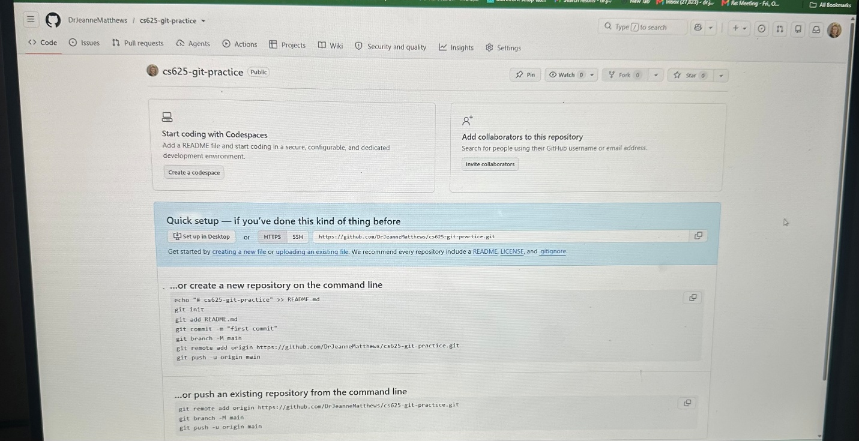
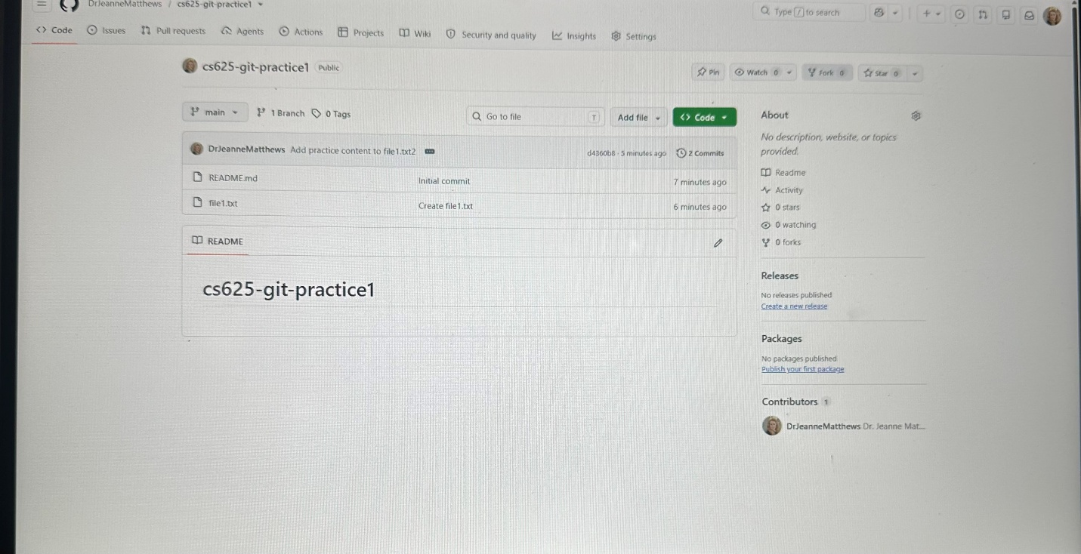

- 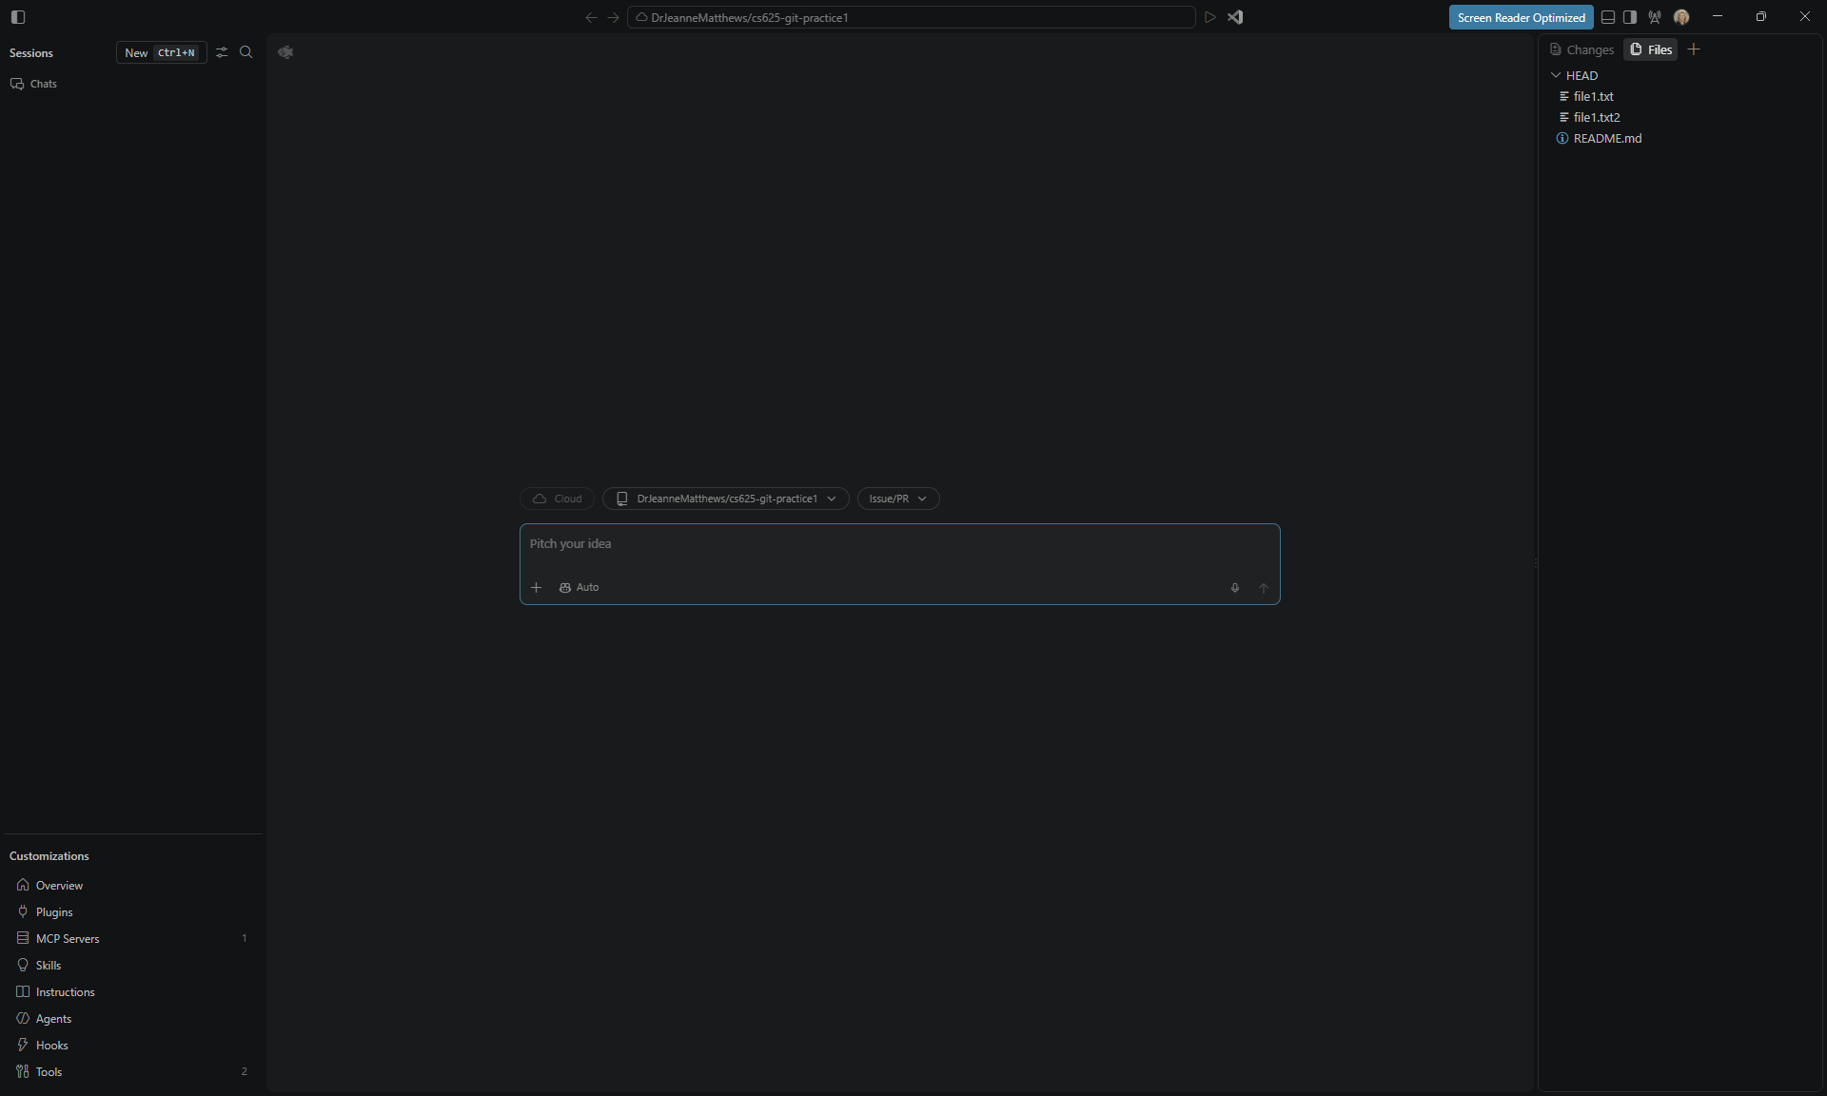
- Repo link: replace with your actual repo URL
Reflection: Git feels like the communication backbone of this course as it is structured, trackable, and transparent. Once the repo was cloned and the template copied, the workflow felt intuitive. It reminds me of how shared structure helps couples coordinate more effectively.
3. Markdown Setup
I edited HW1-report.md using headings, lists, images, and links. I then viewed the file directly on GitHub.com to confirm that formatting rendered correctly.
Evidence:
Reflection: Markdown is a bit tricky, but powerful. It reminds me of the structured scripts I create for clients, syntax that produces clarity. Seeing the rendered version helped me ensure the report would be easy to read and professionally formatted.
4. Tableau Setup
I installed Tableau Desktop, opened the application, and loaded a small CSV file. I created a simple bar chart to confirm that Tableau was functioning correctly.
Evidence:
Reflection: Tableau feels like a natural fit for client-facing visuals. I can already imagine mapping escalation cycles or emotional-tone trends in a way couples can immediately understand. Its drag-and-drop interface makes exploration feel intuitive.
5. Google Colab Setup
I opened Google Colab, created a new notebook, and ran a simple Python cell:
python
print("Hello CS625")
Evidence:

Reflection: Colab is lightweight, flexible, and accessible, and perfect for quick exploration. I appreciate how it removes setup barriers and lets me focus on the analysis itself, especially when experimenting with relational-pattern data.
6. Seaborn Setup
In the same Colab notebook, I imported Seaborn, loaded a sample dataset, and created a simple plot:
python
import seaborn as sns
sns.set_theme()
sns.scatterplot(data=sns.load_dataset("penguins"), x="bill_length_mm", y="bill_depth_mm")
Evidence:

Reflection: Seaborn’s statistical focus aligns well with the pattern-recognition work I do. I can see how it will help me quantify emotional tone or responsiveness over time, especially when I begin structuring relational data into analyzable attributes.
7. Observable + Vega-Lite Setup
I logged into Observable, created a new notebook, and added a simple Vega-Lite chart to confirm that everything was working correctly.
Evidence:
Reflection: Observable feels like a playground for interactive exploration. I’m excited about the possibility of building dynamic visuals that help couples “see” their communication patterns unfold — something that often accelerates insight and change.
8. Challenges & Solutions
I approached each challenge the same way I guide clients: slow down, break the problem into parts, and stay curious.
Examples:
- A minor Git authentication issue resolved by re-logging into GitHub through VS Code.
- A Markdown formatting glitch fixed by previewing the file directly on GitHub.
- A Seaborn import error resolved by running pip install seaborn in Colab.
The Canvas discussion board was helpful for confirming small details and ensuring I was on the right track.

9. References
- GitHub Docs
- Markdown Guide
- Tableau for Students
- Google Colab Documentation
- Seaborn Documentation
- Observable Documentation
- Vega-Lite Documentation

