Phyllochron data analysis report

Dana Looschelders

30 4 2020

name_phyllo=names(list_phyllo[1])  
 data=list_phyllo[[i]]  
 for (x in 5:6) {  
 name_month=names(data[x])  
 print(paste(name_phyllo, "for", name_month))  
 print("DATA EXPLORATION")  
 #histogram for phyllochron values  
 print(summary(data[,x]))  
 hist(data[,x], main=paste(name_phyllo, "for", name_month))  
 #boxplot for treatment  
 boxplot(data[,x]~data$Treatment, main=paste(name_phyllo, "for", name_month))  
 #boxplot for Variety with display of names as labels  
 labels=unique(data$Variety)  
 boxplot(data[,x]~data$Variety,   
 main=paste(name_phyllo, "for", name_month),  
 ylab="Days",  
 xaxt = "n", xlab = "")  
 axis(1, labels = FALSE)  
 # Plot x labs at default x position  
 text(x=labels,y = par("usr")[1] - 0.1, srt = 60, adj = 0.5,  
 labels = labels, xpd = TRUE)  
 print("NORMALITY TEST")  
 qqnorm(data[,x])  
 qqline(data[,x])  
 print(shapiro.test(data[,x]))  
 test.shapiro=shapiro.test(data[,x])  
 if(test.shapiro[[2]]<0.05){  
 print("Based on shapiro test normality cannot be assumed")  
 print(wilcox.test(data[,x]~data$Treatment))  
 print(kruskal.test(data[,x]~data$Variety))  
 test.kruskal=kruskal.test(data[,x]~data$Variety)  
 if(test.kruskal[[3]]<0.05){  
 print("As the Kruskal test is significant a posthoc test will be performed")  
 print(posthoc.kruskal.nemenyi.test(data[,x]~data$Variety))  
 } else {print("The Varieties don't differ significantly")}  
 } else {print("Normal distribution can be assumed")}  
 }

## [1] "Leaf Phyllochron 1-2 for May"  
## [1] "DATA EXPLORATION"  
## Min. 1st Qu. Median Mean 3rd Qu. Max.   
## 3.000 6.000 9.000 8.679 10.000 24.000

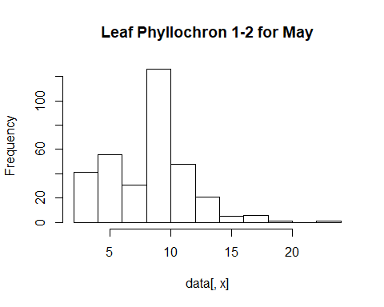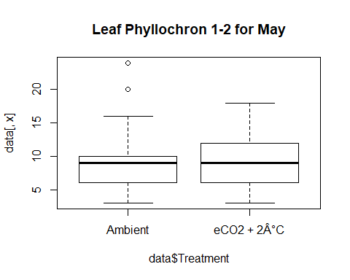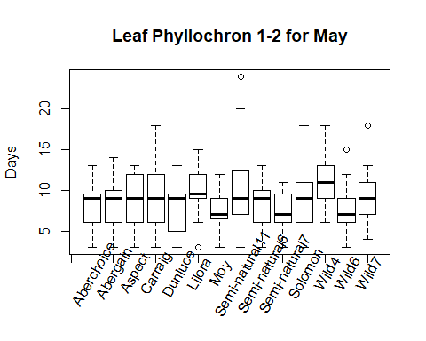

## [1] "NORMALITY TEST"

##   
## Shapiro-Wilk normality test  
##   
## data: data[, x]  
## W = 0.93788, p-value = 1.199e-10  
##   
## [1] "Based on shapiro test normality cannot be assumed"  
##   
## Wilcoxon rank sum test with continuity correction  
##   
## data: data[, x] by data$Treatment  
## W = 12696, p-value = 0.1053  
## alternative hypothesis: true location shift is not equal to 0  
##   
##   
## Kruskal-Wallis rank sum test  
##   
## data: data[, x] by data$Variety  
## Kruskal-Wallis chi-squared = 27.651, df = 13, p-value = 0.01012  
##   
## [1] "As the Kruskal test is significant a posthoc test will be performed"

## Warning in posthoc.kruskal.nemenyi.test.default(c(7L, 13L, 6L, 3L, 4L, 4L, :  
## Ties are present, p-values are not corrected.

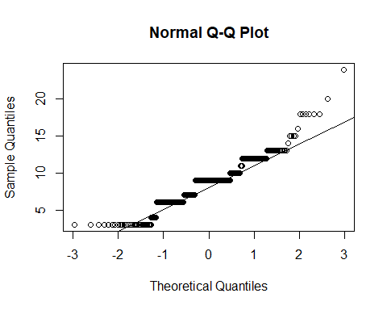

##   
## Pairwise comparisons using Tukey and Kramer (Nemenyi) test   
## with Tukey-Dist approximation for independent samples   
##   
## data: data[, x] by data$Variety   
##   
## Aberchoice Abergain Aspect Carraig Dunluce Lilora Moy   
## Abergain 1.000 - - - - - -   
## Aspect 1.000 1.000 - - - - -   
## Carraig 1.000 1.000 1.000 - - - -   
## Dunluce 1.000 1.000 1.000 1.000 - - -   
## Lilora 0.903 0.887 0.845 0.515 0.364 - -   
## Moy 1.000 1.000 1.000 1.000 1.000 0.308 -   
## Semi-natural11 1.000 0.999 0.998 0.953 0.883 1.000 0.842  
## Semi-natural6 1.000 1.000 1.000 1.000 1.000 0.655 1.000  
## Semi-natural7 0.998 0.999 1.000 1.000 1.000 0.212 1.000  
## Solomon 1.000 1.000 1.000 1.000 1.000 0.928 0.999  
## Wild4 0.638 0.608 0.541 0.222 0.133 1.000 0.105  
## Wild6 0.999 0.999 1.000 1.000 1.000 0.232 1.000  
## Wild7 1.000 1.000 1.000 0.999 0.991 0.992 0.985  
## Semi-natural11 Semi-natural6 Semi-natural7 Solomon Wild4 Wild6  
## Abergain - - - - - -   
## Aspect - - - - - -   
## Carraig - - - - - -   
## Dunluce - - - - - -   
## Lilora - - - - - -   
## Moy - - - - - -   
## Semi-natural11 - - - - - -   
## Semi-natural6 0.984 - - - - -   
## Semi-natural7 0.737 1.000 - - - -   
## Solomon 1.000 1.000 0.997 - - -   
## Wild4 0.995 0.329 0.063 0.690 - -   
## Wild6 0.763 1.000 1.000 0.998 0.071 -   
## Wild7 1.000 1.000 0.958 1.000 0.908 0.966  
##   
## P value adjustment method: none   
## [1] "Leaf Phyllochron 1-2 for June"  
## [1] "DATA EXPLORATION"  
## Min. 1st Qu. Median Mean 3rd Qu. Max.   
## 3.000 4.000 7.000 6.345 7.000 18.000

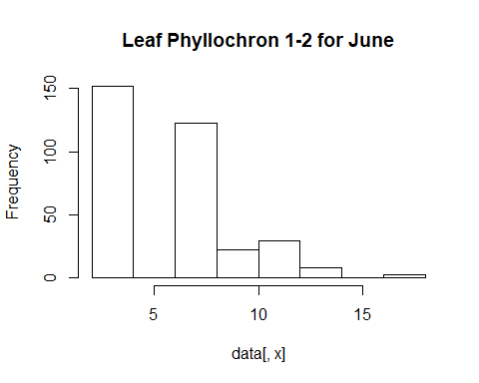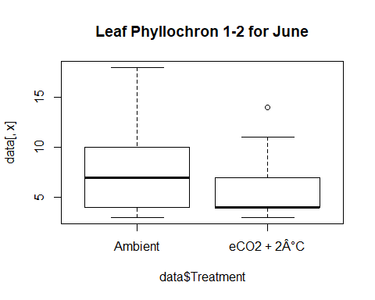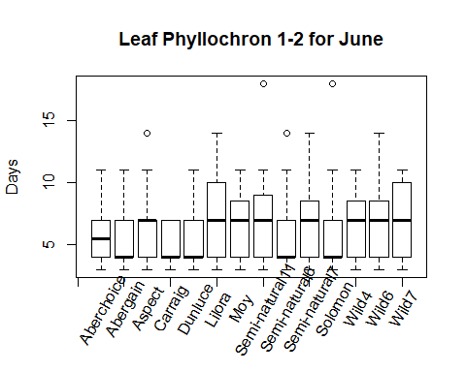

## [1] "NORMALITY TEST"

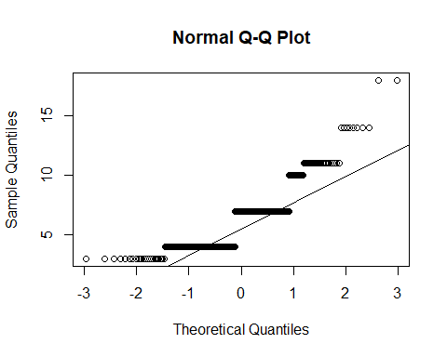

##   
## Shapiro-Wilk normality test  
##   
## data: data[, x]  
## W = 0.83364, p-value < 2.2e-16  
##   
## [1] "Based on shapiro test normality cannot be assumed"  
##   
## Wilcoxon rank sum test with continuity correction  
##   
## data: data[, x] by data$Treatment  
## W = 19129, p-value = 2.561e-09  
## alternative hypothesis: true location shift is not equal to 0  
##   
##   
## Kruskal-Wallis rank sum test  
##   
## data: data[, x] by data$Variety  
## Kruskal-Wallis chi-squared = 19.102, df = 13, p-value = 0.12  
##   
## [1] "The Varieties don't differ significantly"

list_phyllo[[1]][6:7]

## June July  
## 1 14 3  
## 2 7 3  
## 3 7 3  
## 4 7 3  
## 5 7 3  
## 6 7 3  
## 7 7 3  
## 8 7 3  
## 9 7 3  
## 10 7 3  
## 11 7 3  
## 12 7 3  
## 13 14 3  
## 14 7 3  
## 15 7 3  
## 16 7 3  
## 17 7 3  
## 18 7 3  
## 19 7 3  
## 20 7 3  
## 21 14 3  
## 22 7 3  
## 23 7 3  
## 24 7 3  
## 25 18 3  
## 26 7 3  
## 27 7 3  
## 28 7 3  
## 29 7 3  
## 30 7 3  
## 31 7 3  
## 32 7 3  
## 33 7 3  
## 34 7 3  
## 35 7 3  
## 36 7 3  
## 37 7 3  
## 38 7 3  
## 39 7 3  
## 40 4 3  
## 41 7 3  
## 42 4 3  
## 43 7 3  
## 44 7 3  
## 45 7 3  
## 46 7 3  
## 47 7 3  
## 48 7 3  
## 49 7 3  
## 50 7 3  
## 51 7 3  
## 52 14 3  
## 53 11 3  
## 54 7 3  
## 55 7 3  
## 56 7 3  
## 57 4 3  
## 58 7 3  
## 59 7 3  
## 60 7 3  
## 61 7 3  
## 62 7 3  
## 63 7 3  
## 64 7 3  
## 65 7 3  
## 66 7 3  
## 67 14 3  
## 68 7 3  
## 69 7 3  
## 70 7 3  
## 71 7 3  
## 72 4 3  
## 73 4 3  
## 74 7 3  
## 75 7 3  
## 76 7 3  
## 77 7 3  
## 78 7 3  
## 79 5 3  
## 80 11 3  
## 81 7 3  
## 82 7 3  
## 83 4 3  
## 84 7 3  
## 85 14 3  
## 86 4 3  
## 87 7 3  
## 88 7 3  
## 89 7 3  
## 90 7 3  
## 91 7 3  
## 92 7 3  
## 93 7 3  
## 94 7 3  
## 95 14 3  
## 96 7 3  
## 97 7 3  
## 98 7 3  
## 99 7 3  
## 100 7 3  
## 101 7 3  
## 102 7 3  
## 103 7 3  
## 104 7 3  
## 105 7 3  
## 106 7 3  
## 107 7 3  
## 108 14 3  
## 109 4 3  
## 110 7 3  
## 111 7 3  
## 112 7 3  
## 113 4 3  
## 114 4 3  
## 115 4 3  
## 116 7 3  
## 117 7 3  
## 118 7 3  
## 119 4 3  
## 120 7 3  
## 121 7 3  
## 122 7 3  
## 123 4 3  
## 124 7 3  
## 125 7 3  
## 126 7 3  
## 127 7 3  
## 128 7 3  
## 129 7 3  
## 130 7 3  
## 131 7 3  
## 132 7 3  
## 133 7 3  
## 134 7 3  
## 135 7 3  
## 136 4 3  
## 137 11 3  
## 138 7 3  
## 139 7 3  
## 140 4 3  
## 141 7 3  
## 142 7 3  
## 143 7 3  
## 144 7 3  
## 145 7 3  
## 146 7 3  
## 147 7 3  
## 148 7 3  
## 149 7 3  
## 150 4 3  
## 151 7 3  
## 152 7 3  
## 153 7 3  
## 154 7 3  
## 155 7 3  
## 156 7 3  
## 157 7 3  
## 158 7 3  
## 159 7 3  
## 160 7 3  
## 161 7 3  
## 162 7 3  
## 163 7 3  
## 164 7 3  
## 165 7 3  
## 166 7 3  
## 167 7 3  
## 168 7 3  
## 169 7 3  
## 170 7 3  
## 171 7 3  
## 172 7 3  
## 173 7 3  
## 174 7 3  
## 175 7 3  
## 176 7 3  
## 177 7 3  
## 178 7 3  
## 179 7 3  
## 180 7 3  
## 181 7 3  
## 182 7 3  
## 183 4 3  
## 184 7 3  
## 185 7 3  
## 186 7 3  
## 187 7 3  
## 188 7 3  
## 189 7 3  
## 190 7 3  
## 191 7 3  
## 192 7 3  
## 193 7 3  
## 194 7 3  
## 195 7 3  
## 196 7 3  
## 197 7 3  
## 198 4 3  
## 199 7 3  
## 200 7 3  
## 201 7 3  
## 202 7 3  
## 203 7 3  
## 204 7 3  
## 205 7 3  
## 206 7 3  
## 207 7 3  
## 208 7 3  
## 209 7 3  
## 210 7 3  
## 211 7 3  
## 212 7 3  
## 213 7 3  
## 214 7 3  
## 215 7 3  
## 216 4 3  
## 217 7 3  
## 218 7 3  
## 219 4 3  
## 220 7 3  
## 221 7 3  
## 222 7 3  
## 223 7 3  
## 224 7 3  
## 225 7 3  
## 226 4 3  
## 227 7 3  
## 228 7 3  
## 229 7 3  
## 230 7 3  
## 231 7 3  
## 232 7 3  
## 233 7 3  
## 234 7 3  
## 235 7 3  
## 236 7 3  
## 237 7 3  
## 238 7 3  
## 239 7 3  
## 240 7 3  
## 241 7 3  
## 242 7 3  
## 243 7 3  
## 244 7 3  
## 245 7 3  
## 246 7 3  
## 247 7 3  
## 248 7 3  
## 249 7 3  
## 250 7 3  
## 251 7 3  
## 252 7 3  
## 253 11 3  
## 254 7 3  
## 255 7 3  
## 256 7 3  
## 257 7 3  
## 258 7 3  
## 259 7 3  
## 260 7 3  
## 261 7 3  
## 262 7 3  
## 263 7 3  
## 264 7 3  
## 265 7 3  
## 266 7 3  
## 267 7 3  
## 268 7 3  
## 269 7 3  
## 270 7 3  
## 271 7 3  
## 272 7 3  
## 273 7 3  
## 274 7 3  
## 275 7 3  
## 276 7 3  
## 277 7 3  
## 278 7 3  
## 279 7 3  
## 280 7 3  
## 281 7 3  
## 282 7 3  
## 283 7 3  
## 284 7 3  
## 285 7 3  
## 286 7 3  
## 287 7 3  
## 288 7 3  
## 289 7 3  
## 290 7 3  
## 291 7 3  
## 292 7 3  
## 293 7 3  
## 294 7 3  
## 295 7 3  
## 296 7 3  
## 297 7 3  
## 298 7 3  
## 299 7 3  
## 300 7 3  
## 301 7 3  
## 302 7 3  
## 303 7 3  
## 304 7 3  
## 305 4 3  
## 306 7 3  
## 307 7 3  
## 308 7 3  
## 309 7 3  
## 310 7 3  
## 311 7 3  
## 312 7 3  
## 313 7 3  
## 314 7 3  
## 315 7 3  
## 316 7 3  
## 317 7 3  
## 318 14 3  
## 319 7 3  
## 320 7 3  
## 321 7 3  
## 322 7 3  
## 323 7 3  
## 324 7 3  
## 325 7 3  
## 326 7 3  
## 327 7 3  
## 328 7 3  
## 329 7 3  
## 330 7 3  
## 331 7 3  
## 332 7 3  
## 333 7 3  
## 334 7 3  
## 335 7 3  
## 336 7 3

The Phyllochron for July, August and September could’t be analysed as it was the same for all plants and therefore there was no significant difference

## Data Exploration, Normality Test and Significance tests

for (i in 2:length(list_phyllo)) {  
 name_phyllo=names(list_phyllo[i])  
 data=list_phyllo[[i]]  
 for (x in 5:8) {  
 name_month=names(data[x])  
 name_month=names(data[x])  
 print(paste(name_phyllo, "for", name_month))  
 print("DATA EXPLORATION")  
 #histogram for phyllochron values  
 print(summary(data[,x]))  
 hist(data[,x], main=paste(name_phyllo, "for", name_month))  
 #boxplot for treatment  
 boxplot(data[,x]~data$Treatment, main=paste(name_phyllo, "for", name_month))  
 #boxplot for Variety with display of names as labels  
 labels=unique(data$Variety)  
 boxplot(data[,x]~data$Variety,   
 main=paste(name_phyllo, "for", name_month),  
 ylab="Days",  
 xaxt = "n", xlab = "")  
 axis(1, labels = FALSE)  
 # Plot x labs at default x position  
 text(x=labels,y = par("usr")[1] - 0.1, srt = 60, adj = 0.5,  
 labels = labels, xpd = TRUE)  
 print("NORMALITY TEST")  
 qqnorm(data[,x])  
 qqline(data[,x])  
 print(shapiro.test(data[,x]))  
 test.shapiro=shapiro.test(data[,x])  
 if(test.shapiro[[2]]<0.05){  
 print("Based on shapiro test normality cannot be assumed")  
 print(wilcox.test(data[,x]~data$Treatment))  
 print(kruskal.test(data[,x]~data$Variety))  
 test.kruskal=kruskal.test(data[,x]~data$Variety)  
 if(test.kruskal[[3]]<0.05){  
 print("As the Kruskal test is significant a posthoc test will be performed")  
 print(posthoc.kruskal.nemenyi.test(data[,x]~data$Variety))  
 } else {print("The Varieties don't differ significantly")}  
 } else {print("Normal distribution can be assumed")}  
 }  
}

## [1] "Leaf Phyllochron 1-3 for May"  
## [1] "DATA EXPLORATION"  
## Min. 1st Qu. Median Mean 3rd Qu. Max.   
## 8.00 15.00 17.00 16.97 19.00 27.00

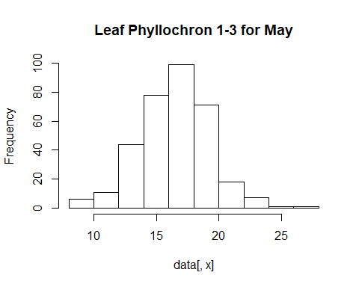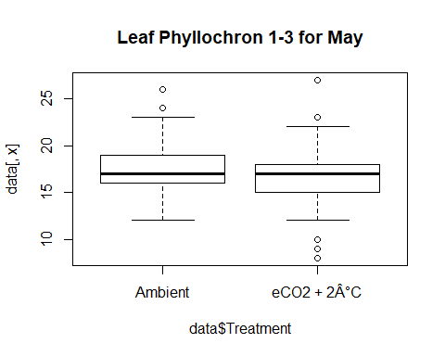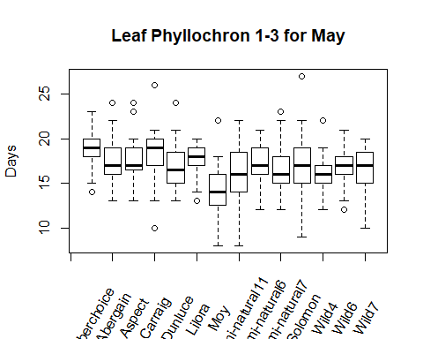

## [1] "NORMALITY TEST"

##   
## Shapiro-Wilk normality test  
##   
## data: data[, x]  
## W = 0.98095, p-value = 0.0001971  
##   
## [1] "Based on shapiro test normality cannot be assumed"  
##   
## Wilcoxon rank sum test with continuity correction  
##   
## data: data[, x] by data$Treatment  
## W = 15928, p-value = 0.03996  
## alternative hypothesis: true location shift is not equal to 0  
##   
##   
## Kruskal-Wallis rank sum test  
##   
## data: data[, x] by data$Variety  
## Kruskal-Wallis chi-squared = 51.326, df = 13, p-value = 1.763e-06  
##   
## [1] "As the Kruskal test is significant a posthoc test will be performed"

## Warning in posthoc.kruskal.nemenyi.test.default(c(17L, 17L, 19L, 20L, 24L, :  
## Ties are present, p-values are not corrected.

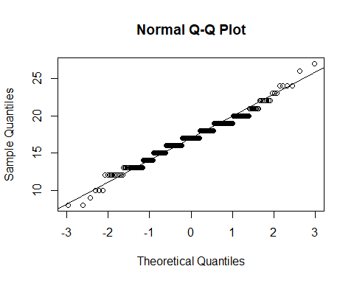

##   
## Pairwise comparisons using Tukey and Kramer (Nemenyi) test   
## with Tukey-Dist approximation for independent samples   
##   
## data: data[, x] by data$Variety   
##   
## Aberchoice Abergain Aspect Carraig Dunluce Lilora Moy   
## Abergain 0.7432 - - - - - -   
## Aspect 0.8131 1.0000 - - - - -   
## Carraig 0.9993 0.9991 0.9997 - - - -   
## Dunluce 0.1903 0.9999 0.9996 0.8456 - - -   
## Lilora 0.7491 1.0000 1.0000 0.9992 0.9999 - -   
## Moy 2.6e-07 0.0073 0.0046 7.1e-05 0.1147 0.0070 -   
## Semi-natural11 0.0401 0.9839 0.9684 0.4677 1.0000 0.9829 0.3953  
## Semi-natural6 0.3744 1.0000 1.0000 0.9599 1.0000 1.0000 0.0442  
## Semi-natural7 0.0305 0.9733 0.9513 0.4078 1.0000 0.9719 0.4547  
## Solomon 0.4423 1.0000 1.0000 0.9765 1.0000 1.0000 0.0323  
## Wild4 0.0046 0.7811 0.7065 0.1338 0.9973 0.7756 0.8144  
## Wild6 0.1340 0.9995 0.9984 0.7648 1.0000 0.9995 0.1650  
## Wild7 0.1797 0.9999 0.9995 0.8332 1.0000 0.9999 0.1222  
## Semi-natural11 Semi-natural6 Semi-natural7 Solomon Wild4 Wild6   
## Abergain - - - - - -   
## Aspect - - - - - -   
## Carraig - - - - - -   
## Dunluce - - - - - -   
## Lilora - - - - - -   
## Moy - - - - - -   
## Semi-natural11 - - - - - -   
## Semi-natural6 0.9998 - - - - -   
## Semi-natural7 1.0000 0.9996 - - - -   
## Solomon 0.9995 1.0000 0.9988 - - -   
## Wild4 1.0000 0.9730 1.0000 0.9548 - -   
## Wild6 1.0000 1.0000 1.0000 1.0000 0.9993 -   
## Wild7 1.0000 1.0000 1.0000 1.0000 0.9978 1.0000  
##   
## P value adjustment method: none   
## [1] "Leaf Phyllochron 1-3 for June"  
## [1] "DATA EXPLORATION"  
## Min. 1st Qu. Median Mean 3rd Qu. Max.   
## 7.0 11.0 14.0 13.1 14.0 21.0

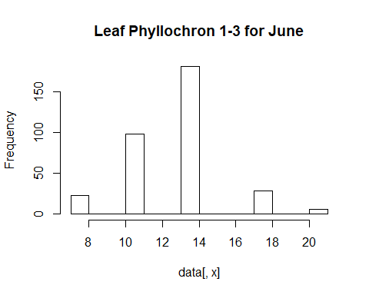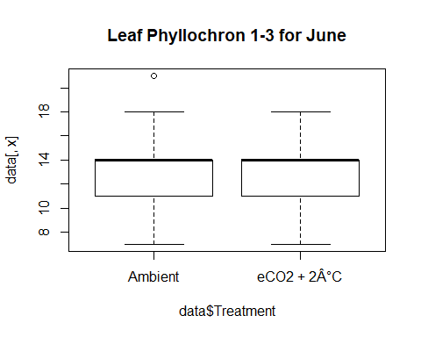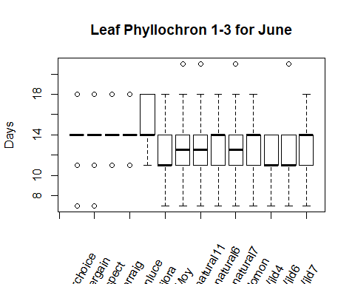

## [1] "NORMALITY TEST"

##   
## Shapiro-Wilk normality test  
##   
## data: data[, x]  
## W = 0.83969, p-value < 2.2e-16  
##   
## [1] "Based on shapiro test normality cannot be assumed"  
##   
## Wilcoxon rank sum test with continuity correction  
##   
## data: data[, x] by data$Treatment  
## W = 12574, p-value = 0.0562  
## alternative hypothesis: true location shift is not equal to 0  
##   
##   
## Kruskal-Wallis rank sum test  
##   
## data: data[, x] by data$Variety  
## Kruskal-Wallis chi-squared = 37.395, df = 13, p-value = 0.0003592  
##   
## [1] "As the Kruskal test is significant a posthoc test will be performed"

## Warning in posthoc.kruskal.nemenyi.test.default(c(21L, 11L, 14L, 11L, 18L, :  
## Ties are present, p-values are not corrected.

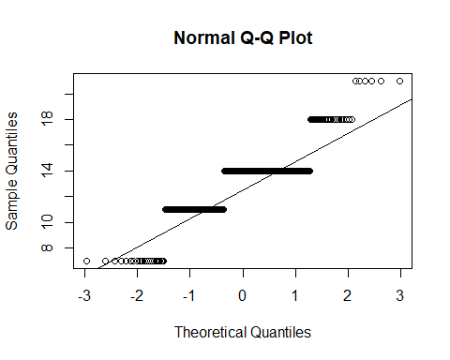

##   
## Pairwise comparisons using Tukey and Kramer (Nemenyi) test   
## with Tukey-Dist approximation for independent samples   
##   
## data: data[, x] by data$Variety   
##   
## Aberchoice Abergain Aspect Carraig Dunluce Lilora Moy   
## Abergain 1.000 - - - - - -   
## Aspect 1.000 1.000 - - - - -   
## Carraig 1.000 1.000 1.000 - - - -   
## Dunluce 1.000 0.998 1.000 1.000 - - -   
## Lilora 0.254 0.383 0.208 0.262 0.018 - -   
## Moy 0.871 0.945 0.826 0.877 0.261 1.000 -   
## Semi-natural11 0.945 0.982 0.918 0.948 0.390 0.998 1.000  
## Semi-natural6 0.999 1.000 0.997 0.999 0.773 0.927 1.000  
## Semi-natural7 0.954 0.986 0.930 0.957 0.418 0.997 1.000  
## Solomon 0.995 0.999 0.989 0.995 0.668 0.966 1.000  
## Wild4 0.531 0.685 0.464 0.541 0.069 1.000 1.000  
## Wild6 0.666 0.802 0.599 0.675 0.115 1.000 1.000  
## Wild7 0.934 0.978 0.904 0.938 0.365 0.998 1.000  
## Semi-natural11 Semi-natural6 Semi-natural7 Solomon Wild4 Wild6  
## Abergain - - - - - -   
## Aspect - - - - - -   
## Carraig - - - - - -   
## Dunluce - - - - - -   
## Lilora - - - - - -   
## Moy - - - - - -   
## Semi-natural11 - - - - - -   
## Semi-natural6 1.000 - - - - -   
## Semi-natural7 1.000 1.000 - - - -   
## Solomon 1.000 1.000 1.000 - - -   
## Wild4 1.000 0.993 1.000 0.998 - -   
## Wild6 1.000 0.999 1.000 1.000 1.000 -   
## Wild7 1.000 1.000 1.000 1.000 1.000 1.000  
##   
## P value adjustment method: none   
## [1] "Leaf Phyllochron 1-3 for July"  
## [1] "DATA EXPLORATION"  
## Min. 1st Qu. Median Mean 3rd Qu. Max.   
## 7.000 7.000 10.000 9.205 10.000 21.000

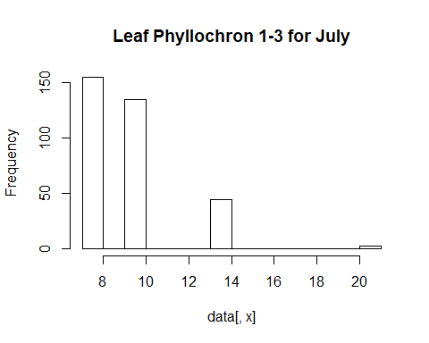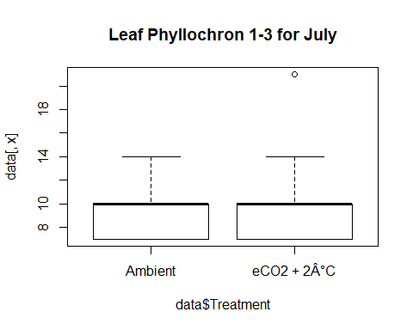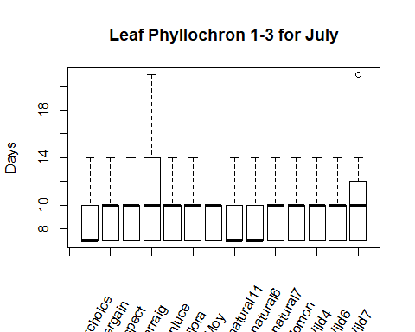

## [1] "NORMALITY TEST"

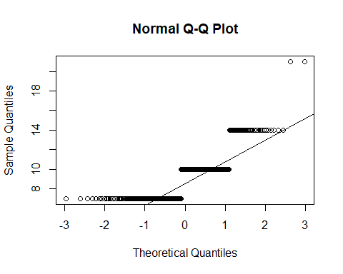

##   
## Shapiro-Wilk normality test  
##   
## data: data[, x]  
## W = 0.75524, p-value < 2.2e-16  
##   
## [1] "Based on shapiro test normality cannot be assumed"  
##   
## Wilcoxon rank sum test with continuity correction  
##   
## data: data[, x] by data$Treatment  
## W = 13668, p-value = 0.5852  
## alternative hypothesis: true location shift is not equal to 0  
##   
##   
## Kruskal-Wallis rank sum test  
##   
## data: data[, x] by data$Variety  
## Kruskal-Wallis chi-squared = 9.5556, df = 13, p-value = 0.7298  
##   
## [1] "The Varieties don't differ significantly"  
## [1] "Leaf Phyllochron 1-3 for August"  
## [1] "DATA EXPLORATION"  
## Min. 1st Qu. Median Mean 3rd Qu. Max.   
## 7.0 14.0 18.0 17.3 21.0 21.0

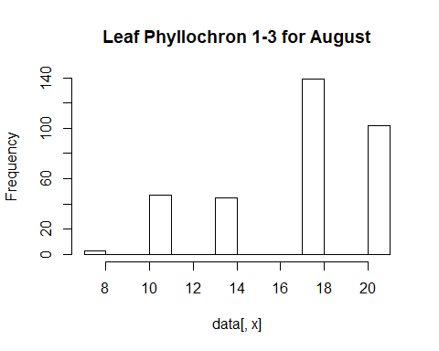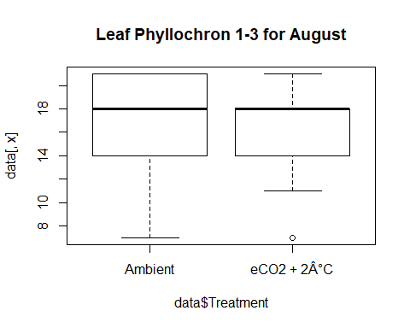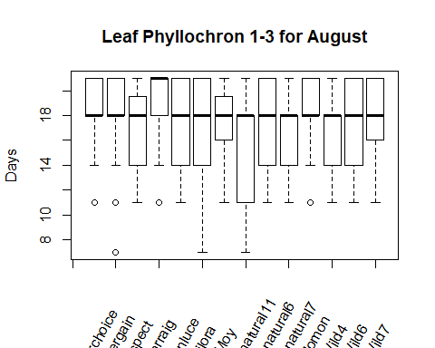

## [1] "NORMALITY TEST"

##   
## Shapiro-Wilk normality test  
##   
## data: data[, x]  
## W = 0.82829, p-value < 2.2e-16  
##   
## [1] "Based on shapiro test normality cannot be assumed"  
##   
## Wilcoxon rank sum test with continuity correction  
##   
## data: data[, x] by data$Treatment  
## W = 15730, p-value = 0.05503  
## alternative hypothesis: true location shift is not equal to 0  
##   
##   
## Kruskal-Wallis rank sum test  
##   
## data: data[, x] by data$Variety  
## Kruskal-Wallis chi-squared = 23.208, df = 13, p-value = 0.03925  
##   
## [1] "As the Kruskal test is significant a posthoc test will be performed"

## Warning in posthoc.kruskal.nemenyi.test.default(c(11L, 11L, 21L, 21L, 14L, :  
## Ties are present, p-values are not corrected.

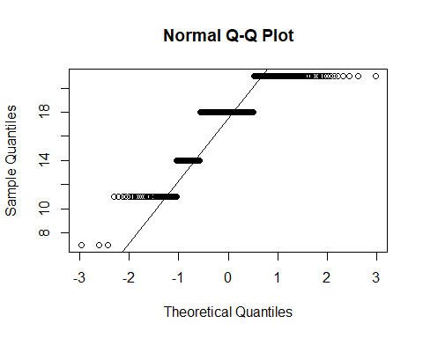

##   
## Pairwise comparisons using Tukey and Kramer (Nemenyi) test   
## with Tukey-Dist approximation for independent samples   
##   
## data: data[, x] by data$Variety   
##   
## Aberchoice Abergain Aspect Carraig Dunluce Lilora Moy   
## Abergain 1.000 - - - - - -   
## Aspect 0.993 1.000 - - - - -   
## Carraig 0.999 0.975 0.539 - - - -   
## Dunluce 1.000 1.000 1.000 0.806 - - -   
## Lilora 0.999 1.000 1.000 0.741 1.000 - -   
## Moy 1.000 1.000 1.000 0.821 1.000 1.000 -   
## Semi-natural11 0.279 0.551 0.978 0.013 0.867 0.911 0.855  
## Semi-natural6 0.995 1.000 1.000 0.571 1.000 1.000 1.000  
## Semi-natural7 0.997 1.000 1.000 0.610 1.000 1.000 1.000  
## Solomon 1.000 1.000 0.966 1.000 0.998 0.994 0.998  
## Wild4 0.941 0.995 1.000 0.291 1.000 1.000 1.000  
## Wild6 1.000 1.000 1.000 0.877 1.000 1.000 1.000  
## Wild7 1.000 1.000 1.000 0.980 1.000 1.000 1.000  
## Semi-natural11 Semi-natural6 Semi-natural7 Solomon Wild4 Wild6  
## Abergain - - - - - -   
## Aspect - - - - - -   
## Carraig - - - - - -   
## Dunluce - - - - - -   
## Lilora - - - - - -   
## Moy - - - - - -   
## Semi-natural11 - - - - - -   
## Semi-natural6 0.971 - - - - -   
## Semi-natural7 0.962 1.000 - - - -   
## Solomon 0.158 0.973 0.980 - - -   
## Wild4 0.999 1.000 1.000 0.844 - -   
## Wild6 0.794 1.000 1.000 0.999 1.000 -   
## Wild7 0.524 1.000 1.000 1.000 0.993 1.000  
##   
## P value adjustment method: none   
## [1] "Leaf Phyllochron 1-4 for May"  
## [1] "DATA EXPLORATION"  
## Min. 1st Qu. Median Mean 3rd Qu. Max.   
## 15.00 23.00 26.00 25.65 28.00 40.00

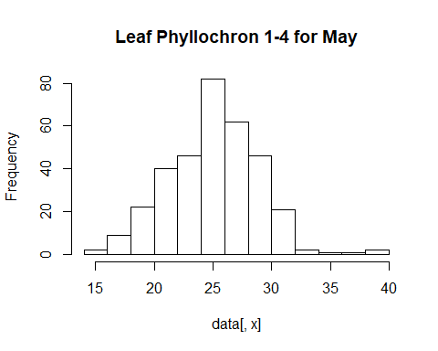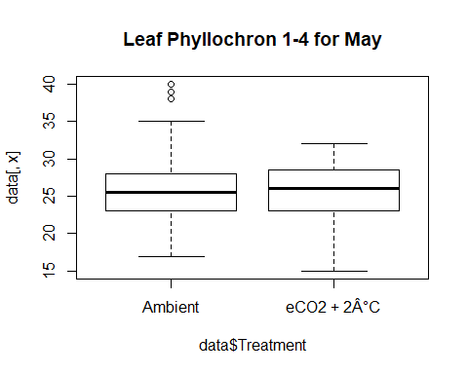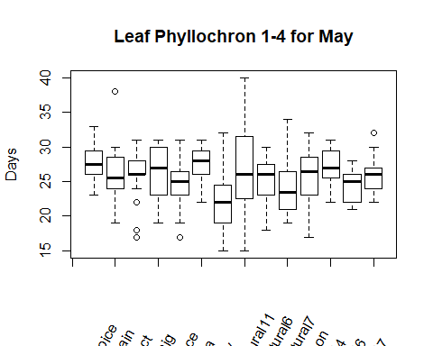

## [1] "NORMALITY TEST"

##   
## Shapiro-Wilk normality test  
##   
## data: data[, x]  
## W = 0.9803, p-value = 0.0001457  
##   
## [1] "Based on shapiro test normality cannot be assumed"  
##   
## Wilcoxon rank sum test with continuity correction  
##   
## data: data[, x] by data$Treatment  
## W = 13071, p-value = 0.2403  
## alternative hypothesis: true location shift is not equal to 0  
##   
##   
## Kruskal-Wallis rank sum test  
##   
## data: data[, x] by data$Variety  
## Kruskal-Wallis chi-squared = 49.865, df = 13, p-value = 3.145e-06  
##   
## [1] "As the Kruskal test is significant a posthoc test will be performed"

## Warning in posthoc.kruskal.nemenyi.test.default(c(24L, 30L, 25L, 23L, 28L, :  
## Ties are present, p-values are not corrected.

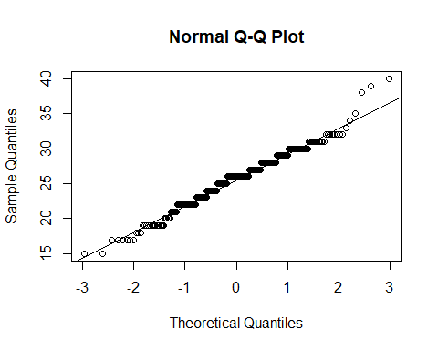

##   
## Pairwise comparisons using Tukey and Kramer (Nemenyi) test   
## with Tukey-Dist approximation for independent samples   
##   
## data: data[, x] by data$Variety   
##   
## Aberchoice Abergain Aspect Carraig Dunluce Lilora Moy   
## Abergain 0.94040 - - - - - -   
## Aspect 0.99704 1.00000 - - - - -   
## Carraig 0.99967 0.99999 1.00000 - - - -   
## Dunluce 0.26465 0.99819 0.95425 0.88222 - - -   
## Lilora 1.00000 0.89976 0.99219 0.99879 0.20161 - -   
## Moy 0.00017 0.09535 0.02179 0.00982 0.74518 9.2e-05 -   
## Semi-natural11 0.98546 1.00000 1.00000 1.00000 0.98649 0.96976 0.04424  
## Semi-natural6 0.75629 1.00000 0.99987 0.99849 0.99999 0.67302 0.25514  
## Semi-natural7 0.04300 0.88637 0.59605 0.43315 0.99999 0.02878 0.98629  
## Solomon 0.98971 1.00000 1.00000 1.00000 0.98125 0.97746 0.03749  
## Wild4 1.00000 0.99269 0.99994 1.00000 0.50239 1.00000 0.00088  
## Wild6 0.08709 0.95928 0.76011 0.60603 1.00000 0.06077 0.94877  
## Wild7 0.91809 1.00000 1.00000 0.99997 0.99910 0.86884 0.11629  
## Semi-natural11 Semi-natural6 Semi-natural7 Solomon Wild4   
## Abergain - - - - -   
## Aspect - - - - -   
## Carraig - - - - -   
## Dunluce - - - - -   
## Lilora - - - - -   
## Moy - - - - -   
## Semi-natural11 - - - - -   
## Semi-natural6 1.00000 - - - -   
## Semi-natural7 0.74664 0.98400 - - -   
## Solomon 1.00000 0.99999 0.71219 - -   
## Wild4 0.99924 0.92836 0.12199 0.99956 -   
## Wild6 0.87631 0.99719 1.00000 0.85200 0.21706  
## Wild7 1.00000 1.00000 0.91446 1.00000 0.98782  
## Wild6   
## Abergain -   
## Aspect -   
## Carraig -   
## Dunluce -   
## Lilora -   
## Moy -   
## Semi-natural11 -   
## Semi-natural6 -   
## Semi-natural7 -   
## Solomon -   
## Wild4 -   
## Wild6 -   
## Wild7 0.97241  
##   
## P value adjustment method: none   
## [1] "Leaf Phyllochron 1-4 for June"  
## [1] "DATA EXPLORATION"  
## Min. 1st Qu. Median Mean 3rd Qu. Max.   
## 14.00 18.00 18.00 19.45 21.00 25.00

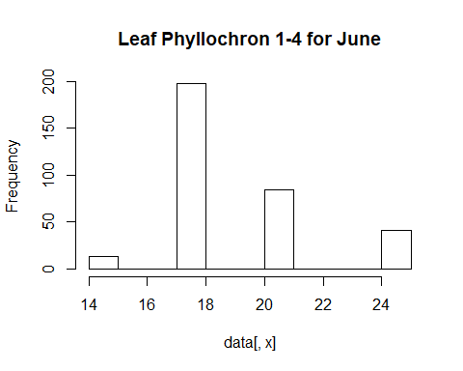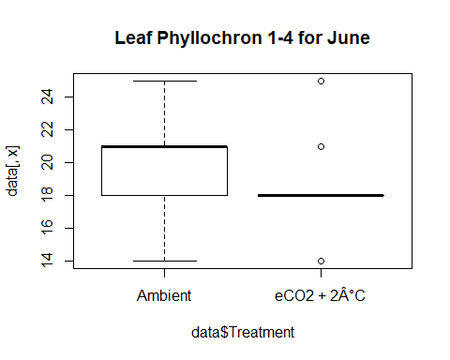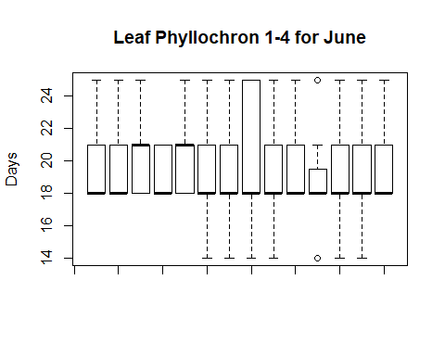

## [1] "NORMALITY TEST"

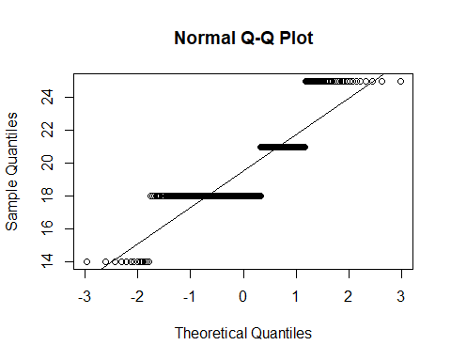

##   
## Shapiro-Wilk normality test  
##   
## data: data[, x]  
## W = 0.77011, p-value < 2.2e-16  
##   
## [1] "Based on shapiro test normality cannot be assumed"  
##   
## Wilcoxon rank sum test with continuity correction  
##   
## data: data[, x] by data$Treatment  
## W = 19341, p-value = 2.763e-11  
## alternative hypothesis: true location shift is not equal to 0  
##   
##   
## Kruskal-Wallis rank sum test  
##   
## data: data[, x] by data$Variety  
## Kruskal-Wallis chi-squared = 14.025, df = 13, p-value = 0.3721  
##   
## [1] "The Varieties don't differ significantly"  
## [1] "Leaf Phyllochron 1-4 for July"  
## [1] "DATA EXPLORATION"  
## Min. 1st Qu. Median Mean 3rd Qu. Max.   
## 10.00 17.00 17.00 18.67 21.00 24.00

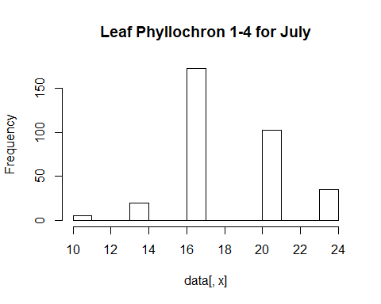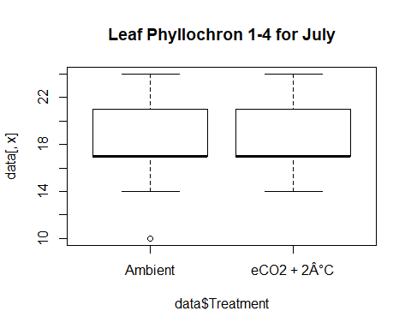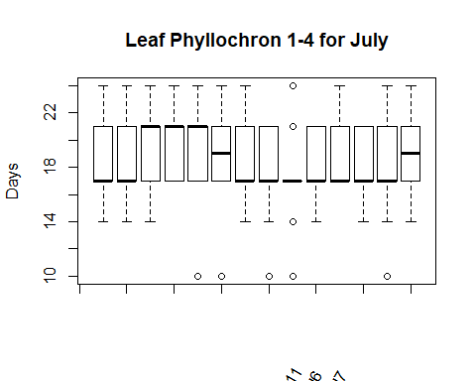

## [1] "NORMALITY TEST"

##   
## Shapiro-Wilk normality test  
##   
## data: data[, x]  
## W = 0.84142, p-value < 2.2e-16  
##   
## [1] "Based on shapiro test normality cannot be assumed"  
##   
## Wilcoxon rank sum test with continuity correction  
##   
## data: data[, x] by data$Treatment  
## W = 10784, p-value = 4.225e-05  
## alternative hypothesis: true location shift is not equal to 0  
##   
##   
## Kruskal-Wallis rank sum test  
##   
## data: data[, x] by data$Variety  
## Kruskal-Wallis chi-squared = 23.314, df = 13, p-value = 0.03806  
##   
## [1] "As the Kruskal test is significant a posthoc test will be performed"

## Warning in posthoc.kruskal.nemenyi.test.default(c(21L, 21L, 17L, 21L, 21L, :  
## Ties are present, p-values are not corrected.

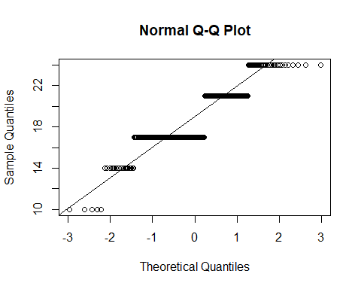

##   
## Pairwise comparisons using Tukey and Kramer (Nemenyi) test   
## with Tukey-Dist approximation for independent samples   
##   
## data: data[, x] by data$Variety   
##   
## Aberchoice Abergain Aspect Carraig Dunluce Lilora Moy   
## Abergain 1.00 - - - - - -   
## Aspect 1.00 1.00 - - - - -   
## Carraig 0.99 1.00 1.00 - - - -   
## Dunluce 1.00 1.00 1.00 1.00 - - -   
## Lilora 1.00 1.00 1.00 1.00 1.00 - -   
## Moy 1.00 1.00 1.00 0.87 0.93 0.99 -   
## Semi-natural11 1.00 0.99 0.95 0.56 0.68 0.87 1.00  
## Semi-natural6 0.97 0.91 0.71 0.23 0.32 0.54 1.00  
## Semi-natural7 1.00 1.00 1.00 0.88 0.94 0.99 1.00  
## Solomon 1.00 1.00 1.00 1.00 1.00 1.00 1.00  
## Wild4 1.00 1.00 0.96 0.62 0.73 0.90 1.00  
## Wild6 1.00 1.00 1.00 0.88 0.94 0.99 1.00  
## Wild7 1.00 1.00 1.00 1.00 1.00 1.00 0.98  
## Semi-natural11 Semi-natural6 Semi-natural7 Solomon Wild4 Wild6  
## Abergain - - - - - -   
## Aspect - - - - - -   
## Carraig - - - - - -   
## Dunluce - - - - - -   
## Lilora - - - - - -   
## Moy - - - - - -   
## Semi-natural11 - - - - - -   
## Semi-natural6 1.00 - - - - -   
## Semi-natural7 1.00 1.00 - - - -   
## Solomon 0.99 0.85 1.00 - - -   
## Wild4 1.00 1.00 1.00 0.99 - -   
## Wild6 1.00 1.00 1.00 1.00 1.00 -   
## Wild7 0.86 0.53 0.99 1.00 0.89 0.99   
##   
## P value adjustment method: none   
## [1] "Leaf Phyllochron 1-4 for August"  
## [1] "DATA EXPLORATION"  
## Min. 1st Qu. Median Mean 3rd Qu. Max.   
## 25.00 25.00 28.00 28.38 32.00 32.00

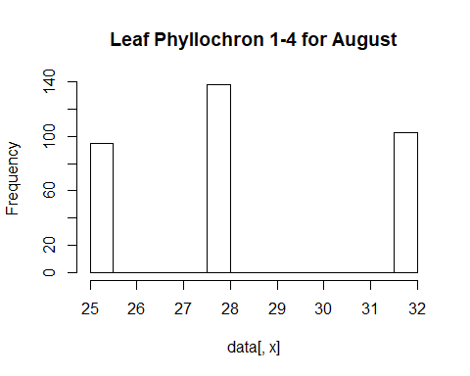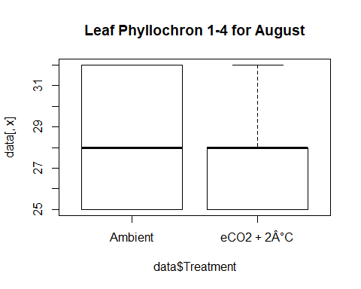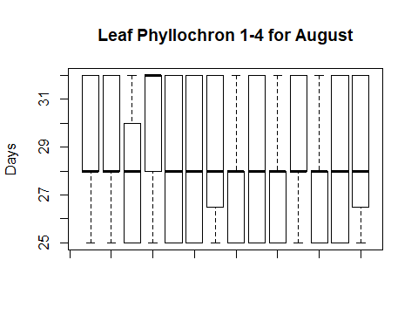

## [1] "NORMALITY TEST"

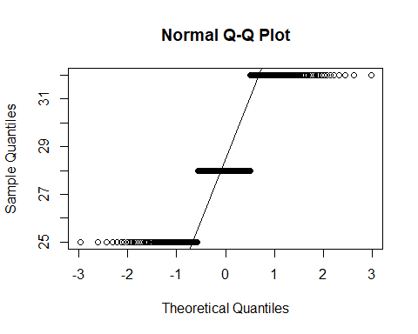

##   
## Shapiro-Wilk normality test  
##   
## data: data[, x]  
## W = 0.80056, p-value < 2.2e-16  
##   
## [1] "Based on shapiro test normality cannot be assumed"  
##   
## Wilcoxon rank sum test with continuity correction  
##   
## data: data[, x] by data$Treatment  
## W = 15793, p-value = 0.04412  
## alternative hypothesis: true location shift is not equal to 0  
##   
##   
## Kruskal-Wallis rank sum test  
##   
## data: data[, x] by data$Variety  
## Kruskal-Wallis chi-squared = 21.401, df = 13, p-value = 0.06536  
##   
## [1] "The Varieties don't differ significantly"  
## [1] "Leaf Phyllochron 2-3 for May"  
## [1] "DATA EXPLORATION"  
## Min. 1st Qu. Median Mean 3rd Qu. Max.   
## 2.000 6.000 6.000 6.866 9.000 16.000

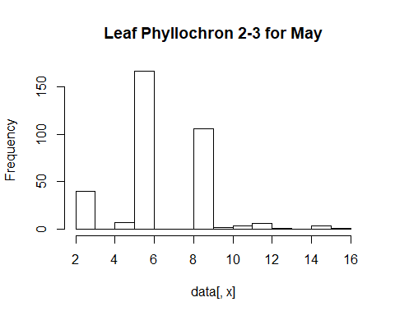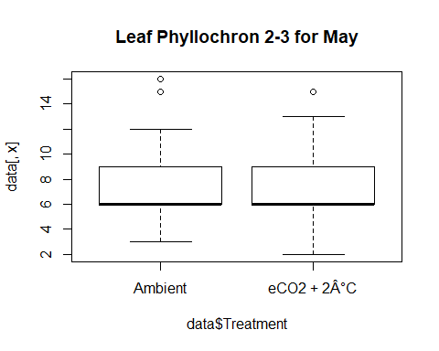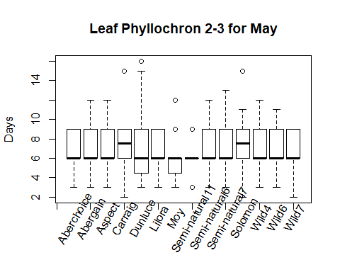

## [1] "NORMALITY TEST"

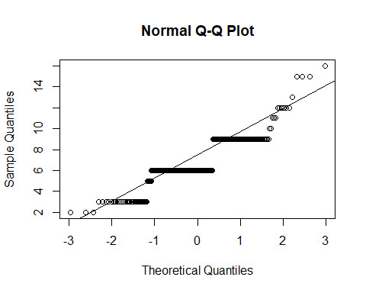

##   
## Shapiro-Wilk normality test  
##   
## data: data[, x]  
## W = 0.85309, p-value < 2.2e-16  
##   
## [1] "Based on shapiro test normality cannot be assumed"  
##   
## Wilcoxon rank sum test with continuity correction  
##   
## data: data[, x] by data$Treatment  
## W = 15146, p-value = 0.2063  
## alternative hypothesis: true location shift is not equal to 0  
##   
##   
## Kruskal-Wallis rank sum test  
##   
## data: data[, x] by data$Variety  
## Kruskal-Wallis chi-squared = 12.363, df = 13, p-value = 0.4981  
##   
## [1] "The Varieties don't differ significantly"  
## [1] "Leaf Phyllochron 2-3 for June"  
## [1] "DATA EXPLORATION"  
## Min. 1st Qu. Median Mean 3rd Qu. Max.   
## 2.000 4.000 7.000 6.039 7.000 11.000

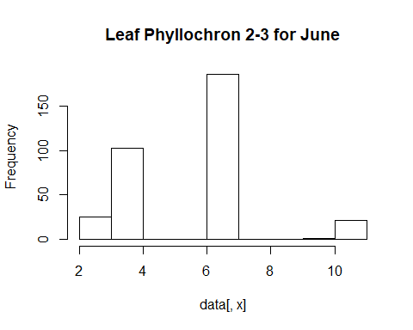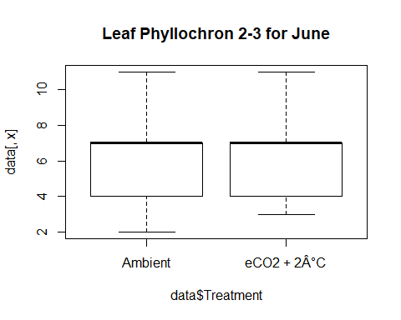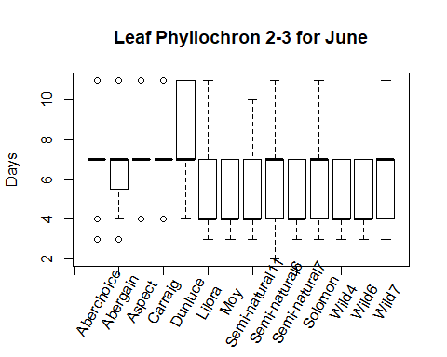

## [1] "NORMALITY TEST"

##   
## Shapiro-Wilk normality test  
##   
## data: data[, x]  
## W = 0.79292, p-value < 2.2e-16  
##   
## [1] "Based on shapiro test normality cannot be assumed"  
##   
## Wilcoxon rank sum test with continuity correction  
##   
## data: data[, x] by data$Treatment  
## W = 11584, p-value = 0.001516  
## alternative hypothesis: true location shift is not equal to 0  
##   
##   
## Kruskal-Wallis rank sum test  
##   
## data: data[, x] by data$Variety  
## Kruskal-Wallis chi-squared = 55.854, df = 13, p-value = 2.86e-07  
##   
## [1] "As the Kruskal test is significant a posthoc test will be performed"

## Warning in posthoc.kruskal.nemenyi.test.default(c(7L, 4L, 7L, 4L, 11L, 4L, :  
## Ties are present, p-values are not corrected.

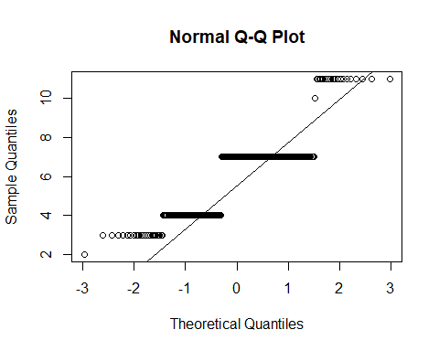

##   
## Pairwise comparisons using Tukey and Kramer (Nemenyi) test   
## with Tukey-Dist approximation for independent samples   
##   
## data: data[, x] by data$Variety   
##   
## Aberchoice Abergain Aspect Carraig Dunluce Lilora Moy   
## Abergain 1.000 - - - - - -   
## Aspect 1.000 1.000 - - - - -   
## Carraig 1.000 1.000 1.000 - - - -   
## Dunluce 1.000 0.965 1.000 1.000 - - -   
## Lilora 0.207 0.592 0.165 0.208 0.012 - -   
## Moy 0.349 0.767 0.290 0.350 0.029 1.000 -   
## Semi-natural11 0.116 0.421 0.089 0.116 0.005 1.000 1.000  
## Semi-natural6 0.998 1.000 0.995 0.998 0.731 0.914 0.974  
## Semi-natural7 0.274 0.686 0.223 0.275 0.019 1.000 1.000  
## Solomon 0.993 1.000 0.986 0.993 0.634 0.954 0.989  
## Wild4 0.481 0.871 0.413 0.483 0.054 1.000 1.000  
## Wild6 0.481 0.871 0.413 0.483 0.054 1.000 1.000  
## Wild7 0.919 0.998 0.882 0.919 0.325 0.997 1.000  
## Semi-natural11 Semi-natural6 Semi-natural7 Solomon Wild4 Wild6  
## Abergain - - - - - -   
## Aspect - - - - - -   
## Carraig - - - - - -   
## Dunluce - - - - - -   
## Lilora - - - - - -   
## Moy - - - - - -   
## Semi-natural11 - - - - - -   
## Semi-natural6 0.805 - - - - -   
## Semi-natural7 1.000 0.951 - - - -   
## Solomon 0.876 1.000 0.977 - - -   
## Wild4 1.000 0.993 1.000 0.998 - -   
## Wild6 1.000 0.993 1.000 0.998 1.000 -   
## Wild7 0.985 1.000 0.999 1.000 1.000 1.000  
##   
## P value adjustment method: none   
## [1] "Leaf Phyllochron 2-3 for July"  
## [1] "DATA EXPLORATION"  
## Min. 1st Qu. Median Mean 3rd Qu. Max.   
## 4.000 4.000 7.000 6.205 7.000 18.000

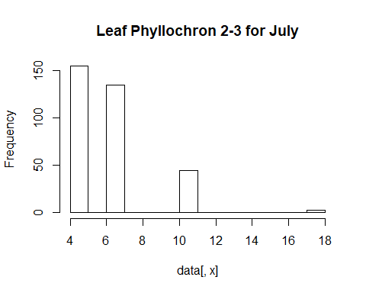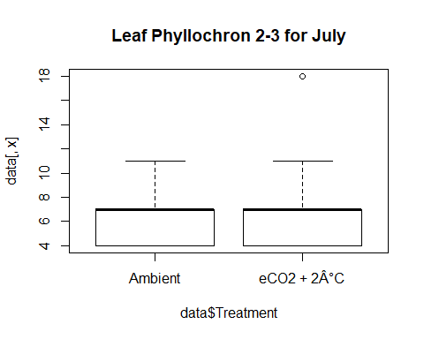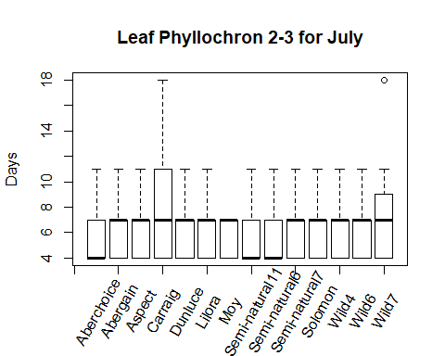

## [1] "NORMALITY TEST"

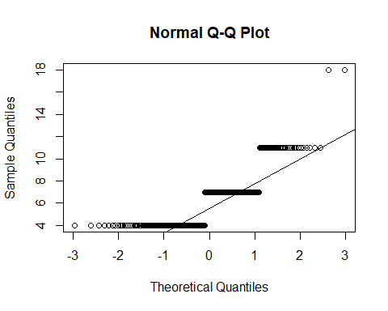

##   
## Shapiro-Wilk normality test  
##   
## data: data[, x]  
## W = 0.75524, p-value < 2.2e-16  
##   
## [1] "Based on shapiro test normality cannot be assumed"  
##   
## Wilcoxon rank sum test with continuity correction  
##   
## data: data[, x] by data$Treatment  
## W = 13668, p-value = 0.5852  
## alternative hypothesis: true location shift is not equal to 0  
##   
##   
## Kruskal-Wallis rank sum test  
##   
## data: data[, x] by data$Variety  
## Kruskal-Wallis chi-squared = 9.5556, df = 13, p-value = 0.7298  
##   
## [1] "The Varieties don't differ significantly"  
## [1] "Leaf Phyllochron 2-3 for August"  
## [1] "DATA EXPLORATION"  
## Min. 1st Qu. Median Mean 3rd Qu. Max.   
## 3.0 10.0 14.0 13.3 17.0 17.0

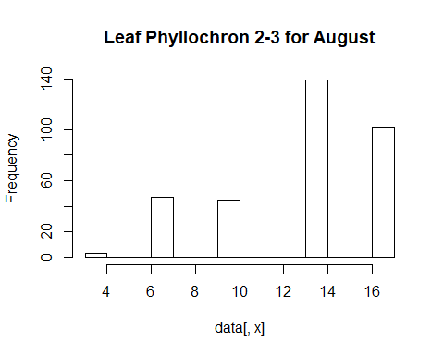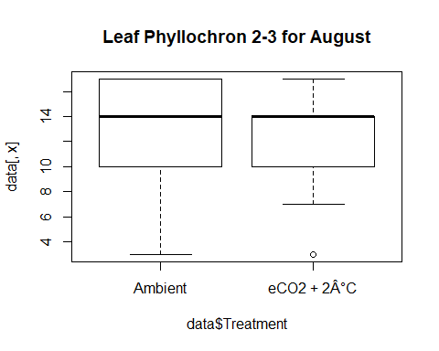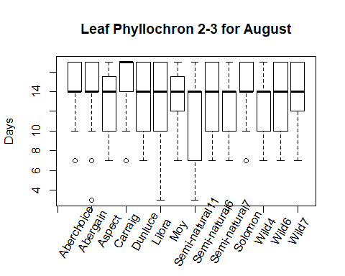

## [1] "NORMALITY TEST"

##   
## Shapiro-Wilk normality test  
##   
## data: data[, x]  
## W = 0.82829, p-value < 2.2e-16  
##   
## [1] "Based on shapiro test normality cannot be assumed"  
##   
## Wilcoxon rank sum test with continuity correction  
##   
## data: data[, x] by data$Treatment  
## W = 15730, p-value = 0.05503  
## alternative hypothesis: true location shift is not equal to 0  
##   
##   
## Kruskal-Wallis rank sum test  
##   
## data: data[, x] by data$Variety  
## Kruskal-Wallis chi-squared = 23.208, df = 13, p-value = 0.03925  
##   
## [1] "As the Kruskal test is significant a posthoc test will be performed"

## Warning in posthoc.kruskal.nemenyi.test.default(c(7L, 7L, 17L, 17L, 10L, : Ties  
## are present, p-values are not corrected.

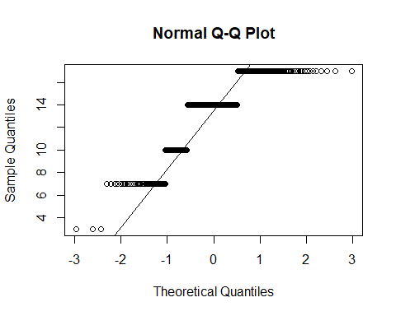

##   
## Pairwise comparisons using Tukey and Kramer (Nemenyi) test   
## with Tukey-Dist approximation for independent samples   
##   
## data: data[, x] by data$Variety   
##   
## Aberchoice Abergain Aspect Carraig Dunluce Lilora Moy   
## Abergain 1.000 - - - - - -   
## Aspect 0.993 1.000 - - - - -   
## Carraig 0.999 0.975 0.539 - - - -   
## Dunluce 1.000 1.000 1.000 0.806 - - -   
## Lilora 0.999 1.000 1.000 0.741 1.000 - -   
## Moy 1.000 1.000 1.000 0.821 1.000 1.000 -   
## Semi-natural11 0.279 0.551 0.978 0.013 0.867 0.911 0.855  
## Semi-natural6 0.995 1.000 1.000 0.571 1.000 1.000 1.000  
## Semi-natural7 0.997 1.000 1.000 0.610 1.000 1.000 1.000  
## Solomon 1.000 1.000 0.966 1.000 0.998 0.994 0.998  
## Wild4 0.941 0.995 1.000 0.291 1.000 1.000 1.000  
## Wild6 1.000 1.000 1.000 0.877 1.000 1.000 1.000  
## Wild7 1.000 1.000 1.000 0.980 1.000 1.000 1.000  
## Semi-natural11 Semi-natural6 Semi-natural7 Solomon Wild4 Wild6  
## Abergain - - - - - -   
## Aspect - - - - - -   
## Carraig - - - - - -   
## Dunluce - - - - - -   
## Lilora - - - - - -   
## Moy - - - - - -   
## Semi-natural11 - - - - - -   
## Semi-natural6 0.971 - - - - -   
## Semi-natural7 0.962 1.000 - - - -   
## Solomon 0.158 0.973 0.980 - - -   
## Wild4 0.999 1.000 1.000 0.844 - -   
## Wild6 0.794 1.000 1.000 0.999 1.000 -   
## Wild7 0.524 1.000 1.000 1.000 0.993 1.000  
##   
## P value adjustment method: none   
## [1] "Leaf Phyllochron 2-4 for May"  
## [1] "DATA EXPLORATION"  
## Min. 1st Qu. Median Mean 3rd Qu. Max.   
## 6.00 13.00 15.00 15.54 18.00 30.00

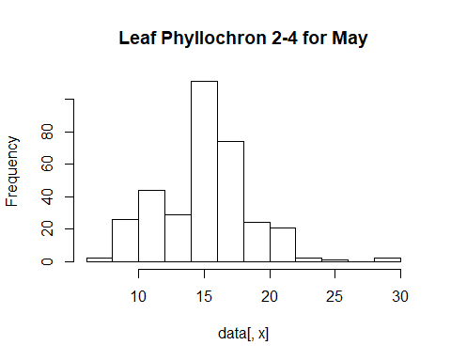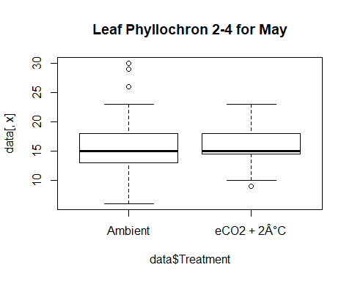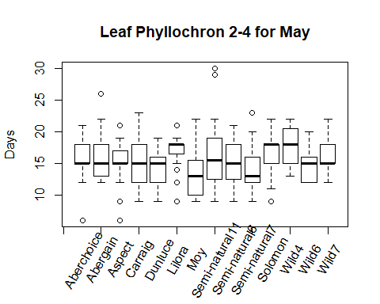

## [1] "NORMALITY TEST"

##   
## Shapiro-Wilk normality test  
##   
## data: data[, x]  
## W = 0.96277, p-value = 1.489e-07  
##   
## [1] "Based on shapiro test normality cannot be assumed"  
##   
## Wilcoxon rank sum test with continuity correction  
##   
## data: data[, x] by data$Treatment  
## W = 13032, p-value = 0.2183  
## alternative hypothesis: true location shift is not equal to 0  
##   
##   
## Kruskal-Wallis rank sum test  
##   
## data: data[, x] by data$Variety  
## Kruskal-Wallis chi-squared = 34.151, df = 13, p-value = 0.001142  
##   
## [1] "As the Kruskal test is significant a posthoc test will be performed"

## Warning in posthoc.kruskal.nemenyi.test.default(c(13L, 19L, 15L, 12L, 19L, :  
## Ties are present, p-values are not corrected.

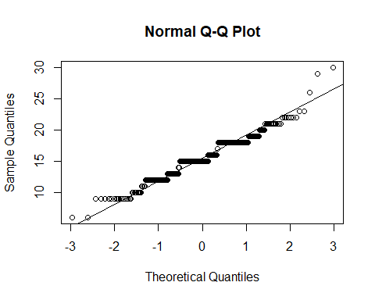

##   
## Pairwise comparisons using Tukey and Kramer (Nemenyi) test   
## with Tukey-Dist approximation for independent samples   
##   
## data: data[, x] by data$Variety   
##   
## Aberchoice Abergain Aspect Carraig Dunluce Lilora Moy   
## Abergain 1.0000 - - - - - -   
## Aspect 1.0000 1.0000 - - - - -   
## Carraig 1.0000 1.0000 1.0000 - - - -   
## Dunluce 0.9918 1.0000 0.9997 0.9998 - - -   
## Lilora 0.9713 0.7719 0.8622 0.8498 0.2427 - -   
## Moy 0.7319 0.9601 0.9150 0.9236 1.0000 0.0276 -   
## Semi-natural11 1.0000 1.0000 1.0000 1.0000 0.9961 0.9522 0.7937  
## Semi-natural6 1.0000 1.0000 1.0000 1.0000 1.0000 0.7625 0.9630  
## Semi-natural7 0.8675 0.9904 0.9731 0.9768 1.0000 0.0590 1.0000  
## Solomon 1.0000 0.9973 0.9995 0.9993 0.8190 0.9999 0.2869  
## Wild4 0.8611 0.5191 0.6407 0.6220 0.1004 1.0000 0.0076  
## Wild6 0.9892 0.9999 0.9995 0.9996 1.0000 0.2226 1.0000  
## Wild7 1.0000 0.9999 1.0000 1.0000 0.9529 0.9960 0.5207  
## Semi-natural11 Semi-natural6 Semi-natural7 Solomon Wild4 Wild6   
## Abergain - - - - - -   
## Aspect - - - - - -   
## Carraig - - - - - -   
## Dunluce - - - - - -   
## Lilora - - - - - -   
## Moy - - - - - -   
## Semi-natural11 - - - - - -   
## Semi-natural6 1.0000 - - - - -   
## Semi-natural7 0.9083 0.9914 - - - -   
## Solomon 1.0000 0.9970 0.4433 - - -   
## Wild4 0.8097 0.5079 0.0183 0.9956 - -   
## Wild6 0.9947 0.9999 1.0000 0.7968 0.0901 -   
## Wild7 1.0000 0.9999 0.6946 1.0000 0.9596 0.9432  
##   
## P value adjustment method: none   
## [1] "Leaf Phyllochron 2-4 for June"  
## [1] "DATA EXPLORATION"  
## Min. 1st Qu. Median Mean 3rd Qu. Max.   
## 7.00 11.00 11.00 12.38 14.00 21.00

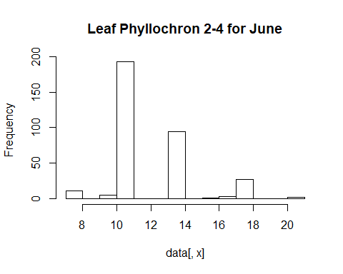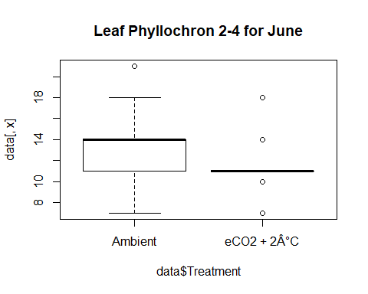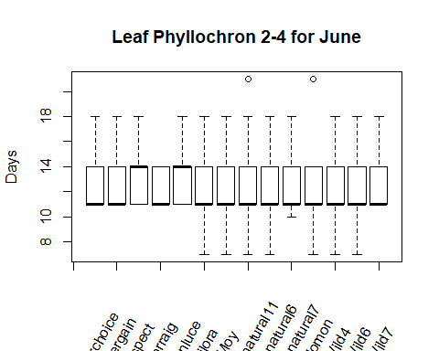

## [1] "NORMALITY TEST"

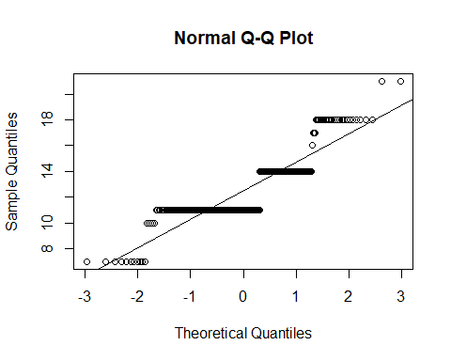

##   
## Shapiro-Wilk normality test  
##   
## data: data[, x]  
## W = 0.78528, p-value < 2.2e-16  
##   
## [1] "Based on shapiro test normality cannot be assumed"  
##   
## Wilcoxon rank sum test with continuity correction  
##   
## data: data[, x] by data$Treatment  
## W = 18853, p-value = 1.996e-09  
## alternative hypothesis: true location shift is not equal to 0  
##   
##   
## Kruskal-Wallis rank sum test  
##   
## data: data[, x] by data$Variety  
## Kruskal-Wallis chi-squared = 12.933, df = 13, p-value = 0.453  
##   
## [1] "The Varieties don't differ significantly"  
## [1] "Leaf Phyllochron 2-4 for July"  
## [1] "DATA EXPLORATION"  
## Min. 1st Qu. Median Mean 3rd Qu. Max.   
## 7.00 14.00 14.00 15.67 18.00 21.00

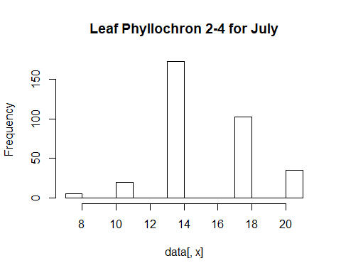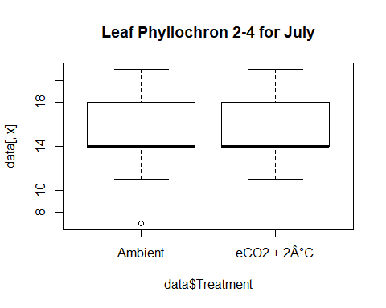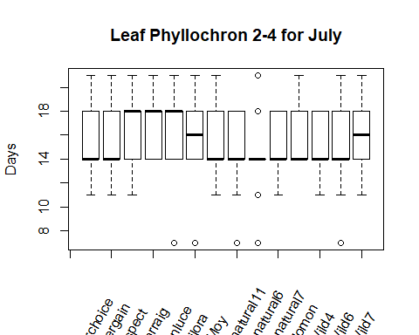

## [1] "NORMALITY TEST"

##   
## Shapiro-Wilk normality test  
##   
## data: data[, x]  
## W = 0.84142, p-value < 2.2e-16  
##   
## [1] "Based on shapiro test normality cannot be assumed"  
##   
## Wilcoxon rank sum test with continuity correction  
##   
## data: data[, x] by data$Treatment  
## W = 10784, p-value = 4.225e-05  
## alternative hypothesis: true location shift is not equal to 0  
##   
##   
## Kruskal-Wallis rank sum test  
##   
## data: data[, x] by data$Variety  
## Kruskal-Wallis chi-squared = 23.314, df = 13, p-value = 0.03806  
##   
## [1] "As the Kruskal test is significant a posthoc test will be performed"

## Warning in posthoc.kruskal.nemenyi.test.default(c(18L, 18L, 14L, 18L, 18L, :  
## Ties are present, p-values are not corrected.

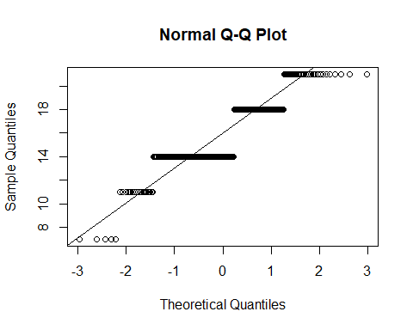

##   
## Pairwise comparisons using Tukey and Kramer (Nemenyi) test   
## with Tukey-Dist approximation for independent samples   
##   
## data: data[, x] by data$Variety   
##   
## Aberchoice Abergain Aspect Carraig Dunluce Lilora Moy   
## Abergain 1.00 - - - - - -   
## Aspect 1.00 1.00 - - - - -   
## Carraig 0.99 1.00 1.00 - - - -   
## Dunluce 1.00 1.00 1.00 1.00 - - -   
## Lilora 1.00 1.00 1.00 1.00 1.00 - -   
## Moy 1.00 1.00 1.00 0.87 0.93 0.99 -   
## Semi-natural11 1.00 0.99 0.95 0.56 0.68 0.87 1.00  
## Semi-natural6 0.97 0.91 0.71 0.23 0.32 0.54 1.00  
## Semi-natural7 1.00 1.00 1.00 0.88 0.94 0.99 1.00  
## Solomon 1.00 1.00 1.00 1.00 1.00 1.00 1.00  
## Wild4 1.00 1.00 0.96 0.62 0.73 0.90 1.00  
## Wild6 1.00 1.00 1.00 0.88 0.94 0.99 1.00  
## Wild7 1.00 1.00 1.00 1.00 1.00 1.00 0.98  
## Semi-natural11 Semi-natural6 Semi-natural7 Solomon Wild4 Wild6  
## Abergain - - - - - -   
## Aspect - - - - - -   
## Carraig - - - - - -   
## Dunluce - - - - - -   
## Lilora - - - - - -   
## Moy - - - - - -   
## Semi-natural11 - - - - - -   
## Semi-natural6 1.00 - - - - -   
## Semi-natural7 1.00 1.00 - - - -   
## Solomon 0.99 0.85 1.00 - - -   
## Wild4 1.00 1.00 1.00 0.99 - -   
## Wild6 1.00 1.00 1.00 1.00 1.00 -   
## Wild7 0.86 0.53 0.99 1.00 0.89 0.99   
##   
## P value adjustment method: none   
## [1] "Leaf Phyllochron 2-4 for August"  
## [1] "DATA EXPLORATION"  
## Min. 1st Qu. Median Mean 3rd Qu. Max.   
## 21.00 21.00 24.00 24.38 28.00 28.00

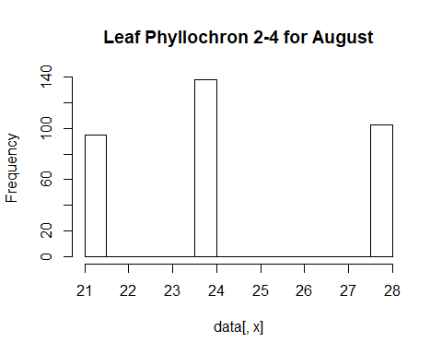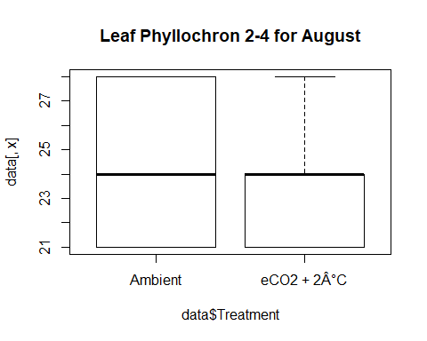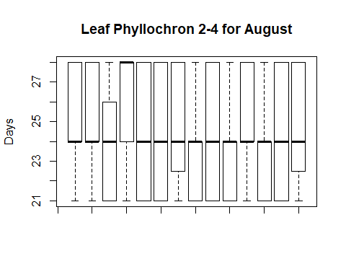

## [1] "NORMALITY TEST"

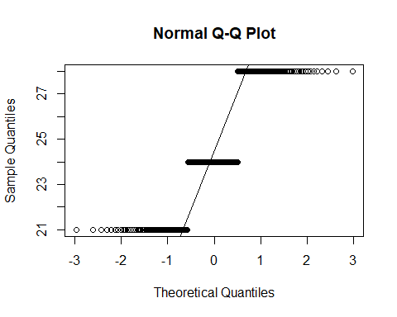

##   
## Shapiro-Wilk normality test  
##   
## data: data[, x]  
## W = 0.80056, p-value < 2.2e-16  
##   
## [1] "Based on shapiro test normality cannot be assumed"  
##   
## Wilcoxon rank sum test with continuity correction  
##   
## data: data[, x] by data$Treatment  
## W = 15793, p-value = 0.04412  
## alternative hypothesis: true location shift is not equal to 0  
##   
##   
## Kruskal-Wallis rank sum test  
##   
## data: data[, x] by data$Variety  
## Kruskal-Wallis chi-squared = 21.401, df = 13, p-value = 0.06536  
##   
## [1] "The Varieties don't differ significantly"  
## [1] "Leaf Phyllochron 3-4 for May"  
## [1] "DATA EXPLORATION"  
## Min. 1st Qu. Median Mean 3rd Qu. Max.   
## 3.000 6.000 9.000 8.679 10.000 24.000

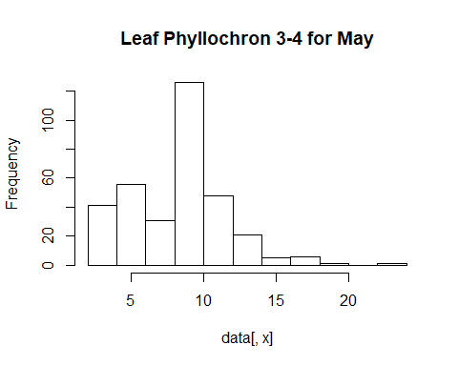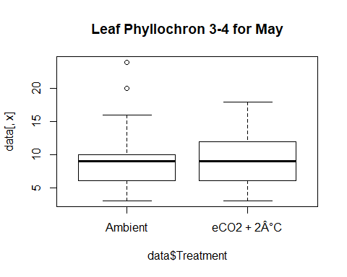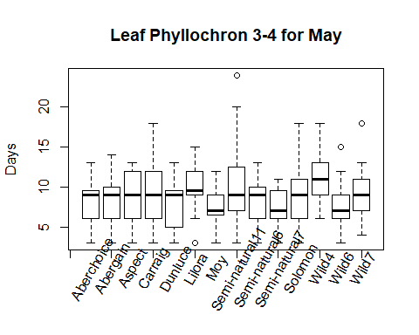

## [1] "NORMALITY TEST"

##   
## Shapiro-Wilk normality test  
##   
## data: data[, x]  
## W = 0.93788, p-value = 1.199e-10  
##   
## [1] "Based on shapiro test normality cannot be assumed"  
##   
## Wilcoxon rank sum test with continuity correction  
##   
## data: data[, x] by data$Treatment  
## W = 12696, p-value = 0.1053  
## alternative hypothesis: true location shift is not equal to 0  
##   
##   
## Kruskal-Wallis rank sum test  
##   
## data: data[, x] by data$Variety  
## Kruskal-Wallis chi-squared = 27.651, df = 13, p-value = 0.01012  
##   
## [1] "As the Kruskal test is significant a posthoc test will be performed"

## Warning in posthoc.kruskal.nemenyi.test.default(c(7L, 13L, 6L, 3L, 4L, 4L, :  
## Ties are present, p-values are not corrected.



##   
## Pairwise comparisons using Tukey and Kramer (Nemenyi) test   
## with Tukey-Dist approximation for independent samples   
##   
## data: data[, x] by data$Variety   
##   
## Aberchoice Abergain Aspect Carraig Dunluce Lilora Moy   
## Abergain 1.000 - - - - - -   
## Aspect 1.000 1.000 - - - - -   
## Carraig 1.000 1.000 1.000 - - - -   
## Dunluce 1.000 1.000 1.000 1.000 - - -   
## Lilora 0.903 0.887 0.845 0.515 0.364 - -   
## Moy 1.000 1.000 1.000 1.000 1.000 0.308 -   
## Semi-natural11 1.000 0.999 0.998 0.953 0.883 1.000 0.842  
## Semi-natural6 1.000 1.000 1.000 1.000 1.000 0.655 1.000  
## Semi-natural7 0.998 0.999 1.000 1.000 1.000 0.212 1.000  
## Solomon 1.000 1.000 1.000 1.000 1.000 0.928 0.999  
## Wild4 0.638 0.608 0.541 0.222 0.133 1.000 0.105  
## Wild6 0.999 0.999 1.000 1.000 1.000 0.232 1.000  
## Wild7 1.000 1.000 1.000 0.999 0.991 0.992 0.985  
## Semi-natural11 Semi-natural6 Semi-natural7 Solomon Wild4 Wild6  
## Abergain - - - - - -   
## Aspect - - - - - -   
## Carraig - - - - - -   
## Dunluce - - - - - -   
## Lilora - - - - - -   
## Moy - - - - - -   
## Semi-natural11 - - - - - -   
## Semi-natural6 0.984 - - - - -   
## Semi-natural7 0.737 1.000 - - - -   
## Solomon 1.000 1.000 0.997 - - -   
## Wild4 0.995 0.329 0.063 0.690 - -   
## Wild6 0.763 1.000 1.000 0.998 0.071 -   
## Wild7 1.000 1.000 0.958 1.000 0.908 0.966  
##   
## P value adjustment method: none   
## [1] "Leaf Phyllochron 3-4 for June"  
## [1] "DATA EXPLORATION"  
## Min. 1st Qu. Median Mean 3rd Qu. Max.   
## 3.000 4.000 7.000 6.345 7.000 18.000

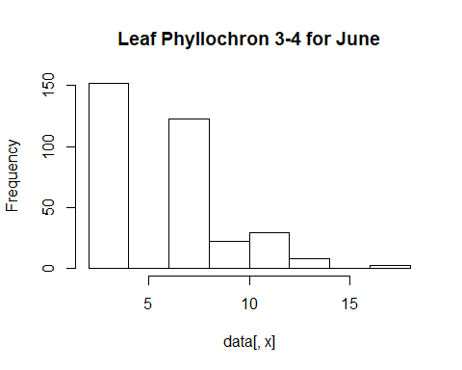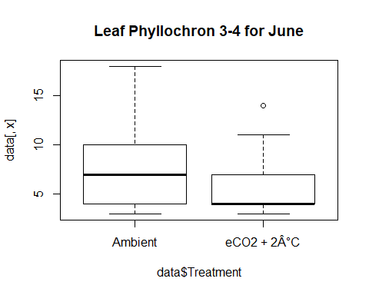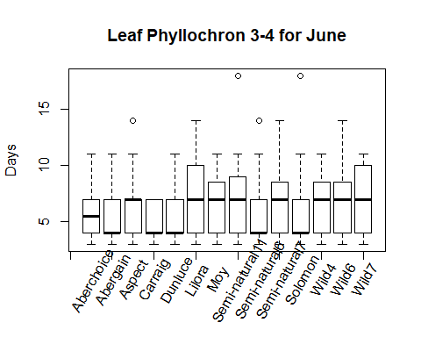

## [1] "NORMALITY TEST"



##   
## Shapiro-Wilk normality test  
##   
## data: data[, x]  
## W = 0.83364, p-value < 2.2e-16  
##   
## [1] "Based on shapiro test normality cannot be assumed"  
##   
## Wilcoxon rank sum test with continuity correction  
##   
## data: data[, x] by data$Treatment  
## W = 19129, p-value = 2.561e-09  
## alternative hypothesis: true location shift is not equal to 0  
##   
##   
## Kruskal-Wallis rank sum test  
##   
## data: data[, x] by data$Variety  
## Kruskal-Wallis chi-squared = 19.102, df = 13, p-value = 0.12  
##   
## [1] "The Varieties don't differ significantly"  
## [1] "Leaf Phyllochron 3-4 for July"  
## [1] "DATA EXPLORATION"  
## Min. 1st Qu. Median Mean 3rd Qu. Max.   
## 3.000 7.000 10.000 9.467 11.000 17.000

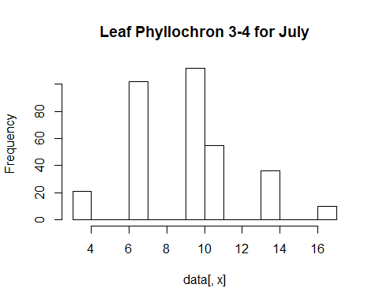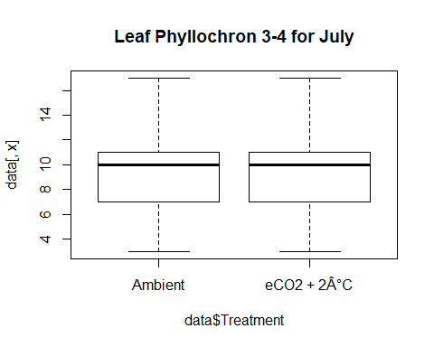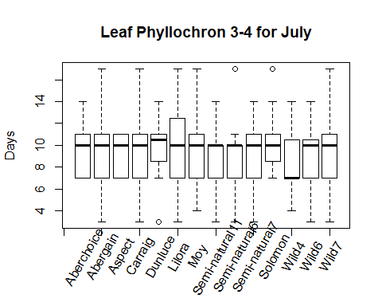

## [1] "NORMALITY TEST"

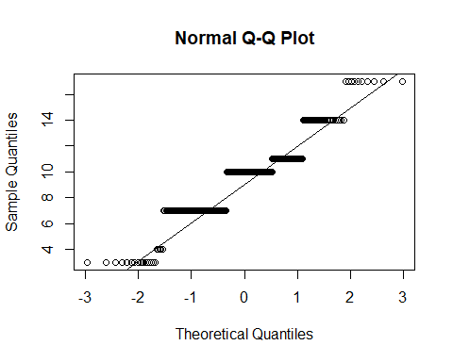

##   
## Shapiro-Wilk normality test  
##   
## data: data[, x]  
## W = 0.9092, p-value = 2.432e-13  
##   
## [1] "Based on shapiro test normality cannot be assumed"  
##   
## Wilcoxon rank sum test with continuity correction  
##   
## data: data[, x] by data$Treatment  
## W = 12070, p-value = 0.01737  
## alternative hypothesis: true location shift is not equal to 0  
##   
##   
## Kruskal-Wallis rank sum test  
##   
## data: data[, x] by data$Variety  
## Kruskal-Wallis chi-squared = 10.359, df = 13, p-value = 0.6644  
##   
## [1] "The Varieties don't differ significantly"  
## [1] "Leaf Phyllochron 3-4 for August"  
## [1] "DATA EXPLORATION"  
## Min. 1st Qu. Median Mean 3rd Qu. Max.   
## 10.00 10.00 11.00 11.08 11.00 18.00

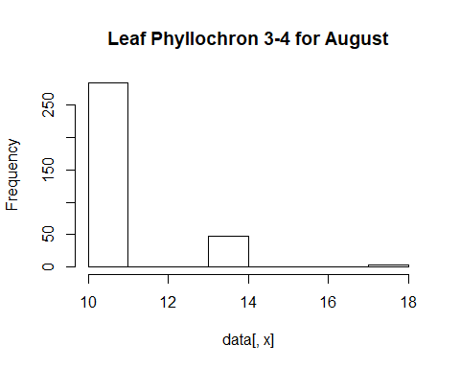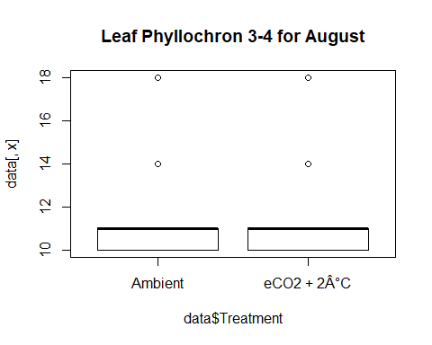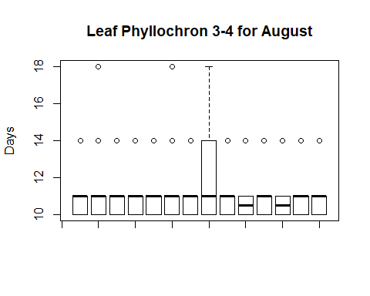

## [1] "NORMALITY TEST"

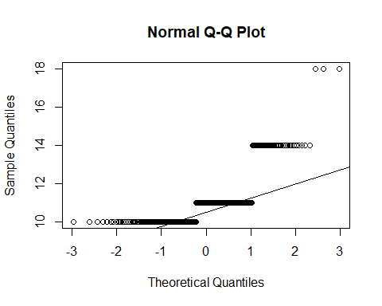

##   
## Shapiro-Wilk normality test  
##   
## data: data[, x]  
## W = 0.6667, p-value < 2.2e-16  
##   
## [1] "Based on shapiro test normality cannot be assumed"  
##   
## Wilcoxon rank sum test with continuity correction  
##   
## data: data[, x] by data$Treatment  
## W = 15644, p-value = 0.06124  
## alternative hypothesis: true location shift is not equal to 0  
##   
##   
## Kruskal-Wallis rank sum test  
##   
## data: data[, x] by data$Variety  
## Kruskal-Wallis chi-squared = 3.8994, df = 13, p-value = 0.9922  
##   
## [1] "The Varieties don't differ significantly"