**NASA AMES Igor CEDA exporter v2.0 user guide**

NASA AMES Igor CEDA exporter is a set of functions that run in Igor Pro to export data in NASA AMES format. It is tailored to exporting data gathered by aerosol mass spectrometer (AMS) or single-particle soot photometer (SP2) on the FAAM BAe-146 aircraft, though you could also use it for saving other data. The Centre for Environmental Data Analysis (CEDA) is the standard place to archive data from the 146- they have a function that checks whether your file fits a certain standard. This software is tailored to pass that test, and not necessarily to fit the exact standards of a particular version of NASA AMES format.

NASA AMES Igor exporter v1.0 was written by James Allan, University of Manchester.

v2.0 was updated by Jonathan Taylor, University of Manchester and tailored to exporting to CEDA using data gathered on the FAAM BAe-146.

This user guide was written by Jonathan Taylor.

If you have comments or questions, please email jonathan.taylor@manchester.ac.uk

**Overview of procedure**

There are 3 parts to the procedure. You can run the functions from the command line or from the data menu

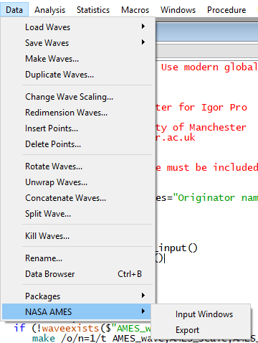

1. Run Ames_input() - this will set up the required fields for you to choose what data to export, and enter the metadata

2. Fill in metadata, data waves, time waves, normal comments and special comments as described below

3. Run Ames_Export() - this will save the actual file.

The filenames have to be a specific format. For the AMS an example is

man-ams_faam_20170816_r0_C028.na

For the SP2 an example is

man-sp2_faam_20170816_r0_C028.na

The date is the date the data were recorded. r0 is the revision number, and C028 is the flight number.

**Metadata**

Some basic details about the data

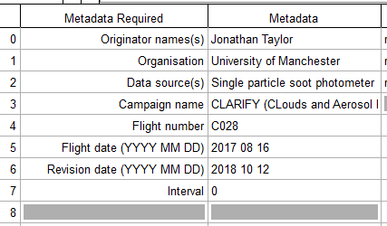

**Originator name** and **organisation** are obvious

**Data source(s)**: The instrument name in full and say it’s on the aircraft, e.g.

“Single particle soot photometer (SP2) refractory black carbon and light scattering particle concentrations from the FAAM Bae-146” or “Aerosol mass spectrometer (AMS) chemical mass concentrations from the FAAM BAe-146”

**Campaign name: T**he full name of the campaign and ideally the grant reference, e.g.

“CLARIFY (CLouds and Aerosol Radiative Impacts and Forcing: Year 2017), NERC grant NE/L013584/1”

**Flight number** and **Flight date** are obvious. If you are not using aircraft data then leave flight number blank and it should be OK.

**Revision date**: The date you are exporting the data, i.e. today’s date

**Interval:** The number of seconds between data points. 0 means it is variable. For the AMS you should leave it at 0, and I would also do for the SP2

**Data waves**

These are your data that you want to save. For SP2 it’s things like BC mass and number concentration, for AMS it’s things like nitrate, organic, sulphate mass concentrations

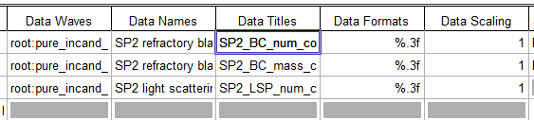

**Data Waves**: The path in your Igor experiment to the data waves you want to save, e.g. “Root:pure_incand_particles:incand_con” or “Root:Org_nofilter”

**Data Names:** A description of what each wave is, including the units, e.g. “SP2 refractory black carbon number concentration (particles per cubic centimetre at standard temperature and pressure)” or “AMS organic aerosol mass concentration (micrograms per cubic metre at standard temperature and pressure”. This will be in the metadata near the top of the file

**Data Titles:** What the waves will be called when someone loads the file into. This will sit at the top of each column when the actual data are saved

**Data Formats:** This is code in Igor to say how precise the data should be saved. In the example the 3 means the data will be saved to 3 significant figures. If you want to know more, search the Igor manual for “Creating Formatted Text” but generally you would just use “%.3f” for all your data waves for AMS and SP2.

**Data Scaling:** If for some reason your data needed scaling then you would set this to something other than 1. Normally you would leave it at 1.

**Time waves**

You need to specify a start and end time for each data point. This is so if someone wanted to average the data they can do it properly, otherwise they have to make some assumptions about what the averaging time was, or their averaging function might be slightly wrong. Most of the time it doesn’t matter if you’re 1 data point out but sometimes it does (e.g. cloud microphysics in an updraft)

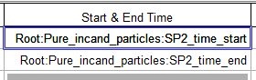

**But I don’t know what the start and end times are!**

There are 2 functions in the toolkit that you can use to calculate the start and end times. For AMS data, go to root:index in your Squirrel experiment and run AMS_make_time_waves_AMES()

For SP2 data, go into wherever your normal timewave is (normally root:pure_incand_particles:hk_time_av_incand) and run SP2_make_time_waves_AMES()

When the time waves are saved, they will be converted to seconds since midnight on that particular day. This is done automatically and makes it easier for everyone to load, as many people use data analysis tools that use a different time format to Igor.

**Normal comments**

These are fairly standard comments that don’t change very much between projects. They are mostly self-explanatory. The parts that would normally change between files are

**PI_CONTACT_INFO:** Input your email address and the PI’s

**LOCATION:** Enter the location of the project

**ASSOCIATED_DATA:** Provide the path on CEDA of the FAAM core data for this flight

**REVISION:** The first batch of data you upload to CEDA will be R0. If you need to update the data for some reason then the next batch would be R1.

Here are examples for the SP2:

PI_CONTACT_INFO: Centre for Atmospheric Science, School of Earth and Environmental Science, University of Manchester, Simon Building, Oxford Road, Manchester, M13 9PL ; jonathan.taylor@manchester.ac.uk; hugh.coe@manchester.ac.uk

PLATFORM: FAAM BAe 146

LOCATION: Ascension Island / South Atlantic. See associated FAAM data below

ASSOCIATED_DATA: See FAAM NetCDF file on CEDA at /badc/faam/data/2017/c028-aug-16/core_processed/

INSTRUMENT_INFO: Droplet Measurement Technologies Single Particle Soot Photometer

DATA_INFO: SP2 narrowband detector calibrated using aquadag selected by differential mobility analyser (DMA) and corrected as recommended by Laborde et al. (2012).

UNCERTAINTY: 20%

STIPULATIONS_ON_USE: Any users wishing to publish these data must offer coauthorship to the University of Manchester data providers and PI, and data must be used in accordance with the NERC data policy located at https://nerc.ukri.org/research/sites/data/policy/data-policy/

DM_CONTACT_INFO: support@ceda.ac.uk

OTHER_COMMENTS:

REVISION: R0

And the AMS:

PI_CONTACT_INFO: Centre for Atmospheric Science, School of Earth and Environmental Sciences, University of Manchester, Simon Building, Oxford Road, Manchester, M13 9PL ; Hugh.coe@manchester.ac.uk; Huihui.wu-3@postgrad.manchester.ac.uk

PLATFORM: FAAM BAe 146

LOCATION: Ascension Island / South Atlantic. See associated FAAM data below

ASSOCIATED_DATA: See FAAM NetCDF file on CEDA at /badc/faam/data/2017/c028-aug-16/core_processed/

INSTRUMENT_INFO: Aerodyne Aerosol Mass Spectrometer

DATA_INFO: Data are calibrated using size-selected ammonium nitrate. The relative ionisation efficiencies of ammonium and sulphate were calculated using ammonium nitrate and ammonium sulphate calibrations. The collection efficiency was calculated as per Middlebrook et al. (2011)

UNCERTAINTY: not included, available on request

STIPULATIONS_ON_USE: Any users wishing to publish these data must offer coauthorship to the University of Manchester data providers and PI, and data must be used in accordance with the NERC data policy located at https://nerc.ukri.org/research/sites/data/policy/data-policy/

DM_CONTACT_INFO: support@ceda.ac.uk

OTHER_COMMENTS: Standard temperature and pressure are 273.15 K, 1013.25 mbar

REVISION: R0

**Special comments**

These are *less* standard comments and might vary a bit more between projects, but they still are often quite similar. The line between what is a normal comment and what is a special comment is a bit blurry, particularly when the normal comments has a field called OTHER_COMMENTS. If you follow the examples here, you won’t go too far wrong

Example special comments for the SP2:

The term "light scattering particles" are particles that do not significantly absorb light and do not contain BC

Standard temperature and pressure correction has been applied using SP2 chamber temperature and pressure, concentrations are corrected to 273.15K and 1013.25mbar

SP2 refractory black carbon measurement range ~50-550nm (100 percent efficiency for particles >1fg)

SP2 light scattering particles measurement range ~200-600 nm

Users should note that in-cloud data are likely to be unreliable

Example special comments for the AMS:

AMS transmission range ~40-700nm (100 percent efficiency) at standard temperature and pressure

AMS values Org43, Org44 and Org60 are reported as partial micrograms per cubic meter - these are the concentrations that appear at m/z 43,44 and 60 in the mass spectrum

Users should note that in-cloud data are likely to be unreliable

The ionization calibration is the campaign postflight average

**Useful functions included in the toolkit**

AMS_make_time_waves_AMES() – generate AMS start and end time waves

SP2_make_time_waves_AMES() – generate SP2 start and end time waves

SP2_prep_AMES() – prepare SP2 data for saving. Makes the SP2 timewaves, averages the scatter concentration to the incand time series

Avg_data_startstop_time_AMES() – Average data from one time series to another

nan_average_AMES(thiswave,sp,ep) – averaging function, works like Igor’s mean() but works for data with NaNs