Great Bay (GRB) NERR Water Quality Metadata
April 14 – December 12, 2022
Latest Update: April 14, 2023

Note: This is a provisional metadata document; it has not been authenticated as of its download date. Contents of this document are subject to change throughout the QAQC process, and it should not be considered a final record of data documentation until that process is complete. Contact the CDMO cdmosupport@belle.baruch.sc.edu or Reserve with any additional questions.

I. Data Set and Research Descriptors

1) Principal investigator(s) and contact persons

Thomas K. Gregory
Research Scientist
Ocean Process Analysis Lab
University of New Hampshire
Durham, NH 03824
Email: Tom.Gregory@unh.edu
Phone (603) 862-5136

Lara Martin
Research Technician
University of New Hampshire
Jackson Estuarine Laboratory
85 Adams Point Road
Durham, NH 03824
Email: Lara.Martin@unh.edu
Phone (415) 680-4944

Christopher Peter
Research Coordinator
Great Bay National Estuarine Research Reserve
New Hampshire Fish & Game Department
89 Depot Road
Greenland, NH 03840
Email: Christopher.Peter@wildlife.nh.gov
Phone (603) 294-0146

2) Entry verification

Deployment data are uploaded from the YSI EXO2 data loggers to a Dell OptiPlex 3050 desktop computer. Files are exported from the KOR Software in a comma separated file (CSV) and uploaded to the CDMO where they undergo automated primary QAQC, automated depth corrections for changes in barometric pressure (cDepth parameter), and then become part of the CDMO’s online provisional database. All pre- and post-deployment data are removed from the file prior to upload. During primary QAQC, data are flagged if they are missing or out of sensor range. The edited file is then returned to the Reserve for secondary QAQC where it is opened in Microsoft Excel and processed using the CDMO’s NERRQAQC Excel macro. The macro inserts station codes, creates metadata worksheets for flagged data and summary statistics, and graphs the data for review. It allows the user to apply QAQC flags and codes to the data, remove any overlapping deployment data, append files, and export the resulting data file for upload to the CDMO. Upload after secondary QAQC results in ingestion into the database as provisional plus data, recalculation of the cDepth parameter, and finally tertiary QAQC by the CDMO and assimilation into the CDMO’s authoritative online database. Where deployment overlap occurs between files, the data produced by the newly calibrated sonde are generally accepted as being the most accurate.
For more information on QAQC flags and codes, see Sections 11 and 12. Tom Gregory and Lara Martin are responsible for data management. GRB NERR archives all raw and QAQC’d files in OneDrive, in addition to back-up hard drives.

3) Research objectives

YSI EXO2 data loggers, hereafter referred to as sondes, are deployed in the middle of Great Bay (GB) and in the Squamscott (SQ), Oyster (OR), and Lamprey Rivers (LR) as part of the National Estuarine Research Reserves' (NERRS) System-wide Monitoring Program (SWMP). The goal is to develop and maintain temporally intensive long-term datasets of physio-chemical parameters of water quality at locations that are representative of the Great Bay estuarine system. The Great Bay site is relatively unimpacted, while the three tidal river sites (Lamprey, Oyster and Squamscott) have large drainage basins and are impacted by both point (wastewater treatment plants) and nonpoint sources of pollution. In addition to establishing a baseline of water quality and increasing our understanding of the spatial and temporal variability of important indicators of estuarine water quality, the data are used by researchers in the analysis of physical and biological processes.

4) Research methods

Sondes are programmed to obtain measurements of specific conductivity, salinity, dissolved oxygen mg/L and percent saturation, pH, temperature, depth, and turbidity every 15 minutes (Eastern Standard Time). Only EXO2 sondes were deployed 2017-2022, although in years before this, YSI model 6600 sondes were used. All are equipped with non-vented depth sensors.

Sondes are swapped every three to four weeks although CDMO protocols permit deployments up to 45 days. The sonde in the field is retrieved and a newly calibrated replacement deployed immediately so there is little to no data gap. The 3-4 week deployment duration may be constrained by battery life (shorter life in colder waters) and fouling of the sensors during the warm summer months. The instruments are deployed continuously during ice-free seasons, except for brief periods when they are removed for cleaning, maintenance, and recalibration.

YSI conductivity standard (YSI 3169 – 50 mS/cm) and Fondriest Environmental pH 7 and 10 buffers (FNBU5007-G and FNBU5010-G) are used for calibration. YSI turbidity standard (YSI 6073G – 124 FNU) is used to calibrate turbidity probes. Air-saturated water is used to calibrate percent dissolved oxygen. Temperature sensors are cross-checked every calibration against a NIST traceable certified thermometer. After a deployment, each sonde is brought back to the laboratory for a post-calibration check. Each sensor is run in its respective standard to determine whether calibration values have drifted during deployment.

During each sonde replacement, field measurements of temperature, salinity, specific conductivity, and dissolved and percent oxygen are recorded using a handheld YSI PRO 2030 field meter.

Total Algae sensors (chlorophyll-a, in addition to blue-green algae/phycocyanin [BGA-PC]) and fluorescent dissolved organic matter (fDOM) sensors are now being deployed at all Great Bay reserve sites. Only chlorophyll-a µg/L data are QAQC’d using the CDMO macro. Blue-green algae and fDOM data are included in the reported dataset but have not been officially QAQC’d. Please contact the reserve for this data and sensor calibration protocols.

Chlorophyll sensors are individually calibrated in RFU and µg/L units using a 2-point calibration method. Deionized water is used as a 0 standard and a Rhodamine WT dye as the second standard (0.625 mg/L Rhodamine WT dilution--200:1 dilution of the original liquid concentrate). The effect of temperature on the fluorescence of Rhodamine WT dye is accounted for when calibrating the EXO Total Algae sensor. The temperature correction coefficient of the Rhodamine WT standard solution is determined using a table provided by YSI. The true temperature of the standard is cross-referenced to table values to obtain the corrected µg/L and RFU chl-a values for Rhodamine WT. The corrected fluorescence value is entered in the KOR software for calibration. After each deployment, we post-calibrate the sensors in deionized water and dye standard to determine if there was significant drift during the deployment.

The Lamprey and Squamscott River sondes are deployed inside vertical piling-mounted 4-inch PVC tubes with the sensors 0.5 meters off the bottom. The bottom of the SQ pipe has four 10-inch rectangular slots cut out to facilitate water flow. The LR sonde pipe has many 2-inch holes cut out for water flow.

The Great Bay sonde is deployed 0.5 meters off the bottom inside a 3-foot PVC tube that is attached to the shank of a 50-pound mushroom anchor. This pipe also has four 10-inch slots cut out.

Due to shallow depths and a narrow channel, the Oyster River sonde must be deployed with the least amount of vertical expression above bottom. Typically, it is around 0.5 meters, but it can be as shallow as 0.3 meters. This is achieved by deploying the sonde inside a 3-foot PVC tube that is attached to the shank of a 50-pound mushroom anchor, like the Great Bay site. This allows for the sonde to be stationed in an upright position but also makes the anchor less susceptible to dragging. The bottom of this pipe also has four 10-inch slots for flow.

Historically, the Squamscott River sonde was telemetered using Nexsens cellular technology, although for 2022 it was not. The transmissions were scheduled hourly and contained 4 data sets reflecting fifteen-minute data sampling intervals. Upon receipt by the CDMO, the data underwent the same automated primary QAQC process detailed in Section 2 above. The “real-time” telemetry data become part of the provisional dataset until undergoing secondary and tertiary QAQC and assimilation in the CDMO’s authoritative online database. Provisional and authoritative data are available at http://cdmo.baruch.sc.edu.

5) Site location and character

Site #1 Great Bay (GB)
Location: Central area of Great Bay proper.
Coordinates: 43º 04' 20" N latitude and 70º 52' 10" W longitude.
Salinity range: 5-32 ppt (seasonally); 0-5 ppt from high to low tide.
Temperature range: -1º C to 24º C (seasonally); 0-3º (from high to low tide)
Depth: 6.5 meters at MLW
Tidal height: 2.7 meters
Bottom type: Mud, shell, and rock channel bottom
Tidal velocity: maximum 50 cm/sec
Watersheds: Squamscott, Lamprey, and Winnicut Rivers plus smaller streams.
High tide influence from Little Bay and associated rivers
Pollutant influence: Unimpacted reference site

Site #2 Squamscott River (SQ)
Location: Mid channel of the Squamscott River - Boston and Maine Railroad Bridge, Stratham, NH.
Coordinates: 43º 02' 30" N latitude and 70º 55' 20" W longitude
Salinity range: 0-32 ppt (seasonally); 5-20 ppt from high to low tide.
Temperature range: -1º C to 27º C (seasonally); difference of 0-5º between high and low tide
Depth: 3.5 meters at MLW
Tidal height: 2.7 meters
Bottom type: Mud/oyster channel bottom
Tidal velocity: maximum 50 cm/sec
Watersheds: Exeter River, adjacent marshes
Pollutant influence: Urban stormwater, agriculture, two municipal wastewater treatment plants, residential septic systems

Site #3 Lamprey River (LR)
Location: West bank of the tidal portion of the Lamprey River, approximately 300 m downstream of the dam at Route 108 in Newmarket, NH.
Coordinates: 43º 04' 48" N latitude and 70º 56' 04" W longitude.
Salinity range: 0-30 ppt (seasonally); difference of up to 15 ppt between high and low tides.
Temperature range: -1º C to 27º C (seasonally); difference of up to 5º C between high and low tides.
Depth: 3.5 meters
Tidal height: 2.7 meters
Bottom type: Mud/rock
Tidal velocity: maximum 40 cm/sec
Watershed: Lamprey River
Pollutant influence: Urban stormwater, adjacent marina, upstream and downstream wastewater treatment plants, upstream agriculture

Site #4 Oyster River (OR)
Location: In the center channel of the tidal portion of the Oyster River, approximately 300 m downstream of the head of tide dam adjacent to Jackson’s Landing in Durham, NH.
Coordinates: 43.134º N latitude and 70.911º W longitude
Salinity range: 0-32 ppt (seasonally); difference of up to 15 ppt between high and low tides
Temperature range: -1º C to 27º C (seasonally); difference of up to 5° C between high and low tides
Depth: 0.3 meters at MLW, 3 meters at highest high tides
Tidal height: 2.7 meters (maximum)
Bottom type: Mud
Tidal velocity: maximum 40 cm/sec
Watershed: Oyster River
Pollutant influence: Urban stormwater, mooring field and crew dock, downstream wastewater treatment plant, upstream agriculture, residential on-site sewage disposal.

Station Code | SWMP Status | Station Name | Location | Active Dates | Reason Decommissioned | Notes
GB | P | Great Bay | 43º 04’ 20" N, 70º 52' 10" W | 07/1995 –  present | NA | NA
LR | P | Lamprey River | 43º 04' 48" N, 70º 56' 04" W | 05/1998 –  present | NA | NA
OR | P | Oyster River | 43º 08’ 02” N, 70º 54’ 40” W | 06/2000 –  present | NA | NA
SQ | P | Squamscott River | 43º 02' 30" N, 70º 55' 20" W | 07/1997 –  present | NA | NA

6) Data collection period

Great Bay data collection began July 24, 1995. This sonde was originally on a floating buoy,
approximately one meter below the surface. It was moved to its current location and depth (0.5
meters off the bottom) April 2014.
Squamscott River data collection began July 1997.
Lamprey River data collection began May 1998.
Oyster River data collection began June 2000.

The instruments are removed from the water during the winter months due to non-navigable conditions caused by ice and the removal of channel markers. Icing is particularly severe in the rivers and is harmful to instruments, boats, and telemetry equipment.

Great Bay Reserve Deployment Dates 2022

Great Bay
Deploy date and time Retrieval date and time
04/14/2022 14:15 05/05/2022 11:45
05/05/2022 12:00 06/02/2022 13:15
06/02/2022 13:30 07/01/2022 12:30 (Sonde batteries died 06/25/2022 08:15)
07/01/2022 13:00 08/01/2022 12:00
08/01/2022 12:30 08/26/2022 09:00
08/26/2022 09:15 09/26/2022 09:45
09/26/2022 10:00 10/26/2022 13:15
10/26/2022 13:30 11/18/2022 10:30
11/18/2022 10:45 12/08/2022 11:15

Lamprey River
Deploy date and time Retrieval date and time
04/15/2022 11:00 05/10/2022 07:15
05/10/2022 07:30 06/07/2022 08:00
06/07/2022 08:15 07/06/2022 07:15
07/06/2022 07:30 08/08/2022 08:45
08/08/2022 09:00 09/09/2022 10:30
09/09/2022 10:45 10/13/2022 13:15
10/13/2022 13:30 11/11/2022 13:00
11/11/2022 13:15 12/12/2022 13:45

Oyster River
Deploy date and time Retrieval date and time
04/14/2022 13:30 05/02/2022 13:30
05/02/2022 13:45 05/26/2022 09:45
05/26/2022 10:15 06/22/2022 09:45
06/22/2022 10:00 07/21/2022 10:15
07/21/2022 10:30 08/15/2022 13:45
08/15/2022 14:00 09/07/2022 09:00
09/07/2022 09:30 09/28/2022 14:30
09/28/2022 14:45 10/28/2022 13:00
10/28/2022 13:15 11/23/2022 13:00
11/23/2022 13:15 12/06/2022 11:30

Squamscott River
Deploy date and time Retrieval date and time
04/18/2022 08:15 05/11/2022 10:15
05/11/2022 10:30 06/07/2022 11:30
06/07/2022 11:45 07/01/2022 13:00
07/01/2022 13:15 08/01/2022 11:00
08/01/2022 12:00 08/22/2022 10:45
08/22/2022 11:00 09/21/2022 10:30
09/21/2022 10:45 10/24/2022 14:30
10/24/2022 14:45 11/18/2022 10:00
11/18/2022 10:15 12/08/2022 11:00

7) Distribution

NOAA retains the right to analyze, synthesize and publish summaries of the NERRS System-wide Monitoring Program data. The NERRS retains the right to be fully credited for having collected and processed the data. Following academic courtesy standards, the NERR site where the data were collected should be contacted and fully acknowledged in any subsequent publications in which any part of the data are used. The data set enclosed within this package/transmission is only as good as the quality assurance and quality control procedures outlined by the enclosed metadata reporting statement. The user bears all responsibility for its subsequent use/misuse in any further analyses or comparisons. The Federal government does not assume liability to the Recipient or third persons, nor will the Federal government reimburse or indemnify the Recipient for its liability due to any losses resulting in any way from the use of this data.

Requested citation format:
NOAA National Estuarine Research Reserve System (NERRS). System-wide Monitoring Program. Data accessed from the NOAA NERRS Centralized Data Management Office website: http://www.nerrsdata.org/; accessed 12 October 2022.

NERR water quality data and metadata can be obtained from the Research Coordinator at the individual NERR site (please see Principal Investigators and Contact Persons), from the Data Manager at the Centralized Data Management Office (please see personnel directory under the general information link on the CDMO home page) and online at the CDMO home page www.nerrsdata.org. Data are available in comma delimited format.

8) Associated researchers, projects, and data end-users

As part of the SWMP long-term monitoring program, GRB NERR also monitors 15-minute meteorological along with monthly grab samples and diel sampling for nutrient data which may be correlated with this water quality dataset. These data are available at www.nerrsdata.org.

Submerged Aquatic Vegetation (SAV) research – Dr. David Burdick; Dr. Gregg Moore; Dr. Fred Short - Jackson Estuarine Laboratory. Supported by Piscataqua Region Estuaries Partnership and NH Department of Environmental Services.

Oyster reef mapping and restoration – Dr. Ray Grizzle, Jackson Estuarine Laboratory. Supported by NH Fish and Game, the NOAA-UNH Joint Hydrographic Center and the Center for Coastal and Ocean Mapping.

EPA National Coastal Assessment Program – Dr. Stephen H. Jones, Jackson Estuarine Laboratory. Funded by the US-EPA.

Oyster spawning and recruitment trends – The Nature Conservancy, University of New Hampshire, Great Bay NERR, and NH Fish and Game utilize temperature and salinity data for predictions.

Lobster and horseshoe crab migration trends – Dr. Win Watson, Jackson Estuarine Laboratory.

II. Physical Structure Descriptors

9) Sensor specifications

Great Bay NERR deployed only EXO2 sondes this monitoring year. Most of the sondes and sensors used were manufactured in 2016, 2017, and 2018. The reserve is still using two EXO2 sondes from 2014 and several probes from that year. Typically, the sondes are outfitted with the same set of sensors throughout the monitoring season, although the sondes are rotated between all the sites. The reserve is now using Total Algae (Chlorophyll/BGA-PC) and fDOM probes which are a part of the sensor configuration.

YSI EXO2 Sonde:

Parameter: Temperature
Units: Celsius (C)
Sensor Type: Wiped probe; Thermistor
Model#: 599827
Range: -5 to 50º C
Accuracy: ±0.2º C
Resolution: 0.001º C

Parameter: Conductivity
Units: milli-siemens per cm (mS/cm)
Sensor Type: Wiped probe; 4-electrode cell with autoranging
Model#: 599827
Range: 0 to 100 mS/cm
Accuracy: ±1% of the reading or 0.002 mS/cm, whichever is greater
Resolution: 0.0001 to 0.01 mS/cm (range dependent)

Parameter: Salinity
Units: practical salinity units (psu)/parts per thousand (ppt)
Model#: 599827
Sensor Type: Wiped probe. Values calculated using conductivity and temperature data.
Range: 0 to 70 ppt
Accuracy: ±2% of the reading or 0.2 ppt, whichever is greater
Resolution: 0.01 psu

Parameter: Dissolved Oxygen % saturation
Units: percent air saturation (%)
Sensor Type: Optical probe w/ mechanical cleaning
Model#: 599100-01
Range: 0 to 500% air saturation
Accuracy: 0-200% air saturation: +/- 1% of the reading or 1% air saturation, whichever is greater.
200-500% air saturation: +/- 5% or reading
Resolution: 0.1% air saturation

Parameter: Dissolved Oxygen mg/L (Calculated from % air saturation, temperature, and salinity)
Units: milligrams/Liter (mg/L)
Sensor Type: Optical probe w/ mechanical cleaning
Model#: 599100-01
Range: 0 to 50 mg/L
Accuracy: 0-20 mg/L: +/-0.1 mg/l or 1% of the reading, whichever is greater
20 to 50 mg/L: +/- 5% of the reading
Resolution: 0.01 mg/L

Parameter: Non-vented Level - Shallow (Depth)
Units: feet or meters (ft or m)
Sensor Type: Stainless steel strain gauge
Range: 0 to 33 ft (10 m)
Accuracy: +/- 0.013 ft (0.04 m)
Resolution: 0.001 ft (0.001 m)

Parameter: pH
Units: pH units
Sensor Type: Glass combination electrode
Model#: 599702 (wiped)
Range: 0 to 14 units
Accuracy: +/- 0.01 units within +/- 10° of calibration temperature, +/- 0.02 units for entire
temperature range
Resolution: 0.01 units

Parameter: Turbidity
Units: formazin nephelometric units (FNU)
Sensor Type: Optical, 90º scatter
Model#: 599101-01
Range: 0 to 4000 FNU
Accuracy: 0 to 999 FNU: 0.3 FNU or +/-2% of reading (whichever is greater).
1000 to 4000 FNU +/-5% of reading
Resolution: 0 to 999 FNU: 0.01 FNU, 1000 to 4000 FNU: 0.1 FNU

Parameter: Chlorophyll/Total Algae (BGA-PC)
Units: micrograms/Liter (µg/L)
Sensor Type: Optical probe with mechanical cleaning
Model#: 599102-01
Range: 0 to 400 µg/Liter
Accuracy: Dependent on methodology
Resolution: 0.1 µg/Liter chl-a, 0.1% FS

Parameter: fDOM (fluorescent dissolved organic matter)
Units: Quinine sulfate units (QSU)
Sensor Type: Optical probe with mechanical cleaning
Model#: 599104-01
Range: 0 to 300 parts per billion (ppb) Quinine Sulfate equivalent (QSE)
Accuracy: Dependent on methodology
Resolution: 0.01 ppb QSE
Detection Limit: 0.07 ppb QSE

Depth Qualifier:

The NERR System-Wide Monitoring Program utilizes YSI data sondes that can be equipped with either vented or non-vented depth/level sensors. Readings for both vented and non-vented sensors are automatically compensated for water density change due to variations in temperature and salinity; but for all non-vented depth measurements, changes in atmospheric pressure between calibrations appear as changes in water depth. The error is equal to approximately 1.02 cm for every 1 millibar change in atmospheric pressure and is eliminated for vented sensors because they are vented to the atmosphere throughout the deployment time interval.

Beginning in 2006, NERR SWMP standard calibration protocol called for all non-vented depth sensors to read 0 meters at a (local) barometric pressure of 1013.25 mb (760 mm/Hg). To achieve this, each reserve calibrated their depth sensor with a depth offset number, which is calculated using the actual atmospheric pressure at the time of calibration and the equation provided in the SWMP calibration sheet or digital calibration log. This offset procedure standardized each depth calibration for the entire NERR System. If accurate atmospheric pressure data are available, non-vented sensor depth measurements at any NERR can be corrected.

In 2010, the CDMO began automatically correcting depth/level data for changes in barometric pressure as measured by the Reserve’s associated meteorological station during data ingestion. These corrected depth/level data are reported as cDepth and cLevel and are assigned QAQC flags and codes based on QAQC protocols. Please see sections 11 and 12 for QAQC flag and code definitions.

NOTE: Older depth data cannot be corrected without verifying that the depth offset was in place and whether a vented or non-vented depth sensor was in use. No SWMP data prior to 2006 can be corrected using this method.
The following equation was used for corrected depth/level data provided by the CDMO beginning in 2010:
((1013-BP)*0.0102) + Depth/Level = cDepth/cLevel.

Salinity Units Qualifier:

In 2013, EXO sondes were approved for SWMP use and began to be utilized by Reserves. While the 6600 series sondes report salinity in parts per thousand (ppt) units, the EXO sondes report practical salinity units (psu). These units are essentially the same and for SWMP purposes are understood to be equivalent, however psu is considered the more appropriate designation. Moving forward the NERR System will assign psu salinity units for all data regardless of the sonde type.

Turbidity Qualifier:

In 2013, EXO sondes were approved for SWMP use and began to be utilized by Reserves. While the 6600 series sondes report turbidity in nephelometric turbidity units (NTU), the EXO sondes use formazin nephelometric units (FNU). These units are essentially the same but indicate a difference in sensor methodology, for SWMP purposes they will be considered equivalent. Moving forward, the NERR System will use FNU/NTU as the designated units for all turbidity data regardless of the sonde type. If turbidity units and sensor methodology are of concern, please see the Sensor Specifications portion of the metadata.

Chlorophyll Fluorescence Disclaimer:
YSI chlorophyll sensors (6025 or 599102-01) are designed to serve as a proxy for chlorophyll concentrations in the field for monitoring applications and complement traditional lab extraction methods; therefore, there are accuracy limitations associated with the data that are detailed in the YSI manual including interference from other fluorescent species, differences in calibration method, and effects of cell structure, particle size, organism type, temperature, and light on sensor measurements.

10) Coded variable definitions

Sampling station: Sampling site code: Station code:

Great Bay GB grbgbwq
Lamprey River LR grblrwq
Oyster River OR grborwq
Squamscott River SQ grbsqwq

11) QAQC flag definitions

QAQC flags provide documentation of the data and are applied to individual data points by insertion into the parameter’s associated flag column (header preceded by an F_). During primary automated QAQC (performed by the CDMO), -5, -4, and -2 flags are applied automatically to indicate data that is missing and above or below sensor range. All remaining data are then flagged 0, passing initial QAQC checks. During secondary and tertiary QAQC 1, -3, and 5 flags may be used to note data as suspect, rejected due to QAQC, or corrected.

-5 Outside High Sensor Range
-4 Outside Low Sensor Range
-3 Data Rejected due to QAQC
-2 Missing Data
-1 Optional SWMP Supported Parameter
0 Data Passed Initial QAQC Checks
1 Suspect Data
2 Open - reserved for later flag
3 Calculated data: non-vented depth/level sensor correction for changes in barometric pressure
4 Historical Data: Pre-Auto QAQC
5 Corrected Data

12) QAQC code definitions

QAQC codes are used in conjunction with QAQC flags to provide further documentation of the data and are also applied by insertion into the associated flag column. There are three (3) different code categories, general, sensor, and comment. General errors document general problems with the deployment or YSI datasonde, sensor errors are sensor specific, and comment codes are used to further document conditions or a problem with the data. Only one general or sensor error and one comment code can be applied to a particular data point, but some comment codes (marked with an * below) can be applied to the entire record in the F_Record column.

General Errors
GIC No instrument deployed due to ice
GIM Instrument malfunction
GIT Instrument recording error; recovered telemetry data
GMC No instrument deployed due to maintenance/calibration
GNF Deployment tube clogged / no flow
GOW Out of water event
GPF Power failure/ low battery
GQR Data rejected due to QA/QC checks
GSM See metadata

Corrected Depth/Level Data Codes
GCC Calculated with data that were corrected during QA/QC
GCM Calculated value could not be determined due to missing data
GCR Calculated value could not be determined due to rejected data
GCS Calculated value suspect due to questionable data
GCU Calculated value could not be determined due to unavailable data

Sensor Errors
SBO Blocked optic
SCF Conductivity sensor failure
SCS Chlorophyll spike
SDF Depth port frozen
SDG Suspect due to sensor diagnostics
SDO DO suspect
SDP DO membrane puncture
SIC Incorrect calibration / contaminated standard
SNV Negative value
SOW Sensor out of water
SPC Post calibration out of range
SQR Data rejected due to QAQC checks
SSD Sensor drift
SSM Sensor malfunction
SSR Sensor removed / not deployed
STF Catastrophic temperature sensor failure
STS Turbidity spike
SWM Wiper malfunction / loss

Comments
CAB* Algal bloom
CAF Acceptable calibration/accuracy error of sensor
CAP Depth sensor in water, affected by atmospheric pressure
CBF Biofouling
CCU Cause unknown
CDA* DO hypoxia (<3 mg/L)
CDB* Disturbed bottom
CDF Data appear to fit conditions
CFK* Fish kill
CIP* Surface ice present at sample station
CLT* Low tide
CMC* In field maintenance/cleaning
CMD* Mud in probe guard
CND New deployment begins
CRE* Significant rain event
CSM* See metadata
CTS Turbidity spike
CVT* Possible vandalism/tampering
CWD* Data collected at wrong depth
CWE* Significant weather event

13) Post deployment information

Great Bay
Date  Deployed | DO% adjusted for BP | Baro Press mmHg | Depth m | Depth Offset m | SpCond 50 mS/cm | pH 7 | pH 10 | Turbidity 0 FNU | Turbidity  124 FNU | Chl 0 DI ug/L | Chl Rhodamine  ug/L | Rhodamine  Standard ug/L
04/14/2022 | 104.2 | 761.7 | 0.014 | 0.02 | 49.71 | 7.05 | 10.00 | -0.21 | 123.1 | 0.05 | 63.3 | 63.3
05/05/2022 | 98.5 | 756.9 | -0.036 | -0.043 | 49.78 | 6.99 | 10.04 | 0.21 | 122.9 | -0.04 | 68.7 | 66.7
06/02/2022 | 98.8 | 762.8 | 0.030 | 0.038 | 50.10 | 6.97 | 9.93 | 0.04 | 122.0 | -0.07 | 63.0 | 62.9
07/01/2022 | 99.4 | 759.1 | -0.020 | -0.012 | 49.97 | 7.07 | 10.05 | 0.06 | 122.5 | -0.04 | 63.8 | 63.3
08/01/2022 | 99.1 | 760.4 | -0.002 | 0.001 | 49.74 | 7.07 | 9.99 | 0.12 | 123.3 | 0.04 | 64.1 | 65.2
08/26/2022 | 99.2 | 752.5 | -0.041 | -0.044 | 49.86 | 7.03 | 10.04 | 0.20 | 122.8 | -0.04 | 65.7 | 67.0
09/26/2022 | 99.0 | 755.5 | -0.061 | -0.061 | 49.68 | 7.00 | 10.07 | 0.26 | 124.2 | -0.05 | 63.9 | 64.7
10/26/2022 | 100.3 | 760.4 | 0.010 | 0.008 | 50.03 | 7.03 | 10.06 | 0.04 | 123.9 | 0.03 | 63.7 | 63.3
11/18/2022 | 101.6 | 767.8 | 0.109 | 0.105 | 50.08 | 7.03 | 10.04 | -0.03 | 124.4 | 0.03 | 64.7 | 64.4

Lamprey River
Date  Deployed | DO% adjusted for BP | Baro Press mmHg | Depth m | Depth Offset m | SpCond 50 mS/cm | pH 7 | pH 10 | Turbidity 0 FNU | Turbidity  124 FNU | Chl 0 DI ug/L | Chl Rhodamine  ug/L | Rhodamine  Standard ug/L
04/15/2022 | 103.5 | 774.2 | 0.19 | 0.19 | 49.96 | 7.09 | 9.99 | -0.14 | 120.5 | 0.06 | 65.9 | 65.9
05/10/2022 | 100.0 | 762.9 | 0.016 | 0.023 | 50.30 | 7.00 | 10.02 | 0.27 | 122.5 | 0.03 | 65.6 | 64.2
06/07/2022 | 101.1 | 763.0 | 0.05 | 0.041 | 49.97 | 7.20 | 10.11 | -0.01 | 123.7 | 0.11 | 61.2 | 61.8
07/06/2022 | 99.1 | 759.8 | -0.021 | -0.003 | 50.31 | 7.09 | 10.07 | 0.04 | 123.7 | 0.03 | 66.4 | 66.5
08/08/2022 | 100.6 | 762.9 | 0.021 | 0.039 | 50.20 | 7.09 | 10.07 | 0.12 | 123.7 | 0.22 | 63.6 | 61.8
09/09/2022 | 100.0 | 760.7 | 0.008 | 0.010 | 48.88 | 7.04 | 10.04 | 0.10 | 123.2 | 0.06 | 65.1 | 64.8
10/13/2022 | 100.8 | 761.0 | 0.002 | 0.014 | 50.03 |  |  | 0.02 | 124.0 | -0.08 | 62.6 | 62.7
11/11/2022 | 100.6 | 761.2 | 0.109 | 0.107 | 50.32 | 7.06 | 10.03 | 0.02 | 124.2 | 0.10 | 67.1 | 65.9

Oyster River
Date  Deployed | DO% adjusted for BP | Baro Press mmHg | Depth m | Depth Offset m | SpCond 50 mS/cm | pH 7 | pH 10 | Turbidity 0 FNU | Turbidity  124 FNU | Chl 0 DI ug/L | Chl Rhodamine  ug/L | Rhodamine  Standard ug/L
04/14/2022 | 101.3 | 765.6 | 0.11 | 0.094 | 49.70 | 7.11 | 10.05 | -0.03 | 124.0 | -0.01 | 64.8 | 64.6
05/02/2022 | 100.9 | 767.1 | 0.085 | 0.095 | 49.80 | 7.08 | 10.13 | 0.39 | 124.3 | -0.08 | 69.4 | 67.9
05/26/2022 | 100.3 | 762.5 | 0.024 | 0.034 | 50.13 | 6.95 | 9.97 | 0.53 | 123.0 | -0.10 | 64.7 | 66.0
06/22/2022 | 99.1 | 750.8 | -0.12 | -0.12 | 0.25 | 7.14 | 10.03 | 0.08 | 123.4 | -0.02 | 64.9 | 64.6
07/21/2022 | 100.2 | 762.1 | 0.021 | 0.050 | 50.54 | 6.98 | 9.95 | 0.06 | 123.9 | -0.02 | 60.9 | 63.3
08/15/2022 | 99.8 | 763.4 | 0.044 | 0.042 | 50.09 | 7.07 | 10.02 | 0.06 | 123.0 | -0.05 | 65.0 | 65.7
09/07/2022 | 101.0 | 770.3 | 0.136 | 0.137 | 49.27 | 7.06 | 10.05 | 0.09 | 123.4 | 0.09 | 70.0 | 69.6
09/28/2022 | 101.9 | 775.5 | 0.212 | 0.211 | 50.05 | 6.99 | 9.99 | -0.03 | 124.2 | -0.05 | 64.1 | 64.8
10/28/2022 | 102.7 | 765.8 | 0.058 | 0.079 | 50.02 | 6.95 | 9.95 | 0.06 | 119.5 | -0.02 | 63.6 | 63.6
11/23/2022 | 100.0 | 764.4 | 0.079 | 0.058 | 50.25 | 6.99 | 9.98 | 0.08 | 124.0 | 0.20 | 62.9 | 63.1

Squamscott River
Date  Deployed | DO% adjusted for BP | Baro Press mmHg | Depth m | Depth Offset m | SpCond 50 mS/cm | pH 7 | pH 10 | Turbidity 0 FNU | Turbidity  124 FNU | Chl 0 DI ug/L | Chl Rhodamine  ug/L | Rhodamine  Standard ug/L
04/18/2022 | 101.8 | 770.4 | 0.13 | 0.14 | 49.93 | 7.05 | 10.01 | -0.10 | 123.6 | 0.03 | 64.7 | 63.8
05/11/2022 | 101.2 | 761.7 | 0.022 | 0.023 | 50.24 | 7.09 | 10.07 | 0.20 | 122.4 | -0.03 | 64.9 | 64.5
06/07/2022 | 101.1 | 759.1 | -0.009 | -0.012 | 49.88 | 7.03 | 10.01 | 0.10 | 123.3 | -0.17 | 65.4 | 64.4
07/01/2022 | 99.9 | 758.9 | -0.013 | -0.016 | 49.94 | 7.51 | 9.73 | -0.03 | 123.4 | 0.15 | 64.2 | 64.0
08/01/2022 | 99.8 | 761.5 | 0.013 | 0.011 | 50.50 | 7.03 | 10.07 | -0.03 | 123.0 | 0.05 | 62.3 | 63.8
08/22/2022 | 100.4 | 759.4 | -0.14 | -0.14 | 50.75 | 7.13 | 10.09 | 0.12 | 123.9 | 0.21 | 67.8 | 66.7
09/21/2022 | 101.7 | 767.2 | 0.11 | 0.098 | 49.94 | 6.97 | 9.94 | 0.10 | 123.9 | -0.04 | 64.0 | 65.1
10/24/2022 | 100.1 | 760.5 | 0.003 | 0.005 | 49.85 | 6.94 | 10.04 | -0.03 | 123.8 | -0.02 | 61.2 | 61.9
11/18/2022 | 101.2 | 768.4 | 0.109 | 0.114 | 49.86 | 6.99 | 10.01 | -0.04 | 124.1 | -0.01 | 63.7 | 63.1

14) Other remarks/notes

Turbidity anomalies – Biological
This type of anomaly includes turbidity readings that are outside of the normal range or greatly elevated above background baseline and unrelated to increased sediment suspension or decreased water column clarity. We believe these data are real and not a sensor malfunction, although not reflective of actual water column turbidity. These extreme values are likely due to biological factors (e.g., fish, crabs, other marine organisms). Our general guideline for flagging single-point spikes which are ≥200 FNU and more than 10 times greater than the surrounding values is to flag the point suspect <1> or to reject <-3> and label it with a turbidity spike [STS] or (CDB) code.

Turbidity anomalies – Suspension
This type of anomaly includes turbidity readings that are either outside the normal range or greatly elevated above background baseline and related to flow or weather-induced suspension. We believe these data are real and not a sensor malfunction, although not reflective of actual water column turbidity. These values are likely due to floating organic matter (e.g., eelgrass, leaves, detritus) suspended in the water column. Our general guideline for flagging this data is to closely analyze readings that are over 200 FNU and more than 5 times the magnitude of the surrounding values and linked to wind or high/changing water currents. These readings may be declared suspect <1> or rejected <-3> and labeled with a turbidity spike [STS] or (CDB) code.

Chlorophyll fluorescence anomalies
Biofouling, floating detritus, and/or a disturbed bottom can cause chlorophyll fluorescence optical sensors to record values which are outside the normal environmental range. Data points over five times the magnitude of surrounding values may be flagged as suspect <1> and labeled with a chlorophyll spike [SCS] or (CDB) code. Additionally, sustained values over 100 µg/L are considered suspect or rejected unless unusual conditions at the site can be verified. Spikes that exceed 400 µg/L are rejected <-3> and labeled with the [SCS] or (CDB) code.

Many of our sites regularly record chlorophyll-a values exceeding 100 µg/L. Although we suspect that some of these data points are real, a result of fluorescing plankton, we have not yet been able to consistently collect grab samples and perform extractive chlorophyll analysis which would validate this high value data.

15) Flagged data and other comments

Great Bay

The Great Bay site is in open water, in the middle of Great Bay proper. There are no pilings or hard structures of any kind to which we can permanently attach a sonde pipe. Instead, the sonde is placed inside of a 0.75 meter long PVC pipe with slots at the bottom, which is then attached to the shank of a 50 pound mushroom anchor. The bottom of the PVC pipe is 0.5 meters above the substrate. There is a rope that extends from the anchor eye to a subsurface and surface float.

Due to this design, the sonde depth data display a fair bit of variability within and between deployments. The substrate at this site is shell and packed mud. This prevents the anchor from setting. The data can show +/- 0.75-meter depth shifts which occur when the anchor, which the sonde is attached to, tips to the side or straightens up. As the logger tips to the side, depth increases; as it straightens, depth decreases. Most of these events happen in the middle of an ebb or flood tide when currents are fastest, or right after slack high or low water when the tide is turning around. On occasion, the anchor stays tipped to one side for a longer period. In addition, because of the sonde rig design, when swapping the instrument, it is necessary to pull up the entire anchor. Even though we have a GPS point for the site and mark the spot with a temporary float/anchor when we pull up the sonde anchor, it is very difficult to return it to the same location. This can cause discrepancies in depth between deployments.

This station set-up is not in compliance with the current NERRS SWMP SOPs that call for the sonde to be at a fixed location. Due to the station design and it not being in line with SOPs, all 2022 depth data have been marked 1 CSM at the Great Bay site.

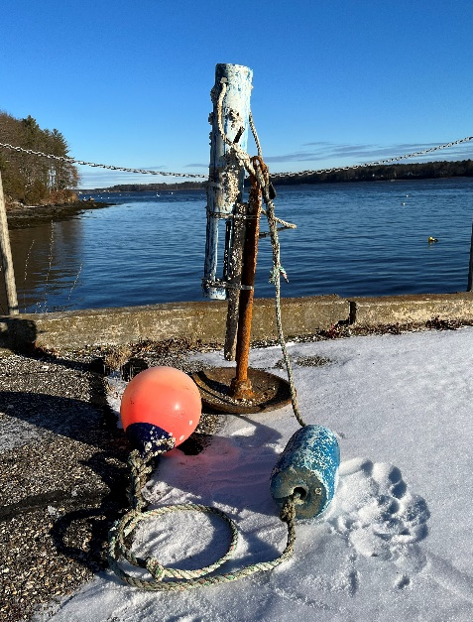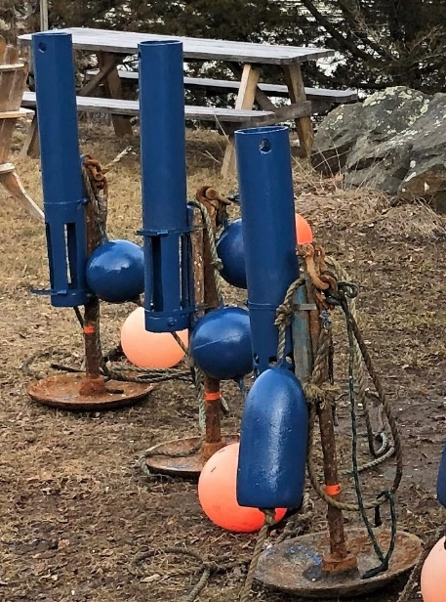

06/25/2022 08:15 – 07/01/2022 12:45 <-2> [GSM] (SWM)
During this deployment, the central wiper began to intermittently malfunction 06/24/2022 05:15. Because the wiper uses a significant amount of battery voltage, the batteries were soon drained, and the sonde lost power completely. No data was collected through the end of the deployment on 07/01/2022.

Overall, 21.4% of the deployment’s data was not collected.

Oyster River

The Oyster River sonde is located on the edge of a narrow boat channel which is surrounded by mudflats. There are no pilings or hard structures of any kind to which we can permanently attach a sonde pipe. In addition, the substrate is so soft that it is impossible to walk out to the rig.
Instead, the sonde is placed inside of a 0.75 meter long PVC pipe with slots at the bottom, which is then attached to the shank of a 50 pound mushroom anchor. There is a rope that extends from the anchor eye to a subsurface and surface float. This site is very shallow, so the bottom of the PVC pipe is <0.5 meters above the substrate. At a 0.5 meter depth, sensor faces would come out of the water regularly.

Due to this design, the sonde depth data can display a fair bit of variability between deployments
(+/- 0.5-meters). Because the mud is soft and deep, this anchor settles firmly once it is deployed. Unlike the Great Bay site, the Oyster River sonde does not tip back and forth. This mooring design requires us to pull up the entire anchor when swapping the instrument. Even though we have a GPS point for the site and mark the spot with a temporary float/anchor when we pull up the sonde anchor, it is very difficult to return it to the same location.

This station set-up is not in compliance with the current NERRS SWMP SOPs that call for the sonde to be at a fixed location. Due to the station design and it not being in line with SOPs, all 2022 depth data have been marked 1 CSM at the Oyster River site.

08/15/2022 14:00 – 08/28/2022 21:30 <1> <-3> [STS] (CSM)
Right after the sonde was deployed 08/15/2022, baseline turbidity values increased. In addition, there were erratic spikes and periods of consistently elevated turbidity that continued through the first 2 weeks of the deployment. Values returned to baseline levels 08/28/2022. (See orange line)

It is not clear what caused this anomalous data, although we believe that it is reflective of environmental conditions. It is possible that the datasonde was placed in an area with a lot of seaweed or particularly soft mud which was easily resuspended. There were no other parameters that showed correlated patterns. There had been no rain or wind events that may have contributed to the disturbance. The datasonde was not fouled when retrieved. The sensor calibrated and post-calibrated within range.

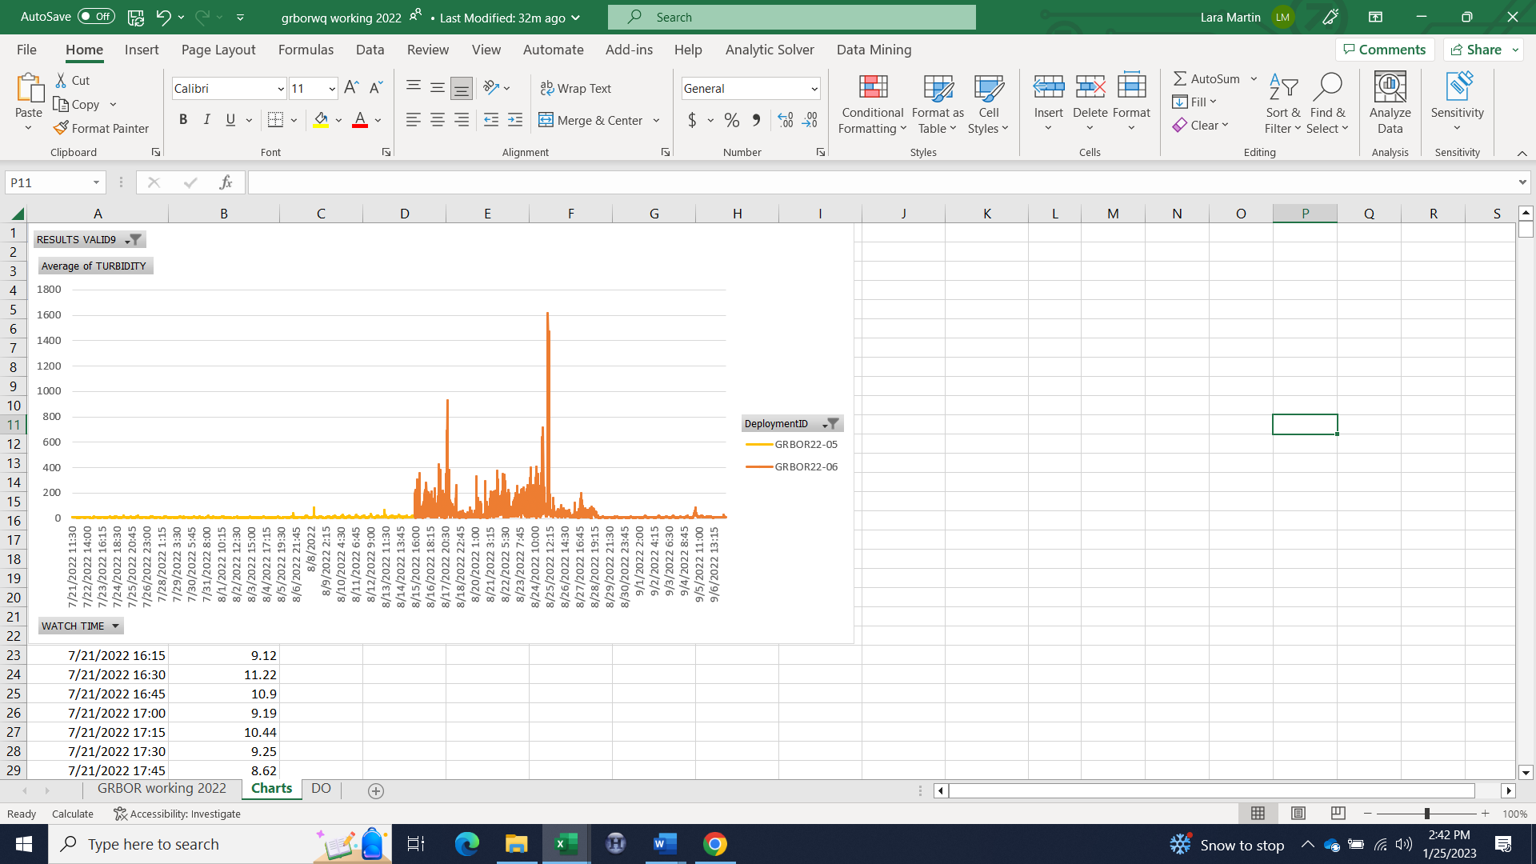

Squamscott River

05/03/2022 09:15-10:00 <-3> [GMC] (CSM)
The sonde pipe was removed from the piling for cleaning. It was reattached at 10:10.

07/01/2022 13:15 – 08/01/2022 11:00 <1> [SPC] (CSM)
When the sonde was retrieved 08/01/2022, field logs noted that the pH bulb was fouled. The sensor post-calibrated 7.51 @ 7 and 9.73 @ 10, slightly higher and lower than normal, respectively. The pH 7 millivolt (mV) reading was -47.2 with a minimum value being -50 mV. The pH 10 mV reading was
-168.1 with a minimum value being -180 mV. Millivolt numbers are a diagnostic tool that allow the user to determine when the pH sensor tip needs to be replaced. The pH 7 mV reading is subtracted from the pH 10 mV reading to attain a slope value, the minimum being 155. The slope of this sensor was 120.9, well out-of-range.

The data do not show any anomalous patterns and the match-up between deployments is good. Despite this, if post-calibration diagnostics fail, all pH data for the deployment must be declared suspect according to the CDMO.

09/05/2022 10:30 – 09/19/2022 02:00 <1> <-3> [STS] (CSM)
Early in the morning of September 5, 2022, one inch of rain fell within 3 hours. There were winds up to 20 mph. It then rained steadily the rest of that day and into the following day. In total, 1.4 inches of precipitation were recorded. Soon after this initial storm, baseline turbidity values increased. In addition, there were erratic spikes and consistently elevated turbidity levels. This trend continued for the next two weeks. Values returned to more normal baseline levels 09/19/2022 although there was still suspended particulate matter floating around, but much less of it. (See orange line)

Although we expect increased turbidity values after significant rain events, it is unusual for the elevated levels to persist this long. There was a correlated increase in chlorophyll-a values during this period which leads us to believe that this data is reflective of environmental conditions. In addition, the datasonde and sensor were not fouled when they were retrieved 09/21/2022. The match-up with the following deployment was good. The sensor calibrated and post-calibrated well-within range.

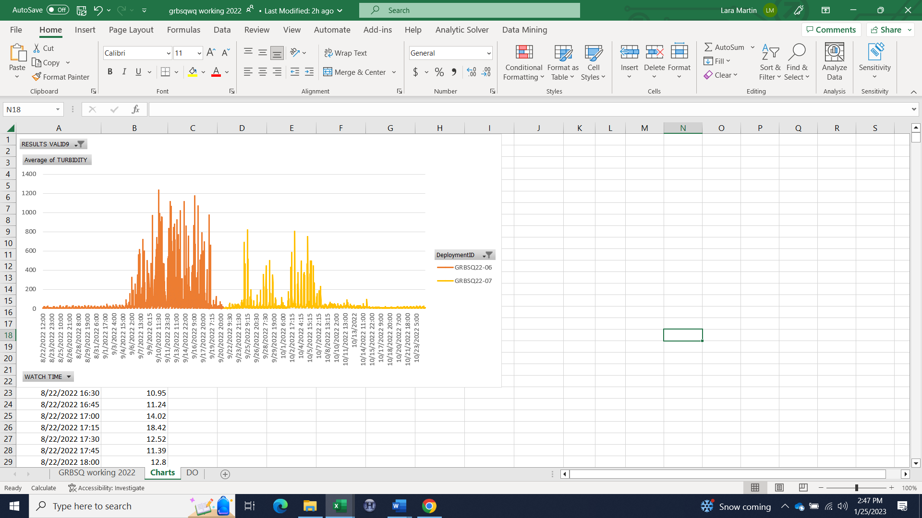

09/24/2022 19:30 – 10/07/2022 10:15 <1> <-3> [STS] (CSM)
Beginning on 09/24/2022, there were extended periods (3-4 hours) of elevated turbidity. Values would return to a predictable baseline after each event. This trend continued for the next two weeks. Most of the spikes occurred on flood tides, beginning about one hour after slack low. Typically, the increased values would dissipate before slack high tide.
Baseline turbidity values stabilized 10/07/2022 although there was still suspended particulate matter floating around for the following 2-3 days, but much less of it. (See orange line)

On 09/19/2022 it rained 0.75 inches, 09/22/2022 1.3 inches, and 10/05/2022 0.5 inches. Although we expect increased turbidity values after significant rain events, it is unusual for the elevated levels to persist. Despite the unusual nature of the data, we believe it is reflective of environmental conditions as the datasonde and sensor were not fouled when they were retrieved 10/24/2022. The match-up with the following deployment was good and the sensor calibrated and post-calibrated well-within range.

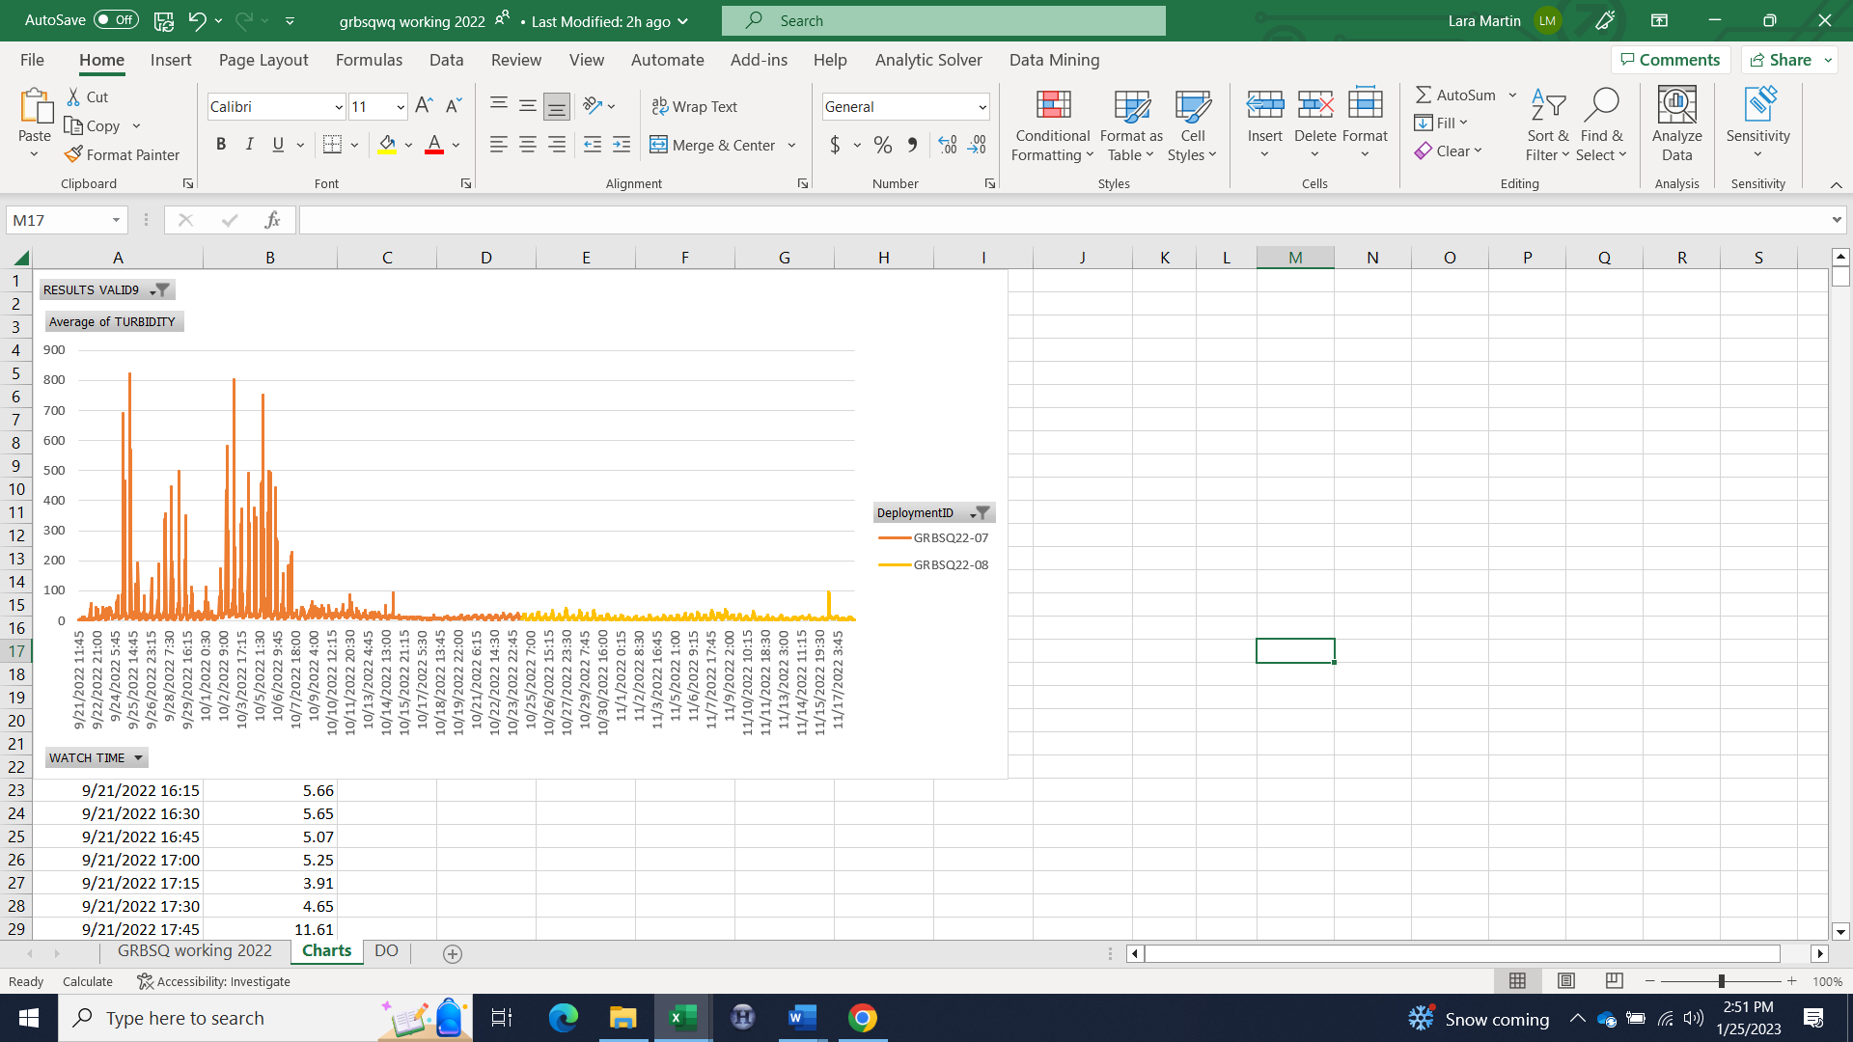

All sites

The following are 2022 daily precipitation totals ≥10.2 mm (0.4 in) recorded at the Great Bay NERR weather station in Greenland, NH. Note that significant rainfall amounts can affect all measured parameters, most noticeably salinity, turbidity, pH, and occasionally dissolved oxygen. In the riverine sites, rainfall exceeding 25.4 mm (1.0 in) in a day or consecutive days of rain, often causes specific conductance/salinity to drop to zero and turbidity spikes at low tides.

Date | Total Daily Precip (mm)
04/16/2022 | 12.2
04/19/2022 | 34.8
05/15/2022 | 11.7
05/28/2022 | 14.5
06/09/2022 | 21.1
07/12/2022 | 13.7
07/21/2022 | 11.7
07/25/2022 | 31.0
08/07/2022 | 18.0
08/22/2022 | 36.1
09/05/2022 | 49.5
09/19/2022 | 19.3
09/22/2022 | 33.8
10/05/2022 | 11.2
10/13/2022 | 25.1
10/14/2022 | 36.8
10/17/2022 | 33.0
11/11/2022 | 18.8
11/16/2022 | 27.2
11/27/2022 | 19.6
11/30/2022 | 20.8
12/07/2022 | 22.9
12/16/2022 | 45.7
12/23/2022 | 34.0

Data are missing due to equipment or associated specific probes not being deployed, equipment failure, time of maintenance or calibration of equipment, or repair/replacement of a sampling station platform. Any NANs in the dataset stand for “not a number” and are the result of low power, disconnected wires, or out of range readings. If additional information on missing data is needed, contact the Research Coordinator at the reserve submitting the data.

