HW 14: AutoCAD Basics

1. Watch the video: <https://www.youtube.com/watch?v=NMEatCF7IZU&feature=youtu.be>
2. Read the Modifying and Dimensions sections of the Hitchhiker’s Guide to AutoCAD Basics:

<http://help.autodesk.com/view/ACD/2016/ENU/?guid=GUID-2AA12FC5-FBB2-4ABE-9024-90D41FEB1AC3>

1. Recreate the following three drawings in AutoCAD. Save each one as its own .dwg file and upload them to the HW 14 assignment on Bridges.
   1. Widget, with labels:

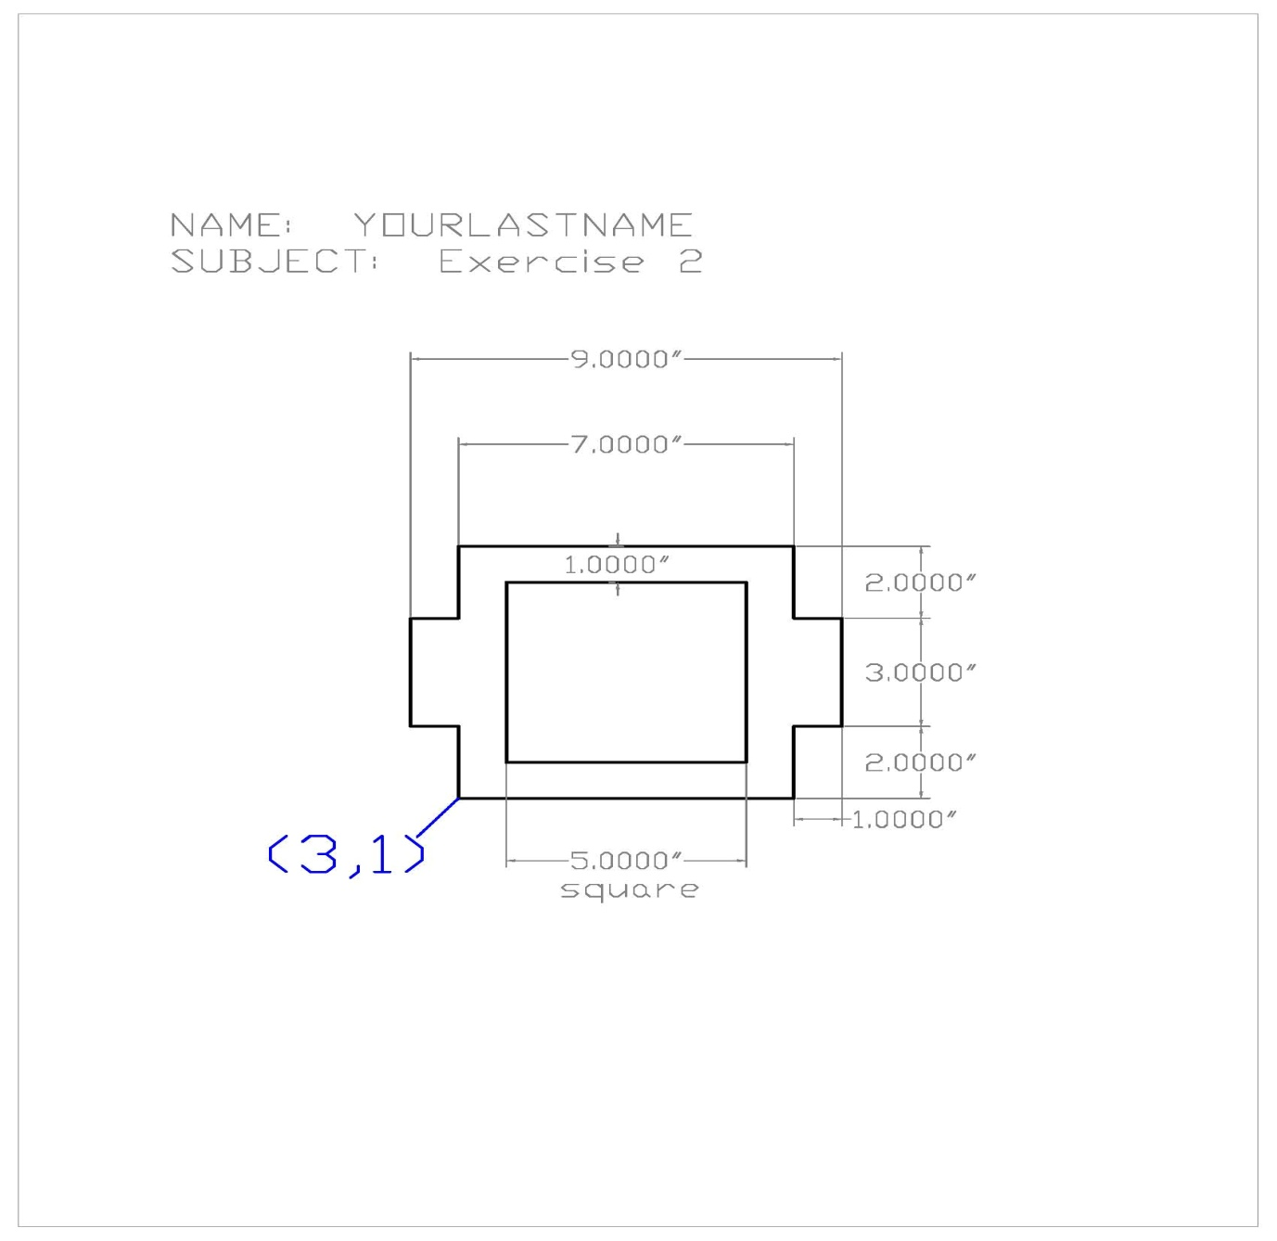

* 1. Formal garden plan:

