**ENGR 115 - Computer Applications for Engineering**

**Homework 15**

**AutoCAD Exercises**

1. Watch the video on Modifying and Dimensioning, <https://www.youtube.com/watch?v=mZNXB4qNoVU>
2. For further information, refer to 1. Read the Layer, Properties, and Layouts sections of the Hitchhiker’s Guide to AutoCAD Basics:

<http://help.autodesk.com/view/ACD/2016/ENU/?guid=GUID-2AA12FC5-FBB2-4ABE-9024-90D41FEB1AC3>

1. Make a duplicate of the following drawing, including the dimensions. Save it as an AutoCAD 2013 .dwg file, using the file name ENGR115_HW15-1_Lastname.dwg:

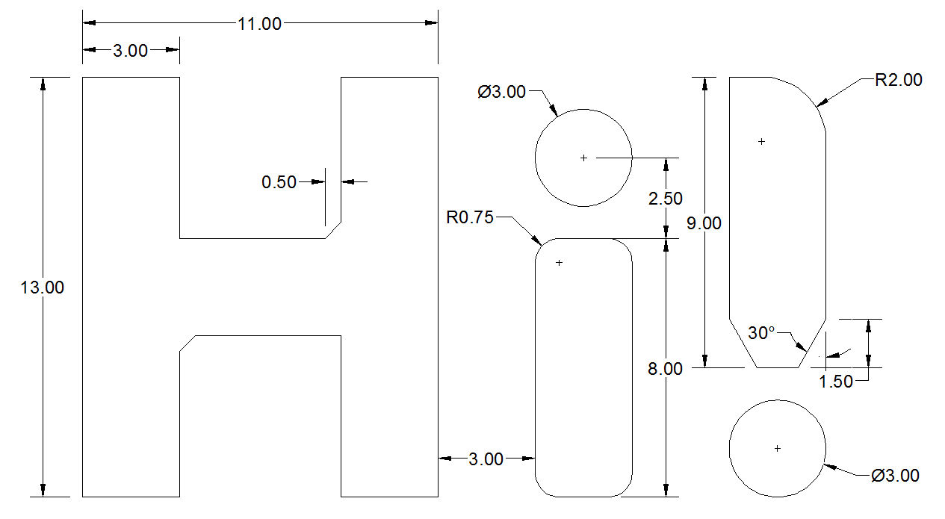

1. Make a duplicate of the drawing on the next page. Save it as an AutoCAD 2013 .dwg file, using the file name ENGR115_HW15-2_Lastname.dwg. This problem is good practice for the Offset and Trim commands in particular. Also, you should look into the Break command on the Modify menu, as it can be quite helpful. Here are some additional instructions that will help you in constructing your drawing:

<http://www.jdawiseman.com/papers/union-jack/union-jack.html>

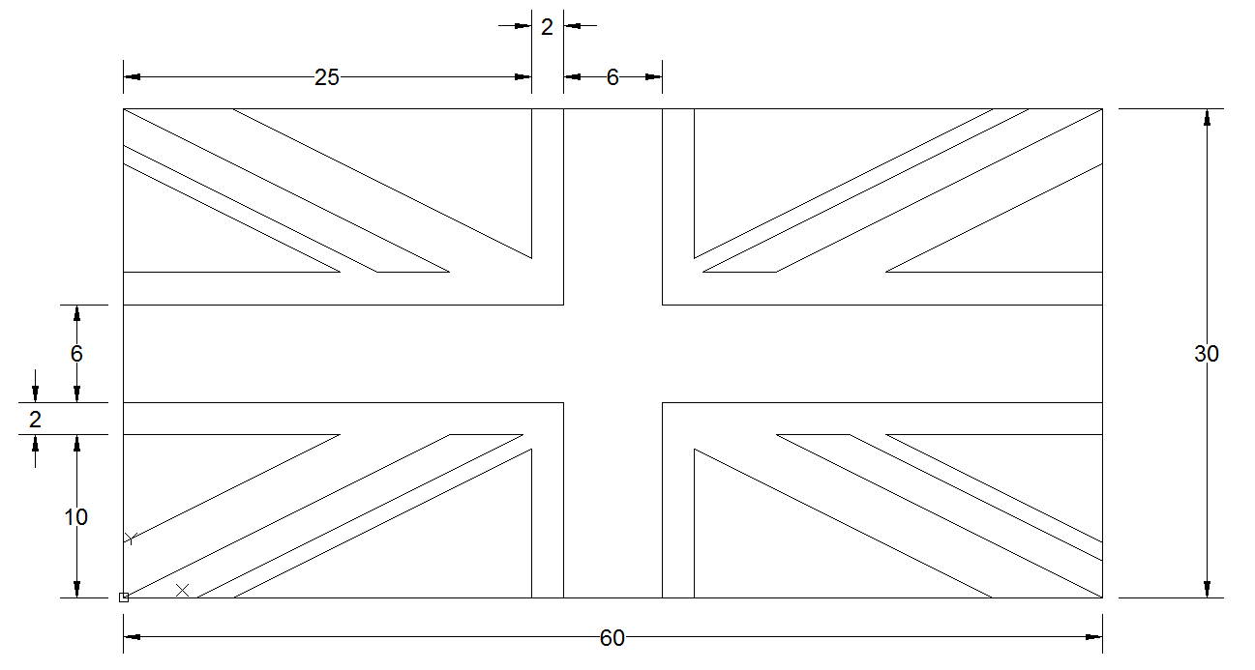

1. Create a floor plan of your dorm room or apartment. Add dimensions (in Architectural Units) to specify the approximate size of the room or apartment (you only need to dimension the outermost walls). Be sure to utilize the ’ and ” symbols when entering your dimensions to specify feet and inches, respectively. Include rectangles or circles on your floor plan to indicate major furnishings. Add text to label the furnishings and/or the rooms in the apartment. Save your drawing as an AutoCAD 2013 .dwg file, using the file name ENGR115_HW15-3_Lastname.dwg.
2. Read the Layer, Properties, and Layouts sections of the Hitchhiker’s Guide to AutoCAD Basics:

<http://help.autodesk.com/view/ACD/2016/ENU/?guid=GUID-2AA12FC5-FBB2-4ABE-9024-90D41FEB1AC3>

Upload all your drawings to Bridges.