**ENGR 115 - Computer Applications for Engineering**

**Homework 16**

Watch the videos linked below.

More Modify Commands: <https://www.youtube.com/watch?v=EUPd1DhylIo>

Layers, Layout, and Scaling: <https://www.youtube.com/watch?v=xRpl_HqSUr4>

**AutoCAD Exercises**

1. Make a duplicate of the drawing shown below (an adapter plate for bolting a round pipe flange to a flat surface). This problem is good practice for the Mirror and Array commands. Include the dimensions, and place them on a different layer from the drawing itself. Also place the dashed bolt hole circle on its own layer. Save it as an AutoCAD .dwg file, using the file name ENGR115_HW17-1_Lastname.dwg.

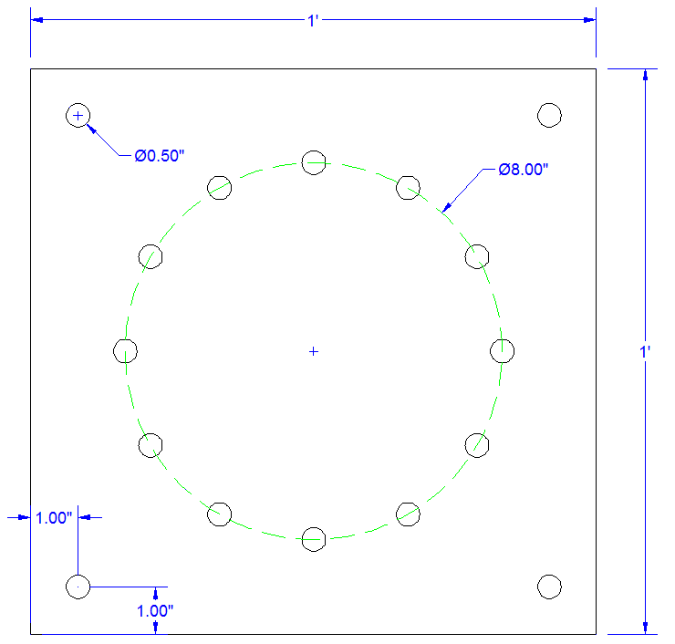

1. Make a duplicate of the drawing shown below. This problem is good practice for the Block and Array commands in particular. Save it as an AutoCAD .dwg file, using the file name ENGR115_HW17-2_Lastname.dwg. Here are some additional instructions that will help you in constructing your drawing: <http://www.usflag.org/flagspecs.html>

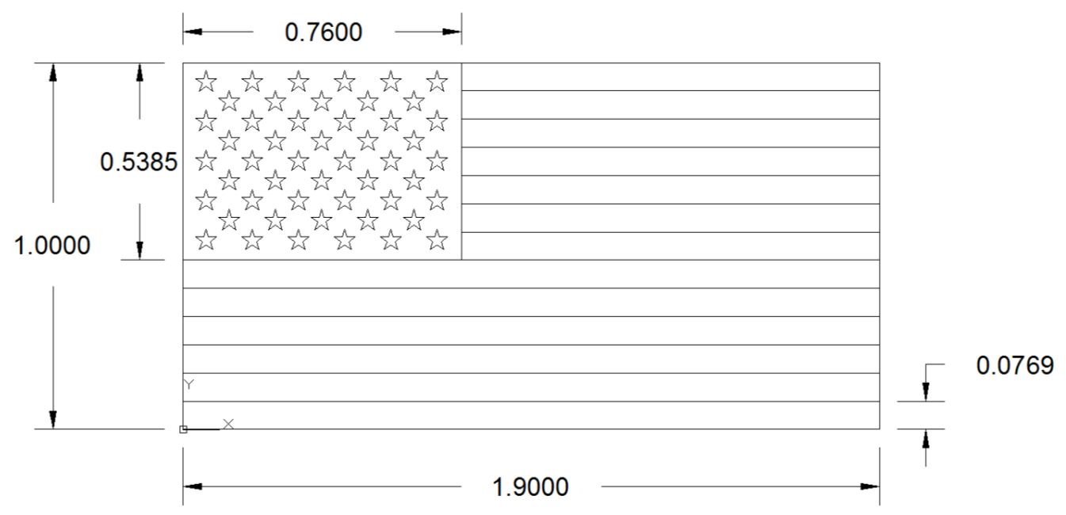

Hint: create the star first and make a block of it. Details on the star:

