**ENGR 115 - Computer Applications for Engineering**

**Homework 17**

**Part 1**

Read the Blocks section and review the Modifying section of the Hitchhiker’s Guide to AutoCAD Basics:

<http://help.autodesk.com/view/ACD/2016/ENU/?guid=GUID-2AA12FC5-FBB2-4ABE-9024-90D41FEB1AC3>

Watch the video about layout, scaling and layers: <https://www.youtube.com/watch?v=xRpl_HqSUr4>

**Part 2**

Recreate this drawing in AutoCAD. Put it in layout view with appropriate scaling and turn off the grid. Use layers for dimensions, drawing, and center marks. Export the file to .pdf and upload the .pdf file to Bridges.



**Part 3**

As a part of the assignment you will see a set of nice AutoCAD drawings, called FASAD_FULL_SET.pdf. This document was created in AutoCAD for a senior design group evaluating the structural properties of Fort Adams in Newport, RI. Take a look at this drawing and, in a new Word document, write a paragraph reflection on the good things about this drawing set. Upload this Word document with your submission.

**Part 4**

On page 5 of this document, you will find plans for the Marine and Natural Sciences building and surrounding area. This problem is designed to mimic a scenario that you might find yourself in as a new hire to a company: you are given an AutoCAD file that someone (who may or may not still be around) in the firm worked on sometime in the past and are asked to extract information from it as well as edit it. Some of the information will be recognizable and you would likely be able to reproduce it (like the traverse around the building), and some will be recognizable, but you will not be able to reproduce it (like the topographic contours).

The image on page 5 of this file is a bitmap image, so if you zoom into it, it will become grainy. The actual AutoCAD file is attached to this assignment, so please use that to complete the exercise.

NOTE: if, when opening the AutoCAD file, a message pops up telling you that “One or more SHX files are missing” just click “Ignore the missing SHX files and continue.” If a message talking about “proxy information” pops up after the first one, just click OK (do not click on any of the radio buttons).

Please do the following. Please place you answers in the boxes (where applicable), so that it is easy for your instructor to find them.

* 1. **Describe what the following layers are used for:**

|  |  |
| --- | --- |
| Layer | Description |
| LD-A-WALL-ST |  |
| ATH_FELD |  |
| NAMES |  |
| My LAYER |  |
| PARKING_OUTLINE |  |

* 1. **Looking at the plan as shown on Page 4 of this file, determine the distance from location 1 (just outside the MNS main entrance) to location 2. Based on your experience with the actual building, is it correct?**

|  |
| --- |
|  |

* 1. **What is the area of the foot print of MNS? Note: most of the foot print is defined on the “LD-A-BLDG” layer, but it is not a closed shape. You might want to use the “join” command to make determining the area easier.**

|  |
| --- |
|  |

* 1. **What is the name of the layer that the topographic contour lines are on?**

|  |
| --- |
|  |

* 1. **What is the name of the layer that the numbers on the topographic contours are on?**

|  |
| --- |
|  |

* 1. **What is the name of the layer that the lines that make up the traverse are on?**

|  |
| --- |
|  |

* 1. **Make it so that all of the numbers and text associated with the layer Traverse are on the layer called “Names”**

|  |
| --- |
|  |

* 1. **Add a layer called “Proposed Gas Line” and draw it between location A and B as shown on page 4 of this file. Make the line type “GAS_LINE”**
  2. **Set the scale on the Layout1 tab in the original AutoCAD document so that it fills the page. What is the scale that you used?**

|  |
| --- |
|  |

* 1. **How would you rate the *quality* of this AutoCAD document? What would you have done differently?**

|  |
| --- |
|  |

When you are done, upload both this document and the modified mns.dwg file to Bridges.

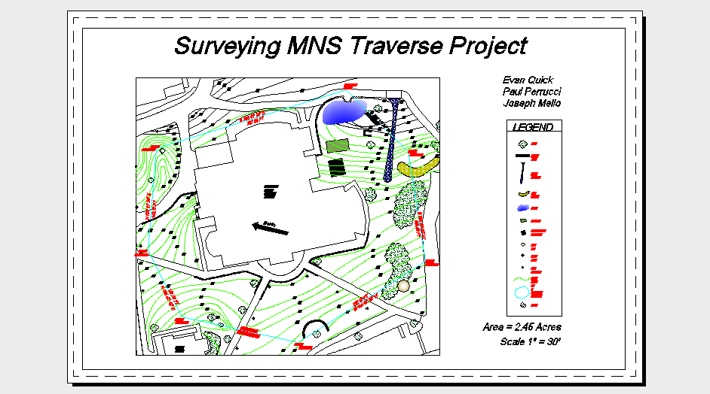

2

1

**B**

**A**