# ENGR 4020 Lectures 11 and 12

In these work at home lectures, you will learn the basics of AutoCAD to facilitate laser cutting parts for your robot. Complete each mini-module at your own pace, and then work on Lab 3. There is no homework associated with these mini-modules, but it would be a good idea to do them in preparation for continued use of AutoCAD.

# Mini-Module 1: AutoCAD Basics

1. Watch the video on AutoCAD Basics: <https://www.youtube.com/watch?v=NMEatCF7IZU&feature=youtu.be>
2. Read the Modifying and Dimensions sections of the Hitchhiker’s Guide to AutoCAD Basics:

<http://help.autodesk.com/view/ACD/2016/ENU/?guid=GUID-2AA12FC5-FBB2-4ABE-9024-90D41FEB1AC3>

1. Watch the video on Modifying and Dimensioning, <https://www.youtube.com/watch?v=mZNXB4qNoVU>
2. Recreate the following drawings in AutoCAD.
   1. Widget:

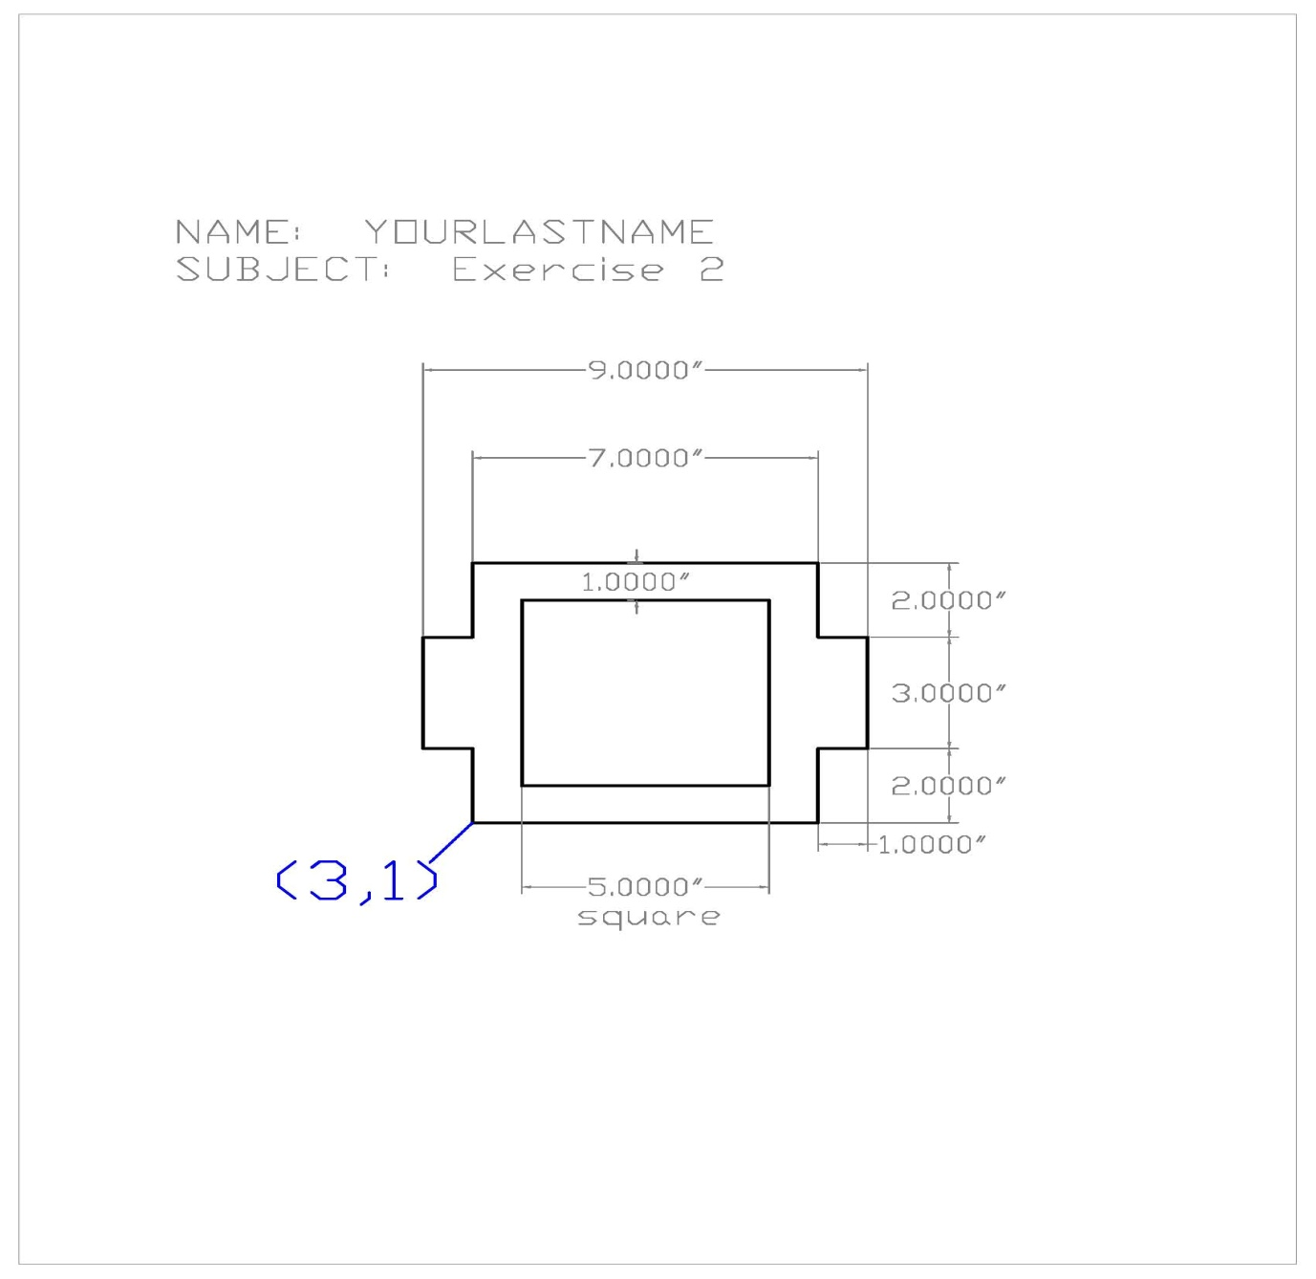

* 1. Formal garden plan:



1. Make a duplicate of the following drawing, including the dimensions.

1. Make a duplicate of the drawing on the next page. This problem is good practice for the Offset and Trim commands in particular. Also, you should look into the Break command on the Modify menu, as it can be quite helpful. Here are some additional instructions that will help you in constructing your drawing:

<http://www.jdawiseman.com/papers/union-jack/union-jack.html>

# Mini-Module 2: More Modify Commands, Layers, and Scaling

1. Watch the video on additional modify commands: <https://www.youtube.com/watch?v=EUPd1DhylIo>
2. Read the Layer, Properties, and Layouts sections of the Hitchhiker’s Guide to AutoCAD Basics:

<http://help.autodesk.com/view/ACD/2016/ENU/?guid=GUID-2AA12FC5-FBB2-4ABE-9024-90D41FEB1AC3>

1. Watch the video on Layers, Layout, and Scaling: <https://www.youtube.com/watch?v=xRpl_HqSUr4>
2. Read the Blocks section and review the Modifying section of the Hitchhiker’s Guide to AutoCAD Basics:

<http://help.autodesk.com/view/ACD/2016/ENU/?guid=GUID-2AA12FC5-FBB2-4ABE-9024-90D41FEB1AC3>

1. Make a duplicate of the drawing shown below (an adapter plate for bolting a round pipe flange to a flat surface). This problem is good practice for the Mirror and Array commands. Include the dimensions, and place them on a different layer from the drawing itself. Also place the dashed bolt hole circle on its own layer.

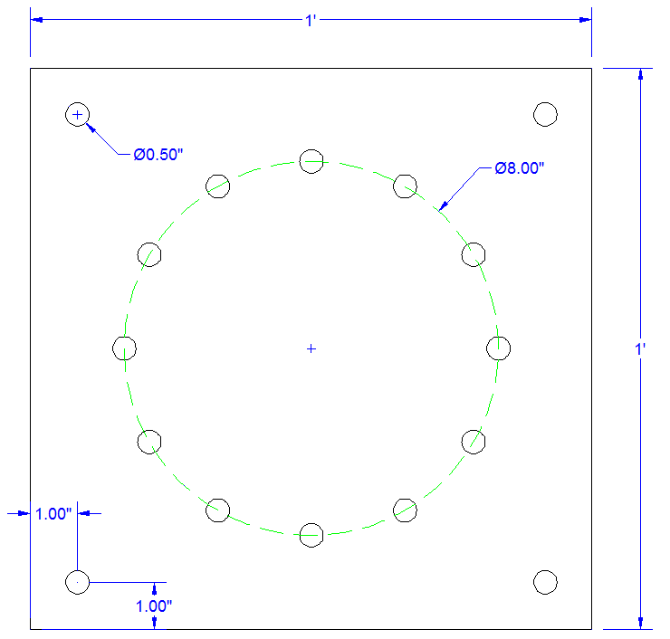

1. Recreate this drawing in AutoCAD. Use layers for dimensions, drawing, and center marks.