**ENGR 4020 Lecture 2 Handout**

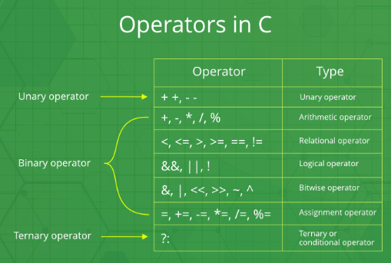

<https://www.geeksforgeeks.org/operators-c-c/>