**ENGR 4020 Course Project[1] [300 pts]**

**Competition Dates: 5/4/2020 and 5/7/2020**

**Requirements**

* Competition performance: 200 pts
* Final report and notebook check: 100 pts

**Objective**

The goal of this project is to design, build, and program an autonomous robot to score as many points as possible in a 4-minute period. The robot will navigate a well-defined playfield and collect objects, sort them by color, and deliver them to specified bases.

**Playfield**

The playfield is shown below in Figure 1 and is 6 feet in length and 4 feet in width. The starting area is considered a 12x12x12 inch cube. All parts of the robot must start within this cube. Within the object locations, there are 8 1x1x1 inch cubes, evenly distributed between white and black in color, but randomized in their configuration. In addition, there is exactly one white or black bonus ball located in each area. For an understanding of the layout of these objects, consult Figure 2.

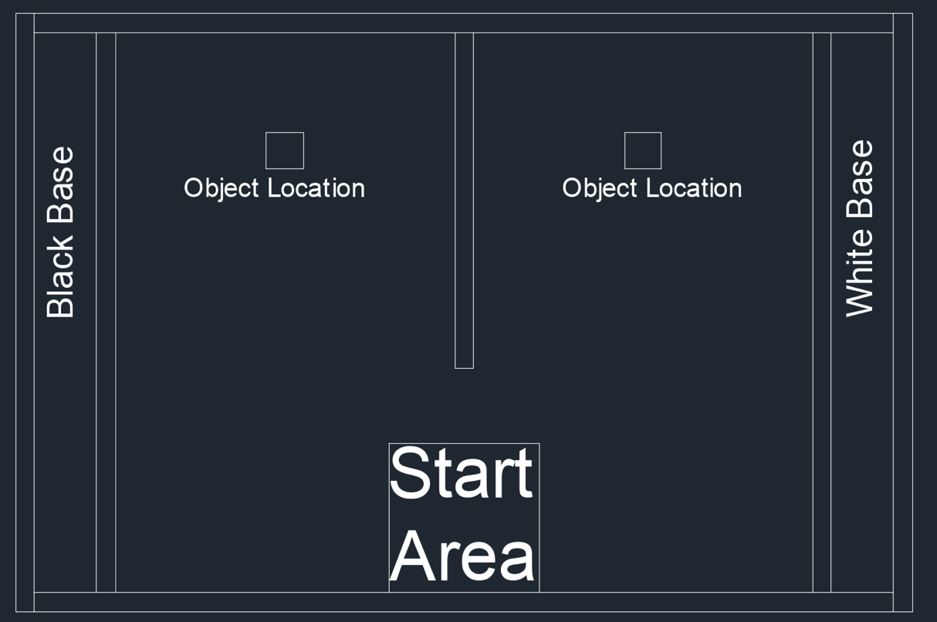

**Figure 1:** Playfield

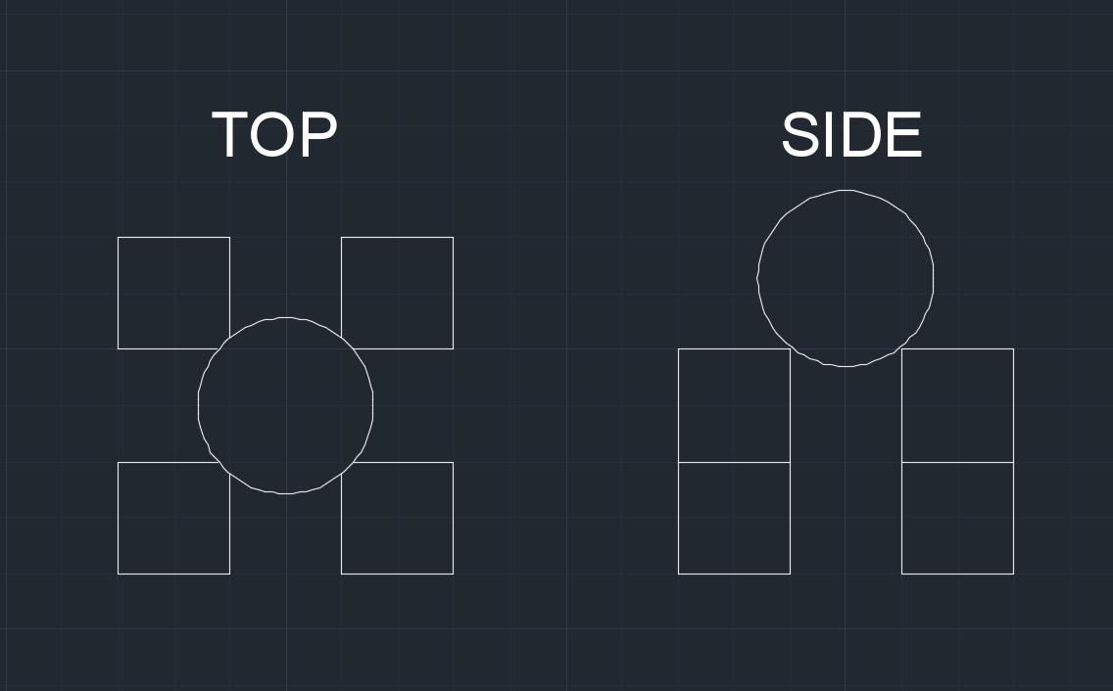

**Figure 2:** Object configuration

**Materials**

Each group will receive the following:

* Complete unassembled robot
* Plastic storage bin
* Binder
* Four hobby servomotors
* Two feet of angled polycarbonate
* Two sheets of 1/8x12x36 inch acrylic
* Wiring kit with supporting electronics
* An additional set of DC motors with wheels and encoders
* Full Sized Breadboard
* Two Nucleo L432KC mbed enabled microcontrollers
* Assorted fasteners
* Battery pack and velcro, which may only be used to attach the battery pack
* Batteries-this is your initial supply, additional batteries must be acquired by each group individually

The final robot design must contain at least one printed circuit board. This can be used for holding sensors and supporting electronics, including your microcontroller. If you desire to connect your microcontroller, you must use pin headers (ask for them if you can’t find any).

Groups may use 3D printed parts on their robot as long as the parts are designed by the group members.

Groups may also use additional:

* Motors
* Wires
* Breadboards
* Sensors
* Wheels
* Electronic components
* Shrink wrap
* Zip ties only for attaching encoders
* Dabs of glue no larger than a grain of rice may be used to secure electronics to acrylic

Groups may not use:

* Tape or additional glue to adhere or attach materials to the robot, or adhere acrylic to acrylic
* Wood, aluminum, carboard or other materials as structural members of the robot

The robot may use a maximum of 12AA batteries as the source of energy for the robot. Note that the driving motors are specified to work from 3-6V DC.

The acrylic used for the final robot design must fit in one 1/8x12x36 inch sheet, and you must provide an AutoCAD drawing demonstrating the group is following the material restriction requirements, as shown in the example below.

**Figure 3:** Demonstration of meeting the material requirements

**Competition**

A total of 16 one-inch cubes (8 black and 8 white) will be arranged in each of the object locations on the playfield. Each side will have an even distribution of black and white cubes (4 black and 4 white per side), but the arrangement of these cubes is at random. Placed atop these cubes is a single bonus ball, black on one side of the playfield, and white on the other.

The final competition will take place over two separate days, Monday 4/27/2020 and Thursday 4/30/2020.

On the days of the final competition, each group will have 12 minutes to complete as many runs as possible. The group order will be chosen at random the week prior to the competition. Teams must go in the order they are assigned and may not switch with each other.

The robot must start completely within 12x12x12 inch cube, and the run must be started by a button press. Points for objects delivered are outlined below:

|  |  |
| --- | --- |
| **Category** | **Score** |
| Any object to any base | 4 points |
| Black/White Cube in correct base | 2 points |
| Black/White Cube in wrong base | -2 points |
| Positive net score from both bases | 4 points |
| Bonus Ball in correct base (only counts if cube of same color in base and positive score from base) | 5 points |
| Bonus Ball in wrong base | -5 points |

This means a maximum one day score is 50 points. The group score for the competition is the high score total of both days (max 2 day score is 100 points). Credit for the competition is awarded as the highest of the following categories:

|  |  |
| --- | --- |
| 10 points group score over two days | 100 points |
| 10 points in a single trial | 120 points |
| 20 points group score over two days | 140 points |
| 20 points in a single trial | 160 points |
| 30 Points group score over two days | 180 points |
| 40 Points group score over both days | 200 points |

In addition, the team with the greatest overall score will receive a +20 point bonus, and the second place team will receive a +10 point bonus.

**Clarifications and Restrictions**

* The robot must be started by a button press. No plugging or unplugging wires to start the robot is allowed, and no interaction with the robot or playfield after the button press happens is permitted.
* Trials start upon button press and may last up to 4 minutes, timed by the instructor. Only objects in the base (completely contained within the 4 walls floor and imaginary ceiling) when the trial ends are scored.
* Groups may agree to end their trial prior to 4 minutes and pick up their robot to start a new trial.
* Groups may use up to 3 feet of colored electrical tape as visible landmarks on the playfield.
* The robot must start completely within 12x12x12 inch cube but may expand to greater volume under its own power after the initial button press.
* Questions about the task and restrictions are expected, and some rules or restrictions may need to be amended. The final rules and restrictions will be posted by April 15, 2020, and no further changes to the rules will be made after this date. Instructor retains final discretion regarding rules violations and interpretations and reserves the right to disqualify designs that intentionally circumvent or exploit loopholes or omission in the rules.

**Milestones**

To help you achieve the end goal of the project, four milestones have been designed that add core functionality to your robot. Detailed descriptions of each milestone may be found on Canvas in their assignment documents. Each milestone is 100 points, includes a demonstration component, and requires submission of a milestone report in your lab notebook.

* Milestone 1: Basic C++ Programming on the mbed microcontroller (1/23/2020)
* Milestone 2: Navigate the playfield with digital input (buttons) as feedback (2/6/2020)
* Milestone 3: Return an object to base (3/5/2020)
* Milestone 4: Sort objects and return to base (4/9/2020)

**Final Report/Lab Notebook**

Both the final project and Milestones require a detailed and organized lab notebook. Each milestone, the lab notebook will be submitted and checked. The following sections are required, separated by labeled dividers.

* Assignment Print Outs (Project, Milestones)
* Final Project Report
* Milestone Reports
* Homework
* Lab Reports
* Circuit diagrams
* Datasheets
* Course Notes
* C++ Code

The final report must summarize the approach to the final competition as well as the performance and reliability in completing the competition. You must also submit a flowchart for the program’s actual structure, a copy of the .cpp file (with comments) and a diagram of the circuit used. This submission is on paper! This report must be put in your group’s design notebook, and the whole notebook turned in to Dr. McPheron.

Included in the Final Report, you must also have a 3D model of your robot, pictures of your robot demonstrating that the two match, and a 2D AutoCAD drawing demonstrating the group is following the material restriction requirements.

1. Adapted from ENGR 450: Mechatronics by Matthew Stein, Roger Williams University