Here's a table with useful vocabulary for different situations in IELTS Writing Task 1 (Academic and General Training).

IELTS Writing Task 1 Vocabulary for Different Situations
Situation | Useful Vocabulary | Example Sentence
Describing Trends (Increase/Decrease) | increase, rise, surge, grow, climb, improve, skyrocket, peak / decrease, drop, decline, plummet, fall, dip, slump | The number of tourists increased significantly in 2020. / The sales figures plummeted in the last quarter.
Describing Stability | remain stable, level off, plateau, stagnate, maintain, stay constant | The unemployment rate remained stable throughout the year.
Describing Fluctuations | fluctuate, vary, oscillate, rise and fall, experience ups and downs | The stock prices fluctuated wildly over the given period.
Describing Comparisons | higher than, lower than, more than, less than, the highest, the lowest, twice as much as, compared to, in contrast to, whereas, while | The population of City A is twice as large as that of City B.
Describing Proportions (Pie Charts, Percentages, Fractions) | a large proportion, a small minority, the vast majority, nearly a quarter, one-third, a significant number, a tiny fraction, a negligible amount | Nearly half of the students prefer online learning over traditional methods.
Describing Time (Process Diagrams, Trends over Time) | over the period, from X to Y, between X and Y, in the following years, subsequently, thereafter, in the next stage | Over the period of ten years, the use of public transport increased steadily.
Describing Maps (Changes in Location and Structure) | was converted into, replaced by, transformed into, expanded, removed, relocated, constructed, demolished | The old factory was demolished and replaced by a shopping mall.
Describing Processes (Diagrams, Flow Charts) | first, next, then, subsequently, following this, finally, after that, before, prior to, meanwhile, simultaneously | First, the raw materials are collected. Next, they are transported to the factory for processing.
Making General Statements | overall, in general, generally speaking, as a whole, in summary | Overall, the data suggests an upward trend in energy consumption.
Making Predictions or Speculations | it is likely that, it is expected that, it is projected that, is forecasted to, is anticipated to | The population is projected to increase by 20% over the next decade.
Describing Extent (How Big/Small the Change Is) | significantly, drastically, sharply, considerably, moderately, slightly, marginally, negligibly | The sales figures sharply declined in the third quarter.
Would you like more vocabulary for a specific type of task?

Here are the pie charts for both questions along with their respective answers.
Here is the pie chart for household expenditure in 1950 and 2010. Below is the answer:
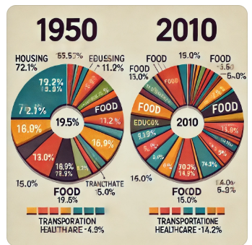

Answer:
The two pie charts compare the distribution of household expenditure in a particular country in the years 1950 and 2010.
Overall, it is clear that there was a significant shift in spending habits over the six decades. While housing accounted for the largest proportion of expenses in 1950, by 2010, expenditure on food had become the dominant category.
In 1950, housing made up 72.1% of household expenses, followed by food at 11.2%. Other categories such as education, healthcare, transportation, and others had relatively smaller shares. However, by 2010, spending on food had increased dramatically to 34.0%, surpassing housing, which dropped significantly to 22.0%. Additionally, expenditure on transportation rose from 3.3% to 14.0%, and healthcare also saw an increase.
In contrast, spending on education remained relatively stable, while the category labeled "other" experienced significant growth. This suggests that over time, people allocated more money to diverse expenses rather than focusing primarily on housing.

Pie charts for energy consumption in 2000 and 2020.

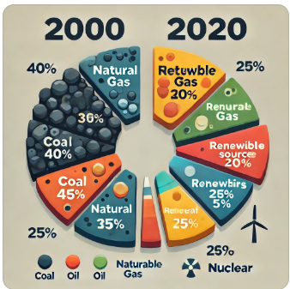
Here is the pie chart for energy consumption in 2000 and 2020. Below is the answer:

Answer:
The two pie charts illustrate the percentages of different energy sources used for electricity generation in a country in the years 2000 and 2020.
Overall, the data indicate a significant shift from fossil fuels to renewable energy sources over the 20-year period. While coal and oil were the dominant energy sources in 2000, by 2020, natural gas and renewable sources had gained a larger share.
In 2000, coal accounted for 40% of the total energy mix, followed by oil at 30%. Natural gas contributed 15%, while renewable energy sources, including solar and wind, represented a minimal share of 10%. Nuclear energy made up just 5% of the total.
By 2020, there was a noticeable decrease in the reliance on coal and oil, which declined to 25% and 20%, respectively. In contrast, natural gas usage increased to 25%, and renewable sources saw a dramatic rise to 20%, indicating a shift towards cleaner energy. Meanwhile, nuclear energy usage remained unchanged at 5%.
In conclusion, the country significantly diversified its energy sources between 2000 and 2020, with a clear move towards sustainability and a reduced dependence on fossil fuels.

Here are different types of table-based questions you may encounter in Task 1 (Academic Writing) for IELTS, along with sample answers.

Question Type 1: Single Table with Comparisons

Question:
The table below shows the percentage of households with internet access in five countries in 2010 and 2020.
Country | 2010 (%) | 2020 (%)
USA | 70 | 90
UK | 65 | 88
Canada | 68 | 89
Germany | 60 | 85
Australia | 72 | 92
Write a report summarizing the information.

Sample Answer:
The table illustrates the percentage of households with internet access in five countries in 2010 and 2020.
Overall, all five countries experienced an increase in internet penetration over the decade. Australia had the highest percentage of households with internet access in both years, while Germany had the lowest in 2010.
In 2010, Australia led with 72%, followed by the USA (70%) and Canada (68%). The UK and Germany had slightly lower figures at 65% and 60%, respectively. By 2020, all five countries saw substantial growth, with Australia reaching 92% and the USA following closely at 90%. The UK and Canada also recorded significant rises, reaching 88% and 89%, respectively. Meanwhile, Germany, despite its initial lag, grew to 85%.
In summary, internet access increased considerably in all five nations, with Australia maintaining the highest proportion throughout the period.

Question Type 2: Table Showing Different Categories

Question:
The table below presents data on the number of tourists (in millions) visiting different types of attractions in three countries in 2022.
Country | Museums | Theme Parks | Natural Sites | Historic Sites
USA | 15 | 22 | 18 | 12
UK | 10 | 12 | 14 | 17
France | 12 | 18 | 20 | 15
Summarize the information in the table.

Sample Answer:
The table provides information on the number of tourists (in millions) who visited various attractions in the USA, the UK, and France in 2022.
Overall, theme parks were the most popular attraction in the USA, whereas natural sites attracted the most visitors in France. The UK, on the other hand, saw the highest number of visitors at historic sites.
In the USA, theme parks received the most visitors (22 million), followed by natural sites (18 million). Museums and historic sites had relatively lower figures, with 15 million and 12 million visitors, respectively.
In the UK, historic sites were the most visited (17 million), while museums and natural sites had 10 million and 14 million tourists, respectively. Theme parks were the least popular, attracting only 12 million visitors.
France had the highest number of visitors to natural sites (20 million), followed by theme parks (18 million). Museums and historic sites had slightly fewer visitors, at 12 million and 15 million, respectively.
In summary, preferences varied across countries, with theme parks being the most popular in the USA, historic sites in the UK, and natural sites in France.

Question Type 3: Table with Trends Over Time

Question:
The table below shows the number of students enrolled in three different courses at a university from 2015 to 2020.
Year | Business | Engineering | Arts
2015 | 200 | 180 | 150
2016 | 220 | 190 | 145
2017 | 250 | 210 | 140
2018 | 280 | 230 | 135
2019 | 320 | 260 | 130
2020 | 350 | 290 | 125
Summarize the main trends shown in the table.

Sample Answer:
The table displays the number of students enrolled in Business, Engineering, and Arts courses at a university from 2015 to 2020.
Overall, Business and Engineering courses saw a steady rise in enrollments, whereas the number of students in the Arts program gradually declined over the period.
In 2015, Business had 200 students, which increased significantly to 350 by 2020. Similarly, Engineering enrollments rose from 180 in 2015 to 290 in 2020, showing a consistent upward trend.
In contrast, the number of students in Arts declined over time, starting at 150 in 2015 and decreasing to 125 in 2020.
In conclusion, while Business and Engineering gained popularity, the Arts course experienced a decline in student enrollment.

- Introduce the Visual: Begin with a paraphrased introduction of the task description.
- Highlight Key Features: Identify and describe the main trends, differences, or notable points.
- Make Comparisons: Use comparative language to show relationships between data points.
- Use Appropriate Vocabulary: Incorporate a variety of verbs and adjectives to describe increases, decreases, and comparisons (e.g., rise, fall, peak, lowest).
- Structure: Organize your response with clear paragraphs—introduction, overview, and detailed paragraphs.
- Avoid Opinions: Stay factual and avoid inserting personal views.
Final Thoughts
By practicing with these varied bar chart scenarios, you're honing the skills necessary to interpret and articulate data effectively. Remember, clarity and coherence are key. Each word should serve a purpose, guiding the reader through the data's narrative smoothly.
Is there a specific aspect of Task 1 you'd like to explore further, or perhaps another type of chart you'd like to tackle?
give me tasks and answers for task-1 writing academic for different types of bar-charts with drawing the bar charts questions
Absolutely, I'd be thrilled to help you practice IELTS Academic Writing Task 1 with a variety of bar chart questions, complete with drawings and model answers. Let's dive into different types of bar charts to give you a comprehensive understanding.

Task: Horizontal Bar Chart

Question:
The bar chart below shows the number of books borrowed from a library by different age groups in a city during one month.
Summarize the information by selecting and reporting the main features, and make comparisons where relevant.
Number of Books Borrowed

Age Groups ┤ Number of Books
│
Under 12 ┤ ██████████ 40
│
13-17 ┤ ███████████████ 60
│
18-24 ┤ ███████████████████ 80
│
25-39 ┤ ████████████████████ 90
│
40-59 ┤ █████████████████ 70
│
60 and over ┤ ██████████ 40

Data Representation:
- Under 12: 40 books
- 13-17: 60 books
- 18-24: 80 books
- 25-39: 90 books
- 40-59: 70 books
- 60 and over: 40 books

Model Answer:
The horizontal bar chart illustrates the number of books borrowed from a city library by various age groups during a specific month.
Overall, the age group 25-39 borrowed the most books, while both the youngest (under 12) and the oldest (60 and over) groups borrowed the least. There is a noticeable variation in borrowing habits across different ages.
Individuals aged 25-39 borrowed the highest number of books, totaling 90. This suggests a strong engagement with reading among young to middle-aged adults, possibly for professional development or personal interest.
The 18-24 age group followed, borrowing 80 books. This could be attributed to university students requiring resources for their studies. The 40-59 age group borrowed 70 books, indicating a moderate level of library use.
Teenagers aged 13-17 borrowed 60 books, signifying a healthy interest in reading among adolescents. The youngest and oldest groups, under 12 and 60 and over, each borrowed 40 books, the lowest figures on the chart. This may reflect limited independent library access for children and possible mobility issues for seniors.
In summary, the data shows that book borrowing from the library varies considerably with age, peaking among adults aged 25-39 and decreasing at the extremities of the age spectrum.
Tips for Tackling Bar Chart Questions:
- Introduction: Paraphrase the question statement to introduce the chart.
- Overview: Summarize the main trends or significant features.
- Details: Provide specific data, making comparisons where relevant.
- Language: Use a range of vocabulary to describe increases, decreases, and comparisons (e.g., "rose," "declined," "higher than," "the most significant").
Remember: Practice makes perfect. By analyzing different types of bar charts and crafting detailed answers, you'll enhance your ability to describe and compare data effectively.

…………………………………………………………………………………………………………………………………………..
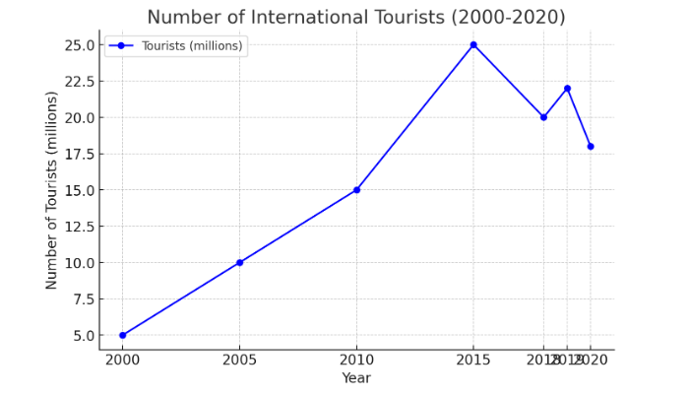

Task 1: Single Line Graph (One Variable Over Time)
Question:
The graph below shows the number of international tourists visiting a country from 2000 to 2020. Summarize the information by selecting and reporting the main features and making comparisons where relevant.
Answer:
The line graph illustrates the number of international tourists visiting a country from 2000 to 2020. Overall, there was a significant increase in tourist arrivals, with some fluctuations in the later years.
In 2000, the number of tourists stood at around 5 million. This figure rose steadily, reaching approximately 15 million in 2010. From 2010 to 2015, the growth rate accelerated, peaking at 25 million. However, between 2015 and 2020, the trend became more volatile, with a sharp decline in 2018, followed by a slight recovery before another drop in 2020, likely due to global travel restrictions.
Despite some downturns, the overall trend shows a considerable rise in international tourist arrivals over the two decades.
(Word count: 162)

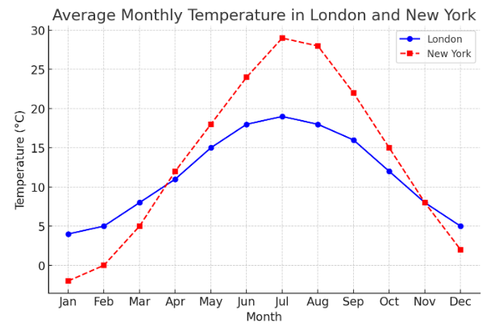

Task 2: Multiple Line Graph (Comparing Two or More Categories)
Question:
The graph below compares the average monthly temperature of two cities, London and New York, over a year. Summarize the information by selecting and reporting the main features and making comparisons where relevant.
Answer:
The line graph compares the average monthly temperature in London and New York throughout the year. Overall, while both cities experience seasonal variations, New York has more extreme temperature fluctuations compared to London.
In January, New York’s temperature is around -2°C, significantly colder than London’s 4°C. As the months progress, both cities see a rise in temperature, but New York experiences a steeper increase, peaking at 29°C in July, whereas London reaches only 19°C. After July, temperatures in both cities decline, with New York dropping more sharply to return to -2°C by December, while London remains milder at around 5°C.
In summary, New York has hotter summers and colder winters compared to London, which maintains a more moderate climate throughout the year.
(Word count: 164)

Task 3: Line Graph with Forecast (Future Trends)
Question:
The graph below shows the projected population growth in three countries from 2020 to 2050. Summarize the information by selecting and reporting the main features and making comparisons where relevant.
Answer:
The line graph presents the projected population growth in three countries—India, China, and the USA—from 2020 to 2050. Overall, India is expected to see the highest population growth, while China’s population is predicted to decline after 2030.
In 2020, China has the highest population at approximately 1.4 billion, followed by India at 1.35 billion and the USA at 330 million. By 2030, India is expected to surpass China, reaching 1.5 billion, while China’s population plateaus before gradually declining to around 1.3 billion in 2050. Meanwhile, the USA’s population is projected to grow steadily but at a slower pace, reaching approximately 400 million by 2050.
Overall, India’s population will continue to rise, China’s will decline after 2030, and the USA will experience gradual growth over the next three decades.
(Word count: 169)

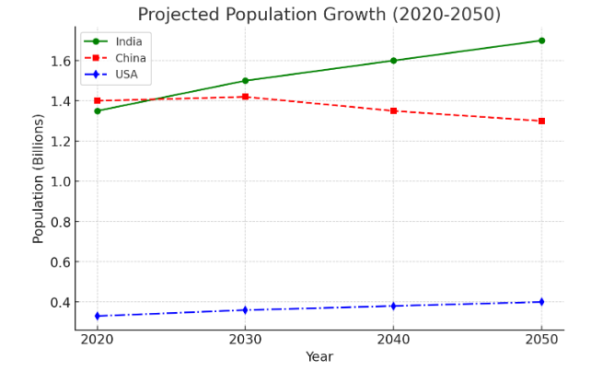

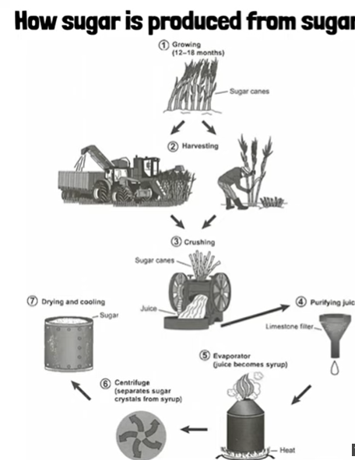
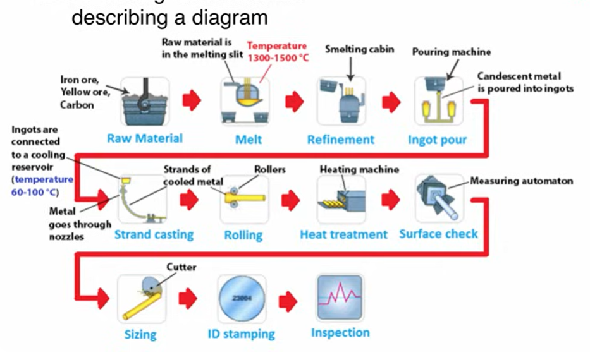

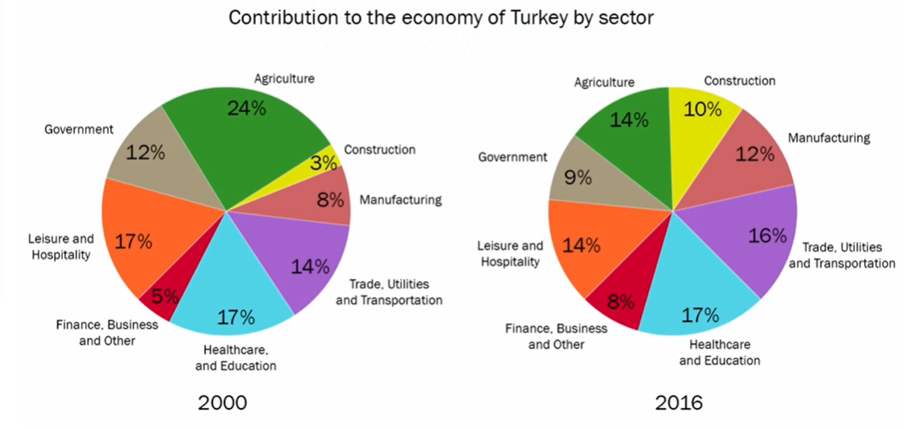
IELTS Task 1 Response (184 words)
The two pie charts illustrate the changes in the contribution of various sectors to Turkey's economy between 2000 and 2016.
Overall, the most significant shift is the decline in the contribution of agriculture and the rise of the service sectors, particularly Trade, Utilities and Transportation, and Finance, Business and Other services.
In 2000, agriculture constituted the largest sector, contributing 24% to the economy. However, by 2016, its share had dropped to 14%. Conversely, the combined contribution of Trade, Utilities and Transportation, and Finance, Business and Other services rose from 22% in 2000 (14% and 8% respectively) to 33% in 2016 (16% and 17% respectively).
The manufacturing sector also experienced a slight decrease, from 9% to 8%, while the construction sector's contribution increased marginally from 3% to 10%. The government sector experienced a decrease from 12% to 9%.
Interestingly, the Leisure and Hospitality sector maintained a relatively stable share, decreasing slightly from 17% to 14% over the 16-year period. The Healthcare and Education sector also saw a small increase in its share of the economy, rising from 17% to 17%.
7 High-Band Features with Examples
- Clear Overview: The response immediately highlights the main trends (decline in agriculture, rise of services). Example: "Overall, the most significant shift is the decline in the contribution of agriculture and the rise of the service sectors..."
- Key Features Identified: The most important changes are selected and presented. Example: "In 2000, agriculture constituted the largest sector, contributing 24% to the economy. However, by 2016, its share had dropped to 14%."
- Accurate Figures: Precise data is used from the charts. Example: "Conversely, the combined contribution of Trade, Utilities and Transportation, and Finance, Business and Other services rose from 22% in 2000 to 33% in 2016."
- Comparison and Contrasting: The answer effectively compares and contrasts data between categories and years. Example: "The manufacturing sector also experienced a slight decrease, from 9% to 8%, while the construction sector's contribution increased marginally from 3% to 10%."
- Range of Vocabulary: A variety of vocabulary is used to describe the changes. Examples: "significant shift," "decline," "rise," "constituted," "conversely," "marginally."
- Coherence and Cohesion: The information is organized logically with clear connections between sentences and paragraphs. Examples: "Overall," "In 2000," "However," "Conversely," "Interestingly."
- Grammatical Accuracy: Accurate grammatical structures are used throughout the response. Example: "The two pie charts illustrate the changes in the contribution of various sectors to Turkey's economy between 2000 and 2016." (correct subject-verb agreement and preposition use).

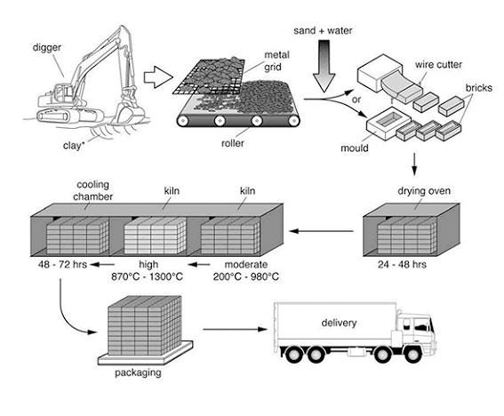
IELTS Writing Task 1 (Academic) answer for the brick manufacturing process shown in the image.

Sample Answer:
The diagram illustrates the various stages involved in the production of bricks, from raw material extraction to final delivery.
Overall, the process consists of seven main stages, beginning with the digging of clay and culminating in the packaging and transportation of finished bricks.
First, clay is extracted from the ground using a digger. The raw clay is then placed onto a metal grid, where large pieces are broken down as they pass through a roller. At the next stage, sand and water are added to the refined clay to create a consistent mixture. This mixture is then shaped into bricks using either a mould or a wire cutter.
Following this, the newly formed bricks are transferred to a drying oven, where they are left for 24 to 48 hours to remove excess moisture. Next, the dried bricks undergo two heating phases in a kiln: first, they are heated at a moderate temperature (200°C - 980°C), and then at a higher temperature (870°C - 1300°C). After this intense heating, the bricks are cooled in a cooling chamber for 48 to 72 hours. In the final stages, the fully processed bricks are packaged and loaded onto delivery trucks, ready to be transported for commercial use.

Word Count: 170

Key Features of a High-Scoring IELTS Response:
✅ Clear and logical structure (Introduction → Overview → Step-by-step process).
✅ Appropriate vocabulary (e.g., "extraction," "refined," "moisture removal").
✅ Passive voice usage (e.g., "Clay is extracted," "Bricks are transferred").
✅ Range of linking phrases (e.g., "Following this," "At the next stage").
………………………………………………………………………………………………………………………………….

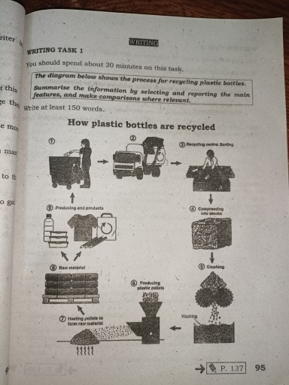
Here is a Band 9 IELTS Writing Task 1 (Academic) sample answer for the plastic bottle recycling process shown in the image.

Sample Answer:
The diagram illustrates the process of recycling plastic bottles, detailing the various stages from collection to the production of new materials.
Overall, the recycling process consists of nine stages, beginning with the collection of used plastic bottles and culminating in the production of new plastic items.
First, discarded plastic bottles are collected from waste bins and transported by truck to a recycling center, where they are sorted manually based on their suitability for recycling. Once sorted, the bottles are compressed into large blocks to facilitate easier handling and processing.
Following this, the compacted plastic is crushed into smaller pieces, which are then washed thoroughly to remove any dirt or impurities. The clean plastic fragments are then processed into small plastic pellets, which serve as the raw material for manufacturing. These pellets are subsequently heated and melted to create new raw materials.
Finally, the recycled plastic is utilized in the production of a variety of new plastic products, such as clothing, containers, and other household items. This completes the cycle, ensuring that plastic waste is repurposed instead of being discarded into the environment.

Word Count: 163

9 Key Features to Get a High Band Score
- Clear Overview
  - Example: "Overall, the recycling process consists of nine stages, beginning with the collection of used plastic bottles and culminating in the production of new plastic items."
  - This provides a concise summary of the process.
- Logical Sequencing
  - Example: "First, discarded plastic bottles are collected... Following this, the compacted plastic is crushed... Finally, the recycled plastic is utilized..."
  - This ensures the description follows the natural order of the process.
- Accurate Vocabulary for Processes
  - Example: "Compressed," "sorted," "crushed," "washed," "heated and melted."
  - Using precise verbs enhances clarity and accuracy.
- Use of Passive Voice
  - Example: "The bottles are collected and transported... The compacted plastic is crushed... The plastic pellets are heated and melted."
  - Passive structures are common in process descriptions.
- Appropriate Linking Words
  - Example: "Following this," "subsequently," "finally," "once sorted."
  - These transition words improve coherence.
- Paraphrasing the Diagram’s Labels
  - Example: Instead of "pellets," the answer uses "small plastic pellets, which serve as the raw material."
  - This avoids copying words directly from the diagram.
- Use of Specific Examples
  - Example: "New plastic products, such as clothing, containers, and other household items."
  - This adds variety and specificity.
- Word Variety and Synonyms
  - Example: "Discarded," "repurposed," "thoroughly washed," "compressed into large blocks."
  - Using different words prevents repetition.
- Formal Tone and Precision
  - Example: "Ensuring that plastic waste is repurposed instead of being discarded into the environment."
  - Maintains an academic style suitable for IELTS Task 1.

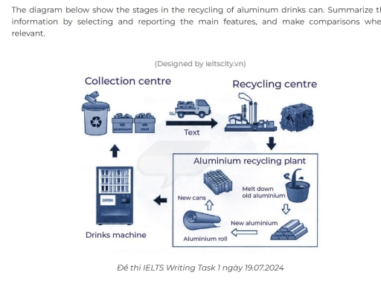

IELTS Writing Task 1 (Academic) - Recycling of Aluminium Cans

Sample Answer:
The diagram illustrates the process of recycling aluminum drink cans, showing the stages from collection to reuse.
Overall, the process consists of five main stages, beginning with the collection of used cans and ending with their reuse as new drink cans or other aluminum products.
First, discarded aluminum cans are collected from bins and vending machines and then transported by truck to a recycling center. At this stage, the used cans are sorted and compressed into large blocks to facilitate further processing.
Following this, the compressed aluminum is sent to a recycling plant, where it undergoes melting and purification to remove any impurities. The purified aluminum is then rolled into sheets, which serve as the raw material for manufacturing new products. Finally, these aluminum sheets are used to create new cans or other aluminum goods, completing the recycling cycle.
In conclusion, this process ensures that used aluminum cans are effectively repurposed, minimizing waste and conserving resources.

Word Count: 160

9 Key Features to Get a High Band Score

1. Clear Overview
- Example: "Overall, the process consists of five main stages, beginning with the collection of used cans and ending with their reuse as new drink cans or other aluminum products."
- A strong overview helps the examiner quickly understand the main idea.

2. Logical Sequencing
- Example: "First, discarded aluminum cans are collected... Following this, the compressed aluminum is sent... Finally, these aluminum sheets are used..."
- The response follows the natural order of the process.

3. Use of Passive Voice
- Example: "The used cans are sorted and compressed into large blocks... The purified aluminum is then rolled into sheets."
- Passive structures are appropriate for process descriptions.

4. Precise Vocabulary for Processes
- Example: "Compressed," "sorted," "melted and purified," "rolled into sheets."
- Using technical terms accurately improves the response.

5. Appropriate Linking Words
- Example: "Following this," "at this stage," "finally."
- These phrases improve coherence and connection between steps.

6. Paraphrasing the Diagram’s Labels
- Example: Instead of copying "collection centre," the answer uses "collected from bins and vending machines."
- Avoids direct repetition from the diagram.

7. Specific Examples Where Relevant
- Example: "New cans or other aluminum goods."
- Adds specificity to the final product stage.

8. Use of Synonyms and Word Variety
- Example: "Discarded," "repurposed," "compressed into blocks," "rolled into sheets."
- Avoids repetitive vocabulary.

9. Formal and Concise Language
- Example: "This process ensures that used aluminum cans are effectively repurposed, minimizing waste and conserving resources."
- The writing is formal, clear, and direct.

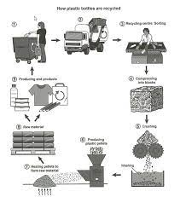

Answer for IELTS Task 1:
The diagram illustrates the process of recycling plastic bottles, showing the various stages involved in converting used plastic into new products.
The process begins with the collection of used plastic bottles, which are placed into recycling bins. These bottles are then transported by trucks to a recycling center, where they undergo sorting. After sorting, the plastic bottles are compressed into large blocks to facilitate further processing.
Once compressed, the blocks are crushed and shredded into small plastic particles. These particles are then washed thoroughly to remove any impurities. After cleaning, the plastic is melted and molded into raw material in the form of pellets. These pellets serve as the basis for producing new plastic products, such as clothing, bags, and containers.
Overall, the recycling process follows a systematic approach, ensuring that used plastic bottles are efficiently transformed into reusable materials, reducing waste and environmental impact.

7 Features for a High Band Score:
- Clear Overview – Summarizing the process in the last paragraph without unnecessary details.
Example: "The recycling process ensures that used plastic bottles are efficiently transformed into reusable materials."
- Logical Sequencing – Presenting the stages in a clear, step-by-step manner.
Example: "The bottles are transported to a recycling center, where they undergo sorting."
- Varied Sentence Structures – Using a mix of complex and simple sentences.
Example: "After sorting, the plastic bottles are compressed into large blocks to facilitate further processing."
- Passive Voice Usage – Making the process sound formal and objective.
Example: "These bottles are then transported by trucks to a recycling center."
- Wide Range of Vocabulary – Using different words to avoid repetition.
Example: "The plastic is melted and molded into raw material in the form of pellets."
- Appropriate Cohesive Devices – Using linking words to connect ideas smoothly.
Example: "Once compressed, the blocks are crushed and shredded into small plastic particles."
- Accurate Data Representation – Describing the diagram accurately without personal opinions.
Example: "These pellets serve as the basis for producing new plastic products, such as clothing, bags, and containers."

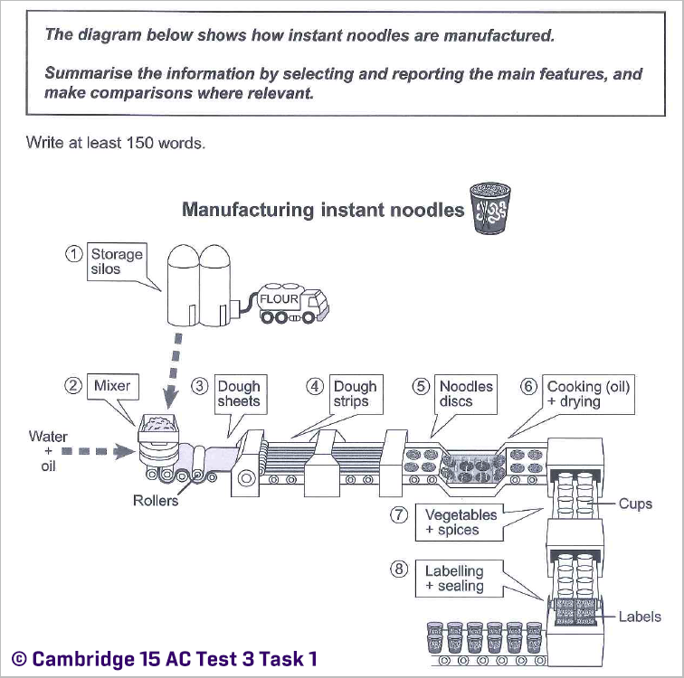

Answer:
The diagram illustrates the step-by-step process of manufacturing instant noodles, from raw materials to the final packaged product.
The process begins with flour being transported from storage silos into a mixer, where it is combined with water and oil. The mixture is then processed through rollers to form dough sheets, which are subsequently cut into strips. These strips are further shaped into noodle discs, ready for the next stage.
Following this, the noodle discs are cooked in oil and then dried to ensure a longer shelf life. Once dried, they are placed into cups, where additional ingredients such as vegetables and spices are added for flavor. Finally, the cups undergo labeling and sealing before they are distributed for sale.
Overall, the production of instant noodles follows a linear process, with each stage ensuring the transformation of basic ingredients into a ready-to-eat product. The key aspects of the process include mixing, shaping, cooking, and packaging, highlighting the efficiency and automation involved in large-scale noodle production.

7 Features for a High Band Score:
- Clear Overview – The response provides a summary of the entire process in the last paragraph: "Overall, the production of instant noodles follows a linear process..."
- Use of Passive Voice – Passive structures enhance formality, e.g., "flour is transported from storage silos", "the noodle discs are cooked in oil and then dried."
- Cohesion and Linking Words – Connectors like "Following this," and "Finally," ensure smooth progression.
- Varied Sentence Structures – A mix of complex and compound sentences improves fluency, e.g., "Once dried, they are placed into cups, where additional ingredients such as vegetables and spices are added for flavor."
- Precise Vocabulary – Specific terms such as "rollers," "noodle discs," and "linear process" demonstrate lexical resource.
- Comparisons and Emphasis – The phrase "each stage ensuring the transformation of basic ingredients into a ready-to-eat product" highlights the step-by-step nature.
- Task Fulfillment – The answer meets the word requirement (150–220 words) while fully addressing the question with all key steps described.

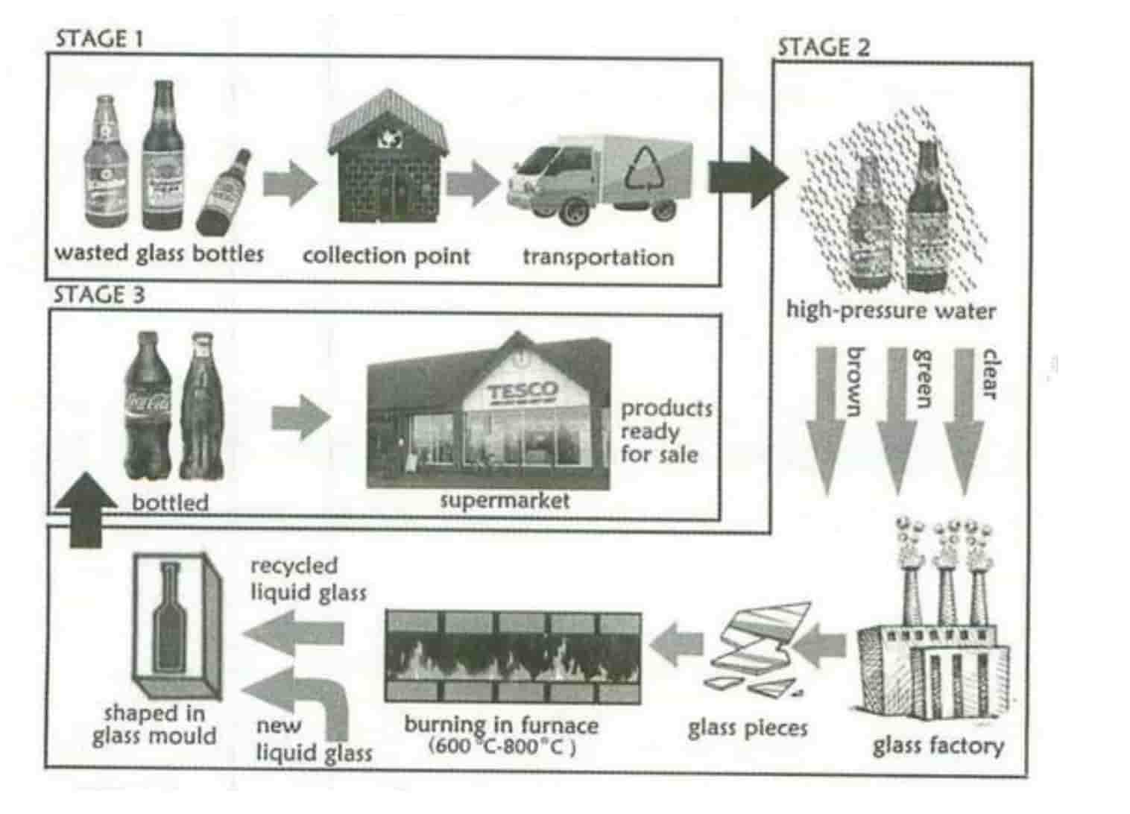

IELTS Task 1 Answer:
The diagram illustrates the recycling process of glass bottles in three stages.
Overall, the process includes 9 steps, beginning with collection of wasted bottles, and ending with re-entry them again in the market to be available for usage. The goal of this circular pattern is ensuring that old glass bottles are repurposed into new ones, minimizing waste and promoting sustainability.
In the first stage, used glass bottles are collected from various sources and taken to collection points. These bottles are then transported to a processing facility for further treatment. In the second stage, the bottles are washed with high-pressure water to remove any impurities. After cleaning, they are sorted into three categories based on color: brown, green, and clear. Once sorted, the bottles are sent to a glass factory, where they are broken into small pieces.
The third stage involves heating these glass fragments in a furnace at temperatures ranging from 600°C to 800°C. The melted glass is then combined with new liquid glass to enhance quality. The resulting liquid glass mixture is poured into molds to form new bottles. Once the bottles are shaped and cooled, they are filled with beverages and distributed to supermarkets for sale.

7 Features for a High Band Score:
- Clear Structure: The response follows a logical sequence, covering each stage step by step.
- Paraphrasing: Instead of repeating words from the diagram, phrases like "processing facility" and "treatment" replace "transportation."
- Cohesion & Coherence: Connectors such as "once," "after," and "overall" ensure smooth flow.
- Passive Voice: "The bottles are washed" and "are shaped and cooled" add variety to sentence structures.
- Range of Vocabulary: Words like "fragments," "enhance quality," and "circular pattern" show lexical resource.
- Data Inclusion: "600°C to 800°C" adds specificity to support the description.
- Concluding Sentence: The summary reinforces the idea of sustainability, which improves cohesion.

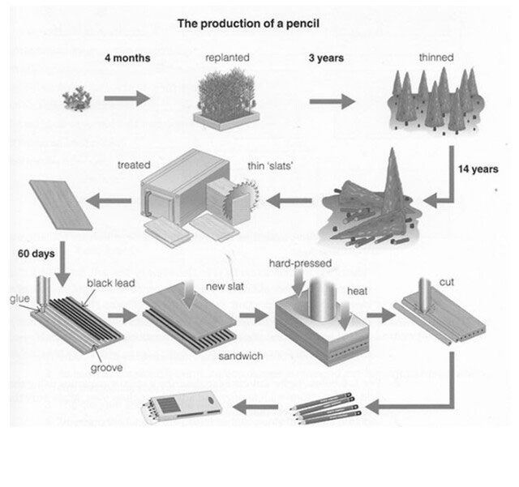
The diagram illustrates the life cycle of a pencil, from the planting of the tree to the final product. The process is cyclical, beginning and ending with the planting of trees.
The journey starts with planting, and after four months, the trees are replanted. Three years later, these trees are thinned out. After a total of 14 years, the trees are harvested and processed. Initially, the harvested wood is treated and cut into thin 'slats'.
These slats then undergo a hard-pressing process. Simultaneously, a separate process involves creating the core of the pencil. A mixture of glue and black lead is combined, and this mixture is then placed into a grooved slat. A new slat is placed on top, creating a 'sandwich' with the lead in the middle. This sandwich is then subjected to heat treatment and cut, resulting in multiple pencils. Finally, these pencils are ready for use, with the cycle concluding as the used pencils are presumably replaced by new ones, perpetuating the need for planting new trees.
Here are 7 features for a high band score in IELTS Task 1, with examples from the response:
- Clear Overview: The response starts with a clear overview of the process. Example: "The diagram illustrates the life cycle of a pencil, from the planting of the tree to the final product."
- Key Features Highlighted: The stages of the process are clearly presented in a logical sequence. Example: "The journey starts with planting, and after four months, the trees are replanted."
- Accurate Data Presentation: The timeframes and processes are accurately represented as shown in the diagram. Example: "Three years later, these trees are thinned out. After a total of 14 years, the trees are harvested..."
- Comparison and Contrast (where applicable): While not directly comparing data points, the response contrasts different stages of the process, such as the tree growing phase versus the manufacturing phase. Example: "Simultaneously, a separate process involves creating the core of the pencil."
- Range of Vocabulary: A good range of vocabulary related to the process is used. Examples: "harvested," "processed," "mixture," "grooved," "subjected to heat treatment."
- Coherent Paragraphing: The information is organized into logical paragraphs, flowing smoothly from one stage to the next.
- Grammatical Accuracy: The sentences are grammatically correct and demonstrate a variety of sentence structures. Example: "These slats then undergo a hard-pressing process." "This sandwich is then subjected to heat treatment and cut, resulting in multiple pencils."

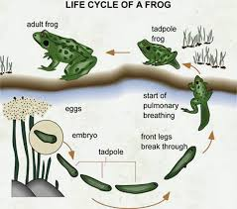
Absolutely! Here's an IELTS Task 1 response for the image you've provided, followed by 7 features for a high band score:
IELTS Task 1 Response (159 words)
The diagram illustrates the life cycle of a frog, an aquatic creature that undergoes a fascinating metamorphosis. The process is cyclical, beginning and ending with the adult frog.
Initially, the adult frog lays eggs, which are typically deposited in water. These eggs then hatch into an embryo, which develops into a tadpole. The tadpole grows significantly, eventually developing into a tadpole frog, marking the start of pulmonary breathing. This stage is a transitional phase where the tadpole begins to acquire characteristics of a frog.
Subsequently, the front legs of the tadpole frog emerge, further transforming it. The final stage sees the tadpole frog develop into an adult frog, completing the cycle and preparing to reproduce. Throughout this cycle, the organism transitions from a fully aquatic creature in its early stages to a semi-aquatic/terrestrial one in its adult form.
Overall, the diagram clearly demonstrates the sequential stages of a frog's life, highlighting the significant physical changes that occur during its journey from egg to adult.
7 Features for a High Band Score (with examples from the answer)
- Clear Overview: The response starts with a concise overview of the diagram and its purpose (e.g., "The diagram illustrates the life cycle of a frog, an aquatic creature that undergoes a fascinating metamorphosis.").
- Logical Organization: Information is presented in a logical sequence, following the stages of the life cycle (e.g., "Initially, the adult frog lays eggs, which...").
- Accurate Description: The stages are accurately described, highlighting key changes (e.g., "This stage is a transitional phase where the tadpole begins to acquire characteristics of a frog.").
- No Unnecessary Detail: The response focuses on the main features and avoids minor details (e.g., it doesn't speculate on the exact timeframes for each stage).
- Effective Linking Words: Cohesive devices are used to connect ideas and ensure a smooth flow (e.g., "Subsequently," "Throughout this cycle," "Overall").
- Varied Vocabulary: A range of vocabulary related to the topic is used (e.g., "metamorphosis," "aquatic," "terrestrial," "transitional phase").
- Grammatical Accuracy: The response demonstrates accurate grammar and sentence structure (e.g., "The process is cyclical, beginning and ending with the adult frog.").
By incorporating these features, you can craft a high-scoring Task 1 response that effectively summarizes the visual information and demonstrates your language proficiency. Remember to practice regularly and analyze sample answers to refine your skills.

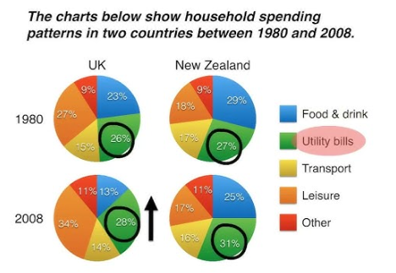

IELTS Task 1 Response (182 words):
The provided pie charts illustrate the evolution of household spending patterns in the United Kingdom and New Zealand between 1980 and 2008. The data is categorized into five expenditure areas: food & drink, utility bills, transport, leisure, and other goods & services.
In 1980, UK households allocated the largest share of their budget to food & drink, accounting for 27%, while New Zealand households spent a larger proportion, 29%, in this category. By 2008, both countries had reduced spending on food & drink, with the UK decreasing to 16% and New Zealand slightly less to 28%.
Conversely, expenditure on utility bills saw an increase in both countries over the 28-year period. In the UK, utility bills rose from 18% in 1980 to 28% in 2008. New Zealand experienced a similar upward trend, with spending on utilities rising from 17% to 31%.
Transport spending in the UK saw a moderate increase from 15% to 23%, while in New Zealand it remained constant at around 17-18%. Expenditure on leisure activities increased significantly in the UK, from 9% to 34%, but in New Zealand, it decreased slightly from 11% to 9%.
Overall, the charts indicate a global trend towards decreased spending on essential items like food & drink and increased spending on leisure and utilities, reflecting changes in lifestyle and cost of living over time.
7 Features for High Band Score (with Examples from the Response):
- Clear Overview: The response begins with a clear and concise overview of the charts and their purpose. ("The provided pie charts illustrate the evolution of household spending patterns in the United Kingdom and New Zealand between 1980 and 2008.")
- Key Features Highlighted: The writer focuses on the most significant changes and trends in the data. ("Conversely, expenditure on utility bills saw an increase in both countries over the 28-year period.")
- Accurate Data Presentation: The data is presented accurately and with correct proportions. ("In 1980, UK households allocated the largest share of their budget to food & drink, accounting for 27%...")
- Comparison and Contrast: The response effectively compares and contrasts spending patterns between the two countries. ("Transport spending in the UK saw a moderate increase from 15% to 23%, while in New Zealand it remained constant at around 17-18%.")
- Logical Paragraphing: Information is organized logically, with each paragraph focusing on specific categories or trends.
- Appropriate Vocabulary: The language used is suitable for describing data and trends. ("evolution," "allocated," "proportion," "conversely," "moderate," "significant")
- Coherence and Cohesion: The response flows smoothly with effective use of cohesive devices. ("In 1980," "By 2008," "Conversely," "Overall," "while")

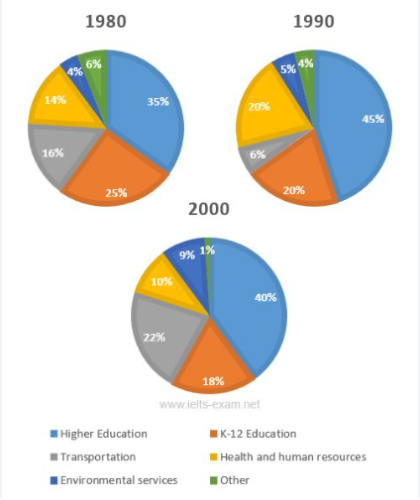

Certainly! Let's break down this pie chart IELTS Task 1 question.
IELTS Task 1 Response (159 words)
The three pie charts illustrate the distribution of government spending across six sectors in three distinct years: 1980, 1990, and 2000.
In 1980, education commanded the largest share of expenditure, with 35% allocated to K-12 and 14% to higher education, totaling 49% for the entire education sector. Health and human resources received the second-largest allocation at 25%, followed by transportation at 16%. Environmental services and other categories received 4% and 6%, respectively.
By 1990, significant shifts occurred. Spending on K-12 education decreased to 20%, while higher education rose slightly to 20%, making the total education expenditure 40%. Health and human resources saw a substantial increase to 45%, becoming the largest sector. Transportation spending decreased to 6%, while environmental services rose to 20%. Other spending remained constant at 20%.
In 2000, the most dramatic change was the surge in environmental services spending to 40%. K-12 education fell to 10%, and higher education dropped to 9%, resulting in a total education expenditure of 19%. Health and human resources spending decreased to 18%, while transportation stabilized at 22%. Other spending experienced a slight decrease to 1%.
Overall, the charts reveal a significant fluctuation in government spending priorities over the two decades, most notably the rise in environmental services and the decline in education spending.
7 Features for High Band Score (with Examples from the Response)
- Clear Overview: The response starts with a concise overview of the charts, summarizing the key information (e.g., "The three pie charts illustrate the distribution of government spending across six sectors in three distinct years: 1980, 1990, and 2000.").
- Key Features Identified: It accurately pinpoints the most significant trends and figures (e.g., "In 1980, education commanded the largest share of expenditure, with 35% allocated to K-12 and 14% to higher education...").
- Accurate Data Representation: The response uses data accurately and avoids misinterpretations (e.g., "Health and human resources received the second-largest allocation at 25%, followed by transportation at 16%.").
- Comparison and Contrasting: It effectively compares and contrasts data between categories and years (e.g., "By 1990, significant shifts occurred. Spending on K-12 education decreased to 20%, while higher education rose slightly to 20%...").
- Range of Vocabulary: A good mix of vocabulary is used, including words like "commanded," "allocated," "substantial," "fluctuation," "priorities," and "stabilized."
- Coherence and Cohesion: The response flows logically with clear connections between sentences and paragraphs (e.g., "In 1980," "By 1990," "In 2000," "Overall").
- Grammatical Accuracy: The response demonstrates a good command of grammar with varied sentence structures and minimal errors (e.g., "The charts reveal a significant fluctuation in government spending priorities over the two decades, most notably the rise in environmental services and the decline in education spending.").

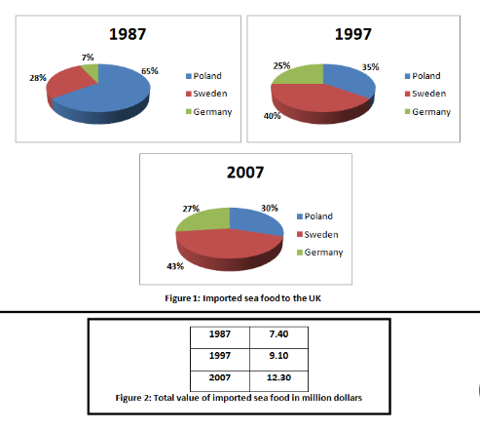

Absolutely! Here's an IELTS Task 1 response within the word limit, followed by 7 high-band features with examples:
Response (159 words):
The provided charts illustrate the changes in the UK's imported seafood sources and the total import value between 1987 and 2007.
In 1987, Germany dominated UK seafood imports, providing 65%, while Sweden and Poland supplied 28% and 7% respectively. By 1997, Germany's share decreased to 40%, Sweden's rose to 35%, and Poland's increased to 25%. A decade later, in 2007, Germany remained the primary source, but its share had fallen further to 43%. Poland's contribution also decreased to 27%, whereas Sweden became the second largest importer with 30%.
Concerning the total value of imported seafood, there was a consistent increase over the 20-year period. From $7.4 million in 1987, it rose to $9.1 million in 1997 and further to $12.3 million in 2007. This demonstrates a significant growth in the value of seafood imports into the UK.
In summary, while Germany remained the main source of UK seafood imports, its share declined over time, with Sweden becoming an increasingly important supplier. Simultaneously, the total value of these imports experienced a steady rise.
7 High-Band Features with Examples:
- Clear Overview (Introduction): The response starts with a concise overview summarizing the main trends in the charts, which is crucial for a high band score.
  - Example: "The provided charts illustrate the changes in the UK's imported seafood sources and the total import value between 1987 and 2007."
- Key Features Highlighted: The answer focuses on the most important changes and trends rather than listing every single detail.
  - Example: "Germany remained the primary source, but its share had fallen further to 43%." (This highlights a significant change.)
- Accurate Figures: The data is reported accurately, demonstrating a good understanding of the information presented.
  - Example: "From $7.4 million in 1987, it rose to $9.1 million in 1997 and further to $12.3 million in 2007."
- Logical Organization: The information is organized logically, making it easy to follow the progression of changes over time.
  - Example: The description moves chronologically from 1987 to 1997 and then 2007.
- Cohesive Devices: The response uses cohesive devices effectively to link ideas and sentences.
  - Examples: "In 1987," "By 1997," "A decade later," "Concerning the total value."
- Varied Vocabulary: A range of vocabulary is used to express the information, avoiding repetition and showing a good command of language.
  - Examples: "Dominated," "Dominated," "Share," "Contribution," "Experienced a steady rise."
- Concise and Focused: The response stays within the word limit and avoids unnecessary details or repetition. It efficiently summarizes the key information.
  - Example: The entire response is succinct and avoids rambling, staying within the 150-220 word target.

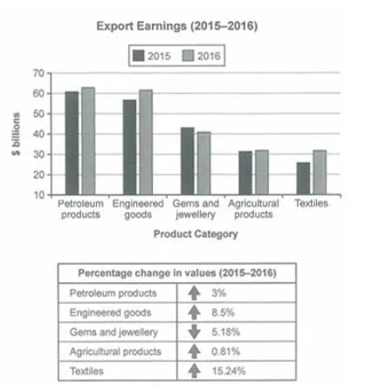

Absolutely! Let's break down this IELTS Task 1 response and highlight its strengths.
IELTS Task 1 Response (156 words)
The bar chart illustrates export earnings for five distinct product categories between 2015 and 2016, measured in billions of dollars. Additionally, a table presents the percentage change in earnings for each category over the same period.
In 2015, petroleum products constituted the largest export earner, generating approximately $62 billion, followed closely by engineered goods at just over $60 billion. Gems and jewelry contributed roughly $44 billion, while agricultural products and textiles earned significantly less, at around $30 billion and $26 billion, respectively.
By 2016, petroleum products and engineered goods remained the dominant export categories, experiencing modest increases. However, gems and jewelry saw a notable decline, while agricultural products and textiles demonstrated growth. The table reveals that textiles witnessed the most substantial growth in export earnings, surging by 15.24%, whereas gems and jewelry suffered the largest decrease, falling by 5.18%. Petroleum products experienced a marginal rise of 3%, and engineered goods an 8.5% increase, while agricultural products saw a slight uptick of 0.81%.
Overall, the data highlights the fluctuating nature of export earnings across different product categories, with textiles demonstrating the most robust growth and gems and jewelry experiencing a significant downturn during the period.
7 Features for High Band Score (with Examples from the Response)
- Clear Overview: The response starts with a concise overview of the chart and table, summarizing the key information (e.g., "The bar chart illustrates export earnings for five distinct product categories...").
- Key Features Identified: It accurately pinpoints the most significant trends and figures (e.g., "In 2015, petroleum products constituted the largest export earner...").
- Accurate Data Representation: The response uses data accurately and avoids misinterpretations (e.g., "petroleum products constituted the largest export earner, generating approximately $62 billion...").
- Comparison and Contrasting: It effectively compares and contrasts data between categories and years (e.g., "By 2016, petroleum products and engineered goods remained the dominant export categories...").
- Range of Vocabulary: A good mix of vocabulary is used, including words like "constituted," "dominant," "marginal," "substantial," and "fluctuating."
- Coherence and Cohesion: The response flows logically with clear connections between sentences and paragraphs (e.g., "However," "whereas," "Overall," "Additionally").
- Grammatical Accuracy: The response demonstrates a good command of grammar with varied sentence structures and minimal errors (e.g., "The table reveals that textiles witnessed the most substantial growth...").

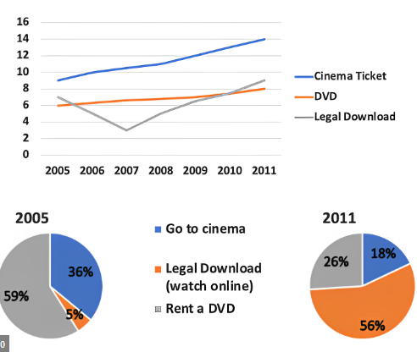

Absolutely! Here's the response tailored for IELTS Task 1, followed by the high-band features:
IELTS Task 1 Response (189 words)
The charts illustrate the average prices of cinema tickets, DVDs, and online film downloads from 2005 to 2011, alongside pie charts depicting the proportion of revenue generated by each sector in those years.
Overall, while cinema ticket and online download prices increased, DVD costs decreased. Initially, DVDs dominated the market. However, by 2011, online downloads had surged, approaching the market share of DVDs, while cinema revenue experienced a slight decline.
Specifically, average cinema ticket prices rose steadily from around £5 to just over £10. Similarly, the cost of online downloads increased, albeit marginally, from roughly £6.50 to £8. Conversely, DVD prices fell significantly from approximately £10 to £4.
In 2005, DVDs constituted a substantial 59% of the market, compared to 36% for cinema visits and a mere 5% for online downloads. By 2011, however, online downloads had grown to 26%, nearing the 56% held by DVDs. Cinema revenue decreased slightly to 18% in 2011.
7 High-Band Features with Examples
- Clear Overview: The response immediately highlights the main trends (price changes and market share shifts). Example: "Overall, while cinema ticket and online download prices increased, DVD costs decreased."
- Key Features Identified: The most important data points are selected and presented. Example: "In 2005, DVDs constituted a substantial 59% of the market, compared to 36% for cinema visits and a mere 5% for online downloads."
- Accurate Figures: Precise data is used from the charts. Example: "average cinema ticket prices rose steadily from around £5 to just over £10."
- Comparison and Contrasting: The answer effectively compares and contrasts data between categories and years. Example: "Similarly, the cost of online downloads increased, albeit marginally, from roughly £6.50 to £8. Conversely, DVD prices fell significantly..."
- Range of Vocabulary: A variety of vocabulary is used to express trends and proportions. Examples: "dominated," "surged," "substantial," "marginally," "constituted."
- Coherence and Cohesion: The information is organized logically with clear connections between sentences and paragraphs. Examples: "Overall," "Specifically," "However," "By 2011."
- Appropriate Grammar: Accurate grammatical structures are used throughout the response. Example: "The charts illustrate the average prices..." (correct subject-verb agreement).

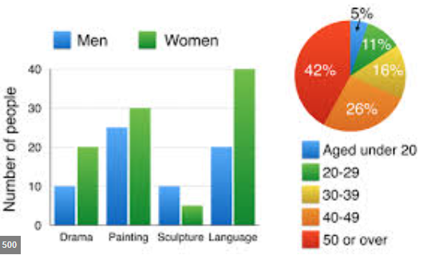
Absolutely! Let's dissect this IELTS Task 1 response and identify its high-band features.
IELTS Task 1 Response (167 words):
The two charts provide insights into travel motivations and the primary concerns of the travelling public. The bar graph illustrates the purposes of journeys, while the pie chart delineates the major issues faced by travelers.
Topping the list of travel reasons is commuting to and from work, accounting for nearly half of all journeys at 49%. Personal reasons constitute the second largest category, with 19% of trips made for such purposes. Shopping comprises 16% of travel motivations, followed by social and recreational activities at 10%. Visiting friends or relatives makes up the smallest proportion of journeys, at just 6%.
Turning to the concerns of travelers, the dominant issue is the price of travel, cited by 36% of respondents. Safety concerns are also significant, representing 19% of the issues. Highway congestion and the behavior of aggressive drivers each account for 17% and 14% of concerns, respectively. Access to public transport and space for pedestrians are the least pressing issues, at 8% and 6%, respectively.
Overall, the charts highlight that commuting is the primary driver for travel, while cost remains the most significant concern for the travelling public.
7 Features for High Band Score (with Examples from the Response):
- Clear Overview: The response begins with a clear and concise overview of both visuals. ("The two charts provide insights into travel motivations and the primary concerns of the travelling public.")
- Key Features Highlighted: The writer focuses on the most prominent data in each chart. ("Topping the list of travel reasons is commuting to and from work, accounting for nearly half of all journeys at 49%.")
- Accurate Data Presentation: The data is presented accurately and with correct proportions. ("Personal reasons constitute the second largest category, with 19% of trips made for such purposes.")
- Comparison and Contrast: Implicit comparisons are made by highlighting the most and least significant categories. ("Visiting friends or relatives makes up the smallest proportion of journeys, at just 6%.")
- Logical Paragraphing: Each paragraph focuses on a distinct aspect of the data (paragraph 1: reasons for travel, paragraph 2: main issues).
- Appropriate Vocabulary: The language used is suitable for describing data and trends. ("dominant issue," "significant," "constitute," "respectively")
- Coherence and Cohesion: The response flows smoothly with effective use of cohesive devices. ("Turning to the concerns of travelers," "Overall, the charts highlight...")

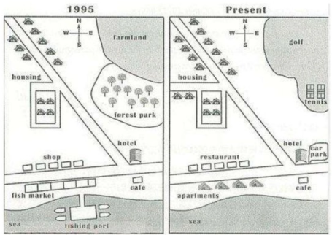
Absolutely! Let's dissect this map change question for IELTS Task 1.
IELTS Task 1 Response (167 words)
The maps illustrate changes in an area between 1995 and the present day. Initially, the area was primarily characterized by farmland and natural features alongside basic infrastructure, but it has since been transformed into a more developed community with additional amenities.
In 1995, farmland occupied the western section, while a forest park was situated in the center. Housing was limited, consisting of only a few houses in the north and a small block of flats near the sea. Infrastructure included a shop, a hotel, and a fish market by the sea, along with a basic road network connecting these facilities. A cafe was present near the flats, and a fishing port existed on the coast.
Currently, the farmland has been repurposed into a golf course, and the forest park has been significantly reduced in size to accommodate a tennis court. Housing has expanded considerably, with more houses in the north and a new apartment block built near the sea, replacing the original flats. Additional amenities now include a restaurant and a car park adjacent to the hotel, catering to increased tourism. The road network has also been upgraded to accommodate the expansion.
Overall, the transformation from 1995 to the present reveals a shift from a predominantly rural landscape with limited development to a more urbanized area with enhanced recreational and residential facilities.
7 Features for High Band Score (with Examples from the Response)
- Clear Overview: The response starts with a concise overview of the changes, summarizing the key transformations (e.g., "The maps illustrate changes in an area between 1995 and the present day...").
- Key Features Identified: It accurately pinpoints the most significant changes (e.g., "Initially, the area was primarily characterized by farmland and natural features...").
- Accurate Data Representation: The response uses information from the maps accurately and avoids misinterpretations (e.g., "In 1995, farmland occupied the western section...").
- Comparison and Contrasting: It effectively compares and contrasts features between the two periods (e.g., "Currently, the farmland has been repurposed into a golf course...").
- Range of Vocabulary: A good mix of vocabulary is used, including words like "characterized," "repurposed," "significantly," "accommodate," and "enhanced."
- Coherence and Cohesion: The response flows logically with clear connections between sentences and paragraphs (e.g., "Initially," "Currently," "Overall," "Furthermore" - though not used in this example, it's a useful cohesive device).
- Grammatical Accuracy: The response demonstrates a good command of grammar with varied sentence structures and minimal errors (e.g., "The road network has also been upgraded to accommodate the expansion.").

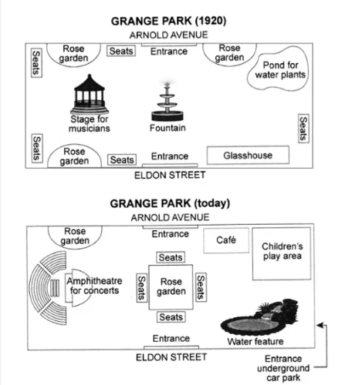

Absolutely! Let's analyze this IELTS Task 1 response and extract its high-band features.
IELTS Task 1 Response (194 words):
The two maps illustrate changes to Grange Park over a period of time, contrasting the park's layout in 1920 with its contemporary design.
In 1920, Grange Park featured two entrances, one on Arnold Avenue and another on Eldon Street. Flanking the Arnold Avenue entrance were rose gardens on either side, each with seating. A glasshouse was situated near the Eldon Street entrance. The park's central area was primarily open space, punctuated by a circular pond for water plants and a stage for musicians, with a fountain positioned between them. Seating was scattered throughout this central area.
By the present day, Grange Park has undergone a significant transformation. While the entrances on both Arnold Avenue and Eldon Street remain, a new underground car park entrance has been added on Eldon Street. The glasshouse near this entrance has been replaced by a café and a children's play area. The pond has been significantly altered into a more naturalistic water feature, and the stage for musicians has been repurposed into an amphitheater for concerts, indicating a shift towards more formal performances. The rose gardens have been retained, but the layout of seating appears to be more structured compared to the less formal arrangement in 1920.
Overall, the changes to Grange Park suggest a move towards providing more structured entertainment facilities and amenities for visitors, alongside the preservation of some historical elements like the rose gardens.
7 Features for High Band Score (with Examples from the Response):
- Clear Overview: The response starts with a concise overview of the maps and the period of change. ("The two maps illustrate changes to Grange Park over a period of time, contrasting the park's layout in 1920 with its contemporary design.")
- Key Features Highlighted: The response focuses on the most significant changes between the two maps. ("By the present day, Grange Park has undergone a significant transformation.")
- Accurate Data Presentation: Information is presented accurately and with correct details. ("In 1920, Grange Park featured two entrances, one on Arnold Avenue and another on Eldon Street.")
- Comparison and Contrast: The response effectively compares and contrasts features between the two time periods. ("The pond has been significantly altered into a more naturalistic water feature, and the stage for musicians has been repurposed into an amphitheater...")
- Logical Paragraphing: Information is organized logically, with each paragraph focusing on specific aspects of the park's layout in different time periods.
- Appropriate Vocabulary: The language used is suitable for describing maps and changes over time. ("flanking," "situated," "punctuated," "repurposed," "naturalistic," "structured")
- Coherence and Cohesion: The response flows smoothly with effective use of cohesive devices. ("While the entrances...remain," "Overall, the changes to Grange Park suggest...")

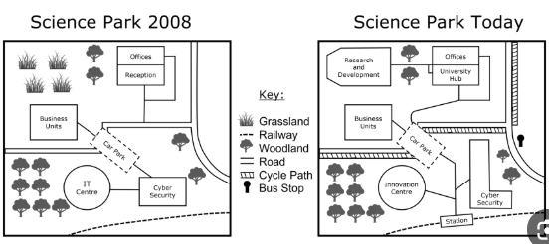
Absolutely! Here's a response tailored for IELTS Task 1, along with the high-band features:
IELTS Task 1 Response (185 words)
The two maps illustrate the development of a science park between 2008 and the present day. Overall, the park has expanded significantly, with new facilities focused on research and development, enhanced transport links, and increased amenities.
In 2008, the park consisted primarily of offices, an IT centre, and a small number of business units clustered around a reception area. A single access road connected the park to the main road, with a car park located near the IT centre. The site also featured areas of woodland and grassland.
Today, the science park has been transformed. A dedicated research and development building and a university hub have been added, indicating a shift towards innovation and collaboration. The number of business units has also increased. Transport infrastructure has been significantly improved with the addition of a railway station connected by a shuttle bus service running along a new cycle path. A new car park has also been constructed closer to the new facilities. The park now includes an innovation centre, reflecting its focus on cutting-edge technology. Interestingly, the cyber security building remains the only original feature alongside the offices, suggesting its continued importance within the park's mission.
7 High-Band Features with Examples
- Clear Overview: The response immediately highlights the main changes (expansion, new facilities, improved transport). Example: "Overall, the park has expanded significantly, with new facilities focused on research and development, enhanced transport links, and increased amenities."
- Key Features Identified: The most important developments are selected and presented. Example: "A dedicated research and development building and a university hub have been added, indicating a shift towards innovation and collaboration."
- Accurate Detail: Specific details are used from the maps. Example: "A single access road connected the park to the main road, with a car park located near the IT centre."
- Comparison and Contrasting: The answer effectively compares and contrasts the two maps. Example: "In 2008, the park consisted primarily of... Today, the science park has been transformed."
- Range of Vocabulary: A variety of vocabulary is used to describe the changes. Examples: "expanded," "transformed," "enhanced," "significantly improved," "clustered."
- Coherence and Cohesion: The information is organized logically with clear connections between sentences and paragraphs. Examples: "Overall," "In 2008," "Today," "Interestingly."
- Grammatical Accuracy: Accurate grammatical structures are used throughout the response. Example: "The two maps illustrate the development of a science park..." (correct subject-verb agreement).

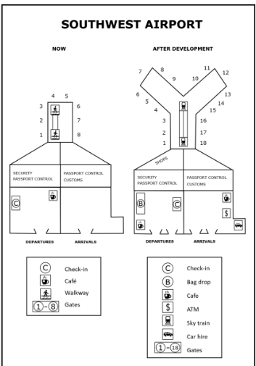
Alright, let's tackle this airport map change question for IELTS Task 1.
IELTS Task 1 Response (161 words)
The maps illustrate the layout of Southwest Airport, depicting changes between its original configuration and its planned development. Overall, the airport will expand to include more gates, enhanced amenities, and improved transportation links.
In its current state, the airport features a single terminal building with gates numbered 1 through 8. Security and passport control are located centrally, leading to both departure and arrival areas. Within the terminal, there is a check-in area, a café, and a walkway. Outside, limited transportation options are available.
The proposed development shows a significant expansion of the terminal building, now accommodating gates 1 through 18. A new sky train station will be added, connecting the terminal to a new car hire facility. The number of shops will also increase substantially, suggesting an expansion of retail services. Additionally, a bag drop area will streamline the check-in process, and an ATM will be conveniently located within the terminal. The café will remain, and a new walkway will provide easier access to the expanded gates.
In summary, the future Southwest Airport will be significantly larger and offer more comprehensive facilities and services compared to its current layout. The changes reflect a focus on enhancing passenger experience and improving connectivity.
7 Features for High Band Score (with Examples from the Response)
- Clear Overview: The response starts with a concise overview of the changes, summarizing the key transformations (e.g., "The maps illustrate the layout of Southwest Airport, depicting changes between its original configuration and its planned development.").
- Key Features Identified: It accurately pinpoints the most significant changes (e.g., "Overall, the airport will expand to include more gates, enhanced amenities, and improved transportation links.").
- Accurate Data Representation: The response uses information from the maps accurately and avoids misinterpretations (e.g., "In its current state, the airport features a single terminal building with gates numbered 1 through 8.").
- Comparison and Contrasting: It effectively compares and contrasts features between the two periods (e.g., "The proposed development shows a significant expansion of the terminal building, now accommodating gates 1 through 18.").
- Range of Vocabulary: A good mix of vocabulary is used, including words like "configuration," "enhanced," "streamline," "comprehensive," and "connectivity."
- Coherence and Cohesion: The response flows logically with clear connections between sentences and paragraphs (e.g., "Overall," "In its current state," "The proposed development shows," "Additionally," "In summary").
- Grammatical Accuracy: The response demonstrates a good command of grammar with varied sentence structures and minimal errors (e.g., "The changes reflect a focus on enhancing passenger experience and improving connectivity.").

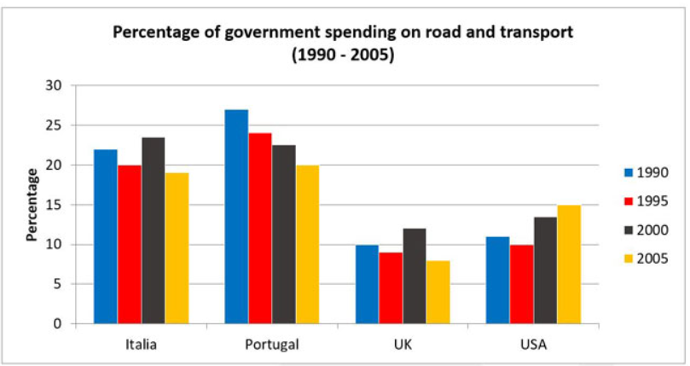
IELTS Task 1 Response (187 words)
The bar chart illustrates fluctuations in government spending on road and transport across four countries – Italia, Portugal, the UK, and the USA – between 1990 and 2005. Spending is expressed as a percentage.
Overall, the data reveals divergent trends. While spending in Italia and Portugal initially rose before declining, the UK saw a continuous decrease, and the USA experienced minor fluctuations with an overall increase.
Specifically, Italia's expenditure started at approximately 22% in 1990, increased to just over 23% in 1995, and then fell to around 19% by 2005. Portugal followed a similar pattern, peaking at nearly 27% in 1995 before dropping to about 20% in 2005.
In contrast, the UK's spending steadily decreased over the 15-year period, from roughly 12% in 1990 to just over 7% in 2005. The USA's spending, on the other hand, fluctuated slightly. It began at about 11% in 1990, dipped below 10% in 1995 and 2000, and then rose to approximately 15% in 2005.
In conclusion, while Italia and Portugal prioritized road and transport spending in the mid-1990s, the UK consistently reduced its expenditure, and the USA demonstrated a net increase by 2005 despite some intermediate fluctuations.
7 High-Band Features with Examples
- Clear Overview: The response immediately highlights the main trends (divergent trends, fluctuations, rise and decline). Example: "Overall, the data reveals divergent trends."
- Key Features Identified: The most important changes are selected and presented. Example: "While spending in Italia and Portugal initially rose before declining, the UK saw a continuous decrease, and the USA experienced minor fluctuations with an overall increase."
- Accurate Figures: Precise data is used from the chart. Example: "Italia's expenditure started at approximately 22% in 1990, increased to just over 23% in 1995, and then fell to around 19% by 2005."
- Comparison and Contrasting: The answer effectively compares and contrasts data between countries and years. Example: "Portugal followed a similar pattern, peaking at nearly 27% in 1995 before dropping to about 20% in 2005. In contrast, the UK's spending steadily decreased..."
- Range of Vocabulary: A variety of vocabulary is used to describe the changes. Examples: "fluctuations," "divergent," "peaking," "steadily," "dipped," "prioritized," "consistently."
- Coherence and Cohesion: The information is organized logically with clear connections between sentences and paragraphs. Examples: "Overall," "Specifically," "In contrast," "On the other hand," "In conclusion."
- Grammatical Accuracy: Accurate grammatical structures are used throughout the response. Example: "The bar chart illustrates fluctuations in government spending..." (correct subject-verb agreement and preposition use).

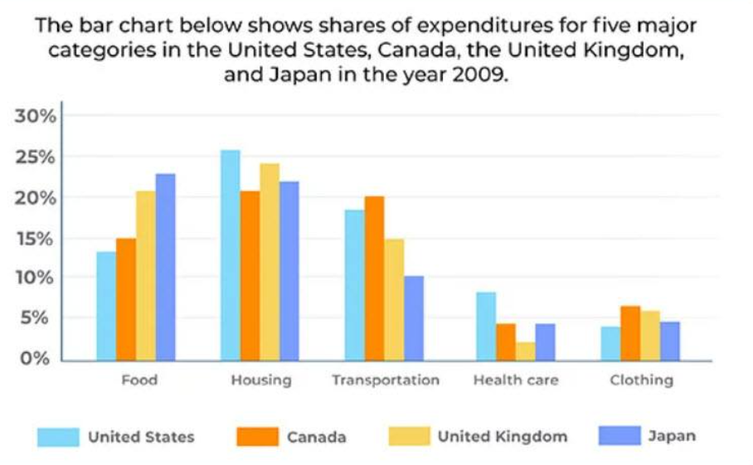
IELTS Task 1 Response (168 words)
The bar chart compares expenditure shares across five categories in the United States, Canada, the United Kingdom, and Japan in 2009. Overall, housing constituted the largest expenditure in most countries, while clothing represented the smallest.
In the US, housing accounted for the highest expenditure share at nearly 26%, followed by transportation at just over 20%. Food expenses were roughly 13%, while health care and clothing had similar shares of around 7% each.
Canadian expenditure patterns mirrored the US, with housing leading at approximately 23%, though transportation spending was slightly lower at about 18%. Food expenses were around 15%, and both health care and clothing comprised similar small proportions of around 6%.
In contrast, the UK allocated the largest share to housing at approximately 20%, closely followed by food at about 21%. Transportation expenses were around 17%, while health care and clothing expenditures were the lowest, at around 8% and 5% respectively.
Japan's spending differed significantly. While housing still represented a major expenditure at roughly 22%, food expenses were the highest across all countries at nearly 25%. Transportation was the second-lowest at around 10%, and health care and clothing expenditures were the lowest at around 5% and 3% respectively.
In conclusion, while housing was a major expenditure in all countries, food expenses varied considerably, notably higher in Japan and the UK compared to the US and Canada. Health care and clothing consistently represented the lowest expenditure shares across all four nations.
7 Features for High Band Score (with Examples from the Response)
- Clear Overview: The response starts with a concise overview of the chart, summarizing the key information (e.g., "The bar chart compares expenditure shares across five categories in the United States, Canada, the United Kingdom, and Japan in 2009.").
- Key Features Identified: It accurately pinpoints the most significant trends and figures (e.g., "Overall, housing constituted the largest expenditure in most countries, while clothing represented the smallest.").
- Accurate Data Representation: The response uses data accurately and avoids misinterpretations (e.g., "In the US, housing accounted for the highest expenditure share at nearly 26%, followed by transportation at just over 20%.").
- Comparison and Contrasting: It effectively compares and contrasts data between categories and countries (e.g., "Canadian expenditure patterns mirrored the US, with housing leading at approximately 23%, though transportation spending was slightly lower at about 18%.").
- Range of Vocabulary: A good mix of vocabulary is used, including words like "constituted," "mirrored," "allocated," "considerably," "notably," and "consistently."
- Coherence and Cohesion: The response flows logically with clear connections between sentences and paragraphs (e.g., "Overall," "In the US," "Canadian expenditure patterns," "In contrast," "In conclusion").
- Grammatical Accuracy: The response demonstrates a good command of grammar with varied sentence structures and minimal errors (e.g., "While housing was a major expenditure in all countries, food expenses varied considerably, notably higher in Japan and the UK compared to the US and Canada.").

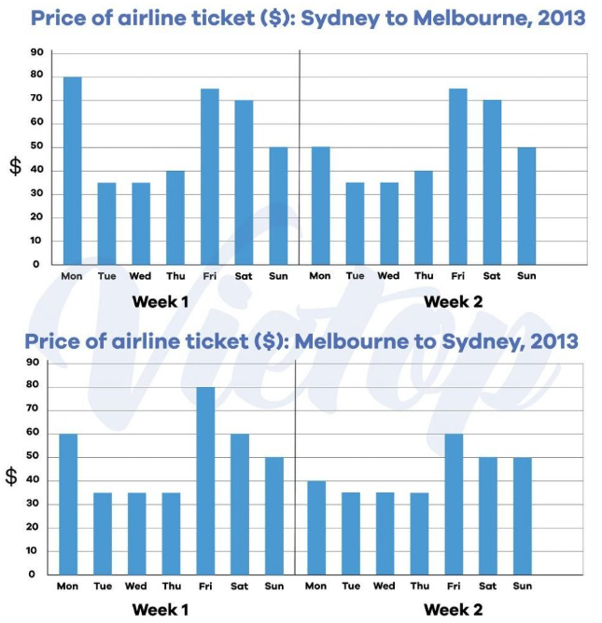
IELTS Task 1 Response (189 words):
The two graphs depict the fluctuations in airline ticket prices for flights between Sydney and Melbourne over a two-week period in 2013. The charts illustrate the price variations for flights from Sydney to Melbourne and vice-versa across identical time frames.
Looking at flights departing from Sydney, prices remained relatively consistent during the first week, hovering around the $30-$40 mark, with a slight peak of just over $50 on Thursday. In the second week, however, we see a more pronounced fluctuation with prices starting at approximately $50 on Monday, dipping to around $30 mid-week, and then rising sharply to nearly $80 by the weekend.
For flights from Melbourne to Sydney, the price patterns show some similarities but also distinct differences. In week one, prices fluctuated between roughly $30 and just over $60, with the highest price observed on Friday. Week two witnessed a significant surge in prices, starting at around $40 on Monday and escalating to over $80 by Friday, before dropping back down to around $50 on Sunday.
Overall, the graphs highlight a general trend of higher prices towards the end of the week and lower prices at the start or middle of the week for both routes. However, the degree of price fluctuation appears to be more significant in the second week, particularly for flights from Melbourne to Sydney.
7 Features for High Band Score (with Examples from the Response):
- Clear Overview: The response begins with a concise overview of the graphs and their purpose. ("The two graphs depict the fluctuations in airline ticket prices for flights between Sydney and Melbourne over a two-week period in 2013.")
- Key Features Highlighted: The writer focuses on the most significant trends and variations in the data. ("In the second week, however, we see a more pronounced fluctuation with prices starting at approximately $50 on Monday...")
- Accurate Data Presentation: The data is presented accurately and with correct details. ("Looking at flights departing from Sydney, prices remained relatively consistent during the first week, hovering around the $30-$40 mark...")
- Comparison and Contrast: The response effectively compares and contrasts price patterns between the two routes and across the two weeks. ("For flights from Melbourne to Sydney, the price patterns show some similarities but also distinct differences.")
- Logical Paragraphing: Information is organized logically, with each paragraph focusing on specific aspects of the data (paragraph 1: Sydney to Melbourne, paragraph 2: Melbourne to Sydney, paragraph 3: overall trends).
- Appropriate Vocabulary: The language used is suitable for describing data and trends in graphs. ("fluctuations," "hovering," "pronounced," "escalating," "significant")
- Coherence and Cohesion: The response flows smoothly with effective use of cohesive devices. ("Looking at flights departing from Sydney," "In the second week," "Overall," "However")

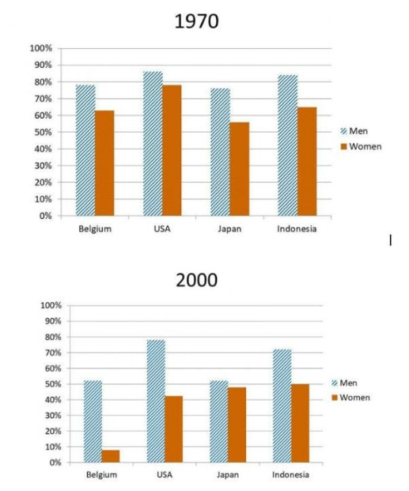
Response (167 words):
The charts illustrate the employment rates of men and women aged 60-64 across four countries in 1970 and 2000.
In 1970, employment rates for men were significantly higher than for women in all four countries. Notably, the USA and Indonesia showed the highest male employment rates, at nearly 80%, followed by Japan and Belgium. For women, rates were much lower, with the highest being in Indonesia at just over 60%, and the lowest in Belgium at around 30%.
By 2000, there were significant shifts. While men's employment rates decreased in all countries, the most substantial drop was in the USA, falling to just over 50%. Indonesia also saw a decrease to around 60%, while Japan and Belgium's rates remained relatively stable. Conversely, women's employment rates increased across all four nations. The most dramatic rise was in the USA, which saw an increase to nearly 50%, surpassing Belgium and Japan. Indonesia also experienced a significant rise, though it remained below the men's employment rate.
In summary, over the 30-year period, there was a general decline in the employment rates of men aged 60-64, while women in the same age group saw increased participation in the workforce across the four countries.

7 High-Band Features with Examples:
- Clear Overview (Introduction): The response starts with a clear and concise overview of the charts' purpose and the main trends.
  - Example: "The charts illustrate the employment rates of men and women aged 60-64 across four countries in 1970 and 2000."
- Key Features Highlighted: The response focuses on the most important changes and differences, avoiding unnecessary details.
  - Example: "Notably, the USA and Indonesia showed the highest male employment rates, at nearly 80%..." (This highlights a significant point of interest.)
- Accurate Figures: The data provided is accurate and reflects the information in the charts.
  - Example: "Indonesia also saw a decrease to around 60%..." (This demonstrates accurate interpretation of the data.)
- Logical Organization: The information is presented in a logical order, making it easy to follow the changes over time and compare countries.
  - Example: The description first discusses the trends in 1970 and then moves to 2000, allowing for direct comparison.
- Cohesive Devices: The response uses cohesive devices to link ideas and sentences, creating a smooth flow.
  - Examples: "In 1970," "By 2000," "Conversely," "While."
- Varied Vocabulary: A range of vocabulary is used to express the information accurately and effectively.
  - Examples: "Significantly," "Notably," "Substantial," "Conversely," "Dramatic."
Concise and Focused: The response stays within the word limit and avoids unnecessary
- repetition or irrelevant information. It efficiently summarizes the key trends and changes.
  - Example: The entire response is succinct and well-structured, staying within the 150-220 word target.

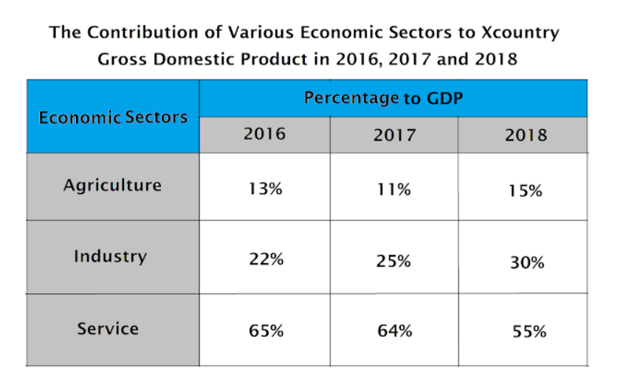
……………………….
IELTS Task 1 Response (163 words)
The table illustrates the contribution of agriculture, industry, and services to Xcountry's Gross Domestic Product (GDP) across three years: 2016, 2017, and 2018. Overall, the service sector consistently made the largest contribution to the GDP, although its share decreased over the period, while the industrial sector's contribution increased.
In 2016, the service sector constituted 65% of Xcountry's GDP, followed by industry at 22% and agriculture at 13%. By 2017, the service sector's share had slightly decreased to 64%, while the industrial sector's contribution rose to 25%. Agriculture experienced a slight decline, contributing 11% to the GDP.
In 2018, the most notable shift occurred. The service sector's contribution dropped to 55%, while the industrial sector's share increased significantly to 30%. Agriculture partially recovered, increasing its contribution to 15% of the GDP.
In summary, while the service sector remained the largest contributor to Xcountry's GDP throughout the period, its share decreased, indicating a diversification of the economy. The growth in the industrial sector's contribution suggests increasing industrialization, while agriculture experienced fluctuations but ended the period with a slightly higher share than it began with.
7 Features for High Band Score (with Examples from the Response)
- Clear Overview: The response starts with a concise overview of the table, summarizing the key information (e.g., "The table illustrates the contribution of agriculture, industry, and services to Xcountry's Gross Domestic Product (GDP) across three years: 2016, 2017, and 2018.").
- Key Features Identified: It accurately pinpoints the most significant trends and figures (e.g., "Overall, the service sector consistently made the largest contribution to the GDP, although its share decreased over the period, while the industrial sector's contribution increased.").
- Accurate Data Representation: The response uses data accurately and avoids misinterpretations (e.g., "In 2016, the service sector constituted 65% of Xcountry's GDP, followed by industry at 22% and agriculture at 13%.").
- Comparison and Contrasting: It effectively compares and contrasts data between categories and years (e.g., "By 2017, the service sector's share had slightly decreased to 64%, while the industrial sector's contribution rose to 25%.").
- Range of Vocabulary: A good mix of vocabulary is used, including words like "constituted," "experienced," "notable," "fluctuations," "diversification," and "industrialization."
- Coherence and Cohesion: The response flows logically with clear connections between sentences and paragraphs (e.g., "Overall," "In 2016," "By 2017," "In 2018," "In summary").
- Grammatical Accuracy: The response demonstrates a good command of grammar with varied sentence structures and minimal errors (e.g., "The growth in the industrial sector's contribution suggests increasing industrialization, while agriculture experienced fluctuations but ended the period with a slightly higher share than it began with.").

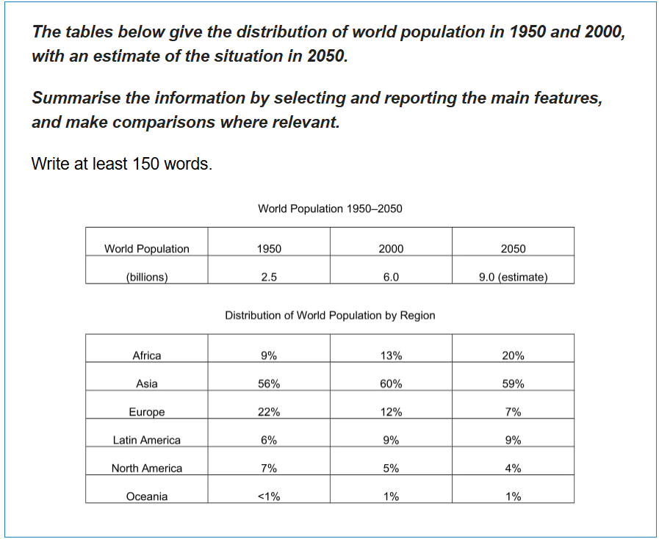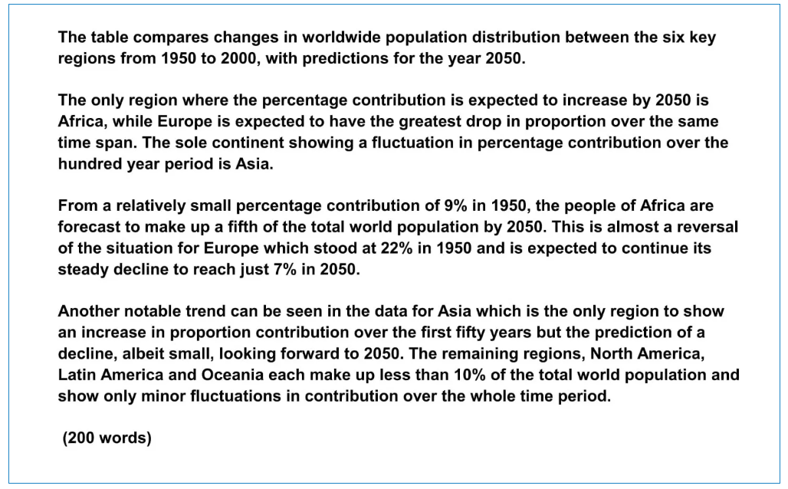
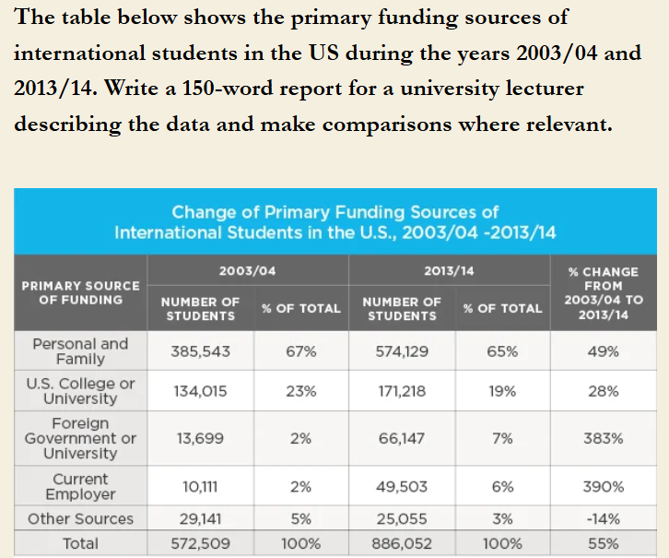
The table shows how international students in the US funded their studies in the years 2003/04 and 2013/14. Overall, there was a noticeable trend towards sponsorship by foreign governments, foreign universities, and current employers over the ten-year period.
First of all, the period 2003/04 to 2013/14 witnessed a significant rise in the number of international students in the US, from 572,509 to 886,052, a rise of more than 50%. Given the large increase, were there any changes in how foreign students paid for their studies?
The table shows that the two main funding sources were ‘Personal and Family’ and ‘US College or University’, which together accounted for 90% of funding in 2003/2004. However, taken together, these two sources had dropped to 84% by 2013/14.
At the same time, there was substantial growth in the numbers of students funded by ‘Foreign Government or University’ and ‘Current Employer’, which saw increases of 383% and 390% respectively. Even though they still accounted for only a small minority of funding, both sources became more important to foreign students during the period.
(177 words, IELTS 9.0)

Why Does This Task 1 Answer Get IELTS 9.0?
Task achievement: The sample answer identifies a major point of interest in the data and supports this with relevant figures from the table.
Coherence and cohesion: The sample answer is organised into paragraphs which are connected logically. There is an overall description at the beginning and end of the answer.
Lexical resource: The sample answer uses vocabulary appropriate to comparing data such as ‘accounted for’ and ‘witnessed a significant rise’. Native-like collocation is used throughout the model answer.
Grammatical range and accuracy: The sample answer includes many examples of complex sentences that combine a main point with supporting evidence in two clauses.

https://ieltsmaterial.com/ielts-map-vocabulary/

