Attract Mode - MaLa 1.0 RC7a

As you know Mala LED’S are configured so that the appropriate buttons are lit for each game selected and/or running.

But they can do more……..

Mala allows you to create custom LED sequences. These can be used to be played on certain events (eg game start) and/or in ‘Attract Mode’. Attract Mode is like a screen saver when no controls have been touched for a while in a game list.

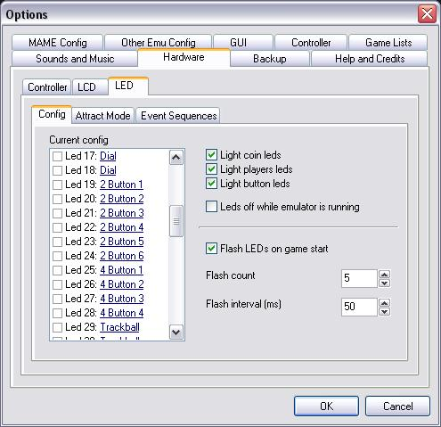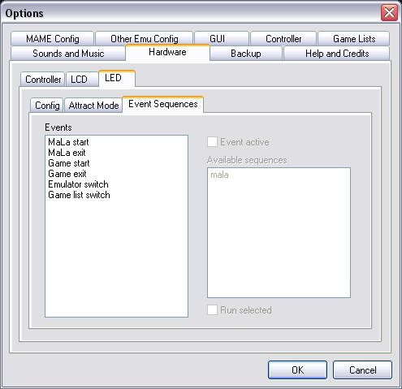

Already built into Mala is a random Sequence called ‘Randomizer’ This sequence can be used on its own if you wish or in combination of sequences you create yourself with the editor. You can also choose not to use this at all

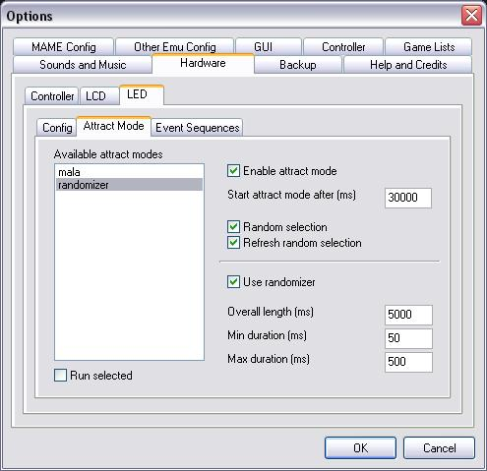

Mala Attract Mode Editor

The beauty of this application is you can create animations anywhere on any PC. This is very handy as you can create sequences at Work in your lunch hour or on a laptop on Public transport if you want. The point is you don’t have to sit at your cab.

There are 4 steps to get your animation sequence running on your cab:
- Set Defaults
- Set Panel
- Create Sequences
- Set desired Sequences in MaLa

You only need to follow steps 1 & 2 for the first animation.

IMPORTATNT: The following assumes that you have already assigned all you LEDS in Mala. As that data will be used to set-up the Editor

Do the following in order and to the letter to avoid problems
(Especially Step #1 which is a bit fiddly)

STEP 1: Setting defaults

- File- Open- mala.mlc
(if you doing this on a remote PC you need to copy this file from you Cab) It has all the LED assignment details
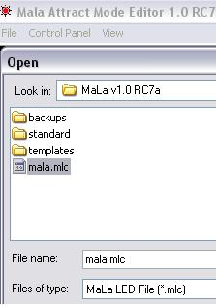

Don’t worry that the panel that loads does not display all your buttons YET!
Just keep moving through this procedure. All will be well very soon ☺

- File – LED Default Config

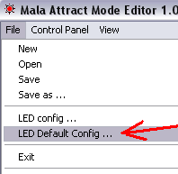

Click on ‘Get from Loaded file’ THEN choose your set-up from the LED Count (in most cases 32 -1 Board)
Click on all the other checkboxes in this window especially the ‘use for new files’ (see picture below)
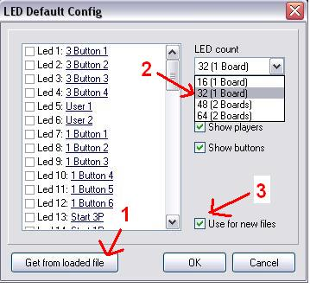

- File – LED Config (Not to be confused with the previous step)

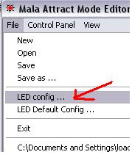
Similar to before choose your set-up from the LED Count (in most cases 32 -1 Board)
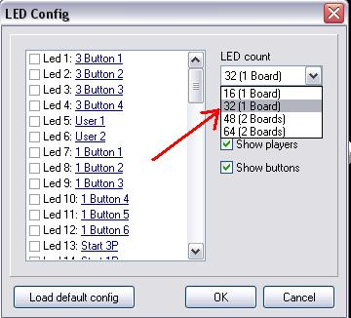

D) File- Save as- mala.mlc (Save over the original file).
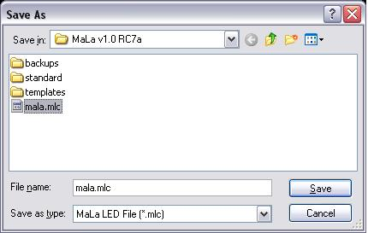

This becomes you base sequence.
Later you will ‘Save as’ under different names of your choosing to create new sequences.

STEP 2: Set Panel

At this stage you should see all your MaLa allocated LED’s displayed in the editor window. Something like this:
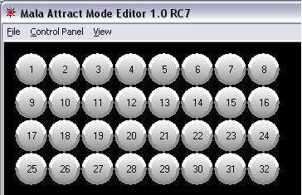

A) To make Led Sequences easier you should arrange them to resemble the arrangement of your control panel. You can change the color and Size of them too (NOTE: It makes no operation difference if you do or not).

To be reminded what that LED is allocated to simply hover the mouse pointer over the button
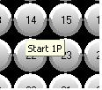

To change button’s Color or size right click on it for those options.

B) Drag and drop the buttons to basically resemble the layout of buttons on your control panel. Here is an example:

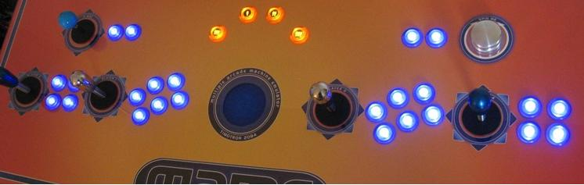
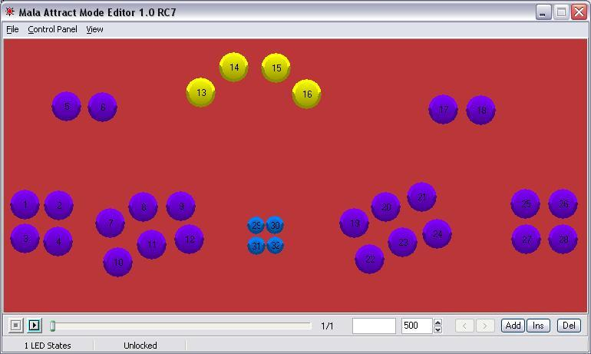
NOTE: In the above example 4 LEDS are used inside the trackball (29-32)

C) Save the control Panel (Save over the original file).
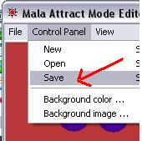

STEP 3) Create Sequences (The Fun Bit)

The slider bar at the bottom shows what frame in the sequence you are editing.

A) Double click on the Button(s) you wish to have lit during that frame

B) Set the duration that you want that frame to be displayed in the number box
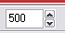

C) To add/insert/delete a frame using the relevant buttons on the bottom right of the frame

D) When you have finished your sequence save it under a new name (Eg Disco.mlc)
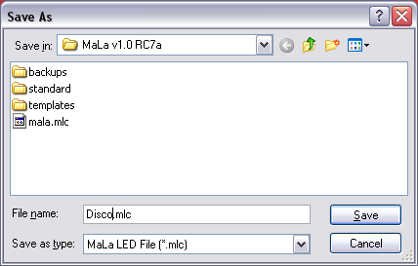

STEP 4) Set desired Sequences in MaLa

As mentioned earlier these LED sequences can be played on certain events (eg game start) and/or in ‘Attract Mode’.
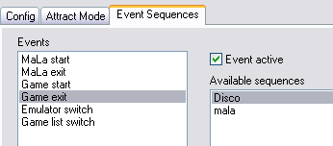

Attract Mode is like a screen saver when no controls have been touched for a while in a game list.
You can choose what order you want your sequences to run in attract mode. You can also choose to have them run in random order.
You will notice now that you have an added sequence ‘Disco’
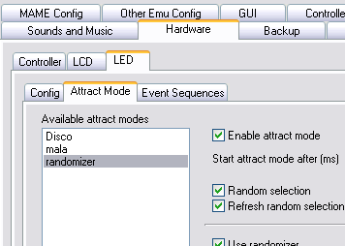

You also have the option of having the ‘Randomizer’ sequence added to the mix

ENJOY

