* Name: Renee Alsop
* Date: 07/11/2017
* ID: P303319

**Online movie search application**

**Development and run environments used:**

* Xampp (Apache and SQL servers),
* MySQL Workbench,
* Excel (to convert .xlsx to .csv),
* NotePad ++ (to write html and php)
* Google Chrome, Internet Explorer (to open and use pages)

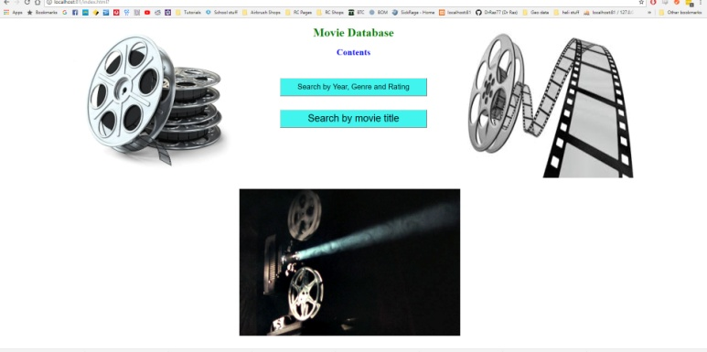

**Testing:**

PHP files were sniffed with PHP Codesniffer and corrected

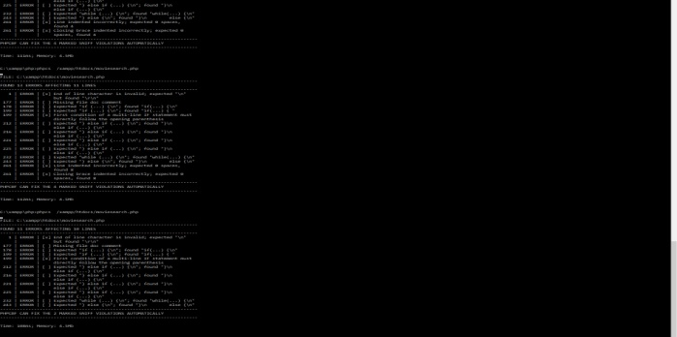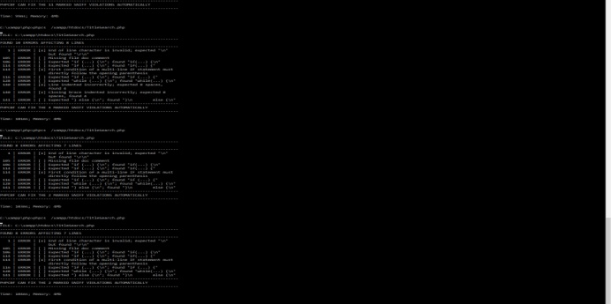

SQL search for Title allows to search for title in part or whole.

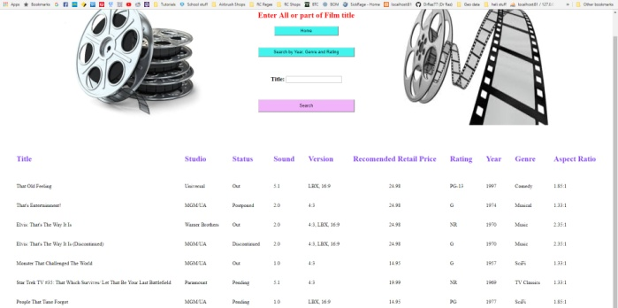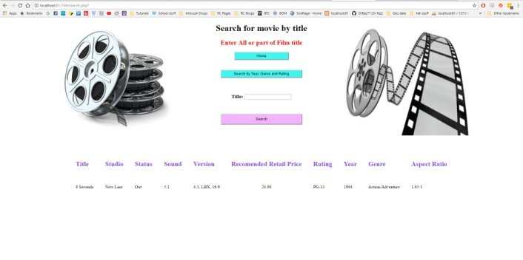

Searching by year, will search the year specified and years preceding

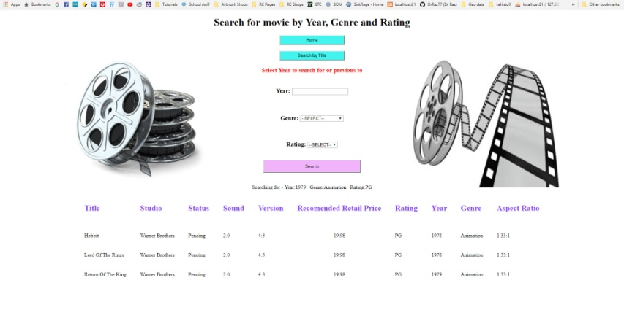

If no results are found, the user is notified

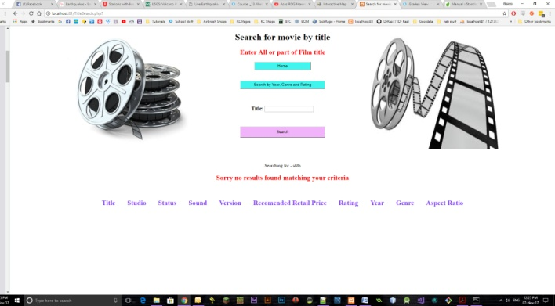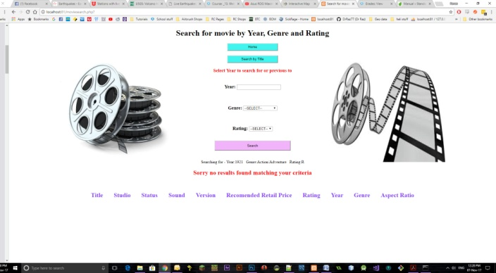

Tested in Google Chrome and Internet Explorer

