1. In “inetpub\wwwroot\” folder, create a new folder “Demo”. Inside “Demo” folder, create “API” and “Web” folders. Then download the attached API.rar and Web.rar and extract each file in its corresponding folder.

Otherwise, you can publish the API directly from VS (Right click on API project => publish => select “inetpub\wwwroot\Demo\API” folder). And for frontend website: run “ng build” command and copy the files form “dist” folder to “inetpub\wwwroot\Demo\Web”.

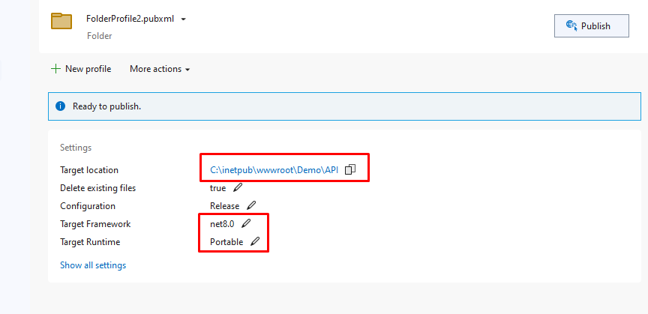

1. In IIS create a new pool “APIPool” for the API site, then create a new pool “WebPool” for the frontend website.

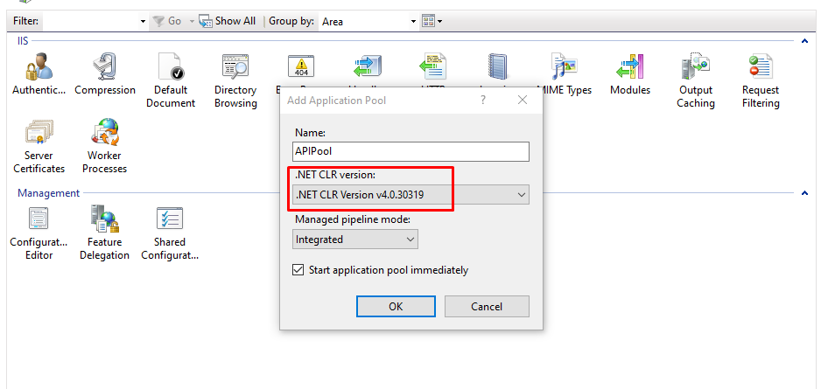

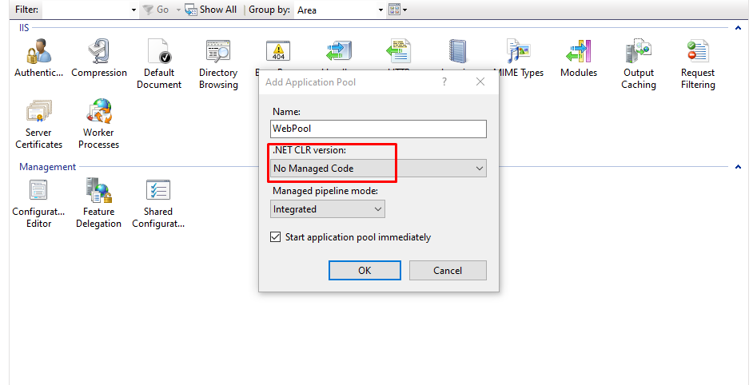

1. Create “APISite” and set its pool to “APIPool”, port 2030 and its physical path to “inetpub\wwwroot\Demo\API”. Then create another site “WebSite” and set its pool to “WebPool”, port 2040 and its physical path to “inetpub\wwwroot\Demo\Web”.

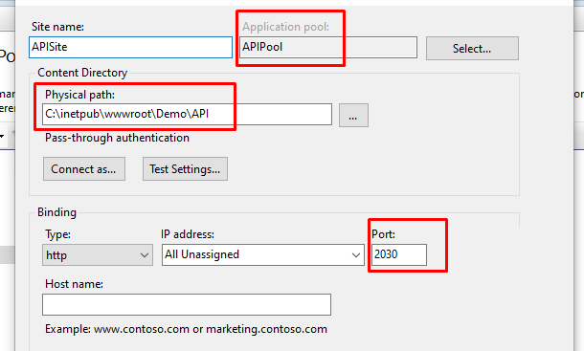

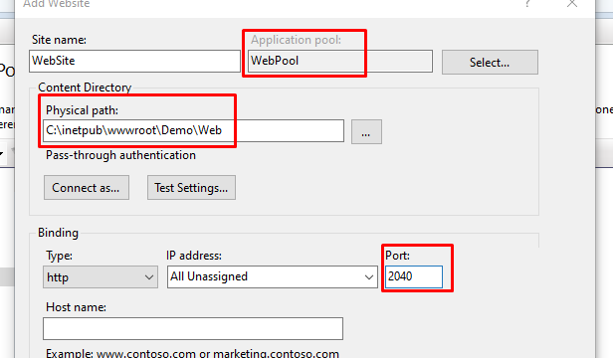

Start both sites and browse to <http://localhost:2030/swagger/index.html> you should find swagger is active and running. And navigate to <http://localhost:2040/> and the frontend web site should be active and running.

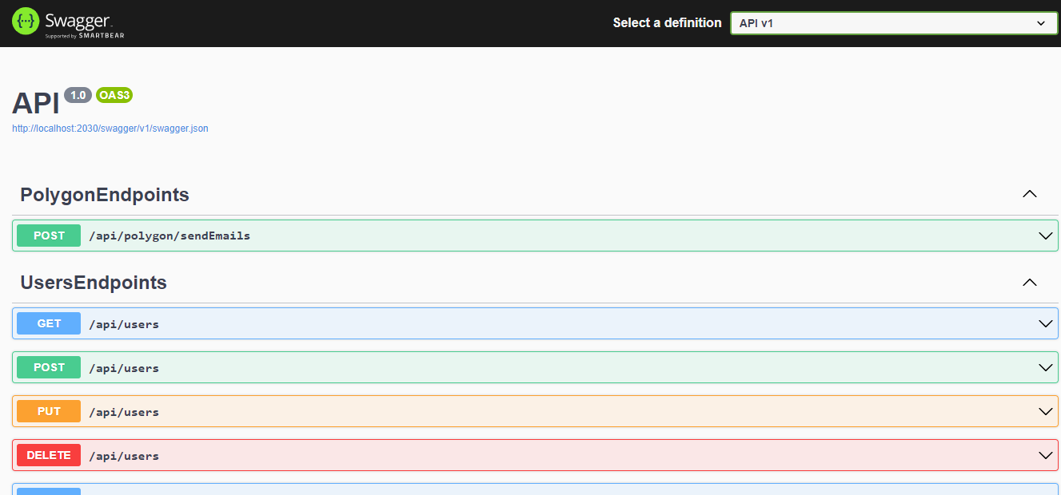

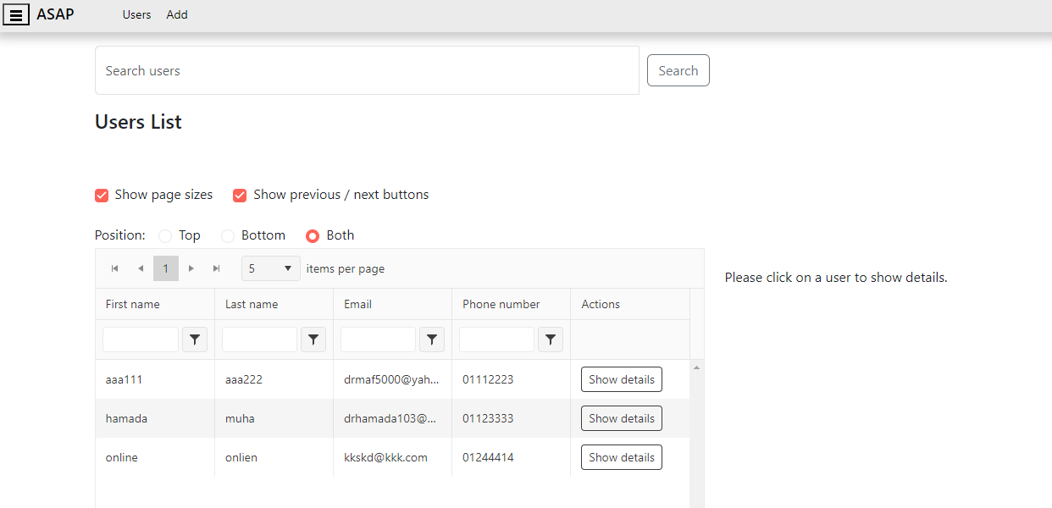

NOTE: you may need to grant write access permission “APIPool” over “inetpub\Demo\API” folder to allow logs to be written in place.

