**Neural machine translation with a Transformer and Keras**

Transformers are deep neural networks that replace CNNs and RNNs with [self-attention](https://developers.google.com/machine-learning/glossary?authuser=0#self-attention). Self attention allows Transformers to easily transmit information across the input sequences.As explained in the [Google AI Blog post](https://ai.googleblog.com/2017/08/transformer-novel-neural-network.html):

Neural networks for machine translation typically contain an encoder reading the input sentence and generating a representation of it. A decoder then generates the output sentence word by word while consulting the representation generated by the encoder. The Transformer starts by generating initial representations, or embeddings, for each word... Then, using self-attention, it aggregates information from all of the other words, generating a new representation per word informed by the entire context, represented by the filled balls. This step is then repeated multiple times in parallel for all words, successively generating new representations.



Figure 1: Applying the Transformer to machine translation. Source: [Google AI Blog](https://ai.googleblog.com/2017/08/transformer-novel-neural-network.html).

That's a lot to digest, the goal of this tutorial is to break it down into easy to understand parts. In this tutorial you will:

* Prepare the data.
* Implement necessary components:
  + Positional embeddings.
  + Attention layers.
  + The encoder and decoder.
* Build & train the Transformer.
* Generate translations.
* Export the model.

To get the most out of this tutorial, it helps if you know about [the basics of text generation](https://www.tensorflow.org/text/tutorials/text_generation?authuser=0) and attention mechanisms.

A Transformer is a sequence-to-sequence encoder-decoder model similar to the model in the [NMT with attention tutorial](https://www.tensorflow.org/text/tutorials/nmt_with_attention?authuser=0). A single-layer Transformer takes a little more code to write, but is almost identical to that encoder-decoder RNN model. The only difference is that the RNN layers are replaced with self attention layers. This tutorial builds a 4-layer Transformer which is larger and more powerful, but not fundamentally more complex.

|  |  |
| --- | --- |
| **The [RNN+Attention model](https://www.tensorflow.org/text/tutorials/nmt_with_attention?authuser=0)** | **A 1-layer transformer** |
|  |  |

After training the model in this notebook, you will be able to input a Portuguese sentence and return the English translation.

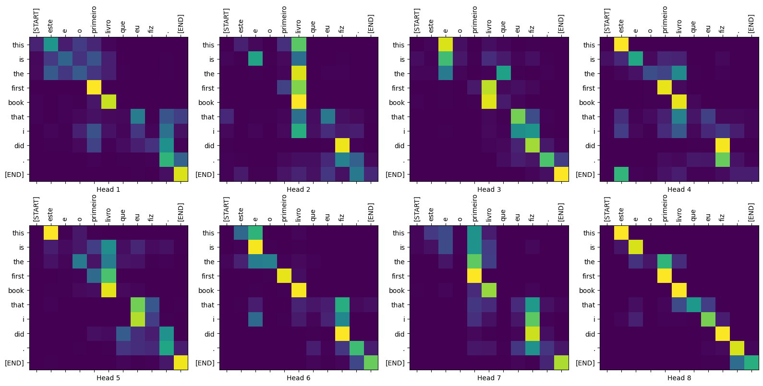

Figure 2: Visualized attention weights that you can generate at the end of this tutorial.

**Why Transformers are significant**

* Transformers excel at modeling sequential data, such as natural language.
* Unlike the [recurrent neural networks (RNNs)](https://www.tensorflow.org/text/tutorials/text_generation?authuser=0), Transformers are parallelizable. This makes them efficient on hardware like GPUs and TPUs. The main reasons is that Transformers replaced recurrence with attention, and computations can happen simultaneously. Layer outputs can be computed in parallel, instead of a series like an RNN.
* Unlike [RNNs](https://www.tensorflow.org/guide/keras/rnn?authuser=0) (like [seq2seq, 2014](https://arxiv.org/abs/1409.3215)) or [convolutional neural networks (CNNs)](https://www.tensorflow.org/tutorials/images/cnn?authuser=0) (for example, [ByteNet](https://arxiv.org/abs/1610.10099)), Transformers are able to capture distant or long-range contexts and dependencies in the data between distant positions in the input or output sequences. Thus, longer connections can be learned. Attention allows each location to have access to the entire input at each layer, while in RNNs and CNNs, the information needs to pass through many processing steps to move a long distance, which makes it harder to learn.
* Transformers make no assumptions about the temporal/spatial relationships across the data. This is ideal for processing a set of objects (for example, [StarCraft units](https://www.deepmind.com/blog/alphastar-mastering-the-real-time-strategy-game-starcraft-ii)).

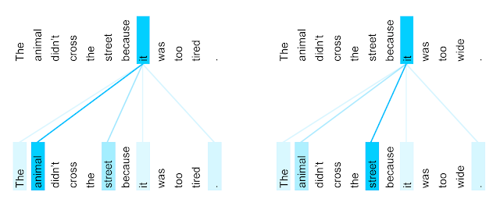

Figure 3: The encoder self-attention distribution for the word “it” from the 5th to the 6th layer of a Transformer trained on English-to-French translation (one of eight attention heads). Source: [Google AI Blog](https://ai.googleblog.com/2017/08/transformer-novel-neural-network.html).

**Setup**

Begin by installing [TensorFlow Datasets](https://tensorflow.org/datasets?authuser=0) for loading the dataset and [TensorFlow Text](https://www.tensorflow.org/text?authuser=0) for text preprocessing:

# Install the most re version of TensorFlow to use the improved  
# masking support for `tf.keras.layers.MultiHeadAttention`.  
apt install --allow-change-held-packages libcudnn8=8.1.0.77-1+cuda11.2  
pip uninstall -y -q tensorflow keras tensorflow-estimator tensorflow-text  
pip install protobuf~=3.20.3  
pip install -q tensorflow_datasets  
pip install -q -U tensorflow-text tensorflow

Import the necessary modules:

import logging  
import time  
  
import numpy as np  
import matplotlib.pyplot as plt  
  
import tensorflow_datasets as tfds  
import tensorflow as tf  
  
import tensorflow_text

2023-11-16 12:37:14.029081: E external/local_xla/xla/stream_executor/cuda/cuda_dnn.cc:9261] Unable to register cuDNN factory: Attempting to register factory for plugin cuDNN when one has already been registered

2023-11-16 12:37:14.029127: E external/local_xla/xla/stream_executor/cuda/cuda_fft.cc:607] Unable to register cuFFT factory: Attempting to register factory for plugin cuFFT when one has already been registered

2023-11-16 12:37:14.030685: E external/local_xla/xla/stream_executor/cuda/cuda_blas.cc:1515] Unable to register cuBLAS factory: Attempting to register factory for plugin cuBLAS when one has already been registered

**Data handling**

This section downloads the dataset and the subword tokenizer, from [this tutorial](https://www.tensorflow.org/text/guide/subwords_tokenizer?authuser=0), then wraps it all up in a [tf.data.Dataset](https://www.tensorflow.org/api_docs/python/tf/data/Dataset?authuser=0) for training.

Toggle section

**Test the Dataset**

# Create training and validation set batches.  
train_batches = make_batches(train_examples)  
val_batches = make_batches(val_examples)

The resulting [tf.data.Dataset](https://www.tensorflow.org/api_docs/python/tf/data/Dataset?authuser=0) objects are setup for training with Keras. Keras [Model.fit](https://www.tensorflow.org/api_docs/python/tf/keras/Model?authuser=0" \l "fit) training expects (inputs, labels) pairs. The inputs are pairs of tokenized Portuguese and English sequences, (pt, en). The labels are the same English sequences shifted by 1. This shift is so that at each location input en sequence, the label in the next token.

|  |
| --- |
| **Inputs at the bottom, labels at the top.** |
|  |

This is the same as the [text generation tutorial](https://www.tensorflow.org/text/tutorials/text_generation?authuser=0), except here you have additional input "context" (the Portuguese sequence) that the model is "conditioned" on.

This setup is called "teacher forcing" because regardless of the model's output at each timestep, it gets the true value as input for the next timestep. This is a simple and efficient way to train a text generation model. It's efficient because you don't need to run the model sequentially, the outputs at the different sequence locations can be computed in parallel.

You might have expected the input, output, pairs to simply be the Portuguese, English sequences. Given the Portuguese sequence, the model would try to generate the English sequence.

It's possible to train a model that way. You'd need to write out the inference loop and pass the model's output back to the input. It's slower (time steps can't run in parallel), and a harder task to learn (the model can't get the end of a sentence right until it gets the beginning right), but it can give a more stable model because the model has to learn to correct its own errors during training.

for (pt, en), en_labels in train_batches.take(1):  
  break  
  
print(pt.shape)  
print(en.shape)  
print(en_labels.shape)

(64, 62)

(64, 58)

(64, 58)

The en and en_labels are the same, just shifted by 1:

print(en[0][:10])  
print(en_labels[0][:10])

tf.Tensor([ 2 72 82 76 9 55 154 1664 75 180], shape=(10,), dtype=int64)

tf.Tensor([ 72 82 76 9 55 154 1664 75 180 6175], shape=(10,), dtype=int64)

**Define the components**

There's a lot going on inside a Transformer. The important things to remember are:

1. It follows the same general pattern as a standard sequence-to-sequence model with an encoder and a decoder.
2. If you work through it step by step it will all make sense.

|  |  |
| --- | --- |
| **The original Transformer diagram** | **A representation of a 4-layer Transformer** |
|  |  |

Each of the components in these two diagrams will be explained as you progress through the tutorial.

**The embedding and positional encoding layer**

The inputs to both the encoder and decoder use the same embedding and positional encoding logic.

|  |
| --- |
| **The embedding and positional encoding layer** |
|  |
|  |

Given a sequence of tokens, both the input tokens (Portuguese) and target tokens (English) have to be converted to vectors using a [tf.keras.layers.Embedding](https://www.tensorflow.org/api_docs/python/tf/keras/layers/Embedding?authuser=0) layer.

The attention layers used throughout the model see their input as a set of vectors, with no order. Since the model doesn't contain any recurrent or convolutional layers. It needs some way to identify word order, otherwise it would see the input sequence as a [bag of words](https://developers.google.com/machine-learning/glossary?authuser=0#bag-of-words) instance, how are you, how you are, you how are, and so on, are indistinguishable.

A Transformer adds a "Positional Encoding" to the embedding vectors. It uses a set of sines and cosines at different frequencies (across the sequence). By definition nearby elements will have similar position encodings.

The original paper uses the following formula for calculating the positional encoding:

𝑃𝐸(𝑝𝑜𝑠,2𝑖)=sin⁡(𝑝𝑜𝑠/100002𝑖/𝑑𝑚𝑜𝑑𝑒𝑙)

𝑃𝐸(𝑝𝑜𝑠,2𝑖+1)=cos⁡(𝑝𝑜𝑠/100002𝑖/𝑑𝑚𝑜𝑑𝑒𝑙)

**Note:** The code below implements it, but instead of interleaving the sines and cosines, the vectors of sines and cosines are simply concatenated. Permuting the channels like this is functionally equivalent, and just a little easier to implement and show in the plots below.

def positional_encoding(length, depth):  
  depth = depth/2  
  
  positions = np.arange(length)[:, np.newaxis]     # (seq, 1)  
  depths = np.arange(depth)[np.newaxis, :]/depth   # (1, depth)  
  
  angle_rates = 1 / (10000**depths)         # (1, depth)  
  angle_rads = positions * angle_rates      # (pos, depth)  
  
  pos_encoding = np.concatenate(  
      [np.sin(angle_rads), np.cos(angle_rads)],  
      axis=-1)   
  
  return tf.cast(pos_encoding, dtype=tf.float32)

The position encoding function is a stack of sines and cosines that vibrate at different frequencies depending on their location along the depth of the embedding vector. They vibrate across the position axis.

Toggle code

(2048, 512)

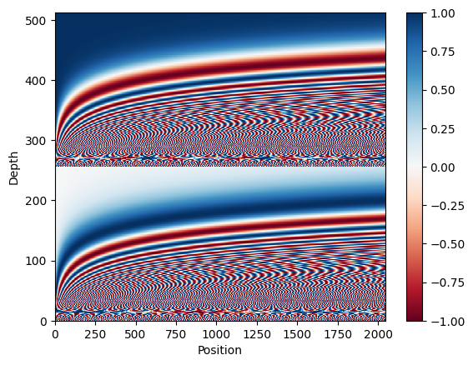

By definition these vectors align well with nearby vectors along the position axis. Below the position encoding vectors are normalized and the vector from position 1000 is compared, by dot-product, to all the others:

Toggle code

(0.0, 1.0)

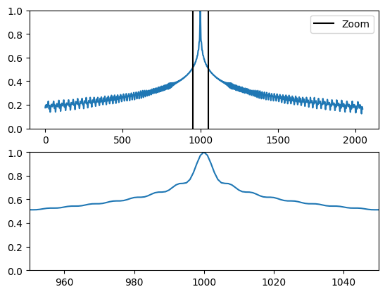

So use this to create a PositionEmbedding layer that looks-up a token's embedding vector and adds the position vector:

class PositionalEmbedding(tf.keras.layers.Layer):  
  def __init__(self, vocab_size, d_model):  
    super().__init__()  
    self.d_model = d_model  
    self.embedding = tf.keras.layers.Embedding(vocab_size, d_model, mask_zero=True)   
    self.pos_encoding = positional_encoding(length=2048, depth=d_model)  
  
  def compute_mask(self, *args, **kwargs):  
    return self.embedding.compute_mask(*args, **kwargs)  
  
  def call(self, x):  
    length = tf.shape(x)[1]  
    x = self.embedding(x)  
    # This factor sets the relative scale of the embedding and positonal_encoding.  
    x *= tf.math.sqrt(tf.cast(self.d_model, tf.float32))  
    x = x + self.pos_encoding[tf.newaxis, :length, :]  
    return x

**Note:** The [original paper](https://arxiv.org/pdf/1706.03762.pdf), section 3.4 and 5.1, uses a single tokenizer and weight matrix for both the source and target languages. This tutorial uses two separate tokenizers and weight matrices.

embed_pt = PositionalEmbedding(vocab_size=tokenizers.pt.get_vocab_size(), d_model=512)  
embed_en = PositionalEmbedding(vocab_size=tokenizers.en.get_vocab_size(), d_model=512)  
  
pt_emb = embed_pt(pt)  
en_emb = embed_en(en)

en_emb._keras_mask

<tf.Tensor: shape=(64, 58), dtype=bool, numpy=

array([[ True, True, True, ..., False, False, False],

[ True, True, True, ..., False, False, False],

[ True, True, True, ..., False, False, False],

...,

[ True, True, True, ..., False, False, False],

[ True, True, True, ..., False, False, False],

[ True, True, True, ..., False, False, False]])>

**Add and normalize**

|  |  |
| --- | --- |
| **Add and normalize** | |
|  |  |
|  |  |

These "Add & Norm" blocks are scattered throughout the model. Each one joins a residual connection and runs the result through a LayerNormalization layer.

The easiest way to organize the code is around these residual blocks. The following sections will define custom layer classes for each.

The residual "Add & Norm" blocks are included so that training is efficient. The residual connection provides a direct path for the gradient (and ensures that vectors are **updated** by the attention layers instead of **replaced**), while the normalization maintains a reasonable scale for the outputs.

**Note:** The implementations, below, use the **Add** layer to ensure that Keras masks are propagated (the **+** operator does not).

**The base attention layer**

Attention layers are used throughout the model. These are all identical except for how the attention is configured. Each one contains a [layers.MultiHeadAttention](https://www.tensorflow.org/addons/api_docs/python/tfa/layers/MultiHeadAttention?authuser=0), a [layers.LayerNormalization](https://www.tensorflow.org/api_docs/python/tf/keras/layers/LayerNormalization?authuser=0) and a [layers.Add](https://www.tensorflow.org/api_docs/python/tf/keras/layers/Add?authuser=0).

|  |  |
| --- | --- |
| **The base attention layer** | |
|  |  |
|  |  |

To implement these attention layers, start with a simple base class that just contains the component layers. Each use-case will be implemented as a subclass. It's a little more code to write this way, but it keeps the intention clear.

class BaseAttention(tf.keras.layers.Layer):  
  def __init__(self, **kwargs):  
    super().__init__()  
    self.mha = tf.keras.layers.MultiHeadAttention(**kwargs)  
    self.layernorm = tf.keras.layers.LayerNormalization()  
    self.add = tf.keras.layers.Add()

**Attention refresher**

Before you get into the specifics of each usage, here is a quick refresher on how attention works:

|  |
| --- |
| **The base attention layer** |
|  |

There are two inputs:

1. The query sequence; the sequence being processed; the sequence doing the attending (bottom).
2. The context sequence; the sequence being attended to (left).

The output has the same shape as the query-sequence.

The common comparison is that this operation is like a dictionary lookup. A **fuzzy**, **differentiable**, **vectorized** dictionary lookup.

Here's a regular python dictionary, with 3 keys and 3 values being passed a single query.

d = {'color': 'blue', 'age': 22, 'type': 'pickup'}  
result = d['color']

* The querys is what you're trying to find.
* The keys what sort of information the dictionary has.
* The value is that information.

When you look up a query in a regular dictionary, the dictionary finds the matching key, and returns its associated value. The query either has a matching key or it doesn't. You can imagine a **fuzzy** dictionary where the keys don't have to match perfectly. If you looked up d["species"] in the dictionary above, maybe you'd want it to return "pickup" since that's the best match for the query.

An attention layer does a fuzzy lookup like this, but it's not just looking for the best key. It combines the values based on how well the query matches each key.

How does that work? In an attention layer the query, key, and value are each vectors. Instead of doing a hash lookup the attention layer combines the query and key vectors to determine how well they match, the "attention score". The layer returns the average across all the values, weighted by the "attention scores".

Each location the query-sequence provides a query vector. The context sequence acts as the dictionary. At each location in the context sequence provides a key and value vector. The input vectors are not used directly, the [layers.MultiHeadAttention](https://www.tensorflow.org/addons/api_docs/python/tfa/layers/MultiHeadAttention?authuser=0) layer includes [layers.Dense](https://www.tensorflow.org/api_docs/python/tf/keras/layers/Dense?authuser=0) layers to project the input vectors before using them.

**The cross attention layer**

At the literal center of the Transformer is the cross-attention layer. This layer connects the encoder and decoder. This layer is the most straight-forward use of attention in the model, it performs the same task as the attention block in the [NMT with attention tutorial](https://www.tensorflow.org/text/tutorials/nmt_with_attention?authuser=0).

|  |
| --- |
| **The cross attention layer** |
|  |
|  |

To implement this you pass the target sequence x as the query and the context sequence as the key/value when calling the mha layer:

class CrossAttention(BaseAttention):  
  def call(self, x, context):  
    attn_output, attn_scores = self.mha(  
        query=x,  
        key=context,  
        value=context,  
        return_attention_scores=True)  
  
    # Cache the attention scores for plotting later.  
    self.last_attn_scores = attn_scores  
  
    x = self.add([x, attn_output])  
    x = self.layernorm(x)  
  
    return x

The caricature below shows how information flows through this layer. The columns represent the weighted sum over the context sequence.

For simplicity the residual connections are not shown.

|  |
| --- |
| **The cross attention layer** |
|  |

The output length is the length of the query sequence, and not the length of the context key/value sequence.

The diagram is further simplified, below. There's no need to draw the entire "Attention weights" matrix. The point is that each query location can see all the key/value pairs in the context, but no information is exchanged between the queries.

|  |
| --- |
| **Each query sees the whole context.** |
|  |

Test run it on sample inputs:

sample_ca = CrossAttention(num_heads=2, key_dim=512)  
  
print(pt_emb.shape)  
print(en_emb.shape)  
print(sample_ca(en_emb, pt_emb).shape)

(64, 62, 512)

(64, 58, 512)

(64, 58, 512)

**The global self attention layer**

This layer is responsible for processing the context sequence, and propagating information along its length:

|  |
| --- |
| **The global self attention layer** |
|  |
|  |

Since the context sequence is fixed while the translation is being generated, information is allowed to flow in both directions.

Before Transformers and self attention, models commonly used RNNs or CNNs to do this task:

|  |
| --- |
| **Bidirectional RNNs and CNNs** |
|  |
|  |

RNNs and CNNs have their limitations.

* The RNN allows information to flow all the way across the sequence, but it passes through many processing steps to get there (limiting gradient flow). These RNN steps have to be run sequentially and so the RNN is less able to take advantage of modern parallel devices.
* In the CNN each location can be processed in parallel, but it only provides a limited receptive field. The receptive field only grows linearly with the number of CNN layers, You need to stack a number of Convolution layers to transmit information across the sequence ([Wavenet](https://arxiv.org/abs/1609.03499) reduces this problem by using dilated convolutions).

The global self attention layer on the other hand lets every sequence element directly access every other sequence element, with only a few operations, and all the outputs can be computed in parallel.

To implement this layer you just need to pass the target sequence, x, as both the query, and value arguments to the mha layer:

class GlobalSelfAttention(BaseAttention):  
  def call(self, x):  
    attn_output = self.mha(  
        query=x,  
        value=x,  
        key=x)  
    x = self.add([x, attn_output])  
    x = self.layernorm(x)  
    return x

sample_gsa = GlobalSelfAttention(num_heads=2, key_dim=512)  
  
print(pt_emb.shape)  
print(sample_gsa(pt_emb).shape)

(64, 62, 512)

(64, 62, 512)

Sticking with the same style as before you could draw it like this:

|  |
| --- |
| **The global self attention layer** |
|  |
|  |

Again, the residual connections are omitted for clarity.

It's more compact, and just as accurate to draw it like this:

|  |
| --- |
| **The global self attention layer** |
|  |
|  |

**The causal self attention layer**

This layer does a similar job as the global self attention layer, for the output sequence:

|  |
| --- |
| **The causal self attention layer** |
|  |
|  |

This needs to be handled differently from the encoder's global self attention layer.

Like the [text generation tutorial](https://www.tensorflow.org/text/tutorials/text_generation?authuser=0), and the [NMT with attention](https://www.tensorflow.org/text/tutorials/nmt_with_attention?authuser=0) tutorial, Transformers are an "autoregressive" model: They generate the text one token at a time and feed that output back to the input. To make this *efficient*, these models ensure that the output for each sequence element only depends on the previous sequence elements; the models are "causal".

A single-direction RNN is causal by definition. To make a causal convolution you just need to pad the input and shift the output so that it aligns correctly (use layers.Conv1D(padding='causal')) .

|  |
| --- |
| **Causal RNNs and CNNs** |
|  |
|  |

A causal model is efficient in two ways:

1. In training, it lets you compute loss for every location in the output sequence while executing the model just once.
2. During inference, for each new token generated you only need to calculate its outputs, the outputs for the previous sequence elements can be reused.
   * For an RNN you just need the RNN-state to account for previous computations (pass return_state=True to the RNN layer's constructor).
   * For a CNN you would need to follow the approach of [Fast Wavenet](https://arxiv.org/abs/1611.09482)

To build a causal self attention layer, you need to use an appropriate mask when computing the attention scores and summing the attention values.

This is taken care of automatically if you pass use_causal_mask = True to the MultiHeadAttention layer when you call it:

class CausalSelfAttention(BaseAttention):  
  def call(self, x):  
    attn_output = self.mha(  
        query=x,  
        value=x,  
        key=x,  
        use_causal_mask = True)  
    x = self.add([x, attn_output])  
    x = self.layernorm(x)  
    return x

The causal mask ensures that each location only has access to the locations that come before it:

|  |
| --- |
| **The causal self attention layer** |
|  |
|  |

Again, the residual connections are omitted for simplicity.

The more compact representation of this layer would be:

|  |
| --- |
| **The causal self attention layer** |
|  |
|  |

Test out the layer:

sample_csa = CausalSelfAttention(num_heads=2, key_dim=512)  
  
print(en_emb.shape)  
print(sample_csa(en_emb).shape)

(64, 58, 512)

(64, 58, 512)

The output for early sequence elements doesn't depend on later elements, so it shouldn't matter if you trim elements before or after applying the layer:

out1 = sample_csa(embed_en(en[:, :3]))   
out2 = sample_csa(embed_en(en))[:, :3]  
  
tf.reduce_max(abs(out1 - out2)).numpy()

4.7683716e-07

**Note:** When using Keras masks, the output values at invalid locations are not well defined. So the above may not hold for masked regions.

**The feed forward network**

The transformer also includes this point-wise feed-forward network in both the encoder and decoder:

|  |
| --- |
| **The feed forward network** |
|  |
|  |

The network consists of two linear layers ([tf.keras.layers.Dense](https://www.tensorflow.org/api_docs/python/tf/keras/layers/Dense?authuser=0)) with a ReLU activation in-between, and a dropout layer. As with the attention layers the code here also includes the residual connection and normalization:

class FeedForward(tf.keras.layers.Layer):  
  def __init__(self, d_model, dff, dropout_rate=0.1):  
    super().__init__()  
    self.seq = tf.keras.Sequential([  
      tf.keras.layers.Dense(dff, activation='relu'),  
      tf.keras.layers.Dense(d_model),  
      tf.keras.layers.Dropout(dropout_rate)  
    ])  
    self.add = tf.keras.layers.Add()  
    self.layer_norm = tf.keras.layers.LayerNormalization()  
  
  def call(self, x):  
    x = self.add([x, self.seq(x)])  
    x = self.layer_norm(x)   
    return x

Test the layer, the output is the same shape as the input:

sample_ffn = FeedForward(512, 2048)  
  
print(en_emb.shape)  
print(sample_ffn(en_emb).shape)

(64, 58, 512)

(64, 58, 512)

**The encoder layer**

The encoder contains a stack of N encoder layers. Where each EncoderLayer contains a GlobalSelfAttention and FeedForward layer:

|  |
| --- |
| **The encoder layer** |
|  |
|  |

Here is the definition of the EncoderLayer:

class EncoderLayer(tf.keras.layers.Layer):  
  def __init__(self,*, d_model, num_heads, dff, dropout_rate=0.1):  
    super().__init__()  
  
    self.self_attention = GlobalSelfAttention(  
        num_heads=num_heads,  
        key_dim=d_model,  
        dropout=dropout_rate)  
  
    self.ffn = FeedForward(d_model, dff)  
  
  def call(self, x):  
    x = self.self_attention(x)  
    x = self.ffn(x)  
    return x

And a quick test, the output will have the same shape as the input:

sample_encoder_layer = EncoderLayer(d_model=512, num_heads=8, dff=2048)  
  
print(pt_emb.shape)  
print(sample_encoder_layer(pt_emb).shape)

(64, 62, 512)

(64, 62, 512)

**The encoder**

Next build the encoder.

|  |
| --- |
| **The encoder** |
|  |
|  |

The encoder consists of:

* A PositionalEmbedding layer at the input.
* A stack of EncoderLayer layers.

class Encoder(tf.keras.layers.Layer):  
  def __init__(self, *, num_layers, d_model, num_heads,  
               dff, vocab_size, dropout_rate=0.1):  
    super().__init__()  
  
    self.d_model = d_model  
    self.num_layers = num_layers  
  
    self.pos_embedding = PositionalEmbedding(  
        vocab_size=vocab_size, d_model=d_model)  
  
    self.enc_layers = [  
        EncoderLayer(d_model=d_model,  
                     num_heads=num_heads,  
                     dff=dff,  
                     dropout_rate=dropout_rate)  
        for _ in range(num_layers)]  
    self.dropout = tf.keras.layers.Dropout(dropout_rate)  
  
  def call(self, x):  
    # `x` is token-IDs shape: (batch, seq_len)  
    x = self.pos_embedding(x)  # Shape `(batch_size, seq_len, d_model)`.  
  
    # Add dropout.  
    x = self.dropout(x)  
  
    for i in range(self.num_layers):  
      x = self.enc_layers[i](x)  
  
    return x  # Shape `(batch_size, seq_len, d_model)`.

Test the encoder:

# Instantiate the encoder.  
sample_encoder = Encoder(num_layers=4,  
                         d_model=512,  
                         num_heads=8,  
                         dff=2048,  
                         vocab_size=8500)  
  
sample_encoder_output = sample_encoder(pt, training=False)  
  
# Print the shape.  
print(pt.shape)  
print(sample_encoder_output.shape)  # Shape `(batch_size, input_seq_len, d_model)`.

(64, 62)

(64, 62, 512)

**The decoder layer**

The decoder's stack is slightly more complex, with each DecoderLayer containing a CausalSelfAttention, a CrossAttention, and a FeedForward layer:

|  |
| --- |
| **The decoder layer** |
|  |
|  |

class DecoderLayer(tf.keras.layers.Layer):  
  def __init__(self,  
               *,  
               d_model,  
               num_heads,  
               dff,  
               dropout_rate=0.1):  
    super(DecoderLayer, self).__init__()  
  
    self.causal_self_attention = CausalSelfAttention(  
        num_heads=num_heads,  
        key_dim=d_model,  
        dropout=dropout_rate)  
  
    self.cross_attention = CrossAttention(  
        num_heads=num_heads,  
        key_dim=d_model,  
        dropout=dropout_rate)  
  
    self.ffn = FeedForward(d_model, dff)  
  
  def call(self, x, context):  
    x = self.causal_self_attention(x=x)  
    x = self.cross_attention(x=x, context=context)  
  
    # Cache the last attention scores for plotting later  
    self.last_attn_scores = self.cross_attention.last_attn_scores  
  
    x = self.ffn(x)  # Shape `(batch_size, seq_len, d_model)`.  
    return x

Test the decoder layer:

sample_decoder_layer = DecoderLayer(d_model=512, num_heads=8, dff=2048)  
  
sample_decoder_layer_output = sample_decoder_layer(  
    x=en_emb, context=pt_emb)  
  
print(en_emb.shape)  
print(pt_emb.shape)  
print(sample_decoder_layer_output.shape)  # `(batch_size, seq_len, d_model)`

(64, 58, 512)

(64, 62, 512)

(64, 58, 512)

**The decoder**

Similar to the Encoder, the Decoder consists of a PositionalEmbedding, and a stack of DecoderLayers:

|  |
| --- |
| **The embedding and positional encoding layer** |
|  |
|  |

Define the decoder by extending [tf.keras.layers.Layer](https://www.tensorflow.org/api_docs/python/tf/keras/Layer?authuser=0):

class Decoder(tf.keras.layers.Layer):  
  def __init__(self, *, num_layers, d_model, num_heads, dff, vocab_size,  
               dropout_rate=0.1):  
    super(Decoder, self).__init__()  
  
    self.d_model = d_model  
    self.num_layers = num_layers  
  
    self.pos_embedding = PositionalEmbedding(vocab_size=vocab_size,  
                                             d_model=d_model)  
    self.dropout = tf.keras.layers.Dropout(dropout_rate)  
    self.dec_layers = [  
        DecoderLayer(d_model=d_model, num_heads=num_heads,  
                     dff=dff, dropout_rate=dropout_rate)  
        for _ in range(num_layers)]  
  
    self.last_attn_scores = None  
  
  def call(self, x, context):  
    # `x` is token-IDs shape (batch, target_seq_len)  
    x = self.pos_embedding(x)  # (batch_size, target_seq_len, d_model)  
  
    x = self.dropout(x)  
  
    for i in range(self.num_layers):  
      x  = self.dec_layers[i](x, context)  
  
    self.last_attn_scores = self.dec_layers[-1].last_attn_scores  
  
    # The shape of x is (batch_size, target_seq_len, d_model).  
    return x

Test the decoder:

# Instantiate the decoder.  
sample_decoder = Decoder(num_layers=4,  
                         d_model=512,  
                         num_heads=8,  
                         dff=2048,  
                         vocab_size=8000)  
  
output = sample_decoder(  
    x=en,  
    context=pt_emb)  
  
# Print the shapes.  
print(en.shape)  
print(pt_emb.shape)  
print(output.shape)

(64, 58)

(64, 62, 512)

(64, 58, 512)

sample_decoder.last_attn_scores.shape  # (batch, heads, target_seq, input_seq)

TensorShape([64, 8, 58, 62])

Having created the Transformer encoder and decoder, it's time to build the Transformer model and train it.

**The Transformer**

You now have Encoder and Decoder. To complete the Transformer model, you need to put them together and add a final linear (Dense) layer which converts the resulting vector at each location into output token probabilities.

The output of the decoder is the input to this final linear layer.

|  |
| --- |
| **The transformer** |
|  |
|  |

A Transformer with one layer in both the Encoder and Decoder looks almost exactly like the model from the [RNN+attention tutorial](https://www.tensorflow.org/text/tutorials/nmt_with_attention?authuser=0). A multi-layer Transformer has more layers, but is fundamentally doing the same thing.

|  |  |
| --- | --- |
| **A 1-layer transformer** | **A 4-layer transformer** |
|  |  |
| **The RNN+Attention model** |
|  |

Create the Transformer by extending [tf.keras.Model](https://www.tensorflow.org/api_docs/python/tf/keras/Model?authuser=0):

**Note:** The [original paper](https://arxiv.org/pdf/1706.03762.pdf), section 3.4, shares the weight matrix between the embedding layer and the final linear layer. To keep things simple, this tutorial uses two separate weight matrices.

class Transformer(tf.keras.Model):  
  def __init__(self, *, num_layers, d_model, num_heads, dff,  
               input_vocab_size, target_vocab_size, dropout_rate=0.1):  
    super().__init__()  
    self.encoder = Encoder(num_layers=num_layers, d_model=d_model,  
                           num_heads=num_heads, dff=dff,  
                           vocab_size=input_vocab_size,  
                           dropout_rate=dropout_rate)  
  
    self.decoder = Decoder(num_layers=num_layers, d_model=d_model,  
                           num_heads=num_heads, dff=dff,  
                           vocab_size=target_vocab_size,  
                           dropout_rate=dropout_rate)  
  
    self.final_layer = tf.keras.layers.Dense(target_vocab_size)  
  
  def call(self, inputs):  
    # To use a Keras model with `.fit` you must pass all your inputs in the  
    # first argument.  
    context, x  = inputs  
  
    context = self.encoder(context)  # (batch_size, context_len, d_model)  
  
    x = self.decoder(x, context)  # (batch_size, target_len, d_model)  
  
    # Final linear layer output.  
    logits = self.final_layer(x)  # (batch_size, target_len, target_vocab_size)  
  
    try:  
      # Drop the keras mask, so it doesn't scale the losses/metrics.  
      # b/250038731  
      del logits._keras_mask  
    except AttributeError:  
      pass  
  
    # Return the final output and the attention weights.  
    return logits

**Hyperparameters**

To keep this example small and relatively fast, the number of layers (num_layers), the dimensionality of the embeddings (d_model), and the internal dimensionality of the FeedForward layer (dff) have been reduced.

The base model described in the original Transformer paper used num_layers=6, d_model=512, and dff=2048.

The number of self-attention heads remains the same (num_heads=8).

num_layers = 4  
d_model = 128  
dff = 512  
num_heads = 8  
dropout_rate = 0.1

**Try it out**

Instantiate the Transformer model:

transformer = Transformer(  
    num_layers=num_layers,  
    d_model=d_model,  
    num_heads=num_heads,  
    dff=dff,  
    input_vocab_size=tokenizers.pt.get_vocab_size().numpy(),  
    target_vocab_size=tokenizers.en.get_vocab_size().numpy(),  
    dropout_rate=dropout_rate)

Test it:

output = transformer((pt, en))  
  
print(en.shape)  
print(pt.shape)  
print(output.shape)  
(64, 58)

(64, 62)

(64, 58, 7010)

attn_scores = transformer.decoder.dec_layers[-1].last_attn_scores  
print(attn_scores.shape)  # (batch, heads, target_seq, input_seq)

(64, 8, 58, 62)

Print the summary of the model:

transformer.summary()

Model: "transformer"

_________________________________________________________________

Layer (type) Output Shape Param #

=================================================================

encoder_1 (Encoder) multiple 3632768

decoder_1 (Decoder) multiple 5647104

dense_38 (Dense) multiple 904290

=================================================================

Total params: 10184162 (38.85 MB)

Trainable params: 10184162 (38.85 MB)

Non-trainable params: 0 (0.00 Byte)

_________________________________________________________________

**Training**

It's time to prepare the model and start training it.

**Set up the optimizer**

Use the Adam optimizer with a custom learning rate scheduler according to the formula in the original Transformer [paper](https://arxiv.org/abs/1706.03762).

𝑙𝑟𝑎𝑡𝑒=𝑑𝑚𝑜𝑑𝑒𝑙−0.5∗min(𝑠𝑡𝑒𝑝_𝑛𝑢𝑚−0.5,𝑠𝑡𝑒𝑝_𝑛𝑢𝑚⋅𝑤𝑎𝑟𝑚𝑢𝑝_𝑠𝑡𝑒𝑝𝑠−1.5)

class CustomSchedule(tf.keras.optimizers.schedules.LearningRateSchedule):  
  def __init__(self, d_model, warmup_steps=4000):  
    super().__init__()  
  
    self.d_model = d_model  
    self.d_model = tf.cast(self.d_model, tf.float32)  
  
    self.warmup_steps = warmup_steps  
  
  def __call__(self, step):  
    step = tf.cast(step, dtype=tf.float32)  
    arg1 = tf.math.rsqrt(step)  
    arg2 = step * (self.warmup_steps ** -1.5)  
  
    return tf.math.rsqrt(self.d_model) * tf.math.minimum(arg1, arg2)

Instantiate the optimizer (in this example it's [tf.keras.optimizers.Adam](https://www.tensorflow.org/api_docs/python/tf/keras/optimizers/Adam?authuser=0)):

learning_rate = CustomSchedule(d_model)  
  
optimizer = tf.keras.optimizers.Adam(learning_rate, beta_1=0.9, beta_2=0.98,  
                                     epsilon=1e-9)

Test the custom learning rate scheduler:

plt.plot(learning_rate(tf.range(40000, dtype=tf.float32)))  
plt.ylabel('Learning Rate')  
plt.xlabel('Train Step')

Text(0.5, 0, 'Train Step')

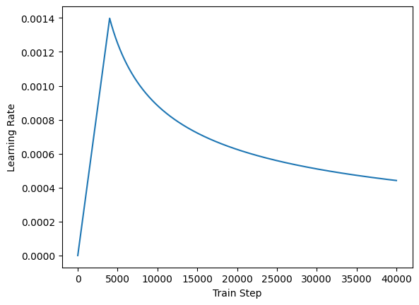

**Set up the loss and metrics**

Since the target sequences are padded, it is important to apply a padding mask when calculating the loss. Use the cross-entropy loss function ([tf.keras.losses.SparseCategoricalCrossentropy](https://www.tensorflow.org/api_docs/python/tf/keras/losses/SparseCategoricalCrossentropy?authuser=0)):

def masked_loss(label, pred):  
  mask = label != 0  
  loss_object = tf.keras.losses.SparseCategoricalCrossentropy(  
    from_logits=True, reduction='none')  
  loss = loss_object(label, pred)  
  
  mask = tf.cast(mask, dtype=loss.dtype)  
  loss *= mask  
  
  loss = tf.reduce_sum(loss)/tf.reduce_sum(mask)  
  return loss  
  
  
def masked_accuracy(label, pred):  
  pred = tf.argmax(pred, axis=2)  
  label = tf.cast(label, pred.dtype)  
  match = label == pred  
  
  mask = label != 0  
  
  match = match & mask  
  
  match = tf.cast(match, dtype=tf.float32)  
  mask = tf.cast(mask, dtype=tf.float32)  
  return tf.reduce_sum(match)/tf.reduce_sum(mask)

**Train the model**

With all the components ready, configure the training procedure using model.compile, and then run it with model.fit:

**Note:** This takes about an hour to train in Colab.

transformer.compile(  
    loss=masked_loss,  
    optimizer=optimizer,  
    metrics=[masked_accuracy])  
transformer.fit(train_batches,  
                epochs=20,validation_data=val_batches)

Epoch 1/20

WARNING: All log messages before absl::InitializeLog() is called are written to STDERR

I0000 00:00:1700138271.584619 39293 device_compiler.h:186] Compiled cluster using XLA! This line is logged at most once for the lifetime of the process.

810/810 [==============================] - 233s 254ms/step - loss: 6.5998 - masked_accuracy: 0.1435 - val_loss: 5.0554 - val_masked_accuracy: 0.2485

Epoch 2/20

810/810 [==============================] - 194s 239ms/step - loss: 4.5772 - masked_accuracy: 0.2972 - val_loss: 4.1541 - val_masked_accuracy: 0.3407

Epoch 3/20

810/810 [==============================] - 194s 239ms/step - loss: 3.8242 - masked_accuracy: 0.3798 - val_loss: 3.5155 - val_masked_accuracy: 0.4196

Epoch 4/20

810/810 [==============================] - 194s 239ms/step - loss: 3.2928 - masked_accuracy: 0.4375 - val_loss: 3.0246 - val_masked_accuracy: 0.4807

Epoch 5/20

810/810 [==============================] - 193s 238ms/step - loss: 2.9003 - masked_accuracy: 0.4818 - val_loss: 2.7157 - val_masked_accuracy: 0.5229

Epoch 6/20

810/810 [==============================] - 192s 236ms/step - loss: 2.5720 - masked_accuracy: 0.5215 - val_loss: 2.5050 - val_masked_accuracy: 0.5463

Epoch 7/20

810/810 [==============================] - 194s 239ms/step - loss: 2.2960 - masked_accuracy: 0.5575 - val_loss: 2.4090 - val_masked_accuracy: 0.5624

Epoch 8/20

810/810 [==============================] - 193s 237ms/step - loss: 2.1058 - masked_accuracy: 0.5833 - val_loss: 2.2977 - val_masked_accuracy: 0.5793

Epoch 9/20

810/810 [==============================] - 193s 238ms/step - loss: 1.9573 - masked_accuracy: 0.6036 - val_loss: 2.1928 - val_masked_accuracy: 0.5937

Epoch 10/20

810/810 [==============================] - 193s 237ms/step - loss: 1.8407 - masked_accuracy: 0.6204 - val_loss: 2.1310 - val_masked_accuracy: 0.6077

Epoch 11/20

810/810 [==============================] - 194s 239ms/step - loss: 1.7406 - masked_accuracy: 0.6353 - val_loss: 2.1256 - val_masked_accuracy: 0.6066

Epoch 12/20

810/810 [==============================] - 193s 238ms/step - loss: 1.6556 - masked_accuracy: 0.6480 - val_loss: 2.1054 - val_masked_accuracy: 0.6122

Epoch 13/20

810/810 [==============================] - 193s 238ms/step - loss: 1.5841 - masked_accuracy: 0.6585 - val_loss: 2.0783 - val_masked_accuracy: 0.6151

Epoch 14/20

810/810 [==============================] - 190s 234ms/step - loss: 1.5220 - masked_accuracy: 0.6682 - val_loss: 2.0700 - val_masked_accuracy: 0.6180

Epoch 15/20

810/810 [==============================] - 192s 236ms/step - loss: 1.4666 - masked_accuracy: 0.6766 - val_loss: 2.0557 - val_masked_accuracy: 0.6194

Epoch 16/20

810/810 [==============================] - 194s 239ms/step - loss: 1.4141 - masked_accuracy: 0.6855 - val_loss: 2.0391 - val_masked_accuracy: 0.6268

Epoch 17/20

810/810 [==============================] - 193s 238ms/step - loss: 1.3688 - masked_accuracy: 0.6924 - val_loss: 2.0478 - val_masked_accuracy: 0.6255

Epoch 18/20

810/810 [==============================] - 192s 236ms/step - loss: 1.3287 - masked_accuracy: 0.6987 - val_loss: 2.0598 - val_masked_accuracy: 0.6251

Epoch 19/20

810/810 [==============================] - 194s 239ms/step - loss: 1.2885 - masked_accuracy: 0.7053 - val_loss: 2.0598 - val_masked_accuracy: 0.6258

Epoch 20/20

810/810 [==============================] - 193s 238ms/step - loss: 1.2529 - masked_accuracy: 0.7107 - val_loss: 2.0712 - val_masked_accuracy: 0.6274

<keras.src.callbacks.History at 0x7f737c5202b0>

**Run inference**

You can now test the model by performing a translation. The following steps are used for inference:

* Encode the input sentence using the Portuguese tokenizer (tokenizers.pt). This is the encoder input.
* The decoder input is initialized to the [START] token.
* Calculate the padding masks and the look ahead masks.
* The decoder then outputs the predictions by looking at the encoder output and its own output (self-attention).
* Concatenate the predicted token to the decoder input and pass it to the decoder.
* In this approach, the decoder predicts the next token based on the previous tokens it predicted.

**Note:** The model is optimized for *efficient training* and makes a next-token prediction for each token in the output simultaneously. This is redundant during inference, and only the last prediction is used. This model can be made more efficient for inference if you only calculate the last prediction when running in inference mode (**training=False**).

Define the Translator class by subclassing [tf.Module](https://www.tensorflow.org/api_docs/python/tf/Module?authuser=0):

class Translator(tf.Module):  
  def __init__(self, tokenizers, transformer):  
    self.tokenizers = tokenizers  
    self.transformer = transformer  
  
  def __call__(self, sentence, max_length=MAX_TOKENS):  
    # The input sentence is Portuguese, hence adding the `[START]` and `[END]` tokens.  
    assert isinstance(sentence, tf.Tensor)  
    if len(sentence.shape) == 0:  
      sentence = sentence[tf.newaxis]  
  
    sentence = self.tokenizers.pt.tokenize(sentence).to_tensor()  
  
    encoder_input = sentence  
  
    # As the output language is English, initialize the output with the  
    # English `[START]` token.  
    start_end = self.tokenizers.en.tokenize([''])[0]  
    start = start_end[0][tf.newaxis]  
    end = start_end[1][tf.newaxis]  
  
    # `tf.TensorArray` is required here (instead of a Python list), so that the  
    # dynamic-loop can be traced by `tf.function`.  
    output_array = tf.TensorArray(dtype=tf.int64, size=0, dynamic_size=True)  
    output_array = output_array.write(0, start)  
  
    for i in tf.range(max_length):  
      output = tf.transpose(output_array.stack())  
      predictions = self.transformer([encoder_input, output], training=False)  
  
      # Select the last token from the `seq_len` dimension.  
      predictions = predictions[:, -1:, :]  # Shape `(batch_size, 1, vocab_size)`.  
  
      predicted_id = tf.argmax(predictions, axis=-1)  
  
      # Concatenate the `predicted_id` to the output which is given to the  
      # decoder as its input.  
      output_array = output_array.write(i+1, predicted_id[0])  
  
      if predicted_id == end:  
        break  
  
    output = tf.transpose(output_array.stack())  
    # The output shape is `(1, tokens)`.  
    text = tokenizers.en.detokenize(output)[0]  # Shape: `()`.  
  
    tokens = tokenizers.en.lookup(output)[0]  
  
    # `tf.function` prevents us from using the attention_weights that were  
    # calculated on the last iteration of the loop.  
    # So, recalculate them outside the loop.  
    self.transformer([encoder_input, output[:,:-1]], training=False)  
    attention_weights = self.transformer.decoder.last_attn_scores  
  
    return text, tokens, attention_weights

**Note:** This function uses an unrolled loop, not a dynamic loop. It generates **MAX_TOKENS** on every call. Refer to the [NMT with attention](https://www.tensorflow.org/text/tutorials/nmt_with_attention?authuser=0) tutorial for an example implementation with a dynamic loop, which can be much more efficient.

Create an instance of this Translator class, and try it out a few times:

translator = Translator(tokenizers, transformer)

def print_translation(sentence, tokens, ground_truth):  
  print(f'{"Input:":15s}: {sentence}')  
  print(f'{"Prediction":15s}: {tokens.numpy().decode("utf-8")}')  
  print(f'{"Ground truth":15s}: {ground_truth}')

Example 1:

sentence = 'este é um problema que temos que resolver.'  
ground_truth = 'this is a problem we have to solve .'  
  
translated_text, translated_tokens, attention_weights = translator(  
    tf.constant(sentence))  
print_translation(sentence, translated_text, ground_truth)

Input: : este é um problema que temos que resolver.

Prediction : so this is a problem we have to solve .

Ground truth : this is a problem we have to solve .

Example 2:

sentence = 'os meus vizinhos ouviram sobre esta ideia.'  
ground_truth = 'and my neighboring homes heard about this idea .'  
  
translated_text, translated_tokens, attention_weights = translator(  
    tf.constant(sentence))  
print_translation(sentence, translated_text, ground_truth)

Input: : os meus vizinhos ouviram sobre esta ideia.

Prediction : my neighbors heard about this idea .

Ground truth : and my neighboring homes heard about this idea .

Example 3:

sentence = 'vou então muito rapidamente partilhar convosco algumas histórias de algumas coisas mágicas que aconteceram.'  
ground_truth = "so i'll just share with you some stories very quickly of some magical things that have happened."  
  
translated_text, translated_tokens, attention_weights = translator(  
    tf.constant(sentence))  
print_translation(sentence, translated_text, ground_truth)

Input: : vou então muito rapidamente partilhar convosco algumas histórias de algumas coisas mágicas que aconteceram.

Prediction : so i ' m going to share a lot of these things with you some magic stories that happened .

Ground truth : so i'll just share with you some stories very quickly of some magical things that have happened.

**Create attention plots**

The Translator class you created in the previous section returns a dictionary of attention heatmaps you can use to visualize the internal working of the model.

For example:

sentence = 'este é o primeiro livro que eu fiz.'  
ground_truth = "this is the first book i've ever done."  
  
translated_text, translated_tokens, attention_weights = translator(  
    tf.constant(sentence))  
print_translation(sentence, translated_text, ground_truth)

Input: : este é o primeiro livro que eu fiz.

Prediction : this is the first book i did .

Ground truth : this is the first book i've ever done.

Create a function that plots the attention when a token is generated:

def plot_attention_head(in_tokens, translated_tokens, attention):  
  # The model didn't generate `<START>` in the output. Skip it.  
  translated_tokens = translated_tokens[1:]  
  
  ax = plt.gca()  
  ax.matshow(attention)  
  ax.set_xticks(range(len(in_tokens)))  
  ax.set_yticks(range(len(translated_tokens)))  
  
  labels = [label.decode('utf-8') for label in in_tokens.numpy()]  
  ax.set_xticklabels(  
      labels, rotation=90)  
  
  labels = [label.decode('utf-8') for label in translated_tokens.numpy()]  
  ax.set_yticklabels(labels)

head = 0  
# Shape: `(batch=1, num_heads, seq_len_q, seq_len_k)`.  
attention_heads = tf.squeeze(attention_weights, 0)  
attention = attention_heads[head]  
attention.shape

TensorShape([9, 11])

These are the input (Portuguese) tokens:

in_tokens = tf.convert_to_tensor([sentence])  
in_tokens = tokenizers.pt.tokenize(in_tokens).to_tensor()  
in_tokens = tokenizers.pt.lookup(in_tokens)[0]  
in_tokens

<tf.Tensor: shape=(11,), dtype=string, numpy=

array([b'[START]', b'este', b'e', b'o', b'primeiro', b'livro', b'que',

b'eu', b'fiz', b'.', b'[END]'], dtype=object)>

And these are the output (English translation) tokens:

translated_tokens

<tf.Tensor: shape=(10,), dtype=string, numpy=

array([b'[START]', b'this', b'is', b'the', b'first', b'book', b'i',

b'did', b'.', b'[END]'], dtype=object)>

plot_attention_head(in_tokens, translated_tokens, attention)

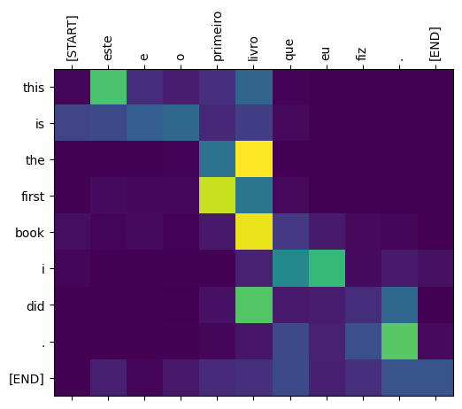

def plot_attention_weights(sentence, translated_tokens, attention_heads):  
  in_tokens = tf.convert_to_tensor([sentence])  
  in_tokens = tokenizers.pt.tokenize(in_tokens).to_tensor()  
  in_tokens = tokenizers.pt.lookup(in_tokens)[0]  
  
  fig = plt.figure(figsize=(16, 8))  
  
  for h, head in enumerate(attention_heads):  
    ax = fig.add_subplot(2, 4, h+1)  
  
    plot_attention_head(in_tokens, translated_tokens, head)  
  
    ax.set_xlabel(f'Head {h+1}')  
  
  plt.tight_layout()  
  plt.show()

plot_attention_weights(sentence,  
                       translated_tokens,  
                       attention_weights[0])

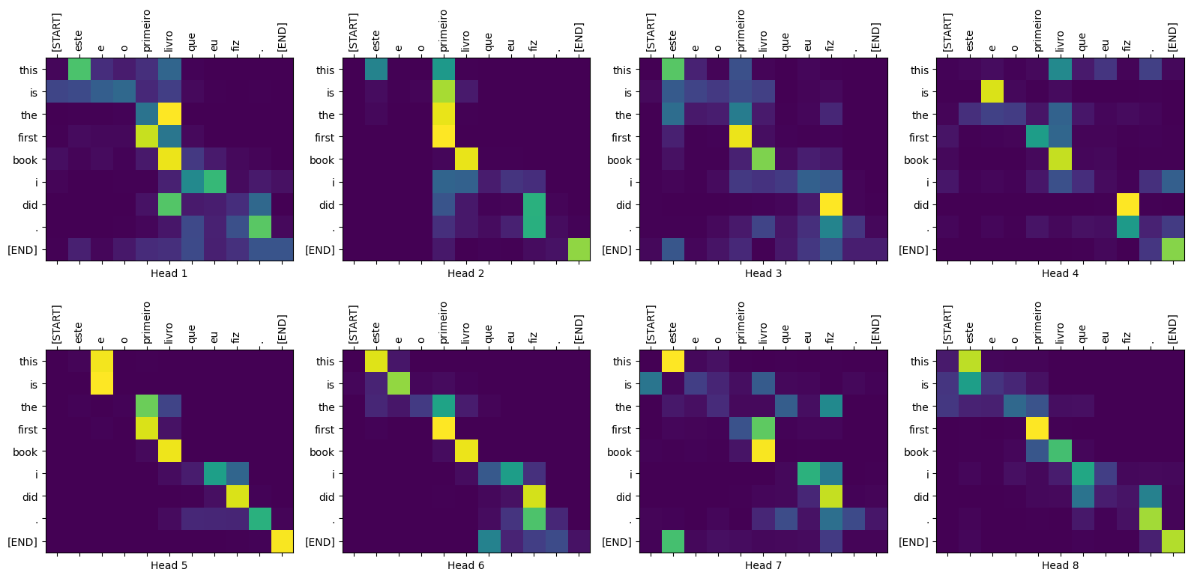

The model can handle unfamiliar words. Neither 'triceratops' nor 'encyclopédia' are in the input dataset, and the model attempts to transliterate them even without a shared vocabulary. For example:

sentence = 'Eu li sobre triceratops na enciclopédia.'  
ground_truth = 'I read about triceratops in the encyclopedia.'  
  
translated_text, translated_tokens, attention_weights = translator(  
    tf.constant(sentence))  
print_translation(sentence, translated_text, ground_truth)  
  
plot_attention_weights(sentence, translated_tokens, attention_weights[0])

Input: : Eu li sobre triceratops na enciclopédia.

Prediction : i read about chonese chops into egypt .

Ground truth : I read about triceratops in the encyclopedia.

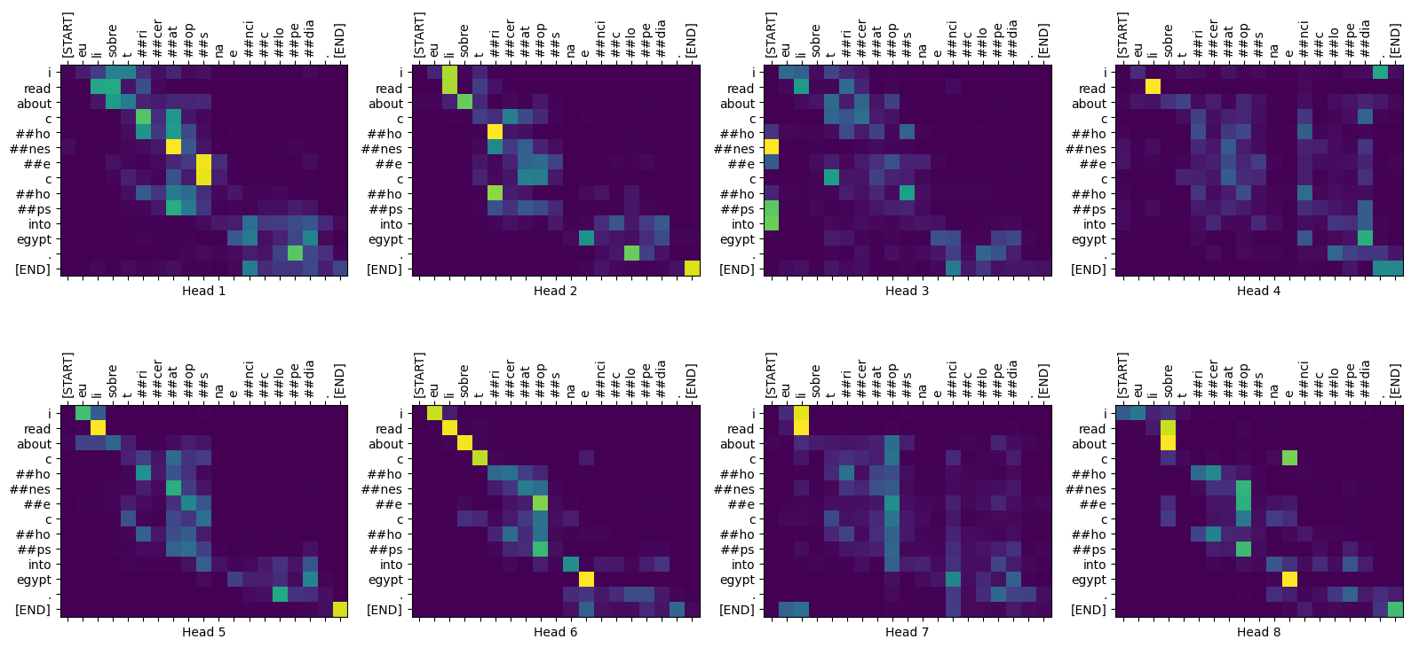

**Export the model**

You have tested the model and the inference is working. Next, you can export it as a [tf.saved_model](https://www.tensorflow.org/api_docs/python/tf/saved_model?authuser=0). To learn about saving and loading a model in the SavedModel format, use [this guide](https://www.tensorflow.org/guide/saved_model?authuser=0).

Create a class called ExportTranslator by subclassing the [tf.Module](https://www.tensorflow.org/api_docs/python/tf/Module?authuser=0) subclass with a [tf.function](https://www.tensorflow.org/api_docs/python/tf/function?authuser=0) on the __call__ method:

class ExportTranslator(tf.Module):  
  def __init__(self, translator):  
    self.translator = translator  
  
  @tf.function(input_signature=[tf.TensorSpec(shape=[], dtype=tf.string)])  
  def __call__(self, sentence):  
    (result,  
     tokens,  
     attention_weights) = self.translator(sentence, max_length=MAX_TOKENS)  
  
    return result

In the above [tf.function](https://www.tensorflow.org/api_docs/python/tf/function?authuser=0) only the output sentence is returned. Thanks to the [non-strict execution](https://tensorflow.org/guide/intro_to_graphs?authuser=0) in [tf.function](https://www.tensorflow.org/api_docs/python/tf/function?authuser=0) any unnecessary values are never computed.

Wrap translator in the newly created ExportTranslator:

translator = ExportTranslator(translator)

Since the model is decoding the predictions using [tf.argmax](https://www.tensorflow.org/api_docs/python/tf/math/argmax?authuser=0) the predictions are deterministic. The original model and one reloaded from its SavedModel should give identical predictions:

translator('este é o primeiro livro que eu fiz.').numpy()

b'this is the first book i did .'

tf.saved_model.save(translator, export_dir='translator')

WARNING:tensorflow:Model's `__init__()` arguments contain non-serializable objects. Please implement a `get_config()` method in the subclassed Model for proper saving and loading. Defaulting to empty config.

WARNING:tensorflow:Model's `__init__()` arguments contain non-serializable objects. Please implement a `get_config()` method in the subclassed Model for proper saving and loading. Defaulting to empty config.

WARNING:tensorflow:Model's `__init__()` arguments contain non-serializable objects. Please implement a `get_config()` method in the subclassed Model for proper saving and loading. Defaulting to empty config.

WARNING:tensorflow:Model's `__init__()` arguments contain non-serializable objects. Please implement a `get_config()` method in the subclassed Model for proper saving and loading. Defaulting to empty config.

INFO:tensorflow:Assets written to: translator/assets

INFO:tensorflow:Assets written to: translator/assets

reloaded = tf.saved_model.load('translator')

reloaded('este é o primeiro livro que eu fiz.').numpy()

b'this is the first book i did .'

**Conclusion**

In this tutorial you learned about:

* The Transformers and their significance in machine learning
* Attention, self-attention and multi-head attention
* Positional encoding with embeddings
* The encoder-decoder architecture of the original Transformer
* Masking in self-attention
* How to put it all together to translate text

The downsides of this architecture are:

* For a time-series, the output for a time-step is calculated from the *entire history* instead of only the inputs and current hidden-state. This *may* be less efficient.
* If the input has a temporal/spatial relationship, like text or images, some positional encoding must be added or the model will effectively see a bag of words.

If you want to practice, there are many things you could try with it. For example:

* Use a different dataset to train the Transformer.
* Create the "Base Transformer" or "Transformer XL" configurations from the original paper by changing the hyperparameters.
* Use the layers defined here to create an implementation of [BERT](https://arxiv.org/abs/1810.04805)
* Use Beam search to get better predictions.

There are a wide variety of Transformer-based models, many of which improve upon the 2017 version of the original Transformer with encoder-decoder, encoder-only and decoder-only architectures.

Some of these models are covered in the following research publications:

* ["Efficient Transformers: a survey"](https://arxiv.org/abs/2009.06732) (Tay et al., 2022)
* ["Formal algorithms for Transformers"](https://arxiv.org/abs/2207.09238) (Phuong and Hutter, 2022).
* [T5 ("Exploring the limits of transfer learning with a unified text-to-text Transformer")](https://arxiv.org/abs/1910.10683) (Raffel et al., 2019)